Potato Cyst Nematode
Globodera rostochiensis and Globodera pallida

What is PCN?
Potato cyst nematodes are microscopic, worm-like organisms that are less than 1 mm in length. They are soilborne pests that primarily feed on the roots of potato plants and other Solanaceous crops. They are one of the most serious threats to potato production worldwide.
Golden potato cyst nematode (Globodera rostochiensis) is currently present in parts of Victoria.
Pale potato cyst nematode (Globodera pallida) is yet to be confirmed to be present in Australia.

How to spot PCN
The symptoms of PCN infection are not specific and can be difficult to distinguish from water and nutrient deficiencies. Damage by PCN can range from patches of poor crop growth to significant reduction in yield depending on the severity of infestation.
Potato plants can exhibit the following symptoms when affected by the presence of PCN
- Stunted growth
- Chlorosis (yellowing) of leaves
- Dieback
- Reduced root systems and tuber sizes
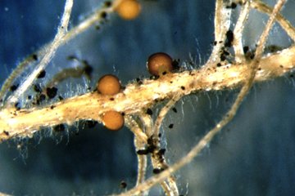
- Presence of yellow or brown cysts (approx. 0.5 mm diameter) on roots
Source: Johnathan D. Eisenback, via USDA-APHIS

How to ID PCN and prevent spread
Cysts can be spotted on the roots of host plants at flowering or later stages. However, diagnostic testing must be conducted to confirm the presence of PCN.
PCN can only move limited distances within soil. It is most commonly spread through the movement of affected potato tubers, potted nursery stock and used agricultural machinery contaminated with PCN infected soil.
Therefore, it is imperative that good hygiene measures are practiced. Ensure all goods and materials arriving on-site as well as leaving are washed or brushed clean of soil. Utilise PCN tested potatoes for seed and ensure detailed and accurate records are kept.

How to manage PCN
If PCN is already present in the soil, it is important to implement management strategies that aim to reduce PCN populations over time. Always ensure appropriate hygiene practices are in place to prevent further spread of PCN within and out of PCN-affected properties.
The most effective strategy to reduce PCN populations is to plant resistant host crops, as these trigger PCN eggs to hatch but do not allow the nematodes to establish feeding sites. Hence, females die off before developing fertilised eggs.
PCN infested fields may also be withdrawn from the production of Solanaceous host plants or long crop rotations can be utilised until PCN populations naturally decline. However, it may take decades to achieve eradication using these strategies.
Some further methods for managing PCN is to apply granular nematicides to the soil. Nematicides are effective in killing juvenile nematodes and are generally effective in protecting the current crop. As such, it should be noted that these often do not reduce PCN populations over time.

