Re-fencing considerations after fire or flood

When faced with the challenging task of re-fencing after a fire or flood your first priority will be to replace the boundary fence. After that, there is an opportunity to consider internal fences as part of a broader assessment of your property. Making time for planning may save you dollars in the longer term and make your enterprise easier to manage.

Will your new fence work with your land classes and land use?
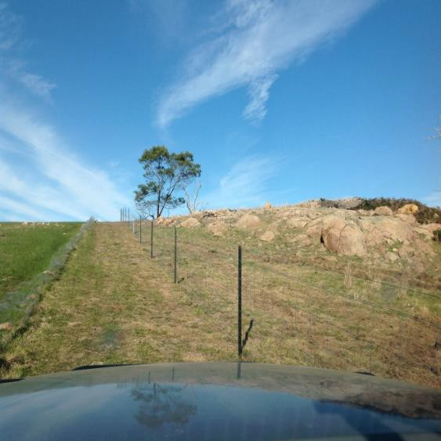
Land class fencing allows you to better manage the different land types on your farm. Benefits can include better pastures, improved productivity and the protection of soils and remnant vegetation. There are eight land classes, ranging from arable (1) to non arable (8).
Land class fencing
Sub-dividing your farm on a land class basis means you are considering attributes that impact on productivity and soil degradation. These attributes include: climate, soil type, slope, topography, aspect, drainage and the occurrence of surface rock or stone.
Management of remnant vegetation and paddock trees is also an important consideration for stock shade and shelter as well as landscape health.
Land class fencing goes hand-in-hand with a grazing management plan, appropriate to land capability. Such a plan can offer more control over grazing pressure along with better use and management of pastures. For example, do the land classes on your farm allow for fencing paddocks into a similar size for an easy rotational grazing system?

How can the fence work best for your enterprise?
A primary consideration is water supply and livestock access.
A new land class fencing plan presents an opportunity to redesign your farm’s watering system.
Studies show stock will select to drink from a trough rather than a dam as the water is cleaner and usually easier to access. Livestock will drink more water if it is of high quality, leading them to eat more dry matter and therefore gain weight.
Excluding or restricting stock access to a dam improves the water quality of the source. Install off-stream water points well away from areas vulnerable to soil erosion, pugging or compaction.
Stock type and class will determine the style of fencing you require. Do you run sheep, or cows and calves, or other livestock? Cattle can be managed with a five-wire standard fence while a three-wire electric may be more suitable for horses.
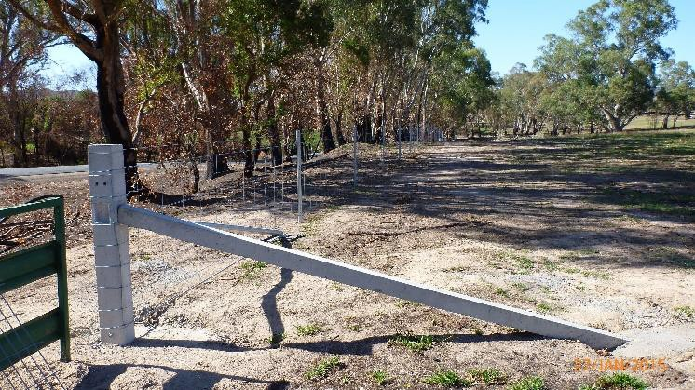
Consider using posts and end-assemblies that are more fire and/or flood tolerant, for example concrete or steel.
Concrete strainer post an a boundary fence
At the very least ensure you have one paddock fenced with tolerant materials for future stock containment.
Consider the behavioral traits of your stock and ease of moving them from one paddock to another.
Does a wagon-wheel arrangement work best around centre gates? Or is some other fence configuration and gate access more desirable for your stock type and landscape?
Will laneways be of value, for stock movement as well as safe vehicle access for either farm or emergency equipment? If so, how best can they be interconnected?

Any other considerations?
Following an event such as a fire or flood there may be areas on your farm that need immediate attention and extra recovery time.
Water sources may need protection from waste run-off or windborne ash and soil. Drainage lines without living grass cover are especially prone to erosion.
Native vegetation may re-seed after a fire and provide cheap shade and shelter renewal.
Temporary fencing will be needed while these areas rejuvenate.
While the aim with a new fencing design is to promote farm recovery and longer-term enterprise viability, plans must be practical and match your financial circumstances. Costing out your new fencing should include a realistic assessment of insurance coverage. Costings may also need to account for cost-share arrangements with boundary fencing.
When constructing your new fencing always be aware of potential hazards resulting from either the fire or flood. Tree trunks or limbs may be unstable, tree roots may still be hot or burning, and tunnel erosion an unexpected concern.

Where do you find assistance with developing a land class fencing plan?
Contact your nearest Agriculture Victoria office on 136 186 for referral to a Land Management Extension Officer.
An aerial map of your property can be provided to aid in planning for your farm’s recovery.

ACCESSIBILITY
If you would like to receive this publication in an accessible format, please telephone the Department of Energy, Environment and Climate Action on 136 186 or the National Relay Service on 133 677. This document is also available in PDF and/or HTML format at www.agriculture.vic.gov.au

