Demonstration goal: To evaluate and demonstrate potential production benefits for both ewes and lambs by weaning lambs at 12–14 weeks from the start of lambing, as opposed to not weaning the lambs and leaving them on the ewes until they’re at a marketable kill weight.
Site location: St Arnaud
Producer group: St Arnaud BestWool/BestLamb
Group coordinator: Steve Cotton
Agriculture Victoria coordinator: Rachel Coombes
Duration: 2018–2022
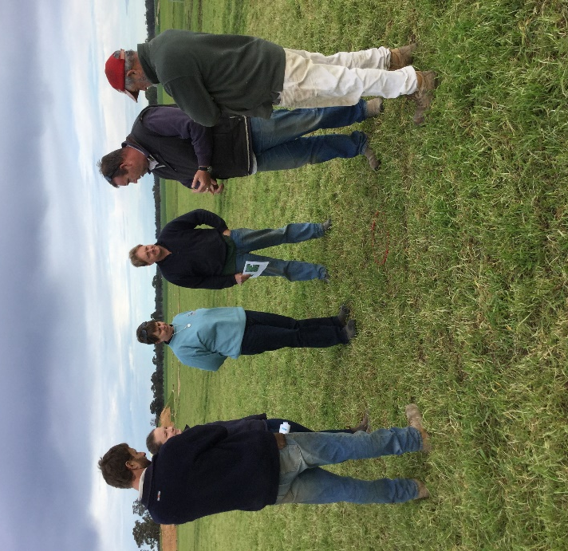

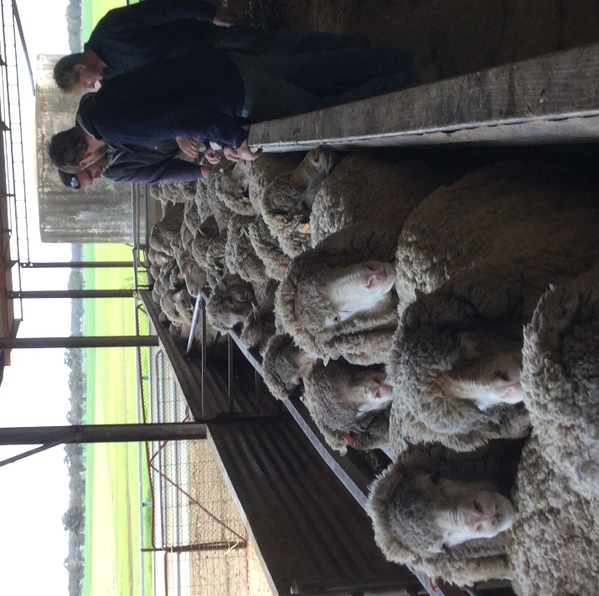
Group members assessing pastures and Feed on Offer
Group members condition scoring ewes
What are we aiming to achieve and why?
This demonstration aims to determine whether weaning lambs at 12–14 weeks is more efficient than not weaning lambs until they’re at a marketable kill weight.

Method
Traditionally, producers in the St Arnaud area sell sucker lambs direct from the ewe at the stock agents’ request. This demonstration compares the growth weights of weaned and unweaned lambs until the point of sale, as well as the condition of their weaned and unweaned dams.

At weaning, the condition score of the ewes is recorded, all lambs are weighed, and ewes and lambs are spilt into three mobs.
The three mobs include:
- weaned lambs
- unweaned ewes and lambs and weaned lambs
- unweaned ewes and lambs and weaned ewes.
The mobs have similar stocking rates and are allocated paddocks with similar pasture composition and Feed On Offer (FOO). Feed quantity and quality are monitored.
At six weeks post-weaning, participants have the option to sell their sucker lambs or keep them on ewes until they wish to sell those lambs. At the point of each sale draft, lambs are weighed to ascertain daily growth rates and, where possible, abattoir kills sheets are analysed for yield. Ewe condition is also recorded.
Partners: This demonstration is conducted with Agriculture Victoria and co-funded by Meat & Livestock Australia (MLA).

Contact
Rachel Coombes
E: rachel.coombes@agriculture.vic.gov.au
Steve Cotton
E: s.cotton@dynamic.com.au

More information
agriculture.vic.gov.au/agriculture/livestock/on-farm-demonstrations

Disclaimer
Any recommendations, suggestions or opinions contained in this publication do not necessarily represent the policy or views of Meat & Livestock Australia (MLA). No person should act on the basis of the contents of this publication without first obtaining specific, independent professional advice. MLA takes no responsibility, in any way whatsoever, to any person in respect to the document, including any errors or omissions therein, arising through negligence or otherwise however caused.
© Meat & Livestock Australia 2019 ABN 39 081 678 364
This work is copyright. Apart from any use permitted under the Copyright Act 1968, all rights are expressly reserved. Requests for further authorisation should be directed to the Corporate Communications Manager, PO Box 1961, North Sydney, NSW 2059 or info@mla.com.au.
Published in January 2020.

