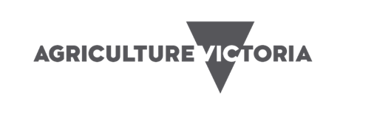
Managing avocado with less water in the Mallee

Introduction
Irrigators may be faced with managing avocado trees with less water due to dry seasonal conditions. In this situation a range of decisions may need to be made including:
- the purchase of additional water from a low availability market
- prioritise water onto preferred patches
- giving other patches reduced volumes with consequent reductions in production
- abandoning poorly performing patches, and
- possibly removing plantings of lowest priority and bringing forward redevelopment plans.
The success of a reduced irrigation strategy must consider the impacts in both the current season(s) and subsequent seasons. This is particularly the case with avocados, as the effects of inadequate moisture are not temporary. A survival mechanism exists where moisture stress leads to blockages in the tree’s water conducting tissues until new conductive tissue is grown. (often termed ‘drought memory’). Water movement can be reduced for up to two years after the stress period has occurred.

water requirEments
Avocados have relatively high-water requirements compared to other horticultural crops, and correct irrigation is the most important cultural practice in their production.
Avocado trees have a relatively shallow root system with very few root hairs. Water uptake can be inefficient, with trees unable to search for and extract water that is tightly held to soil particles. Therefore, this crop is less forgiving of poor irrigation practices. About 90 per cent of the roots typically occur in the top 15 cm, and little water can be extracted from soil that is drier than – 20 kPa.
For these reasons, there may be very little that can be done to save significant amounts of water, other than those generated by standard efficient irrigation practices (depending on the current irrigation management). Water budgeting and purchasing additional water to deliver full production potential to selected blocks (including the need for cooling sprays), canopy reduction, patch prioritisation and possibly bringing forward redevelopment plans are the most effective strategies to be considered when managing low water availability.

Growth stages
It is important to avoid moisture stress in avocados at all growth stages, but it is particularly important to avoid stress at three particular times:
- flower bud extension to flowering — trees have high water requirements from flowering until after initial fruit drop (fruit shedding). Flowering (mid October to November in the Mallee) is a critical period, when the evaporative surface of the tree increases by up to 90 per cent
- early fruit development, cell division and expansion (November–December), and
- major fruit sizing (January–February).
Water demand continues in winter, but at a much-reduced rate, as fruit sizing is occurring and roots are still actively growing.

deficit irrigation
Avocados are sub-tropical trees. They are evergreen with large leaves and a shallow root system, need water year-round and have a ‘drought memory’. Therefore, any deficit irrigation strategy (either regulated deficit irrigation or sustained deficit irrigation) applied in order to save water is not recommended.

immediate Water saving practices

Water budgeting
Estimating the monthly water requirements for each patch using average industry data and historical irrigation records can be used to develop a drought management plan and prioritise allocation of water to blocks. See Water Budget Planning for more information on developing a water budget.

Install irrigation scheduling devices
It is crucial to use soil moisture monitoring devices to accurately check soil water levels and allow irrigations to be scheduled more precisely. Monitoring allows the effectiveness of water saving practices to be readily determined. Tensiometers have often been a recommended tool as they are relatively cheap, easy to install and use.
Tensiometers, however, are not particularly useful for intensively irrigated avocado orchards where frequent irrigations take place. More sophisticated (and expensive) scheduling tools are recommended in this situation. Devices that are continuously logged will provide far greater information, accuracy and effectiveness in monitoring irrigation applications. They are particularly useful in being able to immediately determine appropriate irrigation depth and encourage confident, informed decisions regarding this.
Determining irrigation application depth, and making appropriate adjustments, is something that can generally be adopted quickly with more sophisticated devices, even though it generally takes longer to learn how to use and fully understand the information generated from these tools. If multiple sensor depths are installed, the active rootzone is quickly determined. The long-term benefit from adopting continuously logged soil moisture monitoring and the production benefits that are possible, should also be considered.

Check, manage and maintain the irrigation system
Irrigation systems should be checked for any leaks or blockages. The accuracy of water meters should be checked by cross-referencing readouts with application rates and system specifications. If irrigation uniformity is poor an irrigation consultant may be needed to advise on improvements. The effect an inefficient system has on an orchard will be exacerbated during times of low water supply. Correcting these issues may only result in modest water savings, but during a period of low water availability those savings may be significant. See Checking Irrigation Uniformity in Avocado Orchards.

Avoid leaching losses
Ensure water is not applied and lost below the root zone by carefully monitoring soil moisture levels and irrigation depth. Sampling for soil salinity is recommended to determine if a strategic leaching program is needed. Water during a period of low availability may have elevated salinity levels.

Mulch the wetted strip
Mulching provides many benefits to avocados and is a strong industry recommendation, contributing to long-term orchard health and productivity. The shallow-rooted nature of avocados means that during hot conditions these roots can burn in soils without mulch. Applying mulch moderates soil temperatures and helps reduce soil evaporation which is a significant benefit to such a shallow rooted crop.
A thick layer of rye corn has proven to be beneficial in the Mallee because it has a long breakdown period. Be aware the decomposition of some materials can result in nitrogen draw-down as soil microbes decompose the material.
Mulches can act as a barrier to effective water penetration, and once wet-up can then quickly dry out. Accurate soil moisture monitoring is important in order to recognise this situation.

Reduce the wetted area
This is most applicable to young plantings. If irrigating with low level sprinklers, changing over to a sprinkler head, adaptor, or installing a sleeve over the head of the sprinkler creates a narrower throw, eliminating water application to the inter-row area where roots have not yet significantly colonised. Run times can be significantly shortened while still ensuring the majority of an under-developed root zone is watered. This may involve moving sprinkler heads closer to the butt of the tree. These recommendations are often typically adopted in a young avocado orchard.
For drip irrigated orchards plugs can be installed between trees, leaving only the emitters near the tree functioning.
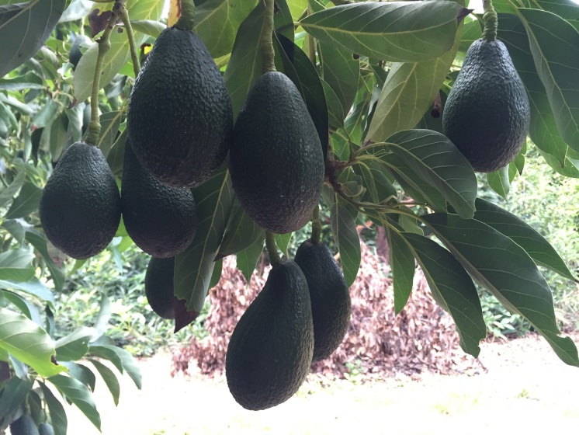

Irrigate at night
Irrigating with low-level sprinklers at night can provide water savings of 20–30 per cent compared with daytime irrigation by reducing evaporative losses. Daytime irrigations may be necessary with avocados, however, particularly during extreme heat conditions.

Eliminate water runoff
Irrigation water should be kept in the orchard. If surface runoff is occurring, consider breaking up soil crusts to improve water penetration and soil aeration. The traditional methods of improving water penetration are applying gypsum and/or ripping. Ripping in a low water scenario is not recommended due to the additional stress created through root damage, and the reduced ability of the tree to access any rainfall. Good mulching programs, which are strongly recommended for avocados, will also help eliminate run-off.

Reduce or cease windbreak irrigation
This can save water but jeopardises the long-term benefits of windbreaks. Additionally, unirrigated windbreaks can scavenge water from the adjacent crop, so deep ripping or trenching to trim windbreak roots may be required.

Re-use filter back-flush water
Contact an irrigation designer to ensure excessive back-flush volumes are not being generated to begin with. Some minor savings may be possible. The back-flush water that is created from drip irrigation filters can be re-used if run to a settling tank. Discuss this option with an irrigation designer. Media filters generally use 4.0–5.0 per cent of the water pumped to backflush, disc and screen filters 1.5–2.0 per cent.

Reduce transpiration
Kaolin-clay-based foliar spray products are claimed to reduce water losses through leaves. While no specific work has been documented for avocados, neither water savings or reduction in plant stress following their application has been reported for a range of other crops.
New products enter the market frequently, and there is always the possibility that some may prove to be of benefit. If using these products, consider leaving untreated areas in order to determine the effectiveness of whatever was applied.

Full cover weed control
Removing weeds and eliminating sods will reduce competition for water. Sods are best sprayed with herbicide (at recommended rates) and allowed to form a layer of mulch, protecting the soil and reducing evaporation.

Buy/trade water
Buying or leasing-in water, if available, can be a viable option. Consider the long-term value of the trees and crops compared with the cost of water. If the cost of water is less than the value of produce lost by withholding that volume of water (including any ongoing recovery to production), then buying permanent or temporary water should be seriously considered. Although developed for winegrapes, spreadsheets such as that produced by CCW (Consolidated Co-operative Wineries – membership required) are available to quickly determine if buying water is a viable option.
Rural Financial Counsellors may be able to help with these tools (Ph. 1300. 735 578).

Keep informed about water allocations
Maintain contact with the water supply authority for the latest information on water allocations, water flows and water levels in storage. Obtain information on current and next season’s likely water allocation scenarios to enable better long-term decision making. This information can be sourced from state (eg http://waterregister.vic.gov.au/) and local water authority web sites, and Apps such as Water Market Watch and Waterflow. Look at long-term weather forecast information to help schedule irrigations.

Managing orchard variation
Orchard variation will be more significant during times of low water application. Variation, for the most part, is due to poor irrigation uniformity and soil type variation.
More localised tree health variation may also occur due to root rot. If infection is severe consider capping sprinklers around infected trees and earmark the trees for replanting. If infection is widespread and tree health is poor, the whole patch could be considered for redevelopment.

Longer-term water saving strategies

Install valves for each patch
Separate valves to blocks or patches that have different water requirements to allow a more accurate match of crop water needs with irrigation applications. Water use differs between varieties, and with tree age. If adopting canopy reduction on part of a patch, the irrigation system should be modified to cater for the significant differences in water requirements which are created.

Install more sophisticated scheduling equipment
More sophisticated scheduling equipment (e.g. capacitance probes) will enable far more accurate irrigation applications and assessment of additional rainfall effectiveness. Leaching losses can be completely avoided while still ensuring that irrigations are fully effective. This equipment is more expensive and requires some time to learn how to use and understand the information generated.

Convert to more efficient irrigation systems
When managed correctly, drip irrigation is potentially the most efficient irrigation system currently available. Conversion to drip is often a standard horticultural recommendation when water allocations are low or predicted to be low. Avocado producers’ personal experiences with drip irrigation have been mixed. Correct management is critical because avocado trees are very unforgiving.
A hasty conversion to drip in a low water situation, without any previous experience with this system, may create problems. Managers in this situation should consider persisting with a system they are familiar with. A change to drip may result in severe crop loss. Many who have trialled drip are moving back to low-level sprinklers for these reasons.
If looking to convert to drip remember a new permanent drip system requires substantial investment and should be professionally designed.

It is important to be aware that converting to drip from a full cover irrigation system changes the distribution of water in the root zone. Roots take time to respond to a change in water distribution, and trees will experience stress until the root system has adjusted. In a normal season, ample drip irrigation applications are recommended in the first year following conversion. Superimposing water deficit on top of the conversion, during low water conditions, is likely to lead to significant stress.

Young tree (0–6 years) management
Significant water savings can be made on young trees if water is applied efficiently. Young trees have a smaller canopy and root zone than older trees and require less water in proportion to their reduced canopy size.
Basic water saving practices for young trees include:
- reducing leaching losses below the root zone
- building a small basin around newly planted trees to trap water (low-level sprinklers)
- spreading mulches around the tree to reduce evaporation from the soil surface
- inline drippers clips (C clips) can be used to block off drippers between trees where the roots have not yet established
- installing additional submains and valves to separate young plantings from mature trees
- installing sprinkler heads that have a smaller throw pattern, and
- installing soil moisture monitoring to accurately and confidently determine water demand from young trees.

Canopy reduction
Tree water use is directly related to canopy size, so reducing the canopy reduces water use. The relationship between canopy size and water use occurs primarily through intercepting solar radiation (sunlight).
Consequently, for a 50 per cent water availability reduction, for example, tree canopy reduction to reduce the shaded area under the trees by 50 per cent will match water demand to availability.
If a patch of trees is in need of pruning due to row access issues, or old trees need to be rejuvenated due to declining productivity, then this presents itself as an opportunity. However, if pruning is used purely as a water saving strategy this must be carefully considered as one part of a whole farm strategy, as it will significantly affect production levels for the next couple of years, even if allocations immediately return to normal. Alternatively, old or unproductive blocks could be abandoned in preparation for replanting when water availability increases.
Unlike citrus, avocados do not lend themselves to hedging or skeletonising (at least in the Mallee), although some recent work on selective limb removal has occurred.
Severe selective limb pruning to remove 50 per cent of producing wood allows the remaining 50 per cent of the tree to remain productive. Whitewashing all remaining branches will be necessary.
Reducing the height of the trees, as well as removing large limbs in older trees, will also reduce irrigation requirements while allowing some production to continue (Figure 1).
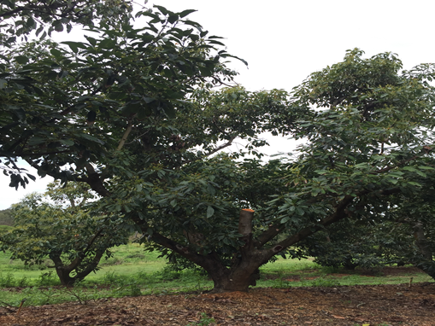
Figure 1. Large limb removal in avocado (Photo: Lisa Martin)

The decision to remove canopy should be based on tree age, crop load, stage of growth, on-off crop load cycle, long-term block viability, water and commodity prices (consider the likely effect of low water supply to district and basin-wide avocado production levels and subsequent fruit prices), and how much water needs to be saved. Providing trees are given sufficient levels of water and nutrients they should recover to form a vigorous canopy that produces good quality fruit.
It is important to treat whole irrigation units (not alternate rows for example), so that a reduced irrigation application can be confidently applied to the patch, and re-growth occurs evenly without excessive shading from unpruned neighbouring trees. If a whole irrigation unit cannot be pruned the irrigation system should be modified to suit, otherwise the full benefits of reduced irrigation demand cannot be achieved. Soil moisture monitoring also becomes important to confirm reduced water demands and allow appropriate irrigation scheduling to take place.

Staghorning
Staghorning involves cutting trees back to a stump, above the graft union, to rejuvenate orchards or allow top-working to new varieties. It can also be an option if severely reduced water supplies exist (Figure 2).
Staghorned trees will require exposed limbs to be painted with whitewash to prevent sunburn. Damage can occur within a day in hot weather, and the risk increases significantly as temperatures rise. Adding a copper fungicide treatment may assist in controlling disease on the pruned surface.
Trees can be out of production for 2–4 years following staghorning. If nurse limbs are retained recent trials have found that trees can be back in production in 1–2 years with correct management and canopy re-growth manipulation.
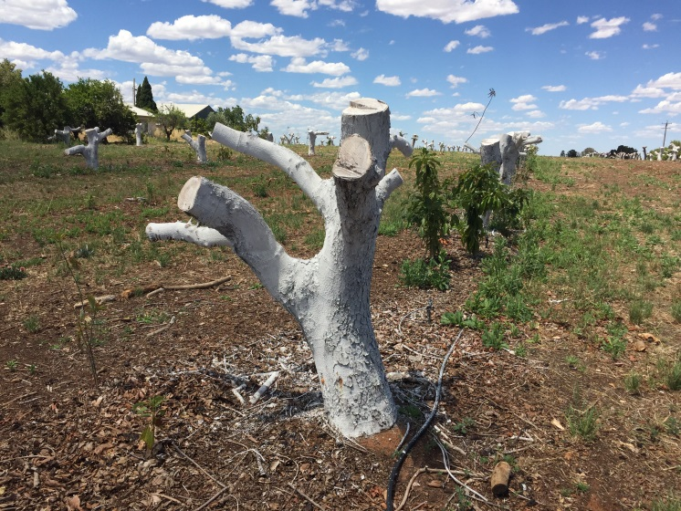
Figure 2. Staghorned mature avocado trees (Photo: Jeremy Giddings)

water budget planning
Table 1 is a sample water budget for a 16 ha sprinkler irrigated avocado orchard. The property has an entitlement of 200 ML. The table considers a scenario where the orchard’s allocation has reached only 40 per cent, leaving 80 ML available.
The first step is to prioritise patches and identify appropriate management strategies. Discussions with packers should take place. Typical annual water use for each block needs to be determined from previous records and experience. The proposed allocation for each patch, and the management strategy to be implemented, must then be determined.
Patch | Tree age (yrs) | Area (ha) | Typical annual water use (ML) | Proposed water application (ML) | Management strategy
1 | 3 | 3 | 15 | 15 | Maintain young growth
2 | 10 | 4 | 48 | 15 | In need of rejuvenation—Staghorning
3 | 10 | 3 | 48 | 48 | Full production
4 | 30 | 6 | 72 | 0 | Poor producing—Redevelop
 | Total | 16 | 173 | 78
Table 1. Sample of a water budget for a 16 Ha avocado orchard with a 40 per cent allocation (This is an example and should be used as a guide only).

case studies

Doug Shephard, Merbein VIC
In 2007/08 the market price of temporary water reached more than $1,000/ML in the first half of the season, as irrigators responded to a seasonal outlook of very low allocation being made to entitlements. While some held carryover from the previous season, it was seen as insufficient to maintain crops.
The market price of water reduced significantly later in the season as other states increased allocation, and demand eased as large horticultural operators had purchased sufficient water to preserve their crops and buying pressure dropped away from the market.
The initial allocation at the start of the 2007/08 season was 0 per cent, and 23 per cent by November 15 2007. Increases through the season resulted in a final allocation of 43 per cent by season’s end. In the following season, a total allocation of 35 per cent was eventually received, with 100 per cent allocations returning from 2009/10 onwards.
Doug Shephard grows 4 ha of avocados at Merbein, supplied with water by Lower Murray Water in Victoria, 15 km from Mildura.

One single approach
“Back then I stumped the lot, then mulched everything back onto the orchard, leaving six inches of mulch. Trees took four years to return to production. In one sense the block did need pruning, especially the Hass, but the long return period is an issue”.

Next time
- “Purchase water would be the main approach given current situation and avocado returns”.
- “I wouldn’t completely stump again; I’d leave a nurse limb. Unless growers are diligent with annually managing the canopy, Hass will probably need some form of staghorning every 10 years anyway”.
- “I’d add chickweed straw to reduce evaporation. It can last up to two years”.

Roger Wescombe, Trentham Cliffs NSW
A 100 per cent allocation was announced for NSW Murray high security entitlements at the start of the 2006/07 season. However, by November 2006, allocations had been ‘suspended’ to approximately half following record low inflows. This had an enormous impact on NSW Murray irrigators who had developed and prepared their properties under the assumption that ample water would be made available in that season. NSW Murray high security irrigators initially received zero allocation the following (2007/08) season. Suspended water from the previous season was gradually returned to irrigators over the season. Critical water was also obtained for NSW high security licences in an attempt to keep permanent plantings alive but not necessarily produce a crop. This critical water represented approximately 50 per cent of avocado water requirements. At the same time, water prices peaked at over $1,000/ML for the first half of the season (normally $100–$300) making water purchases on the open market uneconomic for many.
At this time Roger Wescombe grew 4 ha of avocados at Trentham Cliffs on the Murray River in NSW, 15 km from Mildura.

Two approaches
- “Purchased enough water which I thought I’d get away with. I didn’t know if enough water for the season would be returned. It didn’t appear that we’d have enough to finish crops. I sacrificed the winegrapes a little as I knew they’d recover better than avocados.”
- “Cut approximately 1 ha down to a stump at about 4ft high, cleaned them out and painted them. Chose the patch based on tree age. I was reasonably tight with the watering of the remainder of the avocados. I already had probes which were a huge benefit.”

Next time
“Buy more water. It took too long to get the stumped trees back into full production — about four years. If having to reduce the canopy, I’d now look at removing a proportion, may be half only, to retain some production.”

further information
Irrigation Services, Agriculture Victoria. irrigation@agriculture.vic.gov.au
Avocados Australia Ltd. Best Practice Resource. Membership required.

acknowledgments
Barry Avery — Avocado grower and consultant
Lisa Martin — Ripe Horticulture
Simon Newett — Principal Extension Horticulturalist, Dept. Employment Economic Development and Innovation, Queensland
Doug Shephard — avocado grower, Merbein VIC
Trevor Sluggett — Agronomy Manager, Total Eden, Renmark SA
Jenny Treeby — Senior Project Officer, Agriculture Victoria
Michael Treeby — Group Leader, Agriculture Victoria Research
Matthew Weinert — Industry Development Officer, NSW DPI
Roger Wescombe — retired avocado grower, Trentham Cliffs, NSW
Accessibility
If you would like to receive this publication in an accessible format, please telephone Agriculture Victoria, Irrigation Services on 136 186.
This document is also available in (Word) format at www.agriculture.vic.gov.au

