Guide to managing chestnut blight

Summary

About the disease
• Chestnut blight is a declared exotic plant disease of chestnut and oak trees that is present in Victoria.
• Chestnut blight poses a significant risk to Australia’s chestnut industry, approximately 70 per cent of which is produced in Victoria.
• Chestnut blight is spread through direct contact with the fungus inside an infected plant (e.g. via pruning) or by spores released into the environment from orange stroma formed on infected material. It can easily spread via infected cuttings and budwood,
so only source these from disease free suppliers.

Survey your trees
• Every three months, inspect all host trees on your property, looking for chestnut blight symptoms, which can be difficult to detect.
• If you suspect that you have found chestnut blight, photograph symptoms, mark the tree and exit your orchard immediately.
• Report suspected detections to Chestnuts Australia Incorporated at
ibo@chestnutsaustralia.com.au (in Victoria) or the Exotic Plant Pest Hotline
on 1800 084 881 (outside Victoria).

Destroy infected trees
• In Victoria, the landholder is responsible for managing chestnut blight on their property.
• Where the presence of chestnut blight is suspected or known, and not managed by the landholder, Agriculture Victoria can place the property under quarantine and stop all movements of plant material, machinery and equipment until infected trees are destroyed and equipment decontaminated.
• To manage chestnut blight, you will need to destroy infected plant material by burning it to ash. In Victoria, destruction should occur within 14 days of detection (where weather conditions allow).
• Where possible, use a saw to cut down trees to avoid the need to decontaminate heavy machinery.
• Stumps should be removed and burnt with the tree.
• Make a burn pile with minimal air space suitable for an intense fire that will burn
green and wet infected plant material.
• Chestnut blight spores can still be actively produced from felled trees, so if burning is delayed it is important to cover infected plant material to prevent disease spread.
• Every three months, look for plant regrowth at the remains of destroyed trees.

Decontaminate
• It is important to practice good farm hygiene to avoid spreading chestnut blight to other trees or properties.
• Wear an outer layer of clean, protective clothing such as coveralls that can be removed during decontamination and washed after use.
• A disinfectant solution will be required to decontaminate your shoes, tools, equipment, machinery and vehicles.
• Where possible, remove organic matter before spraying or dipping tools and equipment into disinfectant.
• Always use chemicals safely and responsibly.
• Regularly wash your hands with soap and water throughout the decontamination process, particularly after handling dirty items and before touching clean items.

About chestnut blight
Chestnut blight is a disease of chestnut and oak trees that is present in Victoria. It is caused by a fungus (Cryphonectria parasitica) that grows underneath the bark, resulting in degraded or dead tissue (cankers) that slowly develop and surround the infected trunk, stem or branch. Once a tree is infected, the prognosis is bleak – the tree will eventually die.
In Australia, chestnut blight primarily infects chestnut and oak trees. These are referred to as “host” trees.
Chestnut blight poses a significant risk to Australia’s chestnut industry, approximately
70 per cent of which is produced in Victoria. Once present, the disease can remain dormant for many years before symptoms become visible, making it very difficult to detect and eradicate.
The Industry Biosecurity Officer (Chestnuts Australia Incorporated) can provide support to chestnut growers across Australia regarding surveillance, suspected detections and management of chestnut blight. Growers are encouraged to contact the Industry Biosecurity Officer for further advice.

Growers are our first line of defence
All chestnut growers are asked to remain vigilant and survey their chestnut and oak trees every three months for signs of this devastating disease. If you suspect that you have found chestnut blight, report it immediately to:
• the Industry Biosecurity Officer (Chestnuts Australia Incorporated) at
ibo@chestnutsaustralia.com.au (if you are located within Victoria), or
• the Exotic Plant Pest Hotline on 1800 084 881 (if you are located outside Victoria).
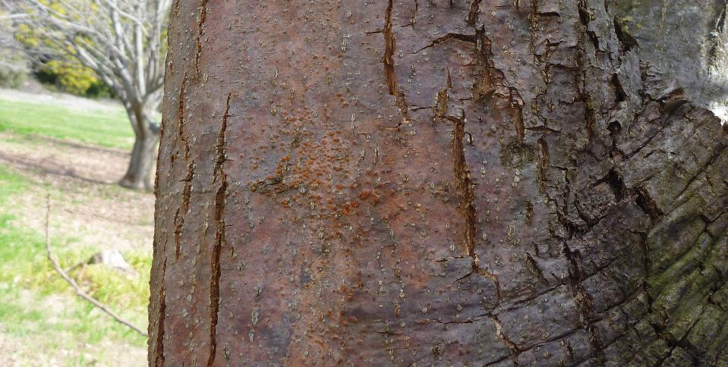
Early detection allows for early intervention and management of the disease. This is critical to minimising the spread of chestnut blight.

Disease symptoms
Chestnut blight symptoms can be difficult to detect. Infected trees are likely to have some or all of the following symptoms.
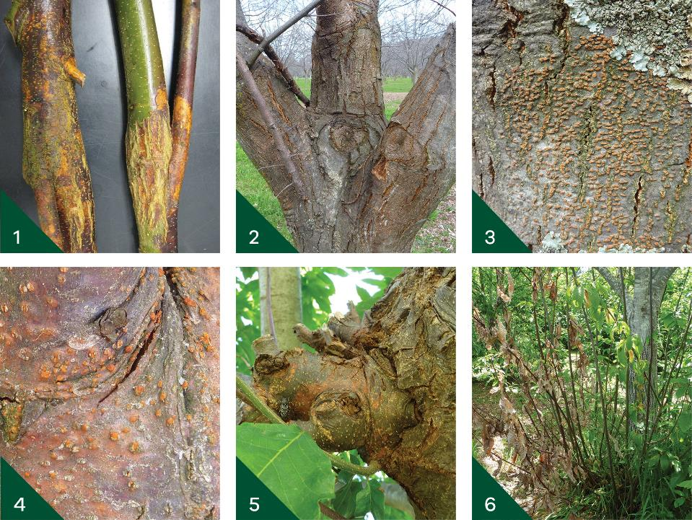
1. Cankers (degraded or dead tissue) on the trunk, stems or branches.
2. Discolouration, cracking, peeling, sinking, shedding or swelling of the bark.
3. Orange stroma (1-3 millimetre diameter structures that contain spores) on the bark. This is the most distinctive symptom of chestnut blight. The colour indicates that the fungus is actively producing spores. Note: orange stroma do not have to be visible for
a tree to be infected with chestnut blight.
4. Red to purple discolouration on young bark, often accompanying cankers. Orange stroma are also depicted here.
5. New growth below a canker (as pictured) or from the base of a tree (referred to as “water shoots”).
6. Dead leaves, branches or whole trees. Cankers cause leaves to wilt and die, ultimately killing branches. The leaves generally stay attached to the dead branch, resulting
in a distinctive ‘flag’ of yellow-brown leaves in contrast with healthy green leaves.
This image shows dead leaves alongside water shoots on a chestnut
blight-infected tree.
Symptoms can appear at any time. However, it is very important to look at your trees in autumn and spring when the weather is moist and warm, and the orange stroma are most likely to be present.

How it spreads
Chestnut blight is spread through direct contact with the fungus inside an infected plant (e.g. via pruning) or by spores released into the environment from orange stroma formed on infected material. If the fungus or spores come into contact with a host tree, they can cause infection. The fungus and spores can be transported by anything that they come into contact with, such as:
• wind
• water and rain-splash
• humans, animals and insects
• equipment, machinery, clothing and packaging.
Chestnut blight can easily spread via infected cuttings and budwood, so only source these from disease free suppliers.
Did you know?
Chestnut blight spores can remain viable on clothing and equipment
for several days and be produced in dead wood for at least a year.

Looking for chestnut blight on your property
Chestnut blight can be difficult to detect because it can grow for years in trees without showing obvious symptoms. Every three months, growers should survey their chestnut and oak trees for chestnut blight symptoms (as well as other pests and diseases).

1. Survey your trees for symptoms

2. Report any suspect symptoms

3. Start a new survey

5: Survey the sites of destroyed trees

4. Destroy infected trees

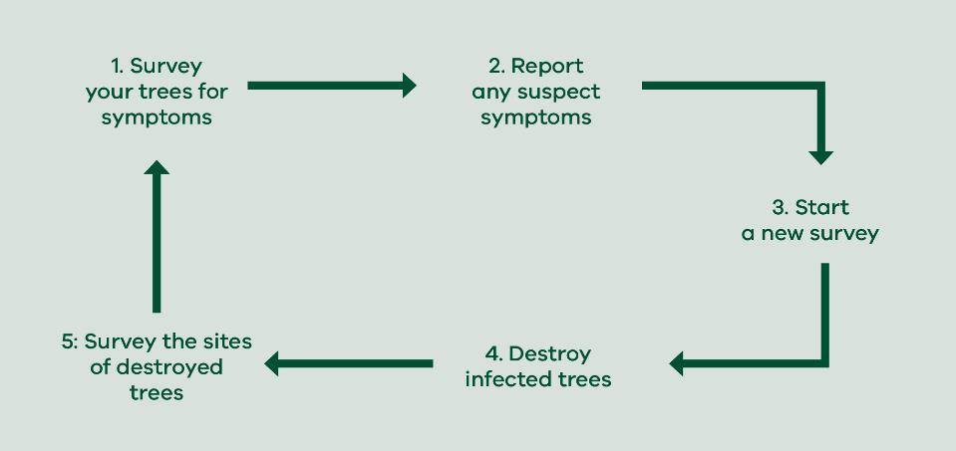
Follow these steps to look for and manage chestnut blight on your property
Remember to always practice good farm hygiene and decontaminate when moving between orchards/blocks to avoid spreading disease to other trees or properties.

Survey your trees for chestnut blight
Every three months, inspect all host trees on your property, looking for chestnut blight symptoms. This is known as “targeted surveillance”. Doing this quarterly provides more opportunities to detect the disease early, to the benefit of your business and the entire chestnut industry.
Symptoms can appear from ground level up to the highest branches; look low to the ground and above head height. Carefully inspect the trunk, branches, wound sites and immediately below any dead branches, pruning sites and graft unions for signs of infection. As a guide, inspect each tree for a few minutes. It may take several days to survey your entire property.
Take a camera and something to mark trees with (e.g. spray paint) in case you find symptoms. Decontaminate your shoes in a footbath and wear different clean clothes when moving between orchards/blocks.
Tip: Avoid conducting surveys when trees are damp or wet, as spores are likely to be released and spread disease via hands, footwear, equipment and clothing.

Record survey results
Use the Chestnut blight surveillance form (see back of booklet) to record your findings, even if you do not find any symptoms. It is important to record the absence of disease to build up confidence that an area is free of chestnut blight. Send the surveillance form to Chestnuts Australia Incorporated at ibo@chestnutsaustralia.com.au.
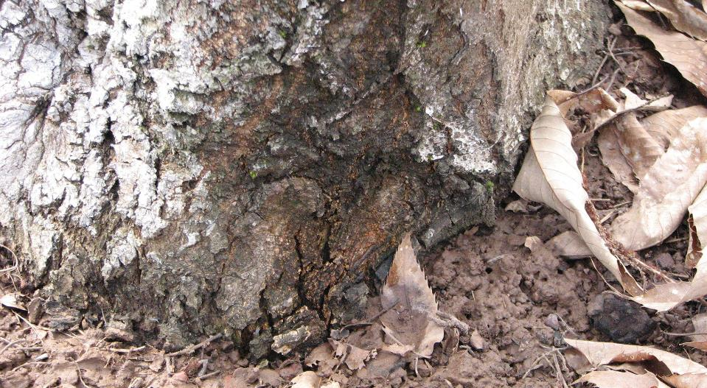
This tree is infected with chestnut blight; note the orange stroma at the base of the trunk

Suspect symptoms found
If you suspect that you have found chestnut blight, photograph symptoms, mark the
tree and exit your orchard immediately, decontaminating your shoes on the way out
(see Hygiene station). Wash your clothes at minimum 50 ºC (where possible) and report the suspect detection of chestnut blight.
Tip: Do not collect samples of suspected chestnut blight. Avoid contact with any trees showing symptoms, as handling could spread the disease.

Report suspected detections
If you suspect that you have found chestnut blight, report it immediately to:
• the Industry Biosecurity Officer (Chestnuts Australia Incorporated) at
ibo@chestnutsaustralia.com.au (if you are located within Victoria), or
• the Exotic Plant Pest Hotline on 1800 084 881 (if you are located outside Victoria).
In Victoria, the landholder is responsible for managing chestnut blight on their property. It is vital to begin a new survey to determine the full extent of the infection, so that the disease can be effectively managed.

Start a new survey to identify trees for destruction
Using the same survey approach outlined above, survey all host trees on your property, marking any with symptoms. You should also mark trees that are touching or very near to infected trees, as they too may be infected but not yet be showing symptoms. Use the surveillance form to record your findings.
Practice good farm hygiene when surveying your trees to avoid spreading disease when moving between orchards/blocks (see Hygiene station).
Tip: Survey suspect or known infected orchards/blocks last to avoid spreading the disease to healthy trees.
In Victoria, where the presence of chestnut blight is suspected or known, and not managed by the landholder, Agriculture Victoria can place the property under quarantine and stop all movements of plant material, machinery and equipment until infected trees are destroyed and equipment decontaminated.

Destroying infected trees
To manage chestnut blight, you will need to destroy infected plant material by burning it to ash. In Victoria, destruction should occur within 14 days of detection (where weather conditions allow). Ensure to practice good farm hygiene when you are entering and exiting an infected orchard/block (see Hygiene station).

Preparing to destroy infected trees
Select a site on your property for infected wood and other plant material to be piled and burnt. Preferably burn at the site of the infected tree. If this is not possible, then the burn site should be close to the original location of the infected trees so that infected material does not have to be carried through the orchard/block, where it could spread disease.
Gather a supply of dry wood to make the fire hot enough to completely burn green or wet infected wood.
As part of your planning, check and comply with requirements of fire authorities and your local council to ensure the necessary conditions, registration and permits for burning are met. Wear appropriate personal protective equipment to protect yourself from the risks posed by wood cutting and fire.
Tip: Copper fungicide spray can be used to kill chestnut blight spores on the bark surface. It may also help to protect healthy trees against infection
by providing a barrier between the bark and spores in the air.
Where possible, spray infected trees with a copper fungicide before cutting them down and spray healthy trees near to or surrounding infected trees. Note copper fungicide will not kill chestnut blight within the tree nor slow the infection if it is already present in a tree.
Refer to the Australian Pesticides and Veterinary Medicines Authority to choose an appropriate copper fungicide spray product that can be used for chestnut blight on chestnut trees. Always read the safety data sheet before use and follow instructions
on the label.
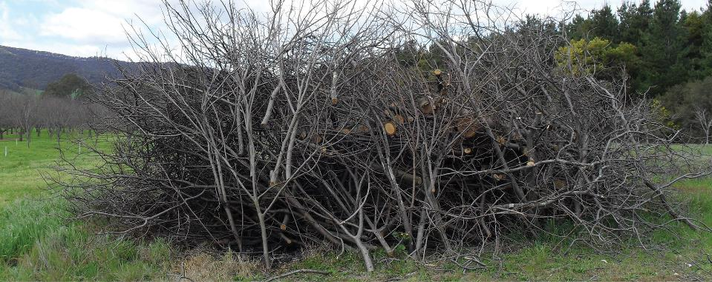
Example of a fire site

Cutting down infected trees
Where possible, use a saw to cut down trees to avoid the need to decontaminate heavy machinery.
Where practicable, use a pruning saw to cut up trees as it generates less dust. Collect sawdust, leaves, sticks, burrs and nuts from the ground for burning.
Remove tree stumps and cut out all major roots, and as many smaller roots as possible to reduce the risk of regrowth.
If you are driving infected wood to the fire site, ensure it is fully contained (e.g. under a tarp) during transport.
Did you know? Chippers should not be used to destroy chestnut blight infected
wood because they create clouds of wood particles that can spread chestnut blight.
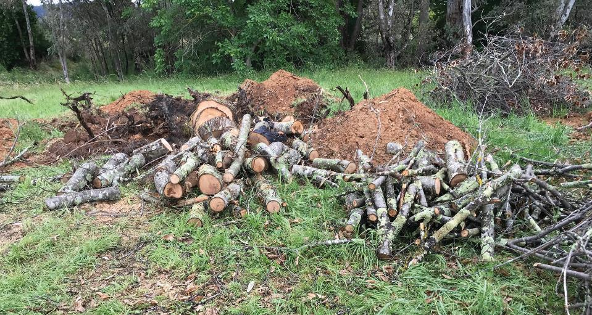
Chestnut trees cut up and ready for burning

Burning infected trees
Make a burn pile with minimal air space suitable for an intense fire that will burn green and wet infected plant material. Do not wait for the wood to dry before burning as chestnut blight spores could spread and infect other trees.
Destruction is complete when the pile is completely burnt to ash, which no longer poses
a biosecurity risk.
Did you know? Chestnut blight can survive on partially burnt or buried material.
Thus, it is important to ensure all plant material is completely burnt.

If burning is delayed
If you cannot burn straight away (e.g. due to fire restrictions), carry out the work outlined above up to and including making a burn pile. Spray the burn pile with a copper fungicide and then cover it with a tarp, securing the tarp in place. In Victoria, this should occur within 14 days of detection.
Chestnut blight spores can still be actively produced from felled trees, so it is important
to cover infected plant material to prevent disease spread.
Burn the infected plant material as soon as possible. When removing the tarp, carefully fold it in on itself (there are likely to be spores on the inside) for later decontamination
or disposal.
Did you know?
Sawdust may contain chestnut blight and contaminate nearby objects, which then become sources of infection. Decontaminate yourself and any equipment or machinery used to avoid spreading disease.
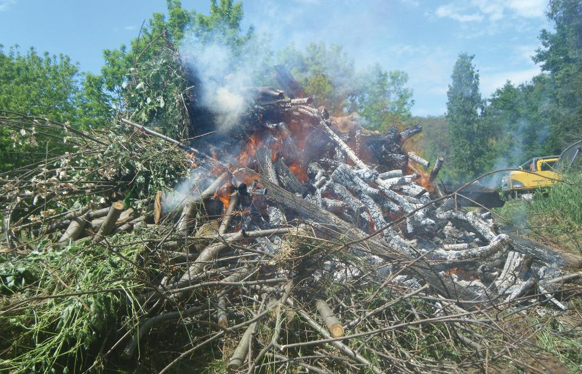
Destroy infected plant material by burning it to ash

Ongoing monitoring after destruction
Did you know?
Even after destruction, there is no guarantee that chestnut blight is absent from your property. It is possible for roots very deep in the soil to survive and produce new infected growth.
Every three months, look for plant regrowth at the remains of destroyed trees. This should be done as part of the regular targeted surveillance of all host trees on your property. Record details on the chestnut blight surveillance form.
Burn any regrowth found and treat the roots with an appropriate herbicide. Check with your local chemical retailer for an appropriate herbicide to use.
You may replant in this area following two years of no regrowth.

Practice good farm hygiene
It is important to practice good farm hygiene to avoid spreading chestnut blight to other trees or properties. Setting up a hygiene station will provide you with a place to decontaminate when leaving the orchard/block.

Hygiene station
You will need to enter and exit the infected orchard/block via the hygiene station. It should be away from infected and susceptible trees, but still on your property, preferably on a hard surface. If you are using vehicles or machinery, ensure there is space to park them for washdown and if available, use high pressure washdown facilities.
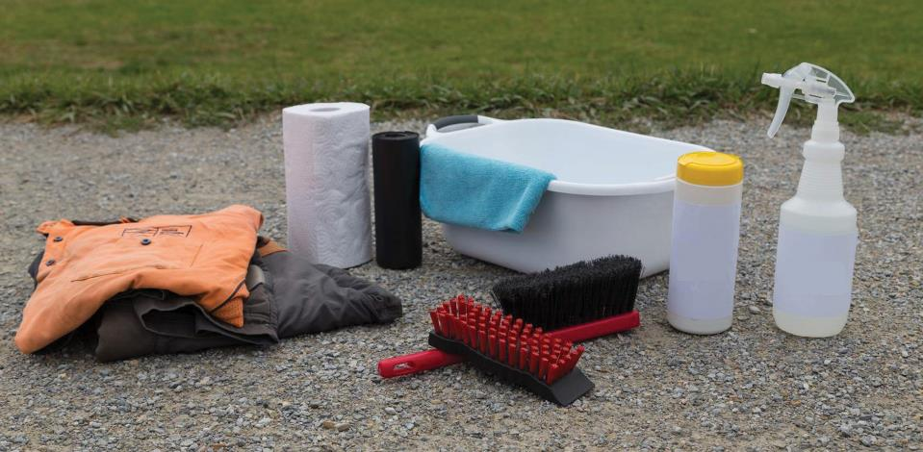
These are some of the contents of a hygiene kit

Contents for your hygiene kit
Item | Reason
Disposable gloves (multiple) to fit | To handle dirty items and protect your hands
Clean protective clothing like coveralls that can be washed after each use | For protection and to have an outer layer that can  be removed during decontamination
Spare clothing and a second pair of clean shoes to change into (optional) | For your comfort
Waterproof footwear | To be rinsed in disinfectant
Scrubbing brush | To remove soil and organic matter from your shoes
Screwdriver or similar implement | To remove tough dirt and mud off shoes
Two plastic tubs suitable for stepping into | These will become the footbaths
Disinfectant in appropriate lidded containers | In case you need to refill spray bottles or to pour  into buckets for equipment decontamination
Spray bottles filled with disinfectant and at least  one filled with water | To disinfect and rinse
Buckets | To dip equipment into for decontamination
Permanent marker | To label containers and footbaths
A copy of the safety data sheet and the label for  the chemicals being used | To have safety information on hand
Any personal protective equipment recommended  in the safety data sheet and the label | For your personal safety
A copy of this document | To have instructions on hand
Large plastic ground sheet (multiple) | To lay on the ground for the hygiene station
Large garbage bags (strong, plenty) | To collect items for disposal
A large bin, lined with two garbage bags | To collect items for disposal
Zip lock bags (multiple) | To separately contain your camera and/or mobile phone
Face and hand wash bowl or face wipes | For personal hygiene
Soap | To wash your hands
Paper towel | To dry your hands and equipment
Brush | To clean wood chips and soil off equipment
Cloth | To be soaked in disinfectant and used to clean equipment
Tools | To disassemble and reassemble equipment like  a chainsaw
Containers of water (maximum 10 L each for manual handling, at least 20 L is recommended) | For rinsing equipment and hand washing
A plastic tub with lid | To contain saws and other small tree cutting/burning equipment for transport to the hygiene station
A strong container | To transport contents of the hygiene kit

Wear an outer layer of clean, protective clothing such as coveralls that can be removed during decontamination and washed after use.
Tip
Machinery, equipment and vehicles take time and effort to decontaminate, so reduce the number used in the infected orchard/block where practical.

Chemical safety
Always use chemicals safely and responsibly. Read and follow the directions for use on
the approved product label and safety data sheet before preparing or using a chemical. Wear the recommended personal protective equipment and check the product’s expiration date to ensure the active ingredients are still effective.
For further information on your legal obligations when using agricultural chemicals, including record keeping and licensing requirements, please contact your relevant state or territory government agency. In Victoria, contact Agriculture Victoria on 1300 502 656 or chemical.standards@agriculture.vic.gov.au.

Prepare disinfectant solutions
A disinfectant solution will be required to decontaminate your shoes, tools, equipment, machinery and vehicles. Use a product containing 100 g/L benzalkonium chloride approved for use as a disinfectant for general horticultural use (e.g. Phytoclean).
Pour disinfectant into suitable lidded plastic containers no greater than 10 litres (for manual handling) and into spray bottles or washdown equipment, where applicable. Clearly label containers with a permanent marker.
Disinfectant is most effective when organic matter (e.g. soil) is avoided. Clean organic matter from shoes and equipment before applying disinfectant.
Did you know? Decontaminating footwear also protects your property against the introduction or spread of Phytophthora cinnamomi, a chestnut tree pathogen.

Set up the hygiene station prior to entering the infected orchard/block
1. Lay out a plastic sheet on the ground and place the footbaths on top.
2. Fill and label one footbath with water and one with disinfectant. Fill the footbaths with enough liquid to cover the base and a few centimetres up the sides of your shoes. Have some spare bottles of water and disinfectant on hand to refill the footbaths as needed.
3. Lay out the other items of your hygiene kit on or near the plastic sheet, ensuring you can reach them from the side nearest to the infected orchard (the “dirty” side).
4. Place your camera and/or mobile phone inside a zip lock bag so they can be used without removing.
5. As shown in the image below, it may help to imagine a line splitting the hygiene station into two sections, where one side is “dirty” (the side toward the infected orchard/block) and the other side is “clean”.
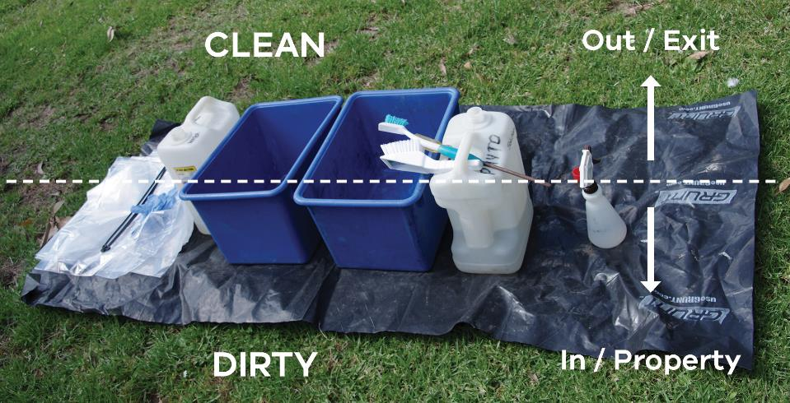
Tip: Before crossing over to the “dirty” side, ensure you have all the equipment you need. If you forget something, you will need to decontaminate (using the hygiene station) before returning to the clean side.
Return to the hygiene station after exiting the infected orchard/block.
If working with others (recommended), one person should decontaminate themself first, while the second person decontaminates equipment and passes it to the first person for clean storage.
If you are working alone, decontaminate equipment first and then yourself.

How to decontaminate yourself
Regularly wash your hands with soap and water throughout the decontamination process, particularly after handling dirty items and before touching clean items. Alternatively, you can wear disposable gloves and change them regularly throughout the process.
1. Remove your outer layer of protective clothing and put it in a plastic bag for washing later on.
2. Step into the first footbath (water) and thoroughly scrub off any soil and organic matter from the outside and base of your shoes.
3. Step into the second footbath (disinfectant) for the recommended amount of time
to kill the fungus (refer to the label).
4. Step out of the footbath and onto the clean side of the hygiene station.
5. If practicable, take off your decontaminated shoes and put on the spare pair of clean shoes (the decontaminated shoes can be packed away clean or left to dry).
6. With clean hands, remove your mobile phone from inside the ziplock bag and dispose of the ziplock bag.
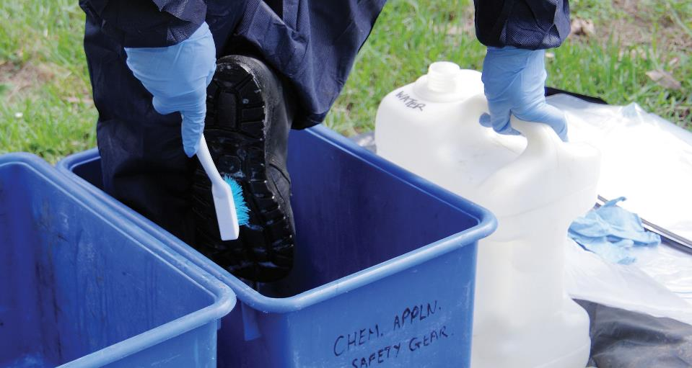
Scrub your shoes to remove soil and organic matter in the first footbath (water)

Decontaminating tools and equipment
Where possible, remove organic matter before spraying or dipping tools and equipment into disinfectant. Allow disinfectant to remain on surfaces for the recommended amount of time to kill the fungus (refer to the label) before rinsing or wiping off.
Once disinfected, put reusable equipment on the clean side of the hygiene station.
Put any single use items into a rubbish bag/bin for later disposal.
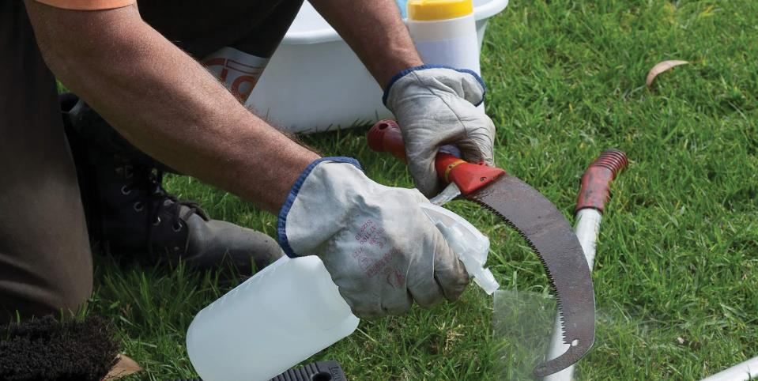
Spraying disinfectant onto a handsaw

Decontaminating a chainsaw
1. Once the chainsaw has cooled, disassemble the chain and bar and remove all
wood chips.
2. Brush out the air filter and clean the fuel filter.
3. When free of debris, wipe down the outside of the chainsaw with a cloth soaked in disinfectant. There is no need to wipe the chain, as the heat would have killed the fungal spores.

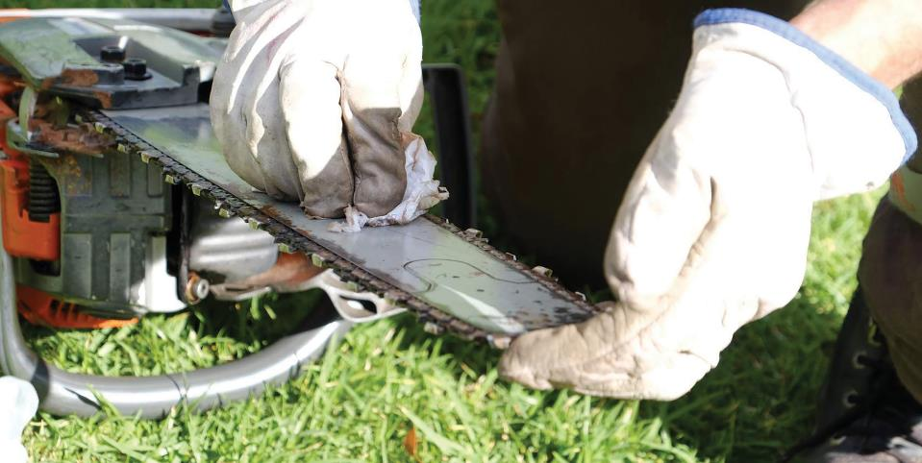
Wiping down a chainsaw with disinfectant

Decontaminating vehicles and machinery
Clean the interior by spraying disinfectant on surfaces and wiping with paper towel.
Clean the exterior by removing debris and apply disinfectant, paying attention to the tyres, undercarriage and hard to reach areas.

Packing up the hygiene station
Dispose of footbath liquids away from host trees (refer to the label for advice on disposal).
Double bag all rubbish including the plastic ground sheet, spray the bags with disinfectant and dispose of in household/council rubbish bins. If you are located outside of Victoria, check with your biosecurity department as to the appropriate means of disposal.
Restock your hygiene kit and wash your clothing at minimum 50 ºC (where possible).

Together we can prevent the spread of chestnut blight

Chestnut blight surveillance form
INSTRUCTIONS
• Use one survey form for each survey date. This form is available for download at
www.chestnutsaustraliainc.com.au.
• All fields are mandatory.
• Submit forms to the Industry Biosecurity Officer (Chestnuts Australia Incorporated)
ibo@chestnutsaustralia.com.au.
Property details
Property Identification Code (PIC)
Property address or ID
Latitude
Longitude
Number of trees on property
Details of person/s conducting the survey
Name/s
Position
Phone
Email
Survey details
Date of survey
Host name
Number of trees inspected
Pest status* | - Present  - Inconclusive (suspect)  - Absent

*If you marked inconclusive, report symptoms to the Industry Biosecurity Officer ibo@chestnutsaustralia.com.au (within VIC) or the Exotic Plant Pest Hotline on 1800 084 881 (outside VIC). Professional diagnosis is required before present pest status can be known/marked. If you marked present or inconclusive, provide the coordinates (where possible), mark and number the location of any suspect or infected trees.
Suspect/infected tree number | Latitude | Longitude
1
2
3
4
5
6
7
8

Sign off
Signature | Date
Industry Biosecurity Officer - This data has been uploaded into AUSPestCheck
Signature | Date

PRIVACY STATEMENT
The data collected in this form will be utilised in the management of chestnut blight. Chestnuts Australia Incorporated will manage and upload the data into AUSPestCheck, a national database for plant pest surveillance data. The data, and summaries of that data, may be shared with government agencies, industry partners, and other organisations involved in biosecurity to support the management of chestnut blight, including advice and statements relating to the presence and absence of chestnut blight.
Chestnuts Australia Incorporated collects and administers a range of personal information for the purposes of managing the affairs of the organisation and promoting the Australian Chestnut Industry. The organisation is committed to protecting the privacy of personal information it collects, holds and administers.
Chestnuts Australia Incorporated recognises the essential right of individuals to have their information administered
in ways which they would reasonably expect – protected on one hand, and made accessible to them on the other.
These privacy values are reflected in and supported by our core values and philosophies.
Chestnuts Australia Incorporated is bound by laws which impose specific obligations when it comes to handling information. The organisation has adopted the principles as minimum standards in relation to handling personal information.
Enquiries about access to information should be directed to the Chestnut Blight Response Coordinator
(Chestnuts Australia Incorporated) by emailing ibo@chestnutsaustralia.com.au.

This booklet has been developed by Agriculture Victoria and Chestnuts Australia Incorporated to help growers look for and manage chestnut blight, a disease which poses a serious threat to Australia's chestnut industry.
Chestnut blight is a declared exotic plant disease in Victoria. This booklet has been developed
to comply with the Victorian Plant Biosecurity Act 2010. If you are located outside of Victoria
and suspect that you have detected chestnut blight, report it to the Exotic Plant Pest Hotline on 1800 084 881.
Authorised and published by the Victorian Department of Jobs, Precincts and Regions, 1 Spring Street, Melbourne, November 2020
© The State of Victoria Department of Jobs, Precincts and Regions, 2020
This publication is copyright. No part may be reproduced by any process except in accordance with the provisions of the Copyright Act 1968.
Print managed by Finsbury Green, November 2020
ISBN 978-1-76090-407-4 (Print)
ISBN 978-1-76090-408-1 (pdf/online/MS word)
Accessibility
If you would like to receive this publication in an alternative format, please telephone the DJPR Customer Service Centre on 1300 502 656, email info@agriculture.vic.gov.au or via the National Relay Service on 133 677, www.relayservice.com.au. This document is also available in PDF and accessible Word formats on the internet at www.chestnutsaustraliainc.com.au.
Disclaimer
This publication may be of assistance to you but the State of Victoria and its employees do not guarantee that the publication is without flaw of any kind or is wholly appropriate for your particular purposes and therefore disclaims all liability for any error, loss or other consequence which may arise from you relying on any information in this publication.

