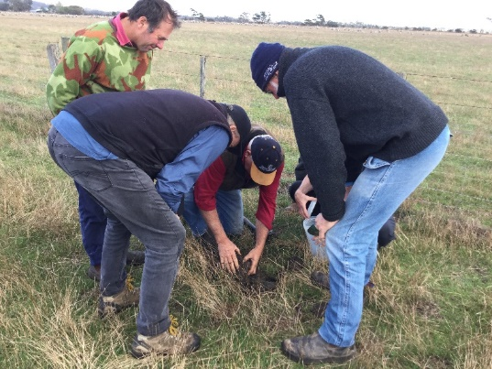
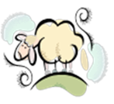
Coordinator – Andrew Kennedy
Group – South West Prime Lamb Group
- Hamilton, Heywood, Cashmore, Cavendish
Enterprise mix
- Prime lamb, merinos, cattle
The South West Prime Lamb Group Inc (SWPLG) was formed in 1994 and joined the Bestwool/Bestlamb network in 2011. Since inception, the group has maintained a membership of around 30 producers and is now coordinated by Andrew Kennedy, after Kate Joseph stepped aside in 2019.
Over its twenty-six years, SWPLG has held more than 140 events, ranging from industry tours to adhoc meetings on topical issues.
The group has also led a number of projects; including a focus farm, targeted drenching program, perennial ryegrass persistence trial, EBV trials, and soil testing and plant tissue testing projects. Between 1998 and 2008 the group had a prime lamb marketing co-operative which was run as an independent commercial business for 10 years.

Getting down and dirty…
Currently the SWPLG is focusing on dung beetles. Despite a wealth of cattle-related research into dung beetles, there is limited research on dung beetles in sheep production systems, therefore the group established an Enhanced Producer Demonstration Site (EPDS), co-funded by Agriculture Victoria and Meat and Livestock Australia (MLA). The group are also supported through the national Dung Beetle Ecosystem Engineers (DBEE) project.

Soil benefits from burying dung
One demonstration is measuring changes in soil fertility to depth from the activity of deep tunnelling dung beetles (Bubas bison). After the first year, the group have measured increases in Phosphorus and Potassium from dung beetles creating dung-filled tunnels to a depth of 40 cm (Figure 1). More trials have been set up this year to understand better what is happening underground and compare activity on different soil types.
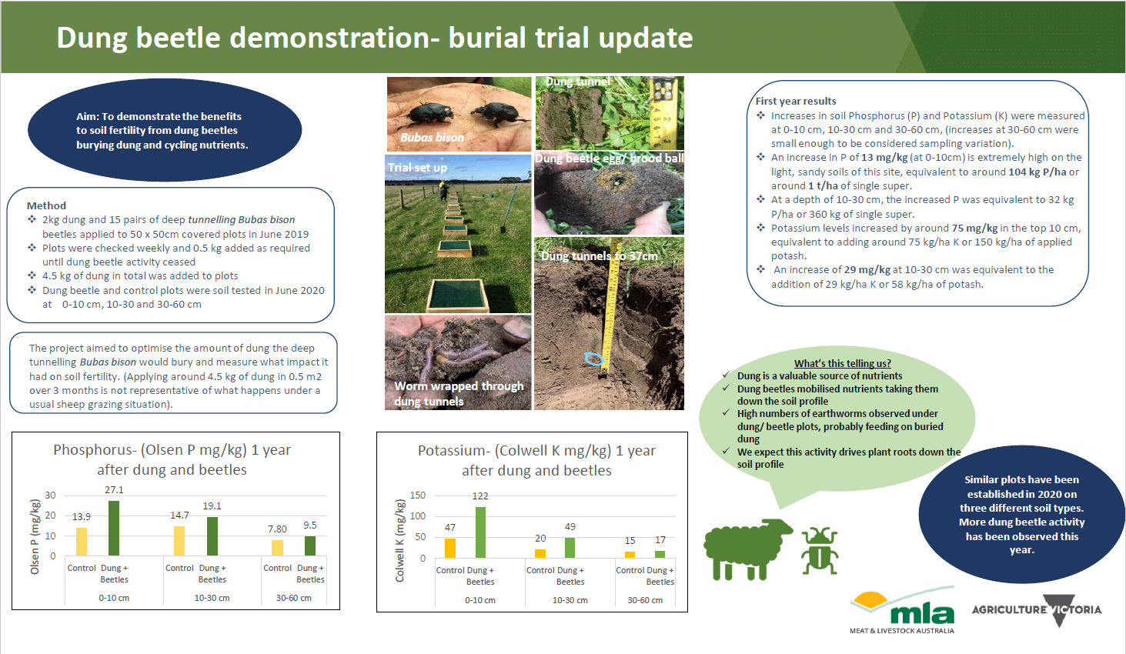
Figure 1: Burial trial update

Identifying what is there
One of the groups’ aims is to identify what beetles are active on sheep dung in the south west, when they are abundant and importantly when there are seasonal gaps that could be filled by introducing more beetles. To achieve this, four producers within the group have undertaken monthly dung beetle trapping.
Five different species have been trapped to date (Table 1), including native and introduced beetles. Abundance was low from June- September, but then increased into late spring and more so into summer and early autumn.

A brief video clip has been developed to help producers find dung beetles https://vimeo.com/465268482

Table 1: Beetle species found June 2019- June 2020.
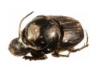 | Onthophagus taurus: 8-10mm Introduced, active in spring, summer, autumn. Found in large numbers shredding dung
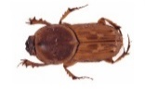 | Euoniticellus fulvus: 8-12mm Introduced, active in spring, summer, autumn. Found with O. taurus
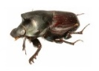 | Onthophagus binodis: 10-13mm Introduced; active in spring, summer, autumn
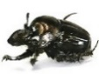 | Onthophagus australis: 7-12mm Native; found throughout the year- in larger numbers during spring/ summer/ autumn
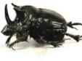 | Onthophagus mnisznechi: 19-21 mm Native; found throughout the year

Dung beetle nurseries
The national DBEE project, is working towards introducing and establishing three new species of dung beetles to fill the gap in late winter/spring when there is very little activity from existing species.
Onthophagus vacca (O. vacca) was bought into Australia from France and Morocco (following quarantine protocols) and bred at CSIRO. The SWPLG group have established nine dung beetle nurseries with DBEE support to breed O. vacca. It is hoped they will breed up in significant numbers to be released in sustainable colonies.
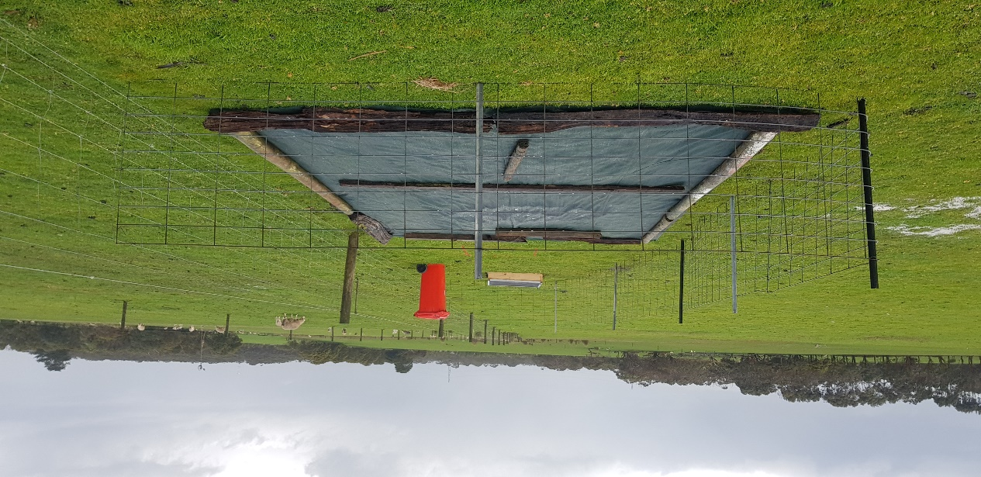
Dung Beetle Nursery
For further information on this project please visit: http://agriculture.vic.gov.au/on-farm-demos

