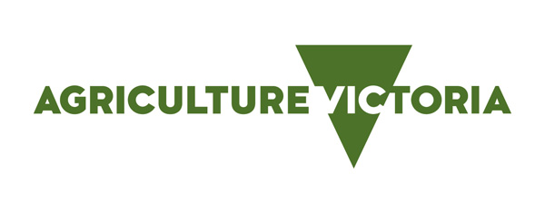
To wean or not to wean
Demonstration goal: To evaluate and demonstrate potential production benefits for both ewes and lambs by weaning lambs at 12–14 weeks from the start of lambing, as opposed to not weaning the lambs and leaving them on the ewes until they’re at a marketable kill weight.
Site location: St Arnaud
Producer group: St Arnaud BestWool/BestLamb
Group coordinator: Steve Cotton
Agriculture Victoria coordinator: Rachel Coombes
Duration: 2019–2022

Potential production benefits from weaning at 12 weeks
Over the last two years, producers in the St Arnaud BestWool/BestLamb (BWBL) group have been managing trial mobs and collecting data for a weaning demonstration. The aim is to see if there are production benefits from weaning at 12 weeks from the start of lambing as opposed to not weaning the lambs and leaving them on the ewes until they are at a marketable weight.
The two years of data collected so far, showed that in most cases there was little difference between the weights of weaned or unweaned lambs. In fact, the weaned lambs from two farms were heavier than the unweaned lambs by the time they were sold at around 22 weeks of age. At no point have lambs incurred a significant setback after weaning, which was an early concern amongst the group.
Adding to the story, one of the 2020 demonstration producers sold the trial lambs direct to the abattoir and there were no significant differences between the carcass weights or the lean meat yield of the weaned and unweaned lambs. This is contradictory to what the producers were expecting to find given published data that suggested weaned lambs will dress 1–2% lower than unweaned lambs.
Management ease key driver to change
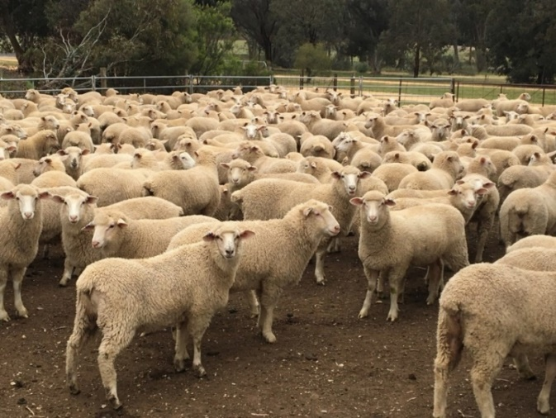
Despite the results showing little difference between the performance of the weaned and unweaned lambs, there were other factors that convinced the group to change. The group have found management of weaned ewes and lambs to be simpler and beneficial to their farming systems. The fact that the weaned ewes have lower nutritional requirements means they can be moved onto lesser value pastures, leaving more of the high-quality feed available for lambs. This has led to one producer increasing his stocking rate. Another producer just enjoys the fact that he and his son don’t need to draft the ewes off before they can weigh the lambs, which makes the job much shorter. After two years of the demonstration, the producers have seen the benefits of weaning their prime lambs at 12 weeks of age. The producers have found the results of the trial to be promising but they will be weaning this year because of the easier management within their production systems.
“The data is giving us confidence that lambs won’t be compromised by weaning, however it’s the ease of management that is making us change our practices”, one group member explained.
For more information, please contact Rachel Coombes, Agriculture Victoria on 0436 001 258 or email, or Steve Cotton on 0447 352 321.
This Producer Demonstration Site is funded by Meat & Livestock Australia and Agriculture Victoria. Refer to the Agriculture Victoria website for more information about our network of On-Farm Demonstrations.

