Dingo conservation and management: Summary of landholder and community engagement sessions 15-17 May 2025
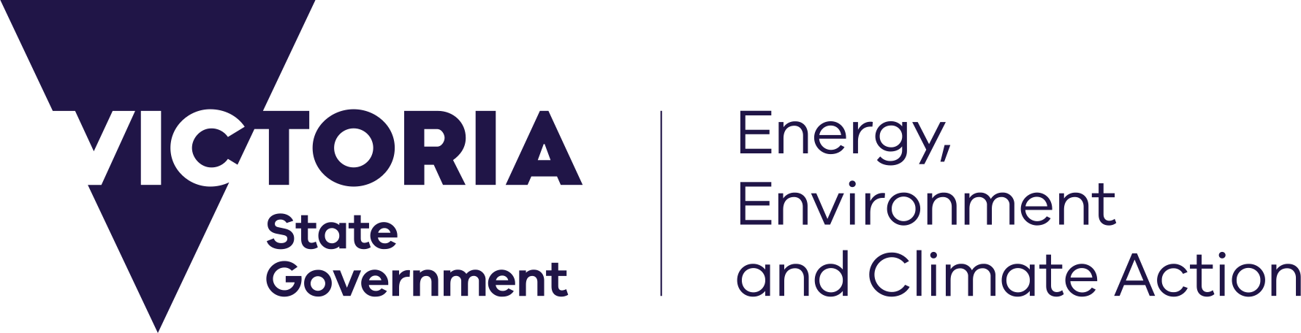








deeca.vic.gov.au

Overview
In May 2025, the Department of Energy, Environment and Climate Action (DEECA) hosted engagement sessions in north west Victoria to discuss dingo conservation and management with local farmers and community members. Sessions were held in Murrayville, Patchewollock, and Yanac. Attendance was strong and productive conversations were held across the three sessions. DEECA attendees included representatives from:
- Agriculture Victoria
- Biodiversity Division, including the Arthur Rylah Institute
- The Conservation Regulator
Attendees shared valuable feedback on their experiences since the dingo unprotection order was lifted on 14 March 2024, as well as their thoughts on the dingo support package which was announced by the Victorian Government in October 2024. DEECA staff also had the opportunity to provide attendees with further information about support package projects.
DEECA is grateful to everyone who took the time to attend the sessions, particularly during a busy period for the farming community.

Background
On 14 March 2024, the dingo unprotection order concluded in northwest Victoria due to the risk of extinction of its local dingo population. Under the subsequent unprotection order made on 1 October 2024, dingoes continue to be protected in north west Victoria and lethal control is not permitted without authorisation. The current unprotection order continues to permit lethal control on certain land in the east of the State. The order is due to expire on 1 January 2028.
Livestock predation is a significant challenge for Victorian farmers. It leads to significant economic losses in areas of Victoria where dingoes are known to exist.
As part of the making of the 1 October 2024 unprotection order, the Victorian Government announced an over $2 million investment to provide increased support to mitigate livestock predation and to involve Traditional Owners in dingo conservation, with a particular focus on the north west.
Stakeholder feedback from engagement throughout 2024 informed the design of the package, which is funding trials, research, and on-ground advice on non-lethal dingo management strategies. The package built on work already underway as part of the $550,000 North West Vertebrate Pest Management Program announced in March 2024.

What we heard

Dingo management in north west Victoria

Decision to lift the dingo unprotection order in March 2024
- Famers expressed significant frustration with the original March 2024 decision to lift the unprotection order, raising questions about the basis for the decision and concerns about the lack of consultation prior to the decision.
- The assessment process and decisions made on Authority to Control Wildlife –applications for lethal control of dingoes was also identified as a source of frustration.

Impacts of livestock predation
- Farmers discussed the increase in livestock predation since the unprotection Order was lifted and the significant financial, social and psychological impacts it has had on farmers and the broader community. Discussions also highlighted hidden impacts such as:
  - farmers transitioning away from sheep farming,
  - reductions to flock sizes to reduce exposure to dingoes,
  - paddocks being rendered unusable due to the risk of attacks on livestock, and
  - the flow on economic and social impacts of these decisions for regional communities facing a range of other pressures.

Feedback on the Dingo Support Package

Predator exclusion fencing and livestock guardian animal trials
- There was interest in the fencing trials underway on properties in north west Victoria. Discussion centred on the establishment costs, effectiveness against predators and other animals, and ongoing maintenance requirements for the outrigged hotwire type of fencing being trialled. Farmers also pointed out that retrofitting fences would be impossible in areas where native vegetation extended to the boundary line due to regulations restricting the amount of vegetation that can be cleared.
- Farmers were interested in the effectiveness of hotwire-type fencing at deterring other species (such as kangaroos).
- The planned guardian animal trials and the use of guardian animals to prevent livestock predation was discussed. Some farmers had experience using guardian animals that was captured to inform the design of the planned trial. Feedback on the pros and cons of using guardian animals was also received, particularly in relation to donkeys, as well as Maremmas.
Camera monitoring and water supplementation projects
- Some farmers expressed interested in participating in private land camera monitoring, though concerns were raised around image sharing and data management.
- The findings of the water supplementation trial and camera monitoring that occurred on public land was requested by a number of landholders.

Population research projects
- There was significant interest in planned population research, and significant discussion was held on previous population estimates and genetic research.
- Farmers were frustrated with research timelines, expressing a view that population estimates should have been prioritised following the initial decision to lift the unprotection order, to understand changes in the dingo population over time.

Other topics raised by landholders

Calls for additional support
- The need for further support from government to manage the impacts of livestock predation was discussed. Themes for additional support included subsidies to fund predator exclusion fencing and a compensation scheme for stock losses.

Previous population estimates and genetic research
- Many landholders expressed uncertainty on past population estimates. Discussion centred on the research methodology and why the lower estimate of 40 dingoes is often cited publicly when the estimate is a range from 40 to 230 dingoes in Big Desert / Wyperfeld.
- There were extensive discussions on the genetic research about dingoes, though many landholders did not accept the finding that the vast majority of free roaming canids are in fact dingoes, rather than wild dogs, and that hybridisation between dingoes and wild or domestic dogs is rare.

Authority to Control Wildlife (ATCW) permits and applications
- The Authority to Control Wildlife assessment and decision-making process was discussed, with explanation of the Wildlife Act’s requirements for an Authority to be granted.
- Farmers expressed some frustration with the ATCW assessment processes and the way the Conservation Regulator communicated with them.
- Disappointment was expressed at the fact that no lethal control ATCWs for dingoes have been granted.
- Some farmers expressed scepticism about whether an ATCW would ever be granted for lethal control of dingoes in the north-west, and some stated that they saw no benefit in submitting applications.

