Goulburn Murray Valley Fruit Fly

Regional Action Plan 2019-2020
- Vision statement
The Goulburn Murray Valley Regional Governance Group (GMVRGG) aims to achieve an Area of Low Pest Prevalence (ALPP) in the region (Figure 1). Low Queensland Fruit Fly (QFF) populations will provide the optimal environment for the successful release of sterile male flies from the Sterile Insect Technology Program (SITPlus).
- Objectives of the Plan
- The Goulburn Murray Valley (GMV) region has strengthened fruit fly management through coordination and collaboration between industry, government and community.
- QFF management in the GMV region is improved in commercial orchards and community areas.
- QFF research is supported and prioritised in the GMV region.

- Key long-term outcomes
- Coordinated, sustainable and cost-effective management of fruit fly in the GMV is improved on orchards and in township areas to work towards ALPP.
- Domestic and international trade of fruit from the GMV is maintained and improved through phytosanitary controls acceptable to trading partners.
- Decision making in QFF management in the GMV is informed by relevant and timely research, development and extension (RD&E).
- The region is recognised by trading partners, government and industry as ALPP and therefore a preferred supplier.
Year three.
The Regional Coordinator will implement Area Wide Management (AWM) principles to manage fruit fly in the region with oversight provided by the GMVRGG. The QFF Trapping Grid will be expanded and monitored to understand where interventions can be made to reduce the QFF populations, implement a range of strategies which will reduce unwanted or unmanaged host trees and increase awareness of best practice QFF management in the community and commercial orchards. The focus is to maintain a proactive approach throughout the 2019 winter and spring, to target the spring population peak leading into the 2019-2020 growing season. Benchmarks and successes achieved in the previous two years will lead to further opportunities in the GMV which will further enhance the reputation which the GMV region has as a leader in QFF AWM.
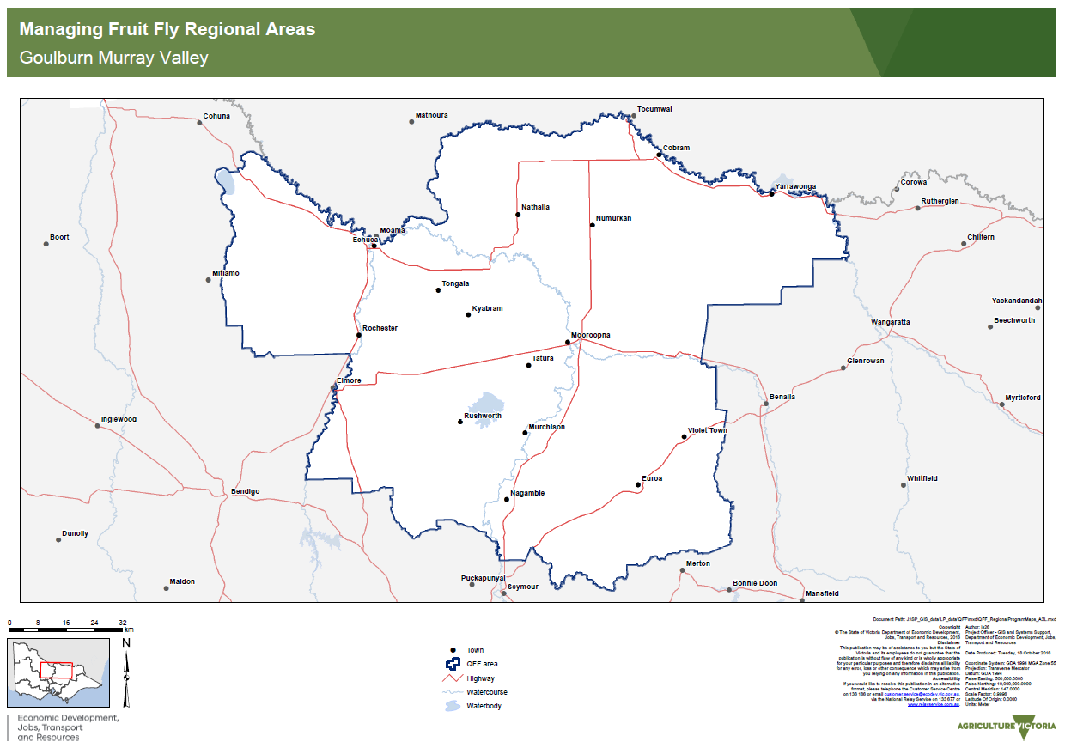
Figure 1: Goulburn Murray Valley fruit fly management region
- Brief background
QFF has been endemic to the GMV region since 2013-2014. Since then commercial producers and regional communities have struggled to control the pest and have lost domestic and international market opportunities as a result.
QFF attack a range of major crops in the region including: pomefruit, stonefruit, tomatoes, berry fruits, cherries, citrus and grapes. With the GMV Horticulture industry equating to $545m (Australian Bureau of Statistics), the QFF has the potential to cause significant economic harm to the horticultural industry.
Historically, the Cobram & District Fruit Growers Association and the GMV Fruit Fly Task Force actively participated in the fruit fly effort.
The GMV Fruit Fly Task Force completed the Management of Queensland Fruit Fly in the Goulburn Valley; Final Business Case in September 2015. The region used this business case to develop the Regional Action Plan for year one and many of the items have been implemented, with the assistance of the GMVRGG and the Regional Coordinator.
QFF in the region currently hinders export, particularly stone fruit and cherries. The monitoring systems for export are complex and costly to producers as are the regulations of international countries they must adhere to. The domestic market is similarly costly with the ongoing requirements for pesticides, trapping and monitoring on farm, and also managing local awareness and market expectations. Access to markets in South Australia and Western Australia is now limited due to the cost of meeting the protocols those markets demand.
The coordinated approach of QFF AWM and engagement in the GMV region has seen the Western Australian Department of Primary Industries and Regional Development request the GMV Action Plan and engagement strategy as a model to revise their existing Fruit Fly Management Plan.
As of 31/01/19 the following statistics were achieved with nil complaints or negative publicity registered.
Residential Fruit Tree Removals. 2,140 (units)
Rogue Fruit Tree Removals. 517 (9,479 remaining)
Unmanaged Orchards Identified. 226 (ha)
Hot Spot Field Reports 872
Signage, Bollards, Banners. 240 (erected throughout 37 townships)
Workshops & Events 6,996 (participants)
Information Packs, etc. 28,180 (units)
Social Media 75,284 (hits)
Electronic Billboards 420,000 (views)
Print Media 3,475,279 (readers)
Television Media 7,348,431 (viewers)
Radio Media 13,891,750 (listeners)
Wider community ‘ownership of issue’ and best practice management has been reflected in increased sales of nursery and hardware QFF control products and a reduction in QFF trap numbers compared to previous years.
Commercial best practice includes monitoring, baiting and insecticide applications. International and domestic protocols recommend post-harvest treatments including fumigation, irradiation, cold treatment and different combinations of cold and fumigations treatments which often limit fruit storage life and affect the quality of the fruit sent to markets.
The Managing Fruit Fly in Victoria Action Plan 2015-2020 is designed to provide key actions required to manage fruit fly across Victoria. The state-wide action plan (SWAP), developed by the Victorian Government in conjunction with industry and the community, focuses on three main action areas:
- Strengthening the coordination and collaboration of fruit fly management
- Improving the management of fruit fly
- Enabling intrastate, interstate and international trade.

- Key activities

Objective 1: The Goulburn Murray Valley region has strengthened fruit fly management through coordination and collaboration between industry, government and community.

Key Activities
  - Undertake Goulburn Murray Valley Regional Governance Group (GMVRGG) meetings to coordinate and implement the Plan
  - Ensure Regional Coordinator connects with other state and national fruit fly programs
# | Key activity | Rationale
1.1 | Undertake GMVRGG meetings to coordinate and implement the Plan | To ensure collaboration, good governance and project delivery, and harnessing multidisciplinary skills of the group to implement the Plan regionally.
Tasks |  | Responsible | Priority rating (20% time) | Due date | Alignment SWAP
Support the Regional Coordinator to develop a work plan and implement work across the whole region, including adequate resourcing and access to administrative support and contractors |  | GMVRGG | High | Ongoing | 1.3d
Document and monitor progress against the plan quarterly, which is aligned to the Regional Coordinators milestones |  | GMVRGG and Regional Coordinator | High | Quarterly | 1.3e
# | Key activity | Rationale
1.2 | Ensure Regional Coordinator connects with other state and national fruit fly programs | To ensure that information is shared, duplication of work is reduced and advances in knowledge of fruit fly work from around Australia benefit the Goulburn Murray region.
Tasks |  | Responsible | Priority rating (10% time) | Due date | Alignment SWAP
Attend meetings, determine synergies between groups and learn from experts in fruit fly |  | Regional Coordinator | Medium-high | Ongoing | 1.1, 1.4, 1.5
Progress is reported quarterly on the Plan |  | Regional Coordinator | Medium-high | Quarterly | 1.3
Advocate for longer-term planning, resourcing and alignment between the regions at a state and national level to ensure sustainability |  | Regional Coordinator,  Dept of Jobs precincts and Regions (DJPR). | Medium-high | Ongoing | 1.1

Objective 2: Fruit fly management in the Goulburn Murray Valley region is improved in commercial orchards and community areas.
  - Increase awareness of best practice with commercial horticulture producers and the community
  - Monitor fruit fly populations in the region
  - Reduce unwanted or unmanaged host species
# | Key activity | Rationale
2.1 | Increase awareness of best practice with commercial horticulture producers and the community | Awareness of best management practice by commercial horticulture producers and the community to improve management of fruit fly in the region.
Tasks |  | Responsible | Priority rating (20% time) |  | Due date | Alignment SWAP
Define and document best practice for orchardists and home gardeners, based on current research and previous effective management practices in the region e.g. combination of hygiene, bait spray, netting, results from Horticulture Innovation Fund over-wintering research project |  | GMVRGG and Regional Coordinator | High |  | Ongoing | 2.1a
Monthly communication and engagement with commercial horticulture in the region to ensure connection to best practice fruit fly management and the latest in research e.g. workshops, seasonal updates, extension support. |  | Regional Coordinator | High |  | Ongoing | 2.1b
Further develop the regional schools and community engagement program in partnership with the Lions clubs network. Resource Lions Clubs to deliver the program across the region.  QFF Train the Trainer Induction and education provided to Lions Club members responsible for delivering the program.  Enhance relationship with GMV Rotary Clubs to become partners in QFF Ambassador Program initiative and assist the elderly/disabled to manage QFF. |  | Regional Coordinator  Lions  Rotary | High |  | Ongoing
Community education and workshops in townships throughout the GMV as targeted and requested. |  | Cobram and District Fruit Growers (CDFGA),  Fruit Growers Victoria Ltd (FGVL),  Regional Coordinator,  Community Champions,  DJPR,  Lions Clubs,  Rotary. | High |  | Ongoing | 2.1 c,
Community awareness and tailored communication campaign at key times of the year including newspaper, radio and local TV advertising, media releases and through social media |  | CDFGA, FGVL,  Regional Coordinator, DJPR. | High |  | Ongoing | 1.2, 2.1c
Maintain existing signage levels and community awareness of QFF AWM |  | CDFGA, FGVL,  Regional Coordinator | High |  | Ongoing | 2.1c
Information packs for real estate agents and landlords on managing fruit trees in rental properties |  | Regional Coordinator | High |  | 2018 | 2.1c
Update local industry websites to ensure latest fruit fly information is available |  | CDFGA, FGVL, Apple and Pear Australia Ltd (APAL). | High |  | Ongoing | 2.1b
# | Key activity | Rationale
2.2 | Monitor QFF populations in the region | QFF is monitored in the GMV to understand QFF population dynamics and distribution and to implement actions based on accurate data. Explore surveillance in other crops such as tomatoes, citrus and grapes.
Tasks |  | Responsible |  | Priority rating (10% time) | Due date | Alignment SWAP
Maintain and expand current trapping and monitoring network established in the region over the previous two years. |  | Regional Coordinator |  | Medium-high | Ongoing | 2.1b,2.1c,2.1d
Explore opportunities to expand trapping, monitoring and control options in urban areas e.g. spraying and baiting in towns, electronic trapping, biological control and other control methods. |  | Regional Coordinator |  | Medium-high | Ongoing | 2.1b,2.1c,2.1d
Purchase traps |  | CDFGA,FGVL, Regional Coordinator |  | Medium-high | Ongoing | 2.1b,2.1c,2.1d
Monitor traps weekly and fortnightly. |  | CDFGA, FGVL, Regional Coordinator |  | Medium-high | Ongoing | 2.1b,2.1c,2.1d
Define process and outputs for monitoring relative pest pressure (hot spots) and movements at a regional level based on monitoring network, including independent data analysis, identification of QFF and other fruit flies and stakeholder engagement through the use grower contact database, grower organisations, newsletters and industry publications |  | GMVRGG and Regional Coordinator,  DJPR |  | High | Ongoing | 2.1b,2.1c,2.1d
Fruit Fly hot spot identification and action. Activate Field Officers to build relationships and advise property owners how to reduce QFF pressure and eradicate unmanaged QFF habitat to reduce QFF populations. Urban, landholders within 200m radius of hot spot. Rural, landholders within 400m radius of hot spot. |  | Regional Coordinator,  GMVRGG. |  | Medium-high | Ongoing | 2.1b,2.1c,2.1d
Determine regional impacts during trapping program by measuring damage in field and packhouses.  Design and develop IT based surveys to determine impacts. Develop Grower data base and communicate directly with growers. |  | Regional Coordinator,  CDFGA, FGVL. |  | Medium-high | During fruit season, harvest
Communicate monitoring network results, peaks, updates and forecasts to commercial growers via direct contact, project grower data base, grower organisations, industry groups, newsletters, etc. |  | CDFGA, FGVL, APAL, Regional Coordinator |  | Medium-high | During fruit season | 2.1b,2.1c,2.1d
Collect and store data and information from the region that may be used as evidence for the development of export protocols. |  | CDFGA, FGVL, Regional Coordinator,  DJPR |  | Medium-high | Ongoing | 3.2
# | Key activity | Rationale
2.3 | Reduce unwanted or unmanaged host trees | Unwanted or unmanaged host trees can provide breeding sites for fruit fly that pose significant risk to commercial orchards and home gardeners
Tasks |  | Responsible |  | Priority rating (25% time) | Due date | Alignment SWAP
Promote removal/eradication of privately owned unmanaged QFF host trees/plants. Maintain and enhance non- commercial QFF host tree/plant removal/eradication register.  Also, maintain separate register for unmanaged QFF host trees/plants on public/ private land and encourage legal owners to remove/eradicate unmanaged host trees/plants. |  | Regional Coordinator  Local Government Authorities (LGAs) & State Government Authorities (SGAs). |  | Very high | Ongoing | 2.1
Educate and negotiate with public and private landholders to ensure they are aware of their obligations in relation to unmanaged QFF host trees/plants, including unmanaged orchards and report issues with host trees to relevant authorities. This will focus on voluntary participation of QFF host tree/plant removal. |  | Regional Coordinator  DJPR  LGAs & SGAs. |  | Very high | Ongoing | 2.1
Maintain register and undertake actions to resolve issues and gain compliance related to unmanaged orchards that are technically assessed as a fruit fly risk. |  | DJPR,  Regional Coordinator  LGAs & SGAs |  | Medium | Ongoing | 2.3b
Better understand values, different community segments and develop tailored communication for urban areas relating to QFF host tree removal. |  | Regional Coordinator, DJPR  LGAs & SGAs |  | Very high | Ongoing | 2.1c
Undertake actions to resolve issues and gain compliance related to neglected hosts in home gardens and peri urban/rural lifestyle properties. |  | LGAs  Regional Coordinator |  | Very high | Ongoing | 2.3b
Build awareness of control required by growers on channel banks and easements not owned by Goulburn Murray Water |  | Regional Coordinator,  CDFGA, FGVL,  Goulburn Murray Water (GMW). |  | Very high | Ongoing | 2.1
Engage contractors to remove/eradicate QFF host trees/plants identified in QFF host tree/plant removal/eradication register. |  | Regional Coordinator  LGAs & SGAs |  | Very high | Ongoing | 2.1

Objective 3: Fruit fly research is supported and prioritised in the Goulburn Murray Valley region
3.1 Provide sites for research trials
3.2 Prioritise new research required to manage fruit fly
# | Key activity | Rationale
3.1 | Provide sites for research trials | Ensure that new research which could benefit the region is supported by local industry
Tasks |  | Responsible | Priority rating (0% time) | Due date | Alignment SWAP
Assist and coordinate researchers utilising the existing DJPR field research facilities to better understand the efficacy of management options in the region, rather than ad-hoc individual private sites |  | GMVRGG,  Regional Coordinator. | Low | As required | 3.1
# | Key activity | Rationale
3.2 | Prioritise new research required to manage fruit fly | Provide prioritised list of gaps in research for to the Victorian Fruit Fly Advisory to improve fruit fly management
Tasks |  | Responsible | Priority rating (10% time) | Due date | Alignment SWAP
Identify new research opportunities in the region through using trapping and monitoring data to refine understanding of fruit fly and ability to respond in a targeted way e.g. hot spot areas. |  | GMVRGG,  Regional Coordinator. | Medium | Ongoing | 3.1
Ensure region is ready for initial roll-out of SITPlus by better understanding control points, supporting pilot trials and leveraging existing investment in region |  | GMVRGG,  Regional Coordinator. | Medium | Ongoing | 3.1d
Inform long-term, strategic and coordinated approach to research priorities at the state and national level. |  | GMVRGG,  Regional Coordinator. | Medium | Ongoing | 3.1
Prioritise new research for fruit fly and explore opportunities for the GMV too progress toward achieving ALPP status. |  | GMVRGG,  Regional Coordinator. | Medium | Ongoing | 3.1

GMVRGG consultation and input into 2019-2020 Action Plan.

On 09/02/19 the 2018-2019 Action Plan and detailed Workplan was circulated to all GMVRGG members seeking their review and comments, to enable the 2019-2020 Action Plan to be formulated. Submissions were received and closed on 25/02/19.
An invitation was sent to all GMVRGG members on 24/02/19 to participate in a teleconference at 3pm on 26/02/19 to review all submissions and take comments in relation to the 2019-2020 Action Plan. This teleconference was duly conducted and Minutes taken (Minutes were circulated to the GMVRGG on 05/03/19).
The 2019-2020 Goulburn Murray Valley Fruit Fly Regional Action Plan has been compiled as a result of a review, comments and recommendations proposed by members of the GMVRGG.

Measurement of success
The Regional Coordinator will collect evaluation data in consultation with the Statewide Coordinator and GMVRGG. The collection and analysis of data and information from the activities undertaken in the 2019-2020 Action Plan will be guide for future management of QFF within the GMV region.

