Demonstration goal: To increase the per hectare production of beef by filling the late autumn/early winter feed deficit using 1) high yielding, high quality fodder beet crops or 2) early sown grazing cereals.
Site location: Murmungee and Corryong (North East Victoria)
Producer group: Mudgegonga and Corryong BetterBeef Network (BBN) Groups
Group coordinator: Chris Mirams
Agriculture Victoria coordinator: Nick Linden
Duration: 2018–2021
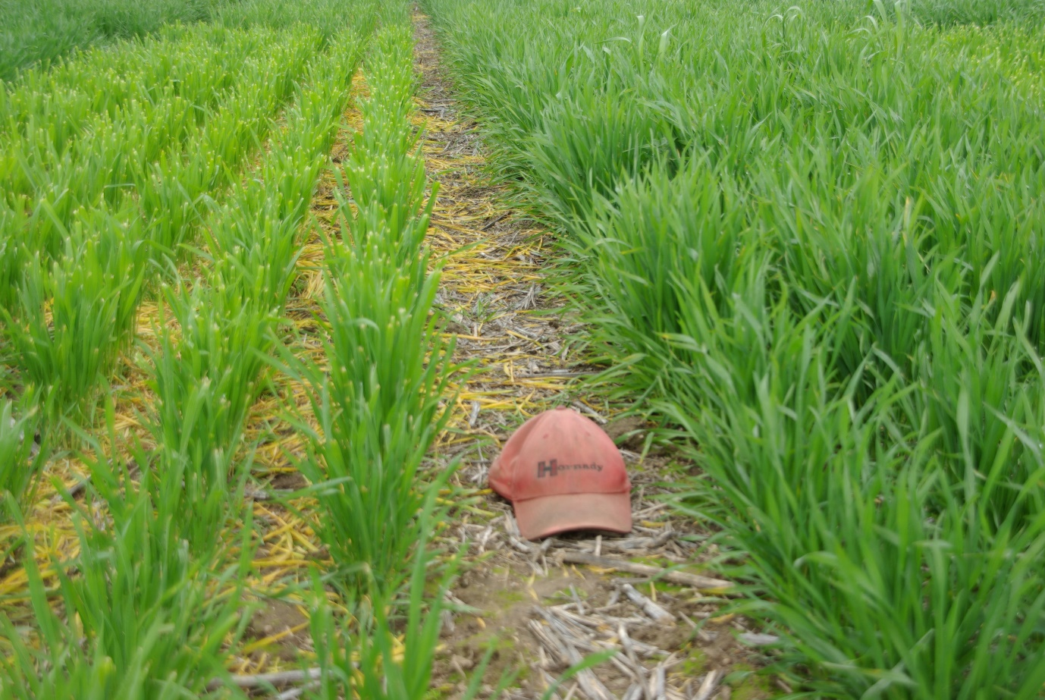

Production from grrazing cereals will be compared with fodder beet

What are we aiming to achieve and why?
While fodder beet has the potential for large yields of high-quality forage, it’s an expensive crop to establish and maintain through to harvest due to the high costs of both the seed and herbicide/pesticide requirements. Achieving a favourable economic outcome relies on high yields. In contrast, while the overall production of grazing cereals is less than that of fodder beet, the establishment costs are considerably lower (less than 50% that of fodder beet). Finding the breakeven levels of production for either system is an important factor for producers when deciding which option is the most suitable for them to use to fill the late autumn/early winter feed gap, while still maintaining acceptable levels of animal production.
The project aims to:
- benchmark existing forage-based methods to fill an identified late autumn/early winter feed gap – including the use of early-sown grazing cereals
- equip producer group members with the skills required to establish and manage a fodder beet crop
- benchmark the production in kilograms of beef per hectare from fodder beets; key data points of fodder production (quality and quantity) will be assessed, in addition to measured changes in animal live weight and pasture growth
- promote demonstration findings to a wider audience through field days and engaging with local consultants, agronomists and agricultural retailers.

Method
This demonstration runs for two years. The first year involves benchmarking two existing strategies to fill a late autumn/early winter feed gap:
- summer-sown forages under irrigation
- early autumn-sown grazing cereals.
In the second year, three small-scale plantings (up to 2ha/site) of fodder beet crops will be sown to investigate:
- two varieties of fodder beet
- dryland versus irrigated fodder beet production
- fodder beet versus grazing cereals.
Monitoring will include crop establishment rates, herbage mass and nutritive characteristics of the crop and animal performance while grazing the crops. Where applicable, the subsequent reproductive performance of heifers will be monitored to compare heifers that have grazed the crop with heifers grazed on ‘normal/control’ pastures.
Partners: This demonstration is conducted with Agriculture Victoria and co-funded by Meat & Livestock Australia (MLA).

Contact
Nick Linden
E: nick.linden@agriculture.vic.gov.au
More information
agriculture.vic.gov.au/agriculture/livestock/on-farm-demonstrations

Disclaimer
Any recommendations, suggestions or opinions contained in this publication do not necessarily represent the policy or views of Meat & Livestock Australia (MLA). No person should act on the basis of the contents of this publication without first obtaining specific, independent professional advice. MLA takes no responsibility, in any way whatsoever, to any person in respect to the document, including any errors or omissions therein, arising through negligence or otherwise however caused.
© Meat & Livestock Australia 2019 ABN 39 081 678 364
This work is copyright. Apart from any use permitted under the Copyright Act 1968, all rights are expressly reserved. Requests for further authorisation should be directed to the Corporate Communications Manager, PO Box 1961, North Sydney, NSW 2059 or info@mla.com.au.
Published in January 2020.

