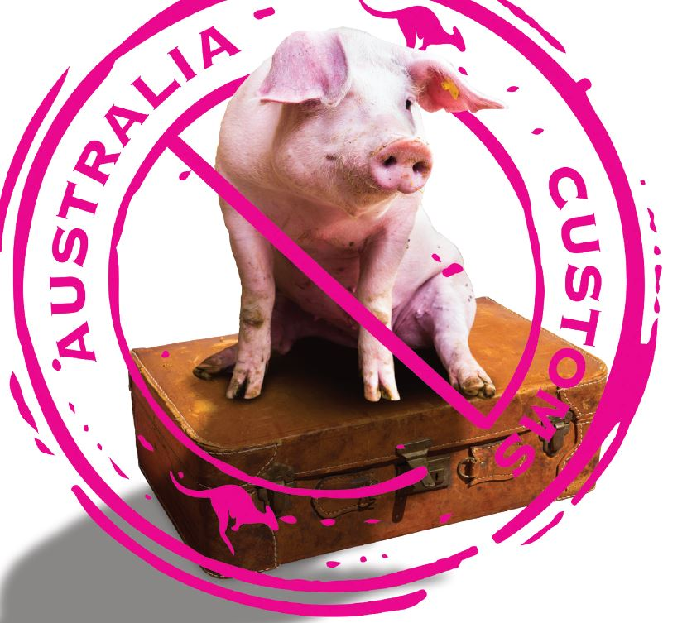
African swine fever (ASF) is a contagious disease of domestic and wild pigs. It is not a danger to human health but is devastating to pigs and farmers.
ASF has continued to spread through European, African, Central American and Asian countries including China, Vietnam, the Philippines, Timor Leste and Papua New Guinea.
Pork meat or pork meat products from overseas could introduce serious animal diseases to Australia that could devastate our valuable livestock industries.
Enjoy the delicacies while you travel overseas, but DON’T BRING THEM TO AUSTRALIA.
Examples of pork meat products include pork, ham, salami, sausage and small goods.

For more information visit agriculture.vic.gov.au/africanswinefever or call 136 186.
Produced with the assistance of the South Australian Government.

