Livestock Farm Monitor Project
Victoria │ Annual Report
2024-25

Further information regarding the Livestock Farm Monitor Project may be obtained from:
Sam Henty
Agriculture Victoria
195-229 Lyttleton Terrace, Bendigo, Victoria, 3550
sam.henty@agriculture.vic.gov.au
Authorised and published by the Victorian Government, Department of Energy, Environment and Climate Action (DEECA) 2025. © The State of Victoria Department of Energy, Environment and Climate Action 2025.
This publication is copyright. No part may be reproduced by any process except in accordance with the provisions of the Copyright Act 1968.
For more information contact the Agriculture Victoria Customer Service Centre on 136 186.

Disclaimer
This publication may be of assistance to you, but the State of Victoria and its employees do not guarantee that the publication is without flaw of any kind or is wholly appropriate for your particular purposes and therefore disclaims all liability for any error, loss or other consequence which may arise from you relying on any information in this publication.
Accessibility
If you would like to receive this publication in an accessible format, such as large print or audio, please telephone 136 186.
Deaf, hearing impaired or speech impaired? Call us via the National Relay Service on 133 677 or visit www. relayservice.com.au
This document is also available on the Agriculture Victoria website.

Contents
Livestock Farm Monitor Project 1
State summary 5
Business profit and returns 6
Average performance measures 7
Feed costs and management decisions 7
Debt 9
Debt servicing 9
The effect of farm debt on risk and return 10
Gippsland 11
Gross margins 11
Costs 11
Price received 12
Capital structure 12
Return on assets and equity 12
Northern Victoria 15
Gross margins 15
Costs 15
Price received 16
Capital structure 16
Return on assets and equity 17
South West Victoria 20
Gross margins 20
Costs 20
Price received 21
Capital structure 22
Return on assets and equity 22
Glossary 25
References 29

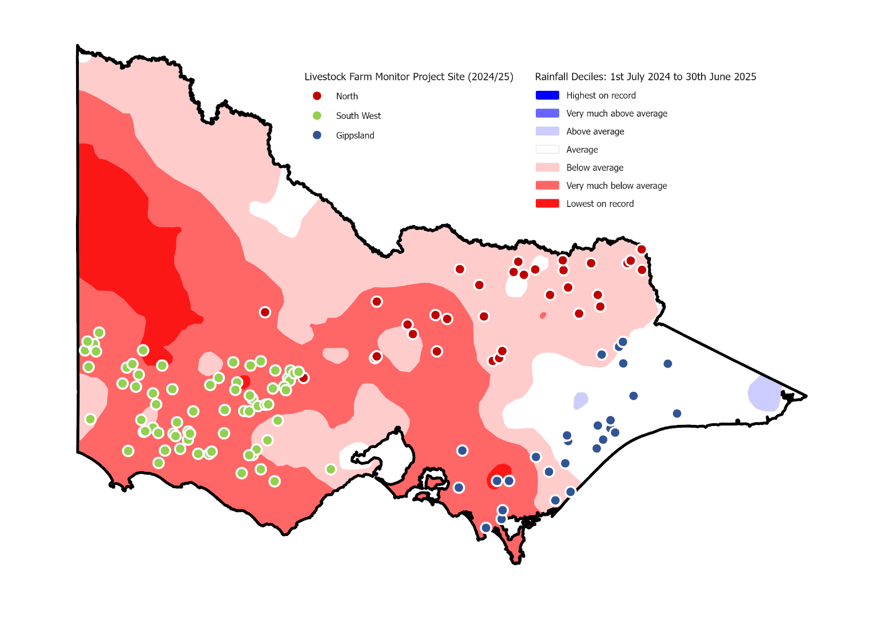

In 2024-25, the Livestock Farm Monitor Project (LFMP) provided 134 Victorian sheep, beef and stock/cropping farmers with detailed financial and production performance information. Of the 134 farms that participated, 111 are continuing farms from 2023-24 and 23 farms are new to the project.
Agriculture Victoria collated the individual business performance information of all surveyed farms to provide insights in this report.
The LFMP is Agriculture Victoria’s primary source of farm-level information for sheep and beef production practices, resource use, and economic data.
The results of this annual survey provide farm-level data to inform Agriculture Victoria’s decisions that impact at a farm level, and to inform the direction of future

policy design, research themes and service delivery programs.
Farmers who participate in the project increase their understanding of their farm business, helping build resilience and improve their ability to adapt to change.
Results published in this report are not statistically representative of any industry or region.
Agriculture Victoria staff are grateful for the cooperation of the farmers who contributed their data to this project.
This project has been running continuously since 1971 and is funded by Agriculture Victoria.

State summary
Key points
- Farm incomes remained below the 10-year average despite improved red meat prices and did not cover the higher variable costs which increased above the 10-year average.
- Poor pasture growth due to challenging dry conditions led to high supplementary feed use and costs and/or decreased stocking rates and livestock inventories.
- In 2024-25, average statewide farm profits (EBIT) fell to the lowest levels in 20 years.
- Half of the participants recorded negative profits which tipped average profits and returns negative and below the 10-year average in all regions.
- Increased interest payments, driven by larger borrowings put additional pressure on farm cash flow.
State summary
Financial parameter bars: | 10-yr average | G | 10-yr average | N | 10-yr average | SW
Gross farm income ($/ha) | $1,293 | $1,195 | $967 | $913 | $1,309 | $1,088
Variable costs ($/ha) | $510 | $561 | $375 | $460 | $547 | $726
Overhead costs ($/ha) | $597 | $648 | $431 | $463 | $383 | $372
Earnings before Interest and Tax ($/ha) | $186 | -$14 | $161 | -$10 | $379 | -$10
Return on assets (%) | 1.3% | -0.1% | 1.6% | -0.2% | 3.1% | -0.1%
Return on equity (%) | 0.8% | -1.5% | 1.1% | -1.0% | 2.8% | -2.7%
Physical parameter bars: | 10-yr average | G | 10-yr average | N | 10-yr average | SW
Effective area (ha) | 744 | 693 | 829 | 755 | 1,302 | 1,626
Stocking rate (DSE/ha) | 16.8 | 17.5 | 11.2 | 13.5 | 15.5 | 14.0
Sheep (head) | 2,181 | 1,115 | 2,813 | 1,972 | 7,471 | 8,040
Cattle (head) | 561 | 530 | 407 | 447 | 297 | 249

Business profit and returns
In 2024-25, farm profitability was the lowest in 20 years. Negative profits were recorded by 49% of surveyed farms, with average earnings before interest and tax (EBIT) decreasing to well below the 10-year average in each region (Figure 1).
Variable costs in the south west and Gippsland increased to the highest values on record. Consecutive years of very dry conditions and poor pasture growth led to an increased reliance on supplementary feed, increasing supplementary feed costs to high levels. Farmers attempted to minimise these costs by reducing stocking rates. Improved red meat prices (price received for sheep, lamb and cattle) increased income from stock sales but decreases in stock inventories meant that the increase in farm incomes were not enough to offset the large increases in costs.
In 2024-25, average return on assets (RoA) and return on equity (RoE) were negative (Figure 2) and below the 10-year average in all regions. Despite the low regional average returns, each region had participant farms that recorded high returns and farms with negative returns (Appendix B1, C1, D1).
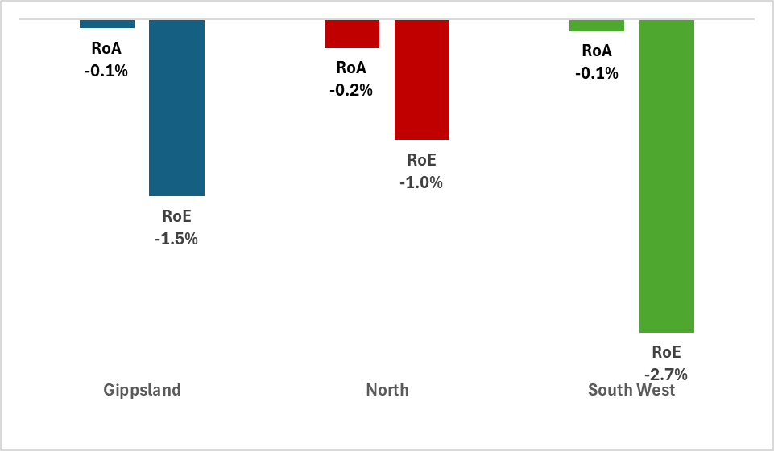
Figure 2. 2024-25 regional return on assets (RoA) and return on equity (RoE).

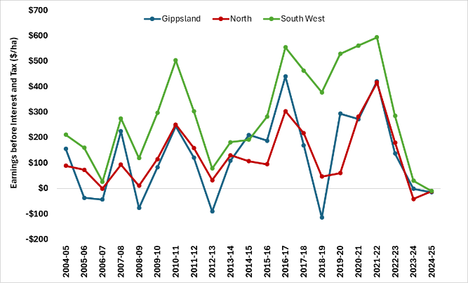
Figure 1. Regional average earnings before interest and tax (EBIT) over time (2004-05 to 2024-25) ($/ha).

Average performance measures
When the dataset was separated into farm business types (see glossary for definitions), on average stock and grain businesses were the best performing and the only business type with positive average annual returns (Table 1). Stock and grain businesses recorded the highest average farm income.
Specialist beef businesses recorded the highest average operating (variable plus overhead) costs per hectare. Businesses specialising in sheep and businesses specialising in beef had the lowest average RoA in 2024-25 (Table 1).
Income
Small and large farms derived their income from different enterprise mixes. On the smallest farms, beef cattle sales contributed an average of 58% of total cash income. In contrast, cattle sales accounted for only 26% of total cash income on the largest farms (Appendix A3). Sheep sales were the dominant income source on larger farms, making up an average of 41% of total cash income, compared with 25% on the smallest farms.

Feed costs and management decisions
Farm managers responded differently to the challenging dry conditions in 2024-25. Feed management decisions were made to fill critical feed and stock water gaps.
Selective de-stocking, selling lighter animals earlier and ultimately lowering stocking rates minimised impacts of dry conditions. This was reflected in the negative livestock inventory change across most enterprises and regions.
Of the stock that remained on farm, the feed gap created by poor soil moisture and low pasture growth was filled with purchased and homegrown supplementary feed. This included farmers drawing on their homegrown feed inventories across the state.
The increased supplementary feeding in 2024-25 resulted in in the highest purchased feed costs in 6 years. Some enterprises were fully fed supplementary feed for a portion of the year. The timing of purchasing feed mattered, as fodder price per tonne became more expensive during the year. On average, supplementary feed comprised 30% of the diet on south west Victoria farms, 22% in northern Victoria and 14% in Gippsland in 2024-25. As a result, south west Victoria had the highest purchased feed costs of all the regions ($/ha).

Business type | Gross farm income | Total variable costs | Total overhead costs | Earnings before Interest and Tax | Return on assets | Return on equity
 | $/ha | $/ha | $/ha | $/ha | % | %
Sheep and beef | 1,048 | 598 | 434 | 16 | 0.0% | -2.2%
Specialist sheep | 971 | 671 | 357 | -57 | -0.4% | -2.8%
Specialist beef | 1,045 | 558 | 619 | -131 | -0.5% | -1.6%
Stock and grain | 1,546 | 668 | 507 | 371 | 1.4% | 0.4%
Table 1. Average performance measures for each business type for the 2024-25 LFMP dataset.

Costs by farm scale
When livestock businesses were separated by size (based on total DSE), scale economies were observed. Figure 3 shows scale economies in sheep and cattle production were in overhead costs. There were significant differences in overhead costs between the small and large size groups, but no differences for variable costs. Non-cash overhead costs per DSE were the main contributor to this difference. Imputed labour and depreciation made up a higher proportion of overhead costs on small farms (61% of overhead costs) compared to larger farms (35%). These non-cash overhead costs are not part of business cash flow. This result highlights that larger farms can reduce their overhead costs per unit of output by spreading overhead costs over more output. Livestock businesses of all sizes controlled their variable costs (mainly feed costs) per DSE in 2024-25.
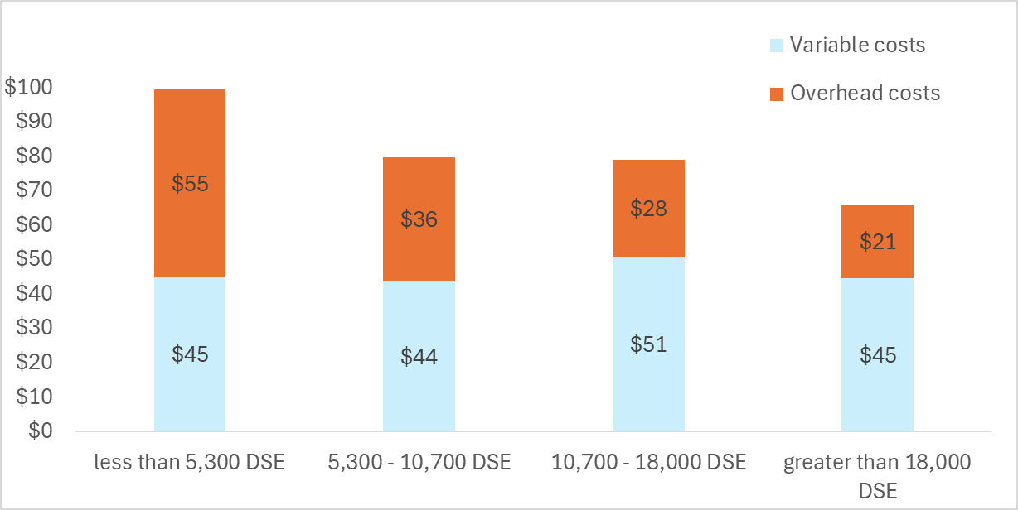
Figure 3. 2024-25 variable and overhead costs ($/DSE) for livestock businesses separated by farm scale (defined by total DSE)
RoA by farm scale
When the LFMP dataset was separated by business size (based on cash income), larger farms had higher average RoA than smaller farms (Figure 4). Surveyed farms with cash income less than $530,000 had the lowest average RoA.
Larger farms have more capacity to reduce their costs through scale. All farms with surplus cash may have the ability to invest in more expensive productivity-enhancing capital additions.
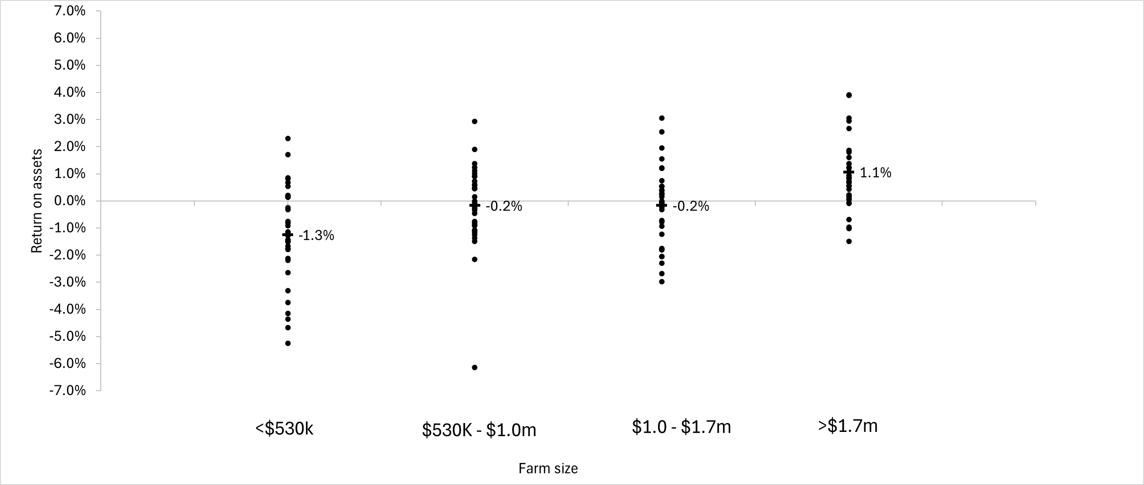
Figure 4. 2024–25 return on assets separated by farm size (defined by total cash income)

Debt
Nearly 60% of south west farms increased debt during 2024-25 (Figure 5). This contrasted with northern farms where 24% of farms increased debt. Around 30% of the farms in northern Victoria and Gippsland had no debt (29% and 28% respectively).

Figure 5. Debt activity from 1 July 2024 to 30 June 2025

Debt servicing
Higher average debt ($/ha) in each region, increased interest costs for LFMP farms in 2024-25. Farms with lower business equity percentage were more likely to spend a large proportion of cash income on interest costs.
Interest costs accounted for 20 cents of every dollar (20%) of cash income on farms with below 65% equity (Figure 6). Whereas interest costs accounted for 6 cents of every dollar of cash income (6%) on farms with above 80% business equity.
These results highlight that the use of debt increases the obligatory costs of farm businesses as interest (and principal) must be paid in good and poor years.
For this reason, farm management strategies employed throughout the year will be influenced by not only seasonal conditions and market prices, but the level of debt held by the farm business.
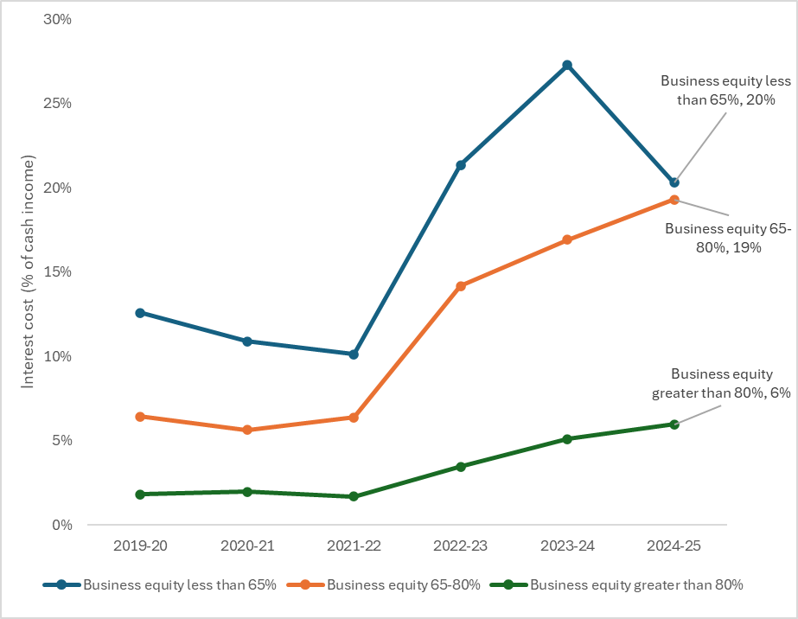
Figure 6. The proportion of farm cash income spent on interest payments from 2019-20 to 2024-25 separated by different categories of business equity (below 65%, 65% to 80%, above 80%).

The effect of farm debt on risk and return
Increasing enterprise and farm size can improve RoA, more so in the longer-term. Expansion often requires taking on additional debt, which raises financial risk and can reduce RoE. The balance between debt, equity, total assets and debt servicing remains central to long-term business viability and growth.
Figure 7 shows average RoE during periods of higher profitability (2020-21 and 2021-22) compared with lower profitability years (2023-24 and 2024-25). Farms with lower business equity (less than 80% equity) had higher returns during the more profitable years but also faced lower returns during the lower profitability years. This reflects the increased financial risk associated with higher debt levels – particularly taking on higher interest costs which need to be paid regardless of the season or how well the business is doing.
The lower average RoE observed in the most recent years (2023-24 and 2024-25) for farms with lower equity highlights the challenges these businesses have faced under tougher operating conditions. It is important to note that there is considerable variation in returns. Farms across all equity categories recorded high and low returns in any given year.

Figure 7. The average return on equity (RoE) for LFMP farms over the last 5 years (2020-21 to 2024-25), separated by business equity

Gippsland

Gross margins

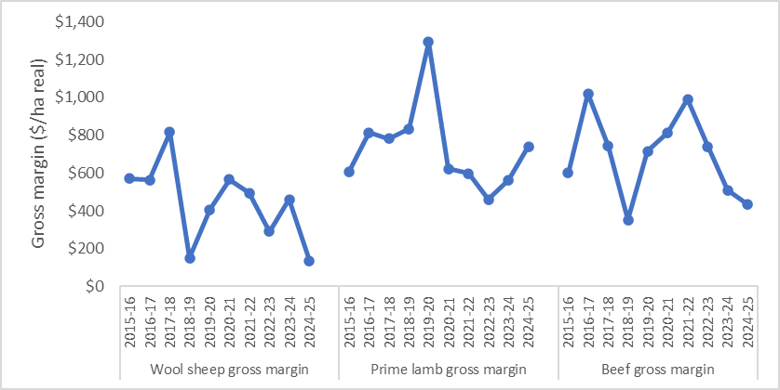
Figure 8. Gippsland average gross margin for wool sheep, prime lamb and beef (2015-16 to 2024-25)
Gippsland beef gross margins decreased for the third consecutive year reaching the second lowest average recorded in the last 10 years (Figure 8). The 2024-25 beef gross margin was 38% below the five-year average. Prime lamb average gross margin increased in 2024-25 and was above the 5-year regional average. Wool sheep average gross margins dropped to a 10-year low in 2024-25 to be 65% below the 5-year regional average. Prime lamb and wool sheep enterprises were less common than beef in Gippsland and enterprise averages were more sensitive to skewing because of outliers.

Costs
Expenditure on pasture fertiliser increased in 2024-25 as average phosphorus application rates increased and superphosphate prices remained steady (Figure 9). Pasture fertiliser remained the largest cost item on Gippsland farms in 2024-25, making up 15% of average farm cash operating costs.
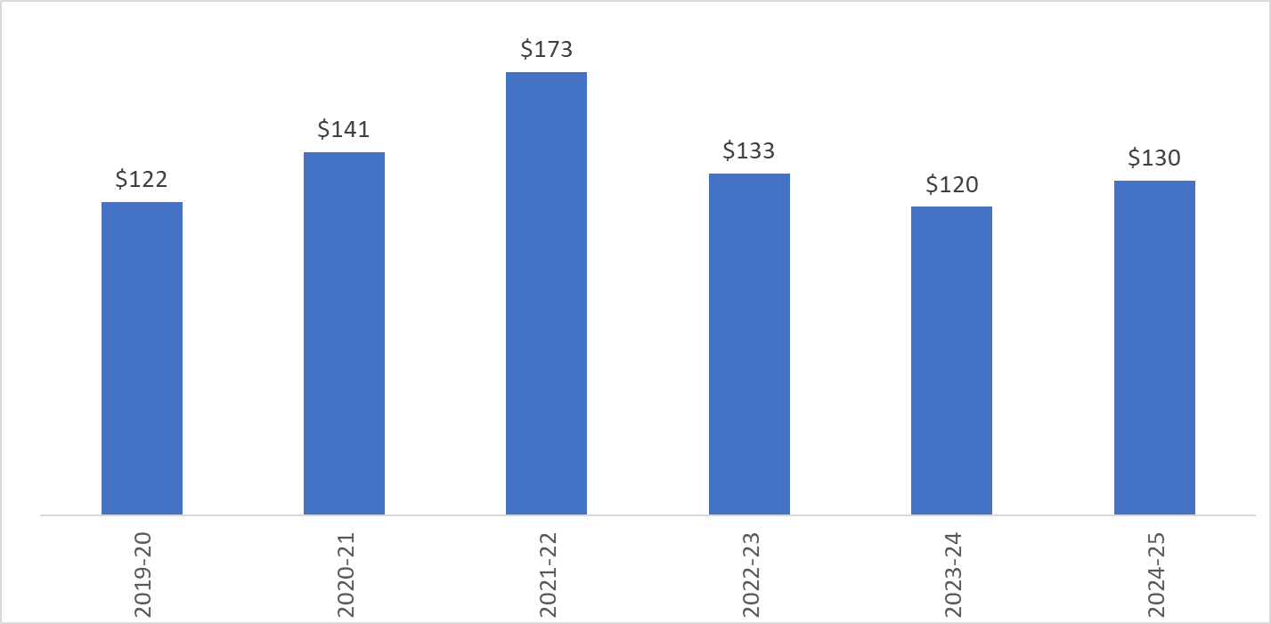
Figure 9. Gippsland farms average expenditure ($/ha) on fertiliser applied to pasture (2019-20 to 2024-25)
Gippsland farms received 85% of their long-term average annual rainfall (Appendix D2). Increased quantities and rates of supplementary feeding to all types of enterprises resulted in a 35% increase in purchased supplementary feed cost (Figure 10).
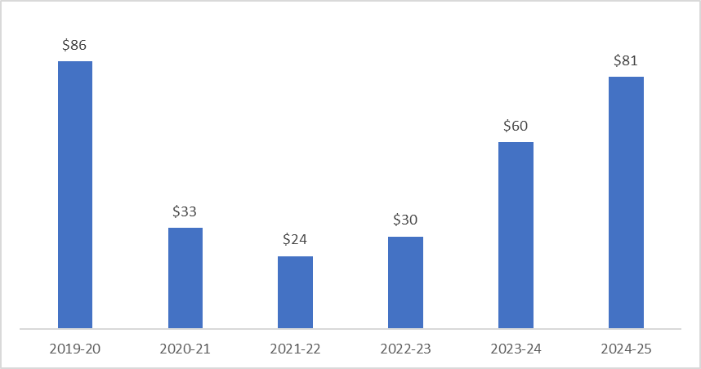Figure 10. Gippsland farms average expenditure ($/ha) on purchased supplementary feed (2019-20 to 2024-24)

Price received

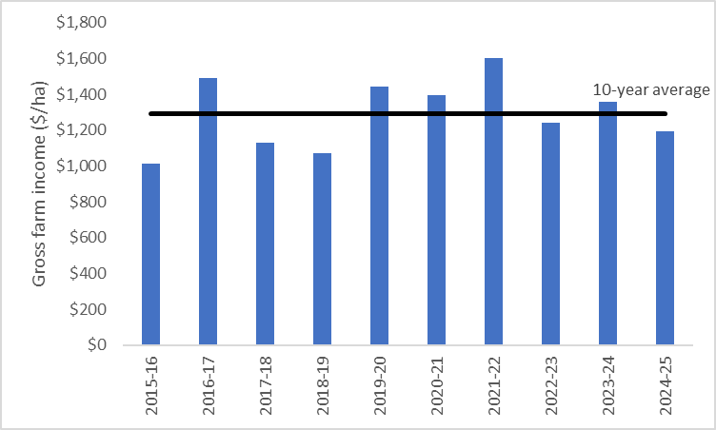
Figure 11. Gippsland average gross farm income ($/ha) and 10-year average gross farm income (line) (2015-16 to 2024-25).
Cattle sales made up 73% of average farm income (Appendix D3), making beef enterprises the dominant enterprise on Gippsland farms in 2024-25. Beef prices increased (+14%) from 2023-24 but remained below 5-and 10-year average price received. Average wool price received dropped by 14% from 2023-24 to the lowest price received in a decade. Beef and wool livestock trading profits were affected by reduced stock inventories as dry conditions led to additional sales and destocking. The low price received for wool and beef coupled with reduced inventories meant gross farm income dropped in 2024-25 to below the regional 10-year average (Figure 11).

Capital structure
Farm debt levels decreased in 2024-25 as 41% of farms reduced the amount of debt owing during the year (Figure 5). However, debt levels remained above the 5-year average, Gippsland farms managed the highest value of total assets per hectare of the LFMP regions ($22,157/ha). Average regional equity percentage improved to 86%, the highest in the state (Appendix A6) aided by increases in farmland values and decreases in debt levels.

Return on assets and equity
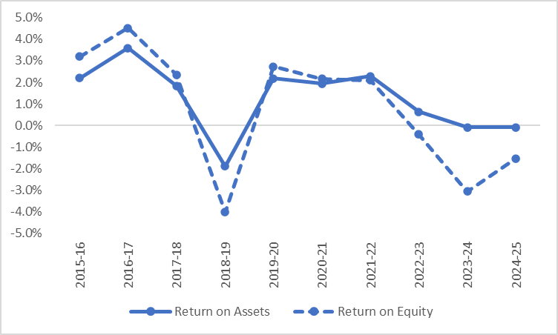
Figure 12. Gippsland return on assets and equity (2015-16 to 2024-25).
Negative profits (EBIT) were recorded by 59% of LFMP farms in Gippsland. This meant the average return on assets was negative (-0.1%) for the second consecutive year (Figure 12). Interest costs remained high and worsened farm businesses losses leading to Gippsland farms recording a negative average return on equity for the third consecutive year.

Gippsland regional summary
- Gippsland farms received 85% of their long-term average annual rainfall.
- Beef was the dominant enterprise on Gippsland farms, with cattle sales making up 73% of average farm income.
- Pasture fertiliser was the largest operating cost, accounting for 15% of total farm cash costs.
- Beef prices rose but stayed below five- and ten-year averages. Despite the increase in prices, beef gross margins fell below the five-year average and were the second lowest in the past decade.
- A decrease in price received and increased costs led to wool sheep gross margins falling to the lowest value in over a decade
- Negative farm profits were recorded on 59% of LFMP farms in Gippsland.
- Average farm business equity percentage increased to 86%, the highest of all LFMP regions, supported by lower debt levels and higher land values.
- Debt levels and interest costs remained high, amplifying losses and a negative average return on equity was recorded for the third consecutive year.

 | 5-yr average | 2024-25
Enterprise income
Beef income ($/ha) | 1,264 | 992
Prime lamb income ($/ha) | 1,098 | 1,459
Wool sheep income ($/ha) | 727 | 522
Variable costs
Beef variable costs ($/ha) | 566 | 557
Prime lamb variable costs ($/ha) | 501 | 718
Wool sheep variable costs ($/ha) | 337 | 386
Production
Beef sold (kg lwt/ha) | 363 | 312
Lamb sold (kg cwt/ha) | 118 | 156
Wool sheep wool cut (kg Gr./ha) | 38 | 34
Labour
Labour use efficiency (ha/FTE) | 308 | 341
Labour use efficiency (DSE/FTE) | 4,858 | 4,982
Phosphorus application
Phosphorus applied to pasture (kg/ha) | 11 | 13
Phosphorus applied to pasture (kg/DSE) | 0.6 | 0.7
Business structure
Total assets managed ($/ha) | 21,866 | 22,157
Total debt ($/ha) | 2,365 | 2,897
Top 5 costs (Proportion of total cash operating costs)
Pasture fertiliser costs (%) |  | 15%
Livestock selling costs (%) |  | 11%
Animal health (%) |  | 6%
Rates (%) |  | 6%
Farm insurance (%) |  | 5%

Northern Victoria

Gross margins
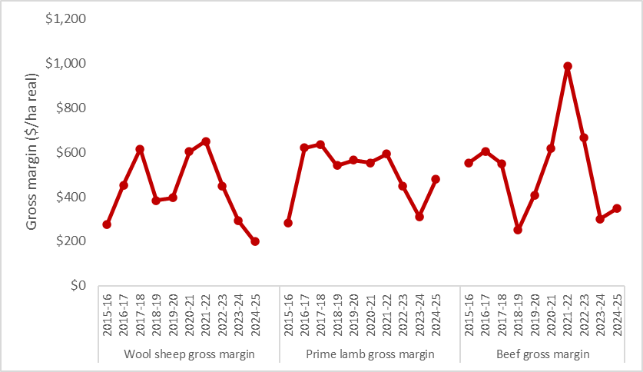
Figure 13. Northern average gross margin for wool sheep, prime lamb and beef (2015-16 to 2024-25)
Wool sheep gross margins continued to fall in 2024-25 to be the lowest enterprise gross margin in the region (Figure 13). Wool sheep gross margins per hectare and per DSE were the lowest in the history of project in Northern Victoria (+20 years) (Appendix C13). Improved red meat prices contributed to the increase in prime lamb and beef gross margins in 2024-25 but both enterprises remained below the 5-year average.

Costs

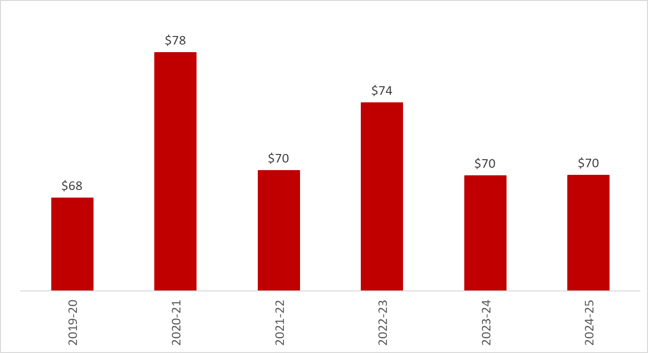
Figure 14. Northern farms average expenditure ($/ha) on fertiliser applied to pasture (2019-20 to 2024-25)
Despite the dry conditions, farmers continued to apply fertiliser at similar rates to last year in Northern Victoria. With stable prices and usage rates, fertiliser expenditure was the same as in 2023-24 (Figure 14). With the additional spending on supplementary feed, fertiliser moved from the largest cost item in 2023-24 to being the third largest item in 2024-25, making up 9% of average farm cash operating costs.
Northern farms received average spring rainfall but well below autumn rainfall (55%) resulting in below average (77%) long-term average annual rainfall (Appendix D2). As a result of the drier conditions, grazed pasture consumption decreased to 3.4 tonne of dry matter per hectare (-7% year-on-year). Lower pasture availability meant a greater reliance on supplementary feed leading to a large increase (130%) in purchased supplementary feed costs from the previous and was higher than 2019-20 – a drought year (Figure 15). Prime lamb enterprises were most reliant on supplementary feed, with supplementary feed (primarily grain and pellets) making up 22% of all feed consumed in northern prime lamb enterprises.
Additional feed expenditure resulted in historically high variable costs on northern farms.
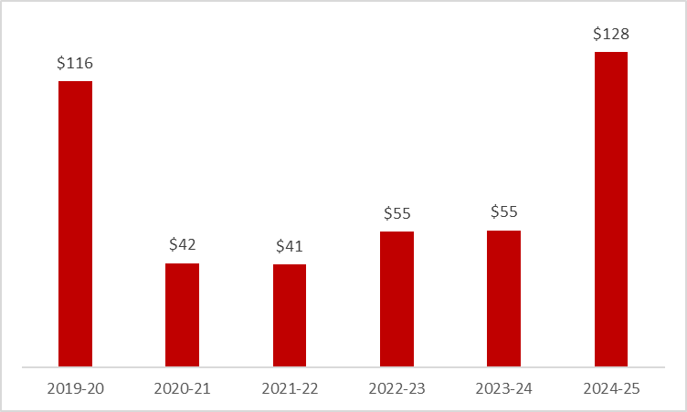
Figure 15. Northern farms average expenditure ($/ha) on purchased supplementary feed (2019-20 to 2024-25).

Price received
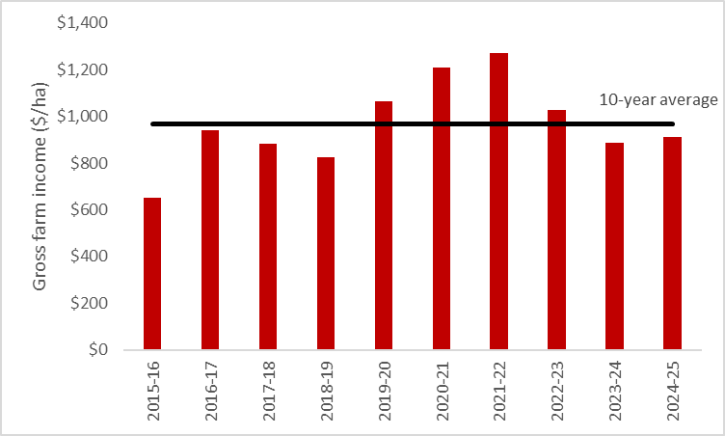
Figure 16. Northern Victoria average gross farm income ($/ha) and 10-year average gross farm income (line) (2015-16 to 2024-25).
The dominant source of income on northern Victorian farms was cattle sales (56%) and sheep sales (26%) (Appendix C5). Improved red meat prices in 2024-25 resulted in only a small annual increase (+3%) in average gross farm incomes on northern farms (Figure 16). Gross farm income includes cash receipts from sales and changes in inventories of commodities on farm (feed, livestock, wool). Dry conditions led farmers across northern Victoria to draw down on feed inventories and reduce the number of livestock on hand. The negative inventory change offset any increases in commodity prices and meant that the 2024-25 gross farm income was below the 10-year regional average.

Capital structure
Although 44% of farms in northern Victoria reduced debt in 2024–25 (Figure 5), the region’s average debt level remained largely unchanged from 2023–24. This was because the 24% of farms that increased their debt took on larger amounts than those that reduced it.
The equity (net worth) of 31% of northern farms declined during the year, resulting in a decline in the region’s average equity percentage. Average equity percentage dropped from 88% in 2023-24 to 85% in 2024-25 (Appendix A6).

Return on assets and equity
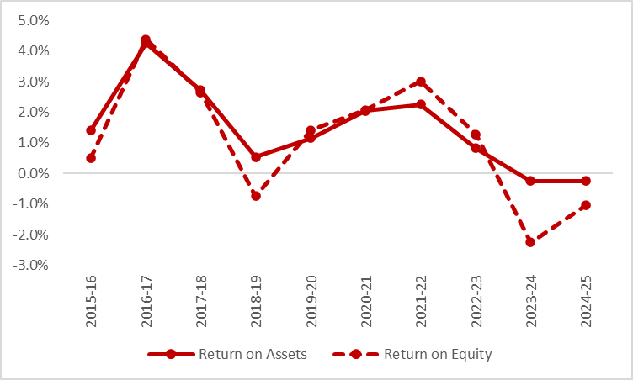
Figure 17. Northern return on assets and equity (2015-16 to 2024-25)
Negative profits (EBIT) were recorded by 47% of LFMP farms in northern Victoria. Average RoA remained negative for the second consecutive year, unchanged from 2023–24 at –0.2% (Figure 17). For most farms, increases in farm income were not enough to offset higher operating expenses, resulting in continued low RoA.
Despite cuts to interest rates during the year, interest payments across the region stayed high. High interest payments amplified already low profits resulting in average RoE remaining negative for the second consecutive year at –1.6% (Figure 17).

Northern Victoria regional summary
- Northern farms received below average annual rainfall leading to reduced pasture availability and increased reliance on supplementary feed.
- Purchased supplementary feed costs rose by 130% and contributed to historically high variable costs.
- Cattle sales remained the dominant source of income (56%), followed by sheep sales (26%).
- Average gross farm income increased slightly (+3%) but remained below the 10-year regional average due to inventory reductions and dry conditions.
- Wool sheep gross margins fell to the lowest in the project’s 20-year history.
- Negative profits were recorded by 47% of farms.
- Average return on assets remained negative for the second consecutive year (–0.2%).
- The net-worth of nearly one-third (31%) of northern farms declined, reducing the regional average equity percentage to 85%.
- Debt levels and interest costs remained high, amplifying losses and contributing to a negative average return on equity (–1.6%) for the second consecutive year.

 | 5-yr average | 2024-25
Enterprise income
Beef income ($/ha) | 1,023 | 881
Prime lamb income ($/ha) | 941 | 926
Wool sheep income ($/ha) | 818 | 706
Variable costs
Beef variable costs ($/ha) | 440 | 534
Prime lamb variable costs ($/ha) | 464 | 447
Wool sheep variable costs ($/ha) | 379 | 507
Production
Beef sold (kg lwt/ha) | 287 | 280
Lamb sold (kg cwt/ha) | 132 | 108
Wool sheep wool cut (kg Gr./ha) | 39 | 43
Labour
Labour use efficiency (ha/FTE) | 406 | 388
Labour use efficiency (DSE/FTE) | 4,695 | 4,453
Nutrient application
Phosphorus applied to pasture (kg/ha) | 9 | 7
Phosphorus applied to pasture (kg/DSE) | 0.6 | 0.5
Business structure
Total assets managed ($/ha) | 19,135 | 21,378
Total debt ($/ha) | 1,514 | 2,101
Top 5 costs (Proportion of total cash operating costs)
Purchased supplementary grain and pellets (%) | 11%
Livestock selling costs (%) | 9%
Pasture fertiliser costs (%) | 9%
Animal health (%) | 7%
Purchased supplementary fodder (%) | 6%

South West Victoria

Gross margins
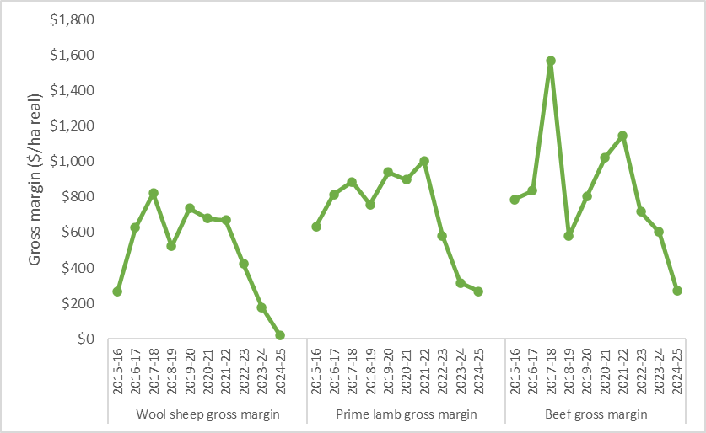
Figure 18. South west average gross margin ($/ha) for wool sheep, prime lamb and beef (2015-16 to 2024-25)
Prime lamb, wool sheep and beef gross margins decreased for the third consecutive year (Figure 18). A lower wool price and high drought induced costs resulted in wool sheep gross margins plummeting (-88% year on year) to the lowest result recorded since project began in 1972. Improved lamb and beef prices in 2024-25 were offset by large quantities and costs of supplementary feed, resulting in prime lamb and beef gross margins dropping to the lowest values since the 2006-07 drought. In 2024-25, south west wool sheep, prime lamb and beef gross margins were the lowest in the state.

Costs
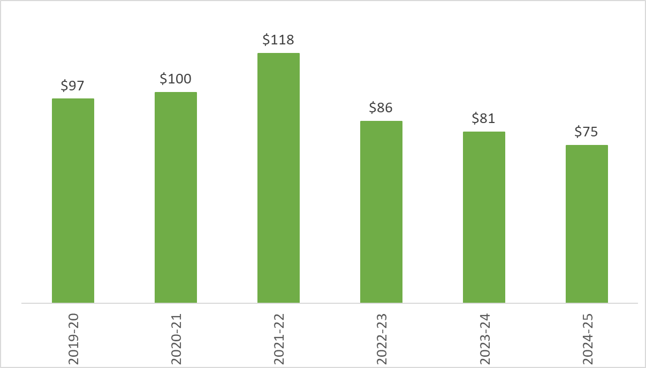
Figure 19. South west farms average expenditure ($/ha) on fertiliser applied to pasture (2019-20 to 2024-25)
In 2024–25, south west farms faced very dry conditions for the second consecutive year, with some areas recording their lowest rainfall on record. In response to the dry conditions, farm managers reduced fertiliser applications and rates, driven by both agronomic and budget considerations. Almost 10% of south west farms did not apply any fertiliser during the year. Average expenditure on pasture fertiliser fell to its lowest level in six years (Figure 19).
Spring 2024 was dry, with farms receiving an average of 82% of long-term spring rainfall, and some as low as 45%. These conditions were compounded by a very dry autumn in 2025, with average rainfall across participants at 47% of the long-term average, and some farms receiving as little as 20% of their long-term average.
In the south west, most lambing in wool and prime lamb enterprises happens in winter, making autumn and spring key seasons. In autumn, farmers focus on building energy reserves in breeding ewes to support late pregnancy and lactation. In spring, fast pasture growth helps meet the feed needs of lactating ewes and supports sale lambs reaching target weights by early summer..
Dry conditions during these critical periods resulted in annual grazed pasture consumption dropping by 23% year-on-year to an average of 3.1 tonne of dry matter per hectare (Appendix B2), the lowest level for the region in 6 years and the lowest recorded for the state.
Low pasture growth created a gap in stock feed requirements on south west farms that was filled by purchased and homegrown supplementary feed. Prime lamb enterprises were most reliant on supplementary feed, with supplementary feed making up 30% of all feed consumed in south west prime lamb enterprises.
Spending on purchased supplementary feed increased by 62% in 2024-25, to be the highest level in 6 years (Figure 20). Purchased supplementary feed was the largest cost item for south west farms in 2023-24, making up 29% of average farm cash operating costs.
The increased cost of drought feeding led to the regional average variable costs increasing to the highest recorded ($726/ha) in the 55-year history of the project in the south west.
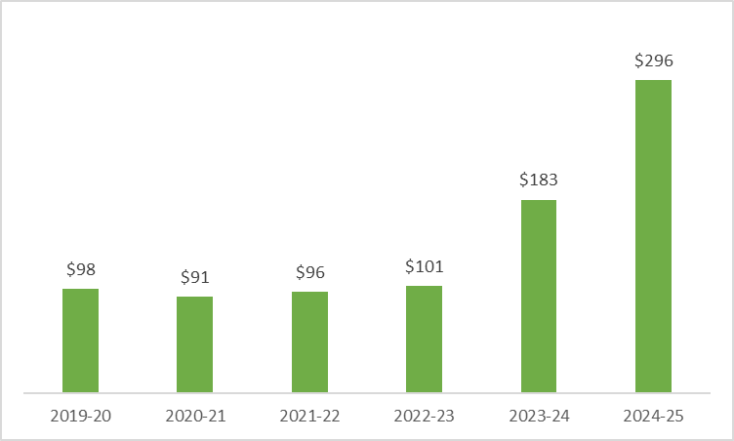
Figure 20. South west average farm expenditure ($/ha) on purchased supplementary feed (2019-20 to 2023-24).

Price received
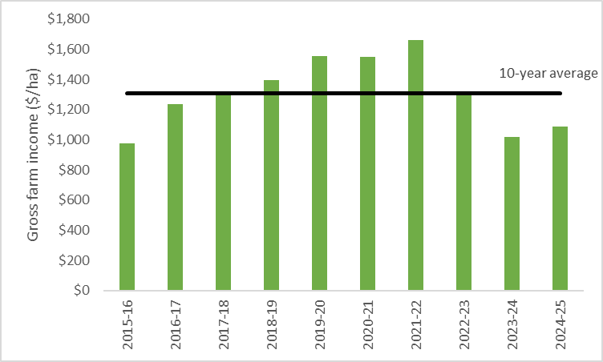
Figure 21. South west average gross farm income ($/ha) and 10-year average gross farm income (line) (2015-16 to 2024-25).
The dominant source of income on south west farms was sheep sales (51%) and cattle sales (18%) (Appendix B5).
There was a small annual increase (+7%) in average gross farm income recorded in 2024-25 (Figure 21). This was a result of improved red meat prices, tempered by decreases in inventories of commodities on farm (feed, livestock, wool). Dry conditions led farmers across the south west to draw down on feed inventories and reduce the number of stock on hand.

Capital structure
In 2024-25, the average amount of farm debt owed by south west farms increased by 8% to $2,822/ha, a 10-year high. Between July 2024 and June 2025, 56% of south west farms (Figure 5) increased their debt.
With farmland values declining across the region and debt levels increasing, equity fell on a large proportion of farms (62%). The regional average equity percentage decreased for the third consecutive year to 82% (Appendix A6). Farm business equity reflects financial risk exposure and has implications for debt servicing and cash flow. Nearly 40% of south west farms had less than 80% equity, meaning management decisions on these farms were shaped not only by seasonal conditions and market prices, but also by the need to maintain cash flow for loan repayments.

Return on assets and equity
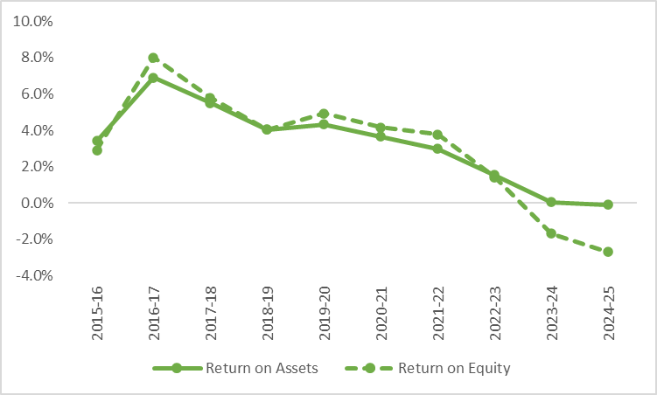
Figure 22. South West return on assets and equity (2015-16 to 2024-25)
In just four years, south west farm profits have fallen from the highest level in 55 years (2021–22) to the lowest on record in 2024–25. South west Victoria recorded the lowest return on assets (-0.1%) since the 1982-83 drought. (Appendix B12). Larger interest payments on higher levels of debt worsened farm businesses losses and the average return on equity fell to -2.7%, the lowest returns since 2006-07.

South west Victoria regional summary
- South west Victoria experienced very dry conditions for the second consecutive year, with some farms recording their lowest rainfall on record.
- Spending on purchased supplementary feed increased by 62% and became the largest single cost item (29% of farm cash operating costs).
- Variable costs rose to $726/ha, the highest in the 55-year history of the project.
- Sheep sales remained the dominant source of income (51%), followed by cattle sales (18%).
- Average gross farm income increased slightly (+7%), supported by improved red meat prices. Income gains were tempered by reductions in stock numbers and feed inventories due to the dry conditions.
- With declining farmland values and higher debt, equity decreased on 62% of farms and the regional average equity percentage declined for the third consecutive year to 82%.
- Nearly 40% of farms held less than 80% equity, increasing financial risk and cash flow pressure.
- Average return on assets fell to –0.1%, the lowest since the 1982–83 drought.
- Return on equity dropped to –2.7%, the lowest since 2006–07.
- Within four years, average south west farm profits have fallen from the highest levels in 55 years (2021–22) to the lowest on record (2024–25).

 | 5-yr average | 2023-24
Enterprise income
Beef income ($/ha) | 1,305 | 925
Prime lamb income ($/ha) | 1,311 | 1,099
Wool sheep income ($/ha) | 1,001 | 725
Variable costs
Beef variable costs ($/ha) | 553 | 653
Prime lamb variable costs ($/ha) | 698 | 832
Wool sheep variable costs ($/ha) | 607 | 704
Production
Beef sold (kg lwt/ha) | 543 | 348
Lamb sold (kg cwt/ha) | 126 | 129
Wool sheep wool cut (kg Gr./ha) | 47 | 41
Labour
Labour use efficiency (ha/FTE) | 420 | 423
Labour use efficiency (DSE/FTE) | 5,917 | 4,922
Nutrient application
Phosphorus applied to pasture (kg/ha) | 11 | 9
Phosphorus applied to pasture (kg/DSE) | 0.7 | 0.6
Business structure
Total assets managed ($/ha) | 19,081 | 18,881
Total debt ($/ha) | 2,374 | 2,822
Top 5 costs (Proportion of total cash operating costs)
Purchased supplementary grain and pellets (%) | 22%
Contract shearing and crutching (%) | 9%
Pasture fertiliser costs (%) | 7%
Purchased supplementary fodder (%) | 6%
Wages for permanent staff (%) | 5%

Glossary
Appreciation
An increase in the value of an asset in the marketplace. Often only applicable to farmland value.
Asset
Anything managed by the farm, whether it is owned or not. Assets include owned land and buildings, leased land, plant and machinery, fixtures and fittings, trading stock, farm investments (i.e., Farm Management Deposits), debtors and cash.
Average
The sum of a collection of numbers divided by the count of numbers in the collection.

Business type
Specialist sheep
Businesses with more than 85% of DSE coming from sheep and less than 30% income coming from grain and cropping.
Specialist beef
Businesses with more than 85% of DSE coming from beef and less than 30% income coming from grain and cropping.
Sheep and beef
Businesses with less than 85% of DSE coming from beef, less than 85% DSE coming from sheep and less than 30% income coming from grain.
Stock and grain
Businesses with more than 30% of income coming from grain and cropping sales and greater than zero stock DSE.

Cash Income
The sum of all cash income related to the operation of the farm/enterprise.

Cash overheads
All fixed costs have a cash cost to the business. Includes all overhead costs except imputed labour costs and depreciation.
Casual labour
A casual employee is an employee engaged casually and paid by the hour. Casual loading is paid instead of annual leave, a notice of termination, redundancy benefits and other attributes of permanent labour.
Contract labour
A contractor controls the work to be done and how it is to be performed. They can employ their own staff and can subcontract or delegate.
Concentrate
Category of feed that includes grains, oilseeds, and pellets.
Debt servicing
Servicing debt consists of making interest payments and repaying principal. The proportion of farm cash income spent on interest expenses (interest cost ratio) is useful to determine the capacity of a farm business to service debt.
The equity of a farm business is the total value amount remaining if all assets were sold and all debts were repaid (total assets minus total debts). Equity is often expressed as percentage and is used to represent the extent to which borrowed funds are used to finance a farm business (also called leverage). It’s calculated as the proportion of total assets owned outright relative to total assets.

Depreciation
Decrease in value over time of capital asset, usually as a result of using the asset. Depreciation is a non-cash cost of the business but reduces the book value of the asset and is therefore a cost.
Dry sheep equivalent (DSE)
The standard unit used to compare the metabolisable energy (ME) requirements of different classes of stock for feed budgeting purposes.
Earnings before interest and tax (EBIT)
Also known as ‘Operating Profit’ or ‘Profit’ is the return on all the capital used in the business before accounting for finance costs. Calculated as gross farm income minus total variable and total overhead costs.
Effective area
Total hectares managed minus the area of land which is of little or no value for livestock or crop production.

Enterprise income
The total income received from an enterprise before any expenses are paid. Includes cash receipts relevant to that enterprise and the value of changes in inventory relevant to that enterprise.

Equity
Total assets minus total liabilities. Equal to the total value of capital invested in the farm business by the owner/operator(s).
Equity per cent
Total equity as a percentage of the total assets owned.
The proportion of the total assets owned by the business.
Equity percentage helps explain the exposure of a farm business to financial risk and the implications to debt serving and cash flow.
Feed inventory change
An estimate of the quantity and value of grain, hay and silage on hand at the start and end of the financial year.
Full time equivalent (FTE)
Standardised labour unit. Equal to 1,920 hours a year.
Calculated as 48 hours a week for 40 weeks a year.
Grazed area
Pasture area plus an estimate of annual cropping area grazed. If a farm has multiple livestock enterprises, the grazed area is apportioned based on the total annual ME demand of each enterprise.
Grazed pasture consumed
Calculated using the back-calculation approach. Grazed pasture is calculated as the difference between the total metabolisable energy required by livestock over the year and the amount of metabolisable energy consumed from other sources (hay, silage, grain, and concentrates).
The total metabolisable energy required by livestock is a factor of age, weight, growth rate, pregnancy and lactation requirements and the number of animals.
Gross farm income
The total income received from a farm. Includes all cash receipts and the value of changes in stock, feed, and wool inventory.
Gross margin
Enterprise income minus enterprise variable costs.
Imputed
An estimated amount is introduced into economic management analysis to allow reasonable comparisons between years and between other businesses.
Interest and lease costs
Total interest plus total lease costs paid. Also known as ‘finance costs’.
Interest cost ratio
Measures the proportion of total income used to pay interest costs. It is calculated as total interest costs divided by cash farm income. Eg An interest cost ratio of 0.09 means 9 cents out of every dollar of income (or 9%) went to paying interest costs.
Liability
Money owed to someone else, e.g., family or a financial institution.
Livestock trading profit
An estimate of the annual contribution to gross farm income by accounting for the changes in the number and value of livestock during the year. It is calculated as the trading income from sales minus purchases, plus changes in the value and number of livestock on hand at the start and end of the year, and accounting for births and deaths. An increase in livestock trading indicates there was an appreciation in the value of livestock per head or an increase in livestock numbers over the year.
Metabolisable energy (ME)
The energy available for use by the animal. It is the energy used for maintenance of body systems, activity, milk production, pregnancy and weight gain. Metabolisable is net of energy lost in the form of urine and methane gas released by rumen and hind-gut microbes.

Net farm income
Earnings before interest and tax (EBIT) minus interest and lease costs. The amount of profit available for capital investment, loan principal repayments and tax.
Nominal terms
Dollar values that have no inflation component.
Livestock costs
All expenses relating to assisting with herd and flock management. Includes animal health costs and shearing contractors.
Livestock marketing costs
All costs associated with buying and selling livestock including freight and cartage.
Operating costs
Overhead and variable costs, i.e., the costs associated with the annual operation of the farm.
Overhead costs
All fixed costs incurred by the farm business that do not vary with the level of production. These include cash overhead costs such as permanent labour and noncash costs such as owner-operator labour, family labour and depreciation of plant and equipment. It excludes interest, lease costs, capital expenditure, principal repayments, drawings, and tax.
Overhead cost ratio
Measures the proportion of total income used to pay overhead costs. It is calculated as total overhead costs divided by gross farm income. Eg An overhead cost ratio of 0.5 means 50 cents out of every dollar of income (or 50%) went to paying overhead costs.
Owner/Operator labour
Staff members (such as family) that take income from business drawings rather than wages. The operators’ labour and management are an input to make a profit and so these must be costed and deducted to estimate the true profit and return to the capital in the business.
Pasture costs
All costs associated with growing pasture including fertiliser, seed and chemicals.
Permanent labour
Farm staff who have an ongoing expectation of work, generally work standard or set hours, are entitled to paid leave and notice of termination.
Principle of increasing financial risk
When a farm borrows to expand, it takes on increased financial risk. In good years, this borrowing can mean the owner’s net worth (equity) grows more quickly than not having debt. But in poor years, this borrowing can lead to equity being eroded faster than it would have grown in the good years. The rate of building equity and erosion of equity are not symmetrical, which is why the principle is called ’increasing financial risk'.
Profit (s)
See Earnings before interest and tax (EBIT).
Real terms
Dollar values that include an inflation component.
Return on equity (RoE)
Measures the per cent return to owner’s equity. ROE is calculated using your net farm income divided by the total equity (total assets minus total debt). If the farm business has no debts and no leased land, ROE will be the same as ROA.
Return on assets (RoA)
Earnings before interest and tax divided by the value of total assets under management, including owned and leased land.
Standard deviation
The standard deviation is a measure of how widely values are dispersed from the average value.

Variable costs
Variable costs (sometimes called direct costs) vary directly as the output of an enterprise varies.
Variable cost ratio
Measures the proportion of total income used to pay variable costs. It is calculated as total variable costs divided by gross farm income. Eg A variable cost ratio of 0.4 means 40 cents out of every dollar of income (or 40%) went to paying variable costs

List of abbreviations
CWT | Carcass weight
DEECA | Department of Energy, Environment and Climate Action, Victoria
DSE | Dry sheep equivalent
EBIT | Earnings before interest and tax
ha | Hectare(s)
kg | Kilograms
Kg Gr. or  Gr. kg | Kilograms of greasy wool
LFMP | Livestock Farm Monitor Project
LWT | Live weight
ME or  MJ ME | Megajoules of Metabolisable energy
mm | Millimetres
RoA | Return on Assets
RoE | Return on Equity
t | Tonne = 1,000 kg
tDM | Dry matter of feed stuffs measured in tonnes
yrs | Years old

References
Kay RD, Edwards WM, Duffy PA 'Farm Management' (Mcgraw-Hill Companies)
Langemeier M. (2016). Leverage and Financial Risk. farmdoc daily, 6.
Malcolm B, Makeham J, Wright V 'The Farming Game - Agricultural Management and Marketing.' (Cambridge University Press: Melbourne)
Malcolm B. (2011). Financing matters. Australian Farm Business Management Journal, 8(1), 11-18.
Sinnett A, Ho C. K. M, & Malcolm, B. (2016). Expanding a dairy business affects business and financial risk. Animal Production Science, 57(10), 2167-2174.

