


Drought Farm Advisory Service
Program Guidelines

December 2025
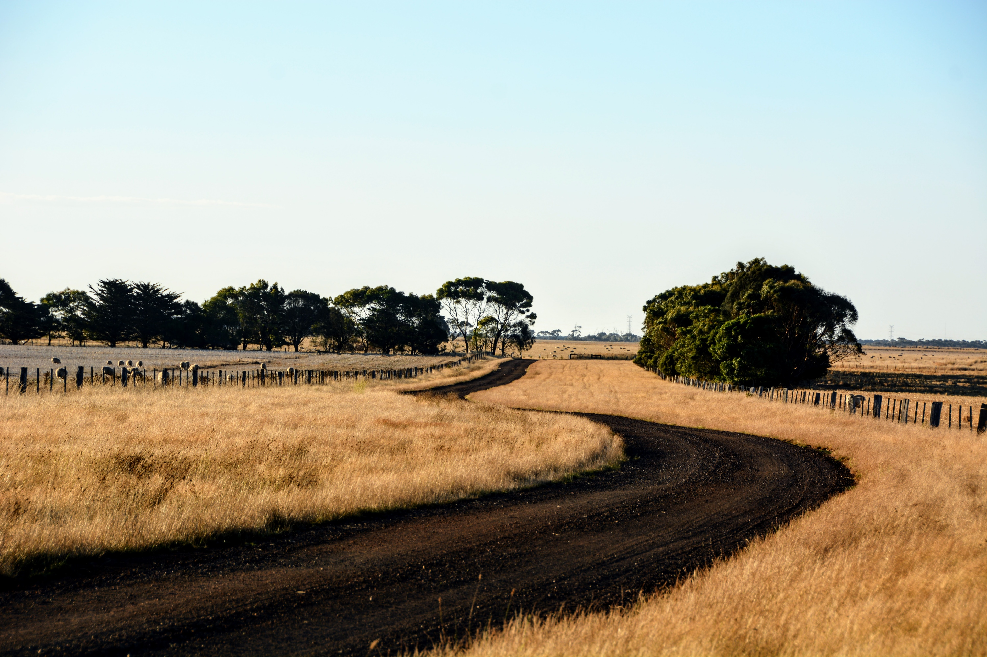



Background
The Victorian Government is providing more than $146.5 million in direct support to help farmers and communities across Victoria impacted by drought.
The package includes 15 targeted programs, with several targeted to south west Victoria, alongside ongoing support services available statewide. The package aims to:
- Recognise the diverse experiences of farmers and communities across the state
- Provide targeted support to meet varying needs, and
- Build long-term capacity to manage drought conditions now and in the future.
A key service within the technical decision-making program is the Drought Farm Advisory Service.

What is the Farm Advisory Service?
Through the Farm Advisory Service, farm businesses can access a one-on-one consultation to help take stock and develop a tailored drought management plan. This service is delivered by a panel of technical specialists (the Approved Suppliers list) that includes:
- Farm business advisers
- Livestock nutritionists
- Soil and pasture specialists
- Water experts
- Veterinarians.

Delivery Period: 1 July 2025 to 30 June 2026, or until funding is exhausted.
Delivery Partners: Agriculture Victoria coordinates the program and sub-contracts delivery of the service through a panel of approved technical specialists (Approved Suppliers list).
Service Format: Up to 3 hours (face-to-face or online), followed by a check-in phone call.
Focus: Take stock of the farm business and farm situation and develop a tailored drought management action plan. Participants choose the core focus of the consultation session and nominate their preferred consultant.
Confidentiality: All sessions and plans are confidential.

Eligibility Criteria
The service is open to Victorian farm businesses that meet the following conditions:
- Own, share, or lease land for primary production (including hobby and small-scale farm enterprises)
- Hold a current ABN or provide other evidence of operating a farm business
- Applicants can be the owner, manager, or leasee of the business
- Applicants operate the majority of the farm business within Victoria.

Consultation Limits
The Farm Advisory Service is open to farm businesses operating anywhere within Victoria subject to the following conditions:
- All regions within Victoria: Two consultations per farm business.
- Two consultations is permitted per farm business, irrespective of how many Australian Business Numbers (ABN’s) are held/linked to it and how many individuals are involved.
- Applicants who operate more than one primary production business can apply for one consultation for one of their businesses only.

Additional Conditions
- Farm businesses that involve a technical specialist listed on Agriculture Victoria’s Approved Supplier list, as owner, manager, or leasee are not eligible for this service#.
- Agriculture Victoria may request further information from applicants to assist in processing the expression of interest and/or to verify eligibility.
- Agriculture Victoria reserves the right to refuse access to this program if eligibility criteria are not deemed to be met by the applicant.
- Agriculture Victoria is committed to creating a workplace where everyone feels respected, valued, and safe—physically and psychologically. Agriculture Victoria and its contractors (service providers) maintains the right to refuse or modify participant access to the service.

How to Apply
To register for the One-on-one Farm Advisory Service, visit Help with farm management decisions | Drought support | Farm management | Agriculture Victoria
To register:
- Fill out the simple expression of interest form
- Review the list of Approved Suppliers to choose your 3 preferred service providers.
- Submit completed form.
Agriculture Victoria will then forward applicant contact details to their preferred technical specialist. If unavailable, applicants may choose to wait or nominate an alternative. Once accepted, the technical specialist will contact the applicant to arrange a suitable meeting time. Assignment of technical specialists is not guaranteed, and preferences are subject to availability. Applicants will be notified of any delays and may update their preferences any time.

Program Evaluation
- Agriculture Victoria may conduct an evaluation to determine the extent to which the One-on-one Farm Advisory Service has contributed to Victorian Government Drought Support Package Objectives.
- Participants of the program will be invited to complete a satisfaction survey (anonymous option available)
- Consultants will submit de-identified confirmation of completed consultations for reporting and payment. This information does not include personal information and is generic in nature. This information will be used to evaluate and report on the Drought Support Package and its support of Victorian farmers.
- Feedback or enquiries about the Farm Advisory Services are welcome at any time by emailing: droughtadvisoryservice@agriculture.vic.gov.au

Further Drought Support
A range of other supports are available to drought-impacted farmers, families and communities across Victoria. This includes:
- Agriculture Victoria’s group events
- Farm Drought Support Grants program (previously known as the On-Farm Drought Infrastructure Grants). Eligible primary producers can also utilise this grant to access professional advice (or alternatively utilise their existing consultant), which is an eligible activity. Applications can be made through the Drought Support Grant Program. Information and guidelines can be accessed here: https://www.ruralfinance.com.au/grants/
- the Rural Financial Counselling Service
- the National Centre for Farmer Health
- Commonwealth Government support such as the Farm Household Allowance, and
- drought loans provided by the Regional Investment Corporation.

For more information and links to all the above support visit https://agriculture.vic.gov.au/farm-management/drought-support or by calling 136 186 during business hours.

