Demonstration goal: Use soil moisture data and modelling to predict spring pasture growth, assisting producers to make early decisions and prepare for increasingly variable springs.
Site location: Dartmoor, Pigeon Ponds and Baynton
Producer group: Glenelg BestWool/BestLamb, Macarthur BetterBeef, Central Ranges Grassland Society of Southern Autstralia
Group coordinators: Andrew Kennedy, Andrew Speirs, John McMaster
Agriculture Victoria coordinator: Jane Court
Duration: 2018–2021
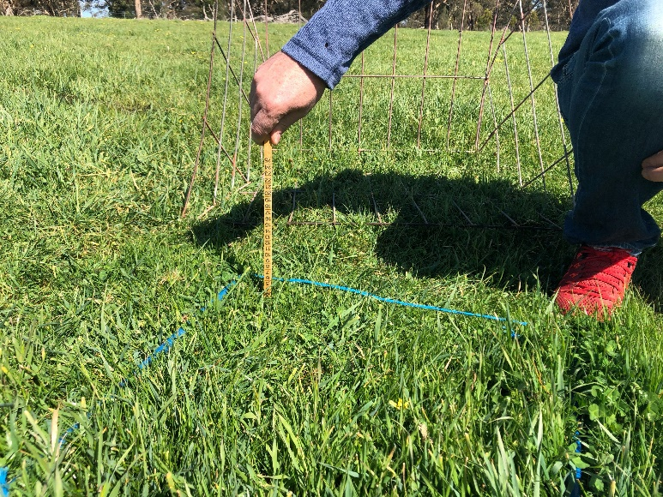
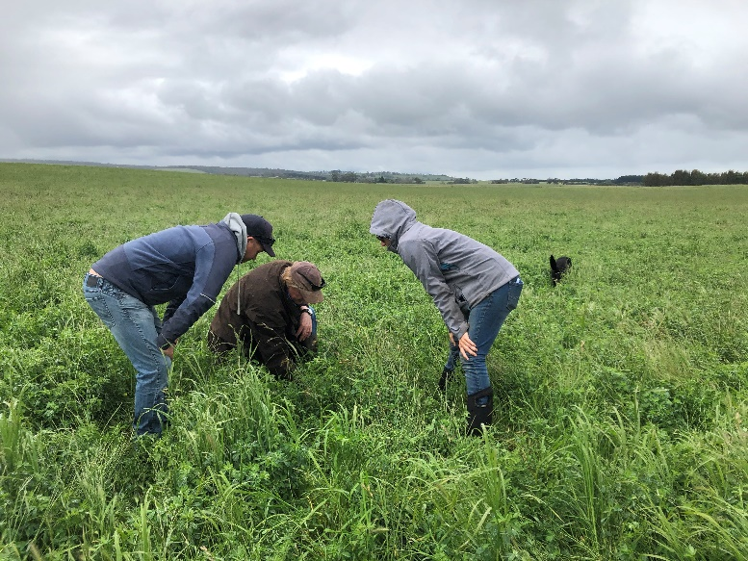

Measuring spring growth near the soil moisture probe

What are we aiming to achieve and why?
This demonstration aims to determine whether soil moisture probes can be used with modelling to make early predictions of spring pasture growth.
Climate projections indicate an increase in the variability – and general shortening – of spring, so reliable pasture predictions could assist producers to make decisions on how best to prepare for the season.
ASKBill and MLA’s rainfall-to-pasture tool are two examples of tools that aim to do this, but they need to be validated and discussed by producers to determine the value and accuracy at a local level.

Cuts are taken to estimate pasture growth

Method
• Modelling predictions of pasture curves for each site by Brendan Cullen at Melbourne University. This includes long-term average annual monthly growth estimates, variability and predictions (e.g. from October) using soil moisture data from the probes.
• Validation of the modelled predictions through monthly cuts to measure pasture growth.
• Discussion with the producer groups involved about the predictions, localised pasture growth and how to use the information to make useful on-farm decisions.

Partners: This demonstration is conducted with Agriculture Victoria and co-funded by Meat & Livestock Australia (MLA).

Contact
Jane Court
E: jane.court@agriculture.vic.gov.au

More information
agriculture.vic.gov.au/agriculture/livestock/on-farm-demonstrations

Disclaimer
Any recommendations, suggestions or opinions contained in this publication do not necessarily represent the policy or views of Meat & Livestock Australia (MLA). No person should act on the basis of the contents of this publication without first obtaining specific, independent professional advice. MLA takes no responsibility, in any way whatsoever, to any person in respect to the document, including any errors or omissions therein, arising through negligence or otherwise however caused.
© Meat & Livestock Australia 2019 ABN 39 081 678 364
This work is copyright. Apart from any use permitted under the Copyright Act 1968, all rights are expressly reserved. Requests for further authorisation should be directed to the Corporate Communications Manager, PO Box 1961, North Sydney, NSW 2059 or info@mla.com.au.
Published in January 2020.

