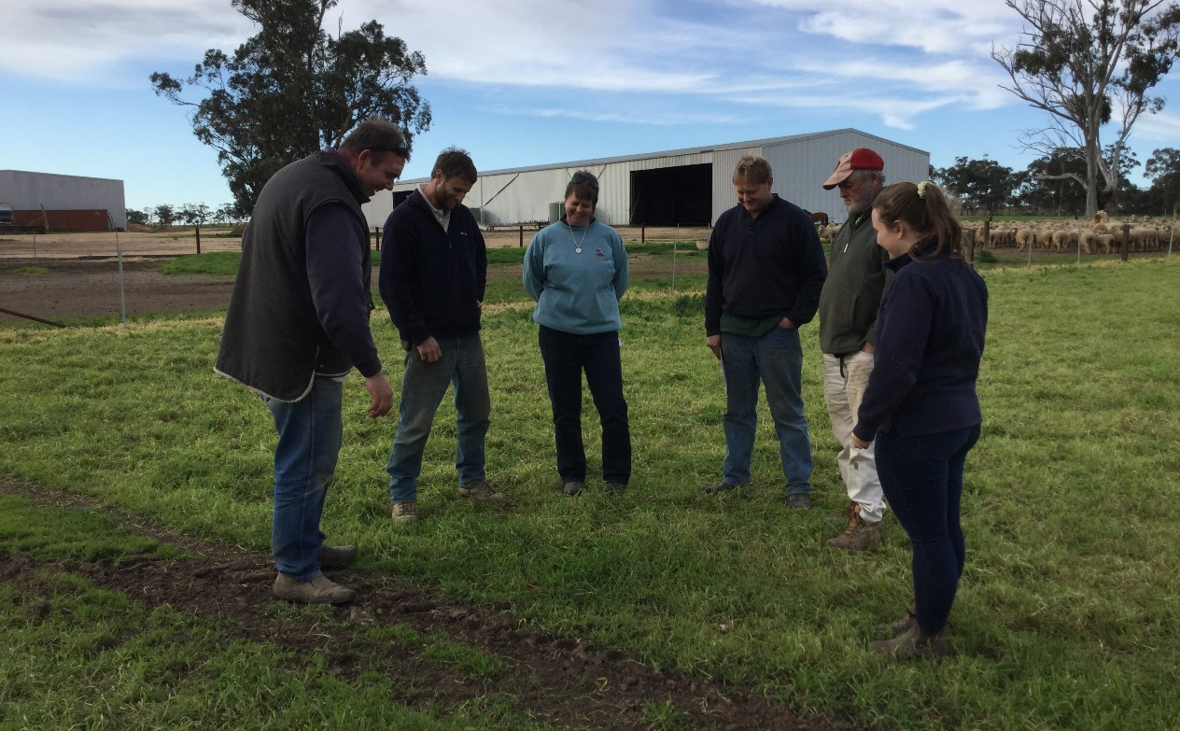
Group members discussing feed on offer, St Arnaud, 2019
Coordinator St Arnaud Group – Dr Steve Cotton
Coordinator Farming Systems Demonstration – Rachel Coombes (Agriculture Victoria)
Group – 19 businesses, with members located in the St Arnaud district
Enterprise mix – Mixed grazing; sheep, beef and cropping
To wean or not to wean
In the Wimmera region of Victoria, autumn-drop prime lambs are commonly marketed as ‘sucker’ lambs and sold unweaned. While many members of the St Arnaud BestWool/BestLamb (BWBL) Group wean their merino lambs at 14 to 16 weeks, very few producers in this region apply these principles to their prime lamb operation.
Producers are often misinformed about the benefits of weaning. The group were keen to explore and weigh up the impact of weaning on dressing percentage and possible setback to lambs, compared to potentially higher liveweights for weaned lambs and the benefits to ewe reproductive efficiency.
In 2019 the group set up an on-farm demonstration, co-funded by Agriculture Victoria and MLA, to evaluate production benefits from weaning prime lambs. The demonstration measures outcomes for both ewes and lambs from weaning at 12 to 14 weeks, compared with unweaned lambs. Both weaned and unweaned lambs are sold when the lambs are normally marketed, at approximately 20 to 28 weeks of age.
The demonstration was undertaken on three host properties in 2019 and will be run on four host properties in both 2020 and 2021. The aim is to enable group members to make informed decisions on whether to wean lambs or sell them directly as ‘suckers’.

Learnings after the first year
In the first year of the demonstration, the sites followed a protocol that suited their enterprise management and compared the growth of weaned lambs (12 weeks from the start of lambing) to unweaned lambs, on similar feed.
The group were interested to observe the weaned lambs from two of the three farms were heavier than the unweaned lambs, and lambs on all three properties did not incur a setback after weaning, which is contradictory to what they were expecting to find. The participants have also seen a major benefit in weaning, in being able to allocate higher quality feed to lambs, while combining mobs of ewes into larger groups to more efficiently utilise pasture.
The producers involved in the trial also expect to see improvements in ewe condition score post weaning (will be measured in year two and three, which ultimately could lead to reduced supplementary feed in early summer and potential improvements in reproductive rates in the subsequent year.
Coinciding with the demonstration, the BWBL group members are taking part in practical sessions on condition scoring, to understand implications on joining success and reproductive outcomes.
Other skills gained through the project include quantifying pasture quantity and quality through visual and subjective assessment, interpreting feed test results, understanding differences in lamb growth rates between early/late and single/twin born lambs.
These outcomes enable the BWBL group to make more informed management decisions post lamb marking and to consider and plan around lamb prices, rainfall and feed budgeting.
The trial will be repeated for a further two years and, when combined with production measurements, will seek to include financial comparisons between weaned and unweaned mobs.
This year the group also plan to take a closer look at the impact of weaning on the ewe, tracking the condition of ewes whose lambs were weaned at 12 weeks and comparing them to ewes with lambs retained through to sale. Where possible, the group will collect abattoir data to compare dressing percentages of weaned and unweaned lambs.
For further information on the demonstration please contact Rachel Coombes, Agriculture Victoria at rachel.coombes@agriculture.vic.gov.au or Steve Cotton, Dynamic Ag at s.cotton@dynamicag.com.au
To find out more about Agriculture Victoria’s on-farm demonstration program visit:
http://agriculture.vic.gov.au/agriculture/livestock/on-farm-demonstrations

