Dairy Farm Monitor Project

2022-23 Northern Victoria performance

Dairying in Northern Victoria
Approximately 805 dairy farm businesses in Northern Victoria produced 1.48 billion litres of milk in 2022-23, accounting for 29% of Victoria’s milk production output and 18% of Australia's milk production.

Physical farm characteristics
The average herd size in Northern Victoria is larger than the other regions and most dairy farms have irrigation infrastructure. Pastures tend to be dominated by annual species and supplementary feeding is higher compared to the other regions.
The average number of cows milked increased slightly, while there was a 6% decrease in milk production per cow. Greater quantities of purchased concentrates were fed with lower quantities of homegrown feed.
2% | 6% | 4%
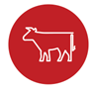
Average herd size  436 cows | Milk solids sold  542 kg MS/cow | Homegrown feed  54% of metabolisable energy consumed

In 2022-23, 28 out of 30 participants recorded a positive return on total assets

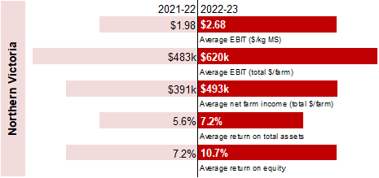

Future expectations 2023-24
Nine-in-ten are optimistic their business returns will improve and 10% expect business returns to remain stable.

Farm profitability was influenced by
31% increase in average milk price to $9.84/kg MS

6% in herd and shed costs to $0.66/kg MS
31% in total feed costs to $4.70/kg MS
15% in overhead costs to $2.93/kg MS.
9% decrease in homegrown feed (pasture grazed plus conserved) due to wet conditions and flood impacts
0.3 t DM/cow increase in average supplements fed (total 5.4 t DM/cow)
3rd highest total costs (variable and overhead) in 17 years of DFM

Return on total assets and milk price

Concerns as reported by farm businesses
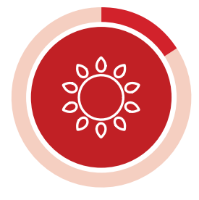 | 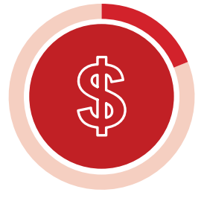 | 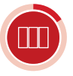
Climate  20% | Input costs  18% | Pasture/fodder  17%

