Shelterbelts and wildlife

Landcare Note LC0139 version June 2023

Introduction
The establishment of shelterbelts is the most common form of revegetation on farms in Victoria. While the primary objective of shelterbelts is to protect farm enterprises from wind, they can also provide significant habitat for wildlife.
Attracting wildlife to a property can add new dimensions to it. The colour, movement and sounds that wildlife create add pleasure and beauty to a property. Wildlife benefits can be added to shelterbelt plantings whether the main goal is to shelter crops, livestock or homes.

BENEFITS OF WILDLIFE
Shelterbelts can be designed to enhance their value as wildlife habitat. Maximising the habitat value of a shelterbelt can provide a number of on-farm benefits. Habitat can include nesting sites, food, shelter, a haven from predators or corridor for migration.
While utilising these resources, many wildlife species will also consume pests such as detrimental insects, rats, mice and rabbits. Studies have shown that many wildlife species consume large volumes of pest insects. Bats, ibis, parrots, robins, fairy wrens, magpies, lizards, bandicoots and sugar gliders are all known to consume a range of insect pests.
Predatory birds, such as hawks, kookaburras and owls consume pests such as mice, rats and rabbits.
This in turn means the landholder costs for pest control should be reduced through time savings and reduced chemical usage.

LOCATION OF SHELTERBELTS FOR WILDLIFE
The design and location of a shelterbelt should be determined by the key objective for the shelterbelt. Measures can be taken to improve the habitat value of a shelterbelt that has been established primarily for productivity purposes. Alternatively a shelterbelt may be established with the primary purpose being to provide habitat for wildlife. The information in this note can be incorporated into the design of shelterbelts established specifically for wildlife or for other purposes.
The location of a shelterbelt requires careful consideration. It is probably best determined through a Whole Farm Planning process. Whole Farm Planning involves the use of an aerial photograph of the whole property to develop a farm plan that takes into consideration those natural characteristics of a property, structures, livestock movement and a range of factors that enable improved farm management.
The location of a shelterbelt to protect livestock should be perpendicular to damaging winds. However ideally shelterbelts for wildlife are best located if they can link or incorporate existing native vegetation, or be placed along waterways or ridgelines (figure 1).
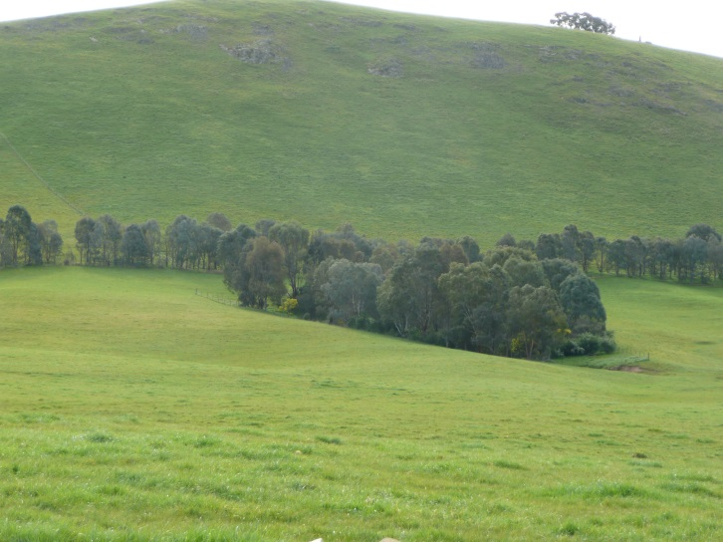

Figure 1. Location of a shelterbelt should give consideration to the landscape and prevailing winds.
The requirements for productivity and wildlife habitat need to be considered. The location of a shelterbelt will be determined by the landholder’s priorities.
Locating a shelterbelt away from areas of disturbance is recommended. Many timid species may be deterred from using a shelterbelt in a busy or noisy location.
Locating a shelterbelt away from disturbed sites can also reduce management issues such as weed invasion.
Connectivity of native vegetation is important to enable species to move along and between patches of vegetation.
A shelterbelt located near a water body will attract more wildlife species. Some species are dependent on a close source of water for drinking, feeding or nest building. Studies have shown that a significantly larger range of species occupies vegetation near water bodies. Locating vegetation near a water body can offer additional benefits such as bank stabilisation and improved water quality.
Incorporating large old trees into shelterbelts can increase the habitat value of shelterbelts significantly (figure 2). Old trees provide hollows, a greater range of food and produce larger quantities of nectar, over longer periods of time and more reliably than younger trees.
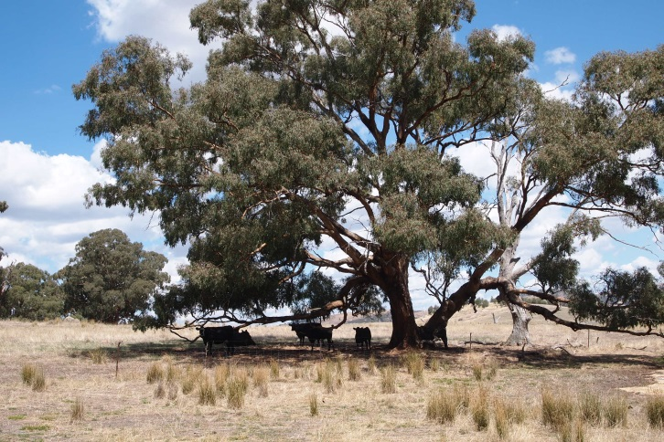

Figure 2. Large old trees provide habitat when incorporated in to new shelterbelts.
One third of mammal species and one-third of land bird species rely on the hollows provided by mature trees for their survival. Owls, possums, bats and a range of birds use hollows for shelter and nesting.
Hollows generally do not begin to appear in Eucalypt trees until they are 100 years old. Some species are dependent on trees of 200 years of age to provide hollows large enough for them to utilise.

ENHANCEMENT TECHNIQUES
Techniques to enhance the habitat value of shelterbelts without compromising their effectiveness include establishing locally native species, creating vegetative layers within the shelterbelt, using a mix of species, providing ground layer components and a mix of age classes of plants.
Other features that can enhance shelterbelts for habitat include:
- The wider a shelterbelt is, the higher the value it provides as habitat and the less susceptible it will be to detrimental 'edge effects'.
- One large wide shelterbelt will provide greater benefits for wildlife than narrow shelterbelts of the same area.
- Larger areas of vegetation will support a larger diversity of species as well as larger populations of wildlife.
- Wider shelterbelts will also provide a greater 'core' area (area away from the edge) which is utilised by particular species because they will be less disturbed and are less susceptible to predation.

Select locally native species
The use of locally native species has many advantages. These include:
- Planting locally native species propagated from locally collected seed maintains the genetics of plants in the area.
- Locally native species have adapted to the conditions of an area over thousands of years. This generally makes them easier to establish and more likely to survive.
- It is more likely through establishing locally native species that natural ecosystem processes will be restored.
- Locally native plants are more likely to regenerate naturally or following fire.
- Natural regeneration not only enhances the habitat value of a shelterbelt, it also provides self-perpetuating shelter.
Another component to consider in species selection is the matching of species to landform. Different plant species and communities occur on different landforms such as drainage lines, hills and gullies.
Identifying the appropriate species and landform can be undertaken by noting remnant vegetation in the surrounding area. Remnant vegetation can usually be observed along roadsides and in reserves.
Advice on species selection can be obtained by contacting your local Agricultural Victoria office.

Structure
Establishing natural layers within a shelterbelt replicates a natural plant community and provides a range of resources and conditions for various species.
Establishing trees, shrubs and ground cover species is more likely to attract a variety of species. Superb fairy wrens, scrub wrens, red-browed finches, yellow robins and other small birds use dense, or prickly shrubs for nesting and feeding because they provide protection from predators.
Vegetative layers can also be created by establishing vegetation over a period of time or incorporating existing vegetation into a shelterbelt. Plants at different stages of development provide different resources and therefore habitat for a greater variety of species.
Placing nest boxes within a shelterbelt can provide a resource that old trees would normally provide. However it is important to monitor nest boxes to ensure they are not used by introduced species.
Many birds such as parrots and owls as well as gliders, possums and bats have been known to use nest boxes.
Planting a range of species has a similar effect to establishing layers. By planting a range of plant species more wildlife species can utilise the habitat as different plant species provide different resources and at different times. Establishing a mix of species creates habitat for a mix of wildlife. Incorporating a range of species will also provide a more reliable food supply.
Randomly or irregularly planting species within a shelterbelt can improve wildlife habitat. Mixing species and sizes creates different habitat types. This needs to be balanced with considerations of the density of a shelterbelt. Uniform density from the top of a shelterbelt to the ground level usually maximises the effectiveness of a break in sheltering a productive area.
Ground layer components within a shelterbelt can greatly enhance its habitat value. Logs, leaf litter, mosses, grasses and rocks provide valuable habitat for small animals and birds and play a role in ecosystem processes. Fallen branches and litter from the established vegetation should be left within the shelterbelt. Small animals such as lizards, small mammals and frogs utilise ground components.

MANAGEMENT
Shelterbelts need to be managed to maintain their effectiveness in providing shelter and also to maintain the level of habitat they provide.
Management activities may include:
- pest animal and weed control
- fence maintenance
- fuel reduction burning as part of fire prevention.
Weeds can significantly reduce the effectiveness of a shelterbelt and degrade habitat quality. Strategic grazing, herbicide application or possibly burning can be used to control weeds.
Rabbits can degrade the habitat value of a shelterbelt by grazing and eliminating understorey species. Foxes and feral cats should be controlled. They will predate on wildlife within a shelterbelt. Studies have shown that nest predation in linear strips of vegetation is almost double that of large areas of remnant vegetation.
An integrated control program for pest animals should be undertaken over the whole property and more broadly if possible.
Shelterbelt fences need to be maintained to a livestock proof standard. If livestock can access the vegetation within a shelterbelt they can significantly reduce the effectiveness of the shelterbelt in terms of shelter and habitat values.
For further information on shelterbelt management see Landcare Note LC0137 Shelterbelt Management.

CONCLUSION
Through consideration and planning shelterbelts can provide significant habitat for local wildlife while also providing productivity benefits for a property. Many of the design principles for enhancing shelterbelts to provide habitat do not involve extra expense. Appropriate plant species selection and variety are important elements.
Locating shelterbelts to link or incorporate existing vegetation, close to water bodies and away from disturbance can significantly increase the value of the habitat they provide. Wider shelterbelts that include a range of local plant species will provide habitat for a larger range of wildlife species.
Once a shelterbelt has been established some maintenance is required, however the benefits for the property and local wildlife can be appreciated for a very long time.

FURTHER READING
Burke, S. (1998) Windbreaks. Inkata Press, Sydney
Platt, S.J. (2002) How to Plan Wildlife Landscapes: a guide for community organisations. Department of Natural Resources and Environment, Melbourne.
Shelterbelt design: https://agriculture.vic.gov.au/farm-management/soil/erosion/effective-shelterbelt-design
Shelterbelt Management: https://agriculture.vic.gov.au/farm-management/soil/erosion/shelterbelt-maintenance-and-management
Shelterbelts for control of wind erosion: https://agriculture.vic.gov.au/farm-management/soil/erosion/shelterbelts-for-control-of-wind-erosion

FURTHER INFORMATION
For more information contact your local Agriculture Services Extension Officer or call the customer service centre on 136 186.

ACKNOWLEDGEMENTS
This document was originally developed as a Landcare note Stephen Platt, January 2003.
It was reviewed by Hayley Malloy, Farm Services Victoria. October 2009.
Updated March 2017.
It was reviewed and updated by Kylie Macreadie, Agriculture Services. June 2023.
ISSN 1329-833X

Disclaimer
This content is provided for information purposes only. No claim is made as to its accuracy or authenticity. Information, data and advice is provided on the basis that readers undertake responsibility for assessing the relevance and accuracy of its content.

The Department of Energy, Environment and Climate Action and as owner of this content on behalf of the Victorian Government, makes no representations, either expressed or implied, as to the suitability of anything in this document for any particular purpose.

We do not accept any liability to any person for the information, data or advice (or the use of such information, data or advice) which is provided on or incorporated into it by reference.

Copyright
We encourage the sharing and re-use of information provided. The State of Victoria owns the copyright in all material produced by the Department of Energy, Environment and Climate Action.

All material provided in this document is provided under a Creative Commons Attribution 4.0 international licence, except:
- any images, photographs or branding, including the Victorian Coat of Arms, the Victorian Government logo and the Department of Energy, Environment and Climate Action; and
- content supplied by third parties.
Read the full licence here: https://creativecommons.org/licenses/by/4.0/

