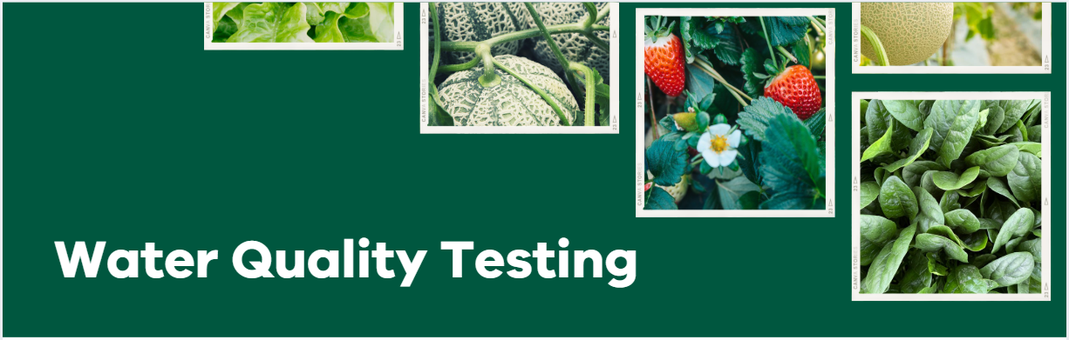

Undertaking water quality testing in horticulture for improved food safety.

Where to get water samples tested in Victoria:
Use a National Association of Testing Authorities (NATA) accredited laboratory and keep records of all tests and results.
Producers can search for a suitable nearby lab using the NATA webpage: https://nata.com.au/find-organisation/.
Use the search term “Analysis for microorganisms fresh waters” and your location to locate a service.

Sampling request:
The key test to request is Escherichia coli (E. coli) expressed as colony-forming units in 100ml (cfu/100ml).
Ask the lab about their recommend sampling protocol, and if they can provide sterile sampling bottles and sample submission paperwork.

Sampling costs:
While every lab is different, as a guide the average cost of a test is $100 - $150 for generic E.coli testing. If testing for additional pathogens (see sampling tips) is requested, cost will increase.

Sampling tips:
E. coli is the most common thermotolerant coliform bacteria and is a reliable indicator of microbial contamination of water.

Water for testing should always be sampled at the point of use after allowing the water to run for a minute or two.

Water samples should be delivered for testing within 24hrs of collection and should be kept cool after collection and during transportation to the laboratory.

If the risk of surface water contamination is high, for example due to proximity to livestock and wildlife, testing for additional foodborne pathogens (e.g. Salmonella species, Listeria monocytogenes and Shiga toxigenic E. coli) may be required to ensure water is safe for use.

For more information and to understand your results:
- Fresh Produce Safety Centre - Food Safety Helpdesk and Managing Water Guideline
- NSW DPIRD - Melon Food Safety Best Practice Guide
- Hort Innovation - Reducing risk from pre-harvest water
- AUSVEG - Safe Leafy Vegetable Project

