Disposing of carcasses after a bushfire, flood or drought

Information sheet – updated April 2026

A bushfire, flood and drought can result in carcasses (bodies of deceased animals) that need to be disposed of.
There are several options outlined below for livestock producers for the removal and disposal of carcasses.
Please note this information does not include the removal and burial of animals affected by an emergency animal disease (EAD).

How to dispose of deceased animals
The landholder is responsible for the disposal of deceased livestock as part of on-property recovery.
Options for the disposal of animal carcasses include:
- knackeries and rendering facilities
- licensed landfills
- on-farm disposal.
Agriculture Victoria supports landholders with guidance, information and technical advice – visit https://agriculture.vic.gov.au/biosecurity/animal-diseases/emergency-animal-diseases/guidance-for-on-farm-burial-of-carcasses-in-an-emergency-animal-disease-outbreak#h2-2
For guidance on managing farm waste, including disposing of deceased livestock, see EPA’s Manage farm waste page. Call EPA on 1300 372 842 for advice.

EPA publications
For managing routine livestock mortalities see https://www.epa.vic.gov.au/about-epa/publications/iwrg641-1.
For more information on carcass disposal after bushfires see the EPA fact sheet: https://www.epa.vic.gov.au/composting-mortalities-farms.

Disposal options

On-farm

Burial
On-farm burial is the most common method of carcass disposal following bushfire, flood or drought events. It is quick, effective and relatively cheaper than other options. However, the environment, environment protection regulations, logistics and safety need to be considered before initiating burial, particularly if it is significant.

Covering with mulch
If burial is not possible, covering the carcasses with a thick layer of mulch can help to reduce odour and the visual impact of the animals. This is a short-term solution which provides time to arrange proper disposal but it will not necessarily create a fully composted material.

Composting

Composting deceased livestock with mulch or green waste is a beneficial process that breaks down the carcasses into a useful product. It’s important to realise that composting is an active process, not a set-and-forget method.

Information on how to compost safely can be found on the Agriculture Victoria website at Compost and farm biosecurity | Composting | Soil | Farm management | Agriculture Victoria.

Detailed information about composting dead stock can be found in the EPA’s Composting mortalities on farm guidance at Composting mortalities on farms | epa.vic.gov.au.

Knackery
Knackeries provide an efficient means of disposing of deceased, unsaleable or suffering livestock. Carcasses can be processed for:
- fresh meat
- saleable hide
- offal.
For commercial reasons, knackeries prefer to process larger animals such as cattle and horses. Knackeries may pick up sheep carcasses, but this is usually as a service and generally only in small numbers.
It is unlikely that knackeries will accept moderate to severely burnt livestock.

Rendering
Rendering is an effective method of converting animal carcasses into saleable products such as meat, bone meal, and tallow. Rendering plants are located throughout Victoria and some have the capacity to process large volumes of animal material.
The practicality of using rendering as a disposal method may be limited by:
- rendering companies' willingness to receive product
- suitability of product (such as degree of burns, decomposition, emaciated stock, amount of wool)
- plant capacity
- cost of transport.

Licensed landfill
Disposing of carcasses to licensed landfills is an acceptable and effective option for agricultural emergencies.
The advantage of landfill is that it may already be licensed to accept animal materials (putrescible waste) and generally has the existing infrastructure to manage long-term containment issues (such as leachate, gas, security).
Another advantage of landfills is that many sites are owned by local government and may already be identified as potential disposal sites under Municipal Emergency Management Plans.

Plan your on-farm burial
When planning for on-farm burial there are many factors that must be considered. These include:
- the environment
- environment protection regulations
- logistics
- safety.
To reduce any impact on the environment (e.g. contamination of ground or surface water), a burial site should be located:
- at least 200 m from any groundwater supply (stock and domestic bore)
- at least 2 m above the water table level (measured from the bottom of the pit)
- at least 200 m from any surface water (creek, river, lake or spring), excluding dams that are not seeping into groundwater or flowing offsite
- away from surface water drainage features, low points or areas at risk of erosion
- on clay soil of low permeability and good stability
- away from underground and above-ground infrastructure (such as powerlines, telephone and fibre optic lines, gas lines, waterpipes or sewerage)
- above the one in 100-year flood level
- at least 200 m from another burial area
- on elevated land but with a slope of less than 5% (preferably less than 2%)
- away from conservation areas and areas of cultural sensitivity
- at least 20 0m from the boundary of neighbouring privately owned land
- at least 300 m from any sensitive use (such as a neighbouring house)
- out of view of the public (by either being far away from public areas or by screening).
Operators should also:
- cover carcasses with at least one metre of soil
- slightly mound pits after backfilling to allow for subsidence and promote runoff rather than infiltration
- where necessary, excavate cut-off drains upslope of the burial pits to direct surface run-off away from the pits
- where possible, plan destruction activities close to burial site
- have good, safe access to site for machinery.
Other important factors that must be considered are:
- monitoring programs (if required by EPA)
- leachate and gas management (if required by EPA)
- use of synthetic liners in pits (if required by EPA)
- native flora and fauna planning controls, heritage overlays, native title and covenants.
Final site selection usually involves the agreed best outcome after consultation with relevant agencies and a risk assessment of all factors.

Burial site requirements

Assessment
A large potential burial site should be assessed for suitability by an EPA representative to minimise its potential environmental impact. In a bushfire response an on-site assessment may not be practical. Provide the EPA the property address, number and type of livestock (e.g. sheep or cattle), and the proposed burial pit location. The location of each disposal site should be recorded for future reference using a global positioning system (GPS) and/or a drawn on a farm map.
The Navigating Farm Development Tool (https://developments.agriculture.vic.gov.au/NFD/index) can assist you to determine a suitable burial pit location in line with the burial criteria. Although this tool is designed for an emergency animal disease event, the burial criteria is the same for bushfire, flood and drought.

Preparation
Animal carcasses should be moved to the intended burial site as soon as possible. A front-end loader and bucket is suitable for moving sheep and similar-sized animals. Large animals (horses, bulls) are more readily moved with a 4-tyne hay fork or silage grab attachment if available.

Pit construction
Construct a deep, narrow, vertically sided pit. This is called trench burial. It is suitable for stable soil.
If soil stability is of concern, use a battered pit design to enhance operator safety. WorkSafe Victoria (https://www.worksafe.vic.gov.au/) can provide information on safety precautions for emergency trenching operations.
The preferred equipment for constructing this type of pit is an excavator. During construction, topsoil should be separated from subsoil for later return to the top during pit closure. Excavated material should be stored along one side or at the ends of the pit, depending on the operation. Surplus soil should be heaped as overfill.

Pit dimensions
Consider the method used to fill the pit with carcasses. Typically, they will be unloaded (out of tip trucks) and then pushed into the pit (loader, bulldozer or excavator) from one of the long sides.
It is critical to establish a safe operating zone as part of a documented work procedure, especially if other machines such as front-end loaders are being used. Excavators can be a good option to fill pits with carcasses, especially where soil stability may be an issue.
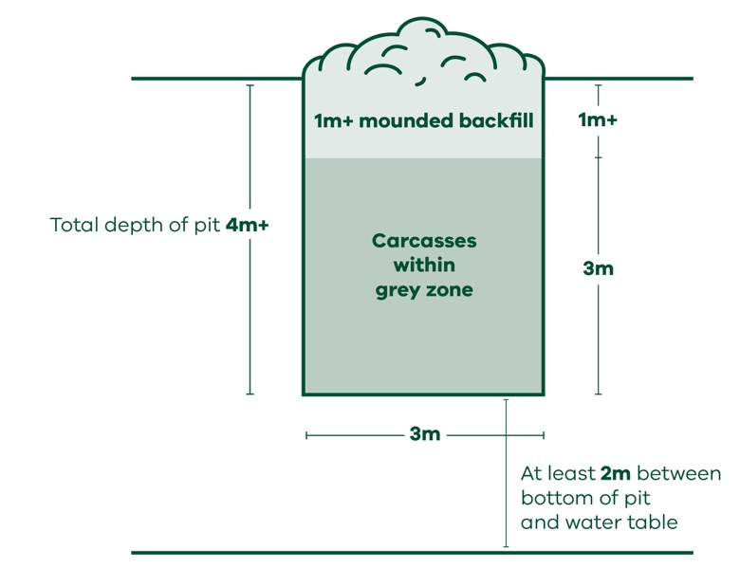  Figure 1: Traditional Trench Style Burial Pit | 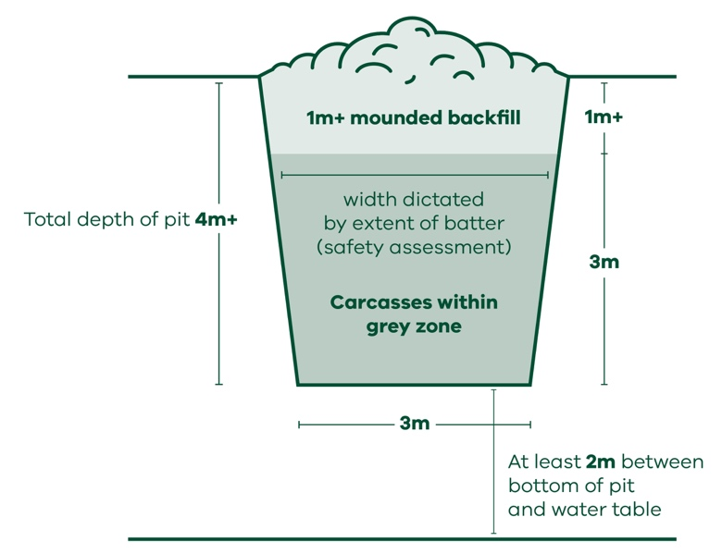  Figure 2: Battered Burial Pit
Use the following dimensions as a guide to on-farm trench burial:
- Depth – 4 m to 5 m (depending on reach of machinery, soil stability and depth to water table). Base of pit to be at least 2 m above water table level.
- Width – not greater than 3 m wide (to allow for even spread of animals in the pit).
- Length – depends on the number and size of carcasses to be buried (volume).
- Backfill – at least 1 m of soil to cover deceased livestock.
- Volume – will vary according to the number and size of animals.

Volume requirements
Previous experience has shown that approximately 10 adult sheep in poor condition and with limited wool will take up one cubic metre of pit space (North-East Region Flock Reduction Scheme). A 156 m³ pit (3 m wide x 13 m long x 4 m deep) will be sufficient to bury 22 beef cattle with 1.8 m of soil cover (Longwood fire 2026).
As a guide, allow 1.5 m³ of pit space for one adult beast or 5 adult sheep in good condition (AUSVETPLAN Disposal Manual, 2015).

Slashing
The slashing of the abdomens of carcasses before burial (to reduce the build-up of gas) is not recommended for sheep or other small animals, or badly decomposed cattle.
For freshly deceased cattle, a risk assessment should be conducted to determine if the benefits of slashing outweigh the safety risks to the operator. Machinery may be used to puncture the abdomens of cattle to reduce manual handling risks.

Personal (worker) safety
Disposing deceased livestock carries risks to human health.
Animal carcasses will putrefy rapidly during hot weather. Contact with body fluids may be unavoidable. Take all reasonable efforts to protect yourself from the inhalation of dust/ash or other aerosols. Be aware when Q fever infection may be a risk. Before commencing disposal activities:
- wear protective clothing (gloves, boots, eye protection)
- wear a mask (P2 particulate respirator)
- minimise exposed skin and ensure broken skin/cuts are clean and covered
- handle carcasses as little as possible
- wash hands with soap and clean water after contact with deceased animals.
- safety of staff and contractors must always be considered. Precautions include:
- having a minimum of 2 people at the pit site.
- maintaining a safe working distance from the pit edge.
- allowing no persons to enter the pit.
- ensuring rescue items such as ropes are available in case of collapsing walls or if a person falls into the pit.
- using appropriate personal protective equipment (PPE), such as gloves, overalls and dust masks.
- assessing every manual handling task – use mechanical aids where possible.
- briefing all personnel on the site operations and on the safety plan.
In some instances, worker illness, injury or accident events may be classified as a notifiable incident to the safety regulator WorkSafe Victoria (https://www.worksafe.vic.gov.au/).

More information
For more information contact the Customer Contact Centre on 136 186.

© The State of Victoria Department of Energy, Environment and Climate Action January 2026.

