Demonstration goal: To provide producers with a greater understanding of factors that affect and impact on the survival of lambs during gestation, birth and post-birth. This project will focus on recommended practices regarding the condition of ewes at lambing, mob size, the use of shelter in lambing paddocks and minimising disturbance and demonstrate their impact on lamb survival.
Site location: South-west Victoria
Producer group: Western Plains BestWool/BestLamb Group
Group coordinator: Andrew Kennedy
Agriculture Victoria coordinator: Cathy Mulligan
Duration: 2018–2021

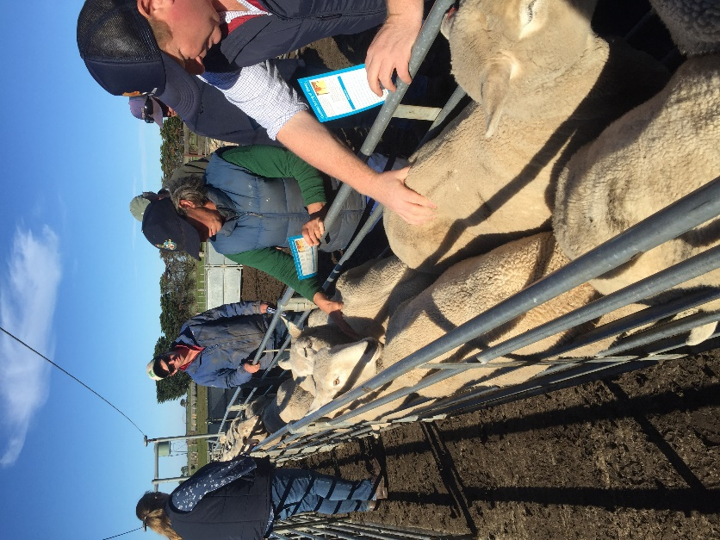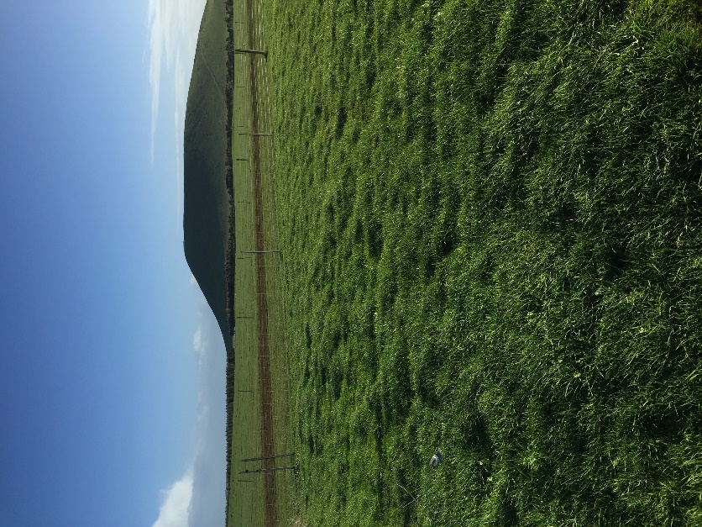
Condition scoring ewes for the demonstration

What are we aiming to achieve and why?
Lamb mortalities represent a major source of reproductive loss across Australia. In 2016, the Western Plains BWBL group experienced a challenging lambing year, mainly due to weather, and experienced higher losses of foetuses than usual. This event was the precursor to the demonstration.
Paddock prior to mob size demonstration

Although many group members follow best lambing practice, there are several management strategies that the group wished to investigate to potentially improve lamb survival and marking rates.
This project aims to demonstrate lamb survival increases by implementing various management practices that are achievable and accepted by sheep producers.
The aim is to lift lamb survival rates by 5–7% through the influence of paddock size, mob size, stocking rate, ewe condition, shelter and disturbance at lambing.
Method
Four demonstration sites are operated on different properties each year.
These are:
Demonstration 1: The impact of ewe condition on lamb survival
Demonstration 2: The impact of stocking rate and mob size on lamb survival
Demonstration 3: The impact of paddock shelter on lamb survival
Demonstration 4: The impact of disturbance around the lambing paddock on lamb survival.

Partners
This demonstration is conducted with Agriculture Victoria and co-funded by Meat & Livestock Australia (MLA).
Contacts
Cathy Mulligan
E: cathy.mulligan@agriculture.vic.gov.au
Andrew Kennedy
E: andrew@thriveagriservices.com.au

More information

https://agriculture.vic.gov.au/support-and-resources/funds-grants-programs/farming-systems-demonstrations-program

Disclaimer
Any recommendations, suggestions or opinions contained in this publication do not necessarily represent the policy or views of Meat & Livestock Australia (MLA). No person should act on the basis of the contents of this publication without first obtaining specific, independent professional advice. MLA takes no responsibility, in any way whatsoever, to any person in respect to the document, including any errors or omissions therein, arising through negligence or otherwise however caused.
© Meat & Livestock Australia 2019 ABN 39 081 678 364
This work is copyright. Apart from any use permitted under the Copyright Act 1968, all rights are expressly reserved. Requests for further authorisation should be directed to the Corporate Communications Manager, PO Box 1961, North Sydney, NSW 2059 or info@mla.com.au.
Published in January 2020.

