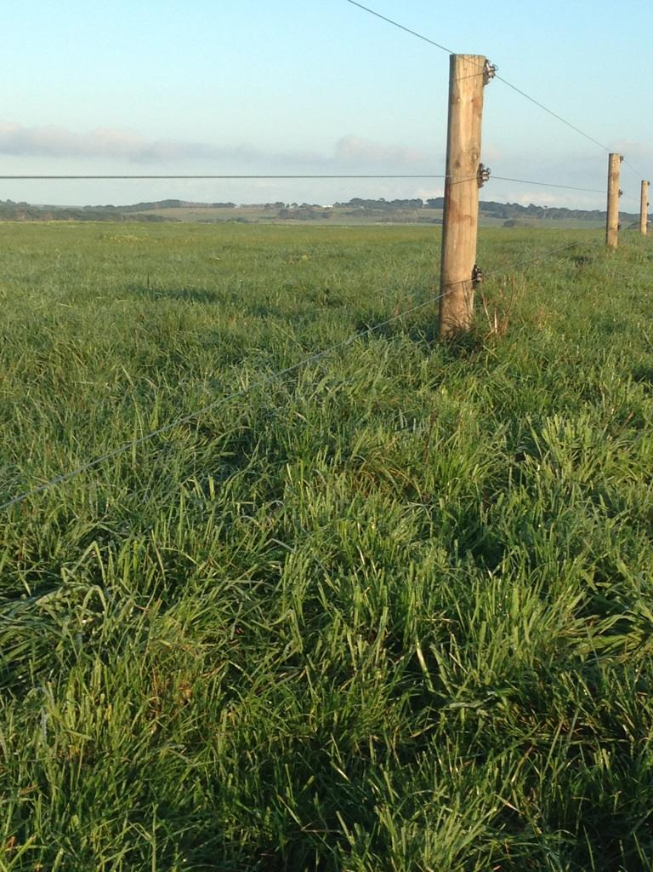
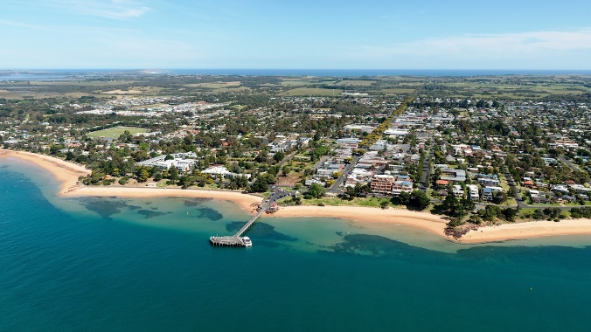
Coordinator – John Gallienne
Group – Phillip Island,SE Victoria
Enterprise Mix: Predominantly breeders, finishers with some store cattle sales.

Phillip Island BetterBeef Group
The Phillip Island BetterBeef group is a long-running group with a focus on topics that increase the production, profitability and sustainability of their enterprises. There is trust among group members coupled with a preparedness to openly discuss issues in a positive manner that always remains confidential within the group.
The climate of Phillip Island (long term average annual rainfall of 725mm) allows for high stocking rates (20-30 DSE/ha) and turning off prime pasture-fed beef cattle.
Group member Bill Cleeland said “every meeting I learn something new”. Another member, Tracey Jeffery said she likes being able to discuss seasonal conditions within the group, and how others are coping as “we are all experiencing the same conditions given the proximity of our farms”.
Seasonal conditions on Phillip Island during this year have been close to average, but with shallow free-draining topsoils on the island it is always at risk of drying out prematurely. “The district can get rain over summer which may lengthen the season, although that can also dry out quickly, too,” Bill said.
Tracey Jeffery sowed annual ryegrass alone, as well as annual rye grass plus clover last autumn. This has yielded three grazings plus a good early silage yield so far. This silage is crucial for feeding to the stock over the summer period, as they wean their calves onto silage.
They have also grown oats in the past for ensiling, but have moved back to annual pastures this year, due to the pre-cropping grazing which increases utilisation. Tracey and her husband also do off-farm contracting (including silage). This year they have passed part of the agricultural contracting business over to their son. Their off farm business complements the 160-cow breeding herd.
Bill Cleeland has been farming on the island since 1978 and has seen a lot of change on the island. Bill highlighted the long-range forecasts from the Bureau of Meteorology and how this service has helped decision making and planning for summer. He aims to have all his weaners sold before Christmas to avoid overstocking in the summer period.
Bill’s farm has beach frontage with a beautiful and unique aspect. But it is basically a long narrow shape beside a major highway. Given the location of his farm with close proximity to tourist hotspots and residential development, urban encroachment is becoming an issue. His concern is the duplication of the highway which may impact the viability of the farming enterprise. He is also bordered by a housing estate and a vineyard.
The increase in visitors and permanent residents on Phillip Island has hidden impacts on group members; for example, it is difficult to schedule trucks at times due to very heavy traffic flows.
During a recent BetterBeef meeting, discussion arose about the population of Cape Barren Geese (CBG). From this, further discussion took place as pieces of information and ideas developed. It became clear that there is little information available in Australia or overseas relating to how to deal with this type of problem in a beef/sheep grazing enterprise.
It is estimated that the population of CBG on Phillip Island is now at 3000.
Locally these birds create a problem because of the pasture and crops they consume. In addition, the amount of fouling on plant material causes it to become unpalatable for stock.
A turning point with the population growth of CBG was the successful fox control program on Phillip Island that led to the complete elimination of foxes. The fox control program was initiated by Phillip Island Nature Parks because the foxes were killing penguins; a major local and international tourist attraction. Since their elimination it has become clear that the foxes were also partly controlling the CBG population through feeding on chicks and eggs.
Since then, CBG numbers have increased with the result that local farmers have been unable to successfully grow crops and paddock rotations are problematic. Previously, many farmers would grow field peas, lucerne, turnips, rape, mustard and millet to feed livestock and improve soil quality. Historically fodder crops have cost effectively fed stock to a saleable condition to meet market specifications for the December – early March period.
As a result of BetterBeef member enquiries a collaborative research project involving the Phillip Island Nature Parks and Federation University was started.
The research project is on one of the group member’s farm.
Key Findings to date:
- One Cape Barren Goose consumes the same amount of pasture as one sheep.
- Wildlife grazing significantly decreased the yield of fodder crops by 40–65 per cent in spring and by 50–100 per cent in summer.
- Costs to farmers caused by wildlife grazing fodder crops was estimated to be ~$2,250/ha.
- Ninety-nine per cent of the wildlife that visited forage crops were Cape Barren Geese (camera image analysis).
- Eighty-seven per cent of the grazing occurred during daylight hours.
- The next phase of the research project has just started – it is investigating microbes, pathogens and parasites present in the faeces of Cape Barren Geese.

