Dairy Farm
Monitor Project
Victoria │Annual Report
2020-21

Acknowledgements

The participant farmers and data collectors are gratefully thanked for their efforts in supplying and collecting data for the Dairy Farm Monitor Project in 2021. A hybrid of face-to-face and remote data collection required additional efforts and is greatly appreciated. For continuing participants and those new to the project, thank you for your participation.
The diligent work of Agriculture Victoria, Dairy Services staff who prepared the report; Natalie Nelson and Olive Montecillo, and those who gathered the final performance data are deserving of thanks, especially Michele Jolliffe, David Shambrook, and Sarah Clack. Thanks to Julie Harman, Nick Tsaktsiras and Terry Batey for providing a thorough review of the report.
The contributions of D-ARM Consulting, Farmanco, Paul Groves Farm Management Consultant, Agribusiness Consulting, Murray Dairy and F. Smith Agribusiness Consulting are thanked. These contributions, in addition to the Agriculture Victoria staff, provided the collection of data, feedback and validation to ensure its accuracy.
Thank you to Brett Mitchard from Agriculture Victoria for creating the map used in this publication.
Many photos in this report are subject to copyright and provided by Craig Dyson and Lauren Nelson.
This report has been produced in conjunction with Dairy Australia.
Further information regarding the Dairy Farm Monitor Project may be obtained from:

Claire Waterman
Agriculture Victoria
PO Box 3100, Bendigo DC, Victoria 3400
Telephone: 0408 785 368
claire.waterman@agriculture.vic.gov.au

To find out the latest information on the project visit the project websitewww.agriculture.vic.gov.au/dairy.

Authorised by the Victorian Government
Department of Jobs, Precincts and Regions
1 Spring Street Melbourne Victoria 3000
Telephone (03) 9651 9999
© Copyright State of Victoria,
Department of Jobs, Precincts and Regions 2021
Except for any logos, emblems, trademarks, artwork, and photography this document is made available under the terms of the Creative Commons Attribution 3.0 Australia license.
This document is also available in an accessible format at agriculture.vic.gov.au

ISSN 1835-9922
Print managed by Finsbury Green.
Disclaimer
This publication may be of assistance to you, but the State of Victoria and its employees do not guarantee that the publication is without flaw of any kind or is wholly appropriate for your particular purposes and therefore disclaims all liability for any error, loss or other consequence which may arise from you relying on any information in this publication.

Accessibility
If you would like to receive this publication in an accessible format, please telephone the department’s Customer Service Centre on 1300 502 656.
This document is also available in PDF and Word format at www.agriculture.vic.gov.au/dairyfarmmonitor
or PDF format at
www.dairyaustralia.com.au/dairyfarmmonitor

Contents
Acknowledgements 2
How to read this report 5
What’s new in 2020-21 6
I. Summary 7
II. DFMP method 9
Dairy Farm Monitor Project method 10
Part One: Statewide overview 12
Statewide overview 13
Whole farm analysis 15
Physical measures 19
Part Two: The North 22
Whole Farm Analysis 25
Feed consumption and fertiliser 32
Part Three: The South West 34
Whole Farm Analysis 36
Feed consumption and fertiliser 42
Part Four: Gippsland 44
Whole Farm Analysis 46
Feed consumption and fertiliser 53
Part Five: Business Confidence Survey 56
Expectations for business profit 57
Part Six: Greenhouse Gas Emissions 62
2020-21 Greenhouse gas emissions 63
Part Seven: Historical analysis 64
Historical analysis 65
Appendices 69
Appendix A: Statewide summary tables 70
Appendix B: North summary tables 78
Appendix C: South West summary tables 95
Appendix D: Gippsland summary tables 111
Appendix E: Glossary of terms, abbreviations and standard value 126

List of Figures

Figure 1. Dairy Farm Monitor profit map - State average data 2020-21
Figure 2. Distribution of participant farms in 2020-21 across Victoria
Figure 3. Monthly rainfall 2020-21
Figure 4. Average EBIT
Figure 5. Distribution of farms by ROTA
Figure 6. Distribution of farms by ROE
Figure 7. Sources of whole farm metabolisable energy
Figure 8. Estimated tonnes of homegrown feed removed
Figure 9. Nutrient application
Figure 10. Monthly distribution of milk sold
Figure 11. Monthly distribution of calving
Figure 12. Annual rainfall and long-term average rainfall – North
Figure 13. Milk solids sold – North
Figure 14. Gross farm income – North
Figure 15. Variable and overhead costs – North
Figure 16. EBIT – North
Figure 17. ROTA – North
Figure 18. ROE – North
Figure 19. Sources of whole farm metabolisable energy – North
Figure 20. Estimated tonnes of homegrown feed removed – North
Figure 21. Nutrient application – North
Figure 22. Annual rainfall and long-term average rainfall – South West
Figure 23. Milk solids sold – South West
Figure 24. Gross farm income – South West
Figure 25. Variable and overhead costs – South West
Figure 26. EBIT - South West
Figure 27. ROTA - South West
Figure 28. ROE - South West
Figure 29. Sources of whole farm metabolisable energy – South West
Figure 30. Estimated tonnes of homegrown feed removed – South West
Figure 31. Nutrient application – South West
Figure 32. Annual rainfall and long-term average rainfall – Gippsland
Figure 33. Milk solids sold – Gippsland
Figure 34. Gross farm income – Gippsland
Figure 35. Variable and overhead costs – Gippsland
Figure 36. EBIT – Gippsland
Figure 37. ROTA – Gippsland
Figure 38. ROE – Gippsland
Figure 39. Sources of whole farm metabolisable energy – Gippsland
Figure 40. Estimated tonnes of homegrown feed removed – Gippsland
Figure 41. Nutrient application – Gippsland
Figure 42. Expected change to farm business profit in 2021-22
Figure 43. Producer expectations of milk prices and production in 2021-22
Figure 44. Producer expectations of fodder production in 2021-22
Figure 45. Producer expectations of costs for the dairy industry in 2021-22
Figure 46. Major issues for individual businesses – 12-month outlook
Figure 47. Major issues for individual businesses – 5-year outlook
Figure 48. Estimated 2020-21 average greenhouse gas emissions intensity (CO₂ equivalent)
Figure 49. Estimated 2020-21 average gross GHG emissions between 2017-18 and 2020-21 (CO₂ equivalent)
Figure 50. Farm profitability (real $) between 2006-07 and 2020-21 – North
Figure 51. Whole farm performance between 2006-07 and 2020-21 – North
Figure 52. Farm profitability (real $) between 2006-07 and 2020-21 – South West
Figure 53. Whole farm performance between 2006-07 and 2020-21 – South West
Figure 54. Farm profitability (real $) between 2006-07 and 2020-21 – Gippsland
Figure 55. Whole farm performance between 2006-07 and 2020-21 – Gippsland

List of Tables

Table 1. Average farm physical data –State overview 2020-21
Table 2. Average farm financial performance - Statewide
Table 3. Risk indicators
Table 4. Farm physical data – North
Table 5. Average farm financial performance – North
Table 6. Cost of production – North
Table 7. Farm physical data – South West
Table 8. Average farm financial performance – South West
Table 9. Cost of production – South West
Table 10. Farm physical data – Gippsland
Table 11. Average farm financial performance – Gippsland
Table 12. Cost of production – Gippsland

How to read this report
This section explains calculations used and data presented in this report.

Participants were selected for the project to represent a distribution of farm size, feeding system, herd size and geographical location within each region. The farms selected do not fully represent Victoria’s entire dairy farm population as the participant farms were not solely chosen on the basis of providing a representative sample.
The report provides visual representations of the data for the 2020-21 year. It is presented for individual farms, as regional averages and for the regional top 25 per cent of farms (Top 25%) ranked by Return on Total Asset (ROTA). Given the small sample size and the fact that farms are not randomly selected, the presented averages should not be considered as the average for the dairy industry in each region.
The Top 25% are presented as darker coloured bars in the regional overview figures. The ROTA was used to identify the Top 25% as it provides an assessment of whole farm performance irrespective of differences in location and production system.
The Quartile one (Q1) to Quartile three (Q3) data range for key measures are presented to provide an indication of the range in the data. The Q1 value is the quartile 1 value, that is, the value of which one quarter (25 per cent) of data in that range are less than the average. The Q3 value is the quartile 3 value, that is, the value of which one quarter (25 per cent) of data in that range is greater than the average. Therefore, the middle 50 per cent of data reside between the Q1-Q3 data range. Given there will be differences in variation in the data for each region, one region should not be compared to another.
This report refers to the group of participating farms in a given region by their regional name:
- The 30 participating farms in the Northern Victoria region are referred to as ‘the North’.
- The 25 participating farms in the South Western Victoria region are referred to as ‘the South West’.
- The 25 participating farms in the Gippsland region are referred to as ‘Gippsland’.
The appendices include detailed data tables, a list of abbreviations, standard values used and a glossary of terms.
Milk production is presented in kilograms of milk solids sold (kg MS) as farmers are paid on this basis.
The report provides averages on a per kg MS basis, with occasional reference to measures on a per farm, per hectare or per cow basis. The Appendix Tables contain most of the financial information on a per kg MS basis.
Percentage differences are calculated as [(new value – original value)/original value]. For example, ‘costs went from $80/ha to $120/ha, a 50 per cent increase’: [{(120-80)/80} x (100/1)] = [(40/80) x 100] = 0.5 x 100 = 50 per cent, unless otherwise stated.
The regional Top 25% consists of seven farms in the North and six farms each in the South West and Gippsland regions. The statewide Top 25% has 20 farms which is taken by considering all 80 farms as the one sample and not from combining the top farms from each region.
The project commenced in 2006-07 and was delivered for the 15th time in 2020-21. Any reference to ‘last year’ refers to the 2019-20 Dairy Farm Monitor Project (DFMP) Victoria Annual Report. Price and cost comparisons between years are nominal unless otherwise stated. Not all participant data from 2019-20 are included in this report, as there were new participants in the 2020-21 dataset. This is an important consideration when comparing datasets between years. At the start of each regional chapter, farms that are new to the project are identified.

The presented averages should not be considered as the average for the dairy industry in each region and one region should not be compared to another.

What’s new in 2020-21
The 2020-21 Dairy Farm Monitor report includes several changes from last year’s report.

Further refinement of the standard values used in the report to better align with market values was adopted in 2021. An accurate farm performance analysis generated through the project relies on objective estimates of market values on individual participant properties located across Victoria. The essential criteria in evaluating the financial health of a business, in terms of profit, is the nature and amount of total asset controlled. Changes to the handling of land, feed, and water values in 2021 include:
- Adjustments to regional land values, mostly upward revisions in north east Victoria, south west Victoria and Gippsland were made based on recent market sales of agriculture land, a comparison with the Valuer General dataset and were subject to the review and validation of the data collection team.
- The value of homegrown feed inventories made in 2019-2020 have been discounted by 20 per cent, to account for the potentially lower quality feedstuffs conserved on-farm relative to bought feed.
- Silage is a more expensive source of metabolisable energy (ME) (MJ/kg DM) therefore a factor of 1.3 was applied to silage as compared with hay. This was based on Agriculture Victoria modelling of silage conservation costs relative to hay.
- Groundwater licences were entered separately in the Dairy Farm Monitor input spreadsheet to enable the accurate recording of this asset.
More information was recorded on the feedbase and feeding system in 2021. The pasture base (percentage of perennial and annual pastures) and the type of feeding system (based on proportion of the diet sourced from grazed pasture and where supplements were fed) were included this year.
Greenhouse gas emissions information in absolute terms is now reported with emissions intensity.

View previous reports on the project website:
http://www.agriculture.vic.gov.au/dairyfarmmonitor or
http://www.dairyaustralia.com.au/dairyfarmmonitor

Summary

Summary
The 2020-21 year was a positive one for participant dairy businesses in Victoria. The Dairy Farm Monitor Project shows average profit was the highest since 2013-14 as positive trading conditions allowed consistent performance across the state. Gippsland and the South West recorded close to long-term average in 2020-21; with the North offering its best result in 15 years. A decline in milk price did not deter 75 of the 80 farms recording a positive performance.

Victoria overview
The positive financial returns in 2020-21 is welcome across the sector after the challenging seasonal conditions and financial pressures experienced over the past decade. In 2020-21, average farm earnings before interest and taxes (EBIT) rose to $422,000 ($1.86/kg MS), from $346,000 ($1.68/kg MS) in 2019-20. Livestock trading profit increased, fodder inventory increased, and costs decreased. Milk price for participants decreased by five per cent to an average of $6.76/kg MS across the state. The overall performance was lifted by improvements in surveyed farms in the North and South West, while Gippsland had lower performance in 2020-21 than the previous year.
The average return on total assets (ROTA) also increased to 5.7 per cent in 2020-21, from 5.4 per cent in 2019-20. The higher asset values, particularly from growth in land values constrained the ROTA in 2020-21. Farmers were able to grow their wealth with a return on equity (ROE) of 8.2 per cent being higher than the average ROTA. The returns on the borrowed assets were higher than the cost of accessing them. Net cash flows also increased on the previous year allowing for timely decisions of key inputs. Many farmers made upgrades to items such as tracks, laneways, and plant, and/or application of lime and fertiliser, which for many had been on hold for several years.

The North
Average EBIT ($1.76/kg MS) increased by 44 per cent for farms in the North in 2020-21 compared to 2019-20. Despite more income being derived from livestock trading, a four per cent lower milk price led to farm incomes decreasing in 2020-21. Offsetting the lower milk income and higher homegrown feed costs (16 per cent higher), purchased feed costs decreased by 27 per cent on a per kg MS metric.
The almost perfect autumn in 2020, set up a 2020-21 season that saw greater pasture harvested (25 per cent increase) and reduced reliance on purchased feed (12 per cent decrease). Milk production remained stable on a per cow basis. Irrigators received 100 per cent allocation of their High Reliability Water Shares (HRWS) and purchased allocation water at a lower price than in the previous two years. This enabled farmers to irrigate at a higher rate per hectare than last year to manage lower than average spring and summer rainfall.
Farmers used their higher cashflow on repairs and maintenance and employed labour. Overall, the year saw increased returns, with ROTA at 6.0 per cent and ROE at 7.5 per cent. Average EBIT per farm was $500,000.

The South West
Average EBIT ($2.04/kg MS) increased by 12 per cent for farms in the South West in 2020-21 compared to 2019-20. While the milk price was seven per cent lower, farms benefitted from higher livestock prices as well as reducing their variable costs. A combination of lower feed prices per tonne, and reduced expenditure on pasture and cropping improvements, as less re-sowing was required, led to the lower average variable costs.
Overhead costs increased by two per cent, largely due to increases in employed labour and repairs and maintenance. The positive cash flow for many South West farms saw additional spending on pasture (lime), repairs, principal repayments, and capital purchases. The growth in land values constrained the average ROTA which decreased from 5.8 per cent in 2019-20 to 5.5 per cent in 2020-21. Average ROE was 9.1 per cent. Average EBIT per farm was $449,000.

Gippsland
Average EBIT ($1.78/kg MS) decreased by 14 per cent for farms in Gippsland in 2020-21 compared to 2019-20. The variability in rainfall patterns and climate across the region strongly influenced performance. The very wet conditions in spring 2020 and winter 2021 reduced the ability to harvest fodder.
Feed costs reduced by six per cent to $2.66/kg MS in 2020-21. Lower concentrate and fodder prices, reduced hay and silage making costs (from reduced fodder conservation opportunities), and irrigation costs decreased. Irrigators in the Macalister Irrigation District relied less on purchased water as 100 per cent low and HRWS were available by season end.
Average overhead costs rose by four per cent to $2.24/kg MS, mostly due to farmers catching up on delayed and overdue repairs. These changes in variable and overhead costs, combined with a six per cent decrease in milk price to decrease average ROTA to 5.4 per cent, from 6.6 per cent in 2019-20. Average EBIT was $300,000 and ROE was 8.0 per cent in 2020-21.

Expectations for profit in 2021-22
Three-quarters of all DFMP farmers are expecting their profits to improve in the coming 12 months (2021-22), with the North the most optimistic (87 per cent). Some respondents commented that the availability of skilled labour is becoming an increasing challenge and others see balancing family and lifestyle as an important issue to manage.

DFMP method

Dairy Farm Monitor Project method
This chapter describes the method used in the DFMP and defines the key terms used. The profit and production performance of dairying businesses is generated using whole farm analysis principles and is consistent with Dairy Australia’s DairyBase tool.

The DFMP provides the dairy industry and government with objective, farm-level information to assist with targeted and strategic decision making. The results of this annual survey provide farm-level data required to inform decisions that have a farm-level impact and to inform the direction of future policy design, research themes and service delivery programs. The method was adapted from The Farming Game (Malcolm et al. 2005) and is consistent and comparable with previous DFMP and Dairy Australia’s DairyBase.
DairyBase is a national dairy database that enables dairy farmers to measure and compare farm business performance over time. The database stores farm-level data generated from the DFMP and publishes aggregated data from a minimum of six additional farms. The standardised database provides the dairy industry with a consistent method and terms for farm financial reporting.
The DFMP method is presented as a profit map in Figure 1 and shows how the different measures are calculated. The performance of all project participants in 2020-21 is also shown. Refer to the glossary of terms in Appendix E for further descriptions of the profit measures.
Gross farm income
The farming business generates a gross farm income which is the sum of milk cash income (net), livestock trading profit and other sources.
Variable costs
Variable costs are the costs specific to an enterprise, such as herd, shed and feed costs. These costs vary in relation to the size of the enterprise. Subtracting variable costs for the dairy enterprise from gross farm income, gives the gross margin. Gross margins are often used to compare similar enterprises and are commonly used in broad acre cropping and livestock enterprises. Gross margins are not generally used in isolation for economic analyses of dairy farming businesses due to the specific infrastructure investment required to operate a dairy farm, with less flexibility to switch enterprises.
Overhead costs
Overhead costs are those costs not directly related to an enterprise as they are expenses incurred through the general operating of the business. The DFMP separates overheads into cash and non-cash overheads, to distinguish between different cash flows within the business.
Cash overheads include rates, insurance, and repairs and maintenance. Non-cash overheads include costs that are not actual cash receipts or expenditure, for example, depreciation on a piece of equipment. An imputed allowance for an operator’s labour and management is also a non-cash overhead that must be costed and deducted from income to obtain a realistic estimate of costs, profit and return on the business capital.
Earnings before interest and tax
Gross farm income minus variable and overhead costs is EBIT and is the return from all capital used in the business.
Net farm income
Net farm income is EBIT minus interest and lease costs and is the reward to the farmer on their own capital. Interest and lease costs are viewed as financing expenses, either for borrowed money or leased land or water that is being utilised.
Net farm income is then used to pay tax, with the remainder being net profit or surplus (and therefore growth), which can be invested into the business to expand the equity base, either by direct reinvestment or the payment of debt.
Return on total assets and return on equity
Two economic indicators of whole farm performance are ROTA and ROE. They measure the return to their respective capital base.
An indicator of the overall earning rate of the total farm assets is ROTA, irrespective of the capital structure of the business. It is EBIT expressed as a percentage of the total assets under management in the farm business, including the value of leased assets.
A measure of the owner’s rate of return on their own capital investment in the business is ROE. It is net farm income expressed as a percentage of total equity (one’s own capital).
The equity percent of total capital or debt: equity ratio varies depending on the individual farm business and farm owner’s attitude towards risk.
Capital appreciation is not considered in the DFMP method. Capital appreciation is a rise in the value of any asset, such as a stock, bond, or piece of real estate. If land value increases five per cent over the year due to an improvement in land carrying capacity or production, this is added to the return from farming to give total return to the investment. This ROTA can be compared with the performance of alternative investments with similar risk in the economy.

FIGURE 1. DAIRY FARM MONITOR PROFIT MAP - STATE AVERAGE DATA 2020-21

Part One: Statewide overview

Statewide overview
The statewide overview section presents the average performance and range in physical and financial indicators for all participant farms across the North, South West and Gippsland regions of Victoria.

Victoria produced 5.65 billion litres of milk in 2020-21, accounting for 64 per cent of Australia’s total milk production. This was an increase of 1.4 per cent compared to the 5.62 billion litres of milk produced in 2019-20. Victorian dairies contributed $2.06 billion to Victoria’s food and fibre exports, with the largest consumers being China ($678 million) and Japan ($297 million). China remains the major destination for Victoria’s dairy exports. Most of Victoria’s dairy products are sold on the global market and as such returns to Victorian dairy farmers are strongly connected to global commodity prices.
The location of Victoria’s dairy industry is predominantly in the North, South West and Gippsland regions. The approximate locations of the participating DFMP farms in 2020-21 are shown in Figure 2.

FIGURE 2. DISTRIBUTION OF PARTICIPANT FARMS IN 2020-21 ACROSS VICTORIA
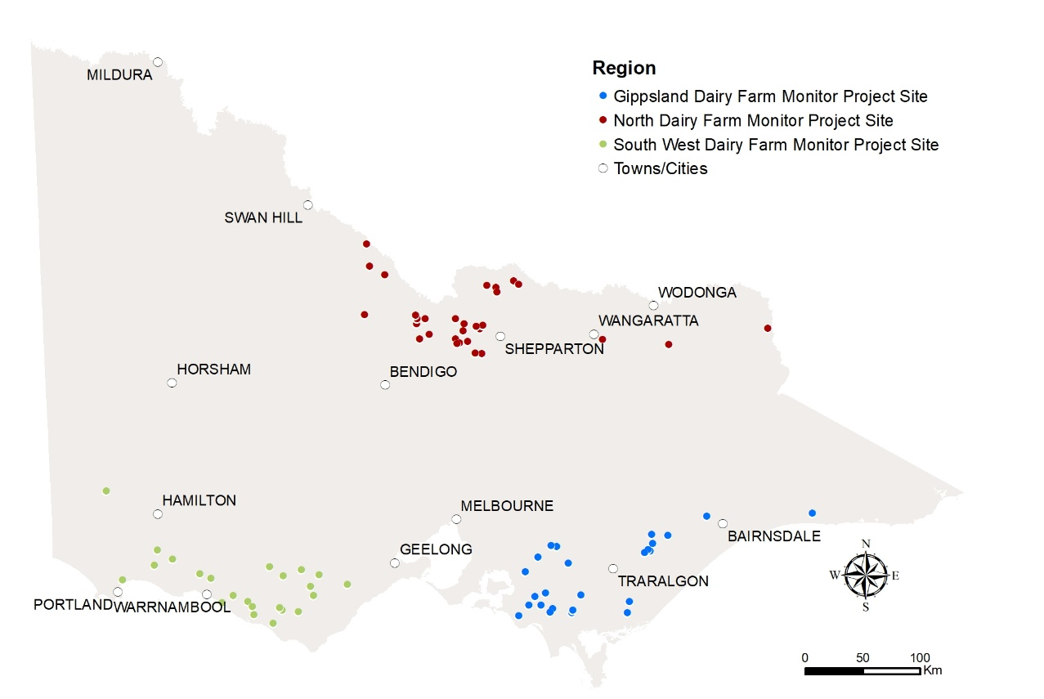

Seasonal Conditions
Seasonal conditions in 2020-21 were characteristic of average rainfall and temperatures. Surveyed farms across the state received more than their long-term average rainfall, however the timing of the rainfall and location of farms resulted in different outcomes. Carryover effects from a favourable 2020 winter helped support increased quantities of pasture harvested in spring 2020, except in those areas that were too wet.

Figure 3 shows the rainfall variation month-to-month for each region. Months of high rainfall in 2020-21 were October, January, and June. The wet conditions in spring provided challenges for conserving good-quality fodder while summer rainfall helped extend pastures and crops through the drier autumn 2021. Temperatures were average across the year, with an absence of extreme heat or extended heatwaves as seen in recent years.
In the North of the state, the almost perfect 2020 autumn, preceding this season, helped springboard pasture and crop growth for the 2020-21 season. Good 2020 winter conditions were followed by a wet 2020 spring causing delays to fodder harvesting and downgraded silage quality. Mild temperatures during summer 2021 helped support some crop yield, such as maize. Autumn 2021 was very dry, with one rainfall event in March causing a ‘false break’ and many newly sown pastures and/or crops required re-sowing or additional irrigating (from May). By the end of the season, irrigators purchased and used more irrigation water than 2019-20. This combined with good seasonal conditions contributed to the higher pasture harvested in 2020-21.
The South West region also benefited from a carryover effect of good conditions heading into the 2020-21 season. A mild 2020 winter soon turned wet in spring 2020. However, as spring progressed many farmers were able to harvest good pasture, hay, and silage yields, contributing to the higher pasture harvested in 2020-21 compared to the previous year. A mild summer 2021 saw pasture growth extend longer than in previous years on some farms. A January rainfall event increased soil moisture and helped offset the below average rainfall in autumn 2021. Reasonable pasture cover and growth was seen heading into winter 2021.
A wide variation in seasonal conditions required different management strategies across the Gippsland region in 2020-21. In south and west Gippsland, spring 2020 rainfall events caused very wet soils providing challenges for grazing and delayed fodder conservation. East Gippsland received consistent rainfall events through spring 2020, while central and east Gippsland received good rainfall events over summer 2021, to support pasture conservation opportunities in these areas. Irrigators in the Macalister Irrigation District purchased 12 per cent less water in 2020-21 compared to the previous year due to the reasonable seasonal conditions and they also had 100 per cent High and Low Reliability water shares by the end of the season.
More detail on seasonal conditions is provided in the regional chapters.

FIGURE 3. MONTHLY RAINFALL 2020-21
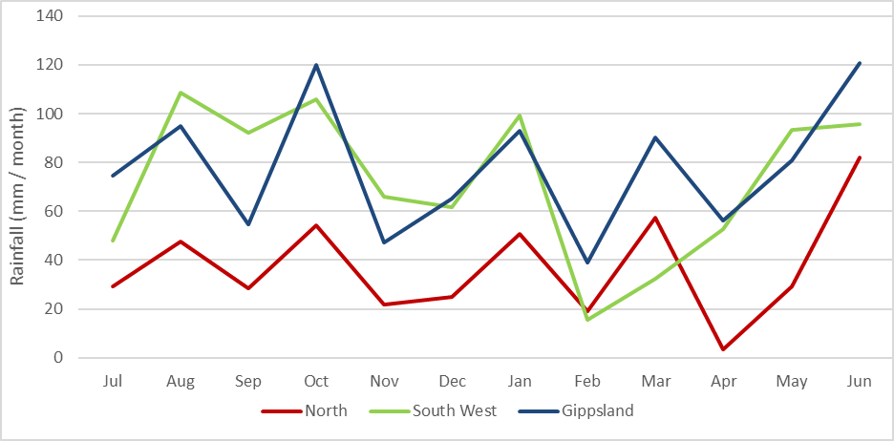

Whole farm analysis
Compared with the previous year, average EBIT improved by $0.18/kg MS in 2020-21 to $1.86/kg MS. While Gippsland was lower, improved performance in the North and South West lifted the statewide average performance in 2020-21. Positive performance (increase in EBIT) was seen on 75 of the 80 surveyed farms.

Average herd size for the state increased slightly this year to 373 cows from an average of 369 cows the previous year (Table 1). The average usable farm area remained almost identical to the previous year at 278 ha.
The amount of milk solids sold increased on both a per cow and per hectare performance. Milk solids sold increased to 530 kg MS/cow, from 523 kg MS/cow the previous year and milk solids sold per hectare (MS/ha) increased to 823 kg MS/ha from 794 kg MS/ha in 2019-20. An increase was seen in the South West and the North, while Gippsland remained stable.
Labour efficiency for the state remained stable at 107 cows/FTE while MS/FTE slightly increased to around 56,000 kg MS/FTE. The amount of labour employed on farm was 3.6 full time equivalents (FTE) in 2020-21, similar to 3.5 FTE in 2019-20. For the first time since 2014-15, the availability of labour was highlighted as one of the top four issues facing farmers over the next 12 months. Further commentary on the issues facing farmers is outlined in Chapter 5.
The regional data showed that herd size is largest in the North, while land area is the greatest for South West farms. Gippsland farms have the highest stocking rate on average at 1.9 cows/ha. In 2020-21, South West farms had the greatest proportion of homegrown feed as per cent of ME consumed by livestock at 68 per cent. On average, grazed pasture constitutes 50 per cent of the livestock diet on South West farms, compared to 57 per cent for the Gippsland farms and 37 per cent for the North.
Table 1 presents the average farm physical parameters for the state and for each region. Further details can be found in Appendix Table 2 for each region.

TABLE 1. AVERAGE FARM PHYSICAL DATA –STATE OVERVIEW 2020-21
Farm physical parameters | State | North | South West | Gippsland
Number of farms in sample | 80 | 30 | 25 | 25
Annual rainfall 20-21 (mm) | 730 | 435 | 878 | 936
Herd size | 373 | 427 | 373 | 308
Total water use efficiency (t DM/100mm/ha) | 0.8 | 0.9 | 0.7 | 0.7
Total usable area (hectares) | 278 | 307 | 335 | 186
Milking cows per usable hectare | 1.6 | 1.7 | 1.1 | 1.9
Milk solids sold (kg MS /cow) | 530 | 572 | 526 | 485
Milk solids sold (kg MS /ha) | 823 | 923 | 602 | 924
Homegrown feed as % of ME consumed | 62% | 55% | 68% | 66%
Labour efficiency (cows / FTE) | 107 | 103 | 99 | 122
Labour efficiency (kg MS / FTE) | 56,441 | 58,041 | 51,787 | 59,174

Gross farm income
Gross farm income in 2020-21 was $7.67/kg MS, which comprised of milk sales (88 per cent), livestock trading (11 per cent) and other farm income (one per cent). The lower milk price was the key factor in an overall two per cent decrease in gross farm income in 2020-21.
In 2019-20, there was a high milk price at $7.15/kg MS. Average milk price in 2020-21 was $6.76/kg MS. While this milk price was five per cent lower, it remained above the 15-year average recorded in the DFMP of $6.55/kg MS in real terms (when the effects of inflation are excluded). The average price across the regions was
- The North at $7.02/kg MS
- South West at $6.68/kg MS
- Gippsland at $6.54/kg MS.
Some farmers were able to take advantage of the strong livestock market to help lift the participant farms’ average livestock trading income by 27 per cent to $0.83/kg MS in 2020-21. A small number of farmers benefited from selling their heifers for export, particularly those in the southern regions, which further increased livestock trading gains. The returns from livestock trading contributed a greater proportion to gross farm income, (11 per cent in 2020-21 compared to eight per cent in 2019-20), providing some diversity in farm incomes and offsetting effects from the lower milk price.

Variable costs
Average variable costs were lower in 2020-21, falling by 12 per cent to $3.41/kg MS compared to $3.88/kg MS in 2019-20. This season’s costs were below the DFMP 15-year average, and the lowest since 2015-16. Herd and shed costs remained the same at $0.32/kg MS and $0.23/kg MS respectively, while feed costs decreased by 14 per cent to $2.86/kg MS (Table 2). The homegrown feed costs and inventory changes remained relatively stable, with a $0.47/kg MS saving in purchased feed costs being the main contributor to the overall decrease in variable costs.
Purchased feed and agistment costs were $1.89/kg MS in 2020-21, compared with $2.36/kg MS in 2019-20. Farmers fed less purchased feed on average, at lower prices. The greatest change in the reliance of purchased feed was seen in the North, due to the improvement in seasonal conditions. In this region, 45 per cent of the diet, as a percentage of ME consumed, was imported compared with 50 per cent the previous year. All regions experienced about a 13 per cent decrease in concentrate price, with the average decreasing from $495/t DM to $430/t DM in 2020-21. The average price of fodder also decreased for silage (18 per cent decrease) and hay (20 per cent decrease).
Homegrown feed costs remained steady at $1.19/kg MS in 2020-21. Average pasture improvement and cropping costs statewide remained unchanged. Many farmers in the North needed to sow pastures and crops twice following a ‘false break’ in autumn 2021, whereas this wasn’t the case in the South West and Gippsland. Hay and silage making costs increased in the South West and the North as more fodder was conserved, while this was not observed in Gippsland. Cheaper irrigation water also contributed to lower homegrown feed costs in 2020-21.
Feed and water inventory changes contributed a combined total of -$0.21/kg MS, similar to that recorded in 2019-20. The changes in feed (-$0.16/kg MS) and water (-$0.05/kg MS) inventory were treated as feed costs and as such, these negative inventory changes meant a reduction in feed cost. The 58 farms that built up fodder reserves increased their feed on-hand by an average of 305 t DM.
Overhead costs
Average overhead costs increased by four per cent in 2020-21 to $2.40/kg MS. Many DFMP farmers attended to earlier delays in repairs and maintenance (11 per cent increase in expenditure from the previous year). Improved cash flows saw upgrades to tracks, laneways, and plant. While every effort has been made to exclude capital items from this category, it is expected some of the benefits from these repairs will extend beyond one year. Employed labour costs were the other major cash overhead category which had an increase (3 per cent increase) from the previous year. On average, non-cash overheads of depreciation ($0.25/kg MS) and imputed labour ($0.83/kg MS) remained steady.

TABLE 2. AVERAGE FARM FINANCIAL PERFORMANCE - STATEWIDE
 | State  $/kg MS | North  $/kg MS | South West  $/kg MS | Gippsland  $/kg MS
INCOME
Milk income (net) | $6.76 | $7.02 | $6.68 | $6.54
Livestock trading profit | $0.83 | $0.79 | $1.04 | $0.67
Other farm income | $0.08 | $0.13 | $0.08 | $0.03
Gross farm income | $7.67 | $7.93 | $7.79 | $7.24
VARIABLE COSTS
Herd costs | $0.32 | $0.32 | $0.31 | $0.33
Shed costs | $0.23 | $0.20 | $0.26 | $0.24
Homegrown feed cost | $1.17 | $1.49 | $1.02 | $0.95
Purchased feed and agistment | $1.89 | $2.20 | $1.65 | $1.76
Feed inventory change | -$0.16 | -$0.23 | -$0.19 | -$0.05
Water inventory change | -$0.05 | -$0.13 | $0.00 | $0.00
Total feed costs | $2.86 | $3.34 | $2.48 | $2.66
Total variable costs | $3.41 | $3.86 | $3.06 | $3.23
GROSS MARGIN | $4.26 | $4.06 | $4.74 | $4.02
OVERHEAD COSTS
Employed labour | $0.61 | $0.64 | $0.63 | $0.57
Repairs and maintenance | $0.40 | $0.38 | $0.49 | $0.33
All other overheads | $0.31 | $0.29 | $0.33 | $0.29
Imputed labour | $0.83 | $0.75 | $0.90 | $0.87
Depreciation | $0.25 | $0.24 | $0.35 | $0.17
Total overhead costs | $2.40 | $2.30 | $2.70 | $2.24
Variable and overhead costs | $5.82 | $6.16 | $5.75 | $5.46
EARNINGS BEFORE INTEREST AND TAX | $1.86 | $1.76 | $2.04 | $1.78

Earnings before interest and tax

Average EBIT improved by 11 per cent in 2020-21, from $1.68/kg MS in 2019-20 to $1.86/kg MS in 2020-21 (Figure 4). The operating returns were positive on 75 of the 80 farms. This reflected strong livestock trading conditions and an above the 15-year average milk price combined with easing variable costs. Average performance lifted but was mixed among the regions.
The North experienced the greatest improvement in economic performance in 2020-21 of all the regions. The average EBIT was $1.76/kg MS, an increase of 44 per cent from the previous year. Managing costs, due to favourable operating conditions, was the key driver of the improved profitability of farms in this region, albeit with lower milk income. For the same 26 farms participating between DFMP years, EBIT improved from $1.31/kg MS in 2019-20 to $1.82/kg MS in 2020-21, indicating that improved EBIT performance was typical for these farms.
The South West also enjoyed improved economic performance in 2020-21. The average EBIT was $2.04/kg MS, an increase of 12 per cent from the previous year. The same 25 farms have participated between years and 13 of these had improved EBIT performance in 2020-21. Easing variable costs and strong livestock prices were the key drivers of the improvement, offsetting a seven per cent lower milk price and increased overhead expenditure.
The average EBIT in Gippsland was $1.78/kg MS, a decrease of 14 per cent from the previous year. Savings experienced in homegrown and purchased feed costs this season were not enough to offset a six per cent lower milk price and increased variable and overhead costs. Of the same 23 farms participating between years, EBIT decreased from $2.09/kg MS in 2019-20 to $1.65/kg MS in 2020-21.
Figures 16, 26 and 36 in the regional sections present the range in EBIT received by participant farms this year.
Return on total assets and equity
Average ROTA was 5.7 per cent in 2020-21, an increase from 5.4 per cent in 2019-20. Despite the larger increase in EBIT in 2020-21, an increase in land values constrained the ROTA, particularly those in the southern regions which had seen significant growth in land values. It was most common for farms (39 farms) to record a ROTA between five per cent and 10 per cent (Figure 5).
When the financing arrangements are considered, returns, as measured by ROE, increase to 8.2 per cent in 2020-21. Having a higher ROE than ROTA indicates that the returns on the additional assets were greater than the cost of accessing those assets. For the 80 DFMP farms, 62 farms have been able to grow their business in 2020-21.
The statewide Top 25% recorded a ROTA of 12.8 per cent and ROE of 15.2 per cent highlighting the strong returns possible from well-operated businesses in 2020-21.
Further discussion of ROTA and ROE occurs in the risk section below and in the regional chapters. Appendix Table 1 presents ROTA and ROE for the participant in each region.
FIGURE 4. AVERAGE EBIT
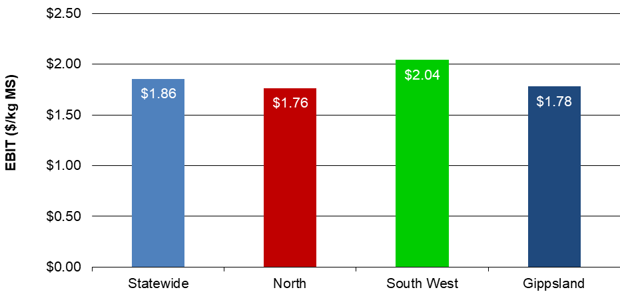

FIGURE 5. DISTRIBUTION OF FARMS BY ROTA
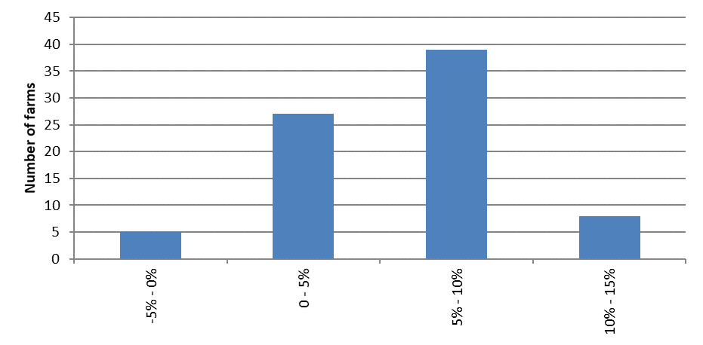

FIGURE 6. DISTRIBUTION OF FARMS BY ROE
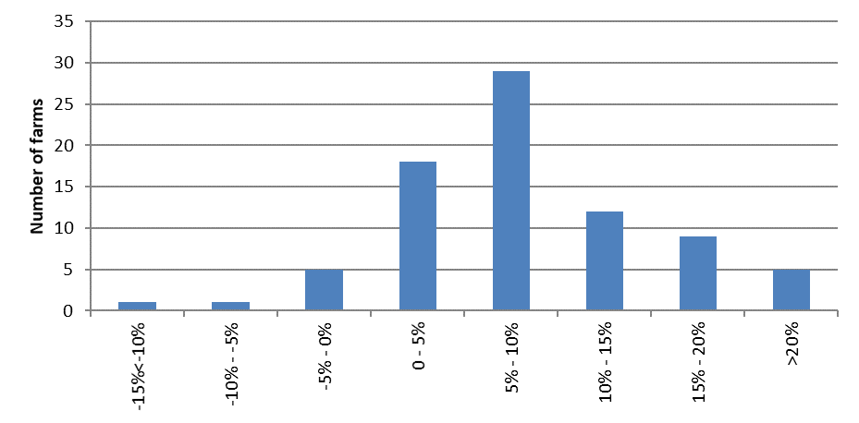

Risk

“Risk is conventionally classified into two types: business risk and financial risk. Business risk is the risk any business faces regardless of how it is financed. It comes from production and price risk, uncertainty, and variability. Business risk refers to variable crop yields, livestock reproduction rates, disease outbreaks, climatic variability, unexpected changes in markets and prices, fluctuations in inflation and interest rates, and personal mishap… Financial risk derives from the proportion of borrowed money that is used in the business relative to the proportion of owner-operator’s capital…”
As most farms use a mix of borrowed and owned capital, most farms are exposed to business and financial risk. It is important to understand that risk drives return and having the right balance between risk and return can drive success.
Table 3 presents some key risk indicators. Refer to Appendix E for the definition of terms used in Table 3. These indicators can also be found in Appendix Tables 1, 3 and 6 for each region.
The cost structure ratio presents variable costs as a proportion of total costs. A lower ratio implies that overhead costs comprised a greater proportion of total costs, which indicates less flexibility in the business. Table 3 shows that across the state for every $1.00 spent, $0.59 was used to cover variable costs, as compared with $0.62 last year. It is worth noting that cost structures vary significantly between regions and farms.
The debt service ratio shows interest and lease costs as a proportion of gross farm income. A ratio of six per cent this year means that on average farms repaid $0.06 of every dollar generated back to their creditors.
On average, equity levels across the state improved to 71 per cent from 67 per cent in 2019-20, with increases observed across all regions. When new farms enter the survey with different equity structures these results can be impacted.
The average proportion of imported feed as percentage of total ME was 38 per cent in 2020-21. Participant farmers in Gippsland and the South West farmers sourced a third of the ME from imported feed, lower than those in the North with 45 per cent.

TABLE 3. RISK INDICATORS
 | State | North | South West | Gippsland
Cost structure (percentage of total costs as variable costs) | 59% | 63% | 53% | 59%
Debt service ratio (percentage of income as finance costs) | 6% | 6% | 5% | 7%
Debt per cow | $4,216 | $4,275 | $4,262 | $4,099
Equity percentage (ownership of total assets managed) | 71% | 68% | 75% | 69%
Percentage of feed imported (as a % of total ME) | 38% | 45% | 32% | 34%

Physical measures
Feed consumption

The contribution of different feed sources to the total ME consumed on the farm is presented in Figure 7. This includes feed consumed by milking herd, dry cows, and young stock across the usable area. Figure 8 shows the estimated grazed and conserved feed removed on the milking area.
The average diet of a DFMP farm consisted of grazed pasture (48 per cent of the diet), concentrates (30 per cent), fodder (22 per cent) and other feed (one per cent). Regional differences show that pasture made up more of the diet on Gippsland farms than those in the South West while North had the lowest at 37 per cent of the diet, with a notable difference of the having more annual than perennial pasture.
In the North, the proportion of grazed feed in the diet was similar to last year’s 36 per cent. However, there was more pasture harvested, with increases observed for both the grazed and conserved pasture. With improved seasonal and irrigation trading conditions, farmers were able to grow and harvest greater quantities of homegrown feed and reduce their reliance on purchased feed (purchased feed fed decreased by 0.5 t DM/cow, to 3.5 t DM/cow in 2020-21). On average, the total supplements fed contributed 63 per cent (like last year’s average of 64 per cent) from homegrown and purchased sources.
In the South West, grazed pasture comprised half of the diet in 2020-21. The remaining diet was made up of concentrates (29 per cent), silage (14 per cent), hay (five per cent) and other feed (one per cent). The proportion of ME from each feed source remained similar to the previous year. Seventeen farms reduced the quantity of supplements fed on a per cow basis, as they fed less homegrown fodder and kept purchased feed fed at the same level. Further, improved average pasture availability reduced the reliance on supplements. Homegrown feed removed (grazed and conserved) increased three per cent to 7.1 t DM/ha in 2020-21 as compared with the previous year.
Grazed pastures comprised less of the diet on Gippsland farms in 2020-21 than the previous year (57 per cent compared to 60 per cent in 2019-20). This reflected the variable seasonal conditions across Gippsland region requiring different farm management approaches. These included feeding greater quantities of silage, and in south and west Gippsland, keeping herd off wet paddocks to prevent damage from pugging. Whereas farms in east Gippsland had relative consistent rainfall events through spring which allowed for reasonable pasture conservation opportunities.
Appendix Table 3 provides further information on purchased feed in each region and Appendix Table 2 on the homegrown feed removed per milking hectare.
Estimated homegrown feed consumed is calculated from the total ME required on farm - determined by stock numbers, liveweight, average distance walked to and from the dairy and milk production. The ME imported from other feed sources is subtracted from the total farm ME requirements over the year to give estimated total ME produced on farm. The ME produced on farm is divided into grazed and conserved feed, using records of the amount of conserved fodder produced.

FIGURE 7. SOURCES OF WHOLE FARM METABOLISABLE ENERGY
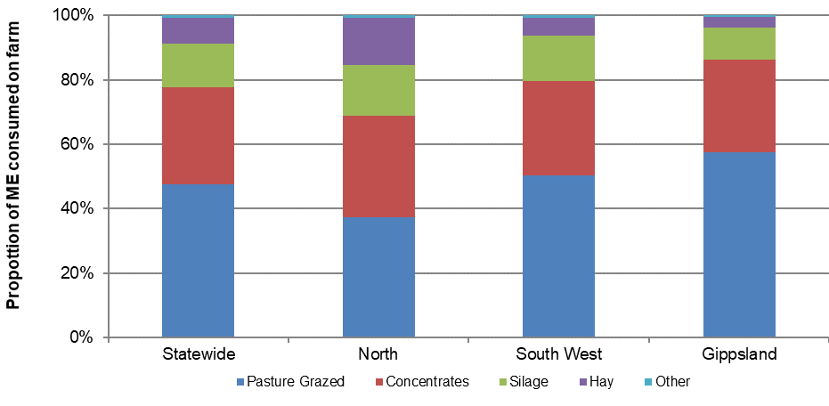

FIGURE 8. ESTIMATED TONNES OF HOMEGROWN FEED REMOVED
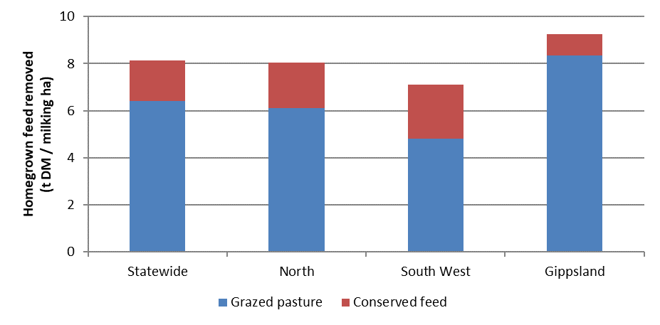

Fertiliser application

The application of nutrients increased on average statewide in 2020-21 compared to the previous year, with variation among the regions (Figure 9).
The South West was the only region to reduce their total nutrients in 2020-21, compared with the previous year. The total amount of NPKS decreased from 273 kg/ha to 259 kg/ha. This was mainly attributable to the lower amounts of nitrogen applied, which decreased by 13 per cent.
In the North, the average fertiliser application was 162 kg/ha, an increase of 22 per cent from last year. This follows a decreasing trend between 2017-18 and 2019-20. Nitrogen and phosphorus were the commonly applied nutrients.
Average nutrient application in Gippsland increased by 12 per cent, from 287 kg/ha to 322 kg/ha. The rainfall events throughout the year influenced the ability of farmers to apply nitrogen, with a few farms engaging aerial application due to the wet soils.
Pasture growth and fertiliser application strategies will be influenced by water availability, pasture species, soil type, pasture management, seasonal variation in response rates to fertilisers, amount of (and nutrient composition of) imported feeds, variations in long-term fertiliser strategies among other factors. This level of detail is not collected as part of this project.
Appendix Table 2 provides further information on nutrient application for participant farms in each region.

FIGURE 9. NUTRIENT APPLICATION
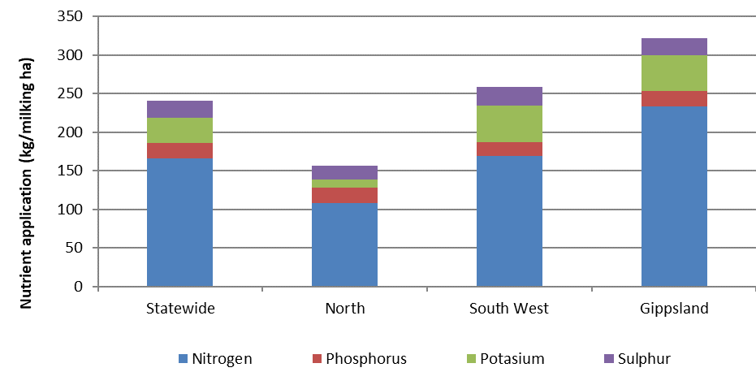

Milk solids sold

Average milk sales remained similar to the previous year for all regions, with less than five per cent variation between sales across the regional averages. The North increased their total milk sales by five per cent, the South West by four per cent and Gippsland by one per cent (based on total milk production for the farm). Each region had its own unique milk production distribution (Figure 10).
In the North, the monthly milk solids sold shows a double peak occurring in spring 2020 and autumn 2021. Spring 2020 sales accounted for 30 per cent of the milk solids sold, while autumn 2021 accounted for 25 per cent notably occurring in May.
The South West had an extended winter to spring milk production peak period, where approximately 59 per cent of milk was produced between July and December 2020. The lowest producing months were February through to April accounting for 16 per cent of the milk solids sold, before a rise heading into winter.
In Gippsland, there was a seasonal supply in spring when milk solid sales accounted for 32 per cent of the yearly supply compared to 27 per cent in summer, 24 per cent in autumn and 17 per cent in winter. As farms in this region have a high proportion of grazed pasture in the diet, the milk production patterns followed a tradition of producing milk when there is normally a greater abundance of homegrown feed.
Calving pattern
The calving pattern for all regions is shown in Figure 11.
The North farms had peak calving in two distinct times; August 2020 and March 2021. This pattern matches the milk supply curve shown in Figure 10.
The South West farms were characterised by autumn calving with the greatest number of calves born in April 2021.
Gippsland had a dominant winter calving period, with over 36 per cent calves born in August 2020. The calving pattern matches the peak milk production which occurred later in spring.

FIGURE 10. MONTHLY DISTRIBUTION OF MILK SOLD
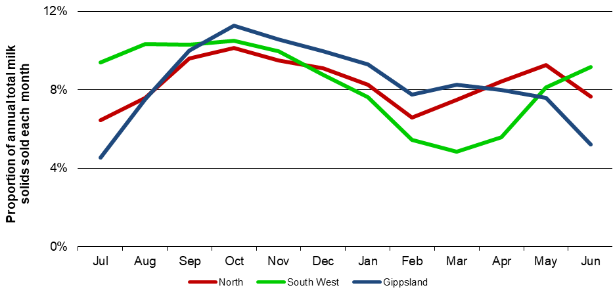

FIGURE 11. MONTHLY DISTRIBUTION OF CALVING
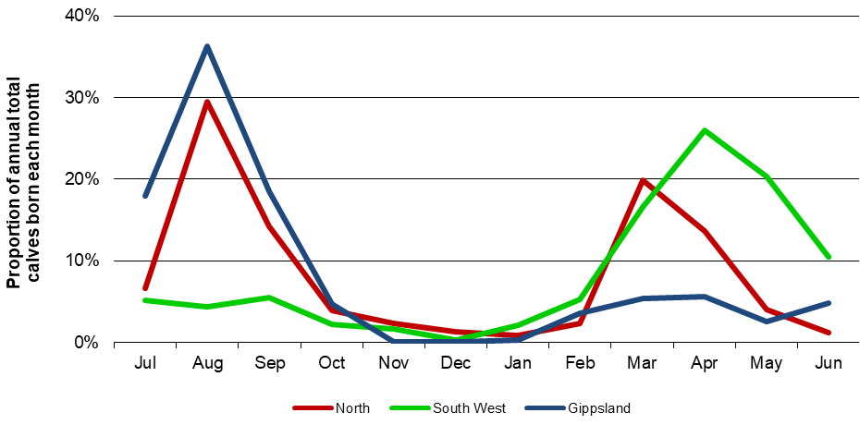

Part Two: The North

Seasonal conditions
A ‘brilliant autumn’ preceding the 2020-21 season had a positive impact on the North performance. Annual rainfall was 91 per cent of long-term average with wet conditions in spring 2020 and good rainfall in January and March 2021. Temperatures remained mild, particularly over the summer months.

On average, North farms received 435 mm of rain in 2020-21, or 91 per cent of long-term average of 478 mm (Figure 12). The almost perfect 2020 autumn preceding this season set up the year. There was substantial feed growing in autumn 2020 that was harvested in spring of 2020. Water use efficiency in spring and summer looked higher than typical because there was residual soil moisture carried into this season.
Winter 2020 was nearly ideal - not too wet to cause any cow health issues nor pugging in the grazing areas. Silage season started early as autumn 2020 pasture was conserved in July and August 2020. Spring rainfall saw good pasture growth and a bigger quantity of pasture and crops that needed to be harvested. There was a smaller window for harvesting, with delays in harvest due to wet soils and wet weather resulting in reduced silage quality. Harvesting was hampered by above-average rainfall in October 2020. Some cut hay and silage were rained on, further reducing quality. Summer 2021’s mild temperature, without the heat waves that the North experiences, was more suitable for the milking herds. Some farmers grew summer crops like millet and sorghum which had reduced growth rates due to the cooler temperature; however, farmers reported good maize yields.
Autumn 2021 was very dry despite the one rainfall event in March. This event had about 50mm, and up to 90 mm overnight in some areas, at a time when some farmers had just irrigated their newly sown annual pastures. This annual pasture was flooded, and some farmers had to wait for the paddock to dry out before resowing. For these farmers. their pasture improvement costs (seeds and re-sowing) were doubled. For those that did not resow, their annual pasture production was severely reduced.
In the north east part of the region, seasonal conditions were also favourable allowing good pasture yields. Farmers had to manage wetter conditions in winter 2021.
Overall, it was a particularly good year for the region. Rainfall supported higher pasture removed and seasonal conditions supported herd health and milk production.
Irrigation systems
Rainfall in autumn 2020 provided soil moisture in the upper catchments and some inflows into the major storages. Allocation of HRWS opened at eight per cent in the Murray and 35 per cent in the Goulburn and Loddon systems. With better than average rainfall in October 2020 and flows into the storages higher than estimates, HRWS in the Goulburn and Loddon systems reached full allocation (100 per cent) in November. The Murray system reached full allocation in February as its storages were boosted by good rainfall in January and February.
The price of water for irrigation is influenced mainly by allocation announcements, trade limits and rainfall events. Published data on water trading showed the median monthly price of allocation water steadily decreased throughout the season. For example, the median prices of allocation water were in the $200-$350/ML range from July to September 2020, then down to $80-95/ML between April and June 2021.
The highest and lowest median price of allocation water this year among the most traded zones were:
- Zone 1A (Greater Goulburn): high $230/ML (July 2020); low $80/ML (April 2021)
- Zone 6 (Victorian Murray - Dartmouth to Barmah Choke): high $240/ML (July 2020); low $80/ML (April 2021)
- Zone 7 (Victorian Murray - Barmah to South Australian border): high of $350/ML (July 2020); low $80/ML (April 2021)
The lower allocation water prices didn’t impact on the capital values of water as there was still strong demand for both HRWS and Low Reliability Water Share (LRWS). Irrigators secure LRWS because of the ability to carryover water into the 2021-22 season. Many irrigators are also leasing out carryover space for horticulturists and those further down the Murray system. The median prices of HRWS in 2020-21 were:
- Zone 1A: $4,000/ML ($4,150/ML 2019-20)
- Zone 6: $4,450/ML ($4,600/ML 2019-20)
- Zone 7: $6,000/ML both years

-------------------
Four new farms (NO0083, NO0086, NO0087 and NO0088) joined the DFMP.
The Top 25% are shown as the darker bars in all graphs as ranked by ROTA.
FIGURE 12. ANNUAL RAINFALL AND LONG-TERM AVERAGE RAINFALL – NORTH
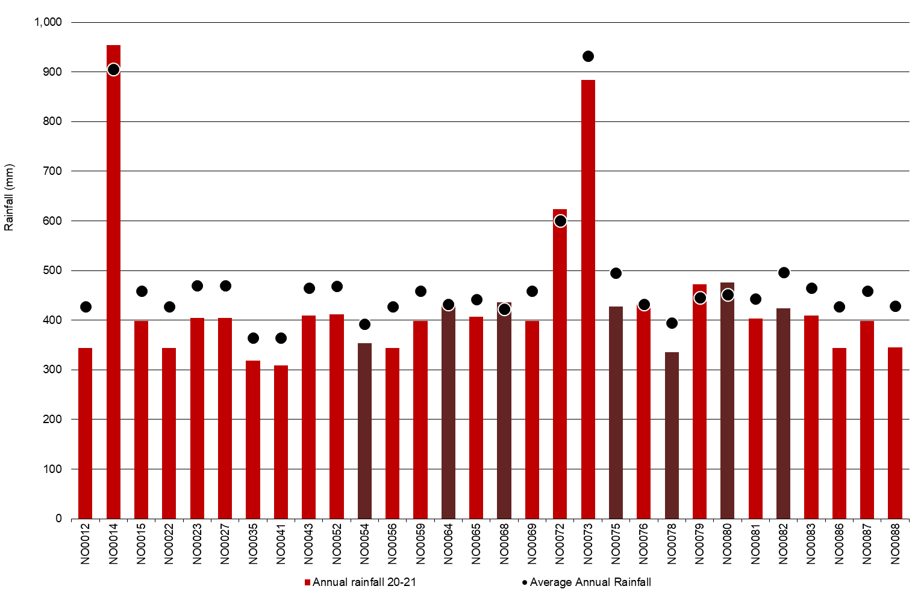

Allocation water prices decreased as the season progressed. Some farmers purchased additional water to carryover into the next season as a risk management strategy for potentially higher future prices. Irrigators received full allocation by mid-season.

Whole Farm Analysis
Average EBIT for North farms was $1.76/kg MS in 2020-21, a 44 per cent increase from the previous year. Lower milk price was offset by increase in income from livestock trading and lower variable costs. Improved settings for homegrown feed production and lower grain and fodder prices resulted in an 18 per cent reduction in feed costs. Farmers used their extra cashflow on repairs and maintenance and employed labour. Returns on total assets and equity increased to 6.0 per cent and 7.5 per cent, respectively. Many participant farmers have modified their risk strategy and have focused on trying to set up greater resilience in their business.

Key whole farm physical parameters for the North are presented below in Table 4. The Q1 – Q3 range shows the band in which the middle 50 per cent of farms sit for each parameter.
The number of milking cows per farm and average usable area was similar to last year with slight increases of two per cent and one per cent, respectively (Table 4).
The average homegrown feed as a percentage of ME consumed improved from 50 per cent to 55 per cent. This result reflected the favourable conditions for growing pasture and less reliance on purchased feed this season.
The average water use (rainfall and irrigation) for the North farms was 910 mm/ha (higher than 762 mm/ha in 2019-20) which produced 0.9 t DM/100mm/ha of homegrown feed. With an improvement in seasonal conditions and irrigation availability, farmers focused on harvesting greater quantities of feed in 2020-21, as compared with previous years of high irrigation water prices.
The Top 25% employed a similar strategy to the rest of the farms in the North. Similar to the average of North farms, homegrown feed supplied half of the ME consumed (52 per cent). They had 15 per cent higher water use efficiency (1.1 t DM/100 mm/ha) than the average for the North.

TABLE 4. FARM PHYSICAL DATA – NORTH
Farm physical parameters | North average | Q1 to Q3 range | Top 25% average
Annual rainfall 20-21 (mm) | 435 | 347 - 430 | 412
Herd size | 427 | 250 - 500 | 704
Total water use efficiency (t DM/100mm/ha) | 0.9 | 0.7 - 1.1 | 1.1
Total usable area (hectares) | 307 | 145 - 353 | 407
Milking cows per usable hectares | 1.7 | 1.2 - 1.9 | 2.0
Milk solids sold (kg MS /cow) | 572 | 522 - 640 | 585
Milk solids sold (kg MS /ha) | 923 | 687 - 1,103 | 1,110
Homegrown feed as % of ME consumed | 55% | 46% - 62% | 52%
Labour efficiency (cows / FTE) | 103 | 84 - 115 | 119
Labour efficiency (kg MS / FTE) | 58,041 | 46,442 - 68,977 | 67,885

Milk solids sold

On average, DFMP farms in the North sold more milk solids than in 2019-20, on a per farm, per cow and per hectare basis. They sold an average of 572 kg MS/cow and 923 kg MS/ha (Figure 13), increases of one per cent and six per cent, respectively, year-on-year.
Many farmers focused on higher milk production this year with strong milk prices and affordable feed prices. However, limited supplies of good quality fodder constrained this approach.
Most of the higher production was generally achieved by milking extra cows rather than improved milk production. This was evident with an increase in stocking rate from 1.5 cows/usable ha in 2019-20 to 1.7 cows/usable ha in 2020-21. The result was a relatively higher increase in milk solids sold per ha than in milk solids sold per cow.
Almost a third of the milk solids sold (30 per cent) occurred in spring, with the greatest amount of milk solids (24,200 kg MS/farm) sold in October 2020 (Figure 10). While most milk was sold in September through to December 2020, there was another peak in May 2021, similar pattern to the 2019-20 season.
The top performing farms sold slightly more milk per cow and per hectare than the average in 2020-21. Compared to the Top 25% last year, the top this year sold more milk per cow (four per cent higher) and per hectare (29 per cent higher) basis.

FIGURE 13. MILK SOLIDS SOLD – NORTH
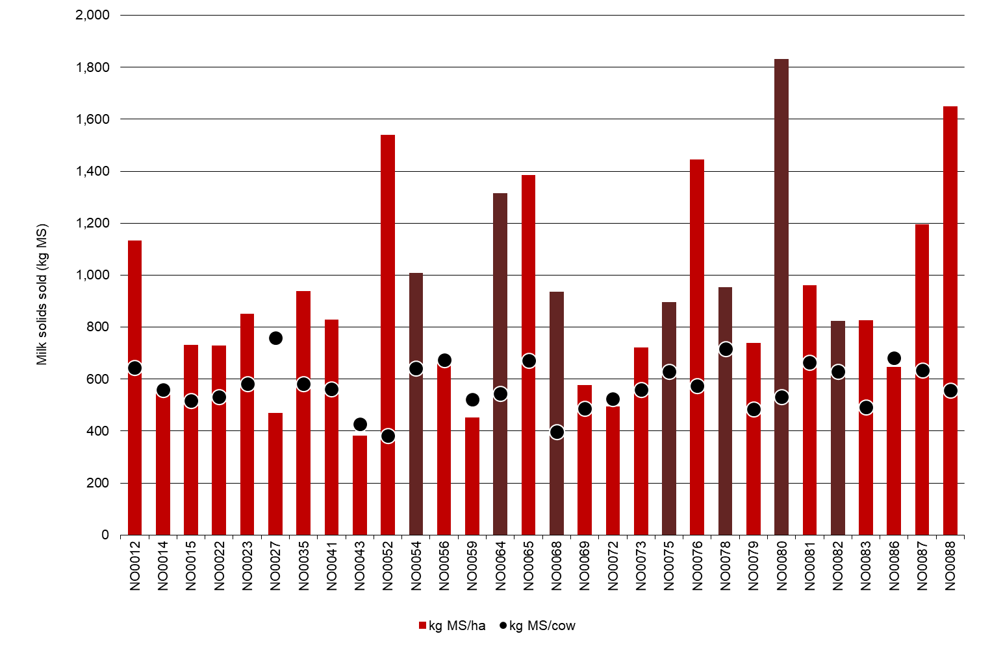
Gross farm income

For farms in the North, milk income on a per kg MS basis contributed 89 per cent, livestock trading 10 per cent and other income one per cent to the gross farm income of $7.93/kg MS (Table 5). The contributions of milk income and livestock trading in 2019-20 were 91 per cent and eight per cent, respectively.
The lower contribution of milk income to gross farm income in 2020-21 was due to the four per cent decrease in average milk price. Figure 14 shows a wide variation in milk price received per kg MS. On average, milk income decreased to $7.02/kg MS, from $7.31/kg MS in 2019-20. In the context of the 15-years of DFMP, the milk price remains strong with it being higher only in 2019-20, 2013-14 and 2007-08 (when accounted for inﬂation).
Improved livestock trading conditions delivered a greater contribution to gross farm incomes in 2020-21. Similar to previous years, many participant farmers raised their newborn calves to take advantage of improved cattle prices and to manage their cashﬂows. Income from livestock sales increased from $178,000 per farm in 2019-20, to $216,000 per fam in 2020-21.
Other farm income was $0.13/kg MS which was mainly from sales of feed or water.
Farms that were in the Top 25% generated an average gross income of $7.87/kg MS, comprised of milk income ($7.01/kg MS), livestock trading ($0.73/kg MS) and other income ($0.14/kg MS). Income from all categories were lower than last year’s top performing group.

FIGURE 14. GROSS FARM INCOME – NORTH
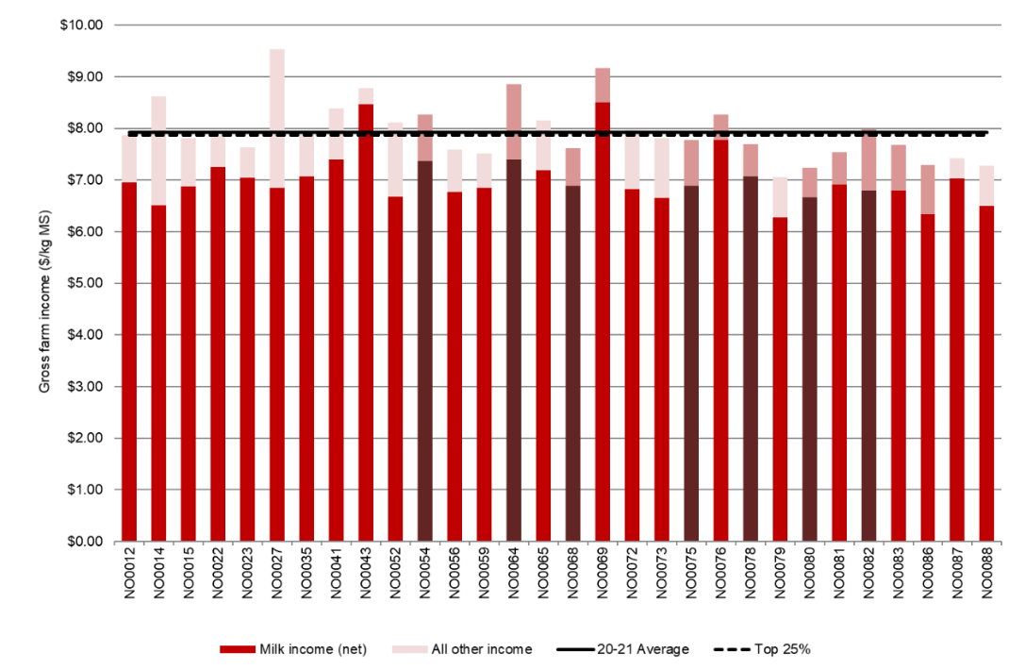

Variable costs

Participant farms in the North spent an average of $3.86/kg MS, 16 per cent lower than in 2019-20 (Figure 15). Feed costs were the major variable cost for farms in the North, accounting for 54 per cent of total costs (lower than last year’s 60 per cent).
Herd and shed costs were similar to 2019-20 at $0.32/kg MS and $0.20/kg MS, respectively.
Feed costs decreased by 18 per cent to $3.34/kg MS from $4.08/kg MS in 2019-20 with half of the participant farms spending between $2.99/kg MS and $3.64/kg MS. Farms increased their fertiliser cost, irrigation cost and decreased the purchased feed cost. These decisions lowered their overall feed costs coupled with increases in reserves of conserved feed and carryover water into 2021-22.
Purchased feed and agistment accounted for 36 per cent of feed costs in 2020-21, decreasing from 44 per cent in 2019-20. The cost of purchased feed decreased this year to $2.20/kg MS from last year’s $3.00/kg MS. This reflected both decreases in price ($/t DM) and quantity fed (t DM per cow). The average purchased feed per cow was 3.5 t DM/cow compared to 4 t DM/cow last year. The quantity of purchased concentrates fed per cow (on usable milking area) increased by three per cent; purchased silage and hay decreased by 20 per cent and 25 per cent, respectively. The price of all purchased feed (concentrate, hay, silage, and other feed) decreased. The average price of purchased feed was 11 per cent lower, from $397/t DM to $354/t DM year-on-year.
Average irrigation costs were $0.55/kg MS and accounted for nine per cent of total costs in 2020-21, up from seven per cent of total costs (or $0.50/kg MS) in the previous year. The higher cost was due to higher water use in 2020-21, from 3.1 ML/irrigated ha to 4.9 ML/irrigated ha.
The purchase of allocation water (across all North farms) increased substantially from 171 ML/farm in 2019-20 to 733ML/farm this year. Two farms sold water at an average of 254 ML/farm compared to 190 ML/farm for four farms year-on-year. For the same 25 irrigated farms that participated in both years, the average irrigation costs were six per cent higher at $0.53/kg MS in 2020-21 compared to $0.50/kg MS in 2019-20.
Many participant farmers have modified their risk strategy, and this year have focused on trying to set up greater resilience in their business to avoid their recent experiences with high input costs.
Many farmers managed to improve their feed and water inventory position. Where a negative change in inventory costs occurred, such as -$0.23/kg MS for the average feed inventory in the North, indicated that fodder reserves increased and is therefore counted as a decrease in feed costs.
Irrigators took advantage of the lower water prices late in 2020-21 to build their irrigation water inventories. Four-in-five farmers carried-over water to 2020-21 on the back of good autumn 2020 rainfall and lower allocation prices. The average water inventory change was -$0.13 compared to last year’s -$0.11/kg MS. Of the 29 North irrigators, 17 farms had built both feed and water reserves by June 2021.
The Top 25% spent $3.63/kg MS on variable costs, six per cent lower than the average of North farms and eight per cent lower than last year’s top performing farms. They spent more on both homegrown and purchased feeds than the average of all participant North farms. They had higher feed inventory and water inventory than the North average.
Figure 15 shows the breakdown of total farm costs as variable and overhead costs per kg MS. A breakdown of the costs for individual farms can be found in Appendix Tables B4 and B5. The price of purchased feed is shown in Appendix Table B3.

FIGURE 15. VARIABLE AND OVERHEAD COSTS – NORTH
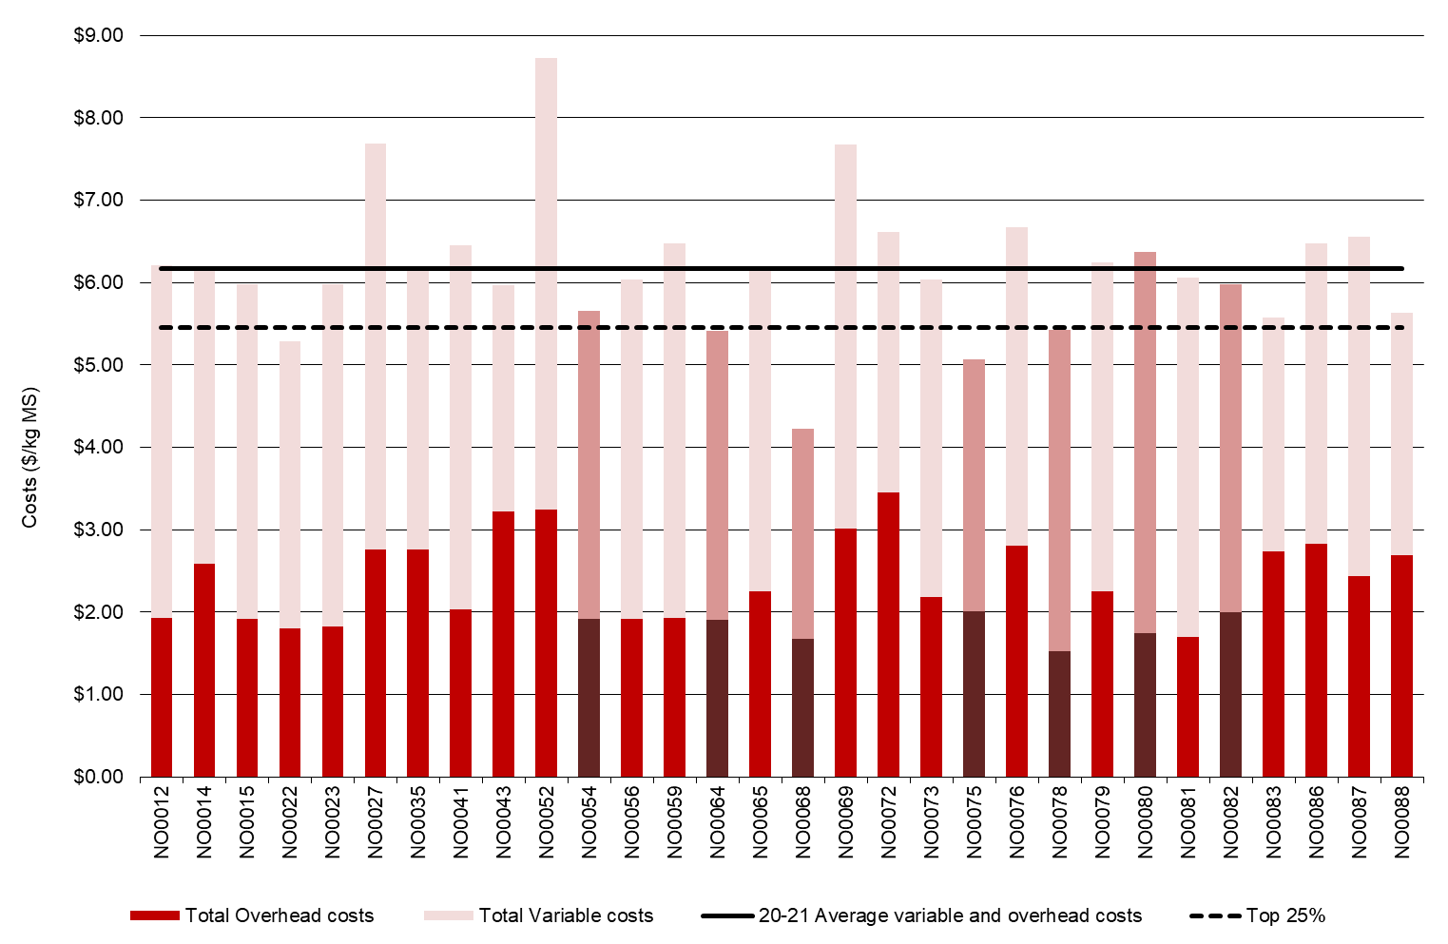

Overhead costs

Average overhead costs accounted for 37 per cent of total costs. In 2020-21, overhead costs were six per cent higher at $2.30/kg MS compared to $2.18/kg MS last year. Increases in many cash overhead cost items were offset by decreases in ‘other overhead’ costs. Employed labour cost increased seven per cent from $0.60/kg MS to $0.64/kg MS year-on-year.
On average, repairs and maintenance was 22 per cent higher (on a per kg MS basis) than last year, or from $78,900/farm to $95,800/farm this year. The same 26 farms that participated between years also increased this cost by 15 per cent and 16 per cent on per kg MS and per farm bases, respectively.
Non-cash overhead costs (depreciation and imputed labour) increased by three per cent compared to 2019-20.
The top performing farms spent more on total overhead cost per farm than the average of North farms. As these farms sold more milk solids per farm than the average, their overhead costs per kg MS was relatively lower at $1.82/kg MS (21 per cent lower). This was supported by their higher labour efficiency on a per cow and kg MS basis (Table 4).

TABLE 5. AVERAGE FARM FINANCIAL PERFORMANCE – NORTH
 | North average | Q1 to Q3 range | Top 25% average
 | $/kg MS | $/kg MS | $/kg MS
INCOME
Milk income (net) | $7.02 | $6.77 - $7.15 | $7.01
Livestock trading profit | $0.79 | $0.55 - $0.88 | $0.73
Other farm income | $0.13 | $0.04 - $0.16 | $0.14
Gross farm income | $7.93 | $7.60 - $8.24 | $7.87
VARIABLE COSTS
Herd cost | $0.32 | $0.27 - $0.39 | $0.31
Shed cost | $0.20 | $0.17 - $0.23 | $0.17
Homegrown feed cost | $1.49 | $1.19 - $1.80 | $1.64
Purchased feed and agistment | $2.20 | $1.81 - $2.65 | $2.28
Feed inventory change | -$0.23 | -$0.38 - $0.02 | -$0.62
Water inventory change | -$0.13 | -$0.20 - -$0.01 | -$0.15
Total feed costs | $3.34 | $2.99 - $3.64 | $3.14
Total variable costs | $3.86 | $3.49 - $4.25 | $3.63
GROSS MARGIN | $4.06 | $3.50 - $4.52 | $4.25
OVERHEAD COSTS
Employed labour | $0.64 | $0.40 - $0.79 | $0.72
Repairs and maintenance | $0.38 | $0.30 - $0.46 | $0.30
All other overheads | $0.29 | $0.21 - $0.30 | $0.22
Imputed labour | $0.75 | $0.38 - $0.92 | $0.40
Depreciation | $0.24 | $0.16 - $0.31 | $0.18
Total overhead costs | $2.30 | $1.91 - $2.75 | $1.82
Variable and overhead costs | $6.16 | $4.81 - $5.87 | $5.45
EARNINGS BEOFRE INTEREST AND TAX | $1.76 | $1.41 - $2.22 | $2.42

Cost of production

Cost of production gives an indication of the cost of producing a kilogram of milk solids. It is calculated as variable plus overhead costs and accounts for changes in fodder and livestock inventory.
Table 6 shows the cost of production (with inventory change) was $6.23/kg MS, nine per cent lower than in 2019-20. The Q1 to Q3 range in 2019-20 was wider ($6.39/kg MS to $7.36/kg MS) compared to 2020-21 ($6.18/kg MS to $6.72/kg MS).
The top performing group had a nine per cent lower cost of production with inventory change ($5.68/kg MS) than the average of North farms. Non-cash overheads and changes in inventory were the main difference between the two groups.

TABLE 6. COST OF PRODUCTION – NORTH
Farm costs | North average  $/kg MS | Q1 to Q3 range  $/kg MS | Top 25% average  $/kg MS
Cash cost of production | $5.53 | $5.23 - $5.93 | $5.64
Cost of production (excl inventory changes) | $6.52 | $6.18 - $6.72 | $6.23
INVENTORY CHANGE
+/- feed and water inventory changes | -$0.36 | -$0.51 - -$0.14 | -$0.78
+/- livestock inventory changes minus purchases | $0.06 | -$0.19 - $0.08 | $0.23
Cost of production (incl inventory changes) | $6.23 | $5.76 - $6.52 | $5.68

Earnings before interest and tax

Average EBIT increased substantially (44 per cent) from $1.22/kg MS last year to $1.76 this year, with middle 50 per cent of farms having a range of $1.41/kg MS to $2.22/kg MS (Table 5 and Figure 16). Managing costs due to favourable operating conditions were the drivers of the improved profitability of farms, albeit with lower milk income. For the same 26 farms that participated between years, EBIT also improved, from $1.31/kg MS to $1.82/kg MS year-on-year.
Almost all farms posted positive EBIT (97 per cent of farms), compared to 90 per cent of farms last year and 40 per cent in 2018-19. The main driver of improved performance of farmers in the North this year was their effectiveness and efficiency in managing their costs. Increasing the stocking rate (rather than focusing on having higher producing cows) also contributed. This strategy was effective in an environment with low feed costs.
The EBIT of $2.42/kg MS for the Top 25% was substantially higher than the average of North farms and last year’s top group ($2.07/kg MS). Compared to the average of all North farms, the Top 25% generated similar milk income and milk solids sold per cow but higher milk solids sold per hectare. The costs of running their business were also lower; six per cent less variable cost and 21 per cent lower overhead costs. Lower overhead costs were reflective of their better labour efficiency.

FIGURE 16. EBIT – NORTH
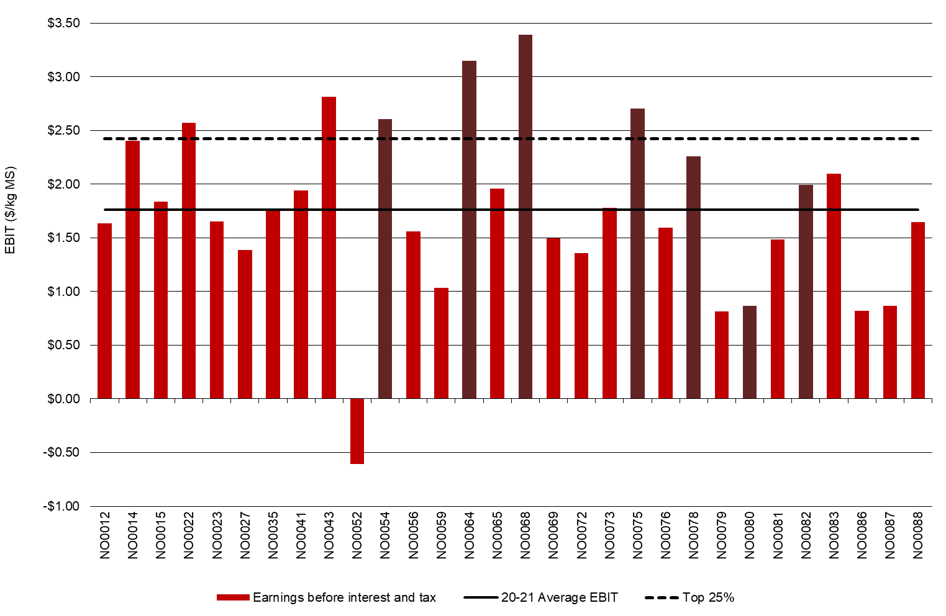

Return on total assets and equity

Average ROTA for North participants continued to improve at 6.0 per cent in 2020-21, compared to last year’s 4.1 per cent and -1.7 per cent in 2018-19 (Figure 17). The 26 farms that participated in both recent years also posted ROTA of 6.0 per cent, up from 4.4 per cent in 2019-20. This reflected favourable seasonal conditions, lower water prices and lower purchased feed costs.
The average value of total assets was about $7.6 million in 2020-21, an increase of 35 per cent from the previous year. The land values in north east Victoria increased substantially. Owned water assets contributed 27 per cent to the total farm assets including leased land and water, lower than last year’s 31 per cent mainly due to higher share of land and buildings in 2020-21. The ROTA of some farmers in Zone 7 was constrained by the high capital value of their water holding. Appendix E shows the standard values for water.
On average, the total value of owned water (HRWS, LRWS and groundwater) decreased by eight per cent in 2020-21 compared with previous year. The total owned water also decreased from 24,989 ML (892 ML/farm) to 23,086 ML (855 ML/farm). The average capital value of water was $4,718/ML in 2020-21 compared to $4,254/ML last year.
For the 25 participant farms in both years with water holdings, the value of owned water assets declined by five per cent due to lower total water holding (21,938 ML in 2020-21 and 24,498 ML in 2019-20). Some farmers opted to lease water rather than own water shares.
The average ROTA of the top performing farms was 10.3 per cent compared to top group’s average of 7.7 per cent in 2019-20.
Return on equity reflects the various capital structures of businesses in the North. The average ROE this year improved from 3.7 per cent last year to 7.5 per cent in 2020-21 (Figure 18).
Almost all farms (97 per cent) posted positive ROE compared to 83 per cent in 2019-20 and 32 per cent in 2018-19. Four in five farms (80 per cent) have recorded a ROE higher than their ROTA, compared to two-thirds last year. A higher ROE than ROTA indicates that the return on the additional asset was worth more than the cost of financing it.
While average equity improved to $5.1 million/farm, an 11 per cent increase from $4.6 million/farm in 2019-20, the average equity percentage remained constant at 68 per cent due to an increase in average liabilities. Average farm liabilities rose five per cent from $1.79 million to $1.89 million year-on-year. For the same 26 farms in both years, equity increased from $4.9 million to $5.5 million (13 per cent increase), and liabilities increased by seven per cent. The increase in liabilities was mostly for capital purchases to replace equipment, investment in feeding out infrastructure and for upgrades to milking and irrigation plant.
The top performing group had an average of 14.1 per cent ROE compared to last year’s top group of 9.8 per cent.
FIGURE 17. ROTA – NORTH
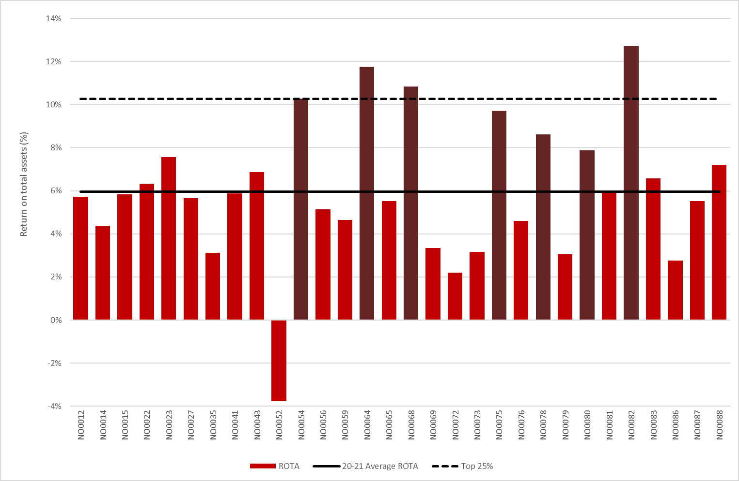
FIGURE 18. ROE – NORTH
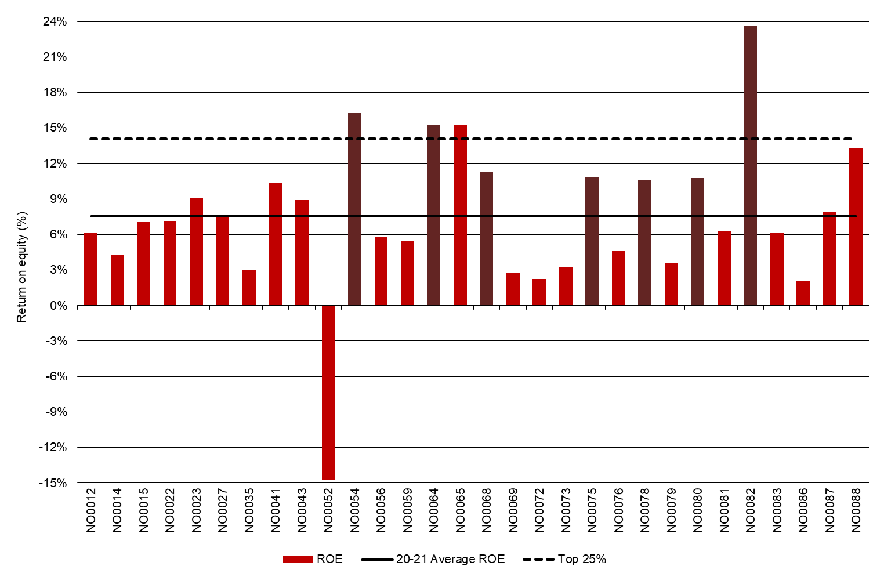

Feed consumption and fertiliser
Farms in the North used a wide range of feeding systems. Reflecting the trend of higher priced water and lower rainfall, the pasture feedbase in the North has changed in recent years from mainly perennial to annual pastures. Directly grazed pasture accounted for an average of 37 per cent of total ME with a range of 12 per cent to 69 per cent. The average fertiliser use on the milking area was 167 kg/ha (compared to 132 kg/ha in 2019-20).

Feed consumption

On average, North farms sourced 37 per cent of their ME from directly grazed pasture, compared to 36 per cent in 2019-20. Five of the 30 farms had less than 25 per cent of diet from directly grazed pasture. Grazed pasture supplied 50 per cent or more ME consumed on six farms (20 per cent of farms) compared to five farms (17 per cent of farms) in 2019-20.
Of the remaining ME consumed, on average 31 per cent were concentrate, 16 per cent silage, 15 per cent hay and a small proportion of ‘other feed’ (Figure 19).
The favourable seasonal conditions to graze and conserve feed were reflected in the reduced quantity of purchased feed fed and an increase in consumption of homegrown silage and hay. Purchased feed fed on milking area decreased from 4 t DM/cow last year to 3.5 t DM/cow this year and feeding of homegrown silage and hay increased by 11 per cent and 17 per cent, respectively. The 26 farms in both years also purchased 3.5 t DM/cow of feed compared to their purchases of 3.9 t DM/cow last year and increased the feeding of homegrown silage by 14 per cent and hay by 42 per cent.
For the top performing farms, the ME consumed from grazed pasture has been trending down. This year, grazed pasture provided 36 per cent of ME consumed compared to 42 per cent recorded in 2019-20, 51 per cent in 2018-19 and 54 per cent in 2017-18 for Top 25%.
The characteristics of the feeding system in the North were predominately moderate to high bail. Reflecting the trend of higher priced water and lower rainfall, the pasture feedbase in the North has changed in recent years from mainly perennial to annual pastures. On average, 70 per cent of pasture feedbase this year was annual pasture, with 11 farms having at least 85 per cent annual pasture.
On the milking area, estimated homegrown feed increased by 26 per cent from 6.6 t DM//ha in 2019-20 to 8.3 t DM/ha in 2020-21, of which 6.3 t DM/ha was grazed pasture (Figure 20). The 26 farms surveyed in both years recorded homegrown feed 8.2 t DM/ha on milking area.
Almost all farmers (90 per cent) this year were able to conserve feed on the milking area compared to 73 per cent last year; the average was two t DM/ha compared to 0.9 t DM/ha year-on-year. The 26 farms in both years conserved similar quantity of feed on the milking area with 2.1 t DM/ha.
The Top 25% conserved feed at slightly less quantity (1.9 t DM/ha) than the average. Their grazed pasture consumption was higher, at 6.8 t DM/ha higher than the top performers last year (6.4 t DM/ha).

FIGURE 19. SOURCES OF WHOLE FARM METABOLISABLE ENERGY – NORTH
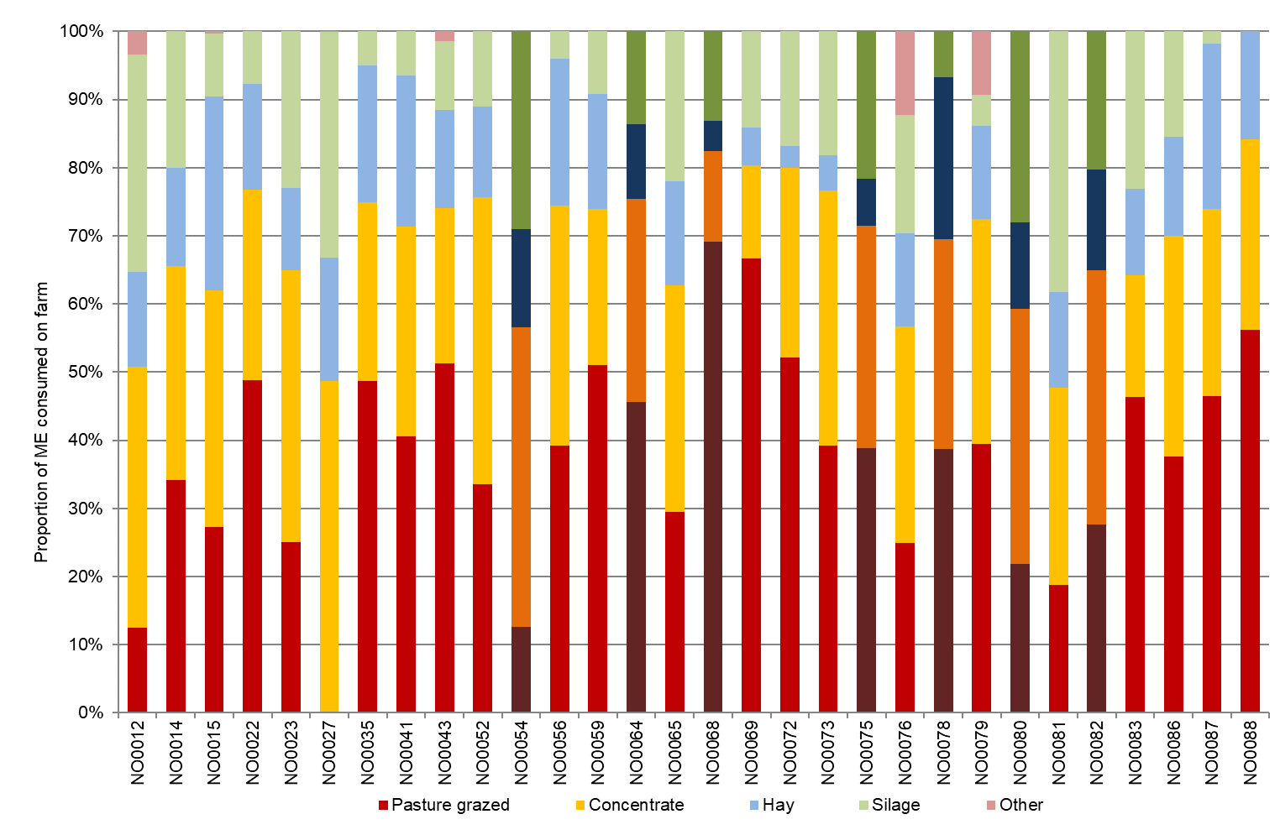

FIGURE 20. ESTIMATED TONNES OF HOMEGROWN FEED REMOVED – NORTH
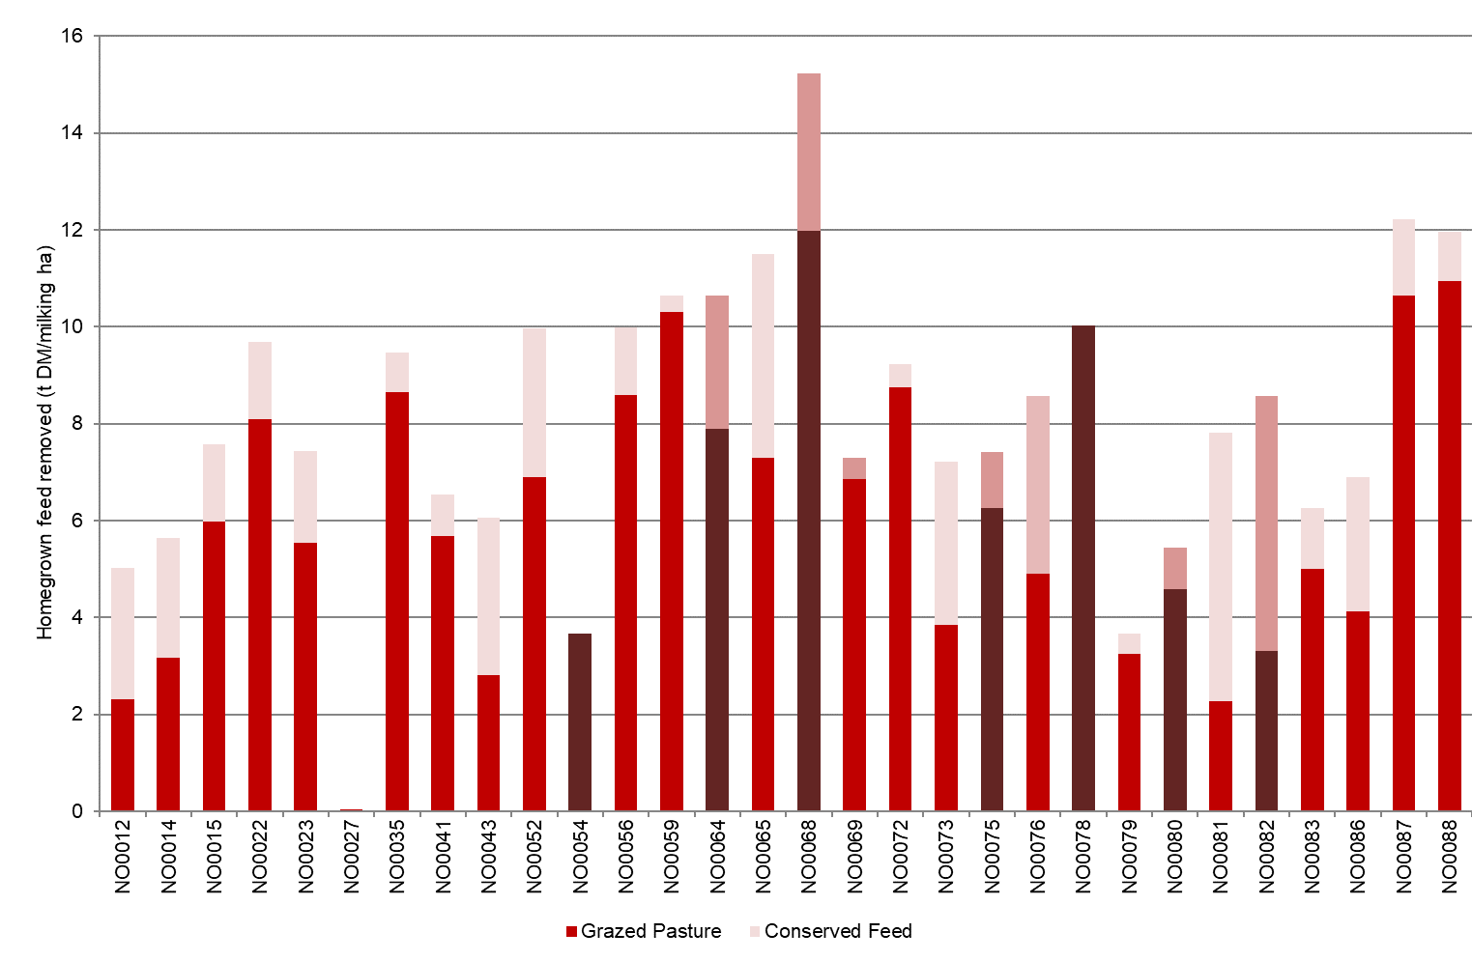
Fertiliser application

Almost all farms in the North applied fertiliser to their crops and pasture (Figure 21) on the milking area.
The average fertiliser application was 162 kg/ha, an increase of 22 per cent from last year, following a decreasing trend between 2017-18 and 2019-20. Nitrogen and phosphorus were the commonly applied nutrients. Application of all nutrients increased from last year, with large rises in potassium and nitrogen (42 per cent and 30 per cent, respectively). The 26 farms surveyed in both years applied on average 161 kg/ha of which 70 per cent was nitrogen.
The Top 25% increased their fertiliser application this year by 60 per cent to 214 kg/ha, compared to last year’s top group application rate of 135 kg/ha.
The values for Figure 20 and 21 can be found in Appendix Table B2.

FIGURE 21. NUTRIENT APPLICATION – NORTH
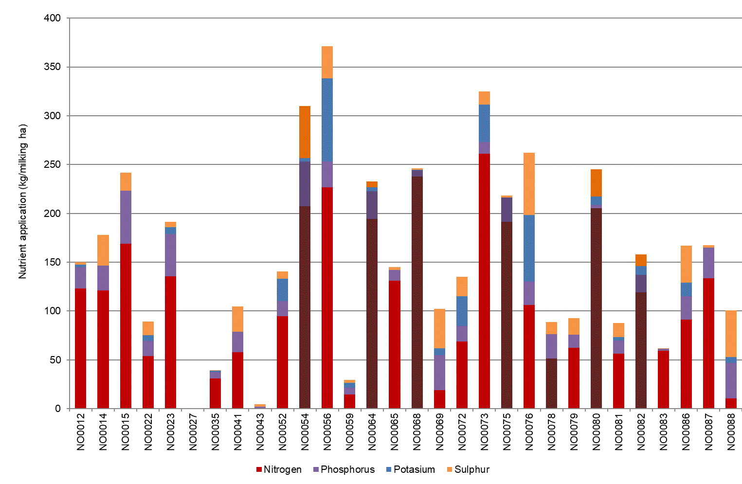

Part Three: The South West

Seasonal conditions
The carryover effect from good seasonal conditions experienced in early winter 2020, helped increase pasture production into spring 2020. The good seasonal conditions for the remainder of 2020-21 supported continued good pasture and crop growth. Homegrown feed increased this season and more than half of the participants (15 farms) grazed and conserved more pasture than the previous year.

On average, participating farms in the South West received 110 per cent of their long-term average annual rainfall in 2020-21 (Figure 22). The timing of the rainfall (Figure 3) shows that one-third of the rainfall fell during the months of August, September and October before conditions turned dry at the end of spring 2020. January rainfall increased to around 100 mm on average, similar to those totals seen for the months of August, September, and October. A dry autumn 2021 was followed by good rainfall in May and June.
Farms entered the season with mild conditions in winter 2020, which saw good pasture growth. It then became wetter from late August through to mid-September, with waterlogged soils and slower pasture growth. As spring 2020 progressed many dairy farmers were able to achieve good pasture, hay, and silage yields. Fertiliser rates increased at this time to assist pasture yields. Average fodder conservation increased slightly (2.3 t DM/ha, compared to 2.2 t DM/ha in 2019-20) leading to an average increase in feed reserves (165 t DM per farm on average, compared to 148 t DM per farm in 2019-20).
A mild 2021 summer and good rainfall events across most of the region, saw good summer pasture growth and excellent forage crops. For some farms, this allowed pasture growth to extend longer than in previous years.
Lower than long-term average rainfall during autumn 2021 was offset in some areas due to good soil moisture extending from the January rainfall event. This led to reasonable pasture cover and growth heading into winter.

FIGURE 22. ANNUAL RAINFALL AND LONG-TERM AVERAGE RAINFALL – SOUTH WEST
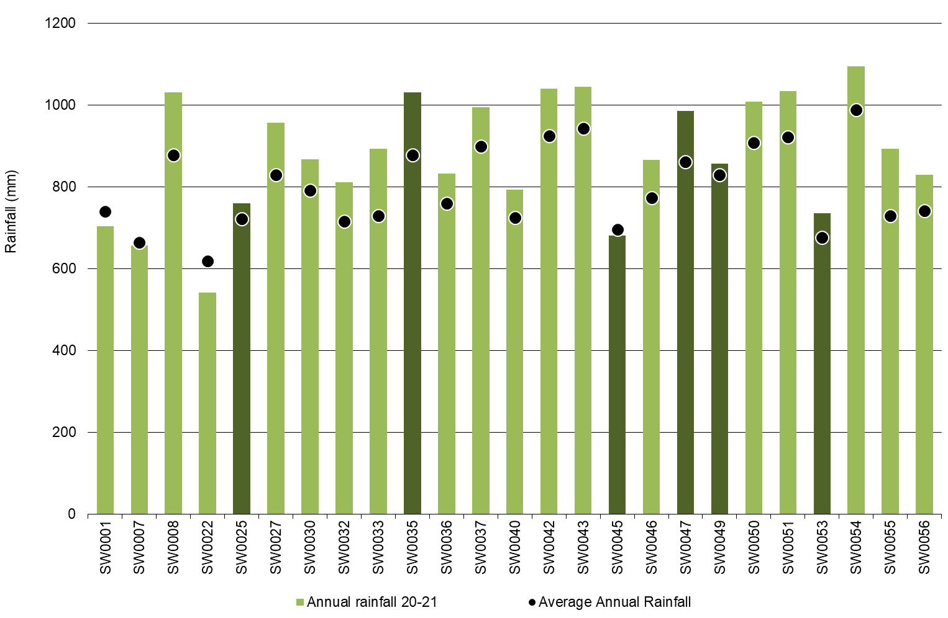

Whole Farm Analysis
Average EBIT was $2.04/kg MS in 2020-21, a 12 per cent increase from the previous year. The milk price was lower, but farms benefitted from higher livestock prices as well as reducing their variable costs. This was achieved through a combination of lower feed prices and reduced expenditure on homegrown feed costs. The growth in land values constrained the average ROTA result which decreased from 5.8 per cent in 2019-20 to 5.5 per cent in 2020-21.

Key whole farm physical parameters for South West farms are presented in Table 7. The Q1 – Q3 range shows the band in which the middle 50 per cent of farms sit for each parameter.
All 25 participating farms in the South West were the same participants as the previous year. While a small number of farms purchased land, this was mostly area previously leased by the farmer and therefore the usable area remained steady at 335 hectares compared to 333 in 2019-20. Average herd size was 373, similar to 369 cows milked in 2019-20, and milking cows per hectare remained stable at 1.1.
Farms in the Top 25% were characterised by higher milk production (measured per cow and per hectare), and higher labour efficiency (based on cows/FTE and kg MS/FTE). Five of the six farms comprising the Top 25% in 2019-20, were in the same group in 2020-21.

TABLE 7. FARM PHYSICAL DATA – SOUTH WEST
Farm physical parameters | South West average | Q1 to Q3 range | Top 25% average
Annual rainfall 20-21 (mm) | 878 | 793 - 1,009 | 841
Herd size | 373 | 216 - 505 | 470
Total water use efficiency (t DM/100mm/ha) | 0.7 | 0.6 - 0.9 | 0.8
Total usable area (hectares) | 335 | 165 - 431 | 411
Milking cows per usable hectare | 1.1 | 1.0 - 1.2 | 1.2
Milk solids sold (kg MS /cow) | 526 | 489 - 564 | 571
Milk solids sold (kg MS /ha) | 602 | 509 - 664 | 700
Homegrown feed as % of ME consumed | 68% | 63% - 73% | 66%
Labour efficiency (cows / FTE) | 99 | 85 - 107 | 109
Labour efficiency (kg MS / FTE) | 51,787 | 43,423 - 61,672 | 61,535

Milk solids sold

On average, South West DFMP farms increased their milk solids sold on a total, per cow and per ha metrics. Total milk production (204,000 kg MS per farm) increased by four per cent on average as 16 of the 25 farms (64 per cent) produced more milk than the previous year. Of the 16 farms that increased their total milk production, 10 milked more cows in 2020-21 compared to 2019-20 and over half increased their feed intake per cow (grazed pasture plus supplements). This suggests that for those farms that increased milk production (total and per cow production), was due to a combination of more cows milked and increased feed intake.
On a per hectare and per cow basis, milk production increased by two per cent and four per cent, respectively. Milk production per cow increased to 526 kg MS/cow, up from 516 kg MS/cow the previous year (Figure 23).
Milk production per hectare also increased to 602 kg MS/ha, up from 577 kg MS/ha in 2019-20.
The months with the highest milk solids sold in the South West were August, September, and October 2020 (Figure 10). There was a shoulder period on either side of these months with approximately 50 per cent of milk solids sold occurring between July 2020 and November 2020.
The top performing group sold more milk per cow and per ha than the average, and more than the top performing group last year for both metrics.

FIGURE 23. MILK SOLIDS SOLD – SOUTH WEST
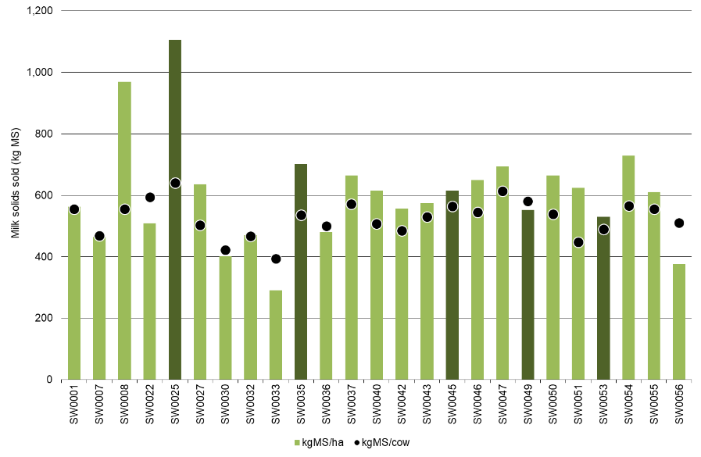
Gross farm income

Average gross farm income was $7.79/kg MS in 2020-21. This was a two per cent decrease from $7.98/kg MS in 2019-20.
South West participants derived more of their income from livestock trading than the previous year, with livestock trading profit accounting for 13 per cent of gross farm income, compared to nine per cent in 2019-20. Higher livestock prices for cull cows in the domestic market as well as favourable trading conditions for export heifers helped livestock trading to increase from $0.74/kg MS in 2019-20 to $1.04/kg MS in 2020-21. Some farmers also held onto their young stock as a strategy to diversify their income and grow their livestock inventories.
This diversification in farm income helped to compensate for the seven per cent decrease in milk price. On average, the milk price was $6.68/kg MS in 2020-21. Figure 24 and Table 8 shows most participants received a milk price in the range of $6.56/kg MS to $6.82/kg MS, as measured by Q1 to Q3.
Other farm income was $0.08/kg MS which was income from sales of feed.
Farms that were in the Top 25% in the South West received an average milk price of $6.88/kg MS, compared with $7.32/kg MS recorded for the Top 25% in 2019-20.

FIGURE 24. GROSS FARM INCOME – SOUTH WEST
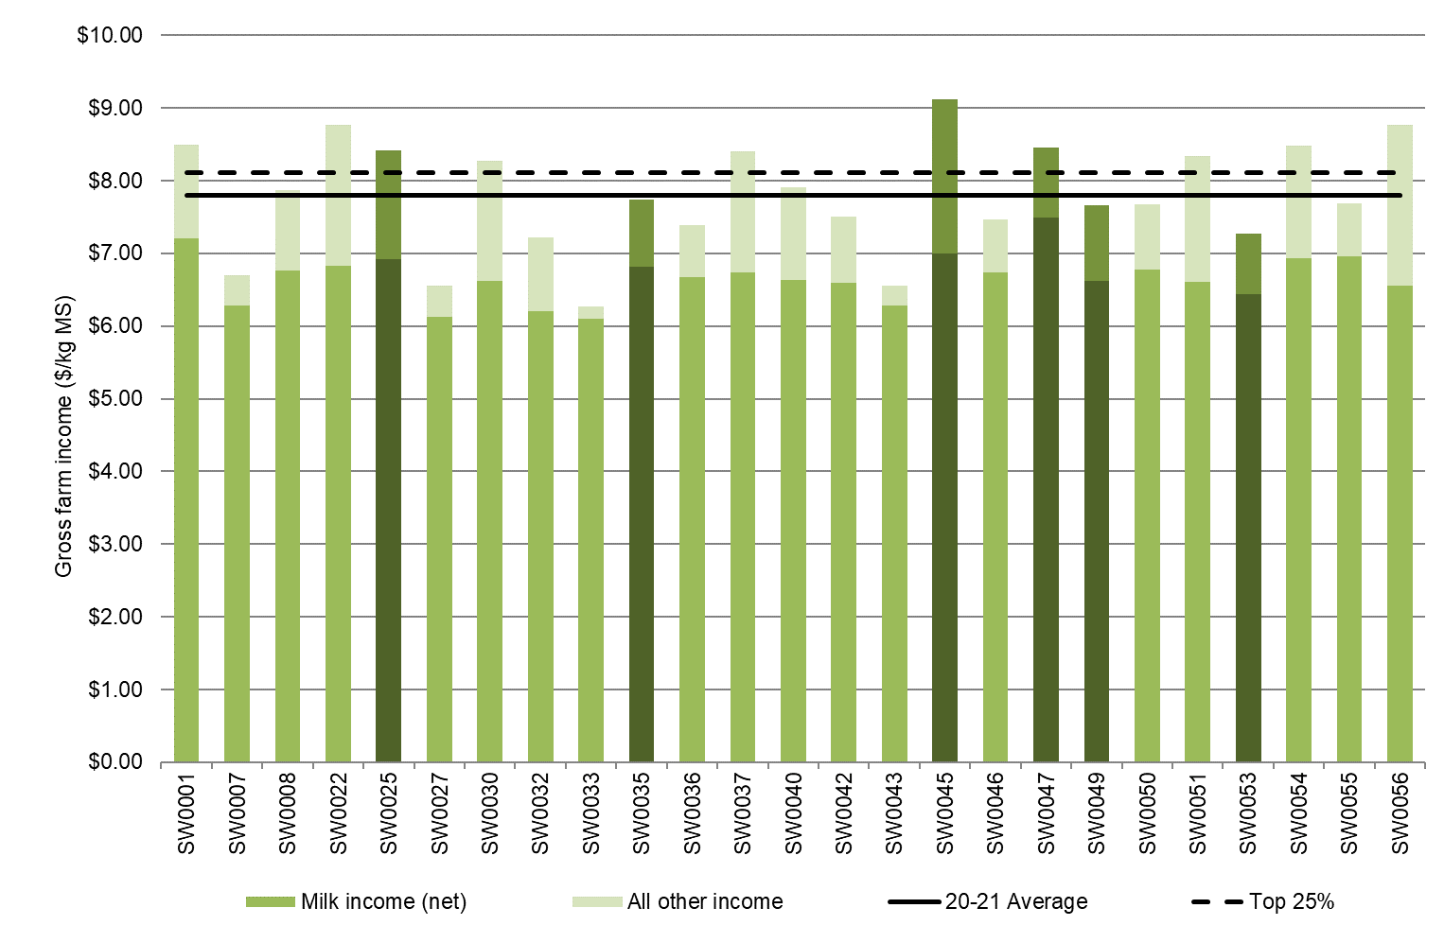

Variable costs

Variable costs decreased on per kg MS in 2020-21, from $3.52/kg MS in 2019-20 to $3.06/kg MS in 2020-21 (Table 8). Average variable costs on a total dollar basis also decreased from $722,000 per farm to $650,000 per farm. Farmers decreased their expenditure to compensate for the lower milk price. The reduction in certain individual cost categories showed that it was a mix of lower input prices and reduced spending that contributed to the lower variable costs in 2020-21.
The main component of variable costs were feed costs which accounted for 43 per cent of variable and overhead costs this year. Last year, feed costs accounted for 48 per cent of total costs. The lower feed costs in 2020-21 (16 per cent decrease from the previous year) came from lower purchased feed costs (21 per cent decrease) and homegrown feed costs (6 per cent decrease).
Purchased feed costs contributed the largest component of the decrease in variable costs in 2020-21. Lower feed prices were the driver as the amount of purchased feed fed remained similar. The price of concentrates fell from $490/t DM in 2019-20 to $421/t DM in 2020-20. All but two farms had lower concentrate price than the previous year. The average amount of concentrates purchased was 764 t DM/farm (or 1.9 t DM/cow) and was unchanged from 2019-20. The average hay price fell from $140/t DM to $112/t DM. Of the 13 farmers who purchased hay, nearly all obtained a lower price. For the small number of farmers who purchased silage in 2020-21, the average price was $155/t DM, similar to 2019-20.
Homegrown feed costs were six per cent lower in 2020-21 compared to the previous year, mainly due to lower pasture improvement and cropping and fertiliser expenses. There was less money spent on re-sowing pastures (seed and sowing costs), as farmers were able to capitalise on the good seasonal conditions.
Changes to feed inventory are considered feed costs and as such, negative inventory changes of -$0.19/kg MS results in a reduction in feed cost. Feed inventory was -$0.22/kg MS in 2019-20. Fodder reserves increased by an average of 165 t DM per farm, with 18 of the 25 farms increasing their inventories in 2020-21.
Herd and shed costs were $0.57/kg MS in 2020-21, the same as that recorded in 2019-20.

FIGURE 25. VARIABLE AND OVERHEAD COSTS – SOUTH WEST
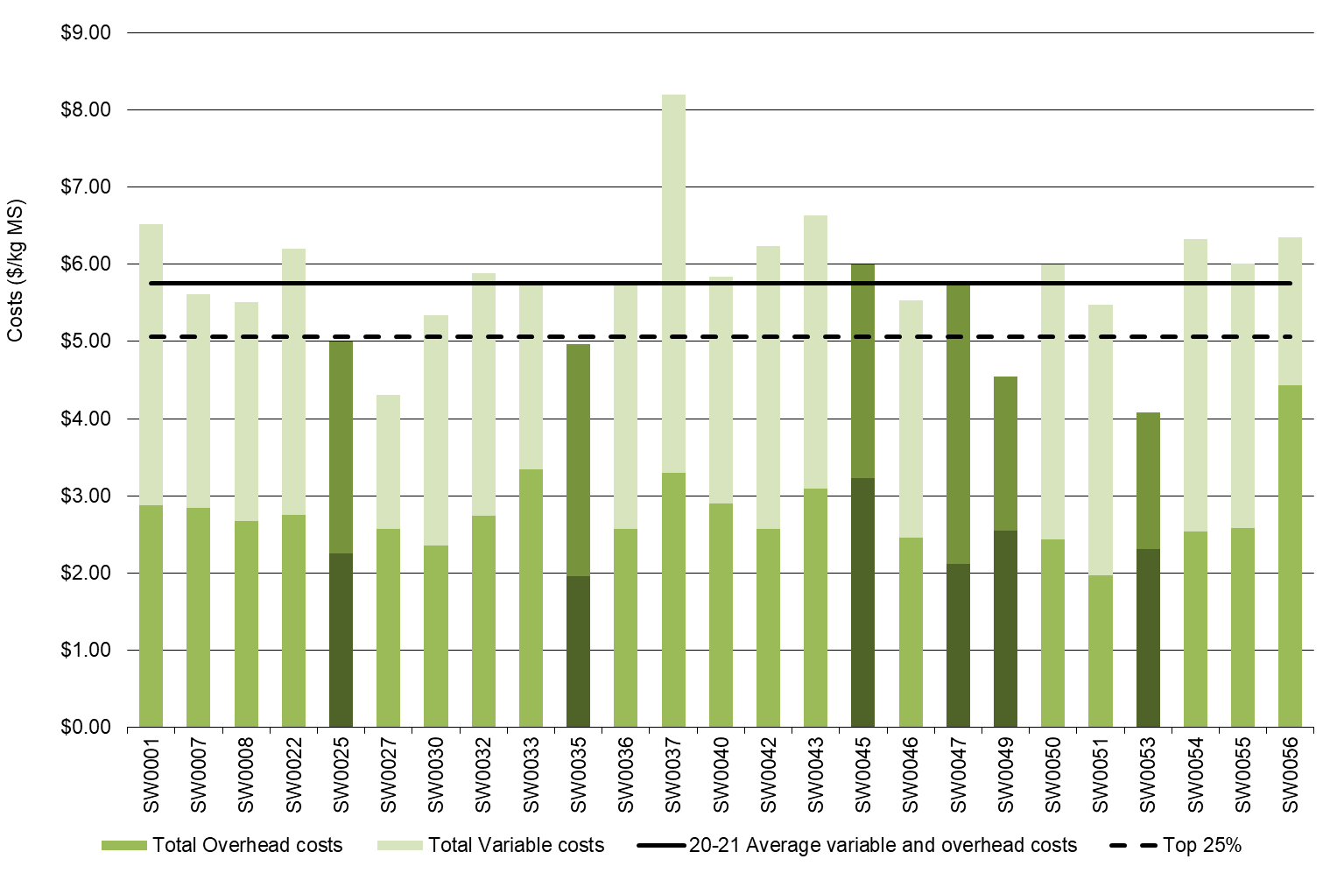

Overhead costs

Overhead costs increased by two per cent in 2020-21, up to $2.70/kg MS. This was mainly due to increases in cash overhead costs, rather than non-cash costs.
Last year many farmers capitalised on the favourable operating conditions and attended to delayed repairs and maintenance. This trend continued in 2020-21 as farmers made use of good cash flows to upgrade tracks, laneways, and irrigation infrastructure. Benefits of some of these repairs and maintenance are likely to be seen for many years, however the costs have been attributed to the 2020-21 performance. Half of the South West sample increased their repairs and maintenance costs leading to an overall increase of four per cent, to $0.49/kg MS in 2020-21 (Table 8).
Increases in employed labour costs also contributed to the higher overhead costs in 2020-21. Employed labour increased by five per cent to $0.63/kg MS in 2020-21, from $0.60/kg MS in 2019-20. The average employed full-time equivalent (FTE) was 2.2 FTE per farm in 2020-20, higher than 2.1 per farm FTE in 2019-20. The owner or family labour (imputed labour) was unchanged at 1.7 FTE per farm, and the average cost was $0.90/kg MS.
Farms in the Top 25% had $0.30/kg MS lower overhead costs than the South West average. The average of this top group was $2.40/kg MS in 2020-21, which was higher than $2.29/kg MS recorded by the top group in 2019-20.
Figure 25 shows the breakdown of total farm costs as variable and overhead costs per kg MS. The breakdown of individual farm costs can be found in Appendix Tables C4 and C5.

TABLE 8. AVERAGE FARM FINANCIAL PERFORMANCE – SOUTH WEST
 | South West average  $/kg MS | Q1 to Q3 range  $/kg MS | Top 25% average  $/kg MS
INCOME
Milk income (net) | $6.68 | $6.56 - $6.82 | $6.88
Livestock trading profit | $1.04 | $0.73 - $1.41 | $1.14
Other farm income | $0.08 | $0.02 - $0.10 | $0.09
Gross farm income | $7.79 | $7.39 - $8.41 | $8.11
VARIABLE COSTS
Herd cost | $0.31 | $0.26 - $0.35 | $0.29
Shed cost | $0.26 | $0.20 - $0.31 | $0.22
Homegrown feed cost | $1.02 | $0.81 - $1.31 | $0.88
Purchased feed and agistment | $1.65 | $1.36 - $2.05 | $1.51
Feed inventory change | -$0.19 | -$0.37 - $0.01 | -$0.24
Water inventory change | $0.00 | $0.00 - $0.00 | $0.00
Total feed costs | $2.48 | $2.21 - $2.96 | $2.15
Total variable costs | $3.06 | $2.77 - $3.53 | $2.66
GROSS MARGIN | $4.74 | $4.11 - $5.19 | $5.45
OVERHEAD COSTS
Employed labour | $0.63 | $0.17 - $0.89 | $0.60
Repairs and maintenance | $0.49 | $0.31 - $0.51 | $0.54
All other overheads | $0.33 | $0.25 - $0.41 | $0.28
Imputed labour | $0.90 | $0.42 - $1.01 | $0.63
Depreciation | $0.35 | $0.25 - $0.42 | $0.35
Total overhead costs | $2.70 | $2.44 - $2.88 | $2.40
Variable and overhead costs | $5.75 | $5.65 - $6.28 | $5.06
EARNINGS BEFORE INTEREST AND TAX | $2.04 | $1.62 - $2.78 | $3.05

Cost of production

Cost of production gives an indication of the cost of producing a kg MS. It is calculated as variable plus overhead costs and accounts for changes in fodder, water, and livestock inventory.
The cost of production with inventory change was $5.73/kg MS in 2020-21, a 10 per cent decrease from $6.35/kg MS in 2019-20. Most farms spent between $5.48/kg MS and $6.10/kg MS as shown by the Q1 to Q3 range in Table 9.

TABLE 9. COST OF PRODUCTION – SOUTH WEST
Farm costs | South West average  $/kg MS | Q1 to Q3 range  $/kg MS | Top 25% average  $/kg MS
Cash cost of production | $4.69 | $4.16 - $5.33 | $4.31
Cost of production (excl inventory changes) | $5.94 | $5.51 - $6.54 | $5.30
INVENTORY CHANGE
+/- feed and water inventory changes | -$0.19 | -$0.37 - $0.01 | -$0.24
+/- livestock inventory changes minus purchases | -$0.02 | -$0.23 - $0.12 | $0.07
Cost of production (incl inventory changes) | $5.73 | $5.48 - $6.10 | $5.13

Earnings before interest and tax

The South West farms recorded a strong EBIT performance at $2.04/kg MS in 2020-21. The EBIT increased 12 per cent from $1.83/kg MS in 2019-20 and was the fourth highest in the 15-years of DFMP, when the effects of inflation are excluded. All but one farm recorded a positive EBIT in 2020-21 (Figure 26). Thirteen farms recorded a higher EBIT performance than the previous year.
The improved EBIT performance was supported by easing variable costs and strong livestock prices. Farmers responded to the seven per cent decrease in milk price and eased their variable costs. Meanwhile, farmers increased their expenditure on overhead costs, mainly in the areas of repairs and maintenance and employed labour. As many farmers had positive cash flows, they were able to purchase inputs and make repairs when required rather than constraining overhead costs as seen in tight cash flow years. Many farmers were able to make timely decisions and were better able to capitalise on the good operating conditions.
The Top 25% recorded an EBIT of $3.05/kg MS in 2020-21, up from $2.87/kg MS the previous year. They received a higher milk price and demonstrated more efficient milk production with higher milk solids sold at lower costs, compared to the average.

FIGURE 26. EBIT - SOUTH WEST
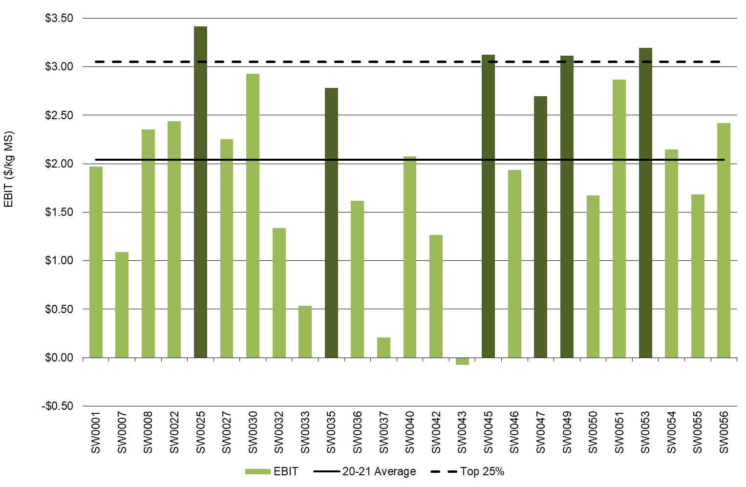

Return on total assets and equity

The returns from the total assets under management slightly decreased from 5.8 per cent in 2019-20 to 5.5 per cent in 2020-21 (Figure 27). The growth in land and building asset values experienced in the South West region was reflected in the valuation of DFMP participant’s asset base. In many cases, the land values increased by around $2,500/ha in 2020-21, depending on the farm location, to align with recent market sales and the Valuer General dataset. While the EBIT increased between years, the higher land values on South West farms constrained the ROTA and means that on average, the returns were lower than in 2019-20.
All but two farms posted a positive ROE indicating that their farm business was worth more at the end of the year than a year ago (Figure 28). The average ROE was 9.1 per cent, and 20 of the 25 farms recorded a higher ROE than their ROTA. This indicated that the return on the additional assets was worth more than the cost of accessing it. These farmers have been able to grow their business.
The top performing group also experienced lower ROTA and ROE than the same group in 2019-20. The top performing group posted a ROTA of 9.2 per cent and ROE of 9.1 per cent in 2020-21 (Figure 27 and 28). Last year, this group had a ROTA of 9.8 per cent and a ROE of 21.7 per cent.
Average equity was $4.49 million (75 per cent), an increase from $3.48 million (or 68 per cent) in 2019-20. The improved equity position was realised on 19 of the 25 farms, as most (15 farms) were able to pay down principal to reduce their liabilities. This reflected a combination of carrying over more feed reserves, more livestock, greater farm investments and/or growth in land values. Net farm income was $1.61/kg MS in 2020-21, up from $1.29/kg MS in 2019-20.
Figures 27 and 28 were calculated excluding capital appreciation.

FIGURE 27. ROTA - SOUTH WEST
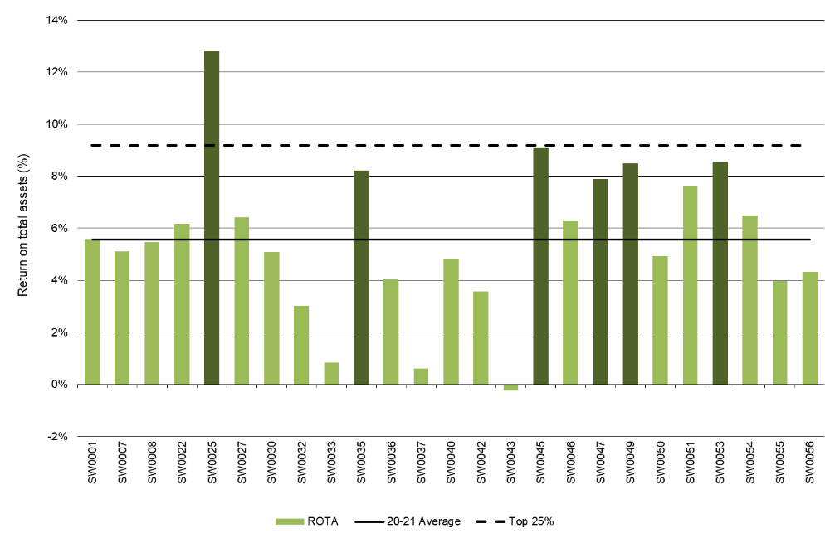
FIGURE 28. ROE - SOUTH WEST
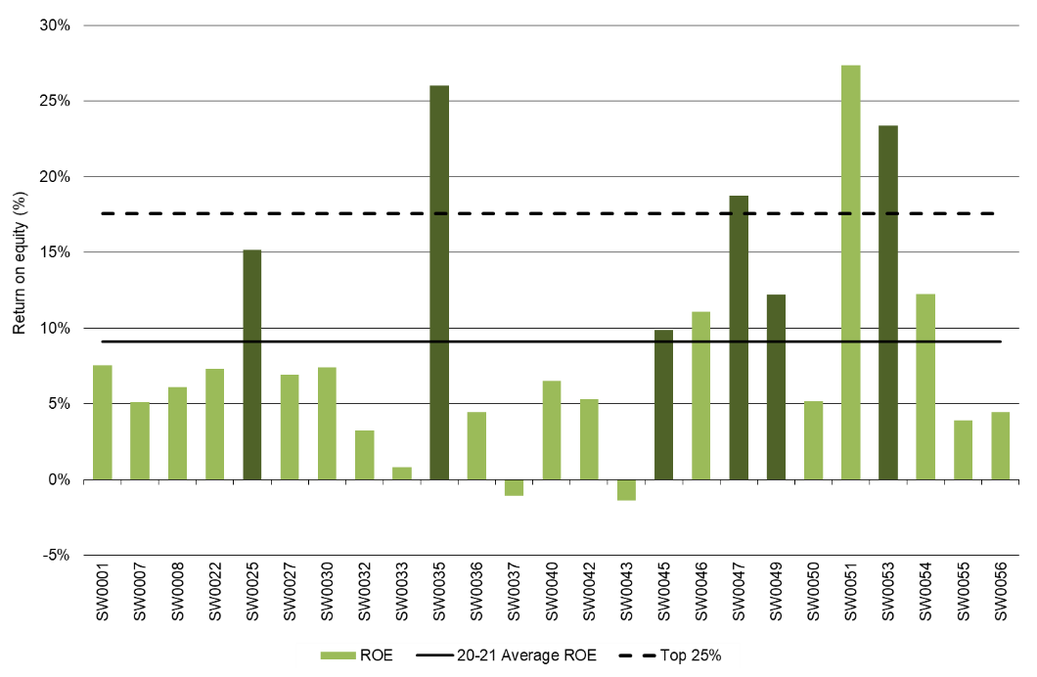

Feed consumption and fertiliser
Half of the South West farms (13 farms) harvested greater quantities of homegrown feed, contributing to an average three per cent increase in total homegrown feed removed in 2020-21 compared to 2019-20. Lower rates of nitrogen fertiliser were applied in 2020-21 and some farmers (10 farms) applied lime for the first time in several years.

Feed consumption

On average, grazed pasture constituted 50 per cent of the ME consumed on South West farms in 2020-21 (Figure 29). This was similar to 49 per cent recorded in 2019-20. The favourable seasonal conditions supported good crop and pasture growth to maintain similar amounts of pasture available between years.
Concentrates were the most used supplement, accounting for 29 per cent of the diet, with 1.9 t DM/cow fed. More than half of the farms (14 farms) reduced their reliance on concentrates by an average of 0.2 t DM/cow in 2020-21.
The total supplements fed decreased from 3.9 t DM/cow to 3.7 t DM/cow in 2020-21. The lower supplements came from reduced homegrown fodder fed (1.6 t DM/cow in 2020-21 compared with 1.8 t DM/cow in 2019-20) as the amount of purchased feed remained the same at 2.1 t DM/cow on average.
Silage fed accounted for 14 per cent of the ME in the diet in 2020-21. On average, farms fed 1.3 t DM/cow, the same as the previous year. Hay accounted for five per cent of the diet with about 0.5 t DM/cow fed on average.
The characteristics of the feeding system on South West farms were predominately moderate to high bail, with grazing a main part of the cow’s diet. There were two farms feeding a low bail, one partial mixed ration and another operating a hybrid system. For nine farms, perennial pastures comprised 100 per cent of the feedbase.
Homegrown feed removed on the milking area increased by 0.2 t DM/ha in 2020-21, up to 7.1 t DM/ha (Figure 30). The increase was split evenly between extra pasture grazed and conserved. Grazed pasture increased from 4.7 t DM/ha to 4.8 t DM/ha in 2020-21, and conserved feed increased from 2.2 t DM/ha to 2.3 t DM/ha in 2020-21.
Farms in the top performing group had greater homegrown feed removed compared to the average. When compared with the top performing group last year, it was also higher reflecting higher conserved feed as grazed pasture was relatively lower. Grazed pasture was 5.3 t DM/ha in 2020-21, a decrease from 5.6 t DM/ha in 2019-20. While conserved feed was 2.5 t DM/ha, an increase from 1.7 t DM/ha in 2019-20.

FIGURE 29. SOURCES OF WHOLE FARM METABOLISABLE ENERGY – SOUTH WEST
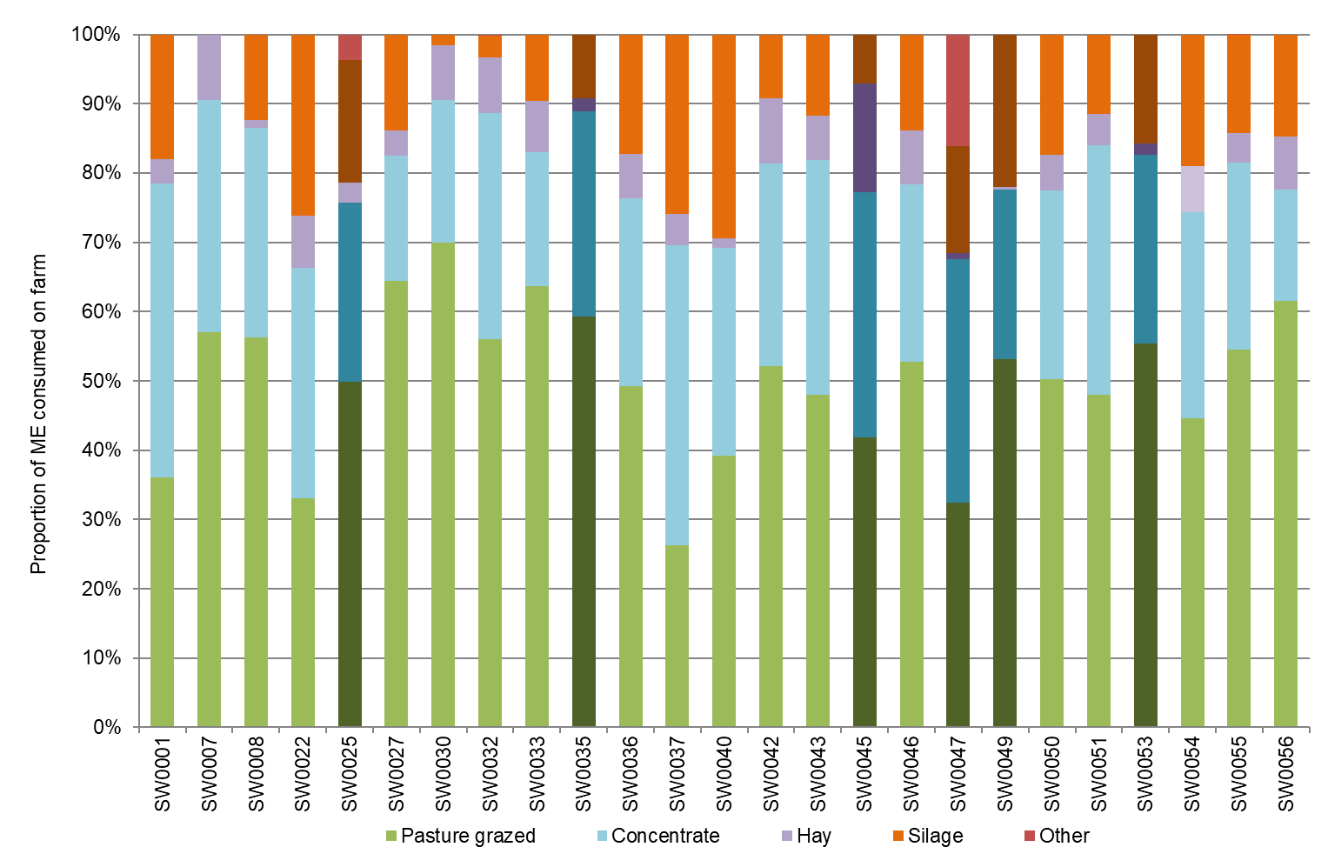

FIGURE 30. ESTIMATED TONNES OF HOMEGROWN FEED REMOVED – SOUTH WEST
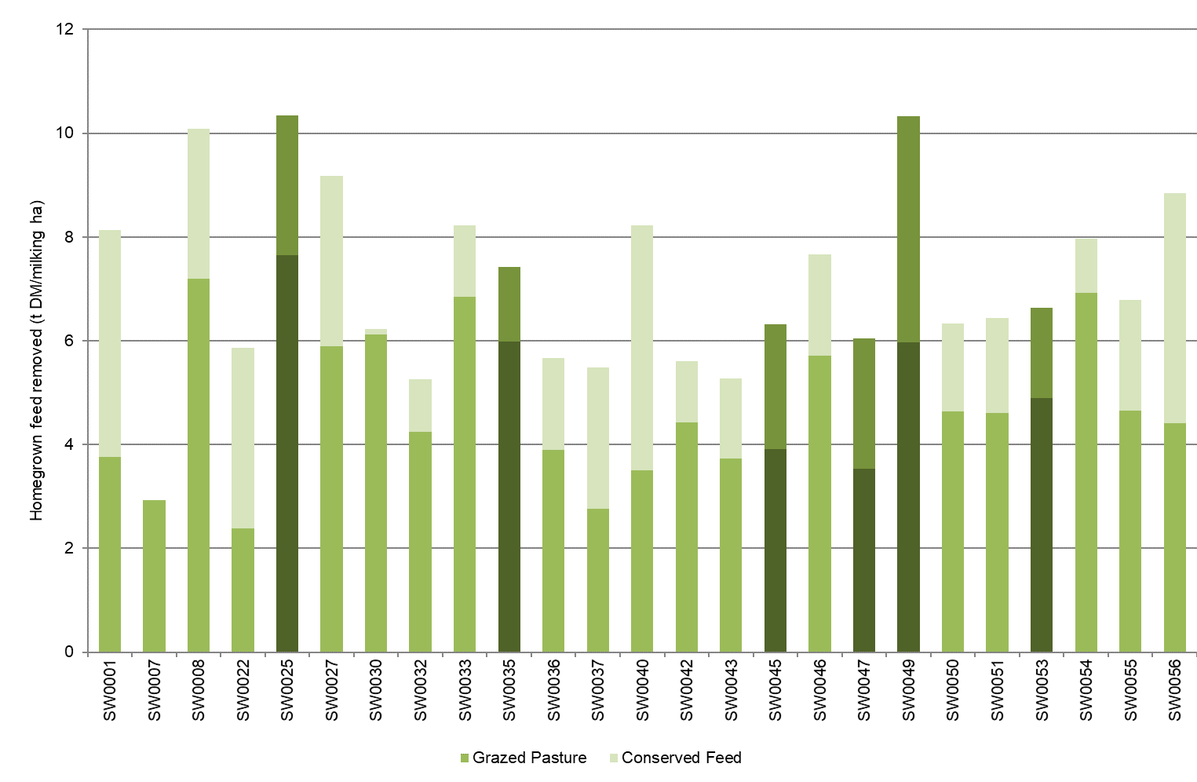

Fertiliser application

Average fertiliser application on the milking area decreased in 2020-21. The total nutrients applied decreased by three per cent from 273 kg/ha in 2019-20 to 265 kg/ha in 2020-21 (Figure 31). This was largely because of lower rates of nitrogen applied in 2020-21 compared to the previous year (an 11 per cent decrease). There were increases in all other macronutrients. Average fertiliser application was comprised of nitrogen (171 kg N/ha), phosphorus (18 kg P/ha), potassium (50 kg K/ha) and sulphur (26 kg S/ha) as shown in Figure 31. While not recorded in the DFMP fertiliser application rates, lime was applied on 10 farms in 2020-21. This was the first time in many years lime was applied due to good seasonal conditions and increased farm cash flows allowing for additional and timely application of inputs. The individual values related to Figure 31 can be found in Appendix Table C2.

FIGURE 31. NUTRIENT APPLICATION – SOUTH WEST
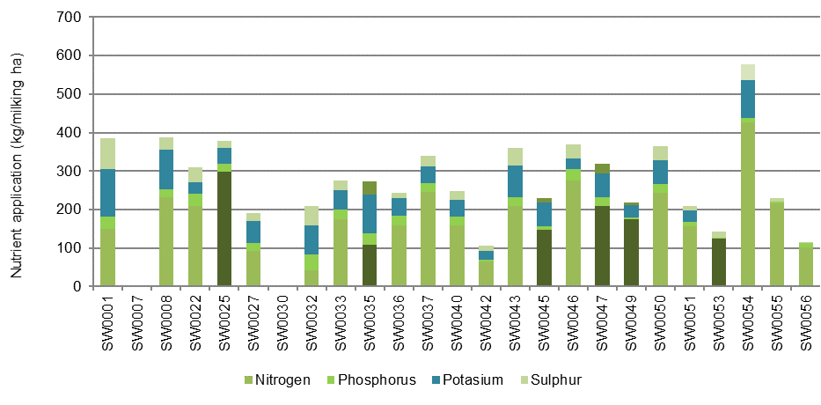

Part Four: Gippsland

Seasonal conditions
Variable seasonal conditions across dryland Gippsland reduced the ability to effectively graze pastures and harvest hay and silage. There were considerable periods of wet and dry conditions at crucial times in the season. Good water availability in the Macalister Irrigation District (MID) enabled participants to maximise direct grazing of pasture this season.

Weather conditions in Gippsland were again challenging with a wide variation in rainfall from west to east. Temperatures across Gippsland were milder than expected with a limited number of hot days mid-summer across the region.
Spring 2020 rainfall events in south and west Gippsland left some soils saturated and provided a challenge to harvest pasture either by direct grazing or by conservation. Lower amounts of pasture were conserved for silage or hay this year. A reasonable early break occurred in autumn 2021 break, but rainfall was only sufficient to maintain green pastures and provide good consistent growth until winter 2021.
The June 2021 severe weather event (storms, winds, and floods) left much of Gippsland with significantly wet soil conditions and challenges in managing pastures over winter 2021.
East Gippsland had relatively consistent rainfall events through spring which allowed for reasonable pasture conservation opportunities. Conditions over much of summer 2021 were much cooler, and in some cases drier than average. Some parts of central and east Gippsland received good rains over January and March allowing silage and hay crops to recover and autumn 2021 fodder crops to thrive.
Water availability was not a limiting factor for pasture production in the MID this season. Irrigation in the MID commenced on the 15 August 2020 with 100 per cent High Reliability water entitlement. The wet 2020 spring conditions meant that the Glenmaggie Weir spill entitlement was available up until mid-November. On 15 December, 10 per cent of Low Reliability water entitlements were announced and was increased to 20 per cent by February. Cooler but drier conditions over summer and early autumn, allowed the irrigation season to finish with 100 per cent of Low Reliability water entitlements.
The average rainfall across participating farms in Gippsland was 936 mm, which is about 106 per cent of the long-term average (Figure 32). It is important to note that many farms across Gippsland in June 2021 had 145 per cent of the long-term average June rainfall which is ‘very much above average’ at rainfall decile range 10 according to the Bureau of Meteorology.

There are two new farms for the Gippsland region in 2020-21, GI0065 and GI0066
Top 25% are shown as the darker bars in all graphs as ranked by ROTA.

FIGURE 32. ANNUAL RAINFALL AND LONG-TERM AVERAGE RAINFALL – GIPPSLAND
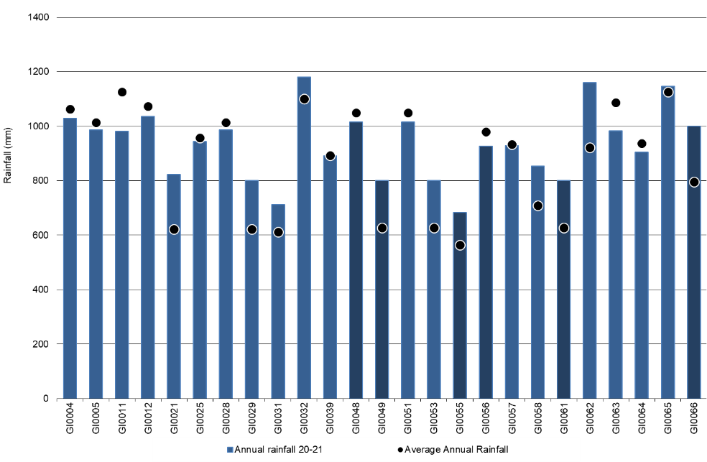

Whole Farm Analysis
Average EBIT for Gippsland participant farms was $1.78/kg MS in 2020-21, a 14 per cent decline from $2.07/kg MS in 2019-20. Participants employed a range of management strategies to maximise income and reduce costs despite a reduced milk price, higher herd and shed costs and higher overhead costs. In 2020-21, farms achieved on average a ROTA of 5.4 per cent, the fifth highest in the 15-year history of the project.

Key whole farm physical parameters for Gippsland are presented below in Table 10. The Q1 – Q3 range shows the band in which the middle 50 per cent of farms sit for each parameter.
Gippsland participants maintained herd size and stocking rate while milk production performance (kilograms of milk solids) per cow and per hectare remained steady. Stocking rate was stable at 1.9 cows/ha as was usable area at 186 ha.
The very wet conditions in spring 2020 and winter 2021 impacted on the ability of farmers to harvest silage and hay. Famers had to manage wet soils appropriately for grazing whilst mitigating damage to pastures. As a result of these conditions there was a reduction of homegrown feed as a percentage of ME consumed, down to 66 per cent from 68 per cent last year.
Labour efficiency per cow remained relatively similar at 122 cows/FTE compared to 121 cows/FTE last year. Labour efficiency increased in 2020-21 to 59,174 kg MS/FTE, up from 58,000 kg MS/FTE in 2019-20.
The Top 25% in Gippsland had a larger herd size of 330 cows, higher stocking rate of 2.1 cows/ha, and higher labour use efficiency per cow and per hectare.
The top performers also had a higher reliance on homegrown feed as a percentage of ME consumed of 69 per cent, with a slight increase in usable area to 197 ha. This proved a valuable cost control measure as discussed further in this chapter.

TABLE 10. FARM PHYSICAL DATA – GIPPSLAND
Farm physical parameters | Gippsland average | Q1 to Q3 range | Top 25% average
Annual rainfall 20-21 (mm) | 936 | 824 - 1,016 | 872
Herd size | 308 | 249 - 378 | 330
Total water use efficiency (t DM/100mm/ha) | 0.7 | 0.6 - 0.9 | 0.8
Total usable area (hectares) | 186 | 106 - 235 | 197
Milking cows per usable hectare | 1.9 | 1.4 - 2.2 | 2.1
Milk solids sold (kg MS /cow) | 485 | 450 - 551 | 476
Milk solids sold (kg MS /ha) | 924 | 632 - 1,098 | 992
Homegrown feed as % of ME consumed | 66% | 63% - 72% | 69%
Labour efficiency (cows / FTE) | 122 | 103 - 137 | 155
Labour efficiency (kg MS / FTE) | 59,174 | 47,129 - 72,273 | 72,349

Milk solids sold

In 2020-21, Gippsland DFMP farms produced an average of 485 kg MS/cow with a range of between 308 kg MS/cow and 573 kg MS/cow. Milk solids sold per ha also remained stable at 924 kg MS/ha with a range of 398 kg/ha to 2,105 kg/ha, with the range heavily dependent on climatic conditions and geographic location. Figure 33 shows the range in milk solids sold per cow and per hectare for Gippsland farms during this season, with the average of around 152,000 kg MS/farm (one per cent improvement on last year).
The Top 25% recorded a lower milk solids sold per cow (476 kg MS/cow in 2020-21) compared to the average of all participants this year and to the Top 25% last year (509 kg MS/cow in 2019-20). The range in per cow production for the top group this year was 408 kg MS/cow to 566 kg MS/cow. The farms in the Top 25% vary from year to year so this result is a combination of a reduction in per cow production as well as a comparison to a different group of farms.
Stocking rates decreased this year for the Top 25% from 2.2 cows/ha to 2.1 cows/ha, which resulted in a reduction in milk solids sold to 992 kg MS/ha compared to 1,058 kg MS/ha last year.

FIGURE 33. MILK SOLIDS SOLD – GIPPSLAND
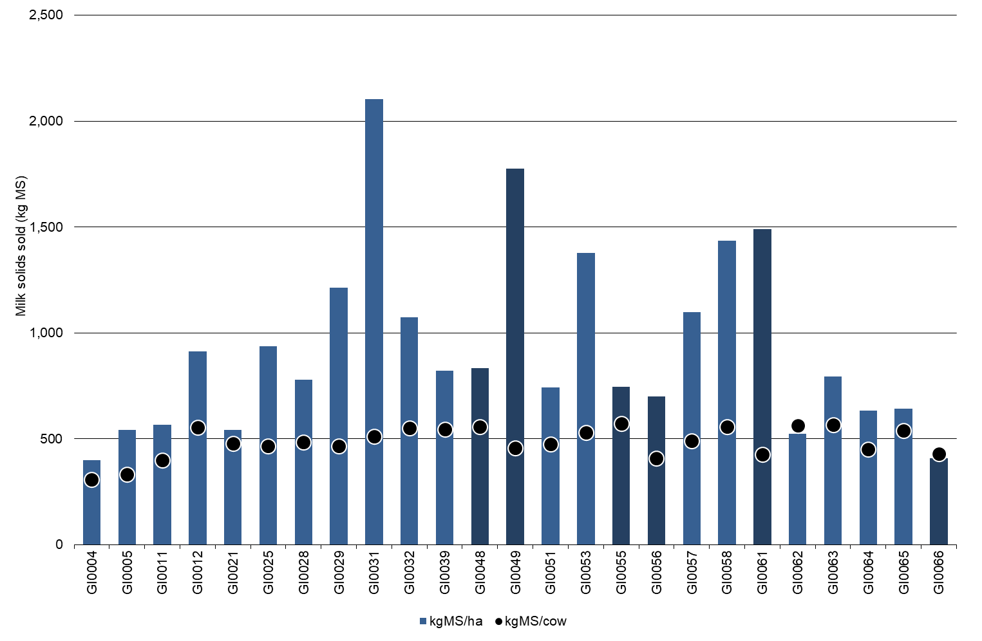
Gross farm income

Gross farm income was on average $7.24/kg MS for Gippsland participants in 2020-21. The five per cent decrease from last year’s $7.59/kg MS reflected a reduced milk price offset somewhat by an improvement in livestock trading profit.
Milk price decreased six per cent from $6.95/kg MS last year to $6.54/kg MS this year. In contrast, there was an average increase of nine per cent for livestock trading profit to $0.67/kg MS from $0.61/kg MS last year. Improved calf prices contributed to this increase as well as strong demand for export heifers. The top performing group capitalised on the improved livestock trading conditions increasing that source of income from $0.55/kg MS last year to $0.71/kg MS in 2020-21.
The lower average milk price of $6.54/kg MS in Gippsland compared to the other two regions was influenced by several factors. In general, these were mainly the seasonality of supply across the Gippsland region (supplying peak milk in spring when milk prices are slightly lower), the reliance on homegrown feed (sourcing the cheapest source of feed is often most plentiful in spring therefore pre-disposing many Gippsland farmers to producing peak milk yields in the spring period), and many farmers choosing milk processing factories that pay them to best suit their milk supply pattern, thereby reducing their exposure to higher input costs to produce a flatter milk supply curve.
The range of milk prices received in 2020-21 was between $6.18/kg MS and $7.32/kg MS (Figure 34), compared to the range in 2019-20 of $6.36/kg MS to $7.69/kg MS.
The Top 25% received an average milk price of $6.91/kg MS, a three per cent reduction from last year with a range of between $6.19/kg MS and $7.32/kg MS. This result demonstrates that milk price alone does not determine profitability and the ability to perform well each year.
Milk income accounted for 90 per cent of gross farm income for both the average of Gippsland participants and the top performing group.
Livestock trading profit contributed 9.3 per cent towards gross farm income for both the average of all Gippsland participants and the Top 25%.
Other (farm) income contributed $0.03/kg MS and $0.01/kg MS to gross farm income for the average and Top 25%, respectively. Data provided in Appendix Table D1.
FIGURE 34. GROSS FARM INCOME – GIPPSLAND
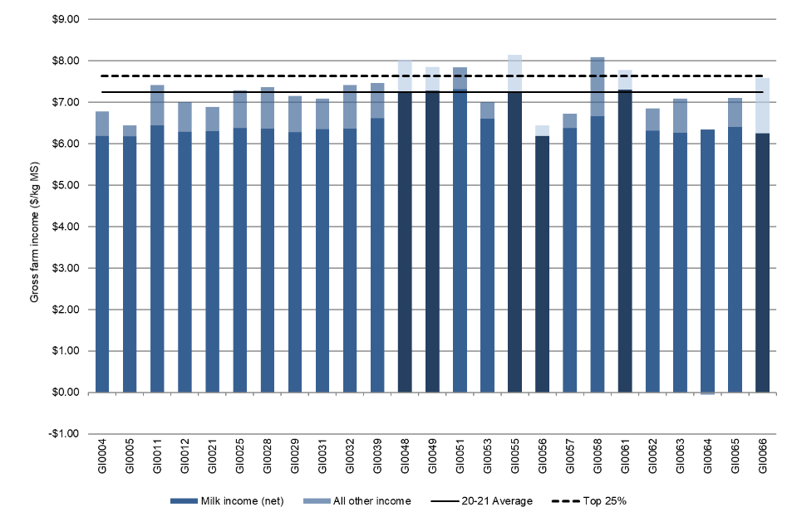
Variable costs

Variable costs in 2020-21 decreased by four per cent in Gippsland to $3.23/kg MS from $3.36/kg MS in 2019-20. This year’s variable costs ranged between $1.95/kg MS and $4.25/kg MS. The disaggregation of variable and overhead costs is shown in Figure 35.
Herd and shed costs increased on average this year for all Gippsland participants, as well as the top performing group. Herd costs rose by four per cent to $0.33/kg and by 36 per cent to $0.36/kg MS for the average and top performing group respectively, partially due to higher costs of managing cows in wet conditions and farmers placing a greater emphasis on cow breeding and general health in 2020-21.
Shed costs increased by eight per cent this year to $0.24/kg MS, with the cost of dairy power increasing by eight per cent to $0.14/kg MS. This increase was far greater in the top performing group with an increase of 29 per cent to $0.13/kg MS in their power costs.
Feed costs accounted for 82 per cent of variable costs, and 49 per cent of total costs (variable plus overhead costs).
There was an overall six per cent reduction in feed costs in 2020-21 to $2.66/kg MS, down from $2.81/kg MS in 2019-20. The reduction in costs occurred in the three key areas of homegrown feed, purchased feed and agistment, and feed inventory change. There was an 11 per cent reduction in homegrown feed costs to $0.95/kg MS, an 11 per cent reduction in purchased feed and agistment to $1.76/kg MS and improved their feed inventory.
The reduction in homegrown feed costs was a result of a reduction to $0.16/kg MS in the cost of conserved forage (hay and silage making), a 21 per cent reduction in fuel and oil costs to $0.06/kg MS as well as a reduction in irrigation costs by 16 per cent to $0.07/kg MS. There were six irrigated farms in the survey and as spill water became available in the MID this year, many reduced the amount of purchased water. When spill water became available this triggered the resetting of High reliability water entitlements to 100 per cent regardless of prior use in the 2020-21 season.
The reduction in purchased feed costs was mainly due to the lower prices paid per tonne. Overall feeding volumes increased per cow with increases occurring in the amount of silage fed per cow from both homegrown and purchased sources. The increased in silage feeding wasn’t matched with a reduction in hay feeding, so in aggregate, supplement volumes increased by eight per cent.
The Top 25% reduced their total variable costs by six per cent to $2.76/kg MS with the greatest savings in fertiliser (down 26 per cent to $0.44/kg MS) and large 63 per cent reduction in agistment costs to $0.05/kg MS. The average cost per tonne of fertiliser increased this year, so fertiliser application was carefully targeted at areas with potentially the greatest gain. Less nutrients were applied to areas outside the milking area. As the cost of nitrogen increased considerably, only modest increases were seen on the milking area.
Fodder inventory increased on average, up to -$0.05/kg MS. There was more conserved feed on 13 of the 25 participant farms at the end of the year than at the start.
Overhead costs
In Gippsland, total overhead costs in 2020-21 ranged between $1.39/kg MS and $4.56/kg MS, with a range much greater than last year. Average overhead costs rose by four per cent to $2.24/kg MS. Employed labour costs decreased by three per cent to $0.57/kg MS. The greatest increase in costs was seen in repairs and maintenance which reflected delayed expenditure in previous years and farmers having higher cash flows to undertake repairs and maintenance this year.
For the Top 25%, although their overhead costs increased by eight per cent to $1.79/kg MS, in contrast to all Gippsland results, they reported a minor two per cent increase in employed labour to $0.51/kg MS, a five per cent decrease in repairs and maintenance but a large increase in other overhead costs (did not include capital purchases) and depreciation.
Imputed or family labour for Gippsland increased on average by six per cent to $0.87/kg MS, with only a one per cent increase for the Top 25% to 0.58/kg MS in 2020-21. Figure 35 illustrates the overhead costs per kg MS.
Total overhead and variable costs for both the average of all Gippsland participants and the Top 25% reduced by only one per cent to $5.6/kg MS and $4.55/kg MS, respectively.
A breakdown of overheads costs can be found in Appendix Tables D5.

FIGURE 35. VARIABLE AND OVERHEAD COSTS – GIPPSLAND
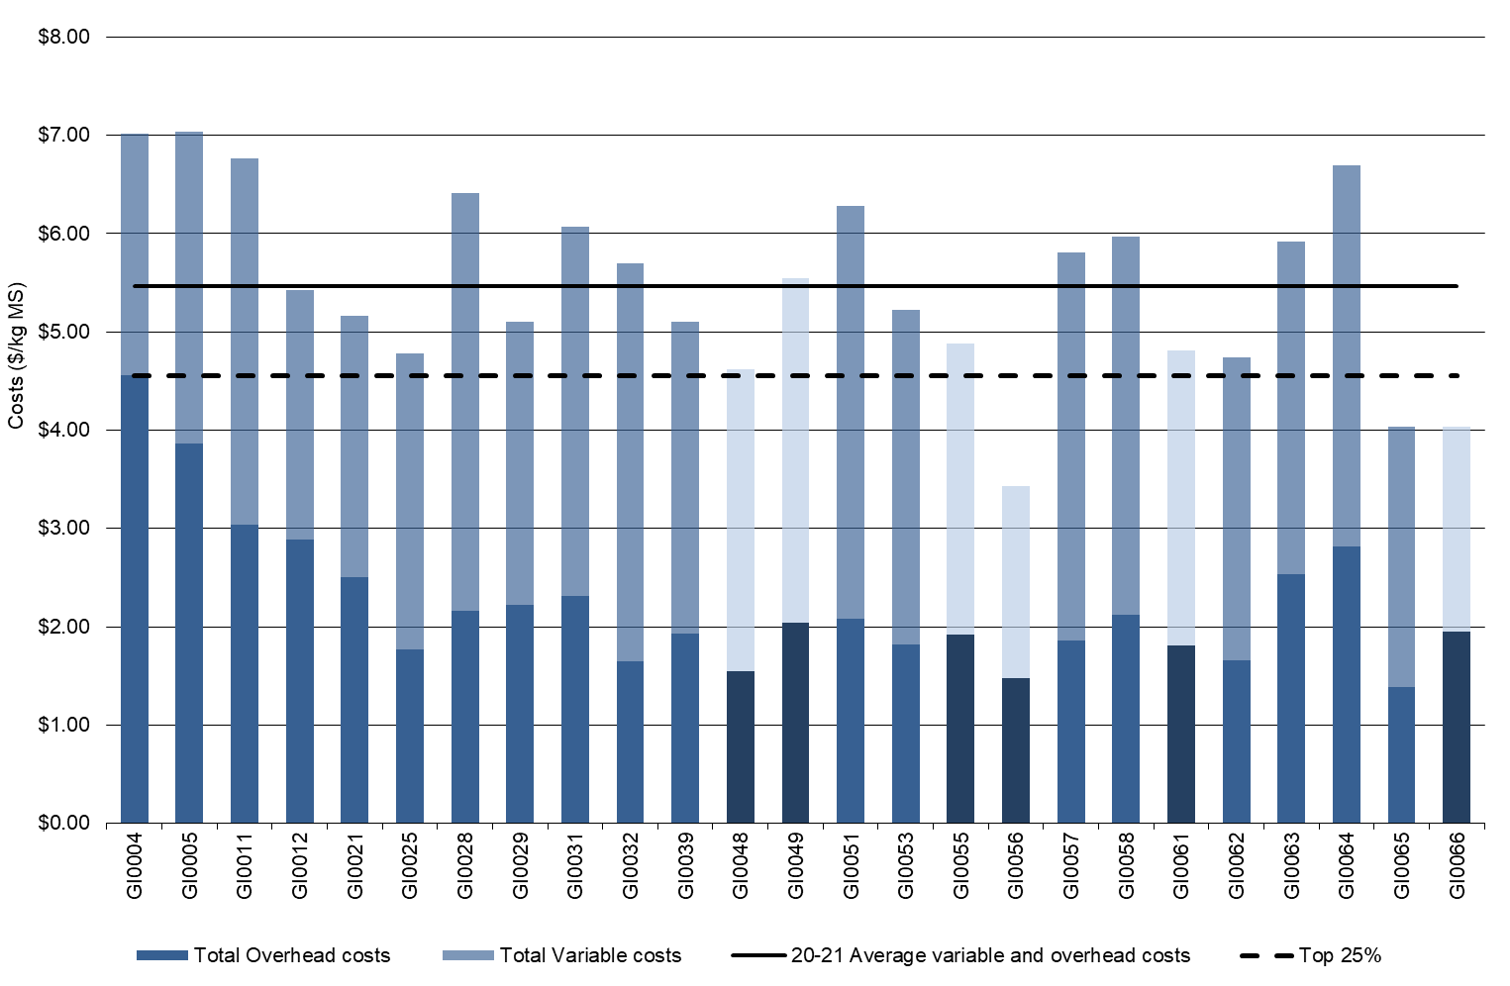

TABLE 11. AVERAGE FARM FINANCIAL PERFORMANCE – GIPPSLAND
 | Gippsland average  $/kg MS | Q1 to Q3 range  $/kg MS | Top 25% average  $/kg MS
INCOME
Milk income (net) | $6.54 | $6.29 - $6.62 | $6.91
Livestock trading profit | $0.67 | $0.47 - $0.88 | $0.71
Other farm income | $0.03 | $0.00 - $0.03 | $0.01
Gross farm income | $7.24 | $6.89 - $7.58 | $7.64
VARIABLE COSTS
Herd cost | $0.33 | $0.24 - $0.44 | $0.36
Shed cost | $0.24 | $0.17 - $0.27 | $0.20
Homegrown feed cost | $0.95 | $0.73 - $1.08 | $0.94
Purchased feed and agistment | $1.76 | $1.53 - $2.00 | $1.45
Feed inventory change | -$0.05 | -$0.06 - $0.09 | -$0.20
Water inventory change | $0.00 | $0.00 - $0.00 | $0.00
Total feed costs | $2.66 | $2.37 - $3.01 | $2.20
Total variable costs | $3.23 | $2.89 - $3.76 | $2.76
GROSS MARGIN | $4.02 | $3.60 - $4.45 | $4.88
OVERHEAD COSTS
Employed labour | $0.57 | $0.16 - $0.97 | $0.51
Repairs and maintenance | $0.33 | $0.20 - $0.45 | $0.27
All other overheads | $0.29 | $0.21 - $0.34 | $0.29
Imputed labour | $0.87 | $0.37 - $1.01 | $0.58
Depreciation | $0.17 | $0.11 - $0.21 | $0.15
Total overhead costs | $2.24 | $1.80 - $2.50 | $1.79
Variable and overhead costs | $5.46 | $5.23 - $6.95 | $4.55
EARNINGS BEFORE INTEREST AND TAX | $1.78 | $1.03 - $2.51 | $3.08
Cost of production

Cost of production gives an indication of the unit cost of one kg MS sold as well as the cost to maintain the livestock at current numbers. It is calculated as variable plus overhead costs and accounts for changes in fodder, water, and livestock inventory.
Table 12 shows that the average cost of production (with inventory change) had increased marginally (2 per cent) from $5.44/kg MS last year to $5.56/kg MS this year. The Top 25% also had a higher cost of production at $4.60/kg MS, compared to $4.42/kg MS in 2019-20.
Feed inventory increased again this year to -$0.05/kg MS. The Top 25% had greater reserves on-hand at the end of the year as reflected by an inventory change of -$0.20/kg MS. A negative inventory value indicates that fodder reserves increased and is counted as a decrease to the cost of production.
The livestock market continued to provide great opportunities for farmers from an income perspective. However, purchasing higher priced cattle to replace those livestock that were sold for a lower price meant that livestock production costs went up this season. Inventory change for the average was $0.10/kg MS $0.05/kg MS for the Top 25%.

TABLE 12. COST OF PRODUCTION – GIPPSLAND
Farm costs | Gippsland average  $/kg MS | Q1 to Q3 range  $/kg MS | Top 25% average  $/kg MS
Cash cost of production | $4.47 | $3.94 - $4.96 | $4.02
Cost of production (excl inventory changes) | $5.51 | $5.07 - $6.02 | $4.75
INVENTORY CHANGE
+/- feed and water inventory changes | -$0.05 | -$0.06 - $0.09 | -$0.20
+/- livestock inventory changes minus purchases | $0.10 | -$0.07 - $0.14 | $0.05
Cost of production (incl inventory changes) | $5.56 | $4.88 - $6.14 | $4.60

Earnings before interest and tax

On average, the EBIT on Gippsland farms was $1.78/kg MS in 2020-21, a 14 per cent decline from $2.07/kg MS in 2019-20. A six per cent decline in milk price, coupled with increased costs of some variable and overhead items were not able to offset by the savings in homegrown and purchased feed costs this season.
All but three of the 25 participant farms achieved a positive EBIT, ranging from -$0.60/kg MS to $3.55/kg MS. Of the same 23 farms participating between years, EBIT decreased from $2.09/kg MS in 2019-20 to $1.65/kg MS in 2020-21.
The Top 25% had an average EBIT of $3.08/kg MS, similar result to the previous year. There were no definitive characteristics in this year’s sample that determine whether a farm performed in the Top 25%. Many but not all had high milk prices. One of the Top 25% farms recorded the lowest milk price while another was in the bottom 20 per cent of milk price received for the regional sample.
Farms located in the MID recorded an average EBIT of $2.23/kg MS in 2020-21. These farms received higher than average milk price of $6.84/kg MS this year. However, livestock trading profit was slightly lower than the average at $0.61/kg MS compared to $0.67/kg MS for the Gippsland average.
Farms in the MID were able to capitalise on good water availability to maximise pasture growth this season. This resulted in lower feed costs, with an emphasis on homegrown feed. With strong milk production (per cow and per hectare) the savings in feed costs allowed them to focus on cost control in other parts of their business in 2020-21. Overhead costs were lower than the average at $2.02/kg MS compared to $2.24/kg MS for the average of Gippsland farms. Variable costs for MID farms came in very similar to the average at $3.25/kg MS (compared to $3.23/kg MS).
Grazed pasture harvested was a major contributor to MID farms’ ability to reduce overall feed costs with 11.9 t DM/ha compared to the average of 8.4 t DM/ha.
With good operating conditions for MID farmers, four of the six Top 25% farms came from MID. The two dryland farms making up the top group had a strong focus on lower cost inputs and an overall reduction in their cost of production this season.

FIGURE 36. EBIT – GIPPSLAND
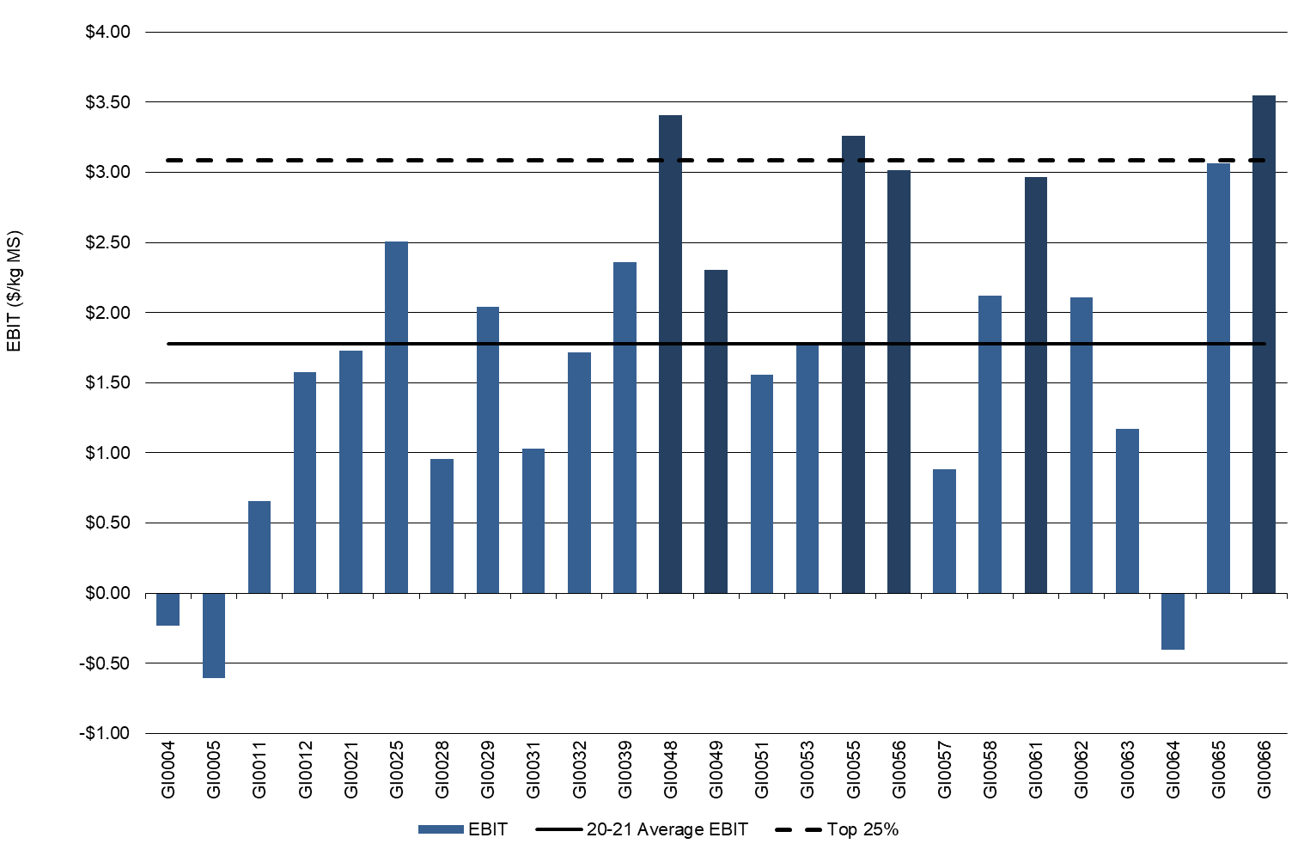

Return on total assets and equity

In 2020-21, farms achieved on average a ROTA of 5.4 per cent, the fifth highest in the 15-year history of the project.
All but three farms in the Gippsland sample had a positive ROTA in 2020-21, compared to the previous year where all farms achieved a positive result. The range for all Gippsland participants in 2020-21 was between -1.2 per cent and 11.1 per cent.
The Top 25% recorded an average ROTA of 9.8 per cent compared to 11.5 per cent last year, with a range of between 4.4 per cent and 11.1 per cent as shown in Figure 37.
Average ROE was 8.0 per cent, a decrease from 12.4 per cent last year, with a range of -7.5 per cent to 29 per cent in 2020-21 (Figure 38). There were 21 of the 25 Gippsland participants, in both years, who generated a positive ROE, but lower individual performances contributed to lower average ROE. Interest and lease costs for 2020-21 reduced a further 20 per cent to $0.52/kg MS from $0.65/kg MS last year. The Top 25% decreased their interest and lease charges by 23 per cent to $0.41/kg MS, from $0.53/kg MS last year and resulted in an average ROE of 15 per cent. Average capital values are provided in Appendix D6.

FIGURE 37. ROTA – GIPPSLAND
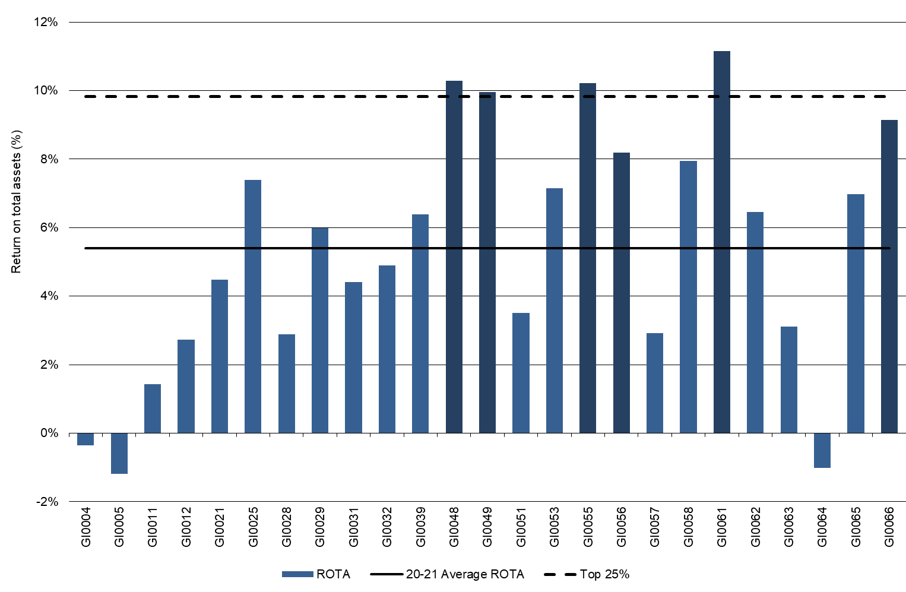
FIGURE 38. ROE – GIPPSLAND
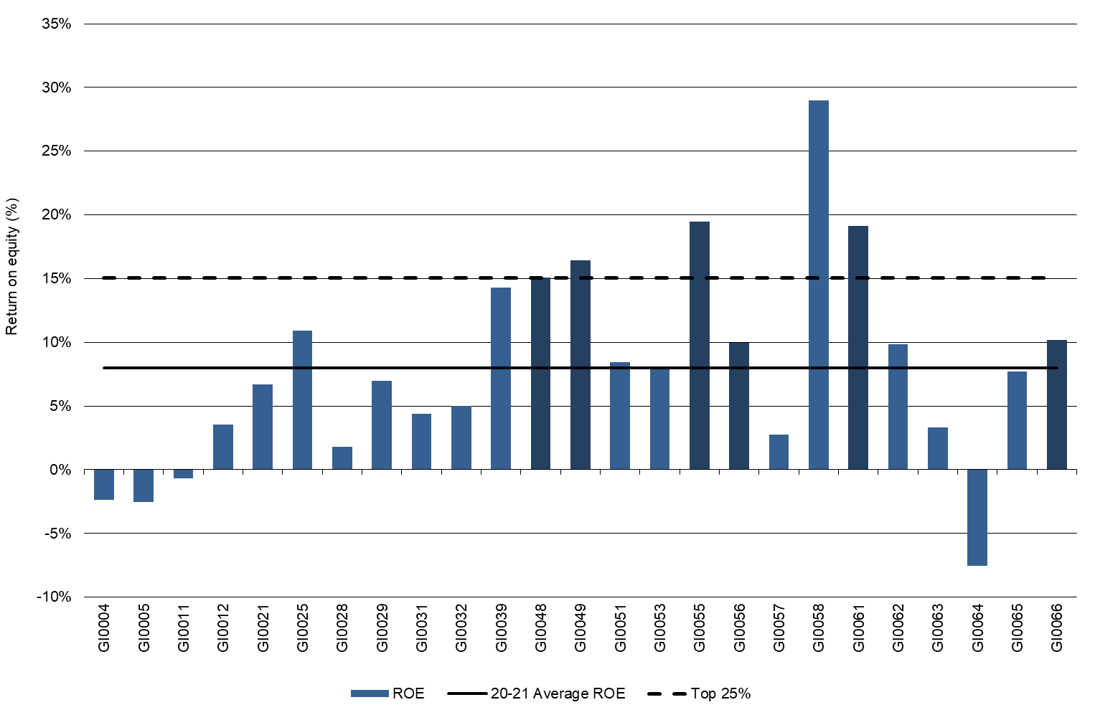

Feed consumption and fertiliser
The climate variability experienced by Gippsland participant farms in 2020-21 impacted significantly on their ability to directly harvest pasture and optimally apply fertiliser. Gippsland participants sourced on average 66 per cent of their ME requirements from homegrown feed. Total pasture harvested on the milking area by direct grazing and conservation decreased for the average (9.3 t DM/ha) and for the top performers (11.2 t DM/ha).

The decrease in homegrown feed directly grazed or conserved by Gippsland participants in 2020-21 was a result of management decisions reflecting the variable seasonal conditions.
Farmers in the south and west of the region generally experienced a very wet winter and spring, limiting their ability to directly capitalise on pasture growth. Soils were often too wet to apply fertiliser or have heavier stocking rates. Farmers made management decisions to minimise pugging damage and preserve pastures until it was dry enough to reduce damage to the pasture (soils, plants) and lessen animal health impacts.
On average 34 per cent of the ME consumed by the herd was imported, with 31 per cent imported ME for the Top 25% (Figure 39). This indicated a greater reliance on homegrown pasture and forage for the higher performers as evidenced by the similar amount of conserved fodder harvested this season.
Pasture harvested directly on the milking area by grazing animals was 8.4 t DM/ha and conservation 0.9 t DM/ha resulting in a total of 9.3 t DM/ha harvested on average. The Top 25% also decreased their directly grazed pasture to 9.6 t DM/ha but pasture conservation remained at 1.6 t DM/ha.
Despite overall conservation being less than the previous season, 13 of the 25 participants increased their fodder reserves between the start and the end of the season.
Homegrown feed on the usable area decreased by nine per cent on average for directly grazed pasture to 6.8 t DM/ha and 1.2 t DM/ha for conserved feed.
The reduction in homegrown feed was matched by a four per cent increase of concentrate feeding per cow. Per cow production was relatively similar to last year and matched by a five per cent increase in purchased feed per cow.
Average concentrate price was $435/t DM, a considerable decrease from $500/t DM last year. Concentrates were fed on average at 1.6 t DM/cow on the milking area. The Top 25% had a similar percentage decline and fed 1.3 t DM/cow of concentrates on the milking area, while paying $409/t DM for concentrates.
Average purchased feed price reduced considerably from last year with participants paying $401/t DM on average compared to 463/t DM last year and the Top 25% paying $366/t DM compared to $461/t DM last year. The average cost of silage reduced to an average of $209/t DM, with a few participants purchasing standing silage this season. The amount of hay fed was 10 per cent lower, with an average cost of $271/t DM.
The estimated quantity of dry matter of homegrown feed consumed per milking hectare is shown in Figure 40. Homegrown feed can be grazed pasture (shown by the dark blue bars) or conserved fodder (light blue bars). A description of the method used to calculate ME sources and feed consumption is given in Appendix E.
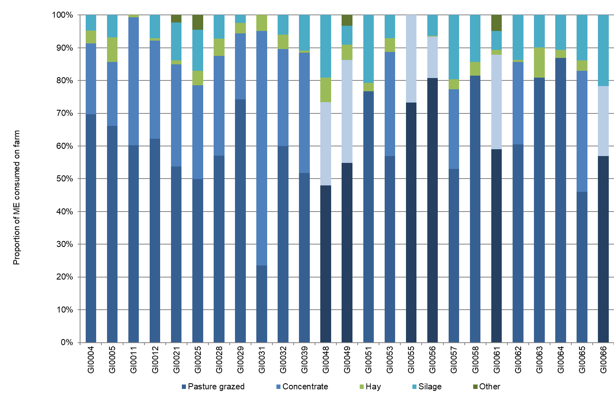
FIGURE 39. SOURCES OF WHOLE FARM METABOLISABLE ENERGY – GIPPSLAND

FIGURE 40. ESTIMATED TONNES OF HOMEGROWN FEED REMOVED – GIPPSLAND
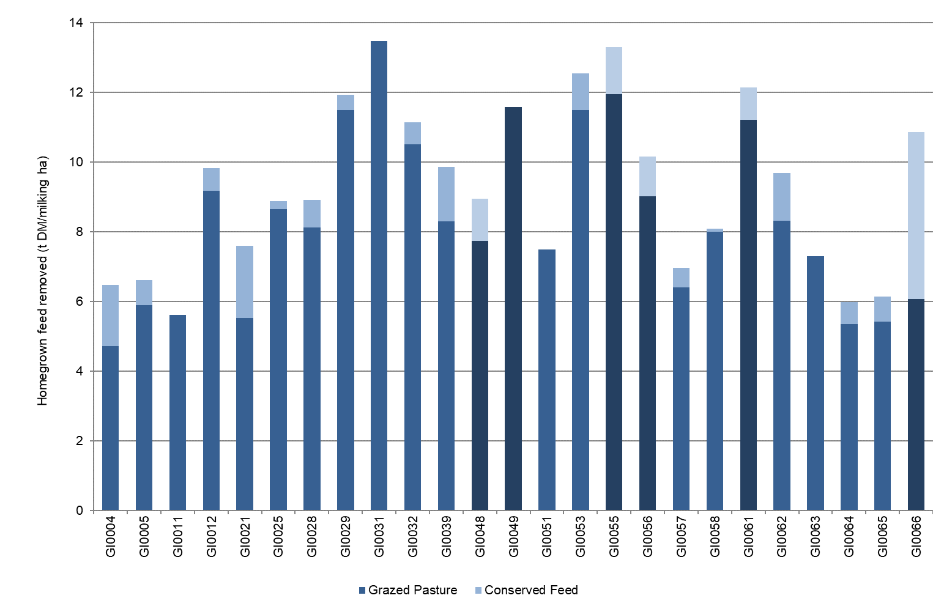
Fertiliser application

Gippsland participants in 2020-21 increased their overall nutrient application on average. The rainfall events throughout the year dictated the ability of farmers to apply nitrogen this year, with a few farms engaging aerial application this year.
There was an average 14 per cent increase in nitrogen application to 233 kg N/ha and a nine per cent decrease in phosphorus application to 20 kg P/ha. There were increases in potassium (16 per cent increase) and sulphur applications (17 per cent increase). Potassium application rose to 47 kg K/ha and sulphur application increased to 22 kg S/ha.
In contrast participants in the Top 25% significantly decreased (by 26 per cent) their nitrogen use to 221 kg N/ha, slightly increased their phosphorous application to 29 kg P/ha and maintained potassium and sulphur at approximately the same levels as the previous year, at 38 kg K/ha and 15 kg S/ha (Figure 41).
Timing of fertiliser applications this year was crucial due to very wet conditions in late winter 2020 and early spring. There was a considerable dry period when plants were not actively growing, reducing the uptake of nutrients during this time. Overall, the increase in fertiliser use was, on average, not matched by increased pasture consumption or conservation. This reflected that farmers needed to manage the challenging wet soils conditions in early spring.
The values for Figures 40 and 41 can be found in Appendix Table D2.

FIGURE 41. NUTRIENT APPLICATION – GIPPSLAND
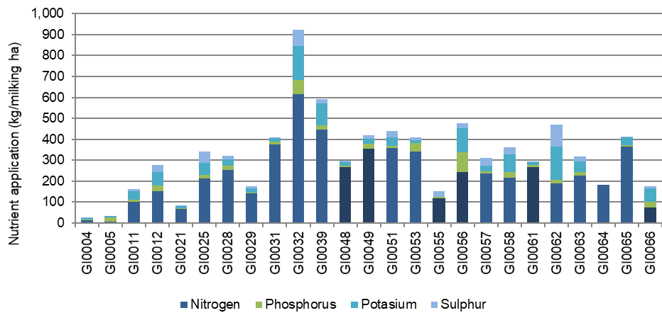

Part Five: Business Confidence Survey

Expectations for business profit
Participant farmers were confident in their outlook for farm business returns in the coming 12 months. The North appeared as the most positive (87 per cent expecting better returns), followed by South West (76 per cent) and Gippsland (60 per cent).

The survey was developed to consider different aspects of farming, from climate outlook to expectations about market conditions for dairy products. While expectations for the coming year were generally positive regarding the seasonal outlook, there were slight regional differences. For example, regional influences on their production system such as the cost of irrigation water, underpins expectations,
Across the state, 75 per cent of respondents were optimistic about business profit for the coming season. There was only one farm in the sample that expected declining returns for 2021-22. (Figure 42). Respondents in the North were most optimistic, with 87 per cent expecting improved returns next season. The South West reported that 76 per cent of respondents were expecting an increase, while only 60 per cent of Gippsland respondents expected an increase to their returns.
No farmers in the North and Gippsland sample were expecting a downturn in their business returns in 2021-22.
Three participants planned to leave the industry in 2021-22.

FIGURE 42. EXPECTED CHANGE TO FARM BUSINESS PROFIT IN 2021-22
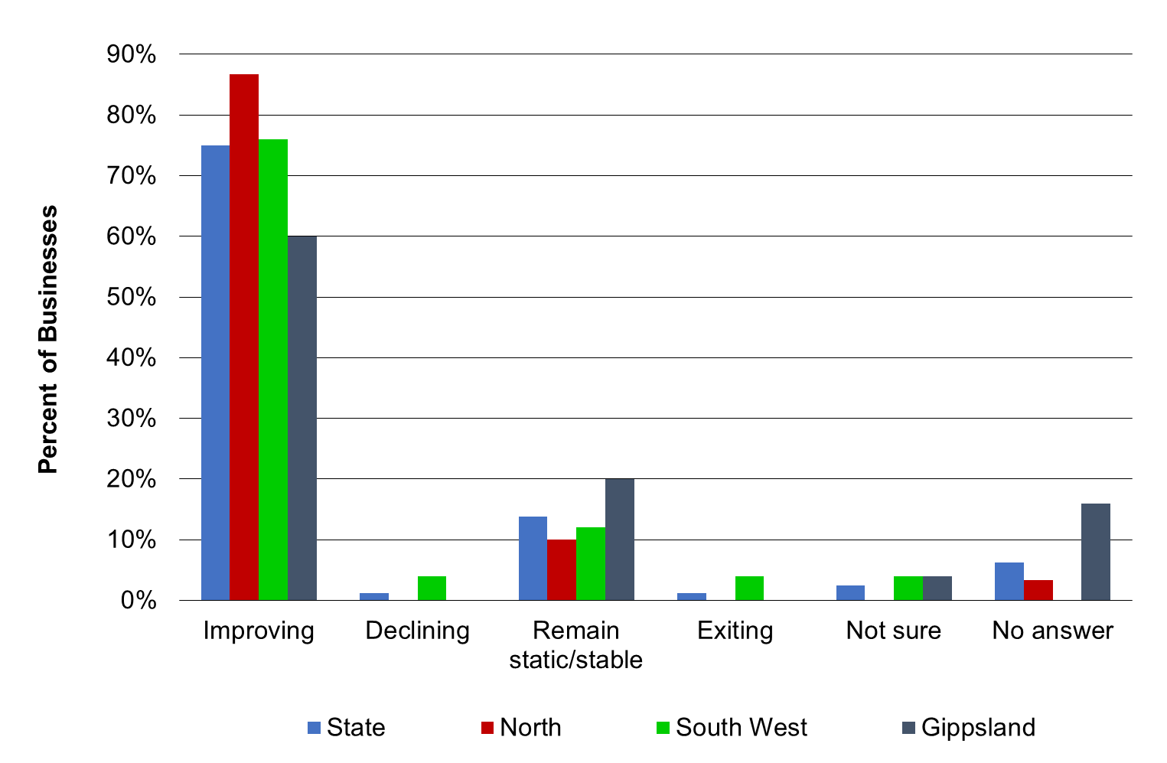

Price and production expectations - milk
Farmer participants were confident in their outlook for milk price, and milk production for 2021-22. Three-quarters of respondents were expecting to see an increase in their milk price in 2021-22 (Figure 43). At the time of year this survey was conducted farmers had the opportunity to reflect on their previous financial year milk price and can elect to remain with their current milk processor or change to supply a different factory under the Dairy Industry Code of Conduct (2020). This ability to reflect on milk price early in the season enables greater confidence in the milk price farmers will receive.
Farms across the state all experienced milk price reduction in 2020-21 and the likely timing of milk price announcements has given a great deal of certainty to how participants’ production systems will respond to the improvement in milk price for 2021-22.

Strong confidence that the milk price will increase was given by 81 per cent of Gippsland participants, 76 per cent of South West respondents and 72 per cent of North respondents.
In the North 37 per cent were expecting to increase their milk production in 2021-22, with 62 per cent indicating their milk production was going to remain stable. The South West was more optimistic with 63 per cent of respondents expecting an increase to their milk production and 33 per cent anticipating maintaining their current total milk production. Similarly, In Gippsland 62 per cent of respondents said they would be targeting a higher milk production in 2021-22 while 33 per cent expected their milk production to remain stable.
A decrease in milk production was only expected by a small number of participants in Gippsland and the South West.

FIGURE 43. PRODUCER EXPECTATIONS OF MILK PRICES AND PRODUCTION IN 2021-22
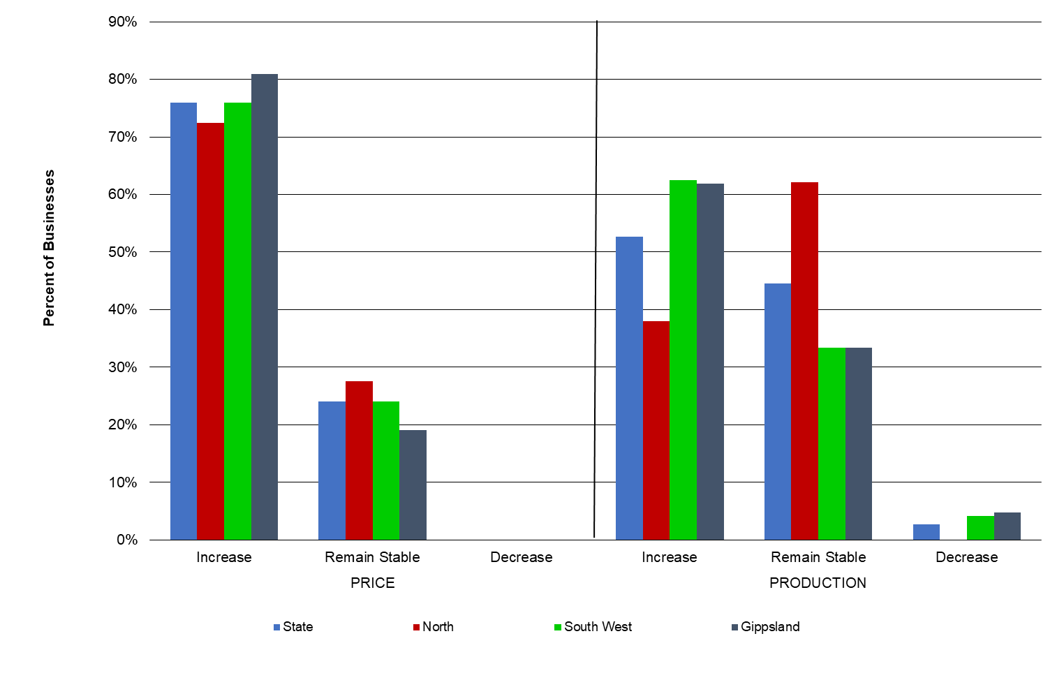
Production expectations - fodder

The expectations for fodder production in 2021-22 were positive with half of the respondents (50 per cent) expecting fodder production to remain stable and 33 per cent expecting to increase their fodder production (Figure 44).
Respondents in all three regions considered that fodder production could go up, down or remain the same, depending on their individual circumstances.
With full soil moisture profiles across much of the state at the end of 2020-21, farmers were anticipating that with a forecast of a good 2021 spring rainfall, fodder production would reflect planned production rather than the impacts of climatic variability.
Just under half of the Gippsland participants are expecting an increase in fodder production with a further 41 per cent expecting their fodder production to remain the same.
In the North 52 per cent of respondents expect an increase in fodder production, 41 per cent expect it to remain stable and just seven per cent expect a decline.
In contrast, after the successful harvest in 2020-21, only 13 per cent of South West participants expect to increase fodder production in 2021-22, 71 per cent to remain stable and 17 per cent expect a decline.
Many participants are continuing to focus on producing as much homegrown feed as possible, given favourable seasonal conditions.

FIGURE 44. PRODUCER EXPECTATIONS OF FODDER PRODUCTION IN 2021-22
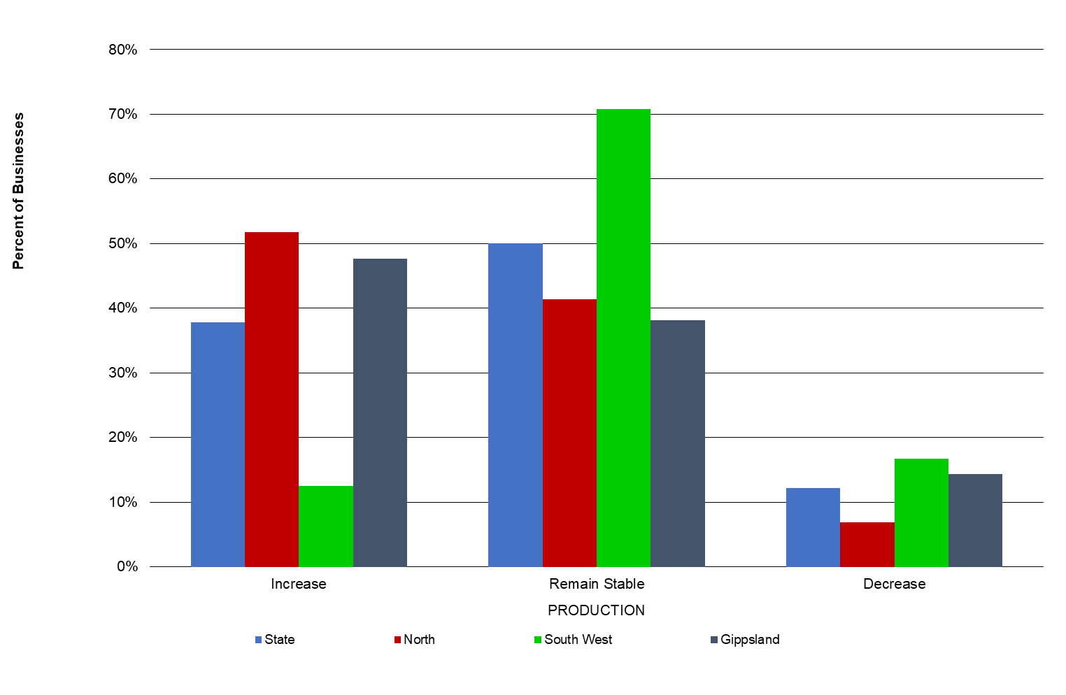
Cost expectations

The cost category that was recorded as most likely to increase in 2021-22 was fertiliser (Figure 45). Repairs and maintenance increased for producers this year, especially in the South West, so the reporting of this as a stable cost was in line with expectations.
The majority of surveyed participants expect purchased feed, fuel and oil, and labour will either remain the same or increase in 2021-22.
Of the 38 respondents, approximately 58 per cent expected irrigation costs to remain the same, while 29 per cent expected a decrease in irrigation costs for the coming season. The remaining 13 per cent expected irrigation costs to rise in 2021-22. This result was largely dependent on the proportion of farms that own water entitlements, those who purchase water on the temporary market and those exposed to the seasonal availability of water share allocation.

FIGURE 45. PRODUCER EXPECTATIONS OF COSTS FOR THE DAIRY INDUSTRY IN 2021-22
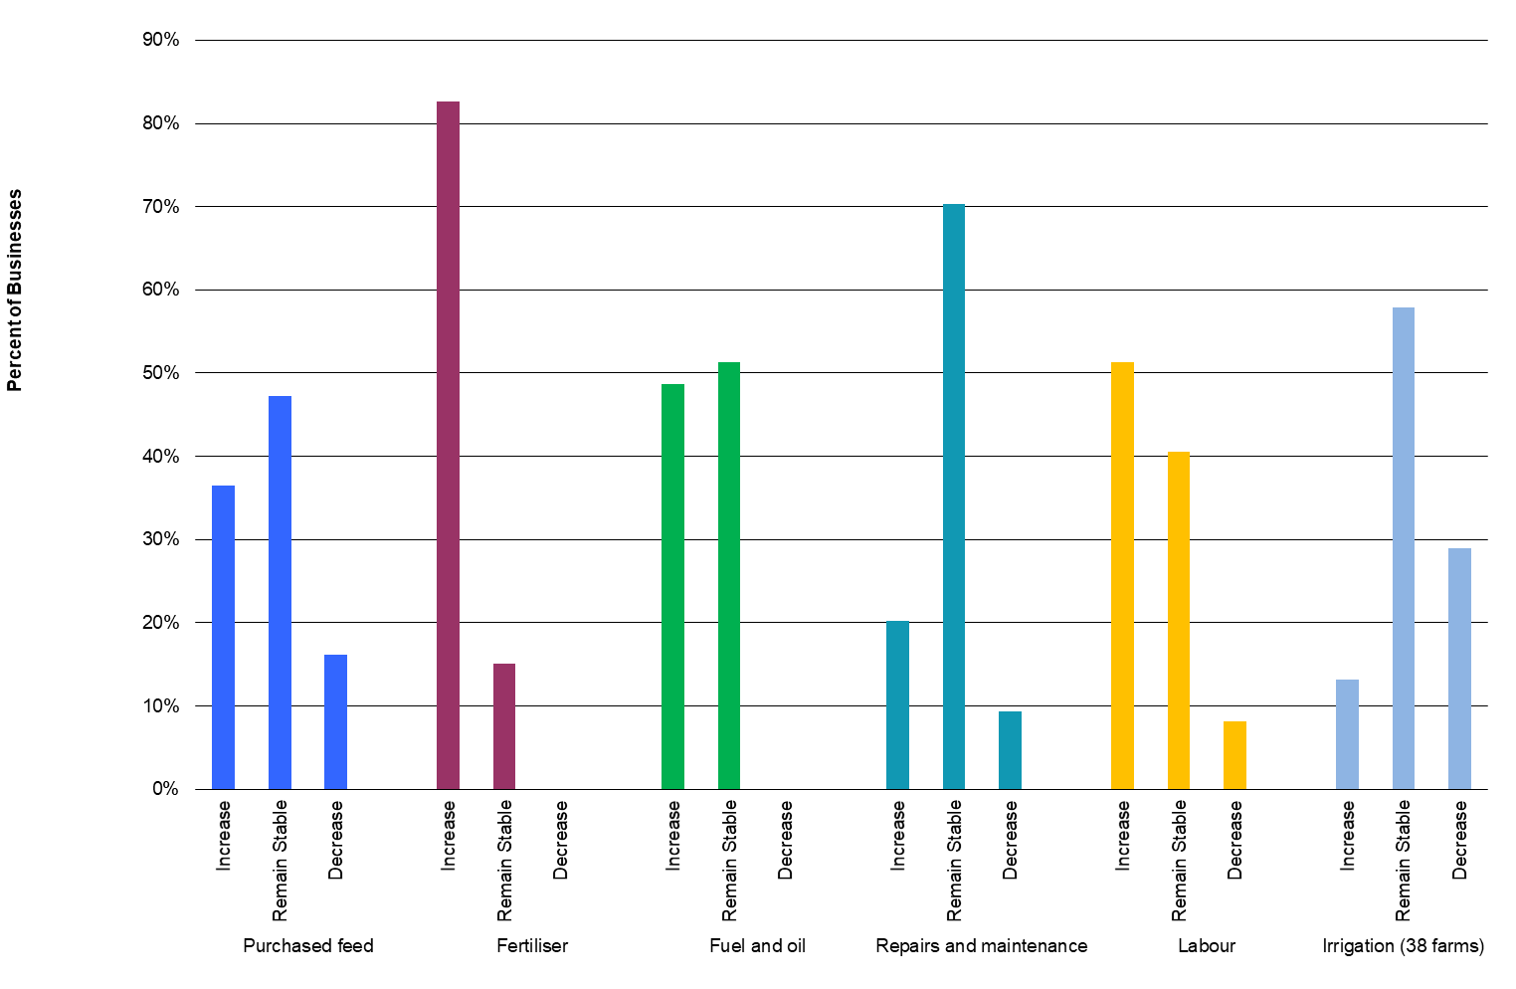

Comments from participants

The second year of the coronavirus (COVID-19) pandemic was of concern to survey respondents. One farmer explained that “Covid (is) starting to take a toll, sick of it”. This concern is not unique to farming but certainly is recognised as affecting some of the services and products that farmers need to access to run their businesses efficiently.
Remaining motivated during the pandemic appeared to be a shared challenge, because of the pandemic, with one farmer commenting “(it’s a) challenge to remain motivated, COVID-19 has created challenges to get staff to take leave”.
Labour availability was also a large concern to farmers. One farmer commented that “labour continues to be an issue, particularly attracting good labour”. Many farmers identified that labour is not available and that sourcing reliable labour ‘willing to do a good job’ was also of concern. This labour shortage is impacting on dairy farmers’ ability to take much-needed breaks.
Capital upgrades and continued focus on repairs and maintenance of existing assets was a strong focus for many surveyed farmers.
Climatic variability and succession planning still generated many identified longer-term issues that engendered comments in the survey.
More so than in previous years, farmers were concerned about land prices. There were strong views about the current upward trend in prices limiting the ability for farm businesses to expand in the future. Some farmers saw expansion as a key limitation to their business, while others were concerned about intensification of their business.
Supporting this expansion and intensification were issues raised regarding future water and resource availability and building business resilience to shocks such as climatic variability. Some farmers chose to focus on debt reduction to lower their finance risk rather than on-farm physical resource decisions to increase their business resilience.

Issues of importance to dairy businesses - the next 12 months

Participant farmers were asked to rank issues based on the level of importance to their business for the upcoming season. The participants were asked to rank these issues from 1 to 7, with (1) being most important and (7) being least important. The results are shown in Figures 46 and 47.
The most important issue in the coming 12 months was input costs, with 17 per cent of respondents ranking this as number 1, very similar to last year’s result. Participants shared their expectations for costs of purchased feed, fertiliser, fuel and oil, repairs and maintenance and labour (Figure 45).
Similar to last year, climate/seasonal conditions were the second most important issue. Pasture and fodder were ranked third by 15 per cent of respondents, closely followed by 14 per cent ranking labour as their fourth greatest concern.
With the new Dairy Industry Code of conduct there was been a noticeable lower ranking for the milk price, as greater surety of and transparency in milk pricing becomes available earlier in the season. Farmers listing this as their fifth concern (13 per cent of respondents).
Water (price and availability) was of concern to 10 per cent of respondents, while succession planning in the next 12 months was of high concern to nine per cent of participants in the survey.
Labour was a consistent issue across all three Victorian regions, as were input costs. Milk price was of greater concern in the two predominantly dryland regions of Gippsland and the South West, while in the North, water was ranked high.

FIGURE 46. MAJOR ISSUES FOR INDIVIDUAL BUSINESSES – 12-MONTH OUTLOOK
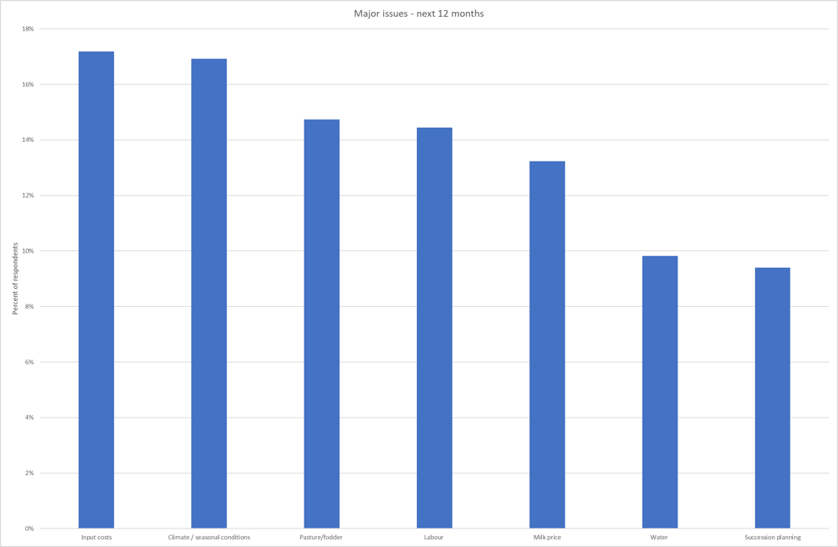

Issues of importance to dairy businesses- the next five years

the ranking of areas of concern for the medium term (five years) has not changed between 2020-21 and 2021-22, either in their order nor magnitude.
As per the previous survey, milk price was the most important issue (18 per cent) followed closely by input costs (17 per cent) and climate/seasonal conditions (16 per cent) (Figure 47). This ranking was consistent at the state and regional level, with all regions ranking the issues in the same order, for the second year in a row.

FIGURE 47. MAJOR ISSUES FOR INDIVIDUAL BUSINESSES – 5-YEAR OUTLOOK
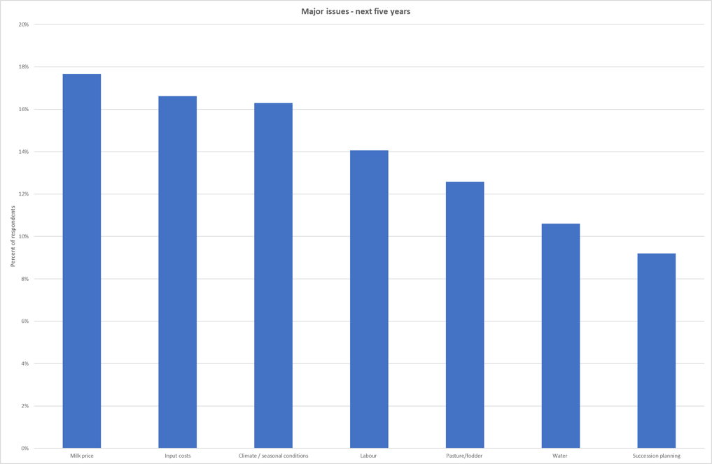

Part Six: Greenhouse Gas Emissions

2020-21 Greenhouse gas emissions

In 2020-21, greenhouse gas emissions increased to 2,800 t CO₂-e/farm*, a 2.2 per cent increase from the previous year. The total increase was primarily driven by increased herd size and nitrogen use. However, with increased milk solids production, average estimated greenhouse gas emission (GHG) emissions intensity reduced to 13.2 t CO₂-e/t MS, 2.9 per cent decrease.

In 2020-21, estimated greenhouse gas emissions intensity ranged from 10.4 t CO₂-e/t MS to 17.6 t CO₂-e/t MS across DFMP farms. On average, emissions intensity decreased by 2.9 per cent from 13.6 t CO₂-e/t MS in 2019-20 to 13.2 t CO₂-e/t MS this year (Figure 48).
Average greenhouse emission intensity decreased across all major sources, on a per kilogram of milk solids basis. Regional variation in farm management meant some emission measures increased. For example, N₂O from nitrogen use increased 36 per cent per kg MS in the North but reduced 12 per cent in the South West.
Average total emissions per farm increased by 2.2 per cent from 2,740 t CO₂-e/farm in 2019-20 to 2,800 t CO₂-e/farm in 2020-21, with a range of between 560 t CO₂-e/farm and 15,090 t CO₂-e/farm (Figure 49). An increase in herd size across the state combined with an increase in nitrogen fertiliser use, led to the overall increase in total carbon emission equivalents across the state, although there was some regional variation.

Methane
Methane was identified as the main GHG emitted from dairy farms, accounting for 8.6 t CO₂-e/t MS, or 65 per cent of all emissions in 2020-21. Of the methane gas, those produced from ruminant digestion (enteric CH₄) was the major source of emissions from DFMP farms, with an average of 56 per cent of total emissions (7.4 CO₂-e/t MS). Methane from effluent ponds accounted for an average of nine per cent of total emissions (1.2 CO₂-e/t MS). Based on emissions intensity metrics, CH₄ emissions reduced across all three regions, both from enteric and effluent ponds sources.
FIGURE 48. ESTIMATED 2020-21 AVERAGE GHG EMISSIONS INTENSITY (CO₂ EQUIVALENT)
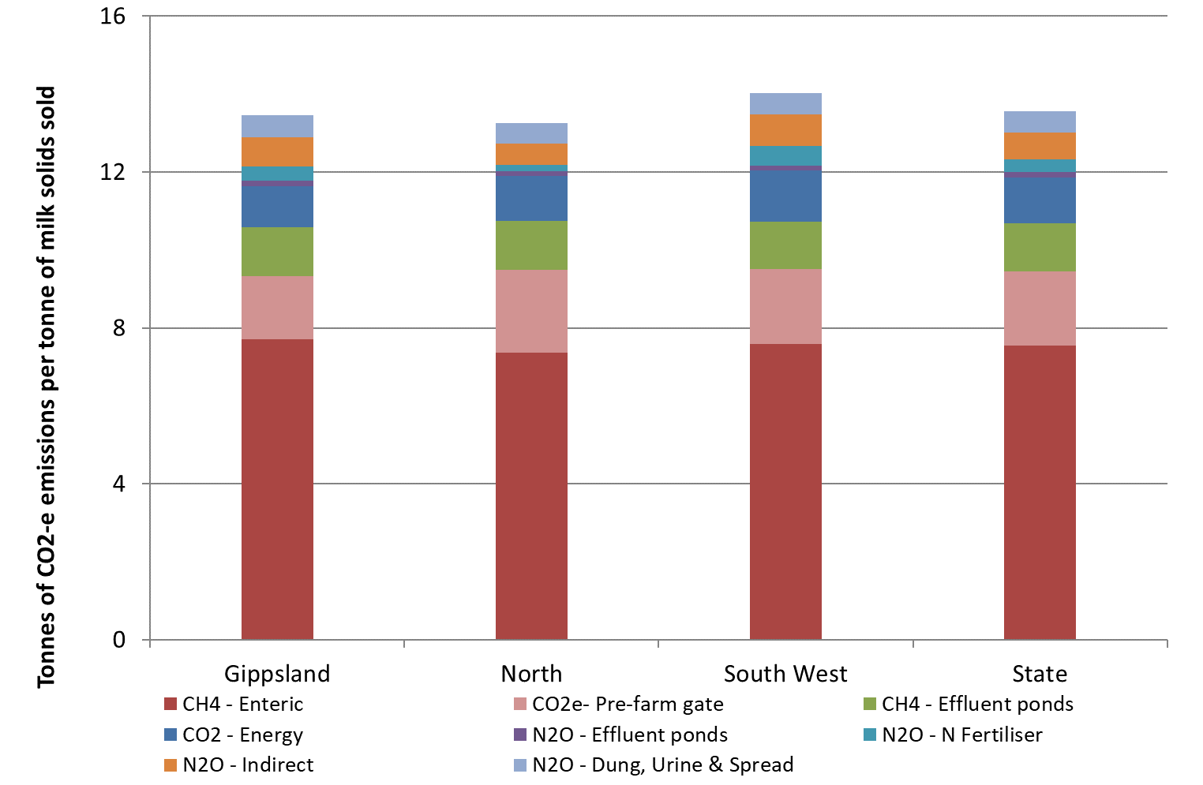

Carbon dioxide
Carbon dioxide (CO₂), produced primarily from fossil fuel consumption (electricity and fuel), accounted for 3.0 t CO₂-e/t MS. Greenhouse gases emitted during the manufacturing of fertilisers and during the production of purchased fodder, grain and concentrates were also included. Pre-farm gate sources accounted for 14 per cent (1.8 CO₂-e/t MS) of the carbon dioxide emissions and nine per cent (1.1 CO₂-e/t MS) was from on-farm energy sources.

Nitrous oxide
Average nitrous oxide (N₂O) emissions intensity was 1.7 t CO₂-e/t MS. Nitrous oxide emissions were from wastes, such as dung and urine (four per cent), fertiliser (two per cent of total emissions) and effluent ponds (one per cent).

Total emissions
Over the last four years total greenhouse gas emissions have been relatively stable with minor increases due mainly to increasing herd size, increasing power use and increase in fertiliser use. Methane sources are the most variable, depending on the season (Figure 49).
The GHG estimation presented in this report did not include any carbon sequestration activities that may be accumulated by farm trees or soils.
Further information on the Australian National Greenhouse Gas inventory can be found at the Department of the Industry, Science, Energy and Resources website.
FIGURE 49. ESTIMATED AVERAGE GROSS GHG EMISSIONS BETWEEN 2017-18 AND 2020-21 (CO₂ EQUIVALENT)
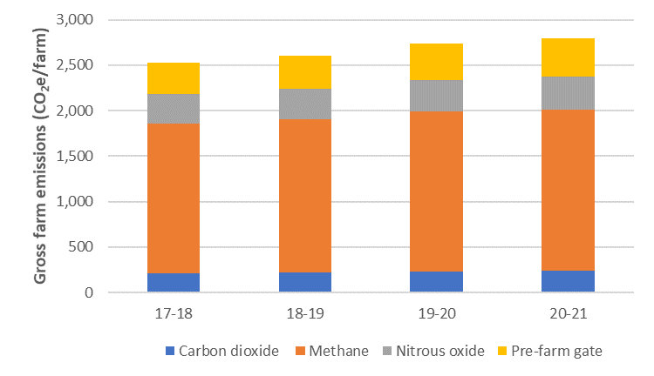

Part Seven: Historical analysis

Historical analysis
Positive trading conditions allowed consistent performance across the state in 2020-21. Livestock trading profit increased, fodder inventory increased, and costs decreased, offsetting the impact of a lower milk price. Gippsland and the South West recorded close to long-term average performance in 2020-21; with the North presenting its best EBIT performance in 15 years.
The North

In 2020-21, farms in the North continued their improvement from the previous year, with the best performance in the 15-year history of the project (Figure 50). The fourth highest milk price in the last 15 years (taking inflation into consideration) aided farmers in the North to take advantage of lower costs due to improved seasonal conditions. The average for North participants was an EBIT in 2020-21 of $500,000 and net farm income of $401,000. Continuing from the improved performance in 2019-20, farmers in the North consolidated their focus on producing low-cost feed by utilising water availability to generate greater feed reserves and reduce the unit cost of milk production.
Low returns have been observed in two five-year periods, with these periods characterised by adverse climatic conditions. At the commencement of the project in 2006-07, extremely dry conditions with very low milk prices and high costs were evident across all dairy regions.
There have been periods with too much rain (first six months of 2016-17), too little rain (2015-16, 2017-18 and 2018-19) and times with record high input prices and significant fluctuations in milk price.
Farmers in the North were challenged with the millennium drought (2002-2009), low water allocations (43 per cent in 2007-08; 35 per cent in 2008-09) and high allocation water prices. The annual median prices in the main water trading zones were between $260/ML and $400/ML between 2007 and 2009 ($340/ML and $520/ML when the effects of inflation are removed).
The millennium drought was followed by the global financial crisis (GFC) in 2008-09 causing mid-season milk price step downs. In 2009-10, farms were still recovering from the effects of the GFC and lingering drought impacts.
Prior to 2020-21, the highest returns for farms in the North occurred in 2013-14. In that year, farmers received 100 per cent allocation of their HRWS and purchased allocation water at prices lower than in the last two years. This was an improvement on the challenges experienced during 2012-13 which corresponded to lower milk prices and high costs.
The milk price step-downs in April 2016 added financial stress to the challenges associated with the water trading market and less than full seasonal determinations in that year.
Over the 15 years, farmers have relied on equity or increased their debt to manage the fluctuations in profits. Having some level of debt enables farms to grow their wealth at a faster rate than without debt. However, the reverse is also true, when a farm has debt, their ROE will fall at a quicker rate than the decrease in ROTA (as seen in 2015-16 and 2018-19) (Figure 51).
Interest and lease costs have reduced considerably in 2020-21 to $99,600 on average compared to quite high levels in 2007-08, 2016-17, 2017-18 and 2018-19.
Average ROTA was 6.0 per cent in 2020-21, above the long-term average of 3.7 per cent while ROE was 7.5 per cent and higher than the long-term average of 1.9 per cent.

FIGURE 50. FARM PROFITABILITY (REAL $) BETWEEN 2006-07 AND 2020-21 – NORTH
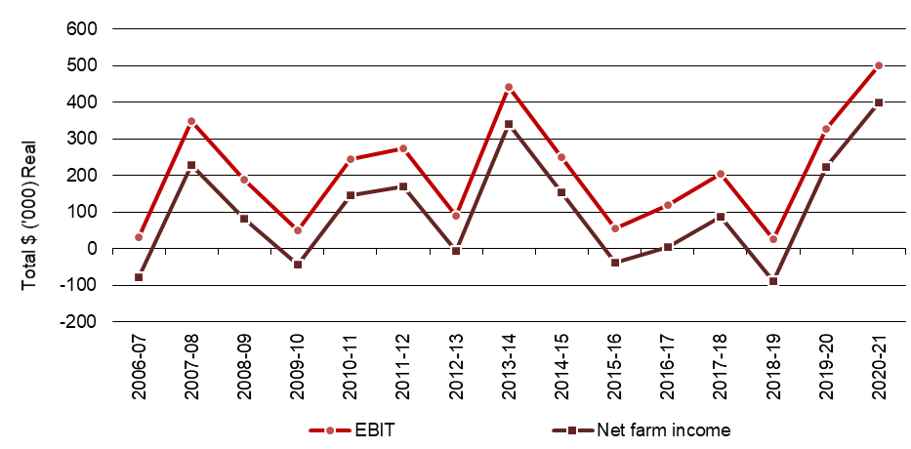
FIGURE 51. WHOLE FARM PERFORMANCE BETWEEN 2006-07 AND 2020-21 – NORTH
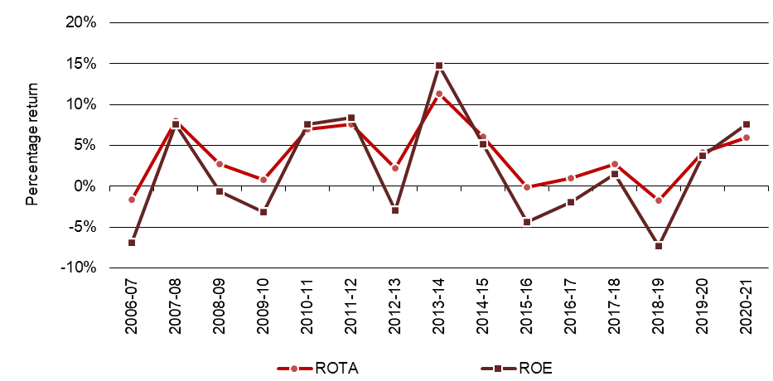
The South West

Farm profit in the South West improved for the third consecutive year in 2020-21 and was the fourth highest since the start of the project in 2006-07 (Figure 52). Average EBIT was $449,000 in 2020-21, compared to the EBIT from the previous year of $389,000. Farmers in the South West continued consolidating their performance from the previous year despite the seven per cent decline in milk price. Costs were moderated to suit the season which led to a further improvement in performance.
Interest and lease costs continued to reduce in 2020-21, decreasing to $95,000, the lowest in the 15-year history of the project. Net farm income rose to $355,000 in 2020-21.
Figure 52 shows the largest fall in ROE was in 2012-13. In this year, farmers experienced their most challenging year since the drought of 2006-07, relying on equity or further borrowings to manage the conditions. Spring rainfall was below average for a second consecutive year; the first time this had occurred in the South West since the 1981-82 drought. The remaining nine months between October 2012 and June 2013 was decile one rainfall for most of the region. Milk price also decreased, and farmers depleted their fodder reserves and purchased additional supplementary feed.
The following year, in 2013-14 was a year of recovery for farms in the South West. Improved seasonal conditions and reduced reliance on the purchased fodder market helped farms record a performance which was among the highest for this region. In the following two years, (2014-15 and 2015-16), seasonal conditions were drier than the long-term average, providing challenges for South West farms. A welcome improvement in seasonal conditions and the milk price led to better performance in 2016-17.
The strong performance in 2020-21 was buoyed by strong milk price, excellent livestock trading conditions and much improved seasonal conditions enabling farmers to reduce expenditure, specifically in feed costs. Average ROTA was 5.5 per cent in 2020-21, decreasing from 5.8 per cent the previous year, but was still above the long-term average of 4.1 per cent. The average ROE in the South West decreased slightly to 9.1 per cent in 2020-21 from 9.6 per cent in 2019-20 and was above the long-term average of 2.9 per cent (Figure 53).

FIGURE 52. FARM PROFITABILITY (REAL $) BETWEEN 2006-07 AND 2020-21 – SOUTH WEST
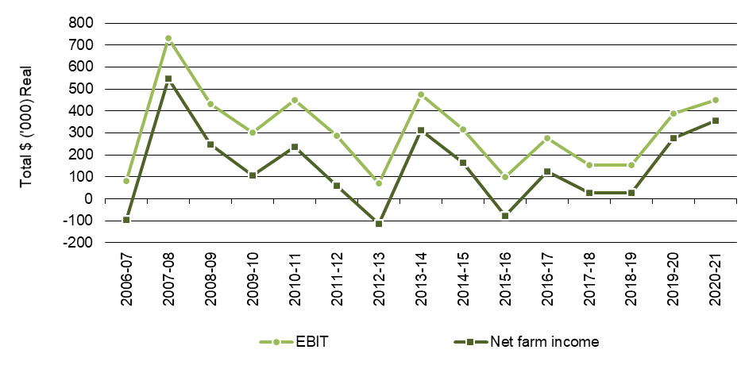

FIGURE 53. WHOLE FARM PERFORMANCE BETWEEN 2006-07 AND 2020-21 – SOUTH WEST
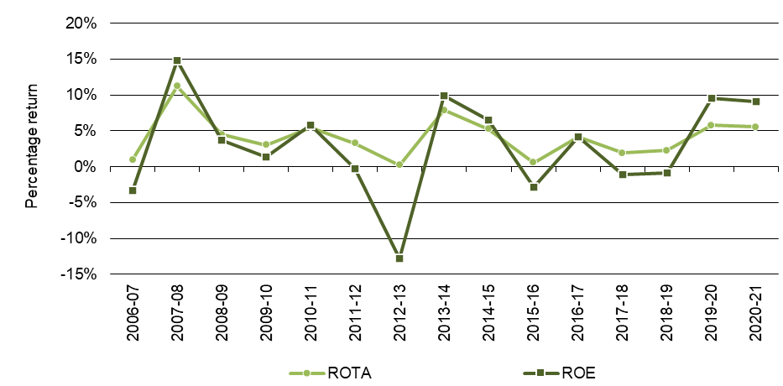

Gippsland

In 2020-21, average Gippsland performance was similar to the long-term average (Figure 54). The average EBIT was $300,000 in 2020-21, which in real terms, was close to the long-term average of $216,000. Net farm income was 10 per cent lower than the previous year at $220,000.
Interest and lease costs in 2020-21 decreased further to $81,000, from $100,000 seen in 2018-19 and 2019-20. Gippsland farmers have shown a desire to capitalise on improved operating conditions in recent years to reduce debt and financial risk.
Variability of rainfall patterns and climate strongly impacts on the performance of Gippsland farms.
Unlike previous years where the climate has not been particularly conducive to homegrown feed, supplementary feed prices in 2020-21 were much lower; after reaching record high prices in 2018-19.
Availability of irrigation water eased feed costs for irrigated farms in the MID, a resource that has had considerable pressure, specifically in 2019-20 when there was a reliance on the Thomson Dam drought reserve to provide underlying high reliability water allocations.
Over the longer term, farm returns have generally followed a three-year cycle where the influences on profit have aligned and strong returns were achieved in the third year (2007-08, 2010-11, 2013-14 and 2019-20).
In Gippsland and the rest of the state, 2006-07 was the most challenging operating environment in the history of the project with very high input costs, low milk prices and very dry seasonal conditions.
Following an earlier wetter than average 12-month period, in 2012-13 Gippsland experienced drier than average conditions. Farmers drew heavily on their long-term fodder reserves and those in the MID strategically stopped irrigating some areas to maximise water use efficiency on more productive pastures. More recently, farmers drew on the fodder reserves in 2018-19 particularly those in east Gippsland and the MID. Farmers supplemented the herd’s diet with purchased fodder at elevated prices. After several years of drought (particularly in East Gippsland) the region received consistent rains, relieving pressure on feed availability and costs, and improving the profitability of farms across the broader region.
Despite the Gippsland ROTA decreasing to 5.4 per cent in 2020-21, it was still above the long-term average of 3.9 per cent. Average ROE of 8.0 per cent was also well above the long-term average of 3.9 per cent (Figure 55).

FIGURE 54. FARM PROFITABILITY (REAL $) BETWEEN 2006-07 AND 2020-21 – GIPPSLAND
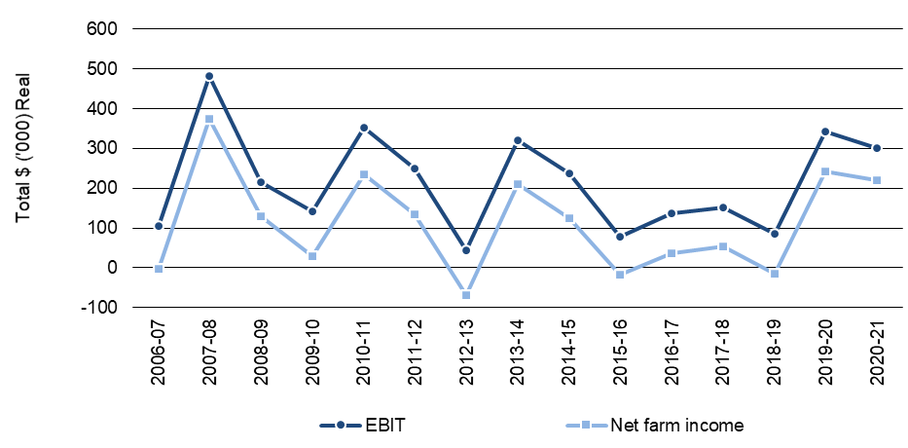

FIGURE 55. WHOLE FARM PERFORMANCE BETWEEN 2006-07 AND 2020-21 – GIPPSLAND
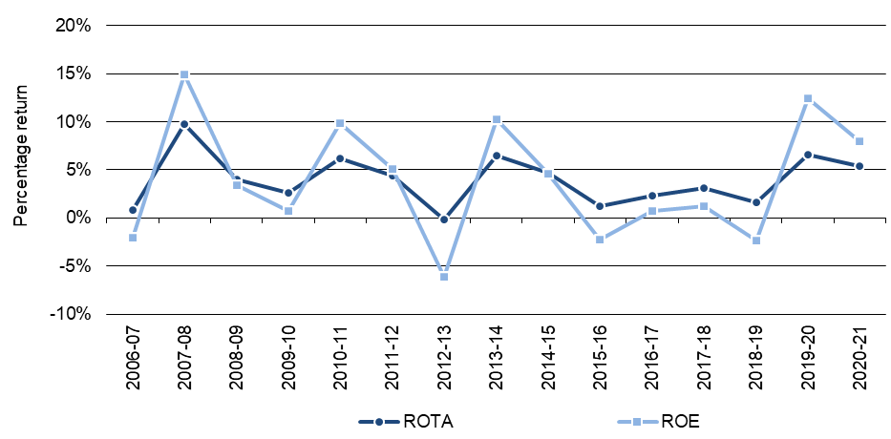

Appendices

Appendix A: Statewide summary tables
Table A1
Main financial indicators - Statewide
 | Milk income (net)  ($/ kg MS) | All other farm income  ($/ kg MS) | Gross farm income  ($/ kg MS) | Total variable costs  ($/ kg MS) | Total overhead costs  ($/ kg MS) | Cost structure (variable costs / total costs) (%) | Earnings Before Interest & Tax  ($/ kg MS) | Return on total assets (%) | Interest & lease charges  ($/ kg MS) | Debt servicing ratio  (% of income) | Net farm income (  $/ kg MS) | Return on equity  (%)
Average | $6.76 | $0.91 | $7.67 | $3.41 | $2.40 | 59% | $1.86 | 5.7% | $0.46 | 6% | $1.39 | 8.2%
Top 25% | $6.92 | $0.96 | $7.88 | $3.09 | $2.00 | 60% | $2.80 | 9.7% | $0.47 | 6% | $2.33 | 16.2%

Table A2
Physical information - Statewide
 | Total usable area  (ha) | Milking area (ha) | Total water use efficiency (t DM/100mm) | Number of milking cows (cows) | Milking cows per usable area (cows/ha) | Milk sold  (kg MS/ cow) | Milk sold  (kg MS/ ha) | Fat  (%) | Protein  (%)
Average | 278 | 170 | 0.8 | 373 | 1.6 | 530 | 823 | 4.4% | 3.5%
Top 25% | 332 | 195 | 0.9 | 505 | 1.8 | 547 | 968 | 4.4% | 3.5%

Table A2
Physical information - Statewide (continued)
 | Estimated grazed pasture**  (t DM/ ha) | Estimated conserved feed**  (t DM/ ha) | Homegrown feed as % of ME consumed  (% of ME) | Nitrogen application** (kg/ ha) | Phosphorous application** (kg/ ha) | Potassium application** (kg/ ha) | Sulphur application** (kg/ ha) | Labour efficiency (cows/ FTE) | Labour efficiency (kg MS/ FTE)
Average | 6.5 | 1.7 | 62% | 168 | 20 | 34 | 21 | 107 | 56,441
Top 25% | 7.3 | 1.9 | 61% | 191 | 22 | 32 | 17 | 126 | 66,840
**on milking area

Table A3
Purchased feed - Statewide
 | Purchased feed per milker**  (t DM/ cow) | Concentrate price  ($/ t DM) | Silage price  ($/ t DM) | Hay price  ($/ t DM) | Other feed price  ($/ t DM) | Average purchased feed price  ($/ t DM) | Purchased feed as % of ME consumed  (% of ME)
Average | 2.6 | $430 | $203 | $239 | $166 | $382 | 38%
Top 25% | 2.7 | $397 | $105 | $143 | $22 | $352 | 39%
** All purchased feed including concentrates, hay, silage, and other feed fed on the usable area to all classes of livestock divided by the number of cows
Calculation of average price of silage, hay and other feed excludes zero values

Table A4
Variable costs - Statewide
 | AI and herd test  ($/ kg MS) | Animal health ($/ kg MS) | Calf rearing ($/ kg MS) | Shed power  ($/ kg MS) | Dairy supplies ($/ kg MS) | Total herd and shed costs  ($/ kg MS) | Fertiliser  ($/ kg MS) | Irrigation **  ($/ kg MS) | Hay and silage making  ($/ kg MS)
Average | $0.13 | $0.13 | $0.06 | $0.14 | $0.10 | $0.55 | $0.44 | $0.38 | $0.22
Top 25% | $0.13 | $0.14 | $0.06 | $0.12 | $0.08 | $0.52 | $0.41 | $0.34 | $0.23
** Calculation of average cost of irrigation excludes zero values

Table A4
Variable costs - Statewide (continued)
 | Fuel and oil  ($/ kg MS) | Pasture improvement/ cropping  ($/ kg MS) | Other feed costs  ($/ kg MS) | Fodder purchases  ($/ kg MS) | Grain/ concentrates/ other  ($/ kg MS) | Agistment costs ($/ kg MS) | Feed and water inventory change  ($/ kg MS) | Total feed costs ($/ kg MS) | Total variable costs  ($/ kg MS)
Average | $0.09 | $0.19 | $0.02 | $0.32 | $1.48 | $0.08 | -$0.21 | $2.86 | $3.41
Top 25% | $0.06 | $0.19 | $0.01 | $0.39 | $1.35 | $0.07 | -$0.41 | $2.57 | $3.09

Table A5
Overhead costs - Statewide
 | Rates ($/ kg MS) | Farm Insurance ($/ kg MS) | Motor vehicle expenses ($/ kg MS) | Repairs and maintenance ($/ kg MS) | Other overheads ($/ kg MS) | Employed labour ($/ kg MS) | Total cash overheads ($/ kg MS) | Depreciation ($/ kg MS) | Imputed labour cost ($/ kg MS) | Total overheads ($/ kg MS)
Average | $0.06 | $0.08 | $0.03 | $0.40 | $0.13 | $0.61 | $1.32 | $0.25 | $0.83 | $2.40
Top 25% | $0.04 | $0.07 | $0.02 | $0.37 | $0.12 | $0.64 | $1.26 | $0.23 | $0.52 | $2.00

Table A6
Capital structure - Statewide
 | Farm assets* Land value ($/ha) | Farm assets* Land value ($/cow) | Farm assets* Permanent water value ($/ha) | Farm assets* Permanent water value ($/cow) | Other farm assets (per usable hectare) Plant and equipment ($/ha) | Other farm assets (per usable hectare) Livestock ($/ha) | Other farm assets (per usable hectare) Hay and grain ($/ha) | Other farm assets (per usable hectare) Other assets ($/ha) | Total assets ($/ha)
Average | $13,703 | $9,953 | $7,104 | $4,153 | $1,435 | $3,367 | $410 | $552 | $22,655
Top 25% | $11,717 | $7,219 | $3,994 | $2,049 | $1,429 | $3,833 | $491 | $340 | $21,805
*Calculation of average values of land, water asset and equity exclude zero values.

Table A6
Capital structure - Statewide (continued)
 | Liabilities per usable hectare ($/ha) | Liabilities per milking cow ($/cow) | Equity per usable hectare ($/ha) | Average equity (%)
Average | $6,222 | $4,324 | $16,433 | 71%
Top 25% | $7,254 | $4,027 | $14,551 | 68%

Table A7
Historical data - Statewide
Main financial indicators
Year | Income  Milk income (net) Nominal ($/kg MS) | Income  Milk income (net) Real  ($/kg MS) | Income  Gross farm income Nominal ($/kg MS) | Income  Gross farm income Real  ($/kg MS) | Variable costs  Herd costs Nominal ($/kg MS) | Variable costs  Herd costs Real  ($/kg MS) | Variable costs  Shed costs Nominal ($/kg MS) | Variable costs  Shed costs Real  ($/kg MS) | Variable costs  Feed costs Nominal ($/kg MS) | Variable costs  Feed costs Real  ($/kg MS) | Total variable costs Nominal ($/kg MS) | Total variable costs  Real  ($/kg MS)
2006-07 | $4.46 | $6.25 | $5.23 | $7.32 | $0.21 | $0.29 | $0.15 | $0.21 | $2.83 | $3.97 | $3.23 | $4.53
2007-08 | $6.57 | $8.78 | $7.80 | $10.43 | $0.24 | $0.32 | $0.14 | $0.19 | $3.39 | $4.53 | $3.79 | $5.07
2008-09 | $5.35 | $6.86 | $6.08 | $7.79 | $0.23 | $0.29 | $0.15 | $0.19 | $2.85 | $3.66 | $3.23 | $4.14
2009-10 | $4.46 | $5.54 | $5.17 | $6.42 | $0.22 | $0.27 | $0.16 | $0.20 | $2.20 | $2.73 | $2.58 | $3.20
2010-11 | $5.64 | $6.80 | $6.47 | $7.81 | $0.26 | $0.32 | $0.18 | $0.22 | $2.27 | $2.73 | $2.71 | $3.28
2011-12 | $5.52 | $6.54 | $5.97 | $7.08 | $0.26 | $0.31 | $0.19 | $0.23 | $2.33 | $2.76 | $2.78 | $3.29
2012-13 | $4.90 | $5.65 | $5.25 | $6.05 | $0.27 | $0.31 | $0.22 | $0.26 | $2.59 | $2.98 | $3.08 | $3.55
2013-14 | $6.79 | $7.61 | $7.44 | $8.35 | $0.28 | $0.31 | $0.22 | $0.24 | $2.90 | $3.25 | $3.39 | $3.81
2014-15 | $6.04 | $6.63 | $6.61 | $7.25 | $0.29 | $0.32 | $0.20 | $0.22 | $2.90 | $3.18 | $3.39 | $3.72
2015-16 | $5.40 | $5.85 | $5.90 | $6.39 | $0.28 | $0.30 | $0.19 | $0.20 | $3.15 | $3.41 | $3.62 | $3.92
2016-17 | $5.07 | $5.39 | $5.80 | $6.17 | $0.29 | $0.31 | $0.20 | $0.21 | $2.40 | $2.56 | $2.89 | $3.07
2017-18 | $5.81 | $6.05 | $6.41 | $6.68 | $0.31 | $0.33 | $0.22 | $0.23 | $2.93 | $3.06 | $3.46 | $3.61
2018-19 | $6.13 | $6.32 | $6.76 | $6.96 | $0.32 | $0.33 | $0.23 | $0.23 | $3.62 | $3.73 | $4.17 | $4.29
2019-20 | $7.15 | $7.27 | $7.87 | $8.00 | $0.32 | $0.32 | $0.23 | $0.23 | $3.33 | $3.39 | $3.88 | $3.94
2020-21 | $6.76 | $6.76 | $7.67 | $7.67 | $0.32 | $0.32 | $0.23 | $0.23 | $2.86 | $2.86 | $3.41 | $3.41
Average |  | $6.55 |  | $7.36 |  | $0.31 |  | $0.22 |  | $3.25 |  | $3.79
Notes: 'Real' dollar values are the nominal values converted to 2020-21-dollar equivalents by the consumer price index (CPI) to allow for inflation
From 2016-17 Gross farm income does not include feed inventory changes and changes to the value of carry-over water. These are included in feed costs.

Table A7
Historical data - Statewide
Main financial indicators (continued)
Year | Overhead costs  Cash overhead costs Nominal ($/kg MS) | Overhead costs  Cash overhead costs Real  ($/kg MS) | Overhead costs  Non-cash overhead costs Nominal  ($/kg MS) | Overhead costs  Non-cash overhead costs Real  ($/kg MS) | Overhead costs  Total overhead costs Nominal ($/kg MS) | Overhead costs  Total overhead costs Real ($/kg MS)
2006-07 | $0.77 | $1.08 | $1.17 | $1.64 | $1.94 | $2.71
2007-08 | $0.84 | $1.12 | $0.88 | $1.18 | $1.62 | $2.17
2008-09 | $0.82 | $1.05 | $0.88 | $1.13 | $1.70 | $2.18
2009-10 | $0.84 | $1.04 | $1.05 | $1.30 | $1.89 | $2.34
2010-11 | $1.00 | $1.21 | $1.02 | $1.23 | $2.02 | $2.44
2011-12 | $0.99 | $1.17 | $1.07 | $1.26 | $2.06 | $2.44
2012-13 | $0.99 | $1.14 | $1.09 | $1.25 | $2.08 | $2.40
2013-14 | $1.05 | $1.18 | $0.97 | $1.09 | $2.03 | $2.28
2014-15 | $1.08 | $1.18 | $0.90 | $0.98 | $1.97 | $2.17
2015-16 | $1.07 | $1.15 | $1.03 | $1.12 | $2.10 | $2.27
2016-17 | $1.09 | $1.16 | $1.06 | $1.13 | $2.16 | $2.29
2017-18 | $1.18 | $1.23 | $1.11 | $1.15 | $2.29 | $2.39
2018-19 | $1.22 | $1.25 | $1.12 | $1.15 | $2.34 | $2.41
2019-20 | $1.24 | $1.26 | $1.07 | $1.09 | $2.31 | $2.35
2020-21 | $1.32 | $1.32 | $1.09 | $1.09 | $2.40 | $2.40
Average |  | $1.17 |  | $1.19 |  | $2.35

Table A7
Historical data - Statewide
Main financial indicators (continued)
Year | Profit  Earnings before interest and tax  Nominal ($/kg MS) | Profit  Earnings before interest and tax  Real  ($/kg MS) | Profit  Interest & lease charges  Nominal  ($/kg MS) | Profit  Interest & lease charges  Real  ($/kg MS) | Profit  Net farm income  Nominal  ($/kg MS) | Profit  Net farm income  Real  ($/kg MS) | Profit  Return on total assets  % | Profit  Return on equity  %
2006-07 | $0.06 | $0.08 | $0.58 | $0.81 | -$0.52 | -$0.73 | 0.1% | -4.1%
2007-08 | $2.39 | $3.19 | $0.63 | $0.85 | $1.75 | $2.34 | 9.8% | 12.4%
2008-09 | $1.08 | $1.39 | $0.59 | $0.75 | $0.49 | $0.63 | 3.8% | 2.2%
2009-10 | $0.65 | $0.81 | $0.68 | $0.84 | -$0.03 | -$0.04 | 2.2% | -0.3%
2010-11 | $1.73 | $2.09 | $0.76 | $0.91 | $0.98 | $1.18 | 6.2% | 7.8%
2011-12 | $1.14 | $1.35 | $0.71 | $0.84 | $0.43 | $0.51 | 5.0% | 4.4%
2012-13 | $0.09 | $0.11 | $0.70 | $0.80 | -$0.60 | -$0.69 | 0.7% | -7.3%
2013-14 | $2.02 | $2.27 | $0.65 | $0.73 | $1.38 | $1.54 | 8.5% | 11.6%
2014-15 | $1.25 | $1.37 | $0.60 | $0.66 | $0.64 | $0.71 | 5.3% | 5.2%
2015-16 | $0.18 | $0.20 | $0.59 | $0.64 | -$0.41 | -$0.44 | 0.6% | -3.2%
2016-17 | $0.75 | $0.80 | $0.63 | $0.67 | $0.12 | $0.13 | 2.5% | 1.0%
2017-18 | $0.66 | $0.69 | $0.61 | $0.64 | $0.05 | $0.05 | 2.5% | 0.4%
2018-19 | $0.25 | $0.26 | $0.64 | $0.66 | -$0.39 | -$0.40 | 0.7% | -3.5%
2019-20 | $1.68 | $1.70 | $0.54 | $0.55 | $1.14 | $1.16 | 5.4% | 8.3%
2020-21 | $1.86 | $1.86 | $0.46 | $0.46 | $1.39 | $1.39 | 5.7% | 8.2%
Average |  | $1.21 |  | $0.72 |  | $0.49 | 3.9% | 2.9%

Table A8
Historical data - Statewide
Average farm physical information
Year | Total usable area (ha) | Milking area (ha) | Total water use efficiency  (t DM/100mm/ha) | Number of milking cows (cows) | Milking cows per usable area (cows/ha) | Milk sold (kg MS/ cow) | Milk sold (kg MS/ ha)
2006-07 | 271 | 268 | 0.8 | 345 | 1.4 | 447 | 636
2007-08 | 265 | 250 | 0.8 | 332 | 1.3 | 489 | 612
2008-09 | 256 | 237 | 0.8 | 330 | 1.5 | 498 | 741
2009-10 | 232 | 219 | 0.8 | 307 | 1.5 | 496 | 752
2010-11 | 236 | 227 | 0.7 | 305 | 1.4 | 493 | 719
2011-12 | 237 | 160 | 0.7 | 328 | 1.6 | 508 | 800
2012-13 | 232 | 154 | 0.8 | 323 | 1.6 | 495 | 781
2013-14 | 242 | 157 | 0.8 | 335 | 1.6 | 498 | 810
2014-15 | 248 | 160 | 0.9 | 350 | 1.6 | 514 | 845
2015-16 | 252 | 162 | 0.7 | 345 | 1.6 | 511 | 818
2016-17 | 268 | 166 | 0.7 | 342 | 1.5 | 503 | 748
2017-18 | 264 | 166 | 0.7 | 352 | 1.5 | 503 | 752
2018-19 | 261 | 162 | 0.9 | 357 | 1.6 | 495 | 757
2019-20 | 277 | 161 | 0.8 | 369 | 1.5 | 525 | 794
2020-21 | 278 | 170 | 0.8 | 373 | 1.6 | 530 | 823
Average | 254 | 188 | 0.8 | 340 | 1.5 | 500 | 759

Table A8
Historical data - Statewide
Average farm physical information (continued)
Year | Estimated grazed pasture* (t DM/ ha) | Estimated conserved feed* (t DM/ ha) | Homegrown feed as % of ME consumed (% of ME) | Concentrate price Nominal ($/T DM) | Concentrate price  Real  ($/ T DM)
2006-07 | 4.9 | 1.0 | 60% | $329 | $461
2007-08 | 4.8 | 1.0 | 64% | $425 | $568
2008-09 | 5.6 | 0.9 | 62% | $375 | $481
2009-10 | 6.2 | 0.8 | 66% | $273 | $339
2010-11 | 5.8 | 1.9 | 65% | $301 | $363
2011-12 | 6.2 | 1.0 | 57% | $296 | $351
2012-13 | 6.2 | 1.2 | 58% | $336 | $388
2013-14 | 6.6 | 1.4 | 62% | $388 | $436
2014-15 | 6.5 | 1.2 | 59% | $405 | $444
2015-16 | 5.8 | 1.2 | 53% | $402 | $435
2016-17 | 6.5 | 1.6 | 65% | $335 | $356
2017-18 | 6.1 | 1.5 | 62% | $373 | $389
2018-19 | 6.4 | 1.7 | 65% | $514 | $536
2019-20 | 6.3 | 1.4 | 61% | $495 | $503
2020-21 | 6.5 | 1.7 | 62% | $430 | $430
Average | 6.0 | 1.3 | 61% |  | $432
* From 2006-07 to 2010-11 estimated grazed pasture and conserved feed was calculated per usable hectare
From 2011-12 estimated grazed pasture and conserved feed was calculated per hectare of milking area

Appendix B: North summary tables

Table B1
Main financial indicators - North
Farm number | Milk income (net)  ($/ kg MS) | All other farm income  ($/ kg MS) | Gross farm income  ($/ kg MS) | Total variable costs  ($/ kg MS) | Total overhead costs  ($/ kg MS) | Cost structure (variable costs / total costs) (%) | Earnings Before Interest & Tax  ($/ kg MS) | Return on total assets  (%) | Interest & lease charges  ($/ kg MS) | Debt servicing ratio  (% of income) | Net farm income  ($/ kg MS) | Return on equity  (%)
NO0012 | $6.96 | $0.89 | $7.85 | $4.29 | $1.93 | 69% | $1.64 | 5.7% | $0.06 | 1% | $1.58 | 6.2%
NO0014 | $6.51 | $2.06 | $8.57 | $3.58 | $2.59 | 58% | $2.41 | 4.4% | $0.50 | 6% | $1.91 | 4.3%
NO0015 | $6.87 | $0.95 | $7.81 | $4.06 | $1.91 | 68% | $1.84 | 5.8% | $0.45 | 6% | $1.39 | 7.1%
NO0022 | $7.25 | $0.61 | $7.86 | $3.48 | $1.81 | 66% | $2.57 | 6.3% | $0.08 | 1% | $2.50 | 7.1%
NO0023 | $7.04 | $0.59 | $7.63 | $4.15 | $1.83 | 69% | $1.65 | 7.6% | $0.21 | 3% | $1.45 | 9.1%
NO0027 | $6.85 | $2.22 | $9.07 | $4.92 | $2.76 | 64% | $1.39 | 5.7% | $0.35 | 4% | $1.04 | 7.7%
NO0035 | $7.07 | $0.81 | $7.89 | $3.38 | $2.76 | 55% | $1.75 | 3.1% | $0.16 | 2% | $1.59 | 3.0%
NO0041 | $7.39 | $1.00 | $8.39 | $4.41 | $2.04 | 68% | $1.94 | 5.9% | $0.34 | 4% | $1.60 | 10.4%
NO0043 | $8.47 | $0.31 | $8.78 | $2.75 | $3.22 | 46% | $2.82 | 6.9% | $1.27 | 15% | $1.54 | 8.9%
NO0052 | $6.68 | $1.43 | $8.11 | $5.47 | $3.25 | 63% | -$0.61 | -3.8% | $0.51 | 6% | -$1.12 | -14.7%
NO0054 | $7.36 | $0.90 | $8.27 | $3.73 | $1.92 | 66% | $2.61 | 10.3% | $0.45 | 5% | $2.15 | 16.3%
NO0056 | $6.77 | $0.82 | $7.59 | $4.12 | $1.92 | 68% | $1.56 | 5.1% | $0.71 | 9% | $0.85 | 5.8%
NO0059 | $6.84 | $0.67 | $7.51 | $4.55 | $1.93 | 70% | $1.04 | 4.6% | $0.58 | 8% | $0.45 | 5.5%
NO0064 | $7.39 | $1.17 | $8.56 | $3.51 | $1.91 | 65% | $3.15 | 11.8% | $0.34 | 4% | $2.81 | 15.3%
NO0065 | $7.18 | $0.97 | $8.15 | $3.94 | $2.25 | 64% | $1.96 | 5.5% | $0.97 | 12% | $0.99 | 15.3%
NO0068 | $6.88 | $0.73 | $7.61 | $2.55 | $1.67 | 60% | $3.39 | 10.8% | $0.05 | 1% | $3.34 | 11.2%
NO0069 | $8.50 | $0.68 | $9.17 | $4.67 | $3.01 | 61% | $1.50 | 3.4% | $0.57 | 6% | $0.93 | 2.7%
NO0072 | $6.81 | $1.16 | $7.97 | $3.16 | $3.45 | 48% | $1.36 | 2.2% | $0.00 | 0% | $1.35 | 2.2%
NO0073 | $6.65 | $1.16 | $7.81 | $3.85 | $2.18 | 64% | $1.78 | 3.2% | $0.30 | 4% | $1.48 | 3.2%
NO0075 | $6.89 | $0.89 | $7.78 | $3.07 | $2.01 | 60% | $2.70 | 9.7% | $0.69 | 9% | $2.02 | 10.8%
NO0076 | $7.77 | $0.49 | $8.27 | $3.86 | $2.81 | 58% | $1.60 | 4.6% | $0.17 | 2% | $1.43 | 4.6%
NO0078 | $7.07 | $0.62 | $7.69 | $3.91 | $1.52 | 72% | $2.26 | 8.6% | $0.58 | 8% | $1.68 | 10.6%
NO0079 | $6.27 | $0.79 | $7.05 | $3.99 | $2.25 | 64% | $0.81 | 3.0% | $0.33 | 5% | $0.49 | 3.6%
NO0080 | $6.66 | $0.58 | $7.23 | $4.63 | $1.74 | 73% | $0.87 | 7.9% | $0.17 | 2% | $0.69 | 10.8%
NO0081 | $6.91 | $0.63 | $7.54 | $4.35 | $1.70 | 72% | $1.48 | 6.0% | $0.06 | 1% | $1.42 | 6.3%
NO0082 | $6.79 | $1.19 | $7.98 | $3.99 | $1.99 | 67% | $1.99 | 12.7% | $0.42 | 5% | $1.58 | 23.6%
NO0083 | $6.79 | $0.89 | $7.68 | $2.84 | $2.74 | 51% | $2.10 | 6.6% | $1.60 | 21% | $0.49 | 6.1%
NO0086 | $6.34 | $0.95 | $7.29 | $3.64 | $2.83 | 56% | $0.82 | 2.8% | $0.34 | 5% | $0.48 | 2.1%
NO0087 | $7.03 | $0.39 | $7.42 | $4.12 | $2.43 | 63% | $0.87 | 5.5% | $0.36 | 5% | $0.51 | 7.9%
NO0088 | $6.49 | $0.78 | $7.28 | $2.94 | $2.69 | 52% | $1.65 | 7.2% | $0.65 | 9% | $0.99 | 13.3%
Average | $7.02 | $0.91 | $7.93 | $3.86 | $2.30 | 63% | $1.76 | 6.0% | $0.44 | 5.6% | $1.32 | 7.5%
Top 25%* | $7.01 | $0.87 | $7.87 | $3.63 | $1.82 | 66% | $2.42 | 10.3% | $0.39 | 4.9% | $2.04 | 14.1%
* Top 25% are bold and italicised

Table B2
Physical information - North
Farm number | Total usable area (ha) | Milking area (ha) | Total water use efficiency (t DM/100mm) | Number of milking cows (cows) | Milking cows per usable area (cows/ha) | Milk sold  (kg MS/ cow) | Milk sold  (kg MS/ ha) | Fat  (%) | Protein  (%)
NO0012 | 472 | 372 | 0.9 | 830 | 1.8 | 645 | 1,134 | 4.3% | 3.4%
NO0014 | 496 | 437 | 0.6 | 487 | 1.0 | 559 | 548 | 3.9% | 3.2%
NO0015 | 247 | 92 | 0.8 | 350 | 1.4 | 517 | 732 | 4.5% | 3.6%
NO0022 | 226 | 105 | 0.9 | 310 | 1.4 | 531 | 728 | 4.7% | 3.5%
NO0023 | 342 | 155 | 0.8 | 500 | 1.5 | 582 | 851 | 4.3% | 3.4%
NO0027 | 1,212 | 1 | 1.2 | 750 | 0.6 | 759 | 470 | 4.1% | 3.2%
NO0035 | 109 | 66 | 0.6 | 176 | 1.6 | 581 | 938 | 4.2% | 3.3%
NO0041 | 217 | 153 | 0.9 | 320 | 1.5 | 561 | 828 | 4.2% | 3.5%
NO0043 | 144 | 144 | 1.1 | 129 | 0.9 | 426 | 382 | 4.3% | 3.4%
NO0052 | 46 | 46 | 1.3 | 185 | 4.0 | 383 | 1,539 | 3.9% | 3.4%
NO0054 | 1,131 | 310 | 1.2 | 1,778 | 1.6 | 642 | 1,010 | 4.0% | 3.4%
NO0056 | 264 | 90 | 0.9 | 265 | 1.0 | 674 | 676 | 3.9% | 3.2%
NO0059 | 311 | 75 | 0.8 | 270 | 0.9 | 522 | 453 | 4.4% | 3.4%
NO0064 | 289 | 254 | 1.1 | 700 | 2.4 | 543 | 1,316 | 4.8% | 3.6%
NO0065 | 218 | 108 | 1.2 | 450 | 2.1 | 671 | 1,385 | 4.3% | 3.5%
NO0068 | 353 | 277 | 1.6 | 830 | 2.4 | 398 | 936 | 4.7% | 3.7%
NO0069 | 162 | 100 | 0.6 | 192 | 1.2 | 488 | 578 | 5.0% | 3.8%
NO0072 | 195 | 57 | 0.8 | 184 | 0.9 | 524 | 495 | 4.5% | 3.5%
NO0073 | 389 | 230 | 0.6 | 500 | 1.3 | 561 | 721 | 3.9% | 3.3%
NO0075 | 373 | 190 | 1.1 | 530 | 1.4 | 630 | 895 | 4.5% | 3.6%
NO0076 | 119 | 94 | 0.7 | 300 | 2.5 | 573 | 1,444 | 4.7% | 3.9%
NO0078 | 269 | 100 | 0.8 | 358 | 1.3 | 717 | 955 | 4.1% | 3.4%
NO0079 | 118 | 118 | 0.5 | 180 | 1.5 | 485 | 739 | 4.7% | 3.7%
NO0080 | 80 | 80 | 0.5 | 275 | 3.4 | 533 | 1,832 | 4.2% | 3.5%
NO0081 | 345 | 345 | 1.3 | 500 | 1.4 | 663 | 961 | 4.3% | 3.4%
NO0082 | 352 | 297 | 1.0 | 460 | 1.3 | 630 | 823 | 4.1% | 3.4%
NO0083 | 149 | 149 | 0.9 | 250 | 1.7 | 493 | 827 | 4.4% | 3.3%
NO0086 | 433 | 315 | 0.7 | 410 | 0.9 | 683 | 646 | 4.3% | 3.5%
NO0087 | 133 | 70 | 0.9 | 250 | 1.9 | 635 | 1,196 | 4.2% | 3.5%
NO0088 | 29 | 29 | 1.1 | 86 | 3.0 | 557 | 1,651 | 4.7% | 3.7%
Average | 307 | 162 | 0.9 | 427 | 1.7 | 572 | 923 | 4.3% | 3.5%
Top 25%* | 407 | 215 | 1.1 | 704 | 2.0 | 585 | 1,110 | 4.3% | 3.5%

Table B2
Physical information - North (continued)
Farm number | Estimated grazed pasture**  (t DM/ ha) | Estimated conserved feed**  (t DM/ ha) | Homegrown feed as % of ME consumed  (% of ME) | Nitrogen application** (kg/ ha) | Phosphorous application** (kg/ ha) | Potassium application** (kg/ ha) | Sulphur application** (kg/ ha) | Labour efficiency (cows/ FTE) | Labour efficiency  (kg MS/ FTE)
NO0012 | 2.3 | 2.7 | 28% | 123 | 22 | 3 | 2 | 145 | 93,287
NO0014 | 3.2 | 2.5 | 56% | 121 | 25 | 0 | 31 | 84 | 47,090
NO0015 | 6.0 | 2 | 53% | 169 | 54 | 0 | 18 | 142 | 73,434
NO0022 | 8.1 | 1.6 | 63% | 54 | 15 | 6 | 14 | 128 | 67,804
NO0023 | 5.5 | 1.9 | 40% | 136 | 43 | 7 | 5 | 119 | 69,211
NO0027 | 0.0 | 0 | 59% | 0 | 0 | 0 | 0 | 69 | 52,106
NO0035 | 8.6 | 0.8 | 60% | 31 | 6 | 2 | 0 | 77 | 44,438
NO0041 | 5.7 | 0.9 | 50% | 58 | 21 | 0 | 26 | 100 | 56,330
NO0043 | 2.8 | 3 | 90% | 1 | 2 | 0 | 2 | 115 | 48,945
NO0052 | 6.9 | 3.1 | 45% | 95 | 16 | 23 | 8 | 95 | 36,549
NO0054 | 3.7 | 0.0 | 36% | 207 | 46 | 4 | 53 | 97 | 62,285
NO0056 | 8.6 | 1.4 | 54% | 227 | 26 | 85 | 33 | 102 | 68,552
NO0059 | 10.3 | 0 | 66% | 14 | 7 | 5 | 3 | 107 | 56,050
NO0064 | 7.9 | 2.8 | 46% | 194 | 29 | 4 | 6 | 131 | 71,106
NO0065 | 7.3 | 4.2 | 49% | 131 | 11 | 0 | 3 | 85 | 56,858
NO0068 | 12.0 | 3.3 | 90% | 238 | 6 | 1 | 1 | 174 | 69,118
NO0069 | 6.8 | 0.4 | 76% | 19 | 36 | 7 | 41 | 83 | 40,566
NO0072 | 8.7 | 0.5 | 70% | 69 | 16 | 31 | 20 | 63 | 33,149
NO0073 | 3.8 | 3.4 | 58% | 261 | 12 | 38 | 14 | 113 | 63,285
NO0075 | 6.3 | 1.2 | 63% | 191 | 25 | 0 | 2 | 114 | 71,715
NO0076 | 4.9 | 3.7 | 38% | 106 | 24 | 68 | 64 | 71 | 40,741
NO0078 | 10.0 | 0.0 | 45% | 51 | 25 | 0 | 12 | 118 | 84,316
NO0079 | 3.2 | 0.4 | 43% | 62 | 13 | 0 | 17 | 106 | 51,551
NO0080 | 4.6 | 0.9 | 26% | 206 | 3 | 9 | 28 | 108 | 57,311
NO0081 | 2.3 | 5.5 | 53% | 57 | 13 | 3 | 15 | 115 | 75,985
NO0082 | 3.3 | 5.3 | 54% | 119 | 18 | 9 | 12 | 94 | 59,347
NO0083 | 5.0 | 1.3 | 55% | 60 | 2 | 0 | 0 | 93 | 45,874
NO0086 | 4.1 | 2.8 | 64% | 91 | 24 | 14 | 38 | 68 | 46,226
NO0087 | 10.6 | 1.6 | 51% | 133 | 31 | 0 | 3 | 92 | 58,444
NO0088 | 10.9 | 1.0 | 59% | 10 | 37 | 6 | 48 | 71 | 39,570
Average | 6.3 | 1.9 | 55% | 112 | 21 | 11 | 18 | 103 | 58,041
Top 25%* | 6.8 | 1.9 | 52% | 172 | 22 | 4 | 16 | 119 | 67,885
**on milking area

Table B3
Purchased feed - North
Farm number | Purchased feed per milker**  (t DM/ cow) | Concentrate price  ($/ t DM) | Silage price  ($/ t DM) | Hay price  ($/ t DM) | Other feed price ($/ t DM) | Average purchased feed price  ($/ t DM) | Purchased feed as % of ME consumed (% of ME)
NO0012 | 6.3 | $363 | $110 | $177 | $94 | $267 | 72%
NO0014 | 3.8 | $403 | $0 | $251 | $0 | $364 | 44%
NO0015 | 3.2 | $293 | $0 | $257 | $0 | $282 | 47%
NO0022 | 2.7 | $453 | $0 | $290 | $0 | $391 | 37%
NO0023 | 4.9 | $360 | $183 | $238 | $0 | $277 | 60%
NO0027 | 4.9 | $514 | $0 | $107 | $261 | $296 | 41%
NO0035 | 3.0 | $280 | $0 | $270 | $0 | $275 | 40%
NO0041 | 4.2 | $460 | $381 | $244 | $0 | $361 | 50%
NO0043 | 0.7 | $573 | $0 | $0 | $0 | $573 | 10%
NO0052 | 2.8 | $504 | $0 | $178 | $0 | $404 | 55%
NO0054 | 4.8 | $394 | $128 | $226 | $0 | $315 | 64%
NO0056 | 3.9 | $479 | $0 | $242 | $0 | $445 | 46%
NO0059 | 2.7 | $677 | $0 | $336 | $0 | $562 | 34%
NO0064 | 3.7 | $388 | $282 | $282 | $0 | $324 | 54%
NO0065 | 4.8 | $395 | $281 | $323 | $0 | $359 | 51%
NO0068 | 0.5 | $308 | $0 | $0 | $0 | $308 | 10%
NO0069 | 1.7 | $680 | $0 | $257 | $0 | $517 | 24%
NO0072 | 2.1 | $302 | $0 | $0 | $0 | $302 | 30%
NO0073 | 2.7 | $423 | $0 | $217 | $0 | $389 | 42%
NO0075 | 2.4 | $438 | $0 | $220 | $0 | $402 | 37%
NO0076 | 4.2 | $407 | $147 | $245 | $319 | $316 | 62%
NO0078 | 5.1 | $365 | $0 | $303 | $0 | $327 | 55%
NO0079 | 3.3 | $334 | $342 | $129 | $132 | $247 | 57%
NO0080 | 4.8 | $434 | $213 | $165 | $0 | $289 | 74%
NO0081 | 4.3 | $444 | $193 | $267 | $0 | $303 | 47%
NO0082 | 3.5 | $441 | $120 | $147 | $0 | $375 | 46%
NO0083 | 3.7 | $533 | $160 | $188 | $0 | $274 | 45%
NO0086 | 2.7 | $434 | $186 | $172 | $0 | $389 | 36%
NO0087 | 4.2 | $460 | $0 | $245 | $0 | $334 | 49%
NO0088 | 3.1 | $455 | $0 | $220 | $0 | $353 | 41%
Average | 3.5 | $433 | $210 | $230 | $201 | $354 | 45%
Top 25%* | 3.5 | $396 |  |  |  | $334 | 48%
** All purchased feed including concentrates, hay, silage, and other feed fed on the usable area to all classes of livestock divided by the number of cows
Calculation of average price of silage, hay and other feed excludes zero values

Table B4
Variable costs - North
Farm number | AI and herd test ($/ kg MS) | Animal health ($/ kg MS) | Calf rearing  ($/ kg MS) | Shed power  ($/ kg MS) | Dairy supplies ($/ kg MS) | Total herd and shed costs  ($/ kg MS) | Fertiliser  ($/ kg MS) | Irrigation **  ($/ kg MS) | Hay and silage making  ($/ kg MS)
NO0012 | $0.21 | $0.13 | $0.08 | $0.11 | $0.15 | $0.68 | $0.39 | $0.50 | $0.59
NO0014 | $0.11 | $0.20 | $0.03 | $0.13 | $0.09 | $0.56 | $0.54 | $0.00 | $0.04
NO0015 | $0.17 | $0.18 | $0.01 | $0.16 | $0.06 | $0.59 | $0.40 | $0.86 | $0.49
NO0022 | $0.11 | $0.16 | $0.01 | $0.15 | $0.06 | $0.49 | $0.14 | $0.54 | $0.27
NO0023 | $0.14 | $0.14 | $0.02 | $0.09 | $0.10 | $0.49 | $0.24 | $0.33 | $0.21
NO0027 | $0.15 | $0.13 | $0.00 | $0.14 | $0.06 | $0.49 | $0.59 | $0.39 | $0.38
NO0035 | $0.07 | $0.14 | $0.02 | $0.11 | $0.05 | $0.39 | $0.23 | $0.90 | $0.15
NO0041 | $0.15 | $0.17 | $0.03 | $0.10 | $0.04 | $0.50 | $0.16 | $0.55 | $0.16
NO0043 | $0.14 | $0.12 | $0.09 | $0.22 | $0.24 | $0.81 | $0.02 | $0.49 | $0.46
NO0052 | $0.17 | $0.13 | $0.05 | $0.16 | $0.11 | $0.62 | $0.22 | $0.63 | $0.20
NO0054 | $0.23 | $0.21 | $0.03 | $0.11 | $0.08 | $0.66 | $0.41 | $0.34 | $0.60
NO0056 | $0.19 | $0.22 | $0.02 | $0.11 | $0.05 | $0.61 | $0.39 | $0.65 | $0.34
NO0059 | $0.09 | $0.03 | $0.01 | $0.15 | $0.09 | $0.38 | $0.06 | $0.78 | $0.36
NO0064 | $0.17 | $0.20 | $0.03 | $0.08 | $0.10 | $0.58 | $0.35 | $0.69 | $0.26
NO0065 | $0.17 | $0.18 | $0.06 | $0.09 | $0.09 | $0.58 | $0.14 | $0.26 | $0.44
NO0068 | $0.09 | $0.19 | $0.00 | $0.19 | $0.03 | $0.51 | $0.41 | $0.31 | $0.51
NO0069 | $0.15 | $0.17 | $0.02 | $0.07 | $0.10 | $0.51 | $0.56 | $0.99 | $0.22
NO0072 | $0.15 | $0.21 | $0.18 | $0.11 | $0.11 | $0.77 | $0.32 | $0.15 | $0.52
NO0073 | $0.11 | $0.14 | $0.33 | $0.11 | $0.12 | $0.81 | $0.45 | $0.06 | $0.28
NO0075 | $0.15 | $0.07 | $0.02 | $0.07 | $0.07 | $0.38 | $0.24 | $0.48 | $0.47
NO0076 | $0.12 | $0.19 | $0.08 | $0.13 | $0.10 | $0.62 | $0.35 | $0.72 | $0.14
NO0078 | $0.06 | $0.21 | $0.00 | $0.07 | $0.05 | $0.38 | $0.21 | $1.00 | $0.04
NO0079 | $0.00 | $0.12 | $0.03 | $0.19 | $0.06 | $0.39 | $0.26 | $0.50 | $0.07
NO0080 | $0.10 | $0.16 | $0.01 | $0.10 | $0.06 | $0.43 | $0.20 | $0.64 | $0.06
NO0081 | $0.17 | $0.04 | $0.00 | $0.07 | $0.08 | $0.35 | $0.32 | $0.47 | $0.48
NO0082 | $0.16 | $0.09 | $0.02 | $0.11 | $0.07 | $0.44 | $0.44 | $0.65 | $0.58
NO0083 | $0.02 | $0.10 | $0.03 | $0.15 | $0.03 | $0.32 | $0.08 | $0.06 | $0.00
NO0086 | $0.12 | $0.13 | $0.12 | $0.08 | $0.07 | $0.53 | $0.39 | $0.75 | $0.29
NO0087 | $0.13 | $0.13 | $0.04 | $0.11 | $0.12 | $0.53 | $0.23 | $0.65 | $0.04
NO0088 | $0.11 | $0.08 | $0.00 | $0.13 | $0.07 | $0.38 | $0.14 | $0.72 | $0.03
Average | $0.13 | $0.15 | $0.05 | $0.12 | $0.08 | $0.53 | $0.30 | $0.55 | $0.29
Top 25%* | $0.14 | $0.16 | $0.02 | $0.10 | $0.07 | $0.48 | $0.32 | $0.59 | $0.36
** Calculation of average cost of irrigation excludes zero values
Table B4
Variable costs - North (continued)
Farm number | Fuel and oil  ($/ kg MS) | Pasture improvement/ cropping  ($/ kg MS) | Other feed costs  ($/ kg MS) | Fodder purchases  ($/ kg MS) | Grain/ concentrates/ other  ($/ kg MS) | Agistment costs  ($/ kg MS) | Feed and water inventory change  ($/ kg MS) | Total feed costs  ($/ kg MS) | Total variable costs  ($/ kg MS)
NO0012 | $0.11 | $0.28 | $0.00 | $0.42 | $1.63 | $0.13 | -$0.42 | $3.61 | $4.29
NO0014 | $0.18 | $0.10 | $0.00 | $0.44 | $2.04 | $0.00 | -$0.33 | $3.01 | $3.58
NO0015 | $0.11 | $0.19 | $0.00 | $0.46 | $1.15 | $0.00 | -$0.18 | $3.48 | $4.06
NO0022 | $0.05 | $0.26 | $0.01 | $0.56 | $1.45 | $0.08 | -$0.38 | $2.99 | $3.48
NO0023 | $0.08 | $0.36 | $0.00 | $1.08 | $1.76 | $0.11 | -$0.52 | $3.65 | $4.15
NO0027 | $0.11 | $0.48 | $0.16 | $0.43 | $1.93 | $0.00 | -$0.04 | $4.42 | $4.92
NO0035 | $0.11 | $0.16 | $0.00 | $0.76 | $0.77 | $0.04 | -$0.15 | $2.99 | $3.38
NO0041 | $0.06 | $0.34 | $0.00 | $1.10 | $1.61 | $0.16 | -$0.21 | $3.92 | $4.41
NO0043 | $0.24 | $0.78 | $0.10 | $0.00 | $0.41 | $0.00 | -$0.58 | $1.93 | $2.75
NO0052 | $0.07 | $0.29 | $0.00 | $0.40 | $2.53 | $0.76 | -$0.26 | $4.85 | $5.47
NO0054 | $0.07 | $0.54 | $0.00 | $0.60 | $1.74 | $0.25 | -$1.47 | $3.08 | $3.73
NO0056 | $0.12 | $0.25 | $0.00 | $0.17 | $1.97 | $0.00 | -$0.39 | $3.51 | $4.12
NO0059 | $0.03 | $0.23 | $0.09 | $0.58 | $2.28 | $0.00 | -$0.24 | $4.17 | $4.55
NO0064 | $0.05 | $0.19 | $0.00 | $1.37 | $1.22 | $0.09 | -$1.29 | $2.93 | $3.51
NO0065 | $0.10 | $0.24 | $0.04 | $1.04 | $1.50 | $0.09 | -$0.49 | $3.36 | $3.94
NO0068 | $0.07 | $0.47 | $0.00 | $0.00 | $0.34 | $0.06 | -$0.14 | $2.04 | $2.55
NO0069 | $0.13 | $0.28 | $0.07 | $0.32 | $1.35 | $0.01 | $0.22 | $4.16 | $4.67
NO0072 | $0.05 | $0.37 | $0.00 | $0.00 | $1.12 | $0.00 | -$0.14 | $2.39 | $3.16
NO0073 | $0.11 | $0.15 | $0.00 | $0.18 | $1.70 | $0.04 | $0.07 | $3.04 | $3.85
NO0075 | $0.08 | $0.40 | $0.01 | $0.14 | $1.41 | $0.21 | -$0.76 | $2.68 | $3.07
NO0076 | $0.10 | $0.12 | $0.00 | $0.66 | $1.73 | $0.00 | -$0.59 | $3.24 | $3.86
NO0078 | $0.06 | $0.13 | $0.02 | $1.88 | $1.44 | $0.00 | -$1.25 | $3.52 | $3.91
NO0079 | $0.09 | $0.24 | $0.00 | $0.31 | $1.25 | $0.54 | $0.33 | $3.60 | $3.99
NO0080 | $0.03 | $0.09 | $0.00 | $1.36 | $1.56 | $0.18 | $0.08 | $4.20 | $4.63
NO0081 | $0.07 | $0.44 | $0.00 | $1.03 | $1.25 | $0.15 | -$0.21 | $4.00 | $4.35
NO0082 | $0.05 | $0.37 | $0.00 | $0.16 | $1.79 | $0.09 | -$0.59 | $3.55 | $3.99
NO0083 | $0.15 | $0.14 | $0.00 | $0.91 | $1.13 | $0.16 | -$0.12 | $2.52 | $2.84
NO0086 | $0.09 | $0.28 | $0.00 | $0.14 | $1.50 | $0.00 | -$0.33 | $3.11 | $3.64
NO0087 | $0.07 | $0.19 | $0.00 | $1.04 | $1.38 | $0.00 | -$0.01 | $3.59 | $4.12
NO0088 | $0.09 | $0.04 | $0.00 | $0.50 | $1.34 | $0.10 | -$0.40 | $2.56 | $2.94
Average | $0.09 | $0.28 | $0.02 | $0.60 | $1.48 | $0.11 | -$0.36 | $3.34 | $3.86
Top 25%* | $0.06 | $0.31 | $0.00 | $0.79 | $1.36 | $0.13 | -$0.78 | $3.14 | $3.63

Table B5
Overhead costs - North
Farm number | Rates  ($/ kg MS) | Farm Insurance ($/ kg MS) | Motor vehicle expenses ($/ kg MS) | Repairs and maintenance ($/ kg MS) | Other overheads ($/ kg MS) | Employed labour ($/ kg MS) | Total cash overheads ($/ kg MS) | Depreciation ($/ kg MS) | Imputed labour cost ($/ kg MS) | Total overheads ($/ kg MS)
NO0012 | $0.04 | $0.01 | $0.01 | $0.42 | $0.12 | $1.02 | $1.63 | $0.28 | $0.02 | $1.93
NO0014 | $0.04 | $0.07 | $0.03 | $0.54 | $0.04 | $0.62 | $1.35 | $0.31 | $0.92 | $2.59
NO0015 | $0.05 | $0.08 | $0.00 | $0.44 | $0.15 | $0.48 | $1.21 | $0.17 | $0.53 | $1.91
NO0022 | $0.07 | $0.07 | $0.01 | $0.34 | $0.09 | $0.49 | $1.07 | $0.15 | $0.58 | $1.81
NO0023 | $0.04 | $0.05 | $0.02 | $0.26 | $0.16 | $0.40 | $0.94 | $0.22 | $0.67 | $1.83
NO0027 | $0.04 | $0.08 | $0.01 | $0.48 | $0.12 | $1.45 | $2.19 | $0.33 | $0.24 | $2.76
NO0035 | $0.06 | $0.12 | $0.01 | $0.33 | $0.19 | $0.00 | $0.73 | $0.30 | $1.73 | $2.76
NO0041 | $0.03 | $0.03 | $0.02 | $0.26 | $0.10 | $0.78 | $1.21 | $0.23 | $0.59 | $2.04
NO0043 | $0.08 | $0.22 | $0.08 | $0.52 | $0.28 | $0.00 | $1.17 | $0.48 | $1.57 | $3.22
NO0052 | $0.05 | $0.19 | $0.07 | $0.30 | $0.35 | $0.07 | $1.02 | $0.15 | $2.07 | $3.25
NO0054 | $0.02 | $0.03 | $0.02 | $0.35 | $0.15 | $1.25 | $1.81 | $0.11 | $0.00 | $1.92
NO0056 | $0.07 | $0.09 | $0.02 | $0.34 | $0.09 | $0.23 | $0.85 | $0.17 | $0.90 | $1.92
NO0059 | $0.04 | $0.05 | $0.03 | $0.38 | $0.08 | $0.56 | $1.15 | $0.17 | $0.61 | $1.93
NO0064 | $0.03 | $0.07 | $0.09 | $0.31 | $0.10 | $0.73 | $1.32 | $0.22 | $0.36 | $1.91
NO0065 | $0.04 | $0.06 | $0.07 | $0.34 | $0.07 | $0.91 | $1.49 | $0.44 | $0.32 | $2.25
NO0068 | $0.07 | $0.03 | $0.01 | $0.30 | $0.08 | $0.69 | $1.18 | $0.12 | $0.37 | $1.67
NO0069 | $0.10 | $0.16 | $0.03 | $0.30 | $0.19 | $0.75 | $1.53 | $0.43 | $1.05 | $3.01
NO0072 | $0.10 | $0.09 | $0.00 | $0.51 | $0.15 | $1.54 | $2.40 | $0.22 | $0.83 | $3.45
NO0073 | $0.06 | $0.07 | $0.02 | $0.48 | $0.11 | $0.75 | $1.49 | $0.32 | $0.37 | $2.18
NO0075 | $0.05 | $0.06 | $0.01 | $0.35 | $0.16 | $0.76 | $1.40 | $0.19 | $0.43 | $2.01
NO0076 | $0.04 | $0.10 | $0.08 | $0.32 | $0.07 | $0.74 | $1.35 | $0.30 | $1.16 | $2.81
NO0078 | $0.05 | $0.07 | $0.01 | $0.24 | $0.05 | $0.25 | $0.66 | $0.29 | $0.57 | $1.52
NO0079 | $0.07 | $0.02 | $0.02 | $0.46 | $0.17 | $0.36 | $1.10 | $0.11 | $1.04 | $2.25
NO0080 | $0.03 | $0.03 | $0.02 | $0.22 | $0.12 | $0.40 | $0.82 | $0.12 | $0.79 | $1.74
NO0081 | $0.05 | $0.08 | $0.04 | $0.27 | $0.05 | $0.49 | $0.98 | $0.24 | $0.48 | $1.70
NO0082 | $0.05 | $0.03 | $0.04 | $0.33 | $0.08 | $0.96 | $1.49 | $0.22 | $0.29 | $1.99
NO0083 | $0.02 | $0.07 | $0.07 | $0.40 | $0.14 | $0.79 | $1.50 | $0.34 | $0.91 | $2.74
NO0086 | $0.06 | $0.07 | $0.04 | $0.68 | $0.16 | $0.87 | $1.87 | $0.15 | $0.81 | $2.83
NO0087 | $0.03 | $0.09 | $0.08 | $0.60 | $0.07 | $0.56 | $1.43 | $0.32 | $0.68 | $2.43
NO0088 | $0.03 | $0.02 | $0.08 | $0.39 | $0.20 | $0.21 | $0.94 | $0.15 | $1.60 | $2.69
Average | $0.05 | $0.07 | $0.03 | $0.38 | $0.13 | $0.64 | $1.31 | $0.24 | $0.75 | $2.30
Top 25%* | $0.04 | $0.05 | $0.03 | $0.30 | $0.11 | $0.72 | $1.24 | $0.18 | $0.40 | $1.82
*Calculation of average values of land, water asset and equity exclude zero values.

Table B6
Capital structure - North
 | Farm assets* Land value ($/ha) | Farm assets* Land value ($/cow) | Farm assets* Permanent water value ($/ha) | Farm assets* Permanent water value ($/cow) | Other farm assets (per usable hectare) Plant and equipment ($/ha) | Other farm assets (per usable hectare) Livestock ($/ha) | Other farm assets (per usable hectare) Hay and grain ($/ha) | Other farm assets (per usable hectare) Other assets ($/ha) | Total assets ($/ha)
Average | $10,539 | $7,722 | $8,144 | $5,106 | $1,572 | $3,522 | $543 | $550 | $24,037
Top 25%* | $8,789 | $4,801 | $8,309 | $4,589 | $1,384 | $4,003 | $844 | $644 | $23,972

Table B6
Capital structure - North (continued)
 | Liabilities per usable hectare ($/ha) | Liabilities per milking cow ($/cow) | Equity per usable hectare ($/ha) | Average equity (%)
Average | $6,318 | $4,275 | $17,719 | 68%
Top 25%* | $7,631 | $4,376 | $16,341 | 66%

Table B7
Historical data - North
Main financial indicators
Year | Income  Milk income (net) Nominal ($/kg MS) | Income  Milk income (net) Real  ($/kg MS) | Income  Gross farm income Nominal ($/kg MS) | Income  Gross farm income Real  ($/kg MS) | Variable costs  Herd costs Nominal ($/kg MS) | Variable costs  Herd costs Real  ($/kg MS) | Variable costs  Shed costs Nominal ($/kg MS) | Variable costs  Shed costs Real  ($/kg MS) | Variable costs  Feed costs Nominal ($/kg MS) | Variable costs  Feed costs Real  ($/kg MS) | Total variable costs Nominal ($/kg MS) | Total variable costs  Real  ($/kg MS)
2006-07 | $4.64 | $6.50 | $5.48 | $7.68 | $0.21 | $0.30 | $0.17 | $0.24 | $3.60 | $5.04 | $4.03 | $5.65
2007-08 | $6.53 | $8.73 | $7.86 | $10.50 | $0.23 | $0.30 | $0.15 | $0.20 | $4.37 | $5.85 | $4.70 | $6.28
2008-09 | $5.32 | $6.81 | $6.06 | $7.76 | $0.21 | $0.27 | $0.13 | $0.17 | $3.47 | $4.45 | $3.81 | $4.88
2009-10 | $4.46 | $5.53 | $5.19 | $6.45 | $0.23 | $0.29 | $0.15 | $0.19 | $2.71 | $3.37 | $3.09 | $3.84
2010-11 | $5.69 | $6.87 | $6.74 | $8.13 | $0.31 | $0.37 | $0.19 | $0.23 | $2.66 | $3.21 | $3.16 | $3.81
2011-12 | $5.64 | $6.68 | $6.06 | $7.18 | $0.26 | $0.31 | $0.18 | $0.21 | $2.52 | $2.98 | $2.95 | $3.50
2012-13 | $5.05 | $5.82 | $5.53 | $6.38 | $0.25 | $0.29 | $0.24 | $0.27 | $2.85 | $3.28 | $3.34 | $3.84
2013-14 | $6.83 | $7.66 | $7.46 | $8.37 | $0.27 | $0.30 | $0.21 | $0.24 | $3.13 | $3.51 | $3.61 | $4.05
2014-15 | $6.09 | $6.68 | $6.62 | $7.27 | $0.30 | $0.33 | $0.19 | $0.21 | $3.20 | $3.51 | $3.69 | $4.04
2015-16 | $5.46 | $5.92 | $5.98 | $6.48 | $0.30 | $0.32 | $0.18 | $0.19 | $3.59 | $3.88 | $4.06 | $4.40
2016-17 | $5.13 | $5.45 | $5.92 | $6.29 | $0.34 | $0.37 | $0.20 | $0.21 | $2.87 | $3.05 | $3.41 | $3.63
2017-18 | $5.87 | $6.12 | $6.55 | $6.82 | $0.34 | $0.36 | $0.20 | $0.21 | $3.21 | $3.34 | $3.75 | $3.91
2018-19 | $6.28 | $6.46 | $6.81 | $7.01 | $0.32 | $0.33 | $0.23 | $0.23 | $4.40 | $4.54 | $4.95 | $5.10
2019-20 | $7.31 | $7.43 | $8.01 | $8.15 | $0.32 | $0.32 | $0.23 | $0.23 | $4.08 | $4.15 | $4.61 | $4.69
2020-21 | $7.02 | $7.02 | $7.93 | $7.93 | $0.32 | $0.32 | $0.23 | $0.23 | $3.34 | $3.34 | $3.86 | $3.86
Average |  | $6.65 |  | $7.49 |  | $0.32 |  | $0.22 |  | $3.83 |  | $4.37
Notes: 'Real' dollar values are the nominal values converted to 2020-21-dollar equivalents by the consumer price index (CPI) to allow for inflation
From 2016-17 Gross farm income does not include feed inventory changes and changes to the value of carry-over water. These are included in feed costs.

Table B7
Historical data - North
Main financial indicators (continued)
Year | Overhead costs  Cash overhead costs Nominal ($/kg MS) | Overhead costs  Cash overhead costs Real ($/kg MS) | Overhead costs  Non-cash overhead costs  Nominal ($/kg MS) | Overhead costs  Non-cash overhead costs  Real ($/kg MS) | Overhead costs  Total overhead costs Nominal ($/kg MS) | Overhead costs  Total overhead costs Real ($/kg MS)
2006-07 | $0.82 | $1.15 | $1.10 | $1.55 | $1.92 | $2.69
2007-08 | $0.78 | $1.04 | $0.90 | $1.20 | $1.57 | $2.10
2008-09 | $0.74 | $0.95 | $0.82 | $1.05 | $1.56 | $2.00
2009-10 | $0.82 | $1.02 | $1.01 | $1.26 | $1.83 | $2.28
2010-11 | $1.01 | $1.22 | $1.05 | $1.26 | $2.06 | $2.49
2011-12 | $0.90 | $1.07 | $0.85 | $1.00 | $1.75 | $2.07
2012-13 | $0.94 | $1.09 | $0.87 | $1.00 | $1.81 | $2.09
2013-14 | $0.99 | $1.11 | $0.85 | $0.95 | $1.83 | $2.06
2014-15 | $1.03 | $1.13 | $0.81 | $0.89 | $1.84 | $2.02
2015-16 | $1.02 | $1.10 | $0.87 | $0.95 | $1.89 | $2.05
2016-17 | $1.13 | $1.20 | $1.01 | $1.07 | $2.14 | $2.27
2017-18 | $1.13 | $1.18 | $1.01 | $1.05 | $2.14 | $2.23
2018-19 | $1.23 | $1.26 | $1.08 | $1.11 | $2.31 | $2.38
2019-20 | $1.20 | $1.22 | $0.98 | $0.99 | $2.18 | $2.21
2020-21 | $1.31 | $1.31 | $0.99 | $0.99 | $2.30 | $2.30
Average |  | $1.14 |  | $1.09 |  | $2.22

Table B7
Historical data - North
Main financial indicators (continued)
Year | Profit  Earnings before interest and tax  Nominal ($/kg MS) | Profit  Earnings before interest and tax  Real ($/kg MS) | Profit  Interest & lease charges  Nominal ($/kg MS) | Profit  Interest & lease charges  Real ($/kg MS) | Profit  Net farm income  Nominal ($/kg MS) | Profit  Net farm income  Real ($/kg MS) | Profit  Return on total assets  % | Profit  Return on equity  %
2006-07 | -$0.47 | -$0.66 | $0.57 | $0.79 | -$1.04 | -$1.45 | -1.6% | -6.9%
2007-08 | $1.59 | $2.12 | $0.55 | $0.73 | $1.04 | $1.39 | 7.9% | 7.6%
2008-09 | $0.59 | $0.75 | $0.54 | $0.69 | $0.05 | $0.06 | 2.7% | -0.7%
2009-10 | $0.20 | $0.25 | $0.51 | $0.64 | -$0.31 | -$0.39 | 0.8% | -3.1%
2010-11 | $1.52 | $1.83 | $0.65 | $0.78 | $0.87 | $1.05 | 7.0% | 7.6%
2011-12 | $1.36 | $1.61 | $0.57 | $0.68 | $0.78 | $0.93 | 7.6% | 8.4%
2012-13 | $0.39 | $0.45 | $0.58 | $0.67 | -$0.19 | -$0.22 | 2.2% | -2.9%
2013-14 | $2.02 | $2.26 | $0.56 | $0.62 | $1.46 | $1.64 | 11.3% | 14.7%
2014-15 | $1.10 | $1.20 | $0.50 | $0.55 | $0.59 | $0.65 | 6.1% | 4.9%
2015-16 | $0.03 | $0.03 | $0.46 | $0.50 | -$0.43 | -$0.47 | -0.1% | -4.4%
2016-17 | $0.37 | $0.39 | $0.59 | $0.62 | -$0.22 | -$0.23 | 1.0% | -2.0%
2017-18 | $0.65 | $0.68 | $0.55 | $0.57 | $0.10 | $0.11 | 2.5% | 1.2%
2018-19 | -$0.45 | -$0.47 | $0.56 | $0.58 | -$1.01 | -$1.04 | -1.7% | -7.4%
2019-20 | $1.22 | $1.24 | $0.45 | $0.46 | $0.77 | $0.79 | 4.1% | 3.7%
2020-21 | $1.76 | $1.76 | $0.44 | $0.44 | $1.32 | $1.32 | 6.0% | 7.5%
Average |  | $0.90 |  | $0.62 |  | $0.27 | 3.7% | 1.9%

Table B8
Historical data - North
Average farm physical information
Year | Total usable area (ha) | Milking area (ha) | Total water use efficiency (t DM/100mm/ha) | Number of milking cows (cows) | Milking cows per usable area (cows/ha) | Milk sold (kg MS/ cow) | Milk sold (kg MS/ ha)
2006-07 | 336 | 331 | 0.7 | 365 | 1.4 | 430 | 636
2007-08 | 294 | 258 | 0.8 | 321 | 1.1 | 511 | 559
2008-09 | 245 | 195 | 0.8 | 322 | 1.6 | 500 | 784
2009-10 | 216 | 195 | 0.7 | 282 | 1.6 | 515 | 806
2010-11 | 196 | 171 | 0.7 | 261 | 1.5 | 495 | 762
2011-12 | 193 | 128 | 0.7 | 304 | 1.9 | 516 | 957
2012-13 | 193 | 123 | 0.8 | 300 | 1.8 | 518 | 961
2013-14 | 210 | 130 | 0.8 | 332 | 1.9 | 522 | 995
2014-15 | 222 | 135 | 0.9 | 356 | 1.9 | 537 | 1020
2015-16 | 234 | 142 | 0.7 | 367 | 1.9 | 527 | 992
2016-17 | 274 | 152 | 0.7 | 370 | 1.7 | 499 | 827
2017-18 | 269 | 149 | 0.7 | 383 | 1.6 | 535 | 838
2018-19 | 271 | 149 | 0.9 | 399 | 1.6 | 524 | 829
2019-20 | 304 | 145 | 0.8 | 418 | 1.5 | 566 | 867
2020-21 | 307 | 162 | 0.9 | 427 | 1.7 | 572 | 923
Average | 251 | 171 | 0.8 | 347 | 1.6 | 518 | 850

Table B8
Historical data - North
Average farm physical information (continued)
Year | Estimated grazed pasture* (t DM/ ha) | Estimated conserved feed* (t DM/ ha) | Homegrown feed as % of ME consumed (% of ME) | Concentrate price Nominal ($/t DM) | Concentrate price  Real  ($/ t DM)
2006-07 | 4.3 | 0.5 | 48% | $316 | $443
2007-08 | 3.1 | 0.7 | 47% | $398 | $532
2008-09 | 4.3 | 0.7 | 46% | $347 | $445
2009-10 | 5.0 | 0.6 | 51% | $256 | $318
2010-11 | 5.1 | 2.6 | 58% | $286 | $345
2011-12 | 7.1 | 1.1 | 53% | $267 | $316
2012-13 | 8.1 | 1.4 | 55% | $311 | $358
2013-14 | 7.6 | 1.6 | 57% | $366 | $411
2014-15 | 7.6 | 1.2 | 54% | $387 | $425
2015-16 | 7.1 | 1.1 | 50% | $389 | $421
2016-17 | 6.8 | 1.1 | 58% | $311 | $330
2017-18 | 7.0 | 1.4 | 59% | $352 | $367
2018-19 | 7.1 | 1.6 | 60% | $513 | $528
2019-20 | 5.7 | 0.9 | 50% | $494 | $502
2020-21 | 6.3 | 1.9 | 55% | $433 | $433
Average | 6.2 | 1.2 | 53% |  | $412
* From 2006-07 to 2010-11 estimated grazed pasture and conserved feed was calculated per usable hectare
From 2011-12 estimated grazed pasture and conserved feed was calculated per hectare of milking area

Appendix C: South West summary tables
Table C1
Main financial indicators - South West
Farm number | Milk income (net)  ($/ kg MS) | All other farm income  ($/ kg MS) | Gross farm income  ($/ kg MS) | Total variable costs  ($/ kg MS) | Total overhead costs  ($/ kg MS) | Cost structure (variable costs / total costs) (%) | Earnings Before Interest & Tax  ($/ kg MS) | Return on total assets  (%) | Interest & lease charges  ($/ kg MS) | Debt servicing ratio  (% of income) | Net farm income  ($/ kg MS) | Return on equity  (%)
SW0001 | $7.20 | $1.29 | $8.50 | $3.65 | $2.88 | 56% | $1.97 | 5.6% | $0.40 | 5% | $1.57 | 7.6%
SW0007 | $6.29 | $0.42 | $6.70 | $2.78 | $2.84 | 49% | $1.09 | 5.1% | $0.00 | 0% | $1.09 | 5.1%
SW0008 | $6.76 | $1.10 | $7.86 | $2.84 | $2.67 | 51% | $2.35 | 5.5% | $0.41 | 5% | $1.94 | 6.1%
SW0022 | $6.82 | $1.82 | $8.64 | $3.45 | $2.76 | 56% | $2.44 | 6.2% | $0.18 | 2% | $2.26 | 7.3%
SW0025 | $6.92 | $1.49 | $8.41 | $2.74 | $2.25 | 55% | $3.42 | 12.8% | $0.20 | 2% | $3.22 | 15.2%
SW0027 | $6.12 | $0.43 | $6.56 | $1.73 | $2.57 | 40% | $2.25 | 5.9% | $0.13 | 2% | $2.12 | 6.3%
SW0030 | $6.63 | $1.64 | $8.27 | $2.99 | $2.35 | 56% | $2.93 | 5.1% | $0.82 | 10% | $2.11 | 7.4%
SW0032 | $6.21 | $1.01 | $7.22 | $3.14 | $2.74 | 53% | $1.34 | 3.0% | $0.58 | 8% | $0.75 | 3.2%
SW0033 | $6.10 | $0.16 | $6.26 | $2.38 | $3.35 | 42% | $0.54 | 0.8% | $0.01 | 0% | $0.53 | 0.8%
SW0035 | $6.82 | $0.92 | $7.74 | $3.00 | $1.96 | 60% | $2.78 | 8.2% | $1.04 | 13% | $1.74 | 26.0%
SW0036 | $6.68 | $0.71 | $7.39 | $3.20 | $2.57 | 55% | $1.62 | 4.0% | $0.20 | 3% | $1.42 | 4.4%
SW0037 | $6.74 | $1.66 | $8.40 | $4.89 | $3.30 | 60% | $0.21 | 0.6% | $0.40 | 5% | -$0.19 | -1.1%
SW0040 | $6.64 | $1.27 | $7.91 | $2.93 | $2.90 | 50% | $2.08 | 4.8% | $0.80 | 10% | $1.28 | 6.5%
SW0042 | $6.59 | $0.91 | $7.50 | $3.67 | $2.57 | 59% | $1.26 | 3.6% | $0.30 | 4% | $0.97 | 5.3%
SW0043 | $6.29 | $0.27 | $6.55 | $3.53 | $3.10 | 53% | -$0.08 | -0.2% | $0.24 | 4% | -$0.32 | -1.4%
SW0045 | $7.00 | $2.12 | $9.12 | $2.77 | $3.22 | 46% | $3.12 | 9.1% | $0.05 | 1% | $3.07 | 9.9%
SW0046 | $6.74 | $0.73 | $7.47 | $3.08 | $2.46 | 56% | $1.94 | 6.3% | $0.37 | 5% | $1.56 | 11.1%
SW0047 | $7.49 | $0.96 | $8.45 | $3.64 | $2.11 | 63% | $2.70 | 7.9% | $0.75 | 9% | $1.95 | 18.8%
SW0049 | $6.62 | $1.04 | $7.66 | $2.00 | $2.55 | 44% | $3.11 | 8.5% | $0.54 | 7% | $2.57 | 12.2%
SW0050 | $6.78 | $0.89 | $7.67 | $3.56 | $2.44 | 59% | $1.67 | 4.9% | $0.26 | 3% | $1.41 | 5.2%
SW0051 | $6.61 | $1.72 | $8.34 | $3.51 | $1.96 | 64% | $2.87 | 7.6% | $0.80 | 10% | $2.07 | 27.4%
SW0053 | $6.44 | $0.83 | $7.28 | $1.78 | $2.31 | 44% | $3.19 | 8.5% | $0.70 | 10% | $2.49 | 23.4%
SW0054 | $6.93 | $1.55 | $8.48 | $3.79 | $2.54 | 60% | $2.15 | 6.5% | $0.66 | 8% | $1.49 | 12.2%
SW0055 | $6.95 | $0.73 | $7.69 | $3.43 | $2.58 | 57% | $1.68 | 4.0% | $0.92 | 12% | $0.77 | 3.9%
SW0056 | $6.56 | $2.21 | $8.77 | $1.92 | $4.43 | 30% | $2.42 | 4.3% | $0.02 | 0% | $2.40 | 4.5%
Average | $6.68 | $1.12 | $7.79 | $3.06 | $2.70 | 53% | $2.04 | 5.5% | $0.43 | 5% | $1.61 | 9.1%
Top 25%* | $6.88 | $1.23 | $8.11 | $2.66 | $2.40 | 52% | $3.05 | 9.2% | $0.55 | 7% | $2.51 | 17.6%
* Top 25% are bold and italicised

Table C2
Physical information - South West
Farm number | Total usable area (ha) | Milking area (ha) | Total water use efficiency (t DM/100mm) | Number of milking cows (cows) | Milking cows per usable area (cows/ha) | Milk sold  (kg MS/ cow) | Milk sold  (kg MS/ ha) | Fat  (%) | Protein  (%)
SW0001 | 523 | 250 | 0.8 | 530 | 1.0 | 556 | 563 | 4.0% | 3.4%
SW0007 | 116 | 116 | 0.4 | 115 | 1.0 | 468 | 464 | 5.3% | 4.0%
SW0008 | 332 | 332 | 0.9 | 580 | 1.7 | 555 | 970 | 4.1% | 3.4%
SW0022 | 759 | 410 | 1.3 | 650 | 0.9 | 594 | 509 | 4.0% | 3.5%
SW0025 | 229 | 164 | 1.2 | 395 | 1.7 | 641 | 1,106 | 4.0% | 3.4%
SW0027 | 125 | 99 | 0.9 | 158 | 1.3 | 503 | 636 | 5.2% | 3.9%
SW0030 | 294 | 200 | 0.6 | 280 | 1.0 | 422 | 402 | 4.7% | 3.7%
SW0032 | 204 | 130 | 0.5 | 205 | 1.0 | 468 | 470 | 5.2% | 3.9%
SW0033 | 146 | 56 | 0.5 | 108 | 0.7 | 393 | 291 | 4.7% | 3.6%
SW0035 | 165 | 135 | 0.7 | 216 | 1.3 | 536 | 702 | 3.9% | 3.3%
SW0036 | 333 | 220 | 0.7 | 320 | 1.0 | 500 | 481 | 4.5% | 3.6%
SW0037 | 431 | 252 | 0.5 | 500 | 1.2 | 572 | 664 | 3.6% | 3.4%
SW0040 | 322 | 240 | 1.0 | 390 | 1.2 | 508 | 615 | 4.0% | 3.4%
SW0042 | 209 | 157 | 0.5 | 240 | 1.1 | 485 | 558 | 4.3% | 3.4%
SW0043 | 129 | 86 | 0.6 | 140 | 1.1 | 530 | 575 | 4.5% | 3.6%
SW0045 | 643 | 505 | 1.0 | 700 | 1.1 | 564 | 615 | 4.1% | 3.6%
SW0046 | 419 | 290 | 0.8 | 500 | 1.2 | 545 | 650 | 4.4% | 3.5%
SW0047 | 596 | 305 | 0.5 | 675 | 1.1 | 614 | 695 | 4.6% | 3.6%
SW0049 | 531 | 305 | 0.8 | 505 | 1.0 | 580 | 552 | 4.4% | 3.5%
SW0050 | 341 | 341 | 0.6 | 420 | 1.2 | 539 | 664 | 4.2% | 3.4%
SW0051 | 165 | 120 | 0.6 | 230 | 1.4 | 447 | 624 | 3.9% | 3.2%
SW0053 | 302 | 240 | 0.9 | 327 | 1.1 | 489 | 529 | 4.2% | 3.4%
SW0054 | 206 | 115 | 0.6 | 265 | 1.3 | 566 | 728 | 4.4% | 3.6%
SW0055 | 728 | 728 | 0.7 | 800 | 1.1 | 556 | 611 | 4.3% | 3.4%
SW0056 | 118 | 80 | 0.9 | 87 | 0.7 | 510 | 376 | 3.9% | 3.2%
Average | 335 | 235 | 0.7 | 373 | 1.1 | 526 | 602 | 4.3% | 3.5%
Top 25%* | 411 | 276 | 0.8 | 470 | 1.2 | 571 | 700 | 4.2% | 3.5%

Table C2
Physical information - South West (continued)
Farm number | Estimated grazed pasture**  (t DM/ ha) | Estimated conserved feed**  (t DM/ ha) | Homegrown feed as % of ME consumed  (% of ME) | Nitrogen application** (kg/ ha) | Phosphorous application** (kg/ ha) | Potassium application** (kg/ ha) | Sulphur application** (kg/ ha) | Labour efficiency (cows/ FTE) | Labour efficiency  (kg MS/ FTE)
SW0001 | 3.8 | 4.4 | 57% | 149 | 32 | 124 | 80 | 102 | 56,672
SW0007 | 2.9 | 0.0 | 57% | 0 | 0 | 0 | 0 | 55 | 25,607
SW0008 | 7.2 | 2.9 | 69% | 232 | 22 | 103 | 31 | 120 | 66,578
SW0022 | 2.4 | 3.5 | 64% | 208 | 33 | 29 | 39 | 107 | 63,582
SW0025 | 7.6 | 2.7 | 65% | 299 | 20 | 40 | 19 | 85 | 54,651
SW0027 | 5.9 | 3.3 | 81% | 93 | 20 | 57 | 22 | 94 | 47,524
SW0030 | 6.1 | 0.1 | 72% | 0 | 0 | 0 | 0 | 137 | 57,617
SW0032 | 4.3 | 1.0 | 62% | 43 | 40 | 75 | 50 | 99 | 46,127
SW0033 | 6.9 | 1.4 | 81% | 174 | 26 | 49 | 26 | 86 | 33,812
SW0035 | 6.0 | 1.4 | 70% | 109 | 28 | 102 | 33 | 146 | 78,133
SW0036 | 3.9 | 1.8 | 73% | 160 | 25 | 46 | 14 | 98 | 49,262
SW0037 | 2.8 | 2.7 | 57% | 245 | 24 | 43 | 27 | 71 | 40,898
SW0040 | 3.5 | 4.7 | 70% | 159 | 21 | 45 | 22 | 83 | 42,343
SW0042 | 4.4 | 1.2 | 61% | 64 | 6 | 22 | 15 | 89 | 43,423
SW0043 | 3.7 | 1.5 | 63% | 208 | 24 | 83 | 46 | 63 | 33,478
SW0045 | 3.9 | 2.4 | 65% | 147 | 11 | 62 | 10 | 116 | 65,347
SW0046 | 5.7 | 2.0 | 74% | 274 | 30 | 28 | 37 | 129 | 70,236
SW0047 | 3.5 | 2.5 | 48% | 209 | 24 | 62 | 25 | 101 | 61,672
SW0049 | 6.0 | 4.4 | 75% | 175 | 5 | 31 | 6 | 102 | 59,411
SW0050 | 4.6 | 1.7 | 73% | 243 | 23 | 62 | 38 | 91 | 49,241
SW0051 | 4.6 | 1.8 | 64% | 155 | 12 | 29 | 12 | 148 | 66,109
SW0053 | 4.9 | 1.8 | 72% | 125 | 3 | 0 | 16 | 102 | 49,995
SW0054 | 6.9 | 1.0 | 65% | 427 | 9 | 99 | 41 | 106 | 59,986
SW0055 | 4.7 | 2.1 | 70% | 217 | 3 | 1 | 9 | 81 | 45,208
SW0056 | 4.4 | 4.4 | 84% | 102 | 11 | 0 | 1 | 54 | 27,754
Average | 4.8 | 2.3 | 68% | 169 | 18 | 48 | 25 | 99 | 51,787
Top 25%* | 5.3 | 2.5 | 66% | 177 | 15 | 49 | 18 | 109 | 61,535
**on milking area

Table C3
Purchased feed - South West
Farm number | Purchased feed per milker**  (t DM/ cow) | Concentrate price  ($/ t DM) | Silage price  ($/ t DM) | Hay price  ($/ t DM) | Other feed price ($/ t DM) | Average purchased feed price  ($/ t DM) | Purchased feed as % of ME consumed (% of ME)
SW0001 | 2.9 | $420 | $0 | $0 | $0 | $420 | 43%
SW0007 | 2.2 | $491 | $0 | $161 | $0 | $372 | 43%
SW0008 | 2.0 | $386 | $0 | $0 | $0 | $386 | 31%
SW0022 | 3.1 | $418 | $0 | $320 | $0 | $397 | 36%
SW0025 | 2.8 | $465 | $203 | $100 | $0 | $416 | 35%
SW0027 | 1.1 | $483 | $0 | $0 | $0 | $483 | 19%
SW0030 | 2.2 | $394 | $0 | $190 | $0 | $325 | 28%
SW0032 | 2.4 | $457 | $0 | $274 | $0 | $428 | 38%
SW0033 | 1.0 | $389 | $0 | $0 | $0 | $389 | 19%
SW0035 | 2.1 | $424 | $0 | $0 | $0 | $424 | 30%
SW0036 | 1.7 | $446 | $0 | $118 | $0 | $439 | 27%
SW0037 | 3.1 | $468 | $0 | $0 | $0 | $468 | 43%
SW0040 | 1.9 | $474 | $0 | $353 | $0 | $474 | 30%
SW0042 | 2.8 | $504 | $0 | $161 | $0 | $430 | 39%
SW0043 | 2.3 | $516 | $0 | $329 | $0 | $491 | 37%
SW0045 | 2.4 | $387 | $0 | $0 | $0 | $387 | 35%
SW0046 | 1.7 | $360 | $0 | $304 | $0 | $358 | 26%
SW0047 | 4.1 | $346 | $0 | $118 | $123 | $258 | 52%
SW0049 | 1.6 | $441 | $150 | $0 | $0 | $420 | 25%
SW0050 | 1.9 | $396 | $0 | $0 | $0 | $396 | 27%
SW0051 | 1.9 | $381 | $0 | $0 | $0 | $381 | 36%
SW0053 | 1.7 | $274 | $0 | $0 | $0 | $274 | 28%
SW0054 | 2.5 | $437 | $111 | $50 | $0 | $281 | 35%
SW0055 | 2.1 | $406 | $0 | $313 | $0 | $397 | 30%
SW0056 | 1.2 | $384 | $0 | $0 | $0 | $384 | 16%
Average | 2.2 | $422 | $155 | $215 |  | $395 | 32%
Top 25%* | 2.4 | $389 |  |  |  | $363 | 34%
** All purchased feed including concentrates, hay, silage, and other feed fed on the usable area to all classes of livestock divided by the number of cows
Calculation of average price of silage, hay and other feed excludes zero values

Table C4
Variable costs - South West
Farm number | AI and herd test ($/ kg MS) | Animal health ($/ kg MS) | Calf rearing  ($/ kg MS) | Shed power  ($/ kg MS) | Dairy supplies ($/ kg MS) | Total herd and shed costs  ($/ kg MS) | Fertiliser  ($/ kg MS) | Irrigation **  ($/ kg MS) | Hay and silage making  ($/ kg MS)
SW0001 | $0.12 | $0.09 | $0.08 | $0.12 | $0.12 | $0.53 | $0.61 | $0.03 | $0.52
SW0007 | $0.13 | $0.12 | $0.01 | $0.14 | $0.06 | $0.45 | $0.00 | $0.00 | $0.00
SW0008 | $0.07 | $0.09 | $0.12 | $0.12 | $0.04 | $0.44 | $0.63 | $0.17 | $0.03
SW0022 | $0.09 | $0.14 | $0.27 | $0.11 | $0.16 | $0.77 | $0.55 | $0.00 | $0.31
SW0025 | $0.08 | $0.14 | $0.09 | $0.09 | $0.07 | $0.46 | $0.43 | $0.03 | $0.07
SW0027 | $0.09 | $0.09 | $0.00 | $0.12 | $0.08 | $0.38 | $0.43 | $0.00 | $0.39
SW0030 | $0.17 | $0.04 | $0.10 | $0.18 | $0.08 | $0.58 | $0.09 | $0.00 | $0.02
SW0032 | $0.08 | $0.08 | $0.09 | $0.13 | $0.05 | $0.44 | $0.31 | $0.00 | $0.11
SW0033 | $0.08 | $0.10 | $0.00 | $0.12 | $0.05 | $0.35 | $0.62 | $0.00 | $0.24
SW0035 | $0.08 | $0.09 | $0.05 | $0.15 | $0.08 | $0.46 | $0.54 | $0.00 | $0.29
SW0036 | $0.17 | $0.11 | $0.04 | $0.17 | $0.14 | $0.63 | $0.49 | $0.04 | $0.42
SW0037 | $0.16 | $0.15 | $0.03 | $0.14 | $0.21 | $0.69 | $0.78 | $0.05 | $0.27
SW0040 | $0.21 | $0.11 | $0.20 | $0.23 | $0.11 | $0.85 | $0.55 | $0.00 | $0.10
SW0042 | $0.08 | $0.13 | $0.00 | $0.11 | $0.16 | $0.49 | $0.42 | $0.00 | $0.12
SW0043 | $0.08 | $0.06 | $0.02 | $0.17 | $0.20 | $0.53 | $0.68 | $0.00 | $0.06
SW0045 | $0.10 | $0.10 | $0.10 | $0.10 | $0.15 | $0.56 | $0.60 | $0.00 | $0.19
SW0046 | $0.12 | $0.14 | $0.10 | $0.15 | $0.07 | $0.58 | $0.74 | $0.00 | $0.38
SW0047 | $0.11 | $0.14 | $0.02 | $0.14 | $0.10 | $0.51 | $0.87 | $0.01 | $0.26
SW0049 | $0.10 | $0.02 | $0.27 | $0.08 | $0.07 | $0.53 | $0.29 | $0.02 | $0.16
SW0050 | $0.13 | $0.16 | $0.06 | $0.16 | $0.10 | $0.61 | $0.75 | $0.00 | $0.22
SW0051 | $0.17 | $0.16 | $0.12 | $0.29 | $0.07 | $0.80 | $0.49 | $0.00 | $0.36
SW0053 | $0.13 | $0.09 | $0.03 | $0.14 | $0.12 | $0.51 | $0.32 | $0.02 | $0.10
SW0054 | $0.15 | $0.16 | $0.03 | $0.15 | $0.17 | $0.67 | $1.00 | $0.00 | $0.14
SW0055 | $0.23 | $0.23 | $0.04 | $0.17 | $0.11 | $0.78 | $0.61 | $0.21 | $0.28
SW0056 | $0.24 | $0.03 | $0.00 | $0.34 | $0.13 | $0.74 | $0.46 | $0.00 | $0.07
Average | $0.13 | $0.11 | $0.07 | $0.15 | $0.11 | $0.57 | $0.53 | $0.06 | $0.20
Top 25%* | $0.10 | $0.10 | $0.09 | $0.12 | $0.10 | $0.51 | $0.51 | $0.02 | $0.18
** Calculation of average cost of irrigation excludes zero values

Table C4
Variable costs - South West (continued)
Farm number | Fuel and oil  ($/ kg MS) | Pasture improvement/ cropping  ($/ kg MS) | Other feed costs  ($/ kg MS) | Fodder purchases  ($/ kg MS) | Grain/ concentrates/ other  ($/ kg MS) | Agistment costs  ($/ kg MS) | Feed and water inventory change  ($/ kg MS) | Total feed costs  ($/ kg MS) | Total variable costs  ($/ kg MS)
SW0001 | $0.09 | $0.13 | $0.03 | $0.00 | $2.14 | $0.02 | -$0.46 | $3.12 | $3.65
SW0007 | $0.04 | $0.00 | $0.01 | $0.30 | $1.61 | $0.36 | $0.01 | $2.33 | $2.78
SW0008 | $0.29 | $0.18 | $0.00 | $0.00 | $1.33 | $0.01 | -$0.24 | $2.40 | $2.84
SW0022 | $0.09 | $0.19 | $0.00 | $0.38 | $1.87 | $0.00 | -$0.73 | $2.67 | $3.45
SW0025 | $0.08 | $0.09 | $0.00 | $0.28 | $1.35 | $0.00 | -$0.06 | $2.28 | $2.74
SW0027 | $0.02 | $0.00 | $0.00 | $0.00 | $0.99 | $0.00 | -$0.49 | $1.35 | $1.73
SW0030 | $0.17 | $0.44 | $0.00 | $0.31 | $1.26 | $0.03 | $0.09 | $2.41 | $2.99
SW0032 | $0.05 | $0.16 | $0.00 | $0.19 | $1.87 | $0.00 | $0.01 | $2.70 | $3.14
SW0033 | $0.12 | $0.21 | $0.00 | $0.00 | $0.95 | $0.00 | -$0.09 | $2.04 | $2.38
SW0035 | $0.06 | $0.09 | $0.02 | $0.00 | $1.62 | $0.00 | -$0.09 | $2.54 | $3.00
SW0036 | $0.12 | $0.25 | $0.00 | $0.01 | $1.50 | $0.00 | -$0.25 | $2.57 | $3.20
SW0037 | $0.11 | $0.17 | $0.02 | $0.00 | $2.53 | $0.00 | $0.28 | $4.21 | $4.89
SW0040 | $0.12 | $0.12 | $0.17 | $0.00 | $1.74 | $0.00 | -$0.71 | $2.09 | $2.93
SW0042 | $0.15 | $0.12 | $0.00 | $0.17 | $1.93 | $0.09 | $0.18 | $3.18 | $3.67
SW0043 | $0.07 | $0.08 | $0.00 | $0.19 | $1.94 | $0.00 | -$0.01 | $3.00 | $3.53
SW0045 | $0.13 | $0.02 | $0.00 | $0.00 | $1.64 | $0.00 | -$0.36 | $2.21 | $2.77
SW0046 | $0.13 | $0.10 | $0.05 | $0.04 | $1.24 | $0.00 | -$0.20 | $2.50 | $3.08
SW0047 | $0.10 | $0.17 | $0.00 | $0.01 | $1.64 | $0.00 | $0.07 | $3.13 | $3.64
SW0049 | $0.09 | $0.11 | $0.00 | $0.03 | $1.19 | $0.21 | -$0.63 | $1.47 | $2.00
SW0050 | $0.07 | $0.21 | $0.00 | $0.00 | $1.36 | $0.00 | $0.35 | $2.96 | $3.56
SW0051 | $0.10 | $0.18 | $0.00 | $0.00 | $1.62 | $0.00 | -$0.04 | $2.70 | $3.51
SW0053 | $0.05 | $0.11 | $0.00 | $0.00 | $1.04 | $0.00 | -$0.37 | $1.27 | $1.78
SW0054 | $0.18 | $0.20 | $0.00 | $0.19 | $1.52 | $0.11 | -$0.21 | $3.12 | $3.79
SW0055 | $0.11 | $0.12 | $0.01 | $0.11 | $1.35 | $0.00 | -$0.15 | $2.65 | $3.43
SW0056 | $0.28 | $0.22 | $0.00 | $0.00 | $0.74 | $0.00 | -$0.59 | $1.18 | $1.92
Average | $0.11 | $0.15 | $0.01 | $0.09 | $1.52 | $0.03 | -$0.19 | $2.48 | $3.06
Top 25%* | $0.08 | $0.10 | $0.00 | $0.05 | $1.41 | $0.03 | -$0.24 | $2.15 | $2.66

Table C5
Overhead costs - South West
Farm number | Rates  ($/ kg MS) | Farm Insurance ($/ kg MS) | Motor vehicle expenses ($/ kg MS) | Repairs and maintenance ($/ kg MS) | Other overheads ($/ kg MS) | Employed labour ($/ kg MS) | Total cash overheads ($/ kg MS) | Depreciation ($/ kg MS) | Imputed labour cost ($/ kg MS) | Total overheads ($/ kg MS)
SW0001 | $0.04 | $0.10 | $0.05 | $0.74 | $0.06 | $0.91 | $1.90 | $0.58 | $0.40 | $2.88
SW0007 | $0.06 | $0.09 | $0.05 | $0.39 | $0.16 | $1.80 | $2.56 | $0.13 | $0.15 | $2.84
SW0008 | $0.03 | $0.07 | $0.03 | $0.83 | $0.11 | $0.69 | $1.76 | $0.42 | $0.49 | $2.67
SW0022 | $0.05 | $0.06 | $0.02 | $0.45 | $0.27 | $0.86 | $1.72 | $0.36 | $0.68 | $2.76
SW0025 | $0.05 | $0.05 | $0.04 | $0.48 | $0.12 | $0.77 | $1.50 | $0.37 | $0.39 | $2.25
SW0027 | $0.06 | $0.10 | $0.14 | $0.23 | $0.14 | $0.06 | $0.73 | $0.30 | $1.55 | $2.57
SW0030 | $0.12 | $0.07 | $0.06 | $0.19 | $0.17 | $0.17 | $0.77 | $0.46 | $1.12 | $2.35
SW0032 | $0.05 | $0.06 | $0.07 | $0.54 | $0.21 | $0.27 | $1.19 | $0.19 | $1.36 | $2.74
SW0033 | $0.09 | $0.21 | $0.07 | $0.24 | $0.19 | $0.04 | $0.84 | $0.25 | $2.26 | $3.35
SW0035 | $0.00 | $0.05 | $0.01 | $0.49 | $0.10 | $0.08 | $0.72 | $0.35 | $0.90 | $1.96
SW0036 | $0.07 | $0.11 | $0.02 | $0.35 | $0.13 | $0.63 | $1.30 | $0.40 | $0.87 | $2.57
SW0037 | $0.06 | $0.13 | $0.01 | $0.85 | $0.06 | $1.32 | $2.45 | $0.42 | $0.42 | $3.30
SW0040 | $0.08 | $0.17 | $0.02 | $0.49 | $0.22 | $0.99 | $1.98 | $0.24 | $0.69 | $2.90
SW0042 | $0.05 | $0.05 | $0.01 | $0.49 | $0.08 | $0.88 | $1.57 | $0.16 | $0.84 | $2.57
SW0043 | $0.05 | $0.09 | $0.03 | $0.23 | $0.15 | $0.07 | $0.61 | $0.22 | $2.26 | $3.10
SW0045 | $0.05 | $0.09 | $0.01 | $1.26 | $0.26 | $0.59 | $2.26 | $0.43 | $0.54 | $3.22
SW0046 | $0.04 | $0.11 | $0.05 | $0.82 | $0.09 | $0.51 | $1.60 | $0.44 | $0.41 | $2.46
SW0047 | $0.05 | $0.09 | $0.01 | $0.30 | $0.14 | $0.95 | $1.53 | $0.29 | $0.29 | $2.11
SW0049 | $0.05 | $0.10 | $0.01 | $0.47 | $0.29 | $0.66 | $1.58 | $0.30 | $0.66 | $2.55
SW0050 | $0.06 | $0.08 | $0.02 | $0.50 | $0.11 | $0.89 | $1.67 | $0.29 | $0.47 | $2.44
SW0051 | $0.00 | $0.12 | $0.02 | $0.31 | $0.09 | $0.12 | $0.67 | $0.30 | $1.00 | $1.96
SW0053 | $0.02 | $0.06 | $0.01 | $0.27 | $0.03 | $0.55 | $0.94 | $0.36 | $1.01 | $2.31
SW0054 | $0.08 | $0.13 | $0.06 | $0.39 | $0.12 | $0.51 | $1.29 | $0.49 | $0.77 | $2.54
SW0055 | $0.05 | $0.13 | $0.02 | $0.51 | $0.05 | $1.39 | $2.15 | $0.25 | $0.18 | $2.58
SW0056 | $0.11 | $0.15 | $0.08 | $0.35 | $0.26 | $0.00 | $0.94 | $0.71 | $2.77 | $4.43
Average | $0.05 | $0.10 | $0.04 | $0.49 | $0.14 | $0.63 | $1.45 | $0.35 | $0.90 | $2.70
Top 25%* | $0.03 | $0.07 | $0.01 | $0.54 | $0.16 | $0.60 | $1.42 | $0.35 | $0.63 | $2.40
*Calculation of average values of land, water asset and equity exclude zero values.

Table C6
Capital structure - South West
 | Farm assets* Land value ($/ha) | Farm assets* Land value ($/cow) | Farm assets* Permanent water value ($/ha) | Farm assets* Permanent water value ($/cow) | Other farm assets (per usable hectare) Plant and equipment ($/ha) | Other farm assets (per usable hectare) Livestock ($/ha) | Other farm assets (per usable hectare) Hay and grain ($/ha) | Other farm assets (per usable hectare) Other assets ($/ha) | Total assets ($/ha)
Average | $13,299 | $12,057 | $2,898 | $2,280 | $1,436 | $2,660 | $376 | $468 | $18,400
Top 25%* | $11,093 | $9,103 | $0 | $0 | $1,644 | $2,802 | $326 | $228 | $16,486

Table C6
Capital structure - South West (continued)
 | Liabilities per usable hectare ($/ha) | Liabilities per milking cow ($/cow) | Equity per usable hectare ($/ha) | Average equity (%)
Average | $4,920 | $4,262 | $13,480 | 75%
Top 25%* | $4,536 | $3,916 | $11,950 | 74%

Table C7
Historical data - South West
Main financial indicators
Year | Income  Milk income (net) Nominal ($/kg MS) | Income  Milk income (net) Real  ($/kg MS) | Income  Gross farm income Nominal ($/kg MS) | Income  Gross farm income Real  ($/kg MS) | Variable costs  Herd costs Nominal ($/kg MS) | Variable costs  Herd costs Real  ($/kg MS) | Variable costs  Shed costs Nominal ($/kg MS) | Variable costs  Shed costs Real  ($/kg MS) | Variable costs  Feed costs Nominal ($/kg MS) | Variable costs  Feed costs Real  ($/kg MS) | Total variable costs Nominal ($/kg MS) | Total variable costs  Real  ($/kg MS)
2006-07 | $4.31 | $6.03 | $5.05 | $7.08 | $0.19 | $0.26 | $0.13 | $0.18 | $2.61 | $3.66 | $2.97 | $4.16
2007-08 | $6.56 | $8.77 | $7.91 | $10.57 | $0.21 | $0.28 | $0.14 | $0.19 | $2.95 | $3.95 | $3.32 | $4.44
2008-09 | $5.40 | $6.92 | $6.13 | $7.86 | $0.22 | $0.28 | $0.15 | $0.20 | $2.55 | $3.27 | $2.93 | $3.75
2009-10 | $4.55 | $5.65 | $5.23 | $6.50 | $0.21 | $0.26 | $0.16 | $0.20 | $2.00 | $2.48 | $2.37 | $2.94
2010-11 | $5.62 | $6.79 | $6.34 | $7.65 | $0.21 | $0.25 | $0.18 | $0.22 | $2.10 | $2.53 | $2.48 | $3.00
2011-12 | $5.56 | $6.58 | $5.97 | $7.07 | $0.23 | $0.27 | $0.21 | $0.25 | $2.35 | $2.78 | $2.79 | $3.31
2012-13 | $4.90 | $5.65 | $5.24 | $6.04 | $0.24 | $0.28 | $0.21 | $0.25 | $2.60 | $3.00 | $3.06 | $3.53
2013-14 | $6.91 | $7.75 | $7.54 | $8.46 | $0.25 | $0.28 | $0.23 | $0.25 | $2.90 | $3.25 | $3.37 | $3.78
2014-15 | $6.16 | $6.76 | $6.70 | $7.35 | $0.25 | $0.28 | $0.20 | $0.22 | $2.88 | $3.16 | $3.34 | $3.67
2015-16 | $5.47 | $5.92 | $5.95 | $6.44 | $0.24 | $0.26 | $0.19 | $0.21 | $3.14 | $3.39 | $3.57 | $3.87
2016-17 | $5.25 | $5.58 | $5.98 | $6.36 | $0.25 | $0.27 | $0.20 | $0.21 | $2.14 | $2.27 | $2.59 | $2.75
2017-18 | $5.80 | $6.05 | $6.42 | $6.69 | $0.29 | $0.30 | $0.24 | $0.25 | $2.90 | $3.02 | $3.43 | $3.57
2018-19 | $6.15 | $6.34 | $6.99 | $7.20 | $0.32 | $0.33 | $0.23 | $0.23 | $3.20 | $3.29 | $3.74 | $3.85
2019-20 | $7.16 | $7.28 | $7.98 | $8.11 | $0.32 | $0.32 | $0.23 | $0.23 | $2.95 | $3.00 | $3.52 | $3.58
2020-21 | $6.68 | $6.68 | $7.79 | $7.79 | $0.32 | $0.32 | $0.23 | $0.23 | $2.48 | $2.48 | $3.06 | $3.06
Average |  | $6.58 |  | $7.41 |  | $0.28 |  | $0.22 |  | $3.04 |  | $3.55
Notes: 'Real' dollar values are the nominal values converted to 2020-21-dollar equivalents by the consumer price index (CPI) to allow for inflation
From 2016-17 Gross farm income does not include feed inventory changes and changes to the value of carry-over water. These are included in feed costs.

Table C7
Historical data - South West
Main financial indicators (continued)
Year | Overhead costs  Cash overhead costs Nominal ($/kg MS) | Overhead costs  Cash overhead costs Real ($/kg MS) | Overhead costs  Non-cash overhead costs  Nominal ($/kg MS) | Overhead costs  Non-cash overhead costs  Real ($/kg MS) | Overhead costs  Total overhead costs Nominal ($/kg MS) | Overhead costs  Total overhead costs Real ($/kg MS)
2006-07 | $0.79 | $1.11 | $0.99 | $1.38 | $1.78 | $2.49
2007-08 | $0.95 | $1.27 | $0.84 | $1.13 | $1.69 | $2.26
2008-09 | $0.92 | $1.18 | $0.89 | $1.14 | $1.81 | $2.32
2009-10 | $0.89 | $1.10 | $1.03 | $1.29 | $1.92 | $2.39
2010-11 | $1.06 | $1.28 | $1.08 | $1.31 | $2.14 | $2.59
2011-12 | $1.11 | $1.31 | $1.29 | $1.53 | $2.40 | $2.84
2012-13 | $0.95 | $1.09 | $1.20 | $1.39 | $2.15 | $2.48
2013-14 | $1.14 | $1.28 | $1.00 | $1.13 | $2.14 | $2.41
2014-15 | $1.15 | $1.26 | $0.92 | $1.01 | $2.08 | $2.28
2015-16 | $1.10 | $1.19 | $1.10 | $1.19 | $2.19 | $2.37
2016-17 | $1.11 | $1.18 | $1.12 | $1.19 | $2.23 | $2.37
2017-18 | $1.30 | $1.35 | $1.22 | $1.27 | $2.51 | $2.62
2018-19 | $1.28 | $1.32 | $1.27 | $1.31 | $2.55 | $2.63
2019-20 | $1.38 | $1.40 | $1.26 | $1.28 | $2.63 | $2.68
2020-21 | $1.45 | $1.45 | $1.25 | $1.25 | $2.70 | $2.70
Average |  | $1.25 |  | $1.25 |  | $2.49

Table C7
Historical data - South West
Main financial indicators (continued)
Year | Profit  Earnings before interest and tax  Nominal ($/kg MS) | Profit  Earnings before interest and tax  Real ($/kg MS) | Profit  Interest & lease charges  Nominal ($/kg MS) | Profit  Interest & lease charges  Real ($/kg MS) | Profit  Net farm income  Nominal ($/kg MS) | Profit  Net farm income  Real ($/kg MS) | Profit  Return on total assets  % | Profit  Return on equity  %
2006-07 | $0.30 | $0.42 | $0.59 | $0.83 | -$0.29 | -$0.41 | 1.0% | -3.3%
2007-08 | $2.89 | $3.86 | $0.72 | $0.97 | $2.17 | $2.90 | 11.2% | 14.8%
2008-09 | $1.32 | $1.70 | $0.69 | $0.89 | $0.63 | $0.81 | 4.5% | 3.7%
2009-10 | $0.91 | $1.13 | $0.80 | $1.00 | $0.10 | $0.13 | 3.0% | 1.3%
2010-11 | $1.71 | $2.07 | $0.95 | $1.14 | $0.77 | $0.92 | 5.5% | 5.8%
2011-12 | $0.78 | $0.92 | $0.90 | $1.06 | -$0.12 | -$0.14 | 3.3% | -0.2%
2012-13 | $0.03 | $0.03 | $0.78 | $0.90 | -$0.75 | -$0.87 | 0.2% | -12.7%
2013-14 | $2.03 | $2.27 | $0.69 | $0.78 | $1.33 | $1.49 | 7.9% | 9.9%
2014-15 | $1.28 | $1.41 | $0.62 | $0.68 | $0.66 | $0.73 | 5.2% | 6.2%
2015-16 | $0.18 | $0.20 | $0.68 | $0.73 | -$0.49 | -$0.53 | 0.6% | -2.8%
2016-17 | $1.16 | $1.23 | $0.63 | $0.67 | $0.53 | $0.56 | 4.2% | 4.3%
2017-18 | $0.48 | $0.50 | $0.60 | $0.62 | -$0.12 | -$0.12 | 1.9% | -1.1%
2018-19 | $0.71 | $0.73 | $0.67 | $0.69 | $0.03 | $0.04 | 2.3% | -0.8%
2019-20 | $1.83 | $1.86 | $0.54 | $0.55 | $1.29 | $1.31 | 5.8% | 9.6%
2020-21 | $2.04 | $2.04 | $0.43 | $0.43 | $1.61 | $1.61 | 5.5% | 9.1%
Average |  | $1.36 |  | $0.80 |  | $0.56 | 4.1% | 2.9%

Table C8
Historical data - South West
Average farm physical information
Year | Total usable area (ha) | Milking area (ha) | Total water use efficiency  (t DM/100mm/ha) | Number of milking cows (cows) | Milking cows per usable area (cows/ha) | Milk sold  (kg MS/ cow) | Milk sold  (kg MS/ ha)
2006-07 | 286 | 285 | 0.8 | 386 | 1.4 | 500 | 688
2007-08 | 320 | 317 | 0.8 | 387 | 1.2 | 489 | 591
2008-09 | 330 | 328 | 0.8 | 384 | 1.3 | 510 | 649
2009-10 | 302 | 298 | 0.8 | 366 | 1.3 | 503 | 665
2010-11 | 322 | 319 | 0.7 | 369 | 1.2 | 491 | 585
2011-12 | 327 | 225 | 0.7 | 387 | 1.2 | 507 | 605
2012-13 | 308 | 205 | 0.8 | 369 | 1.2 | 506 | 601
2013-14 | 330 | 214 | 0.8 | 390 | 1.2 | 503 | 600
2014-15 | 333 | 223 | 0.9 | 389 | 1.2 | 525 | 627
2015-16 | 320 | 222 | 0.7 | 378 | 1.2 | 523 | 625
2016-17 | 326 | 224 | 0.7 | 368 | 1.1 | 525 | 595
2017-18 | 333 | 225 | 0.6 | 378 | 1.1 | 502 | 569
2018-19 | 325 | 215 | 0.8 | 364 | 1.1 | 492 | 553
2019-20 | 333 | 215 | 0.8 | 369 | 1.1 | 516 | 577
2020-21 | 335 | 235 | 0.7 | 373 | 1.1 | 526 | 602
Average | 322 | 250 | 0.8 | 377 | 1.2 | 508 | 609

Table C8
Historical data - South West
Average farm physical information (continued)
Year | Estimated grazed pasture* (t DM/ ha) | Estimated conserved feed*  (t DM/ ha) | Homegrown feed as % of ME consumed (% of ME) | Concentrate price Nominal ($/t DM) | Concentrate price  Real  ($/ t DM)
2006-07 | 4.8 | 1.1 | 61% | $332 | $465
2007-08 | 5.1 | 1.3 | 71% | $425 | $568
2008-09 | 5.3 | 1.2 | 68% | $390 | $500
2009-10 | 6.0 | 1.0 | 71% | $287 | $356
2010-11 | 5.1 | 1.6 | 67% | $302 | $364
2011-12 | 4.2 | 1.0 | 55% | $309 | $366
2012-13 | 4.0 | 1.5 | 58% | $342 | $394
2013-14 | 4.6 | 1.5 | 62% | $395 | $443
2014-15 | 4.5 | 1.2 | 59% | $408 | $448
2015-16 | 3.4 | 1.5 | 51% | $400 | $433
2016-17 | 4.8 | 2.2 | 67% | $345 | $367
2017-18 | 3.9 | 1.9 | 62% | $377 | $393
2018-19 | 4.3 | 2.2 | 68% | $512 | $528
2019-20 | 4.7 | 2.2 | 68% | $491 | $499
2020-21 | 4.8 | 2.3 | 68% | $422 | $422
Average | 4.6 | 1.6 | 64% |  | $436
* From 2006-07 to 2010-11 estimated grazed pasture and conserved feed was calculated per usable hectare
From 2011-12 estimated grazed pasture and conserved feed was calculated per hectare of milking area

Appendix D: Gippsland summary tables
Table D1
Main financial indicators - Gippsland
Farm number | Milk income (net)  ($/ kg MS) | All other farm income  ($/ kg MS) | Gross farm income  ($/ kg MS) | Total variable costs  ($/ kg MS) | Total overhead costs  ($/ kg MS) | Cost structure (variable costs / total costs) (%) | Earnings Before Interest & Tax  ($/ kg MS) | Return on total assets  (%) | Interest & lease charges  ($/ kg MS) | Debt servicing ratio  (% of income) | Net farm income  ($/ kg MS) | Return on equity  (%)
GI0004 | $6.19 | $0.59 | $6.78 | $2.46 | $4.56 | 35% | -$0.23 | -0.4% | $0.82 | $0.12 | -$1.06 | -2.4%
GI0005 | $6.18 | $0.26 | $6.43 | $3.17 | $3.87 | 45% | -$0.60 | -1.2% | $0.47 | $0.07 | -$1.07 | -2.5%
GI0011 | $6.44 | $0.98 | $7.42 | $3.73 | $3.03 | 55% | $0.66 | 1.4% | $0.80 | $0.11 | -$0.15 | -0.7%
GI0012 | $6.29 | $0.71 | $7.00 | $2.54 | $2.89 | 47% | $1.58 | 2.7% | $0.34 | $0.05 | $1.23 | 3.6%
GI0021 | $6.30 | $0.59 | $6.89 | $2.66 | $2.50 | 52% | $1.73 | 4.5% | $1.01 | $0.15 | $0.72 | 6.7%
GI0025 | $6.38 | $0.91 | $7.29 | $3.02 | $1.77 | 63% | $2.51 | 7.4% | $0.41 | $0.06 | $2.10 | 10.9%
GI0028 | $6.36 | $1.00 | $7.36 | $4.25 | $2.16 | 66% | $0.96 | 2.9% | $0.66 | $0.09 | $0.30 | 1.8%
GI0029 | $6.28 | $0.87 | $7.15 | $2.89 | $2.22 | 57% | $2.04 | 6.0% | $0.18 | $0.02 | $1.86 | 7.0%
GI0031 | $6.35 | $0.74 | $7.09 | $3.76 | $2.31 | 62% | $1.03 | 4.4% | $0.14 | $0.02 | $0.89 | 4.4%
GI0032 | $6.36 | $1.05 | $7.41 | $4.05 | $1.65 | 71% | $1.72 | 4.9% | $0.10 | $0.01 | $1.62 | 5.0%
GI0039 | $6.62 | $0.84 | $7.46 | $3.17 | $1.93 | 62% | $2.36 | 6.4% | $0.71 | $0.09 | $1.65 | 14.3%
GI0048 | $7.24 | $0.78 | $8.02 | $3.06 | $1.55 | 66% | $3.41 | 10.3% | $0.28 | $0.03 | $3.13 | 15.1%
GI0049 | $7.28 | $0.57 | $7.85 | $3.50 | $2.04 | 63% | $2.30 | 10.0% | $0.37 | $0.05 | $1.94 | 16.4%
GI0051 | $7.32 | $0.52 | $7.84 | $4.20 | $2.08 | 67% | $1.56 | 3.5% | $1.10 | $0.14 | $0.46 | 8.4%
GI0053 | $6.61 | $0.39 | $7.00 | $3.40 | $1.82 | 65% | $1.78 | 7.1% | $0.25 | $0.04 | $1.53 | 8.0%
GI0055 | $7.23 | $0.91 | $8.14 | $2.96 | $1.92 | 61% | $3.26 | 10.2% | $0.70 | $0.09 | $2.56 | 19.5%
GI0056 | $6.19 | $0.25 | $6.44 | $1.95 | $1.48 | 57% | $3.01 | 8.2% | $0.17 | $0.03 | $2.84 | 9.9%
GI0057 | $6.37 | $0.32 | $6.69 | $3.95 | $1.85 | 68% | $0.88 | 2.9% | $0.72 | $0.11 | $0.16 | 2.8%
GI0058 | $6.67 | $1.42 | $8.09 | $3.85 | $2.12 | 65% | $2.12 | 8.0% | $0.92 | $0.11 | $1.20 | 29.0%
GI0061 | $7.30 | $0.47 | $7.77 | $3.00 | $1.80 | 62% | $2.97 | 11.1% | $0.68 | $0.09 | $2.28 | 19.1%
GI0062 | $6.31 | $0.54 | $6.85 | $3.09 | $1.65 | 65% | $2.11 | 6.5% | $0.66 | $0.10 | $1.45 | 9.8%
GI0063 | $6.26 | $0.83 | $7.09 | $3.39 | $2.53 | 57% | $1.17 | 3.1% | $0.27 | $0.04 | $0.91 | 3.3%
GI0064 | $6.34 | -$0.06 | $6.29 | $3.88 | $2.81 | 58% | -$0.40 | -1.0% | $0.79 | $0.13 | -$1.19 | -7.5%
GI0065 | $6.40 | $0.70 | $7.10 | $2.65 | $1.39 | 66% | $3.06 | 7.0% | $0.14 | $0.02 | $2.93 | 7.7%
GI0066 | $6.25 | $1.34 | $7.58 | $2.09 | $1.95 | 52% | $3.55 | 9.1% | $0.27 | $0.04 | $3.28 | 10.2%
Average | $6.54 | $0.70 | $7.24 | $3.23 | $2.24 | 59% | $1.78 | 5.4% | $0.52 | $0.07 | $1.26 | 8.0%
Top 25%* | $6.91 | $0.72 | $7.64 | $2.76 | $1.79 | 60% | $3.08 | 9.8% | $0.41 | $0.05 | $2.67 | 15.0%
* Top 25% are bold and italicised

Table D2
Physical information - Gippsland
Farm number | Total usable area (ha) | Milking area (ha) | Total water use efficiency (t DM/100mm) | Number of milking cows (cows) | Milking cows per usable area (cows/ha) | Milk sold  (kg MS/ cow) | Milk sold  (kg MS/ ha) | Fat  (%) | Protein  (%)
GI0004 | 143 | 135 | 0.6 | 185 | 1.3 | 308 | 398 | 4.6% | 3.6%
GI0005 | 91 | 84 | 0.6 | 149 | 1.6 | 332 | 543 | 4.0% | 3.2%
GI0011 | 89 | 75 | 0.5 | 126 | 1.4 | 401 | 568 | 3.8% | 3.3%
GI0012 | 97 | 70 | 0.8 | 160 | 1.6 | 554 | 914 | 4.0% | 3.5%
GI0021 | 368 | 188 | 0.7 | 415 | 1.1 | 480 | 541 | 5.2% | 3.9%
GI0025 | 189 | 102 | 0.8 | 380 | 2.0 | 466 | 937 | 4.5% | 3.6%
GI0028 | 168 | 104 | 0.7 | 270 | 1.6 | 484 | 778 | 4.3% | 3.7%
GI0029 | 106 | 103 | 0.9 | 275 | 2.6 | 467 | 1,213 | 4.6% | 3.4%
GI0031 | 73 | 73 | 1.0 | 300 | 4.1 | 512 | 2,105 | 4.2% | 3.7%
GI0032 | 160 | 120 | 0.8 | 312 | 2.0 | 551 | 1,075 | 4.3% | 3.4%
GI0039 | 193 | 120 | 0.8 | 290 | 1.5 | 546 | 821 | 4.0% | 3.6%
GI0048 | 342 | 180 | 0.6 | 510 | 1.5 | 559 | 834 | 4.2% | 3.5%
GI0049 | 72 | 72 | 1.0 | 280 | 3.9 | 457 | 1,777 | 4.6% | 3.7%
GI0051 | 358 | 162 | 0.7 | 560 | 1.6 | 476 | 744 | 4.2% | 3.3%
GI0053 | 123 | 92 | 0.9 | 320 | 2.6 | 530 | 1,379 | 4.5% | 3.5%
GI0055 | 263 | 100 | 0.8 | 342 | 1.3 | 574 | 746 | 4.7% | 3.7%
GI0056 | 189 | 130 | 0.9 | 324 | 1.7 | 408 | 700 | 5.5% | 3.9%
GI0057 | 174 | 174 | 0.8 | 390 | 2.2 | 490 | 1,098 | 4.5% | 3.6%
GI0058 | 147 | 100 | 0.7 | 378 | 2.6 | 559 | 1,437 | 4.0% | 3.4%
GI0061 | 89 | 89 | 0.9 | 310 | 3.5 | 428 | 1,491 | 4.5% | 3.7%
GI0062 | 257 | 105 | 0.5 | 240 | 0.9 | 563 | 525 | 4.2% | 3.3%
GI0063 | 177 | 130 | 0.6 | 249 | 1.4 | 566 | 796 | 4.6% | 3.5%
GI0064 | 235 | 155 | 0.6 | 330 | 1.4 | 450 | 632 | 4.8% | 3.9%
GI0065 | 320 | 147 | 0.5 | 380 | 1.2 | 540 | 641 | 4.7% | 3.9%
GI0066 | 226 | 73 | 0.8 | 215 | 1.0 | 428 | 407 | 4.0% | 3.2%
Average | 186 | 115 | 0.75 | 308 | 1.9 | 485 | 924 | 4.4% | 3.6%
Top 25%* | 197 | 107 | 0.84 | 330 | 2.1 | 476 | 992 | 4.6% | 3.6%

Table D2
Physical information - Gippsland (continued)
Farm number | Estimated grazed pasture**  (t DM/ ha) | Estimated conserved feed**  (t DM/ ha) | Homegrown feed as % of ME consumed  (% of ME) | Nitrogen application** (kg/ ha) | Phosphorous application** (kg/ ha) | Potassium application** (kg/ ha) | Sulphur application** (kg/ ha) | Labour efficiency (cows/ FTE) | Labour efficiency  (kg MS/ FTE)
GI0004 | 4.7 | 1.8 | 77% | 14 | 2 | 7 | 3 | 79 | 24,338
GI0005 | 5.9 | 0.7 | 71% | 6 | 22 | 4 | 0 | 75 | 24,803
GI0011 | 5.6 | 0.0 | 60% | 101 | 12 | 39 | 12 | 112 | 44,997
GI0012 | 9.2 | 0.6 | 70% | 151 | 27 | 65 | 34 | 68 | 37,550
GI0021 | 5.5 | 2.1 | 67% | 68 | 3 | 10 | 4 | 106 | 50,799
GI0025 | 8.7 | 0.2 | 63% | 213 | 17 | 58 | 52 | 156 | 72,867
GI0028 | 8.1 | 0.8 | 66% | 255 | 18 | 32 | 15 | 103 | 49,786
GI0029 | 11.5 | 0.4 | 77% | 142 | 2 | 22 | 10 | 101 | 47,129
GI0031 | 13.5 | 0.0 | 55% | 375 | 12 | 17 | 1 | 124 | 63,330
GI0032 | 10.5 | 0.6 | 68% | 614 | 67 | 164 | 76 | 162 | 89,409
GI0039 | 8.3 | 1.6 | 63% | 445 | 21 | 104 | 21 | 120 | 65,550
GI0048 | 7.7 | 1.2 | 60% | 266 | 9 | 17 | 5 | 134 | 75,046
GI0049 | 11.6 | 0.0 | 56% | 356 | 24 | 21 | 17 | 169 | 77,063
GI0051 | 7.5 | 0.0 | 69% | 358 | 12 | 40 | 30 | 122 | 57,918
GI0053 | 11.5 | 1.0 | 63% | 341 | 40 | 16 | 13 | 120 | 63,532
GI0055 | 11.9 | 1.4 | 72% | 118 | 9 | 0 | 25 | 116 | 66,527
GI0056 | 9.0 | 1.1 | 87% | 245 | 92 | 115 | 23 | 215 | 87,732
GI0057 | 6.4 | 0.6 | 72% | 238 | 7 | 30 | 37 | 108 | 53,072
GI0058 | 8.0 | 0.1 | 40% | 216 | 26 | 85 | 33 | 104 | 58,307
GI0061 | 11.2 | 0.9 | 63% | 268 | 10 | 12 | 6 | 161 | 69,102
GI0062 | 8.3 | 1.4 | 74% | 191 | 16 | 157 | 106 | 128 | 72,273
GI0063 | 7.3 | 0.0 | 65% | 226 | 18 | 51 | 22 | 76 | 42,862
GI0064 | 5.3 | 0.6 | 63% | 181 | 0 | 0 | 0 | 91 | 40,737
GI0065 | 5.4 | 0.7 | 63% | 366 | 6 | 38 | 3 | 159 | 85,994
GI0066 | 6.1 | 4.8 | 77% | 76 | 27 | 63 | 11 | 137 | 58,625
Average | 8.4 | 0.9 | 66% | 233.2 | 20.1 | 46.8 | 22.4 | 122 | 59,174
Top 25%* | 9.6 | 1.6 | 69% | 221.3 | 28.5 | 38.1 | 14.7 | 155 | 72,349
**on milking area

Table D3
Purchased feed - Gippsland
Farm number | Purchased feed per milker**  (t DM/ cow) | Concentrate price  ($/ t DM) | Silage price  ($/ t DM) | Hay price  ($/ t DM) | Other feed price ($/ t DM) | Average purchased feed price  ($/ t DM) | Purchased feed as % of ME consumed (% of ME)
GI0004 | 1.1 | $475 | $0 | $0 | $0 | $475 | 23%
GI0005 | 1.5 | $441 | $241 | $169 | $0 | $337 | 29%
GI0011 | 2.0 | $475 | $0 | $259 | $0 | $456 | 40%
GI0012 | 1.9 | $399 | $0 | $106 | $0 | $393 | 30%
GI0021 | 1.8 | $481 | $0 | $0 | $49 | $454 | 33%
GI0025 | 2.2 | $390 | $180 | $294 | $190 | $336 | 37%
GI0028 | 2.2 | $467 | $0 | $466 | $0 | $467 | 34%
GI0029 | 1.3 | $461 | $0 | $394 | $0 | $448 | 23%
GI0031 | 2.4 | $381 | $176 | $200 | $0 | $334 | 45%
GI0032 | 2.1 | $513 | $0 | $302 | $0 | $490 | 32%
GI0039 | 2.5 | $334 | $0 | $0 | $0 | $334 | 37%
GI0048 | 2.9 | $321 | $205 | $321 | $0 | $281 | 40%
GI0049 | 2.4 | $432 | $280 | $158 | $190 | $351 | 44%
GI0051 | 1.9 | $429 | $200 | $258 | $0 | $416 | 31%
GI0053 | 2.3 | $487 | $385 | $294 | $0 | $458 | 37%
GI0055 | 1.8 | $502 | $0 | $0 | $0 | $502 | 28%
GI0056 | 0.6 | $328 | $0 | $0 | $0 | $328 | 13%
GI0057 | 1.4 | $573 | $0 | $300 | $0 | $524 | 28%
GI0058 | 4.2 | $392 | $234 | $290 | $0 | $332 | 60%
GI0061 | 1.9 | $429 | $191 | $208 | $134 | $353 | 37%
GI0062 | 1.7 | $465 | $0 | $0 | $0 | $465 | 26%
GI0063 | 2.6 | $474 | $196 | $331 | $0 | $373 | 35%
GI0064 | 2.1 | $460 | $114 | $202 | $0 | $413 | 37%
GI0065 | 2.3 | $317 | $0 | $0 | $0 | $317 | 37%
GI0066 | 1.5 | $440 | $100 | $324 | $0 | $382 | 23%
Average | 2.02 | $435 | $209 | $271 | $141 | $401 | 34%
Top 25%* | 1.86 | $409 |  |  |  | $366 | 31%
** All purchased feed including concentrates, hay, silage, and other feed fed on the usable area to all classes of livestock divided by the number of cows
Calculation of average price of silage, hay and other feed excludes zero values

Table D4
Variable costs - Gippsland
Farm number | AI and herd test ($/ kg MS) | Animal health ($/ kg MS) | Calf rearing  ($/ kg MS) | Shed power  ($/ kg MS) | Dairy supplies ($/ kg MS) | Total herd and shed costs  ($/ kg MS) | Fertiliser  ($/ kg MS) | Irrigation **  ($/ kg MS) | Hay and silage making  ($/ kg MS)
GI0004 | $0.00 | $0.04 | $0.22 | $0.24 | $0.14 | $0.63 | $0.15 | $0.00 | $0.02
GI0005 | $0.11 | $0.03 | $0.07 | $0.21 | $0.23 | $0.65 | $0.57 | $0.00 | $0.14
GI0011 | $0.09 | $0.10 | $0.02 | $0.27 | $0.19 | $0.68 | $0.62 | $0.00 | $0.00
GI0012 | $0.09 | $0.12 | $0.01 | $0.13 | $0.06 | $0.41 | $0.39 | $0.00 | $0.05
GI0021 | $0.15 | $0.09 | $0.02 | $0.18 | $0.12 | $0.57 | $0.20 | $0.00 | $0.34
GI0025 | $0.00 | $0.09 | $0.01 | $0.08 | $0.05 | $0.24 | $0.59 | $0.01 | $0.23
GI0028 | $0.18 | $0.15 | $0.08 | $0.11 | $0.13 | $0.65 | $0.90 | $0.00 | $0.17
GI0029 | $0.13 | $0.17 | $0.02 | $0.12 | $0.08 | $0.52 | $0.19 | $0.28 | $0.05
GI0031 | $0.23 | $0.28 | $0.10 | $0.04 | $0.09 | $0.74 | $0.30 | $0.32 | $0.00
GI0032 | $0.20 | $0.11 | $0.17 | $0.12 | $0.05 | $0.66 | $1.05 | $0.00 | $0.13
GI0039 | $0.16 | $0.11 | $0.04 | $0.15 | $0.09 | $0.53 | $0.81 | $0.00 | $0.24
GI0048 | $0.12 | $0.13 | $0.01 | $0.15 | $0.04 | $0.43 | $0.52 | $0.00 | $0.11
GI0049 | $0.14 | $0.15 | $0.16 | $0.09 | $0.08 | $0.61 | $0.41 | $0.21 | $0.00
GI0051 | $0.19 | $0.29 | $0.03 | $0.07 | $0.19 | $0.77 | $0.70 | $0.00 | $0.52
GI0053 | $0.13 | $0.09 | $0.02 | $0.16 | $0.12 | $0.52 | $0.39 | $0.15 | $0.11
GI0055 | $0.20 | $0.09 | $0.04 | $0.07 | $0.06 | $0.45 | $0.43 | $0.24 | $0.14
GI0056 | $0.13 | $0.26 | $0.09 | $0.09 | $0.12 | $0.70 | $0.62 | $0.00 | $0.12
GI0057 | $0.11 | $0.20 | $0.03 | $0.11 | $0.06 | $0.52 | $0.56 | $0.00 | $0.06
GI0058 | $0.16 | $0.11 | $0.07 | $0.14 | $0.08 | $0.56 | $0.30 | $0.17 | $0.01
GI0061 | $0.11 | $0.07 | $0.04 | $0.17 | $0.08 | $0.47 | $0.31 | $0.26 | $0.09
GI0062 | $0.09 | $0.11 | $0.07 | $0.08 | $0.07 | $0.42 | $0.89 | $0.10 | $0.47
GI0063 | $0.11 | $0.26 | $0.02 | $0.13 | $0.05 | $0.57 | $0.57 | $0.01 | $0.16
GI0064 | $0.23 | $0.24 | $0.05 | $0.17 | $0.17 | $0.86 | $0.76 | $0.00 | $0.16
GI0065 | $0.08 | $0.08 | $0.02 | $0.13 | $0.07 | $0.38 | $0.68 | $0.00 | $0.14
GI0066 | $0.10 | $0.30 | $0.05 | $0.21 | $0.06 | $0.71 | $0.35 | $0.00 | $0.59
Average | $0.13 | $0.15 | $0.06 | $0.14 | $0.10 | $0.57 | $0.53 | $0.17 | $0.16
Top 25%* | $0.13 | $0.17 | $0.06 | $0.13 | $0.07 | $0.56 | $0.44 | $0.24 | $0.17
** Calculation of average cost of irrigation excludes zero values

Table D4
Variable costs - Gippsland (continued)
Farm number | Fuel and oil  ($/ kg MS) | Pasture improvement/ cropping  ($/ kg MS) | Other feed costs  ($/ kg MS) | Fodder purchases  ($/ kg MS) | Grain/ concentrates/ other  ($/ kg MS) | Agistment costs  ($/ kg MS) | Feed and water inventory change  ($/ kg MS) | Total feed costs  ($/ kg MS) | Total variable costs  ($/ kg MS)
GI0004 | $0.14 | $0.17 | $0.00 | $0.00 | $1.71 | $0.00 | -$0.37 | $1.82 | $2.46
GI0005 | $0.06 | $0.00 | $0.00 | $0.29 | $1.17 | $0.19 | $0.10 | $2.52 | $3.17
GI0011 | $0.08 | $0.03 | $0.02 | $0.12 | $2.30 | $0.00 | -$0.11 | $3.05 | $3.73
GI0012 | $0.05 | $0.06 | $0.11 | $0.01 | $1.32 | $0.00 | $0.14 | $2.12 | $2.54
GI0021 | $0.08 | $0.07 | $0.01 | $0.00 | $1.69 | $0.00 | -$0.30 | $2.10 | $2.66
GI0025 | $0.05 | $0.10 | $0.03 | $0.26 | $1.46 | $0.01 | $0.06 | $2.78 | $3.02
GI0028 | $0.09 | $0.28 | $0.00 | $0.43 | $1.78 | $0.00 | -$0.05 | $3.60 | $4.25
GI0029 | $0.05 | $0.07 | $0.00 | $0.22 | $1.07 | $0.44 | -$0.00 | $2.37 | $2.89
GI0031 | $0.04 | $0.41 | $0.00 | $0.23 | $1.53 | $0.31 | -$0.12 | $3.01 | $3.76
GI0032 | $0.08 | $0.08 | $0.00 | $0.13 | $1.74 | $0.09 | $0.09 | $3.39 | $4.05
GI0039 | $0.05 | $0.08 | $0.00 | $0.00 | $1.53 | $0.00 | -$0.06 | $2.64 | $3.17
GI0048 | $0.07 | $0.11 | $0.07 | $0.42 | $0.95 | $0.00 | $0.40 | $2.63 | $3.06
GI0049 | $0.04 | $0.10 | $0.00 | $0.31 | $1.56 | $0.17 | $0.09 | $2.89 | $3.50
GI0051 | $0.10 | $0.12 | $0.01 | $0.06 | $1.58 | $0.00 | $0.35 | $3.43 | $4.20
GI0053 | $0.04 | $0.05 | $0.00 | $0.26 | $1.63 | $0.10 | $0.15 | $2.88 | $3.40
GI0055 | $0.05 | $0.23 | $0.01 | $0.00 | $1.46 | $0.00 | -$0.05 | $2.50 | $2.96
GI0056 | $0.02 | $0.03 | $0.00 | $0.00 | $0.45 | $0.00 | $0.01 | $1.25 | $1.95
GI0057 | $0.06 | $0.14 | $0.00 | $0.15 | $1.34 | $0.41 | $0.71 | $3.44 | $3.95
GI0058 | $0.08 | $0.06 | $0.00 | $0.85 | $1.79 | $0.08 | -$0.05 | $3.29 | $3.85
GI0061 | $0.03 | $0.05 | $0.00 | $0.11 | $1.47 | $0.15 | $0.05 | $2.53 | $3.00
GI0062 | $0.04 | $0.21 | $0.16 | $0.00 | $1.35 | $0.00 | -$0.55 | $2.66 | $3.09
GI0063 | $0.08 | $0.05 | $0.00 | $0.88 | $1.13 | $0.00 | -$0.05 | $2.82 | $3.39
GI0064 | $0.06 | $0.08 | $0.02 | $0.08 | $1.67 | $0.12 | $0.07 | $3.01 | $3.88
GI0065 | $0.08 | $0.03 | $0.01 | $0.00 | $1.33 | $0.00 | -$0.01 | $2.27 | $2.65
GI0066 | $0.09 | $0.44 | $0.06 | $0.19 | $1.34 | $0.00 | -$1.68 | $1.38 | $2.09
Average | $0.06 | $0.12 | $0.02 | $0.20 | $1.45 | $0.08 | -$0.05 | $2.66 | $3.23
Top 25%* | $0.05 | $0.16 | $0.02 | $0.17 | $1.21 | $0.05 | -$0.20 | $2.20 | $2.76

Table D5
Overhead costs - Gippsland
Farm number | Rates  ($/ kg MS) | Farm Insurance ($/ kg MS) | Motor vehicle expenses ($/ kg MS) | Repairs and maintenance ($/ kg MS) | Other overheads ($/ kg MS) | Employed labour ($/ kg MS) | Total cash overheads ($/ kg MS) | Depreciation ($/ kg MS) | Imputed labour cost ($/ kg MS) | Total overheads ($/ kg MS)
GI0004 | $0.13 | $0.21 | $0.06 | $0.45 | $0.27 | $0.00 | $1.12 | $0.29 | $3.16 | $4.56
GI0005 | $0.16 | $0.12 | $0.06 | $0.12 | $0.12 | $0.00 | $0.58 | $0.19 | $3.10 | $3.87
GI0011 | $0.06 | $0.10 | $0.02 | $0.49 | $0.13 | $0.32 | $1.13 | $0.37 | $1.53 | $3.03
GI0012 | $0.11 | $0.07 | $0.10 | $0.28 | $0.17 | $0.49 | $1.21 | $0.29 | $1.39 | $2.89
GI0021 | $0.06 | $0.08 | $0.03 | $0.52 | $0.17 | $0.97 | $1.83 | $0.24 | $0.43 | $2.50
GI0025 | $0.05 | $0.05 | $0.01 | $0.35 | $0.07 | $0.16 | $0.70 | $0.21 | $0.86 | $1.77
GI0028 | $0.07 | $0.06 | $0.01 | $0.17 | $0.15 | $0.85 | $1.32 | $0.14 | $0.70 | $2.16
GI0029 | $0.09 | $0.07 | $0.01 | $0.32 | $0.09 | $0.66 | $1.24 | $0.09 | $0.90 | $2.22
GI0031 | $0.05 | $0.07 | $0.00 | $0.45 | $0.23 | $1.33 | $2.12 | $0.18 | $0.00 | $2.31
GI0032 | $0.07 | $0.05 | $0.02 | $0.44 | $0.07 | $0.15 | $0.80 | $0.17 | $0.68 | $1.65
GI0039 | $0.05 | $0.05 | $0.00 | $0.51 | $0.07 | $0.37 | $1.06 | $0.11 | $0.76 | $1.93
GI0048 | $0.07 | $0.06 | $0.01 | $0.26 | $0.06 | $0.43 | $0.88 | $0.09 | $0.58 | $1.55
GI0049 | $0.05 | $0.13 | $0.00 | $0.52 | $0.25 | $1.02 | $1.97 | $0.08 | $0.00 | $2.04
GI0051 | $0.03 | $0.07 | $0.01 | $0.32 | $0.20 | $1.02 | $1.65 | $0.14 | $0.29 | $2.08
GI0053 | $0.06 | $0.07 | $0.01 | $0.30 | $0.15 | $0.38 | $0.98 | $0.15 | $0.70 | $1.82
GI0055 | $0.05 | $0.07 | $0.03 | $0.20 | $0.10 | $0.58 | $1.03 | $0.19 | $0.70 | $1.92
GI0056 | $0.06 | $0.08 | $0.01 | $0.16 | $0.04 | $0.00 | $0.35 | $0.25 | $0.88 | $1.48
GI0057 | $0.00 | $0.02 | $0.00 | $0.27 | $0.04 | $1.36 | $1.70 | $0.08 | $0.08 | $1.85
GI0058 | $0.00 | $0.03 | $0.01 | $0.35 | $0.08 | $1.09 | $1.56 | $0.27 | $0.29 | $2.12
GI0061 | $0.06 | $0.09 | $0.00 | $0.36 | $0.17 | $1.03 | $1.70 | $0.10 | $0.00 | $1.80
GI0062 | $0.09 | $0.06 | $0.01 | $0.19 | $0.13 | $0.05 | $0.53 | $0.11 | $1.01 | $1.65
GI0063 | $0.08 | $0.10 | $0.02 | $0.35 | $0.08 | $0.76 | $1.38 | $0.17 | $0.98 | $2.53
GI0064 | $0.04 | $0.11 | $0.01 | $0.62 | $0.17 | $0.67 | $1.63 | $0.13 | $1.06 | $2.81
GI0065 | $0.07 | $0.02 | $0.03 | $0.16 | $0.13 | $0.49 | $0.90 | $0.12 | $0.37 | $1.39
GI0066 | $0.07 | $0.10 | $0.09 | $0.10 | $0.10 | $0.00 | $0.46 | $0.18 | $1.31 | $1.95
Average | $0.07 | $0.08 | $0.02 | $0.33 | $0.13 | $0.57 | $1.19 | $0.17 | $0.87 | $2.24
Top 25%* | $0.06 | $0.09 | $0.02 | $0.27 | $0.12 | $0.51 | $1.07 | $0.15 | $0.58 | $1.79
*Calculation of average values of land, water asset and equity exclude zero values.
Table D6
Capital structure - Gippsland
 | Farm assets* Land value ($/ha) | Farm assets* Land value ($/cow) | Farm assets* Permanent water value ($/ha) | Farm assets* Permanent water value ($/cow) | Other farm assets (per usable hectare) Plant and equipment ($/ha) | Other farm assets (per usable hectare) Livestock ($/ha) | Other farm assets (per usable hectare) Hay and grain ($/ha) | Other farm assets (per usable hectare) Other assets ($/ha) | Total assets ($/ha)
Average | $18,078 | $10,550 | $5,389 | $1,919 | $1,270 | $3,887 | $284 | $616 | $25,253
Top 25%* | $17,162 | $9,147 | $0 | $0 | $947 | $4,390 | $255 | $156 | $26,138

Table D6
Capital structure - Gippsland (continued)
 | Liabilities per usable hectare ($/ha) | Liabilities per milking cow ($/cow) | Equity per usable hectare ($/ha) | Average equity (%)
Average | $7,409 | $4,099 | $17,844 | 69%
Top 25%* | $9,639 | $3,973 | $16,499 | 68%

Table D7
Historical data - Gippsland
Main financial indicators
Year | Income  Milk income (net) Nominal ($/kg MS) | Income  Milk income (net) Real  ($/kg MS) | Income  Gross farm income Nominal ($/kg MS) | Income  Gross farm income Real  ($/kg MS) | Variable costs  Herd costs Nominal ($/kg MS) | Variable costs  Herd costs Real  ($/kg MS) | Variable costs  Shed costs Nominal ($/kg MS) | Variable costs  Shed costs Real  ($/kg MS) | Variable costs  Feed costs Nominal ($/kg MS) | Variable costs  Feed costs Real  ($/kg MS) | Total variable costs Nominal ($/kg MS) | Total variable costs  Real  ($/kg MS)
2006-07 | $4.46 | $6.25 | $5.16 | $7.23 | $0.23 | $0.32 | $0.15 | $0.21 | $2.31 | $3.24 | $2.72 | $3.82
2007-08 | $6.62 | $8.86 | $7.58 | $10.14 | $0.27 | $0.37 | $0.13 | $0.18 | $2.80 | $3.74 | $3.30 | $4.41
2008-09 | $5.32 | $6.82 | $6.05 | $7.76 | $0.25 | $0.33 | $0.15 | $0.20 | $2.61 | $3.34 | $3.01 | $3.86
2009-10 | $4.38 | $5.44 | $5.07 | $6.30 | $0.22 | $0.27 | $0.17 | $0.21 | $1.95 | $2.42 | $2.33 | $2.89
2010-11 | $5.59 | $6.75 | $6.34 | $7.65 | $0.28 | $0.33 | $0.19 | $0.22 | $2.06 | $2.48 | $2.52 | $3.04
2011-12 | $5.37 | $6.36 | $5.89 | $6.98 | $0.29 | $0.34 | $0.18 | $0.22 | $2.12 | $2.51 | $2.59 | $3.07
2012-13 | $4.75 | $5.48 | $4.99 | $5.75 | $0.31 | $0.36 | $0.22 | $0.26 | $2.31 | $2.66 | $2.85 | $3.28
2013-14 | $6.62 | $7.43 | $7.33 | $8.22 | $0.31 | $0.35 | $0.21 | $0.24 | $2.67 | $3.00 | $3.19 | $3.58
2014-15 | $5.88 | $6.45 | $6.51 | $7.14 | $0.32 | $0.35 | $0.20 | $0.22 | $2.63 | $2.88 | $3.15 | $3.45
2015-16 | $5.28 | $5.71 | $5.79 | $6.27 | $0.30 | $0.33 | $0.20 | $0.21 | $2.73 | $2.96 | $3.24 | $3.50
2016-17 | $4.84 | $5.14 | $5.50 | $5.85 | $0.27 | $0.29 | $0.20 | $0.21 | $2.21 | $2.35 | $2.68 | $2.84
2017-18 | $5.74 | $5.99 | $6.26 | $6.53 | $0.31 | $0.32 | $0.21 | $0.22 | $2.69 | $2.80 | $3.21 | $3.35
2018-19 | $5.97 | $6.15 | $6.47 | $6.67 | $0.32 | $0.33 | $0.23 | $0.23 | $3.27 | $3.37 | $3.81 | $3.92
2019-20 | $6.95 | $7.07 | $7.59 | $7.72 | $0.32 | $0.32 | $0.23 | $0.23 | $2.81 | $2.86 | $3.36 | $3.41
2020-21 | $6.54 | $6.54 | $7.24 | $7.24 | $0.32 | $0.32 | $0.23 | $0.23 | $2.66 | $2.66 | $3.23 | $3.23
Average |  | $6.43 |  | $7.16 |  | $0.33 |  | $0.22 |  | $2.88 |  | $3.44
Notes: 'Real' dollar values are the nominal values converted to 2020-21-dollar equivalents by the consumer price index (CPI) to allow for inflation
From 2016-17 Gross farm income does not include feed inventory changes and changes to the value of carry-over water. These are included in feed costs.

Table D7
Historical data - Gippsland
Main financial indicators (continued)
Year | Overhead costs  Cash overhead costs Nominal ($/kg MS) | Overhead costs  Cash overhead costs Real ($/kg MS) | Overhead costs  Non-cash overhead costs  Nominal ($/kg MS) | Overhead costs  Non-cash overhead costs  Real ($/kg MS) | Overhead costs  Total overhead costs Nominal ($/kg MS) | Overhead costs  Total overhead costs Real ($/kg MS)
2006-07 | $0.69 | $0.97 | $1.44 | $2.01 | $2.13 | $2.98
2007-08 | $0.80 | $1.06 | $0.90 | $1.20 | $1.59 | $2.13
2008-09 | $0.78 | $1.01 | $0.93 | $1.19 | $1.71 | $2.19
2009-10 | $0.80 | $1.00 | $1.09 | $1.35 | $1.90 | $2.35
2010-11 | $0.93 | $1.13 | $0.93 | $1.12 | $1.86 | $2.24
2011-12 | $0.95 | $1.13 | $1.05 | $1.25 | $2.01 | $2.38
2012-13 | $1.09 | $1.25 | $1.19 | $1.37 | $2.28 | $2.62
2013-14 | $1.04 | $1.17 | $1.07 | $1.20 | $2.11 | $2.37
2014-15 | $1.05 | $1.15 | $0.96 | $1.05 | $2.00 | $2.20
2015-16 | $1.09 | $1.18 | $1.13 | $1.22 | $2.22 | $2.40
2016-17 | $1.03 | $1.10 | $1.07 | $1.13 | $2.10 | $2.23
2017-18 | $1.11 | $1.16 | $1.10 | $1.15 | $2.21 | $2.30
2018-19 | $1.14 | $1.18 | $1.01 | $1.04 | $2.15 | $2.22
2019-20 | $1.16 | $1.18 | $0.99 | $1.01 | $2.16 | $2.20
2020-21 | $1.19 | $1.19 | $1.04 | $1.04 | $2.24 | $2.24
Average |  | $1.12 |  | $1.22 |  | $2.34

Table D7
Historical data - Gippsland
Main financial indicators (continued)
Year | Profit  Earnings before interest and tax  Nominal ($/kg MS) | Profit  Earnings before interest and tax  Real ($/kg MS) | Profit  Interest & lease charges  Nominal ($/kg MS) | Profit  Interest & lease charges  Real ($/kg MS) | Profit  Net farm income  Nominal ($/kg MS) | Profit  Net farm income  Real ($/kg MS) | Profit  Return on total assets  % | Profit  Return on equity  %
2006-07 | $0.31 | $0.43 | $0.57 | $0.80 | -$0.26 | -$0.36 | 0.8% | -2.1%
2007-08 | $2.69 | $3.60 | $0.61 | $0.82 | $2.08 | $2.78 | 9.7% | 14.9%
2008-09 | $1.28 | $1.64 | $0.51 | $0.66 | $0.76 | $0.98 | 4.0% | 3.4%
2009-10 | $0.80 | $0.99 | $0.70 | $0.87 | $0.10 | $0.12 | 2.6% | 0.7%
2010-11 | $1.96 | $2.36 | $0.67 | $0.81 | $1.29 | $1.56 | 6.1% | 9.9%
2011-12 | $1.30 | $1.54 | $0.65 | $0.77 | $0.64 | $0.76 | 4.4% | 5.1%
2012-13 | -$0.14 | -$0.16 | $0.73 | $0.84 | -$0.86 | -$0.99 | -0.2% | -6.2%
2013-14 | $2.03 | $2.27 | $0.69 | $0.77 | $1.34 | $1.50 | 6.4% | 10.2%
2014-15 | $1.36 | $1.49 | $0.68 | $0.75 | $0.68 | $0.74 | 4.7% | 4.6%
2015-16 | $0.33 | $0.36 | $0.64 | $0.69 | -$0.30 | -$0.33 | 1.3% | -2.3%
2016-17 | $0.73 | $0.77 | $0.68 | $0.72 | $0.05 | $0.06 | 2.3% | 0.7%
2017-18 | $0.84 | $0.88 | $0.69 | $0.72 | $0.15 | $0.16 | 3.0% | 1.0%
2018-19 | $0.51 | $0.53 | $0.69 | $0.72 | -$0.18 | -$0.19 | 1.7% | -2.3%
2019-20 | $2.07 | $2.11 | $0.65 | $0.66 | $1.43 | $1.45 | 6.6% | 12.4%
2020-21 | $1.78 | $1.78 | $0.52 | $0.52 | $1.26 | $1.26 | 5.4% | 8.0%
Average |  | $1.37 |  | $0.74 |  | $0.63 | 3.9% | 3.9%

Table D8
Historical data - Gippsland
Average farm physical information
Year | Total usable area (ha) | Milking area (ha) | Total water use efficiency  (t DM/100mm/ha) | Number of milking cows (cows) | Milking cows per usable area (cows/ha) | Milk sold  (kg MS/ cow) | Milk sold  (kg MS/ ha)
2006-07 | 191 | 187 | 0.8 | 282 | 1.4 | 405 | 579
2007-08 | 181 | 174 | 0.9 | 289 | 1.6 | 464 | 741
2008-09 | 182 | 172 | 0.9 | 276 | 1.6 | 483 | 803
2009-10 | 172 | 160 | 0.8 | 268 | 1.7 | 472 | 792
2010-11 | 190 | 187 | 0.8 | 285 | 1.6 | 494 | 811
2011-12 | 189 | 126 | 0.6 | 291 | 1.7 | 501 | 843
2012-13 | 194 | 134 | 0.8 | 299 | 1.7 | 462 | 781
2013-14 | 186 | 126 | 0.8 | 284 | 1.8 | 468 | 835
2014-15 | 189 | 123 | 0.9 | 304 | 1.8 | 479 | 890
2015-16 | 201 | 122 | 0.7 | 291 | 1.7 | 482 | 836
2016-17 | 203 | 122 | 0.8 | 290 | 1.7 | 486 | 823
2017-18 | 189 | 124 | 0.9 | 294 | 1.8 | 471 | 849
2018-19 | 186 | 123 | 1.0 | 307 | 1.9 | 468 | 888
2019-20 | 187 | 124 | 0.8 | 310 | 1.9 | 486 | 925
2020-21 | 186 | 115 | 0.7 | 308 | 1.9 | 485 | 924
Average | 188 | 141 | 0.8 | 292 | 1.7 | 474 | 821

Table D8
Historical data - Gippsland
Average farm physical information (continued)
Year | Estimated grazed pasture* (t DM/ ha) | Estimated conserved feed*  (t DM/ ha) | Homegrown feed as % of ME consumed (% of ME) | Concentrate price Nominal ($/t DM) | Concentrate price  Real  ($/ t DM)
2006-07 | 5.6 | 1.2 | 71% | $339 | $475
2007-08 | 7.2 | 1.1 | 74% | $451 | $603
2008-09 | 7.2 | 0.8 | 71% | $385 | $493
2009-10 | 7.6 | 0.9 | 73% | $273 | $339
2010-11 | 7.1 | 1.7 | 69% | $315 | $380
2011-12 | 7.4 | 0.9 | 62% | $311 | $368
2012-13 | 6.9 | 0.6 | 62% | $356 | $410
2013-14 | 7.6 | 1.0 | 68% | $403 | $453
2014-15 | 7.4 | 1.1 | 66% | $419 | $460
2015-16 | 6.9 | 1.0 | 59% | $418 | $453
2016-17 | 7.8 | 1.4 | 70% | $350 | $372
2017-18 | 7.4 | 1.2 | 66% | $391 | $408
2018-19 | 7.9 | 1.1 | 66% | $518 | $534
2019-20 | 8.6 | 1.2 | 68% | $500 | $509
2020-21 | 8.4 | 0.9 | 66% | $435 | $435
Average | 7.4 | 1.1 | 67% |  | $446
* From 2006-07 to 2010-11 estimated grazed pasture and conserved feed was calculated per usable hectare
From 2011-12 estimated grazed pasture and conserved feed was calculated per hectare of milking area

Appendix E: Glossary of terms, abbreviations, and standard value

Glossary of terms

All other farm income
Income to the farm from all sources except milk. Includes livestock trading profit, dividends, interest payments received, and rent from farm cottages.
Allocation
Water that is actually available to use or trade in any given year, including new allocations and carryover. Previously known as temporary water. Full allocation means irrigators receive 100 per cent of their HRWS.

Allocation trade
The transfer of a volume of allocation water between a seller and buyer. Water is traded within a current irrigation season. Previously this was known as trading of temporary water entitlement and some irrigators still use this term.

Appreciation
An increase in the value of an asset in the market.
often only applicable to land value.
Asset
Anything managed by the farm, whether it is owned or not. Assets include owned land and buildings, leased land, plant and machinery, fixtures and fittings, trading stock, farm investments (i.e., Farm Management Deposits), debtors, and cash.
Cash overheads
All fixed costs that have a cash cost to the business. Includes all overhead costs except imputed labour costs and depreciation.
Cost of production
The cost of producing the main product of the business; milk. Usually expressed in terms of the main enterprise output i.e., dollars per kg MS. It is reported at the following levels.
- Cash cost of production; variable costs plus cash overhead costs
- Cost of production excluding inventory changes; variable costs plus cash and non-cash overhead costs
- Cost of production including inventory changes; variable costs plus cash and non-cash overhead costs, accounting for feed inventory change and livestock inventory change minus livestock purchases
Cost structure
Variable costs as a percentage of total costs, where total costs equal variable costs plus overhead costs.
Debt servicing ratio
interest and lease costs as a percentage of gross farm income.
Depreciation
Decrease in value over time of capital asset, usually as a result of using the asset. Depreciation is a non-cash cost of the business but reduces the book value of the asset and is therefore a cost.
Earnings before interest and tax (EBIT)
Gross income minus total variable and total overhead costs.
Employed labour cost
Cash cost of any paid employee, including on-costs such as superannuation and Workcover.
Equity
Total assets minus total liabilities. Equal to the total value of capital invested in the farm business by the owner/ operator(s).
Equity per cent
Total equity as a percentage of the total assets owned.
The proportion of the total assets owned by the business.
Feed costs
Cost of fertiliser, irrigation (including effluent), hay and silage making, fuel and oil, pasture improvement, fodder purchases, grain/concentrates, agistment and lease costs associated with any of the above costs, and feed inventory change.
Feed inventory change
An estimate of the feed on hand at the start and end of the financial year to capture feed used in the production of milk and livestock.
Finance costs
See interest and lease costs.
Full time equivalent (FTE)
Standardised labour unit. Equal to 2,400 hours a year.
Calculated as 48 hours a week for 50 weeks a year.
Grazed pasture
Calculated using the back-calculation approach. Grazed pasture is calculated as the difference between total metabolisable energy required by livestock over the year and amount of metabolisable energy available from other sources (hay, silage, grain, and concentrates).
Total metabolisable energy required by livestock is a factor of age, weight, growth rate, pregnancy, and lactation requirements, walking distance to shed, terrain and number of animals.
Total metabolisable energy available is the sum of metabolisable energy from all feed sources except pasture, calculated as (weight (kg) x dry matter content (DM per cent) x metabolisable energy (MJ/ kg DM)).
Gross farm income
Farm income including milk sales, livestock trading and other income such as income from grants and rebates.
Gross margin
Gross farm income minus total variable costs.
Herd costs
Cost of artificial insemination (AI) and herd tests, animal health and calf rearing.
Imputed
An estimated amount introduced into economic management analysis to allow reasonable comparisons between years and between other businesses.
Imputed labour cost
An allocated allowance for the cost of owner/operator, family, and sharefarmer time in the business.
Interest and lease costs
Total interest plus total lease costs paid.
Labour cost
Cost of the labour resource on farm. Includes both imputed and employed labour costs.
Labour efficiency
FTEs per cow and per kg MS. Measures productivity of the total labour resources in the business.
Labour resource
Any person who works in the business, be they the owner, family, sharefarmer or employed on a permanent, part time or contract basis.
Liability
Money owed to someone else, e.g., family or a financial institute such as a bank.
Livestock trading profit
An estimate of the annual contribution to gross farm income by accounting for the changes in the number and value of livestock during the year. It is calculated as the trading income from sales minus purchases, plus changes in the value and number of livestock on hand at the start and end of the year, and accounting for births and deaths. An increase in livestock trading indicates there was an appreciation of livestock or an increase in livestock numbers over the year.
Milk income
income from the sale of milk. This is net of compulsory levies and charges.
Milking area
Total usable area minus out-blocks or run-off areas.
Net farm income
Earnings before interest and tax (EBIT) minus interest and lease costs. The amount of profit available for capital investment, loan principal repayments and tax.
Nominal terms
Dollar values or interest rates that include an inflation component.
Number of milkers
Total number of cows milked for at least three months.
Other income
Income to the farm from other farm owned assets and farm business related external sources. Includes milk factory dividends, interest payments received, and rent from farm cottages.

Overhead costs
All fixed costs incurred by the farm business that do not vary with the level of production. These include cash overhead costs such as employed labour and noncash costs such as imputed owner-operator labour, family labour and depreciation of plant and equipment. It excludes interest, lease costs, capital expenditure, principal repayments, drawings, and tax.
Real terms
Dollar values or interest rates that have no inflation component.
Return on equity (ROE)
Net farm income divided by the value of total equity.
Return on total assets (ROTA)
Earnings before interest and tax divided by the value of total assets under management, including owned and leased land.
Shed costs
Cost of shed power and dairy supplies such as filter socks, rubberware, vacuum pump oil etc.
Top 25%
Regional or State average for the Top 25% of farms ranked by return on total assets; can also be referred to as the top group, top performers within a region or the state.
Total income
See gross farm income.
Total usable area
Total hectares managed minus the area of land which is of little or no value for livestock production e.g., house and shed area.
Total water use efficiency
Homegrown feed consumed or harvested per 100 mm water applied (rainfall and irrigation) to the usable hectares on the farm.
Variable costs
All costs that vary with the size of production in the enterprise e.g., herd, shed and feed costs (including feed and water inventory change).
Water inventory change
An estimate of the values irrigation water on hand at the start and end of the financial year to capture water used in the production of pasture and crops.

AI | Artificial insemination
CH₄ | Methane
CO₂ | Carbon dioxide
CO₂-e | Carbon dioxide equivalent
CoP | Cost of production
DFMP | Dairy Farm Monitor Project
DM | Dry matter of feed stuffs
DJPR | Department of Jobs, Precincts and Resources, Victoria
EBIT | Earnings before interest and tax
FTE | Full time equivalent
ha | Hectare(s)
hd | Head
HRWS | High Reliability Water Shares
kg | Kilograms
LRWS | Low Reliability Water Shares.
ME | Metabolisable energy (MJ/kg DM)
MJ | Megajoules of energy
ML | Megalitres
mm | Millimetres. 1 mm is equivalent to 4 points or
 | 1/25th of an inch of rainfall
MS | Milk solids (protein and fat)
N₂O | Nitrous oxide
Q1 | First quartile, i.e., the value of which one quarter, or 25 per cent, of data in that range is less than the average
Q3 | Third quartile, i.e., the value of which one quarter, or 25 per cent, of data in that range is greater than the average
ROTA | Return on total assets
ROE | Return on equity
t | Tonne = 1,000 kg

List of abbreviations

Standard values
Irrigation values
The 2020-21 standard opening values used to estimate the inventory and capital values of irrigation water in the North were:
Category | HRWS  ($/ML) ¹ | LRWS  ($/ML) ² | Allocation  ($/ML) ³
Zone 1A Greater Goulburn | $4,335 | $401 | $474
Zone 2 Broken | $1,955 | $154 | $498
Zone 3 Lower Goulburn | $4,104 | $549 | $453
Zone 6 Vic Murray - Dartmouth to Barmah Choke | $4,829 | $542 | $459
Zone 6B Lower Broken Creek | $5,970 | $547 | $532
Zone 7 Vic Murray - Barmah Choke to South Australian border | $5,615 | $654 | $600
Zone 9 King and Ovens | $1,113 | no LRWS | $81
Groundwater licence (permanent) | $1,832
Notes:
- Weighted average of all trades in each trading zone: (1) $1,000/ML except Zone 9 ($500/ML) and above; (2) $100/ML and above; (3) $50/ML and above.
- Closing values were the weighted average of opening, allocation and the farm’s purchases and sales, if applicable.
- Groundwater: Weighted average of transactions $500/ML and above in northern Victoria.
- Source: waterregister.com.au

Livestock values
The standard vales used to estimate the inventory values of livestock were:
Category | Opening value ($/hd) | Closing value ($/hd)
Mature cows | $1,600 | $1,600
2-year-old heifers | $1,200 | $1,600
1-year old heifers | $600 | $1,200
20-21 calves |  | $600
Mature bulls | $2,400 | $2,400

Imputed owner/operator and family labour
In 2020-21, the imputed owner/operator and family labour rate was $32/hr based on a full time equivalent (FTE) working 48 hours/week for 50 weeks of the year.

Pasture
The pasture consumption calculation assumes 11 ME for homegrown feed.

Profit map adapted from Queensland Dairy Accounting Scheme - 2010 with permission from Ray Murphy, Department of Employment, Economic Development and Innovation, Queensland.
Victorian Food and Fibre Export Performance report 2020-21
Malcolm, L.R., Makeham, J.P. and Wright, V. (2005), The Farming Game, Agricultural Management and Marketing, Cambridge University Press, New York. p180.
The Top 25% are shown as the darker bars in all graphs as ranked by ROTA.
*t CO₂-e/farm is an abbreviation for tonnes of carbon dioxide equivalent per farm, and t CO₂-e/t MS is tonnes of carbon dioxide equivalent per tonne of milk solids.
Dollar values are adjusted to allow comparison between years; however, some farms have not participated each year and care is needed when comparing performance across years.

