
Dairying in Victoria

Dairy Farm Monitor Project
2023-24 Victoria statewide performance
There were approximately 2,768 dairy farm businesses in Victoria that produced 5.3 billion litres or 63% of Australia’s national milk production in 2023-24.

Dairy Farm Monitor Project farm locations and rainfall in 2023-24
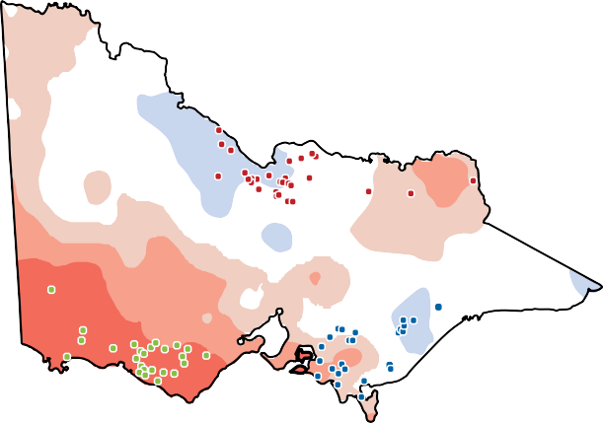
Northern South West Gippsland Rainfall Decile Ranges

In 2023-24 farm profitability for the state has been influenced by:


1% ↓ in average milk price to $9.64/kg MS

3% ↓ in total feed costs to $4.21/kg MS 1% ↑ in overhead costs to $2.96/kg MS

Profitability
The statewide average profit (earnings before interest and tax, EBIT) was $2.64/kg MS in 2023-24, the third highest in 18 years, accounting for inflation. Profitability was mixed across the regions with Northern Victorian participants recording their highest profit, while South West Victoria and Gippsland recorded their fourth and fifth highest profit respectively.
Seasonal conditions and operating environment influenced the profitability of participants in 2023-24.

$3.50

$2.92

$2.64

$2.53

$2.40
$3.00
Proﬁt (EBIT $/kg MS)
$2.50
$2.00
$1.50
$1.00

Highest on record
Very much above average
Above average
Average Below
average
Very much below average
Lowest on record
$0.50
$0.00

Statewide Northern
Victoria

South West Gippsland Victoria

In 2023-24, 96% of all Victorian participants had positive returns (77 out of 80)

2022-23 2023-24

Greenhouse gas emissions

2,700  tCO2-e/farm | 2023-24  Greenhouse gas emissions | 0.91  tCO2-e/t FPCM

$2.64
$2.87

Average EBIT ($/kg MS)
$629k
$617k

Average EBIT (total $/farm) Average net farm income (total $/farm)
6.1%
7.0%
$440k
$478k
Victoria
Average return on total assets

Future expectations 2024-25

Of the farmers who responded, 75% of farmers expect business returns to decline

Further information: www.agriculture.vic.gov.au/dairyfarmmonitor
If you would like to receive this publication in an accessible format, telephone 136 186
or email fmp.victoria@agriculture.vic.gov.au
7.7%
10.9%
Average return on equity

