


Greenhouse Gas Farm Monitor

2023-24
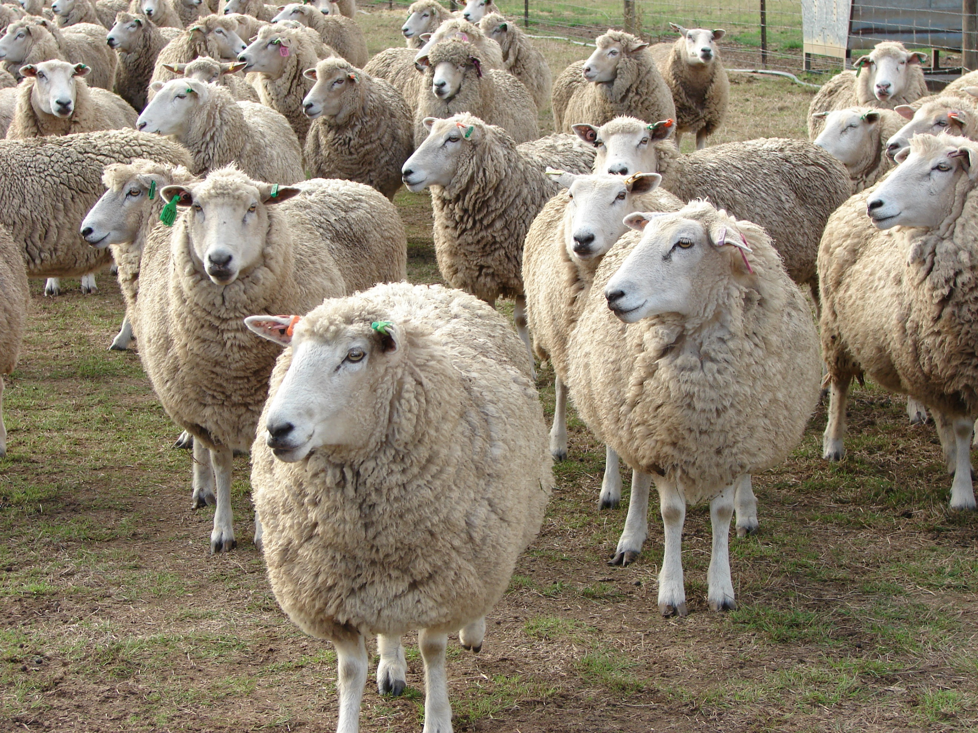


CONTENTS
ABOUT THE REPORT 2
Livestock Farm Monitor 2
Greenhouse gas emission estimates 2
Acknowledgments 2
DATA COLLECTION 3
STATEWIDE SUMMARY 4
DRIVERS OF ON-FARM EMISSIONS 5
TREE CARBON SEQUESTRATION 6
EMISSIONS INTENSITY 7
EMISSIONS AND PROFIT 8
APPENDIX 9
GLOSSARY 12
FURTHER INFORMATION 14

ABOUT THE REPORT

Livestock Farm Monitor
The Livestock Farm Monitor Project is Agriculture Victoria’s primary source of farm-level information for sheep and beef production practices, resource use, and economic data. The results of the annual Livestock Farm Monitor Project provide farm-level data to inform Agriculture Victoria’s decisions that impact at a farm level and inform the direction of future policy design, research themes and service delivery programs.

Greenhouse gas emission estimates
In 2023-24 the type, source and quantity of greenhouse gas (GHG) emissions and sequestration was estimated using the University of Melbourne Sheep and Beef Accounting Framework (SB-GAF version 2.4) for each of the 138 farms surveyed. The aggregated emissions results generated from the analysis are summarised in this report. Farm emissions and sequestration are reported in carbon dioxide equivalents (CO₂-e). This allows for more meaningful comparisons of total emissions by adjusting each different GHG type by its global warming potential.
Scope 1 emissions are direct GHG emissions that occur from sources owned or controlled by the farmer. Scope 2 GHG emissions are from purchased electricity consumed by the farm business. Scope 3 emissions are from upstream or downstream activities that are consequence of the farm business but from sources not controlled or owned by the farm business. For this analysis only upstream sources are included in the scope 3 emissions reported.

Acknowledgments
Agriculture Victoria staff are grateful for the cooperation of the farmers who contributed their data to this project.
This work is funded by Agriculture Victoria.

DATA COLLECTION
The Livestock Farm Monitor Project annually collects detailed financial and production performance information from 138 farm businesses from across Victoria. The map below shows the location of the farms from which data was collected in 2023-24 and whether they are categorised as being from Gippsland, Northern Victoria or South West Victoria.
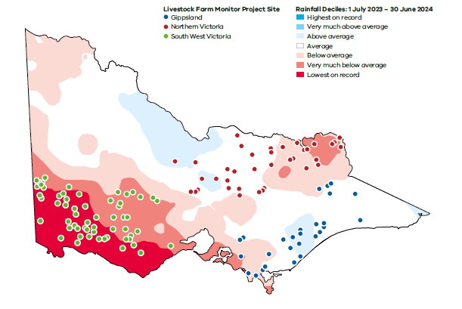

12
Stock and grain businesses

43
Sheep specialist businesses
44
Beef specialist businesses

138
Farm businesses surveyed
39
Sheep and beef businesses

STATEWIDE SUMMARY

The median total emissions per livestock farm was 2,468 tonnes CO₂-e (Figure 1). Figure 1 shows the median and range in emissions from different sources.
The major source of emissions from livestock farm businesses across the state is methane. Methane emissions made up 80% of total farm emissions (Figure 2). Most methane produced from livestock farms is from the process of ruminant digestion. Nitrous oxide emissions and Scope 3 emissions were the next largest emission sources on livestock farms in 2023-24, making up a median of 9% and 8% of total emissions respectively.

Figure 2. Median livestock farm emissions profile

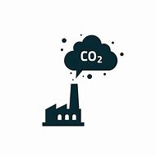






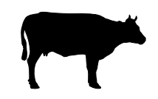




Upstream indirect emissions from farm purchases and inputs
Indirect emissions (Scope 3)
Carbon dioxide
Energy, lime, urea
Methane
Enteric methane and manure
Nitrous Oxide
Fertiliser, urine and dung, crop residues
Annual greenhouse gas emissions
from the farm
Trees
Annual change carbon storage on the farm (new sequestration)
Net farm annual emissions footprint

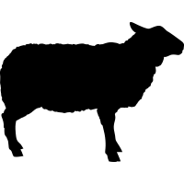

Median emissions | 186 t  CO₂-e | 2,009 t  CO₂-e | 221 t  CO₂-e | 52 t  CO₂-e | 61 t  CO₂-e | 2,468 t  CO₂-e
Range | 58-449  t CO₂-e | 832-3,268  t CO₂-e | 104-362  t CO₂-e | 21-127  t CO₂-e | 12-240  t CO₂-e | 1,364-4,006  t CO₂-e
Figure 1. The median and range (as shown by Q1 to Q3) in emissions from different sources.

DRIVERS OF ON-FARM EMISSIONS
Farm size is an important determinant of the quantity of farm emissions. When the dataset was separated by size based on total farm cash income, it was found that larger farms produce more emissions than smaller farms (Figure 3). The largest 25% of farms surveyed produced an average of 7,156 tonnes CO₂-e per farm during the 2023-24 year.
The total number of livestock on a farm is a good predictor of total farm emissions. The number of Dry sheep equivalent (DSE) stocked per farm explained almost all the variation in Scope 1 and 2 emissions (Figure 4). An important consequence of this trend is that any changes to total farm emissions on livestock farms over time will likely correspond with changes in total stock numbers.

Figure 3. The influence of farm size on total livestock farm emissions.

Figure 4. The dry sheep equivalent of individual farms versus total scope 1 and 2 emissions. The colour of the dots represents the business type.

TREE CARBON SEQUESTRATION

Trees can capture and store carbon, this process is called sequestration. Carbon that is sequestered in trees can be used in greenhouse gas accounting to balance against emissions produced from a farm business.
Across the state, tree area made up an average of 6% of the total farm area of the 138 farm businesses involved. Smaller farms were more likely to have a larger proportion of the farm area as trees than larger farms (Figure 5).

6%

of farm area allocated to trees

Figure 5. The relationship between farm size and the proportion of farm area allocated to trees.

EMISSIONS INTENSITY

The measure of emissions intensity is used to provide a comparison of the amount of emissions per unit of product. Emissions intensity includes Scope 1, 2 and 3 emissions but not sequestration. The goal is to achieve a lower emissions intensity, which indicates fewer emissions produced per unit of farm product.
A variety of emission intensity benchmarks generated from the 2023-24 Livestock Farm Monitor Project dataset are listed in Tables 1-4 in the Appendix. Comparisons against industry averages or median values need to be done with caution since individual farm circumstances, environment, resources and climatic variation between years can significantly affect the emissions footprint of a farm business.
Farmers should assess their baseline emissions, set goals and targets for emissions reduction in their own business, then track their progress over time.

Figure 6. 2023-24 and 4-year median emissions intensity for production of beef, sheep and wool.



Median 26.1 kg CO₂-e emitted for every kilogram of greasy wool shorn.
(Q1 to Q3 range was 21 to 34)


Median 6.7 kg CO₂-e emitted for every kilogram of sheep liveweight sold.
(Q1 to Q3 range was 5 to 9)

Median 12.6 kg CO₂-e emitted for every kilogram of beef liveweight sold.
(Q1 to Q3 range was 11 to 16)

EMISSIONS AND PROFIT

The Livestock Farm Monitor Project estimates the greenhouse gas and financial performance of all surveyed farms. Reporting these measures together allows farm managers to investigate the link between on-farm profit and emissions. Return per emission is a metric that enables comparison of the financial value generated for each tonne of greenhouse gas emissions.
Return per emission uses one of the main measures of farm profit, earnings before interest and tax (EBIT) divided by the farm’s total greenhouse gas emissions. Return per emission in 2023-24 was well below the 4-year median across all business types (Figure 7). This was likely due to declining red meat and wool prices and poor seasonal conditions which led to lower farm profits in 2023-24.
When the cost of implementing on-farm emissions reduction technology is expressed as the cost in dollars per tonne of CO₂-e reduced, return per tonne of emissions can highlight whether a farm business can undertake emissions reduction and remain profitable.
Return on emission doesn't consider any other benefits that may come from implementing emission reduction practices.

Figure 7. 2023-24 and 4-year median return per emission for each business type.

APPENDIX

Table 1. 2023-24 statewide emissions intensity benchmarks (scope 1, 2,3 excluding sequestration)

 | Whole farm Emissions intensity | Whole farm Emissions intensity | Whole farm Emissions intensity | Whole farm Emissions intensity | Whole farm Emissions intensity | Sheep Emissions intensity | Beef Emissions intensity | Beef Emissions intensity | Sheep meat Emissions intensity | Wool Emissions intensity
 | kg CO₂₋e  /cash income $ | t CO₂₋e/$m Assets | EBIT ($)/ t CO₂₋e | kg CO₂₋e  /DSE | kg CO₂₋e  /ha | kg CO₂₋e  /DSE | kg CO₂₋e  /DSE | kg CO₂₋e  /kg LWT | kg CO₂₋e  /kg LWT | kg CO₂₋e  /kg greasy
Statewide average | 3.8 | 206 | -$4 | 305 | 4,266 | 216 | 421 | 17 | 7 | 28
Statewide median | 3.4 | 192 | $1 | 221 | 3,399 | 206 | 234 | 13 | 7 | 26
Statewide Q1 to Q3 range | 3 - 5 | 133 - 231 | -58 - 52 | 205 - 257 | 2,654 – 4,427 | 185 - 228 | 214 - 307 | 11 - 16 | 5 - 9 | 21 - 34
Statewide 4-year median | 2.6 | 193 | 79 | 214 | 3,094 | 198 | 227 | 13 | 7 | 29
Statewide 4-year average | 3.0 | 207 | 79 | 260 | 3,542 | 211 | 352 | 18 | 8 | 30

Table 2. 2023-24 median emissions intensity benchmarks (scope 1, 2,3 excluding sequestration) for each Livestock Farm Monitor region. | Whole farm Emissions intensity | Whole farm Emissions intensity | Whole farm Emissions intensity | Whole farm Emissions intensity | Whole farm Emissions intensity | Sheep Emissions intensity | Beef Emissions intensity | Beef Emissions intensity | Sheep meat Emissions intensity | Wool Emissions intensity
Region  Median | kg CO₂₋e/cash income $ | t CO₂₋e/$m Assets | EBIT ($)/ t CO₂₋e | kg CO₂₋e  /DSE | kg CO₂₋e  /ha | kg CO₂₋e  /DSE | kg CO₂₋e  /DSE | kg CO₂₋e  /kg LWT | kg CO₂₋e  /kg LWT | kg CO₂₋e  /kg greasy
Gippsland | 4.3 | 217 | -$16 | 226 | 4,157 | 204 | 228 | 14 | 6 | 24
Northern Victoria | 3.7 | 178 | $4 | 230 | 3,229 | 216 | 231 | 13 | 8 | 31
South West Victoria | 2.9 | 184 | $9 | 214 | 3,359 | 203 | 242 | 11 | 7 | 25
Table 3. 2023-24 median emissions intensity benchmarks (scope 1, 2,3 excluding sequestration) for each Livestock Farm Monitor business type.

 | Whole farm Emissions intensity | Whole farm Emissions intensity | Whole farm Emissions intensity | Whole farm Emissions intensity | Whole farm Emissions intensity | Sheep Emissions intensity | Beef Emissions intensity | Beef Emissions intensity | Sheep meat Emissions intensity | Wool Emissions intensity
Business type  median | kg CO₂₋e/cash income $ | t CO₂₋e/$m Assets | EBIT ($)/ t CO₂₋e | kg CO₂₋e  /DSE | kg CO₂₋e  /ha | kg CO₂₋e  /DSE | kg CO₂₋e  /DSE | kg CO₂₋e  /kg LWT | kg CO₂₋e  /kg LWT | kg CO₂₋e  /kg greasy
Sheep and Beef | 3.4 | 199 | $4 | 216 | 3,406 | 210 | 230 | 13 | 6 | 24
Beef specialist | 4.4 | 212 | -$12 | 231 | 4,877 |  | 230 | 13
Sheep specialist | 3.3 | 183 | -$27 | 211 | 2,863 | 205 |  |  | 7 | 29
Stock and grain | 1.3 | 87 | $148 | 238 | 1,833 | 193 | 230 | 13 | 7 | 25

Table 4. 2023-24 median emissions intensity benchmarks (scope 1, 2,3 excluding sequestration) for each farm size (defined by farm cash income) quartile in the Livestock Farm Monitor Project.

 | Whole farm Emissions intensity | Whole farm Emissions intensity | Whole farm Emissions intensity | Whole farm Emissions intensity | Whole farm Emissions intensity | Sheep Emissions intensity | Beef Emissions intensity | Beef Emissions intensity | Sheep meat Emissions intensity | Wool Emissions intensity
Farm size  median | kg CO₂₋e/cash income $ | t CO₂₋e/$m Assets | EBIT ($)/ t CO₂₋e | kg CO₂₋e/DSE | kg CO₂₋e  /ha | kg CO₂₋e  /DSE | kg CO₂₋e  /DSE | kg CO₂₋e  /kg LWT | kg CO₂₋e  /kg LWT | kg CO₂₋e  /kg greasy
Smallest 25% | 4.3 | 179 | -$20 | 220 | 3,527 | 203 | 230 | 13 | 9 | 36
Lower mid 25% | 3.5 | 199 | -$17 | 227 | 3,385 | 206 | 242 | 13 | 6 | 23
Upper mid 25% | 3.5 | 196 | $2 | 218 | 3,412 | 212 | 230 | 13 | 7 | 26
Largest 25% | 2.7 | 183 | $43 | 221 | 3,237 | 210 | 257 | 11 | 6 | 25

GLOSSARY

Average
The sum of a collection of numbers divided by the count of the numbers in the collection
Asset
Value of anything managed by the farm, whether it is owned or not. Assets include owned land and buildings, leased land, plant and machinery, stock and cash.
Business type
Specialist sheep: Businesses with more than 85% of DSE coming from sheep and less than 30% income coming from grain and cropping.
Specialist beef: Businesses with more than 85% of DSE coming from beef and less than 30% income coming from grain and cropping.
Sheep and beef: Businesses with less than 85% of DSE coming from beef, less than 85% DSE coming from sheep and less than 30% income coming from grain.
Stock and grain: Businesses with more than 30% of income coming from grain and cropping sales and greater than zero sheep or cattle DSE.
Carbon accounting
The process used to quantify greenhouse gas emissions from an enterprise.
Carbon sequestration
The process whereby carbon dioxide is removed from the atmosphere and stored in soils and vegetation.
Carbon dioxide equivalents (CO₂-e)
Carbon dioxide equivalents are a unit used to compare emissions from different greenhouse gases based on their global warming potential (GWP) over a specified time period, typically 100 years (GWP100).
Dry sheep equivalent (DSE)
A standardised animal unit. One DSE represents the daily energy requirement of a 50kg dry ewe that is maintaining condition (8 ME MJ).
Earnings before interest and tax (EBIT) The return on all the capital used in the business before accounting for finance costs. Calculated as gross farm income minus total variable and total overhead costs. Also known as ‘Operating Profit’ or ‘Profit’.
Enteric methane
Enteric methane is produced through enteric fermentation where plant material is broken down in the rumen. Enteric methane is the by-product of this process and is expelled by the animal through belching.
Global warming potential (GWP)
A measure of cumulative radiative forcing, which aims to quantify the long-term contribution of a gas to global warming. Each GHG has a specific GWP value and this is relative to a specified time period (typically 100 years, but values are also available for 20-year and 50-year time horizons). For the 100-year time horizon, this is abbreviated as GWP100.
Greenhouse gases (GHGs)
Gases that absorb and emit radiant energy. The main GHGs associated with agriculture are carbon dioxide (CO₂), methane (CH₄) and nitrous oxide (N₂O).
Median
The middle value in a set of numbers when they are arranged in order from smallest to largest. The median is often used to find a "typical" value in a group and is less affected by very high or very low numbers than the average (mean).
Q1 to Q3 range
The range that covers the middle half of a set of numbers. Q1 (first quartile) is the point where the lowest 25% of numbers end, and Q3 (third quartile) is where the highest 25% begin. The difference between them (Q3 - Q1) shows how spread out the middle half of the data is.
Range
See Q1 to Q3 range
Return per emission Calculated as farm EBIT divided by the total farm greenhouse gas emissions in tonnes of carbon dioxide equivalents.
SB-GAF
The Sheep and Beef GHG accounting tool created and maintained by the University of Melbourne which generates farm emission and sequestration estimates. The version used for 2023-24 data in this report was 2.4.
https://piccc.org.au/resources/Tools.htm

FURTHER INFORMATION
Sam Henty
Agriculture Victoria
195-229 Lyttleton Terrace, Bendigo, Victoria, 3550
sam.henty@agriculture.vic.gov.au
Authorised and published by the Victorian Government, Department of Energy, Environment and Climate Action (DEECA) 2025. © The State of Victoria Department of Energy, Environment and Climate Action 2025.
This publication is copyright. No part may be reproduced by any process except in accordance with the provisions of the Copyright Act 1968.
For more information contact the Agriculture Victoria Customer Service Centre on 136 186.
Disclaimer
This publication may be of assistance to you, but the State of Victoria and its employees do not guarantee that the publication is without flaw of any kind or is wholly appropriate for your particular purposes and therefore disclaims all liability for any error, loss or other consequence which may arise from you relying on any information in this publication.

Accessibility
If you would like to receive this publication in an accessible format, such as large print or audio, please telephone 136 186.
Deaf, hearing impaired or speech impaired? Call us via the National Relay Service on 133 677 or visit www. relayservice.com.au
This document is available on the Agriculture Victoria website.
www.agriculture.vic.gov.au/livestockfarmmonitor

