

Biosecurity control measures for abalone viral ganglioneuritis

Code of Practice
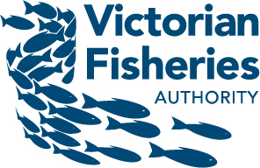
We acknowledge and respect Victorian Traditional Owners as the original custodians of Victoria’s land and waters, their unique ability to care for Country and deep spiritual connection to it. We honour Elders past and present whose knowledge and wisdom has ensured the continuation of culture and traditional practices.
We are committed to genuinely partner, and meaningfully engage, with Victoria’s Traditional Owners and Aboriginal communities to support the protection of Country, the maintenance of spiritual and cultural practices and their broader aspirations in the 21st century and beyond.
Published by Agriculture Victoria
Department of Energy, Environment and Climate Action
8 Nicholson Street Melbourne, Victoria 3000
Telephone: 136 186
September 2023
© Copyright State Government of Victoria 2023
Authorised and published by Agriculture Victoria
1 Spring Street Melbourne, Victoria 3001
Author: Tracey Bradley
Original publication: Gavine et al (2009), FRDC Project No. 2006/243.
Designed by: Creative Services Design Studio (Department of Jobs, Skills, Industry and Regions)
ISBN 978-1-76136-308-5 (Print)
ISBN 978-1-76136-309-2 (pdf/online/MS word)
Creative commons
We encourage the sharing and re-use of information provided.
The State of Victoria owns the copyright in all material produced by the Department of Energy, Environment and Climate Action. All material provided in this document is provided under a Creative Commons Attribution 4.0 international licence, except:
- any images, photographs or branding, including the Victorian Coat of Arms, the Victorian Government, Department of Energy, Environment and Climate Action and Agriculture Victoria logos; and
content supplied by third parties.
Read the full licence at Creative Commons
Accessibility
This publication is also published in PDF and Word formats at Agriculture Victoria
Contents
Introduction 4
Code of Practice for the Wild Harvest Sector 8
Background 8
Risks and control measures for the wild harvest sector 10
Standard Operating Procedures for the Wild Harvest Sector 11
Protocol for decontamination in areas where the virus is not active: 13
Protocol for decontamination in areas where the virus is active: 15
Code of Practice for Recreational Divers and Fishers 19
Background 19
Standard Operating Procedures for Recreational Divers and Fishers 19
Code of Practice for the Aquaculture Sector 22
Background 22
Risks and control measures for the abalone aquaculture sector 23
Standard Operating Procedures for land-based abalone farms 25
Decision support pathway for abalone disease status 27
Code of Practice for Abalone Processors 28
Background 28
Key risks in processing plants related to AVG: 30
Standard Operating Procedures (SOP) for abalone processors 31
Reducing the risk of AVG entering an abalone receiver 33
Reducing the risk of the spread of AVG within an abalone receiver and out into the marine environment 33
Decontamination of equipment, vehicles and personnel 35
Frequently Asked Questions (FAQs) 37
Help stop the spread of abalone disease 37

Introduction
This Code of Practice has been developed to standardise and improve the biosecurity measures currently in place in the Victorian abalone industry. It was developed in consultation with the commercial catch, processing and aquaculture sectors and informed by a series of “Rapid Risk Assessments” undertaken with the above-named sectors. The Code of Practice was originally an FRDC Project “Development of management strategies for herpes-like infection of abalone” Project No. 2006/243.
This Code of Practice is not a regulatory tool. Rather, it aims to minimise the risk of outbreaks and spread of abalone viral ganglioneuritis (AVG) through implementing standard operating procedures (SOPs) in the following industry sectors:
- commercial harvesting operations,
- recreational divers and fishers,
- aquaculture farms, and
processors.
AVG (the disease caused by haliotid herpesvirus-1, HaHV-1) first appeared in southern Victoria in late 2005. It had never been recorded in Australia before. The disease can have a devastating impact on both wild and farmed abalone populations, and it is therefore important that effective control measures are in place to minimise the impact of an outbreak.
Once AVG was identified as the cause of the disease outbreak in January 2006, it was declared a notifiable disease under the Livestock Disease Control Act, 1994. Abalone aquaculture farms affected by the virus voluntarily stopped the movement of stock to other farms. The farms were subsequently de-stocked, and the facilities decontaminated.
Although the source of the virus is unknown, early investigations concluded that the virus most likely came from live wild abalone brought onto a Victorian abalone farm (Hardy-Smith, 2006).
When the virus appeared in the marine environment in May 2006, the Victorian State Government imposed a range of controls to restrict movement, but the virus gradually spread over 4 years to affect around 200km of coastline. Since 2010 there had been no recorded occurrence of AVG on farms or in the wild abalone population.
In May 2021, several sick and dying abalone were reported by a commercial diver near Portland in western Victoria. The cause of these mortalities was determined to be AVG. At the time of writing, the virus has impacted the western zone in the vicinity of Portland. Abalone aquaculture farms remain free of the disease.
Since the initial detection of AVG, research has advanced our understanding of the virus and effective methods for eliminating it. A review of research undertaken up to 2020 provides much of the information that follows (Corbeil, 2020). References within the Corbeil paper are not duplicated here.
Origin of the virus: internationally, it is believed that the abalone herpes virus has caused significant mortalities in cultured abalone since the late 1990s. The cause of the losses was not known at the time. The first official report of mortalities due to the virus was made in Taiwan in 2003.
Tasmania has detected several genetic variants of HaHV-1 in processing plants where animals are presumably stressed. The virus is known to occur in wild abalone without causing clinical disease (Travis Baulch pers comm). Given the pattern of infection in Tasmania, it is quite possible that the virus evolved in Tasmania and was transported to China through live abalone movements decades ago. Similarly, it is believed the virus was transported to Victoria in live abalone where it presented as an epidemic in a naive population.
Clinical signs of disease: the clinical signs of disease differ in Australian and Taiwanese abalone, and further, between Victorian and Tasmanian manifestations. In Victoria, in both farmed and wild abalone, the clinical disease presents as rapid mortality, inability to adhere to a substrate, curling of the foot and swelling of the mouthparts. The mortality rates in both farmed and wild environments varied between 10% and 90%. In Tasmania the syndrome was seen in processing plants as a more chronic condition with increased mortalities and “hard foot” where the large muscular foot of the abalone became very rigid. In Taiwan, the clinical picture was noted as a chronic disease lasting several months with wasting of the foot muscle and no swelling of the mouthparts. It may be that a new variant of HaHV-1 has emerged although some aspects of this clinical manifestation appear quite similar to that recorded in Tasmanian processing plants.
General epidemiology: AVG is known to occur in Australia (Victoria and Tasmania), Taiwan and mainland China. All age classes of the abalone appear to be susceptible. Under laboratory conditions, the disease was found to be transmissible in water. The virus is however quite fragile and survived for one day in sea water at different temperatures, but viability was reduced after 24 hours. It is likely that the virus can be spread by contaminated mucous, direct contact with infected abalone, short range movements in the water column or attached to fomites.
It is unknown what the point of entry of the virus is, but it is presumed to be the mouth or gills. The incubation period for the disease was found to be 60 hours under laboratory conditions. A range of abalone species are susceptible to the virus in both Australia and Taiwan.
Diagnostic tests: Historically the virus was detected by visualisation of tissue changes through histopathology until more modern molecular tests were developed. Currently, all tests involve destruction of the abalone and are performed on an individual animal (i.e. there is no pooling of samples). Through laboratory challenge studies it has been determined that the time from viral challenge to diagnosis is 36 hours with the PCR test, 48 hours with in situ hybridisation and 60 hours with histopathology (tests are described in the “Definitions” section below). More recently, a “LAMP” test has been developed to enable detection of small amounts of virus rapidly and accurately. The need for rapid tests will no doubt result in the development of accurate, validated “tank side” tests for this virus. Analysing water samples and marine microorganisms for environmental DNA is another area of development.
Carrier status and susceptibility: A well-known attribute of herpes viruses is the ability to occur in clinically healthy hosts. Across all animal species, herpes viruses are known to be activated to a clinical disease when the host is under some form of stress. This observation has been made in oysters affected by ostreid herpesvirus 1. It is highly likely that this pattern of disease manifestation is applicable to abalone.
The potential for genetic resistance to the virus in abalone has been investigated. A transmission trial across 49 family lines of greenlip abalone concluded that some families had a delay to mortality rather than survival to disease. Resistance in areas previously impacted by the virus in western Victoria did not find a difference between the mature survivors and juvenile recruits. It is possible that the survivors selected were not exposed to the virus originally. The robustness of this study has been questioned based on the sample size used and lack of DNA sequencing performed. Work is currently underway to further explore this issue. A study examining the pathogenicity of the 5 known variants of HaHV-1 was undertaken and it was established that all 5 variants caused disease and mortality in all abalone stocks tested. The New Zealand paua (H. iris) is known to be highly resistant to disease as is H. discus hannai (from work undertaken in China). The mechanism for this resistance is still under investigation.
Deactivation: HaHV-1 belongs to a group of viruses that have a lipid envelope and are of intermediate to large size. This type of virus should not be difficult to destroy as the lipid envelope should be sensitive to many compounds including soaps, detergents and disinfectants. Experiments were performed to determine the virucidal effect of three disinfectants: calcium hypochlorite, Buffodine (an iodophore) and benzalkonium chloride (a non-ionic surfactant). All chemical products were effective at the dose rates provided in Table 1 (page 12). The latter 2 chemicals were able to inactivate the virus without an adverse effect on the abalone.
Currently (August 2023), a project is examining the possibility of immune priming stock and their progeny as a form of protection against the virus (FRDC Project 2021-085).

Test definitions
PCR – the polymerase chain reaction is a test that can detect the DNA of the virus in frozen or fresh abalone.
In situ hybridisation – similar to the above PCR, this test detects the DNA of the virus but also shows where it is located in the tissues.
LAMP – Loop mediated isothermal amplification (LAMP) is another test looking for the DNA of the virus but has some advantages over the PCR in terms of ease of operation, portability etc.
Histopathology – is the traditional method of looking at fixed tissues down a microscope. This method is less sensitive at detecting AVG than the molecular methods.

References
Corbeil, S. (2020). Abalone viral ganglioneuritis review. Pathogens. 2020, 9, 720
Hardy – Smith, P. Report on the events surrounding the disease outbreak affecting farmed and wild abalone in Victoria. (Confidential). 2006.

Code of Practice for the Wild Harvest Sector

Background
Commercial abalone harvesting operations in Victoria are managed under the Fisheries Act 1995 in line with the Victorian Wild Harvest Abalone Fishery Management Plan (DEDJTR, 2015). The fishery is predominantly blacklip abalone (Haliotis rubra), with a small greenlip abalone (Haliotis laevigata) fishery in the central and western zones.
The Victorian wild harvest sector has an annual value of $16.2 million (2020), most of which is exported. The wild harvest sector employs over 250 people directly and many more indirectly in support industries. The fishery is closely monitored through catch trends, population surveys and modelling.
The fishery is managed through gear restrictions, closures, legal minimum lengths, zonation (Figure 1), limited access and catch quotas. Abalone are harvested by divers operating under an Abalone Fishery Access Licence (AFAL) which are exclusive to the zone for which they are issued and only one diver can be nominated on a licence at a time. There are currently 71 AFAL holders in Victoria.
Divers use a chisel-like, iron bar to prise the abalone from the rocks. The divers can stay under water for long periods by using hookah gear (air supplied through an air-hose connected to an air compressor on the support vessel). The abalone are transported to shore in sealed bins and subsequently transported to a processor that holds a Fish Receivers (Abalone) Licence.
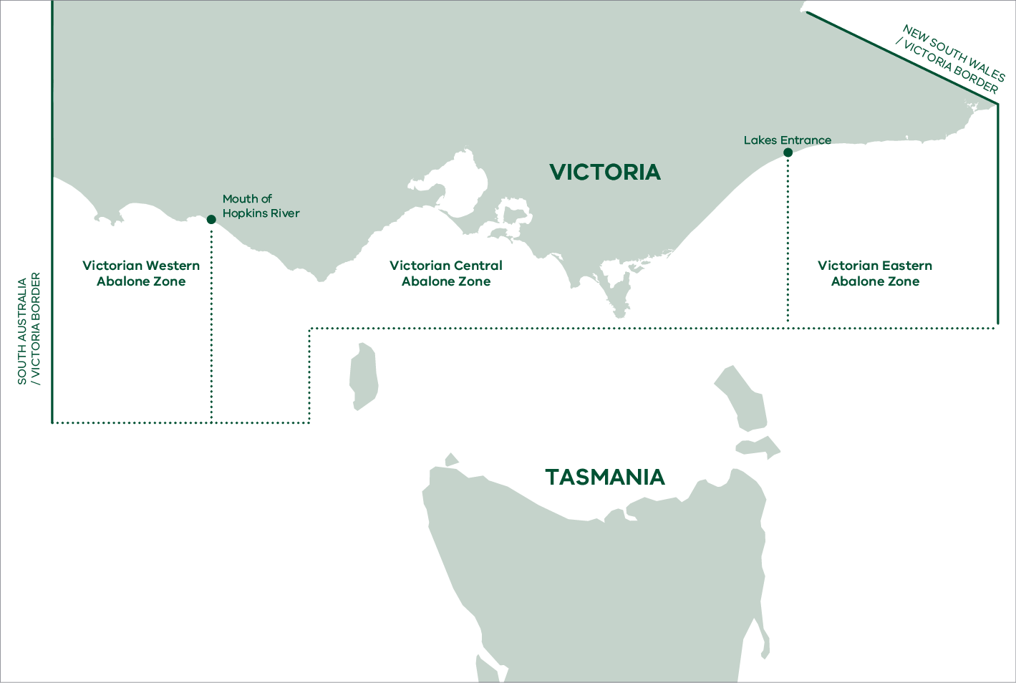
Figure 1: Management zones for the commercial harvest of abalone in Victoria (DNRE, 2002).
The movement of landed abalone is carefully tracked in Victoria to ensure that the Total Allowable Commercial Catch (TACC) is not exceeded. Within one hour of landing, the diver must register the catch through the VFA’s electronic reporting system “eCatch”. The diver must provide their ID number, total weight of the catch and reef code where the catch was harvested. The consignment is then assigned a code which is used to track the abalone through the supply chain. Apart from monitoring compliance with the TACC, this information is fed into a website (fisherweb) to provide real-time information on the catch history of individual reefs in the current season and past seasons.
Abalone divers can only offload their catch to a licensed abalone receiver. On receipt of the abalone, the processor or holding facility must access eCatch to get a confirmation number. The consignment must be left sealed for 1 hour so that it can be inspected by Victorian Fisheries Authority (VFA), if required.

Risks and control measures for the wild harvest sector
A rapid risk assessment was conducted by the Department in 2022 utilising the expertise of a diverse panel on the risks associated with translocating abalone. Three major areas were identified as risks for the wild harvest sector:
- movement of contaminated abalone,
- movement of equipment (including from other industries)
movement of personnel.
Following the outbreak in wild abalone in the western zone, it was acknowledged that divers have an ability to recognise animals showing clinical signs of disease. As such they are an excellent form of passive surveillance.

Standard Operating Procedures for the Wild Harvest Sector

Identifying and reporting AVG
This protocol provides basic information for commercial fishers and divers on how to identify and report the signs of AVG in abalone.

Identification of infected abalone
AVG causes damage to the nerve tissues of abalone (the ganglia) and results in paralysis and death in most cases.
The virus seems to occur most often where there are dense populations of abalone. The role of stress factors in AVG disease outbreaks is not well understood. However, it is hypothesised that stressors such as high-water temperatures and spawning may pre-dispose abalone to becoming infected or showing clinical signs of the disease. This aligns with the pattern of infection seen in other herpes viruses.
Infected abalone are lethargic, do not adhere well to the reef, may have enlarged mouthparts and a curled foot (see FAQs, page 26). The presence of enlarged mouthparts alone is not sufficient to diagnose AVG. When clinically affected by the virus, the abalone are weak and easily removed from the substrate. The presence of a large quantity of empty shells may indicate previous infection or active infection where abalone are easily removed from the reef.

Reporting and preserving samples for diagnosis
If commercial divers encounter abalone that they suspect may be infected with the virus they should take the following action:
- Collect a sample of the suspect abalone and immediately cease fishing.
- Place the sample in a sealed plastic bag (if available) label and record the location.
- Call the Disease Watch Hotline (phone 1800 675 888) and the zonal Executive Officer and provide the following information:
- diver contact details, reef code, GPS coordinates and description of the area
- basis for suspecting disease (clinical signs, number of dead or dying abalone).
Details of sample collection and submission are provided in FAQs on page 26. Arrangements for transportation of these samples to the state laboratory for testing will be discussed upon notification.
The state diagnostic laboratory at La Trobe University, Bundoora can receive chilled entire abalone or if delivery time is predicted to be more than 8 hours, frozen samples.

Decontamination procedures where AVG is known or confirmed
This protocol describes the decontamination process for equipment and other resources used in the commercial harvesting of abalone, particularly where AVG is known to occur. This protocol applies not only to commercial divers but to individuals or organisations undertaking research or surveillance studies of wild abalone. Items that should be decontaminated under this protocol, include the following:
- Boats, including hulls and decks, anchors, anchor lines and mooring lines.
- Divers, diving equipment including wetsuits, fins, masks, weight vest, hookah gear and other abalone harvesting equipment (especially fish bins, nets and knives etc.).
- Transport vehicles and fish bins.
Personnel (other than divers).
The highest risk items are those that have been in contact with infected abalone and could retain organic material harbouring virus.
More detailed information on decontamination processes can be found in Chapter 4.4 of the WOAH Aquatic Animal Health Code: Disinfection of Aquaculture Establishments and Equipment and the Australian aquatic veterinary emergency plan (AQUAVETPLAN) for decontamination.
Both detergents and disinfectants can be used in the decontamination process.

Detergents
Detergents are normally a complex mixture of compounds that help to remove and disperse dirt. Detergents should be used for the removal of gross fouling and organic matter. The removal of organic matter by scrubbing and other mechanical means is the most important first step in the decontamination process. Many disinfectants are inactivated in the presence of large quantities of organic material. The class of virus that causes AVG is susceptible to soaps, detergents and disinfectants.
At a minimum, all equipment should be washed with detergent as per the instructions below:
- Boats: detergents used for washing trucks or specifically designed for cleaning boats are available from a number of suppliers. These compounds (e.g. “truckwash”) are not classified as hazardous and are normally bio-degradable.
- Wetsuits and other diving equipment: specialised wetsuit wash preparations are available, but a mild liquid soap or shampoo may also be used.
- Bins and nets: any of the above detergents should be suitable for cleaning equipment.
People: soaps should be used to wash hands and laundry detergents to wash clothes.

Disinfectants
To ensure the virus is killed or inactivated, disinfectants should be used. A limited number of agents have been assessed for efficacy against the virus (HaHV-1). See Table 1, page 12.
Suitable disinfectants include:
- iodine-based disinfectants e.g. “Buffodine” at 50ppm; and
- chlorine-based disinfectants e.g. hypochlorite at a concentration of 15ppm active chlorine at the site of application
benzalkonium chloride e.g. “Impress” at 1% concentration.
The efficacy of the disinfection process is affected by various factors including temperature, pH and most importantly the presence of organic matter (OIE, 2021). Although the effectiveness of all specific disinfectants against AVG has not yet been evaluated, disinfection is likely to be highly effective against the virus given its fragility.
The manufacturer’s instructions for the safe use of chemicals will be specified in the Material Safety Data Sheets for the chemicals; these should be requested when the product is purchased.

Protocol for decontamination in areas where the virus is not active:

Decontamination of vessels
All commercial abalone dive vessels currently operating in Victoria are removed from the water at the end of each day. However, vessels in other jurisdictions or used for other purposes (research or surveillance) may remain in the water. The decontamination protocol for vessels that are removed from the water will be different from those that remain in the water.
Commercial vessels will not be routinely entering areas that are known or suspected to be infected with AVG, but research or surveillance vessels may deliberately enter these areas. It is possible that commercial vessels could encounter diseased abalone during their routine operations.

General Protocol for Vessels Removed from the Water
This protocol applies under normal operating conditions where the boat has not been operating in areas recently known to have been, or suspected to be, infected with AVG.
Prior to leaving port all gross fouling and organic matter should be removed from the hull of the vessel. The hull of the vessel should be cleaned after each trip with freshwater and kept free of organic matter and marine organisms. Decks, diving equipment and other equipment should be hosed down with freshwater, washed with disinfectant (such as “truckwash”), rinsed with freshwater and left to air dry after each trip.
Operators should ensure that organic matter accumulated under carpets or in other difficult to reach places is removed and the area rinsed with freshwater.
Back bungs (if present) should be undone to allow any water to drain out of the boat onto land and any bilge areas should be rinsed thoroughly with fresh water.

General Protocol for Vessels Remaining in the Water
This protocol applies under normal operating conditions where the boat has not been operating in areas known to have been, or suspected of being, infected with AVG.
All decks, equipment and superstructures should be cleaned through scrubbing or with high pressure sprayers. The use of a detergent in this process is recommended. All external areas should be rinsed with fresh water. Air drying parts of the vessel not submerged in the sun for over 24 hours can effectively kill many pathogens.

General protocol for divers, wetsuits and equipment
The appropriate level of decontamination for diving equipment will depend on the level of risk associated with the activities undertaken by the diver. This will result in more frequent decontamination rather than different procedures. The categories of decontamination for divers have been identified as follows.
General: Applies to divers operating in areas where there is no recent history of infection and where no abalone suspected of infection have been observed.
- Remove gross contamination of organic material by rinsing divers, equipment and decks throughout diving operation.
- At the end of diving rinse all equipment in freshwater to remove salt, including rinsing the inside of a weight vest if used.
- All equipment must be washed or sprayed with a wetsuit cleaning solution or mild soap or shampoo to remove traces of organic matter. Dive suits must be washed inside and out (note that Virkon is not suitable for cleaning dive suits) and other equipment can be immersed in large plastic bins with disinfectant.
- Gloves and catch bags need to be scrubbed clean prior to air drying.
Thoroughly rinse all dive equipment in freshwater and dry in a well-ventilated area, preferably in the sunshine.

General Protocol for Transport Vehicles and Bins
All solid debris and organic matter should be removed from transport vehicles, trailers and harvest bins, cleaned with soapy water and rinsed with freshwater. All residual mucous and faecal material must also be removed and disposed of in trade waste pits or general waste.

Protocol for decontamination in areas where the virus is active:

Protocol for Vessels Exposed to AVG
This applies when vessels are deliberately taken into areas where infection with AVG is known to occur, or when diseased animals are encountered during routine harvesting, surveillance or research operations.
Prior to leaving port, all gross fouling and organic matter should be removed from the vessel hull. All material removed should be disposed of in appropriate waste disposal away from the water.
There are no boats in Victoria that require slipping. All dive boats are trailable. After the harvest has been offloaded the vessel should be removed from the water to allow for thorough cleaning. Cleaning should take place in an area (for example, a car wash) where none of the washdown water can re-enter the marine environment.
- All decks, equipment and superstructures should be rinsed with fresh water through scrubbing or with high pressure sprayers.
- Detergent should be sprayed on all surfaces on the inside of the hull, gunwales and topsides (outside of the hull) and rinsed off with a hose or similar appliance.
- Similarly, the external hull of the vessel should be sprayed with detergent and rinsed with freshwater.
- All pipework and pumps, particularly deck hoses should be rinsed with disinfectant.
- Scrub and clean all equipment (anchors, mooring lines, net bags and fenders etc.) in detergent or a foaming disinfectant to ensure all organic matter is removed then allow to air dry outside.
- Bilges and scuppers should be emptied while in the area of infection. If they are full of water on return to shore, they will require additional dosing with disinfectant before opening or pumping onto land.
All internal areas should be thoroughly cleaned. All catch bags should be scrubbed clean with detergents/disinfectants and air dried in the sun for at least 24 hours.

High risk decontamination protocol for divers
Applies to divers involved in the observation or removal of dead or moribund abalone confirmed, or suspected, to be infected with AVG or operating within areas known to be infected, but with no direct contact with infected abalone.
As for “General” above but using effective disinfectants (see Table 1). Dive operations must cease immediately following detection.

Protocol for Vehicles and Bins that have Carried Infectious Animals
Remove and clean the harvest bins using soapy water followed by an effective disinfectant then air dry outside. Clean the entire cargo area of the transport vehicle using soapy water.
The area of the vehicle that has been in contact with fish bins should be scrubbed down with an effective disinfectant (see Table 1). Wastewater from this process should not be allowed to re-enter the marine environment. The truck should be left to air dry outside.

Decontamination Protocol for Personnel
Personnel other than divers must also undergo decontamination to ensure that the virus is not transmitted. Heaviest contamination of personnel will occur when infected animals are handled on-board the boat, where mortalities are collected and where there is exposure to mucous or faecal material from the abalone. The following steps should be taken to decontaminate personnel:
- Protective clothing should be cleaned. Rubber boots should be scrubbed.
Personnel should regularly wash their hands in soapy water.
Table 1: Chemicals used for decontamination of the AVG virus (HaHV-1) and their effectiveness. (Table courtesy of the National AVG Decontamination Working Group)
Chemical class | Chemical name | Dosage (details on registered label/ permit) | Research information | Comment
Oxidising agents | Potassium monopersulphate  “Virkon aquatic” | 0.5% (Cleaning and disinfecting equipment, boats, vehicles and other non-porous surfaces) to 1% (porous surfaces/footwear) | Not assessed | Very expensive, strips boats/harsh on skin, not often used, toxic, oxidising agent
Oxidising agents | Hypochlorite solutions e.g. “EEZI pool”, “Barracuda” etc. | Range of doses in current permit | Assessed: effective at 15ppm active chlorine at site of application | Not used by dive industry – damages wetsuits, discolours boats. Used extensively in processing/ farm sectors for treating tubs, footbaths, surfaces etc.
Oxidising agents | Iodophors e.g. “Agridyne” (Iodine 16g/l) | 0.1% iodine in solution (= 1000 ppm Buffodine) | Assessed - “Buffodine” assessed as effective at 50ppm | Safe. Not used by industry – obscurity and price. Stains brown. Highly effective
Quaternary  ammonium | Didecyldimethyl-ammonium chloride “Virukill” | No dose information | Not assessed | Expensive, used by some Victorian industry for hard surfaces e.g. boats, fins, irons etc.
Ionic surfactants | Sodium dodecylbenzene sulfonate e.g. “Truck wash” | Dosage as recommended by manufacturer | Not assessed | Commonly used for boats in Victoria, some use on wetsuits and other gear  Disposal issues
Non-ionic surfactants | General detergent, laundry detergent and dishwasher powder | Dosage as recommended by manufacturer | Not assessed | Very commonly used and presumed effective for general biosecurity.  Includes specific wetsuit washing products
Non-ionic surfactants | Impress | 1% solution (50g/L Benzalkonium chloride) | Assessed: effective at 1% “Impress” | Not commonly used

Code of Practice for Recreational Divers and Fishers

Background
The activities of recreational divers and fishers pose a risk of spreading the virus in the marine environment. The number of individuals that take part in recreational diving and fishing is significant. This sector needs protocols to raise awareness of biosecurity issues and to minimise the risk of groups or individuals inadvertently transferring the virus. Although the recreational sector was not specifically considered in the risk assessment process for this project, this protocol attempts to provide a framework for improving biosecurity in this sector.
After the 2021 outbreak of the virus, the State Government took steps to restrict entry of people to marine areas known to be infected with the virus by declaring Control Areas. Fishing and diving activities in the Control Area were restricted to minimise the risk of human activity transferring the disease to unaffected abalone populations elsewhere in the state. In October 2021, AVG was removed from the exotic diseases list under the Livestock Disease Control Act, 1994. A Fisheries Notice under the Fisheries Act 1995 for stock protection purposes was introduced to further restrict both commercial and recreational abalone and lobster fishing in the disease area.
The purpose of this Code of Practice is to minimise the risk of the virus being spread between management zones within Victoria and interstate by human related activity.

Standard Operating Procedures for Recreational Divers and Fishers
This protocol provides basic information on how recreational divers and fishers can identify and report abalone that have been affected by the disease. It also provides guidance on decontaminating vessels, equipment and personnel.
Before diving, fishers are advised to visit the VFA website and see where the current disease outbreak is located and what restrictions may apply. Divers and fishers can also watch informative videos about AVG and decontamination. The VFA strongly advises divers and fishers to fish well away from known disease outbreaks.

Identifying and reporting AVG
It is vital that recreational divers and fishers can identify abalone that could be infected with AVG and report that information to the Emergency Animal Diseases hotline (1800 675 888). This information will be used by government agencies to respond quickly and effectively to an outbreak of AVG in the wild in areas where it may otherwise have gone unrecorded.

Identification of infected abalone
AVG causes damage to the nerve tissues of abalone (the ganglia) and results in death. The virus seems to occur most often where there are dense populations of abalone, but other stress factors such as high water temperatures, spawning or the presence of other disease agents may pre-dispose abalone to becoming infected or showing clinical signs of the disease.
Infected abalone are lethargic, do not adhere well to the reef and may have enlarged mouthparts and a curled foot (see FAQs, page 26). The presence of enlarged mouthparts alone is not sufficient to diagnose AVG as it is not always present in infected abalone. A more reliable sign is the presence of numerous empty shells and weak/easily removed abalone.

Reporting the virus
If recreational divers and fishers encounter abalone that they suspect may be infected with the virus they should take the following action.
Call the Emergency Animal Disease Hotline (Phone 1800 675 888) and provide the operator with as much detail as possible:
- GPS Co-ordinates of the reef and full description of the area where the abalone was found (including depth of water).
- Contact details of diver or fisher.
- Photos of infected abalone if possible.
Basis for suspecting disease.

Decontamination procedures
This SOP is principally aimed at recreational divers and fishers who have inadvertently been in areas or zones that have disease or who encounter disease when diving. However, it is also applicable to all recreational divers and fishers.
Key areas that need to be addressed to minimise the risk of disease transfer through recreational diving and fishing activities include the following:

Decontamination of vessels
Prior to returning to shore, return all organic matter (seaweed, sand) to the water. If your vessel has a self-draining deck, wash down the deck. Contain all wet diving equipment and catch bags in a fish bin, tub or dive bag.
When you return to shore, the vessel should be removed from the water away from the boat ramp. At either a commercial operator or private residence, remove the bung and hose the vessel down, preferably with freshwater and detergent to remove organic matter from inside and outside of the vessel. Allow the vessel to dry in the fresh air.
If you live or have accommodation in the area, decontamination can be done when returning home.

Decontamination of wetsuits and other dive equipment
Wetsuits should be washed inside and out in fresh soapy water, rinsed and allowed to dry in a well-ventilated place, preferably in the sun.
Tanks, buoyancy/weight vests, regulators, mask and snorkel, dive floats, hookah hose and fins should be scrubbed clean with fresh soapy water, rinsed clean then allowed to dry.
Equipment that has touched abalone (such as catch bags, gloves, knives and measuring devices) should be carefully scrubbed with fresh soapy water to remove any grit, seaweed etc., rinsed then air dried for at least 24 hours – preferably in the sun. This cleaning should be done away from the water.
All equipment should be allowed to dry outside before re-use.

Decontamination of people
After diving for abalone, ensure that all people who have come in contact with abalone wash their hands with soap and water.
All waterproof clothing (lifejackets etc.) should be sprayed with soapy freshwater, rinsed and left to dry in the sun. Normal clothes can be washed with laundry detergent when you get home.

Appropriate disposal of shells and gut
Abalone may only be shucked at home with all waste disposed of in household rubbish.
Under no circumstances should shells or gut be dumped in the sea or used as bait/berley. This is an illegal activity and especially important if the abalone are moved to another area when landed.

Code of Practice for the Aquaculture Sector

Background
The Victorian abalone aquaculture industry has grown substantially over the past 10 years.
There are currently 4 land-based farms licensed under the Fisheries Act 1995 authorising abalone aquaculture. Current sites actively producing abalone are located at Narrawong, Port Fairy, Indented Head and Avalon (Figure 2). These farms produce abalone under license through the VFA with certain conditions attached.
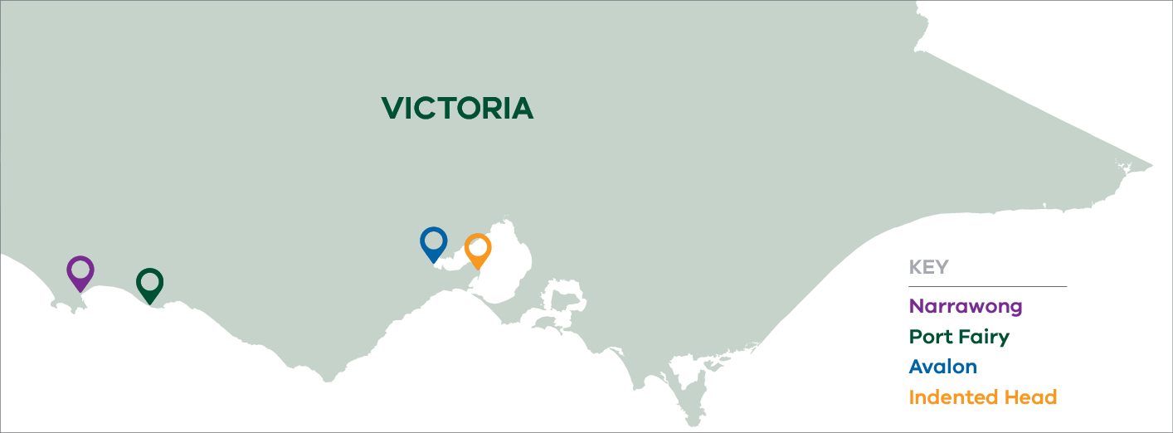
Figure 2: Location of land-based aquaculture farms licensed to culture abalone.

Land-based aquaculture systems
Land-based abalone aquaculture systems need access to large quantities of good quality seawater and require substantial coastal infrastructure. Larger farms pump ocean water at rates up to 1000 litres/second. According to Hone and Fleming (1997), there are two types of land-based abalone farms: hatchery-based and growout only. Hatchery-based farms are vertically integrated comprising hatchery, nursery and growout components. Growout farms buy juvenile abalone (20–25mm, 1 year old) from hatcheries aiming to grow out to market size in 2.5 years. Growout systems culture abalone in tanks of various designs and materials and require a regular exchange of seawater.

Longline or offshore culture systems
A number of licences have been issued for offshore culture of abalone. A variety of cage and barrel systems have been trialled. These systems have equipment located on the sea floor or suspended in the water column. In all cases, offshore abalone diets have involved feeding seaweed or artificial feed. To date results have shown that whilst stock can be grown to commercial size in some instances, problems have been encountered with the efficiency and economic viability of artificial feed. Currently there is no commercial production from these systems and they are considered outside the scope of this SOP.

Ranching
Abalone ranching is the uncontained stocking of abalone, onto natural reef or created habitat not within an Aquaculture Fisheries Reserve, for the purpose of growth and exclusive harvest. (Victorian Offshore Abalone Stocking Policy, 2020).
Since there is no commercial production from abalone ranching, they are considered outside the scope of this SOP.

Risks and control measures for the abalone aquaculture sector
A rapid risk assessment was conducted by the Department in 2022 utilising the expertise of a diverse panel on the risks associated with translocating abalone. This process identified that major risks of spreading AVG could be separated into the risks associated with movement of infection onto farms and movement of infection off farms.
For movement onto farms, the high unrestricted risk estimate was:
- Intake water from the marine environment carrying sufficient viable virus to cause infection in stock, the origin for this could be local populations etc.
Stock translocated onto the farm are infected with the virus (for example wild broodstock).
For movement off farms, the high unrestricted risk estimate was:
- Discharge water from the farm released into the marine environment post settlement pond.
Escapees from the farm moving into the marine environment.
The rapid risk assessment process identified 12 key pathways in total but the above were considered high risk. Mitigation strategies were not considered during this process however, they could be conducted on an as-needs basis for individual farms based on the actual situation and risks.
An earlier risk assessment resulted in the creation of the Abalone Aquaculture Translocation Protocol (2007), a Victorian protocol, with several controls in place to address the above risks.
Nationally, a program, the Abalone Health Accreditation Program (AHAP) was endorsed out of session by the Animal Health Committee in April 2015. This program provides technical guidelines for the abalone aquaculture sector to maintain a farm “compartment” free of AVG. The AHAP incorporates initial surveillance testing and ongoing sentinel testing for the virus that causes AVG (HaHV-1). The program requires annually audited biosecurity plans including a component that addresses surveillance outside the farm for the virus in wild populations. The AHAP is overseen by the competent authority (relevant government body) in each state and incorporates a SOP outlining steps required to achieve accreditation. The elements of the AHAP will not be repeated in this Code.
All Victorian land-based farms are members of the AHAP at the time of publication. The program is funded by individual farms.

Standard Operating Procedures for land-based abalone farms

Identifying and reporting AVG
Figure 3 (next page) shows a decision support process to assist farmers in determining if the virus is a likely cause where moribund or dead abalone are observed in culture units.
Where clinical signs of disease (see FAQs, page 26) are present, samples must be submitted for diagnostic testing at a laboratory to confirm the presence or absence of AVG and other pathogenic organisms. AVG is a notifiable disease under Victorian (and other state) legislation.
If AVG is confirmed on the farm, discussions will take place with the Chief Veterinary Officer regarding management of the farm. The aim is to limit the spread of disease to other farms and the wild (assuming endemic infection does not already exist in local wild stock). Means to achieving this end include restricting movements of stock and water off the farm; harvesting or culling and processing of stock; and drainage, drying and disinfection of culture units housing infected abalone.
All Victorian farms have a licence condition to report unexpected mortalities that exceed 1% per tank per day. There are a range of potential causes of mortalities on abalone farms. It is good biosecurity practice to remove any mortalities from tanks as soon as possible.

Stock Management
Stock management is a critical component of animal husbandry and the following factors should be considered to reduce animal stress and the potential spread of disease. These elements are all incorporated into the farm biosecurity plan which is auditable under the AHAP.
- Separation and/or physical isolation of areas on the farm. Individual sheds or groups of sheds should be kept physically separate and be managed separately, by different staff members to prevent the spread of disease.
- Manage stocking densities to minimize stress and maintain optimal water quality.
- Feed commercial pelleted diets specifically formulated for abalone at an appropriate rate to sate stock. Diets should be sourced from a known and reliable manufacturer.
Housing different age classes of abalone separately to reduce the potential for disease to spread.

Quarantine procedures
Quarantine facilities are required for stock movements approved under the AHAP, or any other legal translocations. These facilities should be completely isolated from the rest of the farm (separate room or building) until the health status of new stock can be determined. Key features of a quarantine facility include the following:
- Water used in the facility must not be allowed to mix with the water of other culture systems within the farm.
- Equipment used in the quarantine area should not be used in other areas of the farm and appropriate sanitation procedures should be employed.
The health status of the stock should be certified through an approved program (for example, the AHAP).

Disinfection of influent and effluent water
Given the current design and system of operating land-based abalone farms, it is likely that disinfection of influent and/or effluent water could only be practically applied on a small scale to discrete parts of the farm (i.e. hatcheries and broodstock holding facilities by filtration, chlorination and/or UV treatment).
The EPA would need to approve any chemical disinfectant used for this purpose because it will form a component of the discharge license. The farmer would be required to carry out a risk assessment prior to implementing a disinfection program.

Decision support pathway for abalone disease status
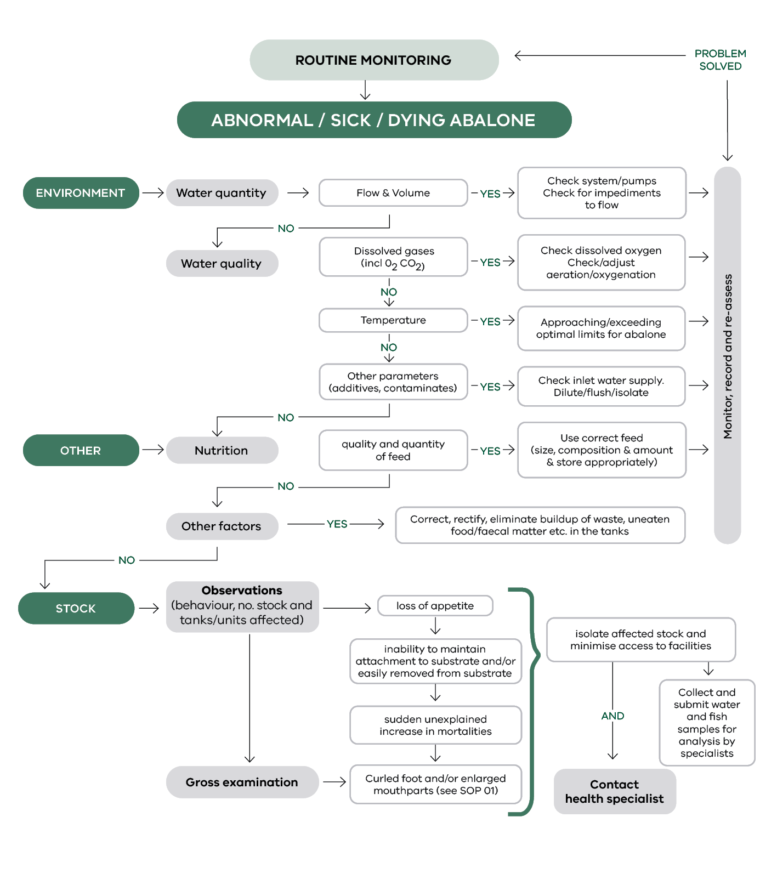
Figure 3: Decision support pathway for abalone disease status.

Code of Practice for Abalone Processors

Background
Abalone processors must hold a Fish Receiver’s (Abalone) Licence to receive abalone in Victoria. There are currently 12 licensed processors in Victoria (Figure 4), most of which are in the Central Zone. Victorian processors receive abalone from within the zone they are located in, other Victorian zones, other states and aquaculture farms. Some processors also deal with other fish species from Victoria and interstate.
The Victoria abalone industry is highly export oriented with a total of 621 tonnes of product exported in 2019/20 at a value of $27 million (ABARES, 2020). Approximately 34% (210 tonnes) was exported live with the remainder exported as processed products.
To export abalone, processors must be registered with the Australian Department of Agriculture, Fisheries and Forestry (DAFF). Abalone are prescribed goods, and their export is regulated under Commonwealth legislation. It is a condition of registration that the processor facility has an approved food safety management system known as an Approved Arrangement (AA). The AA must contain a Hazard Analysis and Critical Control Point (HACCP) plan that is an internationally recognised system used to manage food safety, staff training, knowledge and skills, product traceability, protection from contamination and other aspects of food safety. Prior to exporting each consignment, the processor must sign a declaration of compliance. The AA and HACCP plan may not cover additional risks presented by AVG.
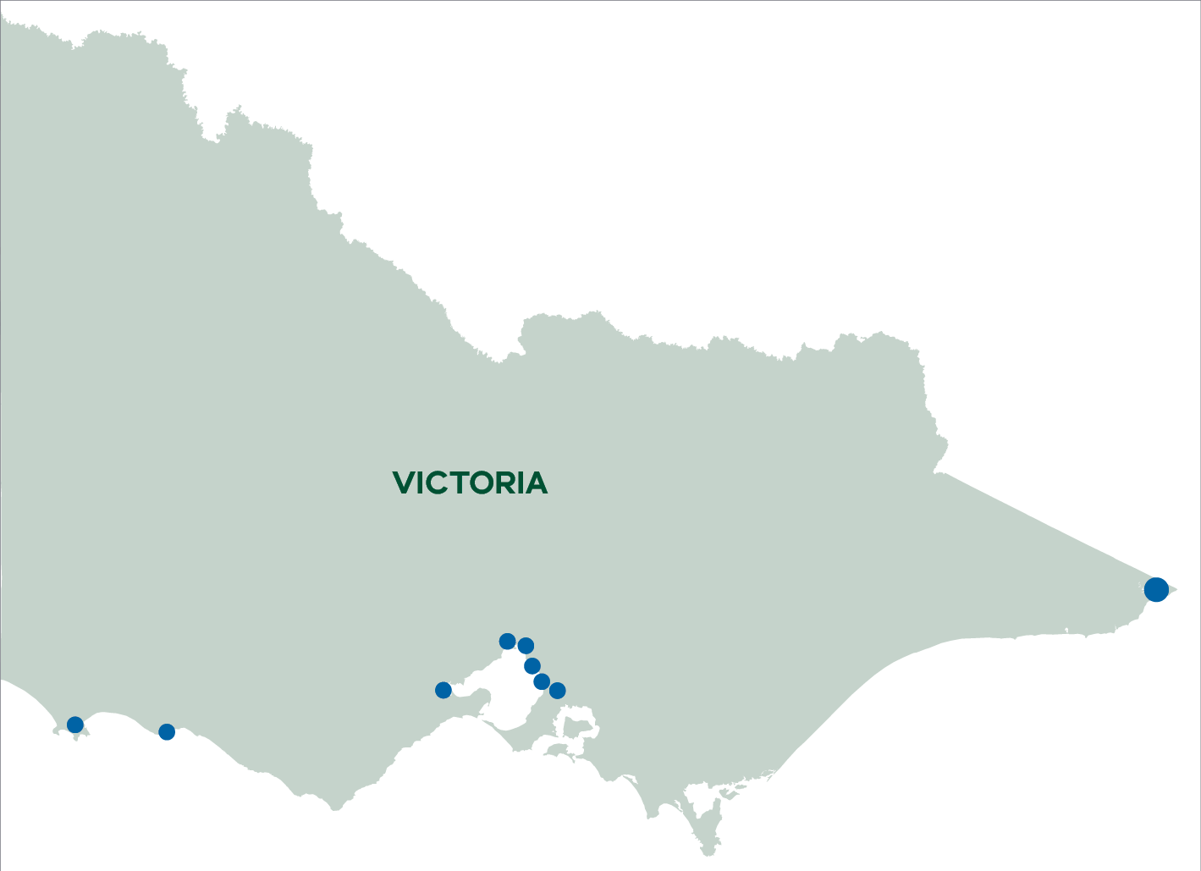
Figure 4: Location of abalone processors in Victoria.
The licensing of Fish Receivers (Abalone) is managed through the VFA. License conditions have been updated to reflect higher biosecurity requirements to ensure the protection of the marine environment and our domestic and international markets. The new permit requirements include the development of an approved, auditable biosecurity plan. This plan details the standard operating procedures specific to each licensed receiver to ensure the major risks associated with live holding of abalone are mitigated.
The purpose of this Code of Practice is to address issues concerning the potential entry of AVG into the marine environment; entry and spread through receivers and through the domestic and international export of abalone. The virus is not a concern for human health.

Risks and control measures for abalone processors
A rapid risk assessment process was conducted by the Department in 2022 and it highlighted the key risks associated with the transmission of AVG to processors, the marine environment and the supply chain.

Key risks in processing plants related to AVG:

Marine Environment
- Untreated waste exiting a live holding receiver without treatment discharging directly into the marine environment.
- Live holding floor waste reaching the marine environment e.g. biofouling and water spillage entering the marine environment through inappropriate waste disposal practices.
- Live holding mortalities entering the marine environment through inappropriate disposal or sale.
Inappropriate disposal of solid waste including shell and viscera through poor waste disposal practices or sale.

Entry into live holding receiver
- Abalone displaying clinical symptoms of AVG entering a live holding receiver that were not identified during wild harvesting operations.
- Infected abalone not displaying clinical symptoms of the disease, entering a live holding receiver (silent infection).
Transfer of abalone between receivers which were sourced from known currently impacted areas (Portland area and Tasmania).

Transfer within live holding receiver
- Live holding with recirculation system combining multiple tanks.
- Mixing of consignments from known AVG areas with abalone from areas where AVG is not known to occur.
Transfer of live holding crates between tanks.

Export (Domestic and International)
- Failure to identify clinical disease during pack out.
Abalone with sub clinical AVG being packed out.

Standard Operating Procedures (SOP) for abalone processors
This SOP relates to license conditions for specified fish receiver (abalone) licenses (Reg 324 of the Fisheries Regulations 2019).
Abalone receivers may receive abalone from areas where AVG is currently known to be active (parts of western Victoria and Tasmania). Staff need to be familiar with the key signs of disease and how to diagnose it. There are a range of resources to assist with training staff. See FAQs (page 26).

Recording mortalities
There are legal requirements for the identification and notification of suspicion of AVG. The most obvious sign of virus infecting abalone in a tank is high mortality rates. Trigger levels for notification of mortality rates are now part of the permit conditions for abalone receivers.
The license holder must keep full and accurate daily written records of all fish mortalities and make the records available on request by an authorised officer.
The trigger level is greater than 10% of unexplained stock mortality in 24 hours within a single tank.
Abalone received from impacted areas may exhibit clinical signs when they arrive for live holding. It is vital that employees in live holding facilities and processing plants can identify the clinical signs of disease so that they can prevent further spread of the virus and the origin of the consignment can be traced.

Identifying the disease in live animals
- The most prominent sign that an abalone has AVG is that it is weak or dead.
- Potential signs in live abalone:
- poor suction and can be easily removed from holding tanks
- inability to right itself if inverted
- swollen and protruding mouth parts
- edges of the foot curling inwards, exposing clean shiny shell
- excessive mucus.

Reporting suspicion of AVG in abalone
AVG is a notifiable disease so license holders must report any abalone on the premises that they suspect have the virus. This will help control the spread of virus through the facility and into the marine environment.
The license holder must notify the Chief Veterinary Officer (through the Emergency Animal Disease Watch Hotline on 1800 675 888) where the above trigger level is met.

Information that may be required
- Name and full contact details for the processing facility.
- The catch disposal record number, the diver and receival date.
- The location where the abalone were collected (reef codes, GPS, etc.).
- Total number of abalone in the tank and the total number of tanks on the premises and current holding.
- Details of the signs and symptoms the animals have including photographs.
- History of the abalone, for example, transportation to the premises or movement within tanks.
Export history, both domestic and International of suspect consignment or abalone held in the same recirculation system.
Where there is suspicion of disease, government (Biosecurity) staff will be available to assist with queries around sample submission, quarantine of tanks to reduce risk of spread and decontamination processes. Contact can be made through the Emergency Animal Disease Watch Hotline on 1800 675 888 (24 hours per day).

Sampling suspect abalone
Staff can provide guidance on sample selection based on individual circumstances but in the absence of such guidance, five sick or moribund abalone as well as five recently dead abalone (these can be shucked and frozen) is appropriate.

Sample storage
- Place samples of sick and moribund abalone in a sealed plastic bag and refrigerate as soon as possible.
- Previously shucked and frozen abalone suspected of being infected with the disease are suitable for testing.
Transport of samples will be arranged in consultation with staff. If there is a delay with the transportation of over 24 hours, then samples can be frozen.

If you have come in contact with infected abalone
- Wash your hands with fresh, soapy water.
- Spray waterproof clothing with fresh, soapy water, rinse and allow to air dry.
- Wash clothes in laundry detergent.
The virus causing AVG is not a human health risk.

Reducing the risk of AVG entering an abalone receiver

Receival of new stock
- Where possible receivers should fallow tanks for 48 hours before tanking new stock.
- Receivers are to check the origin of all abalone received for live holding. Do not receive abalone for live holding from known AVG areas with current active disease (VFA Abalone Disease webpage). Where abalone are inadvertently received from known AVG areas, they should be subjected to enhanced visual inspection.
- All abalone in live holding should be held in crates and labelled with the date, licence number, zone and state.
- Each live holding tank must have complete and accurate written records of all abalone in that tank including mortalities (expressed as a percentage per tank), water tests, incomings, outgoings, visual observations and cleaning.
- Avoid transfer of live abalone from known AVG regions between receivers.
Abalone must only be received from appropriately licensed individuals or businesses.

Reducing the risk of the spread of AVG within an abalone receiver and out into the marine environment

Live holding water and waste discharge
- All effluent water from the processing plant (including washdown water and live holding water) should be discharged to trade waste or a sewer.
- Where the effluent water is discharged to the marine environment, the effluent must be treated with chlorine to a minimum level of 15ppm residual chlorine for 30 minutes. At the point of release into the marine environment, the effluent water must be less than 1ppm chlorine.
- Alternatively, using a system capable of achieving (on comparing water as it enters treatment with water as it leaves treatment) a minimum 3 log 10 reduction in total marine heterotrophic bacteria; and achieve a discharge concentration value of <3 log 10 (≤ 999 bacterial colony forming units per mL).
Settlement pits should be pumped out on a regular basis and disposed to landfill.

Live holding Floor waste
Live holding floor waste is to be retained in drainage pits, cleaned out regularly with waste disposed to general waste or landfill. The wastewater fraction is to be discharged to trade waste or sewer. If this is not possible then it must be suitably disinfected as per above.

Disposal of live holding mortalities
- Mortalities should be appropriately processed or disposed of in general waste or landfill.
- Under no circumstances should mortalities be given away or sold as bait or berley.
- All shells intended for export or commercial use must be free of viscera prior to drying.
- Receivers located near marine waters should ensure that any area designated for that purpose is scavenger proof.
Shell not intended for commercial use must be disposed of in general waste or landfill.

Disposal of solid waste (viscera)
- Viscera not intended for commercial use (food stuffs, fertiliser, stock feeds) must be disposed of in general waste or land fill.
Under no circumstances should abalone viscera be given away or sold unprocessed to fishers to use as bait in marine waters.

Movement of abalone within a live holding receiver:
- Abalone from known AVG regions must not be tanked with abalone from non AVG regions.
- Abalone sourced from interstate must only be tanked with abalone received from that state.
- Receivers are to avoid moving abalone from one tank to another.
- Receivers are to avoid moving small quantities of abalone into other tanks and mixing stock in the same tanks.
All live holding crates should be cleaned with a suitable disinfectant (see Table 1), rinsed with freshwater and dried outside prior to reusing. All equipment (brushes, nets, sponges, cloths, vacuum) including PPE should be washed between cleaning tanks.

Export of abalone from live holding receiver
- All abalone leaving live holding should have tank logs examined for unexpected mortality increases – expressed as a percentage.
- All abalone leaving the live holding facility must be inspected during pack out for clinical symptoms of disease.
All abalone consigned from the receiver must be accompanied by a long form receipt.

Decontamination of equipment, vehicles and personnel

Boxes and crates
- Boxes and crates that are used to transport the animals between commercial divers, processors and aquaculture farms were identified as a key risk area for potential cross-contamination. Processors should make sure that the boxes are clean before they leave the premises by undertaking the following measures:
- a dedicated wash area should be set up
- boxes and crates should be scrubbed clean of any organic matter (grit/dirt etc.) cleaned with water and a suitable disinfectant (see Table 1)
- boxes and crates should be fully air dried before return to commercial divers or farmers, preferably in direct sunlight.

Vehicles
- All solid debris should be removed from trailers and vehicles and the area wiped with disinfectant. All residual mucous and faecal material must also be removed.
- Where the vehicle has carried abalone that are known or suspected to be infected with AVG, all boxes and contact areas should be scrubbed clean with a dilute detergent or suitable disinfectant (see Table 1) and allowed to dry in the sun for at least 24 hours.
Any fixtures and fittings (aeration equipment, pipework etc.) coming in contact with potentially infected animals must be dismantled and rinsed with freshwater to ensure that infected material is removed.

Personnel
- It is important that appropriate protective clothing is worn at work.
- Protective clothing should be cleaned with a sponge or low-pressure pump while being worn to remove gross organics. The clothing can then be rinsed and hung up to dry. Rubber boots should be scrubbed.
Personnel should regularly wash their hands in soapy water.

Frequently Asked Questions (FAQs)

Help stop the spread of abalone disease
Abalone viral ganglioneuritis (AVG) is a viral disease affecting the nervous system of abalone. This often results in the curling of the foot and swelling of the mouth and can lead to weakness and death of abalone.

What does an abalone with AVG look like?
While abalone with AVG usually show one or more of these signs, the virus can also be present without any visible signs.
The most common sign that an abalone has AVG is that it is weak or dead. The presence of a large number of empty shells in the wild may be an indication of infection with AVG.

In some abalone you may see:
- swollen and protruding mouth parts
- the mouth coming out from under the foot
- edges of the foot curling inwards, exposing clean shiny shells
- abalone with poor suction that can be easily removed from substrate whether that is the rock they are attached to in the wild or a tank on a farm or processing plant
- an inability for the abalone to right itself when turned over
excessive mucus.

What do I do if I suspect abalone have AVG?
- AVG is a notifiable disease and should be reported through the Emergency Animal Disease (EAD) Watch Hotline on 1800 675 888.
- If you are a farmer or processor it is important that you report any suspicion of disease immediately to increase the chance of effectively controlling the disease.
- If you are a commercial fisher, it is also important that you report suspicion of disease to ensure protection of the resource. Providing the GPS location will greatly assist with further investigations.
Recreational fishers can assist with providing reports where there are multiple dead abalone. One or 2 deaths is unlikely to be caused by the virus.

Processor and farm actions where there is a strong suspicion of disease
If you see an unusual number of sick or dead fish:
- Contact the Emergency Animal Disease (EAD) Watch Hotline on 1800 675 888.
- Quarantine the tanks immediately.
- Use a commercial grade disinfectant to clean shucking tables, tools, rumblers and any other equipment used to handle abalone whilst waiting for advice on next steps.
Await detailed instructions on next steps if AVG is confirmed on your site. This may involve stopping water discharge and emergency harvest followed by a complete disinfection of affected parts of the site.

What happens when I make the report?
You can call the Emergency Animal Disease Watch Hotline 24 hours a day, every day of the year, to report any significant animal disease. The operator will take some details from you and arrange for a government officer to contact you. This officer will be able to provide you with guidance on further action you need to take.

What information do I need to provide?
- Name and full contact details.
- Location of your farm/processing plant or the GPS location of where abalone were seen if in the wild.
- Total number of abalone seen dead/dying. If you are from a farm or processing plant, how many tanks affected and the number of dead in each tank.
Details of the signs and symptoms the animals have, as well as photographs of affected abalone.

Which abalone do I select as samples for testing?
If possible, please supply five live, sick abalone for your sample as well as five freshly dead abalone.
Abalone shell cannot be tested for the virus and most of the meat in the shell needs to be intact for sampling.

How do I store abalone samples?
- Live, sick abalone: place your sample in a sealed plastic bag with a label and refrigerate as soon as possible for transport within 24 hours. Keep the sample moist, out of direct sunlight and allow some air (or oxygen if available) to remain in the bag.
- Freshly dead abalone: place in a separate sealed plastic bag with a label and transport with ice bricks.
- If there is going to be a delay in transporting to the laboratory (more than 24 hours), the samples can be frozen.
Transport of samples to the laboratory will be discussed after the report has been made.

What measures do I need to follow to help stop the spread of AVG?
- For recreational and commercial fishers, follow the basic biosecurity protocols provided in this Code.
- For processing plants, do not place abalone sourced from west of Cape Otway or Tasmania in the same tank as abalone sourced from elsewhere in Victoria and do not share equipment between tanks.
- For farms, follow the biosecurity practices in your farm biosecurity plan.
For all people working with, or fishing for abalone, we rely on your vigilance to report suspicions of AVG. Please report suspicions in line with these FAQs.

What if I think I have come in contact with infected abalone?
- Wash your hands with fresh, soapy water.
- Spray waterproof clothing with fresh, soapy water, rinse and allow to air dry.
Wash clothes in laundry detergent.

How do I correctly dispose of abalone waste?
- Ensure shells can dry for several months in an area designed to keep out any scavenger animals or birds, away from the marine environment.
Ensure abalone gut is disposed of in commercial waste, landfill or to an approved food waste recycler.

Information from the SCAAH AVG Decontamination Working Group

