At the Epicentre: Essentials for epidemiologists
in outbreaks

Acknowledgements
Agriculture Victoria would like to acknowledge the author of this report, Dr Roger Paskin, and Animal Health Australia for assisting with this publication.

Published by the Victorian Government Department of Jobs, Precincts and Regions, August 2022
© Copyright The State of Victoria , Department of Jobs, Precincts and Regions, Melbourne 2022.
This publication is copyright. No part may be reproduced by any process except in accordance with the provisions of the Copyright Act 1968.
Authorised by the Victorian Government, 1 Spring Street, Melbourne, Victoria 3000, Australia
First edition, 2009
Revised and reprinted, October 2019
Minor editorial changes, August 2022
ISBN 978-1-76090-116-5 (Print)
ISBN 978-1-76090-117-2 (pdf/online/MS word)
For information about Agriculture Victoria, visit http://agriculture.vic.gov.au
or call the Customer Service Centre on 1300 502 656.

Accessibility
If you would like to receive this publication in an accessible format, please telephone the Customer Service Centre on 1300 502 656 or TTY 1800 122 969, or email info@agriculture.vic.gov.au.
This document is also available in PDF format at http://agriculture.vic.gov.au

Disclaimer: This publication may be of assistance to you but the State of Victoria and its employees do not guarantee that the publication is without flaw of any kind or is wholly appropriate for your particular purposes and therefore disclaims all liability for any error, loss or other consequence which may arise from you relying on any information in this publication. While every effort has been made to ensure the currency, accuracy or completeness of the content we endeavour to keep the content relevant and up to date and reserve the right to make changes as required. The Victorian Government, authors and presenters do not accept any liability to any person for the information (or the use of the information) which is provided or referred to in the publication.

Contents
Acknowledgements 2
Introduction 5
Acronyms and abbreviations 6
Part 1. General principles of disease investigation and response at the local control centre (LCC) 7
1. Considerations 8
2. What to take with you to the LCC 8
3. First steps 8
3.1. Establish the existence of an outbreak 9
3.2. Confirm the diagnosis 9
3.3. Establish the case definition and count cases 9
3.4. Data linked to space and time 9
3.5. What about populations at risk? 10
3.6. Think like a detective 10
3.7. Start planning the follow-up 10
4. Getting it all together: data sources and data gathering 10
4.1. The principal data source: MAX or equivalent emergency animal disease (EAD) management software 10
4.2. Maps 11
4.3. Statistical data 11
4.4. Key informants 11
4.5. Farmer interviews 12
4.6. Previous reports 12
4.7. Go walkabout 12
4.8. Organising data in the heat of battle 12
5. ‘Rough epidemiology’ – turning my data into information 13
5.1. How many animals at risk? 13
5.2. Generate an epidemic curve 14
5.3. How do I measure the progress of this disease? 14
5.4 Make a map and animate it 17
5.5 Generate a timeline 19
5.6 How far, how fast? 19
5.7 What about links? 22
5.8 Examine the risk factors 22
5.9 Make short-term projections for Planning Management 23
6. Daily and non-regular reporting duties 25
6.1 Daily sitreps 25
6.2 Analytical reports 25
6.3 Recommendations 25
6.4 Other 25
7. Continuity 26
8. Follow-up studies 26

Part 2. General principles of disease response at the state coordination centre (SCC) 27
9. SCC epidemiology 28
10. What to do when the summons is received 28
11. Getting started at SCC 28
12. Is everybody on the same wavelength? 32
13. Getting your surveillance going 32
13.1 The beginning: a good place to start 32
13.2 Finding more than disease 33
13.3 Moving towards disease freedom 33
14. Daily tasks 34
15. Scenario construction 35
15.1 Scenarios: getting it together 35
16. Proving freedom – establishing the absence of disease 38
Appendix 1 40
LCC Situation Report (sitrep) – example proforma 40
Appendix 2 41
Notes on useful software packages 41
MAX (MAXimum disease/pest management) 41
Geographic Information Systems (GIS) 41
Business Intelligence Software 41
Link analysis 41
Useful weblinks 42
References 43

Introduction
The veterinary epidemiologist is often thrown in at the deep end when working in a Local Control Centre (LCC). The epidemiologist will be confronted by two simultaneous pressures: to fully describe and measure the disease outbreak and to help introduce control measures.
‘Classical’ epidemiology does not provide the tools needed to work in the data-sparse environment of a developing animal disease epidemic. Each disease outbreak will present its own particular problems and challenges, and non-traditional tools and methods, especially the practice of ‘rough’ epidemiology, will be more useful.
This book gives guidelines to veterinary epidemiologists (working in the LCC or State Coordination Centre (SCC) Planning Section in the Technical Analysis – Epidemiology function) about the procedures to be followed at LCCs and at the SCC. While the AUSVETPLAN Control Centres Management Manual Part 2 outlines the tasks, this book gives more detail on how epidemiologists should operate, the analysis they will be expected to provide, and key relationships and networks.

Acronyms and abbreviations
ABARES | Australian Bureau of Agricultural & Resource Economics & Sciences
ABS | Australian Bureau of Statistics
AHA | Animal Health Australia
AHFS | Animal health field staff
AHO | Animal health officer
AVA | Australian Veterinary Association
BoM | Bureau of Meteorology
CCEAD | Consultative Committee on Emergency Animal Disease
CVO | Chief veterinary officer
DCP | Dangerous contact premises
DVO | District veterinary officer
EDR | Estimated dissemination ratio
ELISA | Enzyme linked immunosorbent assay
FAO | Food and Agriculture Organisation of the United Nations
FCP | Forward command post
FMD | Foot and mouth disease
GIS | Geographic information system
IAP | Incident action plan
IP | Infected premises
LCC | Local control centre
MAX | MAXimum disease/pest management – emergency response software
NLIS | National Livestock Identification System
OIE | World Organisation for Animal Health (previously the Office International des Epizooties)
PIC | Property identification code
RA | Restricted area
SCC | State coordination centre
SP | Suspect premises
TP | Trace premises

Part 1.
General principles of disease investigation
and response at the
local control centre
(LCC)

Considerations
Disease outbreak situations are typically data-sparse, particularly at the beginning of a disease outbreak. This environment must be negotiated to make sense of the evolving outbreak, and to manage the pressure to act without having adequate knowledge.
The LCC Technical Analysis – Epidemiology function (the LCC epidemiologist(s)) may be constrained by:
- Lack of up-to-date static population and property data
- Lack of meaningful incident data
- Lack of knowledge on local ecology, farming systems and risk factors.
Accurate, property-by-property animal populations and distribution may not be known (available data may be inaccurate or outdated); data on disease occurrences will build up over time. Even as data does build, it is unlikely to be sufficient in quantity or accuracy to withstand rigorous analysis.
Forensic or ‘battlefield’ epidemiology comes into its own in an outbreak.

What to take with you to the LCC
When you are called to the LCC, you should take reference materials, a computer and relevant software.
You will need:
- AUSVETPLAN Control Centre Management Manual (Parts 1 and 2)
- AUSVETPLAN manual/s for the suspected or diagnosed disease outbreak
- Computer with Internet access and access to the national traceability database, the state disease reporting system and a GIS package.
- Spreadsheet software such as Excel and a statistics package such as Epi-Info 2000
- Digital camera
- Training manuals or user manuals for the analytical packages mentioned above.

First steps
To control a disease outbreak, you need to know:
- what disease this is
- where it is right now
- where it came from
- how it is spreading
- where it might go.
Gather as much up-to-date information on the outbreak as you can before you go to the LCC.
The disease will have been characterised to some extent by the time a local disease centre is established and incident action plans (IAPs) may have been prepared. Update your knowledge by talking to the Incident Controller, Planning and Operations Managers and any fellow epidemiologists.
LCC briefings and teleconferences with the state coordination centre (SCC) and the forward command post (FCP) will be useful and you should find out when they occur.
Make a list of what you know and what you still need to find out, then start working through the seven steps on the following pages.

Establish the existence of an outbreak
An outbreak is said to occur when the number of cases of a disease exceeds the number expected (for exotic diseases, the number expected is zero). It is necessary to compare the number of cases reported with historical data to establish that an outbreak is occurring.
This should already have been done as part of the initial response before setting up the LCC.

Confirm the diagnosis
Propose a working case definition to guide your work (see Section 3.3).
Confirming the diagnosis does not stop with the index case. The main concentrations of the disease should be confirmed as far as possible (see Section 4.8). New hotspots should be typed from time to time as well.
Foot and mouth disease (FMD) is a good example of a disease that can introduce two or more serotypes into an epidemic. A disease introduced as part of a bioterrorism attack, for example, might have numerous strains of the causative organism to deliberately frustrate control efforts.
Diagnostic confirmations should continue throughout the course of an outbreak.

Establish the case definition and count cases
A case definition should already exist if the disease is covered by AUSVETPLAN. However, under field conditions, it is necessary to establish a working case definition or a provisional case definition to describe the kind of ‘suspicious entities’ that might attract an emergency response or disease investigation. This definition should be communicated to field teams and also to livestock producers in the area (see Box 1).
Box 1. Example of suspected FMD case
Any susceptible animal displaying one or more of the following signs would trigger an emergency investigation:
- Lameness
- Salivation
- Sudden drop in milk production
This ‘working definition’ would be communicated to field workers so they can report suspect cases.

Gaining data on cases can be a challenge. Software packages such as MAX provide the means for recording the data but gaining the data and ensuring that cases are properly diagnosed can be demanding.
The LCC epidemiologist has a professional duty to ensure that cases are correctly investigated and recorded despite having no authority over field staff activities. Consultation with the LCC Operations Management and LCC Investigations (previously called Veterinary Investigations or VI) functions is therefore crucial.
Cases should be recorded on emergency management software (e.g. MAX) for later analysis. Obviously, such software must be fully networked and ‘visible’ from all control and coordination centres.

Data linked to space and time
Ensure that the data on all cases has accurate time-space linkages. The date of the first case confirmed on a property is important and you should also establish the dates of earlier suspected or probable cases.
Determine the geographic coordinates of each focus so that the concentrations can be plotted on a map (these may already be available in the state’s property database). Cross-check the data on data input forms with ownership and contact data on the property database to ensure that these are up to date (in some jurisdictions, this process is automated, especially where remote data entry via mobile devices is in use).
Make sure that the number of livestock on each property has been correctly entered because you will need
denominator data.

What about populations at risk?
The size and distribution of the population at risk must be established very quickly. This will inform all efforts at controlling the outbreak.
Identifying risk factors will assist in identifying the population at risk. This includes gaining a very good impression
of the farming systems in the outbreak area, and the local ecology, infrastructure and social factors that influence
the farming systems.

Think like a detective
Formulate a tentative hypothesis to explain the cause of the disease or how it was introduced. This may give you an idea of where the disease might spread; understanding its source may help devise strategies to slow its dissemination.
You should be flexible and ready to change your hypothesis.

Start planning the follow-up
The LCC epidemiologist should plan ahead to determine what information should be collected immediately to assist with the inevitable post-outbreak follow-up studies.
You have an advantage because you are on the ground. You will get to understand the people, the animals and the territory – this will be crucial to planning the follow-up. In the wake of the outbreak, you will be expected to compile a structured report on the outbreak giving details of what happened, how the disease behaved, the impact of the controls and the lessons learned.
The follow-up study will require resources, and you should ensure that the response agency is advised of the
required resources.
The SCC may lead the follow-up work. However, the SCC Technical Analysis – Epidemiology function (the SCC epidemiologist(s)) might not have the benefit of your field exposure, therefore the LCC should be involved in the design and delivery.
Remember to:
- Propose a working case definition to guide your work.
- Determine location of the disease and where it might spread.
- List what you need to know and what you don’t yet know.
- Ensure that the data you collect are referenced in time and space.
- Use available data to hypothesise means of disease introduction and spread.
- Determine what information should be collected now for the post-outbreak follow-up studies.

Getting it all together: data sources and data gathering
The first few days of an outbreak are frustratingly characterised by a paucity of quantitative data and by the need to make projections based on educated guesswork and experience.
Understanding epidemics requires more than quantitative data. There is a need for qualitative data to understand farming systems, livestock and movements that might spread disease, important ecological and geographic factors, socio-economic factors and production and marketing issues. These, together with population density and pathogen-associated factors, will determine disease spread, and the optimum means of disease control.

The principal data source: MAX or equivalent emergency animal disease (EAD) management software
The principal data source for infected, suspect, trace and dangerous contact premises is the MAX/equivalent report. These reports are completed in the field and stored on specialised disease management databases such as MAX.
Management data critical to a disease investigation include:
- Information on animals affected by disease
- Date of visit and diagnosis
- Age of lesions or estimated date of first case
- Information on total animals present on the farm
- Size of farm to help determine population density on the farm
- Nutritional information including both grazing and feeding
- History of recent treatments and/or vaccinations
- Contacts and traces of on- and off-farm livestock movements and dates; visits for milk collections, feed deliveries, private veterinarians; contacts with overseas visitors or recent returns from foreign holidays
- Farming practices, especially changes such as recent ploughing, laser-grading, new water sources
- Assessment of whether farming is intensive or extensive
- Other information identified in the available literature as being associated with the disease.
While these data will show how the disease is behaving, you should conduct your own quality
spot checks.
Make sure the forms are completely and consistently filled in: look for obvious errors such as the number of dead animals exceeding the total number on the farm and check the original forms against what has been entered on the database. In systems where data are directly entered from the field, personal conversations with field investigators will be needed to verify data.
It may help to copy a dataset into a spreadsheet (easy if you’re using MAX) and sort by columns to show whether the maximum and minimum values are realistic. Also, for example, note whether text has been entered inadvertently into numeric fields and try to gain an overall ‘feel’ for the data.
Notes on useful software packages for EAD management are provided in Appendix 2.

Maps
Maps are a critical source of information about an area; they help you understand topography, roads and rivers, location of villages, and local distances and approximate property sizes. Most jurisdictions have useful property maps, and other maps may also be available from local authority and State government agencies. Google Earth and similar systems may also be helpful.

Statistical data
Official statistics about livestock, farming practices, production capacity, people, and even the weather are also very helpful and easily available on the Internet. Sources include the Bureau of Meteorology (BoM), Australian Bureau of Statistics (ABS), Australian Bureau of Agricultural and Resource Economics and Sciences (ABARES) and records held by the state government agriculture/primary industries department.

Key informants
In any area, there will be useful authoritative sources of information. Local state officials including animal health field staff, extension officers and wildlife officers or industry representatives such as the relevant state farmers’ organisation will be invaluable sources of information on:
- Livestock species
- Stocking rates
- Farming practices
- Marketing practices
- Important ecological and geographic factors
- Irrigation sources
- Sources of feed
- The location of local knackeries, abattoirs, dairies, saleyards, private practices
- Wildlife species, habitats, movements
- Weather patterns.
Local government officials and community members might also give pointers on local history and customs. The people undertaking the Liaison – Livestock Industry function are also a good source of information, and a good means of disseminating it.

Farmer interviews
There will be information gaps, and a system such as MAX may not provide everything that you need from a farmer. In fact, you should treat some farmers as key informants with valuable information on risk factors prevalent in the area from livestock movement patterns to emerging feeding practices. Consider holding a focus group to discuss specific issues, such as perceived risk factors or how well they use the National Livestock Identification System (NLIS).
Schedule meetings with informants and take detailed notes.

Previous reports
Previous reports about diseases in the area, or even about non-related issues such as environmental research and pasture types, will be valuable. Many of these reports can be found on the web, and in the offices of local officials
or town libraries.

Go walkabout
Understanding the local ecology, farming systems, topography, distances and weather conditions is crucial to building an understanding of the disease situation. Weekly field excursions, to observe changing seasons and associated farming activities, may help in evaluating the course of a lengthy epidemic.
First-hand knowledge of these conditions will also help you understand the conditions for surveillance teams.
Take photos of the outbreak area. Illustrating your report/s will give the state control centre a much better impression of the situation.

Organising data in the heat of battle
It is easy to lose track of what’s happening during an outbreak because of possible backlogs of data to be entered, properties yet to be classified (MAX status), lab results and reports.
If property classifications (infected premises (IP), suspect premises (SP), dangerous contact premises (DCP) etc) are not up to date, you may get a distorted picture of the outbreak. If you’re constructing an epidemic curve (see section 5.2), it may break up, punctuated by gaps or apparently inexplicable spikes. You fall behind, and the state coordination centre (SCC) won’t be able to make sense of the data and your reports.
Applying ‘battlefield epidemiology’ will help you. You will need to be creative, nimble and pragmatic, and it is vital that you communicate your approach very clearly with the LCC Planning Management function, LCC Controller and the SCC.
Firstly, recommend fast tracking property classification. Simplify procedures and definitions. If there are no lab samples, or waiting for results takes too long, then propose an alteration of your working case definition. If a diagnosis of FMD requires a positive Enzyme Linked Immunosorbent Assay (ELISA) test, then remove this requirement. This is easy with highly infectious diseases, or diseases with dramatic clinical pictures, and it is unlikely to sacrifice diagnostic accuracy. For example, you might accept inappetence, lameness and salivation as sufficient evidence to classify a property as an IP. Clarify this approach and seek approval from your SCC.
Be pragmatic about the use of field staff. You may not be able to send staff out to investigate every case reported to you. When a farmer visits or phones, immediately initiate a record in MAX (or equivalent). Then you can classify and record the property with minimal delay to remain on top of what’s happening. Box 2 shows what you can expect to happen during a rapidly spreading disease outbreak.

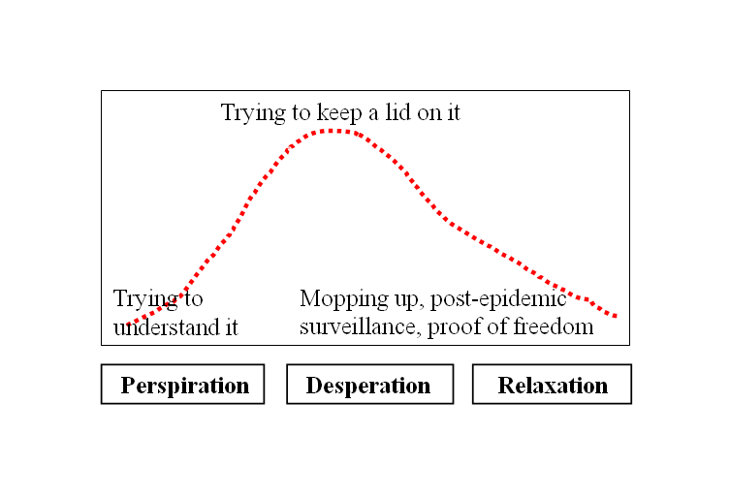
Box 2. The three stages of epidemic management

The first days are spent trying to understand what is happening.
When the extent of the problem is understood, much energy is expended on containing it.
In the final phase, one can go back and ‘clean up’ the data.

You may consider only attempting to confirm every fifth or tenth reported property using laboratory tests if field staff are overstretched. However, don’t eliminate laboratory investigations as it will be necessary to have ongoing assurance that you are still dealing with the same disease. Just a warning here – if your control measures are based on culling, you will need lab confirmations!
Ensure that you get data into the computer on time. If you can’t do it straight away, ensure that you use the reported date when registering the IP, not the date of input. The wrong date will shift the epidemic curve you are trying to generate in
the wrong direction. The objective is to try to record the epidemic so that it can later be faithfully reconstructed from computer data.
A discrepancy between the reporting date and the data input date is not an issue. Once the peak of an outbreak has passed, you can go back and re-check the data, and follow up on lab results. (The increasing use of mobile devices for remote data input will eventually eliminate this issue).
Ensure that you have access to the data. There should be no technical or administrative impediments to your ability to access and analyse outbreak data.
Remember to:
- Get to know the key data elements gathered through MAX.
- Use a variety of maps of the area to gain an understanding of all key spatial data available.
- Use population and climate data available from official internet sites.
- Be creative in harnessing local knowledge and using historical information sources where necessary.
- Get your feet on the ground and gain a real understanding of the environment where the disease is
present (without compromising biosecurity by visiting infected premises).
- Use data from all possible surveillance sources, even where laboratory confirmation is not available.
Time and resource constraints may mean that only a percentage of cases can be confirmed.
- Be flexible in terms of applying property classification as IP; you may have to rely on ‘innovative’
case definitions.
- Your database system should ensure that you have full access to all data for analytical purposes.

‘Rough epidemiology’ – turning my data into information
Access to a large amount of quantitative and qualitative data isn’t valuable until some attempt has been made to
evaluate it.

How many animals at risk?
You can expect to face a situation where little, if anything, is known about the number of animals in the restricted area (RA). You will be bombarded with requests for population estimates. The SCC will need to know things like how much vaccine to purchase and how many animals might require slaughter. They may also need to understand how big an outbreak is likely to become. The epidemiologist will need a ‘denominator’ for later calculations.
Start out with some idea of the size of the problem. Using a rapid appraisal technique called ‘triangulation’ allows you to compare information from a number of sources to develop an estimate of the value of a particular variable when the true value is unknown. Box 3 shows how you can develop a guesstimate.

Box 3. Gaining estimates of the unknown
- Start with the first outbreak data forms received. Add up the total population figures from these forms and divide by the number of forms. This gives an average number of animals per property for the properties visited. This is a ballpark figure for the properties immediately involved.
- Check the latest ABS statistics. Find a statistical subdivision that more or less fits the outline of the RA. This will give you information on the number of livestock and the number of properties registered in the division. Calculate the average number of animals per property. Now you have a second figure, which admittedly is not congruent to the RA but is useful.
- Take the averages you have calculated to some local experts: the district veterinary officer (DVO), animal health officer (AHO) and extension officers for their opinions. Then you can fine-tune the estimates.

You need to find out how many registered farming properties are in the RA. The mapping officer should be able to generate this information, albeit roughly, within a very short time, or you may be able to generate it directly through a property identification code (PIC) database query.
Multiplying the average stock numbers per property by the total number of properties in the RA will give a guesstimate of the number of animals at risk. This does not take into account large intensive enterprises such as poultry sheds. Information about these enterprises is usually available from local informants (and if you’re lucky from the state property database!) and can be added to the totals.

Generate an epidemic curve
It may seem futile to generate an epidemic curve at the start of an investigation when the full extent of the epidemic is unknown. However, it will be necessary from a very early stage to understand, at the very least, how many new properties are being infected each week to make projections about the resources required to combat the outbreak.
It will be good practice to construct epidemic curves daily to regularly update the required projections even though the first estimates will be rough.

How do I measure the progress of this disease?
Measuring the progress of a disease can be very difficult in the early stages. It may not be possible to determine the virulence of the pathogen. The data forms will give you a hint of how a disease is progressing. The data will give some idea of the attack rate; this may be helpful, especially when you need to estimate the future course of the disease. Note that attack rates classically have no defined time denominator.
You can conclude that the disease is aggressive and likely to cause major losses if the MAX data shows, for example, that on average 30% of the animals in affected herds are sick or dead. Box 4 shows how you can group early rough data to give it meaning.
Box 4. Giving meaning to the rough stuff
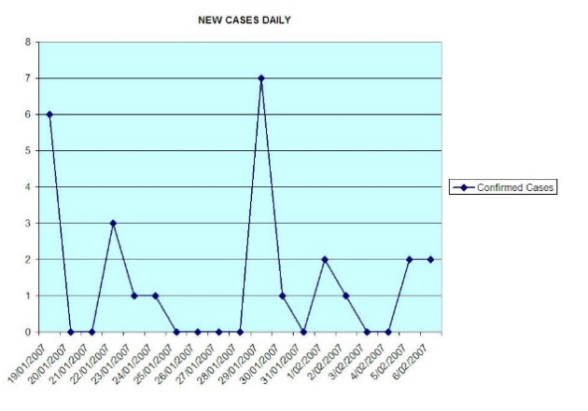

The first graph (left) shows an attempt to represent new daily cases. This is not very meaningful four weeks into a small outbreak. Grouping the same data by week would be better.

The second graph (middle left) is a more meaningful representation of the data (cases per week). Note the preference to work on a ‘per property’ or ‘per herd/flock’ basis for disease control measures therefore it is better the present the epidemic curve as the number of new properties infected.
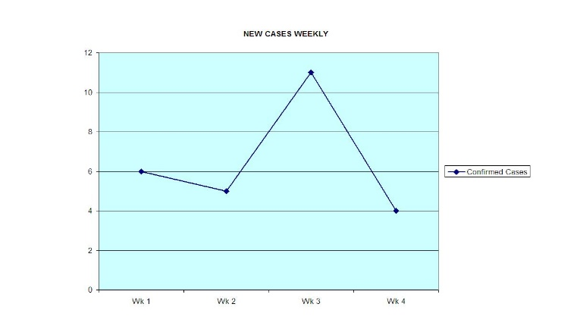

The third graph (bottom left) shows the number of new infected premises confirmed on a weekly basis.

The fourth graph (below right) shows the above with a trendline.

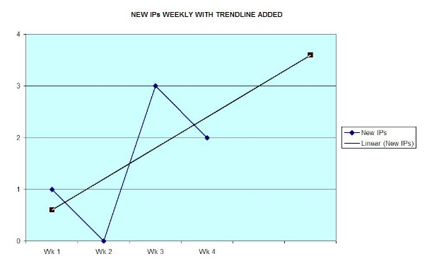
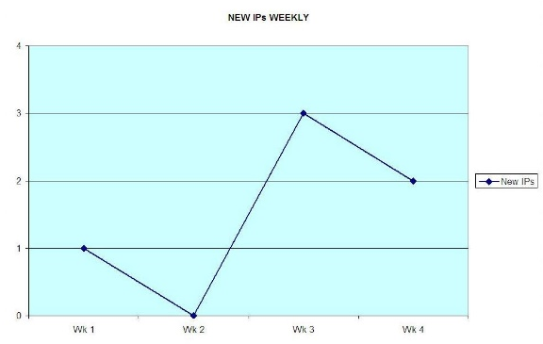

Another useful indicator would be a rough incidence rate using the total population estimate derived from the MAX forms and other data. If you have estimated that there are 50,000 susceptible animals in the RA, and for the past two weeks, an average of 200 new cases per week have been detected, it is possible to render an incidence rate estimate of 400/100,000/week.

Box 5. Incident rate estimation
Incident rates are normally calculated as the number of new cases per 100,000 animals at risk per time period (in a short-lived epidemic, the time period would be expressed per week).
Thus: Incidence = no. new cases per week x 100,000
no. animals at risk
= cases / 100,000 / week

This estimate must be updated regularly. It will tend to rise at the beginning of the epidemic curve. It should fall as control measures take effect.
Plotting an epidemic curve and regular calculations of incidence will help monitor the efficacy of control efforts.
Another way to monitor the speed of spread is to estimate the basic reproductive number R₀ – the number of new cases of disease generated by a single existing case within a single incubation period. A R₀ of 10, for example, means that one sick animal will successfully infect another ten susceptible animals during one incubation period. This gives a measure of the transmission rate of the disease.
This may not be possible for very rapidly propagating diseases and it is not sensible to use limited staff to count numbers of sick animals. For some diseases, you could measure the number of new infected premises (IPs) generated by a single IP during an incubation period – the Property R₀ or Estimated Dissemination Ratio (EDR). Guidance on calculating the EDR is shown at Box 6.

Box 6. EDR
Calculating the Property R₀ or EDR is relatively easy. Assume that a disease has an incubation period of four days and therefore the number of IPs reported over a number of days looks like this.

Day number: 3 4 5 6 7
Number new IPs reported: 2 1 3 2 1

The starting number of IPs is 2 (on day 3). Over the next four days (from day 4 to day 7), the total number of new IPs is 1+3+2+1 = 7.

The EDR = total new IPs in one incubation period
number of new IPs at start

= 7 / 2
= 3.5

Interpreting the EDR is important. In the early phases of a propagating epidemic, it will exceed one
(i.e. EDR >1).
The EDR should be calculated at least every few days and monitored. It may be possible to infer that the epidemic is peaking and being controlled if it has remained around one (EDR ≈ 1) for a while. Once the EDR remains at below one (EDR <1) for some time, it may be a sign that the epidemic is waning.
Understanding the EDR may also help make some predictions over time; used as the slope of a graph, it may give an indication of how an epidemic is either building or decaying.
You need several weeks of data to make workable predictions.

Box 7. Using EDR in prediction models
Calculating the EDR and inserting the value into a spreadsheet. May enable some predictive curves to be drawn. However, use these with care.

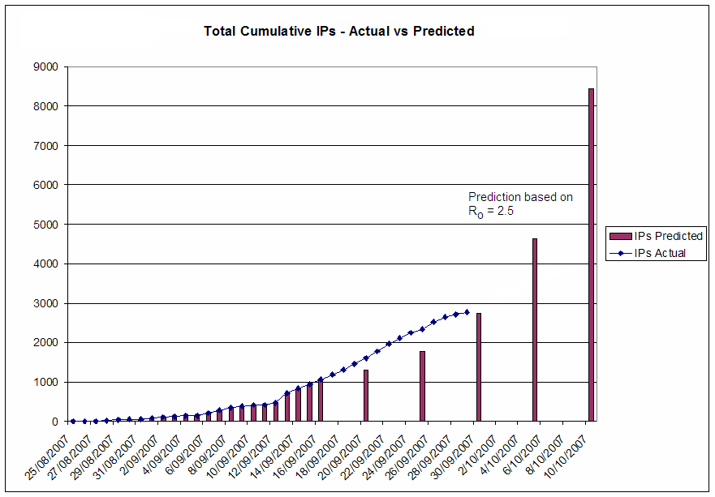
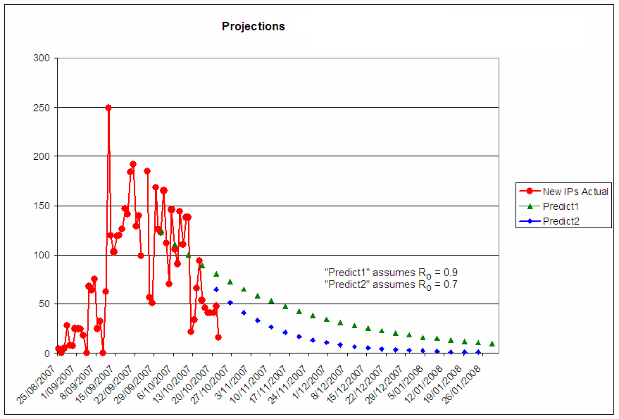

5.4 Make a map and animate it
A map of IPs gives you a good overall view of the situation, and shows the relationship of IPs to each other and to other geographic features. It will be useful to plan the best travel routes for surveillance and inspection.
Maps should be available from MAX or similar software. Detailed overlays will show features such as roads, rivers and property boundaries. The mapping officer can provide more detailed information such as contours, irrigation channels and footpaths. Box 8 shows a simple hand-drawn map.
Animating a map provides a valuable tool to help appreciate disease spread with information on clustering in time
and space.
Generate a series of standard maps on a computer showing the IPs in existence at the end of each week. Importing these into presentation software such as PowerPoint, and then flipping through the slides in quick succession (i.e. animating the map), will show disease spread across the landscape.
Interpretation is the most important thing about a map. Look at where the IPs are clustered. Do they occur near a particular geographic feature? Are they distributed along roads or watercourses? Careful examination of spatial distribution may yield clues about disease spread.

Box 8. Map examples
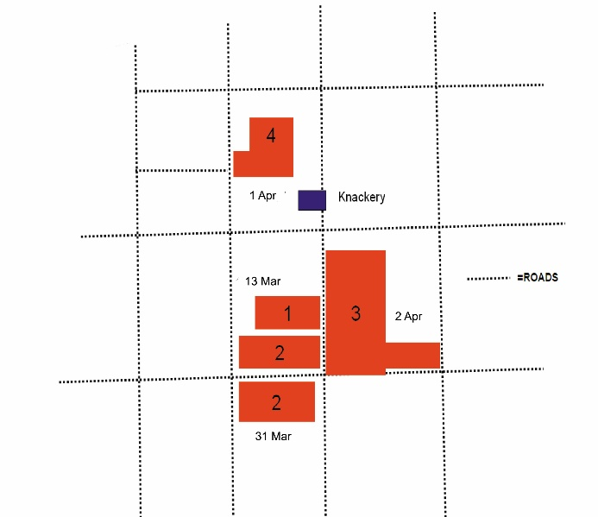
This is a simple hand-drawn map. The dates of each property’s first confirmations have been added.
The proximity of the infected premises to a knackery already indicates a priority: the possible role of the knackery in the disease outbreak needs to be investigated.

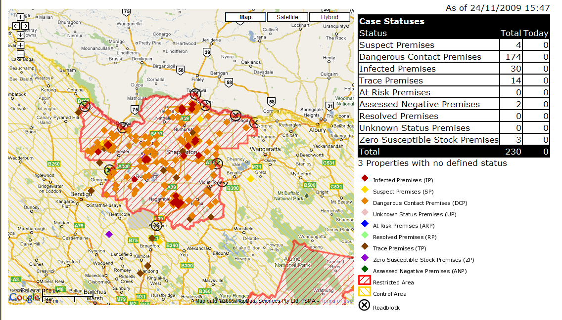

Automated map from early version of MAX from a training activity.

5.5 Generate a timeline
Maps provide a tool for examining a disease in space, and relating it to local features of geography. Timeline
analysis enables an examination of spread in time, and enables one to visualise disease events in relation to
other time-defined events.
Some software packages (e.g. Smartdraw or Smartsheet) are able to generate timelines, often from a spreadsheet. These are especially useful in this context as they enable the rapid viewing of dates against events of interest.
Cattle movements between the IPs and any dangerous contact premises (DCPs) can be added to the timeline, as well as other relevant events. Further updates from the latest outbreak recorded in MAX will automatically appear on the timeline. MAX tables are easily exportable to MS Excel – and such spreadsheets can be used by timeline generators.
Other events can be added to the timeline by hand, for example, visits by knackery trucks and feed deliveries. Index cases and subsequent cases can be added if MAX disease event data is not on the timeline.
The interpretation of the timeline is important. A timeline provides a tool to view disease events against other events and to look for possible relationships between them. Box 9 shows how to generate timelines.

5.6 How far, how fast?
Understanding distance and time is important to understanding spread, or at least being able to ask the right questions. Producing animated maps is one way of understanding spread over time. Another way is plotting spread distances versus dates on a graph. Also helpful is categorising spread distances, for example 1-10 km, 20-40 km, and seeing how many IPs have resulted from spread over a given distance.
Spread charts, such as those in Box 10, should help you ask the right questions and help you with analysis.
A large number of IPs within a small area can be explained by local spread; those separated by great distances need further investigation.
You should ask:
- How far is a disease likely to spread around a new focus?
- How far from the centre of a focus should control measures extend?
- How far away from a focus could be considered safe?
- Are there any hints as to means of spread?

Box 9. Generating timelines

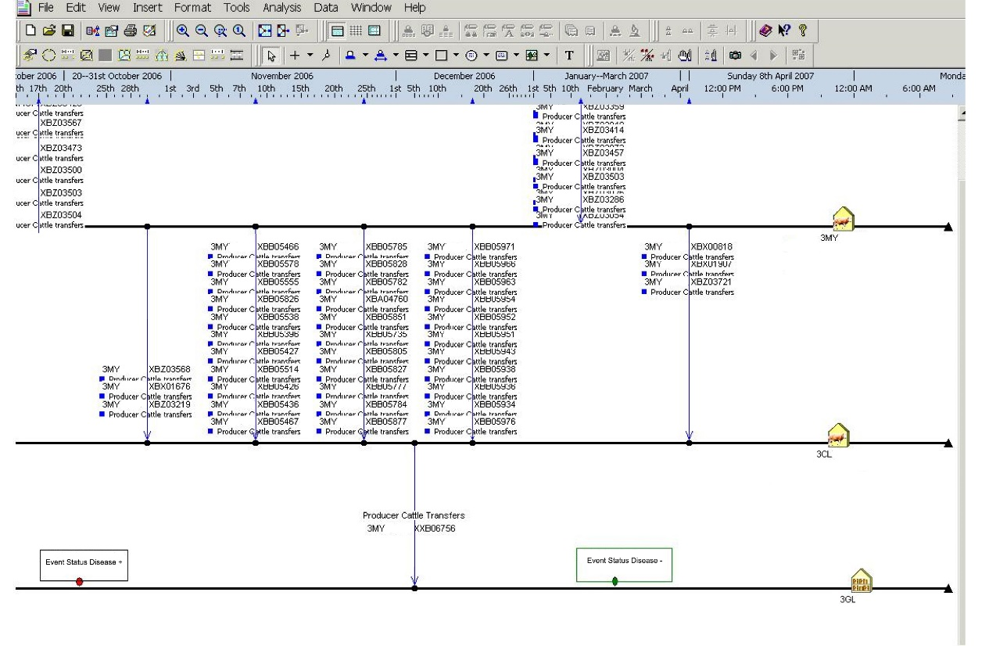

The timeline above was generated automatically with a software tool. It relates cattle movements between three properties to a disease status of one of the properties. Other events can be added manually.
The timeline below is more elementary and has been drawn by hand.
Timeline
Date
First disease event on IP
1 Jan
4 Jan
13-01
31-01
1-02
2-02
1 IP
2 IP
4 IP
3 IP
Significant events
Knackery truck visits 2IP
Irrigation 1IP
(pre-New Year)
Continuing deaths on 1IP
17
18
24
Carcasses ex NSW to knackery; all rendered
20
Rain

Box 10. Generating distance/spread graphs
Start with an IP that was reported early in the outbreak and plot the new IPs by date and by distance from the original IP. Similarly, group the new IPs into distance categories and compare them in a pie chart.
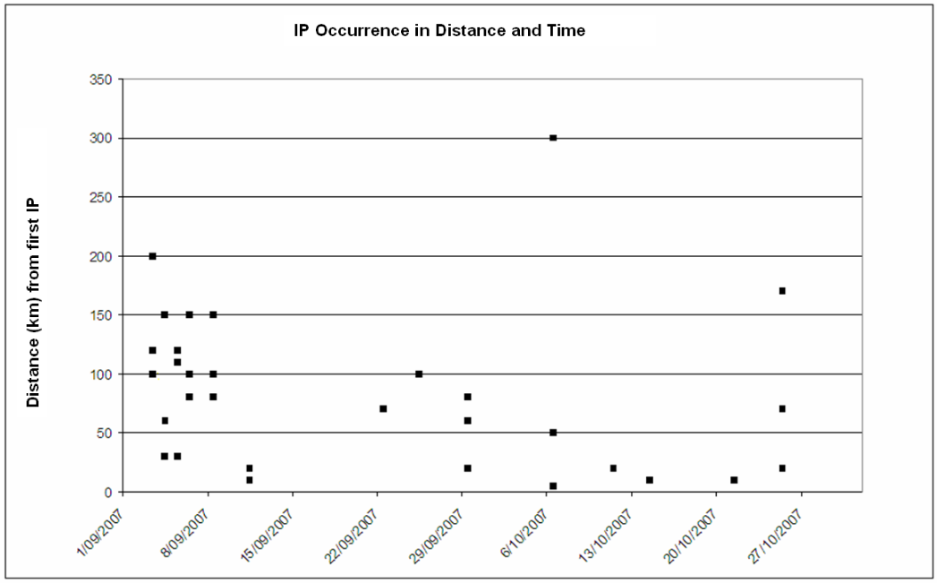

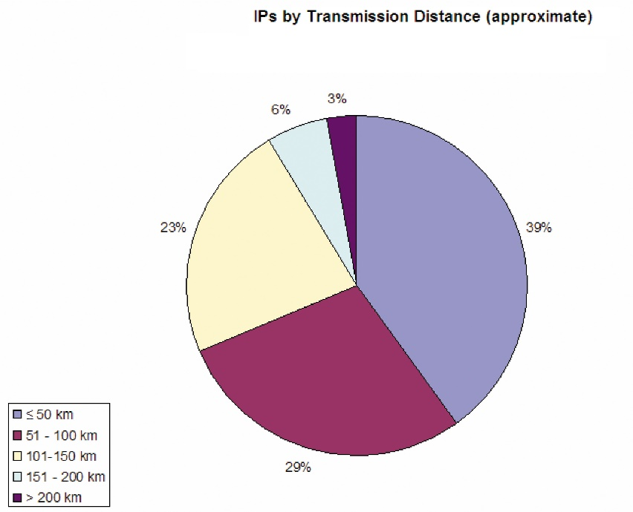

5.7 What about links?
The NLIS enables the links between properties created through livestock movement to be traced. There is a tool within MAX (the NLIS Visualiser) which enables easy visual analysis of these links. In the case of a disease spread through stock movements, it may show where the disease came from and to where it may have spread.
Link charts or relationship diagrams for IPs and DCPs can also be generated with link analysis tools such as UCINET and Graphviz, which are able to make use of spreadsheet data.
The intelligent use of such software for creating link charts and timeline charts will be at the forefront of many disease interventions in future.

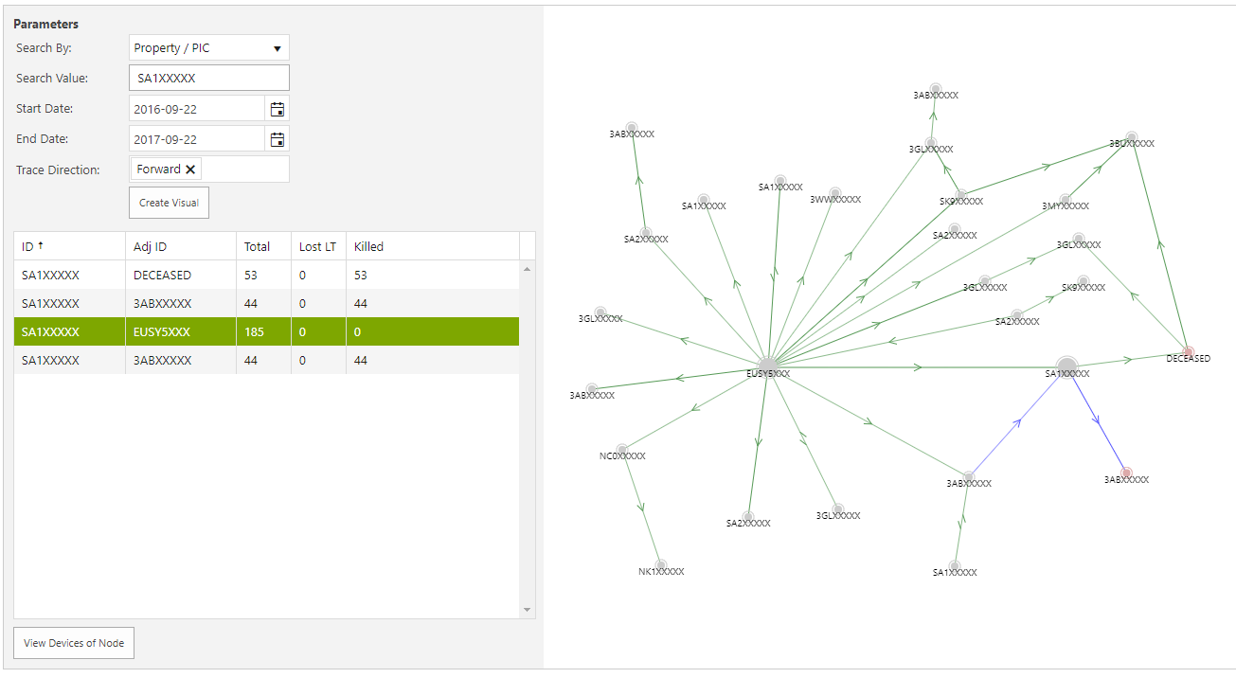
Box 11. Link charts

A simple link chart drawn with MAX NLIS Visualiser showing distribution of animals through a saleyard.

5.8 Examine the risk factors
It is at this point that detective skills come into their own. All the information gained in key informant interviews, all the analyses – epidemic curves, timelines, link analyses, previous experience, academic knowledge – must be marshalled to gain some understanding of the risk factors underlying the disease.
Laboratory diagnosis will identify the causative organism. You will get valuable clues for possible management by understanding the local risk factors that may play a role in disease spread.
Here are some of the risk factors to consider:
- Possible reservoirs of infection:
  - soil/water
  - wildlife / feral animal populations
  - garbage tips
  - knackers’ yards

- Possible mechanisms of spread:
  - wildlife
  - insects
  - livestock movements
  - people and vehicle movements – visitors, veterinarians, milk trucks, feed deliveries, knackery vehicles
  - waterways
  - wind
- Increasing or decreasing host susceptibility through:
  - nutrition, grazing practices
  - medication, vaccination, dipping, drenching, dehorning, castration
  - housing, ventilation, exposure
  - extreme weather
  - age-related factors
  - breed-related factors.

Relating factors such as the above to disease events using maps, timelines and link analysis will help you to formulate some hypotheses as to the factors underlying the disease spread. Careful consideration of the plausibility of the hypotheses will narrow the field to one or two that are most likely.
You are unlikely to have time to formally test these hypotheses but they may suggest additional measures to manage the disease beyond standard measures such as vaccination, quarantine and/or culling.
A good understanding of the risk factors may also lead to a redefining of the RA. For example, a strong association between a disease and riverine areas may mean that control measures in drier, non-riverine areas could be relaxed.

5.9 Make short-term projections for Planning Management
It can be difficult to make projections about how a disease is likely to behave, but some attempt must be made. This will help the LCC Planning Management function who should be considering the resources needed to combat the disease.
Provision has to be made for resources including people, vehicles, vaccines and accommodation. Usually these can be called upon a few days in advance, giving the LCC epidemiologist the opportunity to update projections regularly as the disease outbreak progresses.
Most projections of what the disease will do are made on a ‘case scenario’ basis. In the face of uncertainty, the best that can be attempted is a ‘best case – most likely case – worst case’ series of scenarios.
Scenarios should typically look one or two weeks ahead. Should mass vaccination be a part of your planning (where immunity typically takes about 14 days to develop), trying to visualise what a disease would do after two weeks would in any case be a fraught process. These short-term scenarios would be generated by LCCs within the RA who would then pass them to the SCC. SCC would be working on larger, longer-term projections.
In Box 12, there are two types of scenario estimation: a disease that spreads rapidly from property to property across a large area, and a disease that spreads locally through direct contact between animals.

Box 12. Reading the tea leaves
Example 1: Rapidly spreading infection
You determine that over the past two weeks, an average of 30 new properties per week has been infected and the total IPs now stand at 50. Your best guess is that if it continues at that rate, by two weeks’ time the new total will stand at 110. If the epidemic curve climbs steeply, perhaps this might double (or more – follow your instincts on this one!); if your control measures begin to take effect, the spread may slow to only ten new properties per week. If you believe that there are an average of 150 animals per property, this gives three scenarios for the situation in two weeks’ time:
- Best case: 90 IPs – 13,500 animals involved
- Most likely: 110 IPs – 16,500 animals involved
- Worst case: 200 IPs – 30,000 animals involved

Example 2: Slower local spread
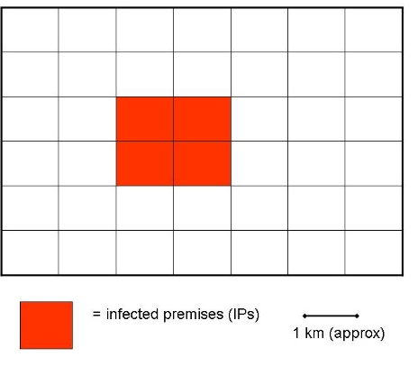
Use a simple map to visualise how spread is occurring.

If the disease seems to be spreading at a distance of one property per week (i.e. one property per week outward from the centre of the focus in this simple diagram), then the best guess is that in a week’s time, about 16 properties (2400 animals) will be involved. Doubling this estimate will give a credible worst-case scenario; halving it will yield a best-case scenario.

It is also possible to use EDR and time-distance analysis to help with projections – see Boxes 7 and 10.

It will become easier to determine how many staff will be needed and how many private veterinarians and other resources are required when you have an idea of the likely number of IPs.
Remember to:
- Use data from several sources (triangulation) to estimate the population at risk in the area covered
by the LCC.
- Start to generate and update an epidemic curve as soon as possible.
- Use available data to generate attack rates, incidence rates and estimated dissemination rates.
- Use whatever technology is available to generate and, if possible, animate maps to appreciate spread patterns.
- Create a timeline to relate disease events to non-disease events.
- Measure distance spread over time.
- Use link analysis to appreciate and analyse known links between properties.
- Carefully evaluate all risk factors that may have a bearing on disease spread.
- Integrate all information amassed in order to start generating spread predictions to support the planning needed for LCC resources.

6. Daily and non-regular reporting duties
Ongoing analysis of the outbreak and provision of guidance to surveillance teams and logistic advice to the planning section as described above form a major part of the LCC epidemiologist’s responsibilities.

6.1 Daily sitreps
One of the most important reports of the LCC is the daily situation report (sitrep). This is a military-style report that simply informs the chief veterinary officer (CVO) and the SCC what has happened up to the day in question, what has been done in terms of control, and a brief evaluation of progress made. The sitrep should not be an exhaustive record; it is a synopsis of what has happened on a given day. An example proforma for an LCC sitrep is shown in Appendix 1.
The CVO and his/her team will use this report to inform themselves of the situation and to make decisions regarding resource needs, reporting further up the chain of command within government, and any information for the media.
The sitrep will be prepared by the LCC – Situation Assessment function, with input from others. To develop epidemiology input for the sitrep you should:
- check the MAX/equivalent outputs with respect to infected properties detected
- ensure that laboratory confirmations are correctly listed
- check any maps submitted
- add any comments about the epidemiology of the disease that may be helpful
- be sure to add suggestions for work/actions needed by the SCC epidemiologist
- include any requests for assistance.

6.2 Analytical reports
Analytical reports detailing the outcomes of all the investigations and analyses described in Sections 5 and 6.1 will be an important contribution to the overall understanding of the outbreak and may provide some guidance for the follow-up work once the outbreak is over.
These reports should provide evaluations of all the geographic, ecological, population, climatic and management factors that may have contributed to the outbreak. These reports may include hypotheses about the disease source and spread; graphs, maps, photos with interpretation; and, recommendations and conclusions.
Such reporting is not required by AUSVETPLAN but you should be prepared to provide a scientific basis for the efforts being made to control the disease. These reports should appear regularly with a frequency determined by new information. They should be discussed with the LCC Planning Management function and the LCC controller; and, circulated to SCC.

6.3 Recommendations
The LCC epidemiologist is approached on a regular basis for inputs into planning and control actions. Consider your contributions very carefully, and keep a record of what you provide including any data and calculations used in making your recommendations. Review your recommendations regularly and update them when necessary.

6.4 Other
During your time at the LCC you will obtain and analyse data from many sources. You may initiate and/or be part of specialised investigations. Keep detailed notes of this work. This may prove extremely valuable and could be used in future emergency responses.

7. Continuity
Most emergency responses last a few weeks, and therefore all LCC staff will be rotated between their normal duty stations and the LCC. A detailed hand-over avoids continuity problems.
- Organise a hand-over meeting to discuss what you have done, your findings and experiences, the initiatives you have undertaken which will need to be continued or followed up, and anything you regard as important.
- If you can’t have a meeting, write a brief hand-over report detailing all the issues. Follow this up with a phone call as soon as possible.
- Hand over copies of all of reports that you may have generated and provide clear written outlines of what you think still needs to be done from the point of view of the epidemiologist.

8. Follow-up studies
The end of the outbreak is but a stage in the work. The epidemiologist will play a key role in follow-ups to further clarify the origins and spread of the disease and to evaluate the efficacy of the response.
Each LCC epidemiologist should make suggestions for follow-up studies and provide all possible information and analysis to support such studies. While this is undertaken at the initiative of SCC, the input of those who worked in the field is essential for this work to succeed.
Most follow-up studies are observational, but may also involve serological surveys or other forms of sampling. The topics of such studies, as well as their design, will be informed by the experience of those who served in the LCC.
Remember to:
- Submit both regular and ad hoc reports. The contribution to the daily sitrep will be important, as will analytical reports. Reports must be useful at both LCC and SCC level.
- Document and record everything, including calculations and the data upon which they were based.
- Think ahead and plan for follow-up studies.
- Ensure that there are detailed hand-over notes for the next epidemiologist if staff are being rotated.

Part 2.
General principles of disease response at the state coordination centre (SCC)

9. SCC epidemiology
The State Coordination Centre (SCC) Technical Analysis – Epidemiology function (the SCC epidemiologist(s)) has to develop and maintain key relationships and reports, including:
- Liaison with the Local Control Centre (LCC) Technical Analysis – Epidemiology function (the LCC epidemiologist(s)) to describe and evaluate the field situation
- Gathering and evaluation of data from neighbouring states if the epidemic affects a number of states simultaneously
- Advising the SCC Coordinator function and chief veterinary officer (CVO) on the disease situation and associated risks, setting up of surveillance systems and disease management mechanisms
- Compilation of analytical reports and briefing documents on the disease situation for various levels of consumption within the state agriculture department/equivalent as well as outside of the department
- Drafting of publicity and training material for departmental staff and the Liaison – Livestock Industry function.
The SCC epidemiologist must be experienced in practical epidemiology and be able to communicate effectively with everyone from politicians to farmers.
The rotation of epidemiologists through the SCC should be minimised as far as possible given the importance of maintaining continuity in management of a statewide disease situation.

10. What to do when the summons is received
You will need:
- AUSVETPLAN Control Centre Management Manual – parts 1 and 2
- AUSVETPLAN manual/s for the disease outbreak diagnosed/suspected
- Computer with Internet access and access to the emergency animal disease (EAD) management software/MAX, geographic information systems (GIS) software, State property database, link analysis software and other relevant programs (e.g. rapid business analysis package such as Tableau)
- Spreadsheet software such as Excel and a statistics package
- Any training manuals or user manuals for GIS, link analysis and other software packages
- Contact details of all LCCs in the state, and names of the LCC epidemiologist(s).
- Web addresses for key state and federal government departments, especially the Bureau of Meterology (BoM), Australian Bureau of Statistics (ABS), and Australian Bureau of Agricultural and Resource Economics and Science (ABARES), and your own intranet and SharePoint sites. You may also need non-government web resources such as Google Maps and Google Earth as well as other disease information resources such as the Food and Agriculture Organisation of the United Nations (FAO) and World Organisation for Animal Health (OIE).

11. Getting started at SCC
Understanding a disease situation is like understanding a battlefield: knowing the enemy’s location, the terrain, the inroads made by the enemy, and their abilities, strengths and weaknesses.
Understanding as much as possible about the disease pathogen, its behaviour, and the environmental and husbandry practices that favour its spread are as important as up-to-date information on infected properties. It will be important to know the microbiology, the ecology of the organism, and the behaviour of the disease in other epidemics. This will help predict its behaviour and provide hints as to how it might be controlled. You need to know:
- What you’re dealing with
- When and where it first appeared in your jurisdiction
- Where it is right now.

At the start of the outbreak, you may or may not have updated and mappable data available on your department’s property database. If not (hopefully unlikely), you need to call the LCC(s) or involved district veterinarians, if a centre hasn’t yet been set up, to discover at least the following:
- The properties infected
- The dates they became infected
- The species infected
- Any information relevant to understanding transmission and spread.
Draw a map, add the dates and try to establish the direction in which the disease is moving. Diseases transmitted by livestock movements may be moving apparently randomly over long distances, while vector-borne diseases may be moving in lowlands, or along river banks.
Box 13. Getting it mapped: an example of a crude situation map
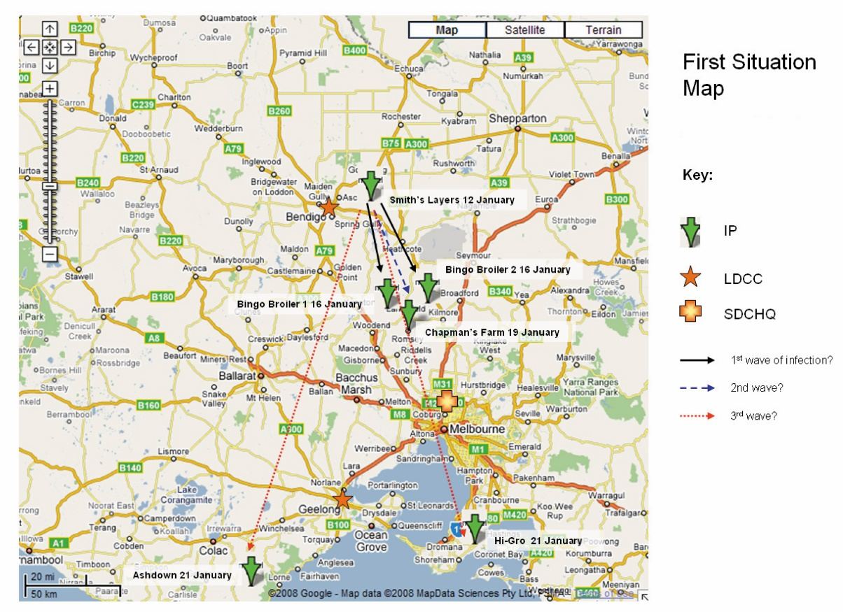
Map from a training exercise showing the situation and likely spread.

Your first map may be hand-drawn due to the absence of available computerised data. Place everything you know
on the map.
It will become necessary to generate maps automatically using a GIS program, sourcing infected property data from your property/property identification code (PIC) database. Regular contact with LCC colleagues will be necessary to ensure that disease data is rapidly finding its way onto
the database.
Find out the distribution of susceptible species in the state. Rough population density maps are able to be constructed using stock numbers from, e.g. ABS data plotted against spatial polygons (to generate chloropleth maps); they can be updated as statistics from ABS become available. Also available are actual population data from ABS. This data will help you understand where a disease might go, and how big the problem might become.

Box 14. Population big picture

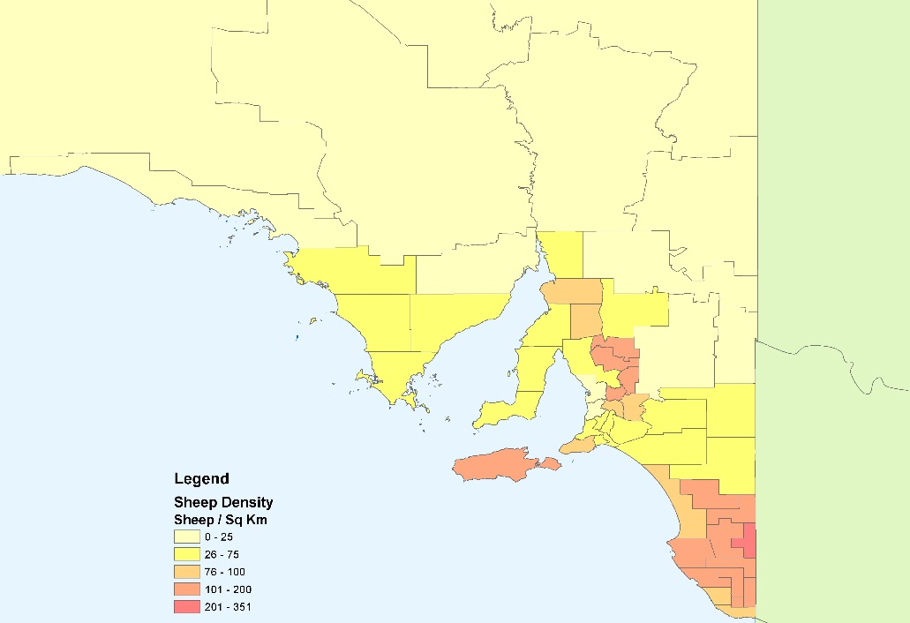

Choropleth maps like this one and tabulated population statistics should be built from available population and spatial data. This background information will help you understand the dimensions of a disease outbreak and likely management efforts.

Understanding the concentration of livestock populations will focus resources for planning management measures.
Be prepared to challenge your information because you may be missing something. You have information on the first infected premises (IP) but is it really the first? Scour your surveillance database for ‘look-alike’ diseases. If you’re dealing with a foot-and-mouth (FMD) outbreak, search for recent records of footrot. Phone local vets for the latest information on lameness cases. The disease may be in more places than you know about, and if so, you need more information quickly.
Within a few hours of an outbreak, you should know:
- The location and date of infection of the first reported IP in the state
- The locations and dates of infection of subsequent IPs to date
- Traces to and from these properties, especially interstate traces
- Possible areas for further investigation
- The approximate distribution within the state of the population/s at risk
- The most likely means and pace of further spread.

You can now evaluate any existing control strategies, and give advice on the best way forward.
When you have an idea of the disease location, you can begin to make recommendations about restricted areas (RAs) and control areas. AUSVETPLAN can be used as a guideline but ultimately the size and shape of these areas will be a compromise between the nature and extent of the disease and the resources available to control it. The borders of zones need to fit in with local geography and not bisect towns or mountain ranges.

Box 15. Getting it figured out: sources of information
Finding the information you need to get through the first day might be confusing. The following summary may help you find what you need to know:
- IPs declared to date: phone calls to district vets or LCCs (if they are functional), the state’s surveillance database, use of GIS systems or Google Maps/other to help plot current distribution of disease
- Traces: calls to district vets/LCCs should yield the most significant trace information; double-checking with MAX NLIS visualiser/NLIS will also be helpful.
- Population at risk: PIC database/Australian Bureau of Statistics (ABS) data; well-placed phone calls to district vets or agricultural extension officers for finer details where necessary
- Possibilities of further spread: available scientific information on the pathogen itself; information from district vets/LCCs on spread detected thus far; calls to extension officers/industry bodies on how livestock and products are transported/distributed within the sector concerned.

In the case of highly infectious diseases such as FMD, RAs need to take possibilities for local spread into account as well as the extent of movements of feed suppliers, knackery trucks, and dairy deliveries, for example. RAs for diseases of intensively farmed species such as poultry and pigs may be fairly small provided that infected properties are not close to extensive farms of the same species. It may also be wise at the beginning of the outbreak to declare the entire state a control zone until the extent of the disease is better understood.
When recommending boundaries of RAs and control areas (CAs), ensure that the boundaries are both easily mapped and easily described in legal documentation such as orders or regulations.

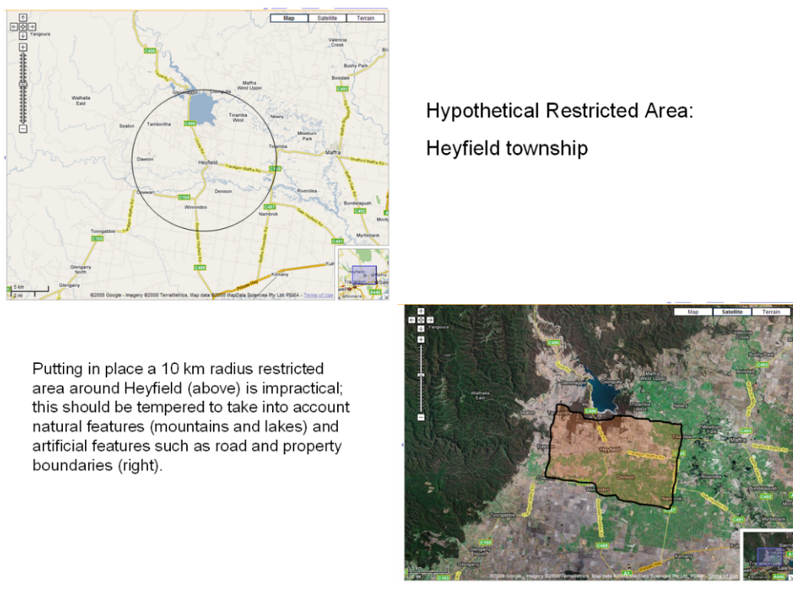
Box 16. Setting up a restricted area

Remember to:
- Collate the data and analysis from the LCCs for senior decision-makers. Analysis generated by the SCC epidemiologist(s) will also form the basis for overall policy and strategy development and for publicity information.
- Understand the pathogen and its likely behaviour; and understand the population at risk and likely pathways of spread.
- Use large-scale maps to get the ‘big picture’ and to help understand how the disease might spread. Use the ‘big picture’ to make recommendations about the extent of RAs and CAs.

12. Is everybody on the same wavelength?
Very early in the outbreak, one or more LCCs will be set up to deal with disease management at field level. Colleagues in these centres will be trying desperately to get a handle on things; some of the activities occupying them will be case investigations and data input. They will be reacting to events based on working case definitions that they have helped establish. This is very practical for field use.
However, it is important to understand the role of the SCC and overall disease monitoring. All LCCs should agree on a working case definition; all should agree on uniform standards for declaring infected premises (IPs), and all should be entering the same standard data on the computer system.
To ensure statewide consistency, and to make SCC reporting accurate, all LCCs should be using the same case definitions, and all should be entering the same data in the same way. Data entry must be as up-to-date as possible so that any picture painted by the SCC epidemiologist(s) is a realistic one.
Ensure that the division of labour between the LCC and SCC epidemiologists is well-understood. SCC should not get bogged down in managing surveillance or tracing activities but must have access to the data yielded by these activities. SCC should be alerted when surveillance shows up possibly infected properties outside the current control zones, or when traces yield important links outside of control zones or in neighbouring states. Interstate disease suspicions are then followed up by SCC Coordinator or the CVO.
Recommending boundaries of RAs and CAs is best done in close collaboration with LCC epidemiologist(s).

13. Getting your surveillance going
The first and most important surveillance data being received in the field will be passive reports of clinical disease on affected properties. This will lead to their being declared IPs.
To build a reliable picture of the disease situation you will need to investigate properties linked to existing IPs
through traces back and traces forward. This will be time-consuming, and careful liaison will be needed between epidemiologists and planning managers at LCC and SCC levels to ensure that staff levels are adequate to carrying
out these investigations.

13.1 The beginning: a good place to start
At the beginning of the outbreak, it is more important to know where the disease is present, rather than to know where it is not present (information on disease freedom is provided in section 16).
It is vital to harness all possible assistance to ensure statewide passive surveillance. Gain as much public cooperation as possible in disease reporting early on. You should consider:
- A media blitz via radio and television to inform the public and request information on possible cases
- Communications to peak industry bodies, the Australian Veterinary Association (AVA) and the veterinary profession’s registration boards to enlist the assistance of livestock producers and veterinarians in disease reporting
- Disease recognition information and reporting requests on your public website
- All communications should include simple and easily recognisable disease descriptions so that both lay people and veterinarians know what they need to report; veterinarians need more details on sampling and personal biosecurity.
These measures must be coordinated statewide to ensure consistency in passive reporting across the whole state. This will likely involve smaller rural radio stations as well as television channels operating outside the main metropolitan areas.
If the outbreak continues over a period of weeks, you should consider community meetings, and the publication of leaflets with information on the disease.
Another idea worth considering is that of telephone surveillance: calling all properties in the vicinities of IPs or clusters of IPs to determine whether signs of disease have been seen. Using the mapping facility of MAX will be useful in identifying such properties and finding contact details.
Diseases tend to occur, at least superficially, on a haphazard basis. This means that planned and systematic active surveillance will not always deliver the desired results in discovering where the disease is present. Passive reporting and tracing, underpinned by a thorough publicity effort, will be the preferred way of working.
New tactics are required once it becomes obvious that the outbreak is being controlled and the disease is beginning
to recede.

13.2 Finding more than disease
It is necessary to understand the numbers and location of the total population at risk. You may need to know how
many animals are in a given area to organise a cull, or to order vaccines, or to plan the number and composition of surveillance teams.
This may pose problems, as the number of animal species is not necessarily known for each property in the state. Use triangulation as described in section 5.1 as a starting point in conjunction with LCCs.
The state property identification database may be useful to show how many properties in an area carry the livestock species in question, though not necessarily the correct numbers on each property; a best guess will be arrived at using the triangulation method. This yields an approximation of the average numbers on each farm.
The use of triangulation with some reliance on the latest ABS statistics will give a working figure of sufficient accuracy for use at a local government level. The SCC will have to be guided by LCC staff on this issue.
Gaining information on enterprise distribution and their population sizes will be a relatively easy matter with diseases in confined intensive systems which spread to more extensive farming systems, for example Newcastle disease in poultry. The industry concerned will probably be able to provide adequate statistics and so the Liaison – Livestock Industry function has an important role.

13.3 Moving towards disease freedom
When the outbreak is moving towards resolution, it may be necessary to prove absence of disease, for example, for international trade.
This changes the terms of surveillance: reports of newly infected properties will be dropping off, and the emphasis will be on showing that this represents a true reduction in disease and on proving that the pathogen is disappearing.
There are two major components to proving disease freedom that will need to receive attention before the outbreak comes to a final end, and you will need to prepare for them.
The first is to show that previously infected properties really are disease-free. Settle on a period of time by which you can be sure that the disease has gone through all animals on a property, they are all either dead or recovered, and there is no longer any environmental contamination. You might also test animals on IPs to show that there is no longer any pathogen present (e.g. post equine influenza) or place sentinel animals on a cleared IP for testing (e.g. post Newcastle disease).
Culling is probably the only effective control strategy in the case of diseases where carrier states are a problem. The passage of time or (preferably) active decontamination are required for assurance that the disease is gone. Consult AUSVETPLAN for more clarity on these issues.
The other main pillar of proof of freedom is demonstrating that the disease did not spread beyond the identified IPs and that the remaining properties are truly disease-free. Options for targeted and random surveillance to do this are discussed in section 16. You will need to get this under way as the disease winds down, with a formal disease survey once reports of disease dry up completely.
Remember to:
- Coordinate between LCCs to ensure consistency of reporting.
- Help raise public awareness to raise the sensitivity of passive surveillance.
- Start planning for proving disease freedom once the outbreak is over – data gathered during the outbreak will contribute to this.

14. Daily tasks
A daily state-level situation report (sitrep) will be prepared by the SCC – Situation Assessment function (within the SCC Planning Section) giving both background information on the outbreak as well as actual disease data. This will feed into the incident action plan (IAP) (also prepared by the SCC Planning Section).
As the SCC epidemiologist, you will be asked for input into the daily sitrep. The sitrep will contain (as a minimum) a brief summary of disease events to date, noting spread, possible spread mechanisms, progress with containment, etc. Following close on the heels of any descriptive narrative should be some maps: an overview map of the entire state, and perhaps one or two detailed maps of local disease situations. The main aim of a sitrep is to record events over the 24 hours since the last sitrep: ensure that the sitrep does this adequately.
Also, be sure to provide tables showing the numbers of IPs, suspect premises (SPs), trace premises (TPs) and dangerous contact premises (DCPs) per affected local government area, together with estimated total animal populations on these properties, and actions taken – e.g. valuations, culling.
At the beginning of the outbreak – within the first few days – providing a plot of the epidemic curve (the number of new IPs reported daily or weekly) might not make sense but by the end of the first week, giving such information will be very helpful. It may also help later on the outbreak, in collaboration with the LCC epidemiologists, to provide separate epidemic curves to describe the situations being managed by the various LCCs.
Details of disease control actions such as quarantines, vaccinations and culls must also be given, together with an assessment of their efficacy.
Performing daily situation analyses an important task. The SCC Coordinator and CVO will require briefings; participation in teleconferences with LCC and other field staff is also a must. It may also be advisable to sit in on Consultative Committee on Emergency Animal Diseases (CCEAD) teleconferences when they occur in order to supply background detail: consult with the SCC Coordinator and CVO on this.
Also important will be attending daily SCC briefings and ensuring that the SCC Planning Management function has enough information to plan for resource needs.
Keep in daily contact with counterparts at LCCs. You won’t be doing this to get data but to ensure that everybody is keeping up with data input, that case definitions are being maintained and that LCC staff have a good understanding of what is happening across the rest of the state.
It is a good idea to keep up with what is happening on the database and to conduct a series of ad hoc analyses every day. Follow the number of new IPs per day and per week; update and examine the epidemic curve. Be aware of ‘gaps’ in the curve – why are they there? Were no cases reported during that particular period, or is there a hitch with data input?
Map new IPs both daily and cumulatively and look for spread patterns. Again, look for gaps between IPs on the map. If IPs are generally closely clustered and yet there are visible gaps between some of them, seek an explanation from the relevant LCC. Do the gaps represent genuinely disease-free properties, have they been missed by investigations, or are they devoid of susceptible species?
If an IP shows up on a map in apparent isolation, some distance from other clustered IPs, try to find out why. Ask the LCC concerned whether this represents fomites or other spread and whether it can be linked to other established IPs.
Keeping an eye on what information is flowing into the database from LCCs will help focus their efforts and contribute to understanding the disease.
Remember to:
- Provide daily Sitreps based on a synthesis of data from all LCCs; giving regular briefings to staff and other stakeholders will be important.
- Construct and follow an epidemic curve and regular maps to monitor (and help predict) the behaviour of the epidemic in space and time.
- Maintain regular contact with colleagues at LCC level.

15. Scenario construction
The SCC epidemiologist(s) will be required to construct scenarios similar to those of the LCC epidemiologist(s) (see section 5.9). In this instance, the SCC will be looking at statewide issues and consequences. Building state-level scenarios will involve knowledge of livestock distribution, movements and management practices right across the state. It will involve tapping into the knowledge of industry experts and building plausible alternatives for the course that an epidemic might take.
It will enable the Planning Section to plan resource needs, but more immediately, for the epidemiologist(s), it will help to see whether progress is being made in terms of disease control. Scenario construction will help you draw conclusions on outcomes and will help answer key questions such as whether the disease is eradicable, and if so, within what timeframe.

15.1 Scenarios: getting it together
Start out with defining what it is that you want to know. Typically, with disease outbreaks, you will need to know:
- How far will it spread? How big will it get?
- How long might it continue?
- Will it be eradicable? Or might it become endemic?
The next step is to identify the drivers behind the epidemic. This will involve consulting with knowledgeable people – field staff, veterinarians, industry representatives, and possibly other experts such as ecologists and meteorologists.
Critical drivers will be the transmissibility of the pathogen, available transmission pathways (animal contact, people, insects) and other factors that may retard or promote spread (vehicles, visitors to properties, temperature, rain, population density).
At this point, sufficient data may have been collected to put into a software model, such as TADsimulator or the Australian Animal Disease Spread model (AADIS). Such models may provide useful illustrations of how a disease might behave but should be treated with great caution. Typically, about six weeks’ worth of detailed data are needed to begin working on a model. If no suitable software is available, or if you simply don’t trust computer models, then proceed without one – but do not to go it alone. Convene a group of interested and informed individuals to discuss scenario constructions.

Box 17. Using computer-generated models
Models are intended to help understand reality, and are thus a crude representation of it, but no model ever truly even comes close to imitating reality. Models such as TADsimulator are generic. Custom-made models (e.g. AADIS) containing real geographic and population data, which look like the real thing, have a great potential to mislead. It is better to use models illustratively, not predictively.
Any model, no matter what its level of complexity, requires careful and realistic inputs – a process known as ‘parameterisation’. Therefore, feeding such information as population density, likely contact rates, etc into any model will require great care and a good deal of consultation with experts.

When building your scenario, start with a map showing, albeit crudely, the population distribution, major geographic features and infrastructure. Then, with the aid of your carefully chosen group of experts, plot out likely spread routes, estimate contact rates and list all the factors promoting and retarding spread. Work on scenario logic: where did the disease start, how is it behaving now, and what will it likely do in the near future? And if it spreads to x, y and z in the next few weeks, what might it do after that?
The next step is to tease out of all the information before you, a number of likely scenarios. Try to work out 6-10 possibilities, then narrow down the choices to three: the best case, the worst case, and an intermediate case.
Finally check the plausibility of your scenarios with experts. You should have some ideas which will help you answer
the questions that you need to answer. The scenarios should give you some idea of the likely geographic extent of the epidemic, the number of properties and animals involved, and the time within which you will need to exercise your
control measures.
Some brief ideas on scenario planning are given in Boxes 18, 19 and 20 below. They relate to an imaginary FMD outbreak in an imaginary country (Trident State).

Box 18. What your planning map might look like
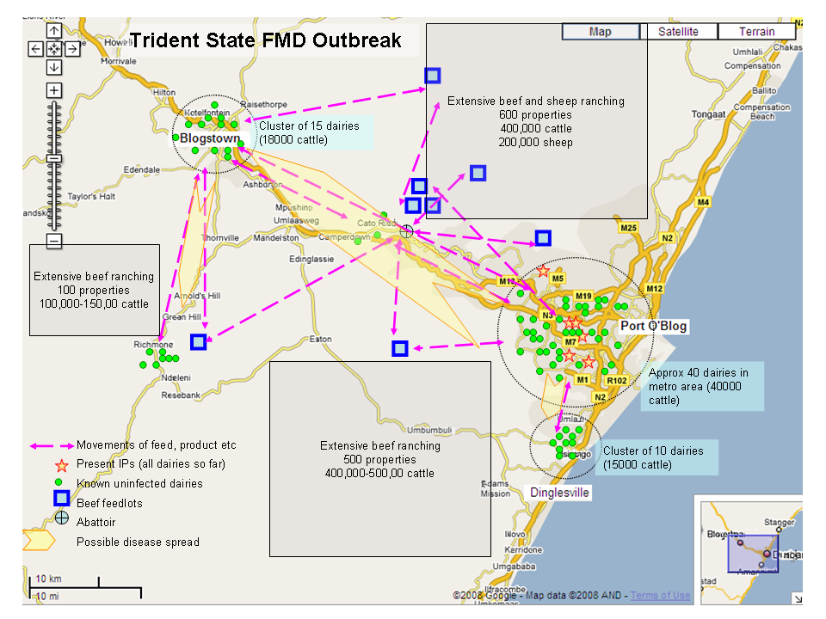

Box 19. Factors and outcomes

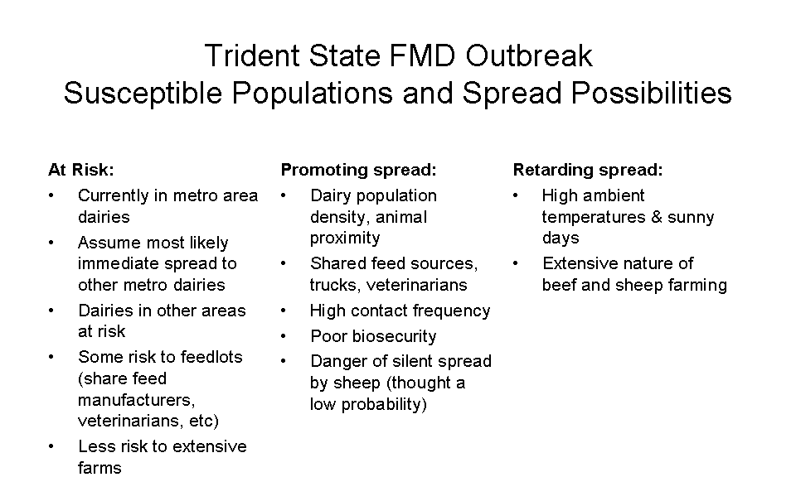

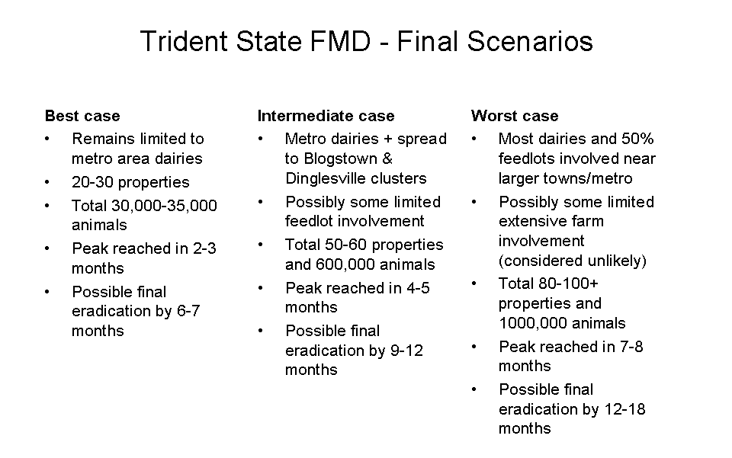

Box 20. Computer model output
The illustration below shows a typical output from TADsimulator: it illustrates the possible spread of an imaginary disease between three imaginary geographic regions.
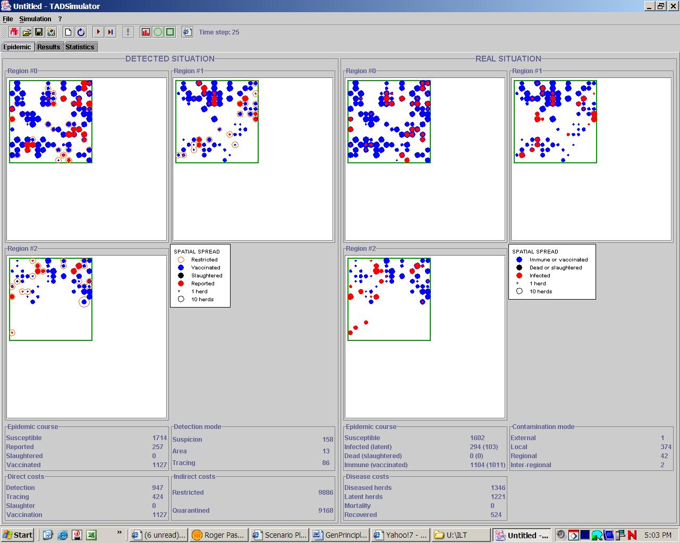

Remember to:
- Work on scenario creation, establishing what you need to know, the drivers, and using maps.
- Use computer models with great circumspection.
- Build three scenarios – worst case, best case and intermediate.

16. Proving freedom – establishing the absence of disease
Epidemic diseases usually have serious consequences for international trade.
Australia may need to report to the OIE, which sets international standards for trade in animals and
animal products, or to trading partners that the disease threat has passed and that trade in affected products can
return to normal.
It will then be necessary to carry out surveillance aimed at proving disease absence. It is likely that the SCC epidemiologist(s), together with other senior veterinarians, will play a key role in planning the ‘proof of freedom’ exercise and in compiling the final documentation.
These surveillance issues should be considered:
- Previously infected properties (resolved premises, RPs) – what has been done to resolve them and prove absence of disease from those properties? Were animals culled – or perhaps vaccinated and subject to subsequent diagnostic testing? What investigations have been done to show that these properties are disease free? Knowing and proving absence of disease on previously infected premises is a good place to start, and gathering these data will provide a strong basis for making any argument for freedom.
- Use of sentinels. Some diseases, e.g. Newcastle disease and the swine fevers, lend themselves to the use of sentinel animals. Devising a strategy for using sentinels could be very helpful.
- Surveillance of animal congregation points. Targeting livestock shows or sales may provide a wealth of useful data.
- Randomised surveillance. There is no getting around this one. Assembling a sampling frame and designing a sampling strategy may require time and resources, but it will need to be done.
- Sentinel practice network. Getting agreement from a number of veterinary practices which have good contacts with the livestock subsector/s concerned is a good way of getting data. This surveillance is often visual, but may cover large numbers of properties and animals. Being able to say that x properties carrying y animals were visited over a period of z months with no visible sign of disease can be a powerful assurance of disease freedom.
- Public awareness and passive surveillance. It is very important to keep the disease on the public agenda, and to investigate all suspicious cases to exclude the particular disease.
- Telephone surveillance. Running a disease eradication campaign often leads to the creation of a list of contact telephone numbers of concerned livestock owners. Phoning them and recording that they are not seeing signs of disease is useful indicator. It may lack diagnostic rigour, but lends weight to whatever other evidence has
been collected.
The next step is to draw up a coherent report of the surveillance findings.
This report should be as complete as possible, especially if you wish to convince an organisation such as the OIE of the veracity of claims to disease freedom, and it should include:
- Description of the state (geographic features, climate etc. that influence disease behaviour) and a description of the population at risk with density, distribution and likely movements. Include a description of the industry concerned and how this affects disease spread and disease control.
- Describe official veterinary structures and legislation. A convincing case will have to be made that animal health services are able not only to control a disease outbreak but also able to monitor and fully comprehend the animal health situation on an ongoing basis. Also give an account of available diagnostic capacity.
- Give a full description of the outbreak, showing origin and spread. Support the narrative with maps and tables where relevant. Also describe in detail the means used to control and eradicate the disease.
- Describe the various surveillance methods used for providing proof of freedom.
- Supply the results of your surveillance, with an analysis and logically argued conclusion (i.e. that the disease is eradicated). You will need to supply adequate tables and maps, but it may be necessary to relegate such data to an appendix rather than to clutter the body of the report with it.
- Was there a cordon sanitaire – a natural or man-made barrier that impeded disease entry? Describing this would provide valuable additional assurance of ongoing disease freedom.

Remember to:
- Proving disease freedom after an epidemic is over is often essential for trade resumption.
- Use resolved premises data and data from a variety of differing surveillance actions.
- Draw up a complete report detailing relevant geographic and climatic information, veterinary structures and legislation, an outbreak description and surveillance outcomes.

Appendix 1

LCC Situation Report (sitrep) – example proforma

To: (tick distribution boxes)

Executive Director Biosecurity |  | CVO |  | Regional Manager |  | SCC Coordinator
LCC Planning |  | LCC Operations Management |  | LCC Investigations |  | LCC Movement Controls
LCC Infected Premises Operations (IP Ops) |  | LCC Logistics |  | LCC Records Management |  | Other ……………

From: LCC Controller

Name of LCC
Cut off Time and date | This sitrep includes information for the 24 hours up to …….h…… on ……/……./200…..
Release time and date | This sitrep was released at …….h…… on ……/……./200…..
Situation to date | Insert summary, drop off old detail
Actions to date | Insert summary, drop off old detail
Actions to be completed | Insert major targets for the next 24h
Issues | List major current issues including resource issues
Significant achievements | List major achievements for the reporting period
Significant challenges | List significant challenges for the next 24hours
Statistical Reports | See below

Approved by:……………………………………………LCC Controller

Print the following six reports from MAX and attach them to the sitrep
- Daily situation report
- Inspection report
- Valuation report
- Disposal report
- Disinfection report
- Statistical analysis report

Note SCC may elect to print their own MAX reports covering multiple LCCs

Appendix 2

Notes on useful software packages
The following notes provide some details on potentially useful software programs.

MAX (MAXimum disease/pest management)
MAX is a software package originally developed in Victoria for use in managing emergencies – both for animal diseases and plant diseases and pests.
The package is divided into modules relevant to the various components of an emergency control centre (Operations, Planning, Logistics etc) as well as a comprehensive data repository for property operations on a case-by case basis.
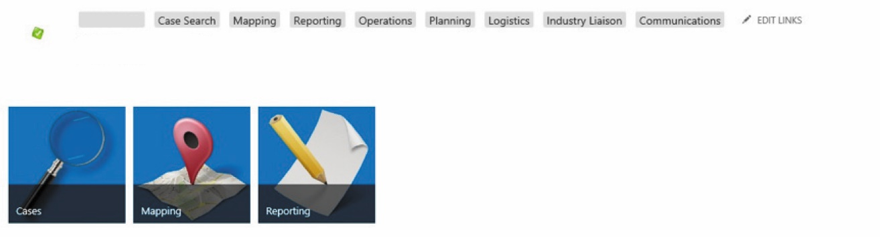

Typical MAX entry screen showing “headline” menu.

Almost everything relating to an outbreak – lab investigations, property status, on-property activities, tracing, telephone calls – can be recorded, queried and mapped. Simple mapping outputs include property status, restricted and control area overlays, livestock movement diagrams. Data exports to MS Excel are easy which enables further analysis through GIS, link/network analysis and timeline generation.
MAX was originally developed in Victoria and is now used in several Australian jurisdictions. More recent versions can also be used for storing routine passive surveillance data, meaning that MAX has become a one stop shop for all livestock-related data.

Geographic Information Systems (GIS)
While MAX has a simple map viewer built in for reporting purposes, GIS software enables more sophisticated spatial analysis. These programs allow analytical interactions between data layers so that relationships between, for example, IPs and rainfall maps, or IPs and various geographic features, can be tested. They also enable the generation of specialised maps to visualise data more easily. A number of systems are available commercially (MapInfo and ArcView are two well-known ones) and free open-source packages are also available (QGIS is a popular example).
A list of free GIS packages (including QGIS) can be found on the gisgeography website: http://gisgeography.com/free-gis-software/

Business Intelligence Software
Business intelligence packages such as Tableau and Spotfire are becoming increasingly popular. These link to both complex databases and simple spreadsheets and through a simple “drag and drop” interface are able to produce tables, graphs and simple maps with great speed.
Timeline generators
A number of software packages are able to import data from databases (sometimes via spreadsheets) and arrange the data on a timeline. Smartdraw and Smartsheet are two commercially available options. Some websites also offer free timeline templates for use within MS Excel. These make use of Excel’s inbuilt graphic capabilities.
The Preceden website claims to offer a comprehensive list of timeline makers: https://www.preceden.com/timeline-makers

Link analysis
While MAX’s NLIS Visualiser offers a simple link viewer, purists might like to try something more sophisticated that is custom built for network analysis. UCINET is one such package that is available commercially; Netdraw is available for free and is also bundled with UCINET. A list of available packages is available on the KDnuggets website (https://www.kdnuggets.com/software/social-network-analysis.html).

Useful weblinks
ABARES livestock | http://agriculture.gov.au/abares/research-topics/surveys/farm-survey-data
ABS statistics | http://abs.gov.au/ausstats/abs@.nsf/web+pages/statistics?opendocument
Animal Health Australia | http://www.animalhealthaustralia.com.au/
AUSVETPLAN manuals and documents | https://www.animalhealthaustralia.com.au/our-publications/ausvetplan-manuals-and-documents/
BoM weather observations | http://www.bom.gov.au/climate/dwo/index.shtml
Australian Government Department  of Agriculture and Water Resources (DAWR) | http://www.agriculture.gov.au/
European Commission for the Control of Foot-and-Mouth Disease (EUFMD) | http://www.fao.org/ag/againfo/commissions/eufmd/commissions/eufmd-home/en/
FAD (Foreign Animal Diseases – “The Gray Book”) | https://www.aphis.usda.gov/emergency_response/downloads/nahems/fad.pdf
FAO/EMPRES | http://www.fao.org/ag/againfo/programmes/en/empres/home.asp
FAO/EMPRES information resources | http://www.fao.org/eims/secretariat/empres/eims_search/e_publi.asp?lang=en
FAO/GEMP (Good Emergency Management Practices) | http://www.fao.org/3/a-ba0137e.pdf
Google Earth download | https://www.google.com/earth/download/gep/agree.html
Merck Veterinary Manual | http://www.merckvetmanual.com/
OIE homepage | http://www.oie.int/
OIE Disease Cards | http://www.oie.int/animal-health-in-the-world/technical-disease-cards/
OIE Terrestrial Animal Health Code | http://www.oie.int/international-standard-setting/terrestrial-code/access-online/

References
Animal Health Australia (2015) AUSVETPLAN Control Centres Management Manual Part 2: Operational centres: functions and linkages (Version 4.0). Australian Veterinary Emergency Plan (AUSVETPLAN), Edition 4, Australian Agriculture Ministers’ Forum, Canberra, ACT. Available at: http://www.animalhealthaustralia.com.au/our-publications/ausvetplan-manuals-and-documents/
Durand B & Gerbier G (2001) Transboundary Animal Diseases Simulator. FAO
Jubb, T (2006) Animal Disease Investigation. Victoria Department of Primary Industries.
Manitoba Health (2007) Communicable Disease Management Protocol Manual – Epidemiological Investigation of Outbreaks. Communicable Disease Control Unit, Manitoba Public Health, accessed June 2007 at: http://www.gov.mb.ca/health/publichealth/cdc/protocol/investigation.pdf
Mariner J & Paskin R (2000) Manual on Participatory Epidemiology. FAO.
Paskin R (1999) Manual on Livestock Disease Surveillance and Information Systems. FAO.
Salman M & McLaws,M (2012) Putting it together: The potential role of modelling to explore the impact of FMD. EuFMD

