AVIAN BOTULISM
Information kit
Feb 2014



Published by the Victorian Government, Agriculture Victoria, Melbourne,
February 2014.
© The State of Victoria Department of Agriculture Victoria, Melbourne 2014
This publication is copyright. No part may be reproduced by any process except in accordance with the
provisions of the Copyright Act 1968.
Authorised by the Victorian Government, 8 Nicholson Street, East Melbourne.
Print managed by Finsbury Green. Printed on recycled paper.
ISBN [Insert number for print and/or online]
For more information contact the DJPR Customer Service Centre 136 186
Disclaimer
This publication may be of assistance to you, but the State of Victoria and its employees do not guarantee that the
publication is without flaw of any kind or is wholly appropriate for your particular purposes and therefore disclaims all
liability for any error, loss or other consequence which may arise from you relying on any information in this publication.
Accessibility
If you would like to receive this publication in an accessible format, such as large print or audio, please telephone
136 186, or email customer.service@agriculture.vic.gov.au
Deaf, hearing impaired or speech impaired? Call us via the National Relay Service on 133 677 or visit
www.relayservice.com.au
This document is also available in PDF format on the internet at www.DJPR.vic.gov.au

Contents
Contact list ....................................................................................................................................2

Introduction…................................................................................................................................3

Background...................................................................................................................................3

Occurrence of Avian Botulism.......................................................................................4
Disease transmission......................................................................................................4

Avian Botulism Prevention............................................... ...........................................................5

Monitoring and Survelliance..........................................................................................5 Detection..........................................................................................................................6
Removal...........................................................................................................................6
Carcass Handling and disposal.....................................................................................7
Carcass Reporting .........................................................................................................7
Wetland Management ....................................................................................................7
Bird Rehabilitation .........................................................................................................7
Bird Hazing .....................................................................................................................7
Summary ........................................................................................................................8

Human and Pet Health..................................................................................................................8

Frequently Asked Questions......................................................................................................9

General Avian Botulism Information .......................................................................... 9
Human and Pet Health.............. ...................................................................................11
What Can I Do to Help? ...............................................................................................12
Sources........................................................................................................................................14

Contact list

Agency | Role & Responsibilities | Phone | Email | Website | Contact Person
Department of Jobs, Precincts and Regions (DJPR) | Manage outbreaks on land managed by DJPR  and provide technical information and support for disease investigations | +61 0418240831 | Yonatan.segal@agriculture.vic.gov.au |  | Yoni segal
PARKS VICTORIA (PV) | Manage outbreaks on land managed by PV
Environmental Protection Agency (EPA) | Disposal instructions
AGRI-BIO (DPI) | Laboratory services & Diagnosis | +61 3 9032 7275 | mark.hawes@agriculture.vic.gov.au |  | Mark Hawes
MELBOURNE WATER | Waterways within the Port Phillip and Westernport CMA Region with catchments
REGIONAL WATER AUTHORITIES | Wetlands, ponds & lakes management in regional Victoria
LOCAL COUNCILS | Manage outbreaks
Australian Wildlife Health Network (WHIS) | Collating & disseminating  information | +61 2 9978 4788 | tgrillo@zoo.nsw.gov.au | www.wildlifehealthaustralia.com.au | Tiggy Grillo
Melbourne University | Diagnosis and treatment | +61 400 119 301 | pamw@unimelb.edu.au |  | Pam Whiteley
RSPCA | Treatment & culling of sick birds
Department of Health and human services (DHS) | Technical information and support for disease investigations in human | +61 3 9096 0414 | Rachael.Poon@health.vic.gov.au |  | Rachael Poon

Introduction

This manual has been prepared by Agriculture Victoria of DJPR for the information of relevant state agencies such as, Parks Victoria and local councils. The second part of the manual was prepared for the general public and includes a selection of the most frequently asked questions (FAQ) about avian botulism. The manual is intended to generate awareness and provide information and guidance regarding avian botulism in wild birds and how to control its spread.

The following topics regarding avian botulism are included as part of this manual:

- Background: biology, occurrence, and transmission
- Outbreak prevention
- Human and pet health protection, and
- Frequently Asked Questions (FAQ).

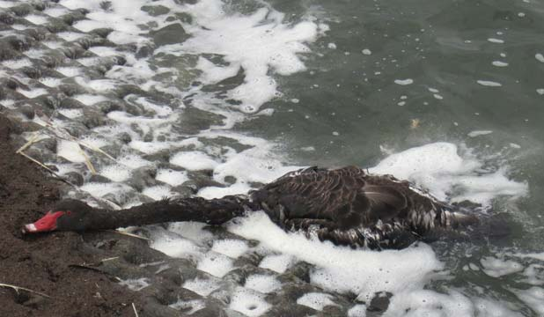
Black swan with clinical signs of “limber neck” due to Avian Botulism

Background

Avian botulism is a disease caused by several different strains of the bacterium Clostridium botulinum, which produces a toxin that acts on the neuromuscular system of animals and humans. The disease is characterised by paralysis leading to progressive muscle weakness and eventually respiratory arrest if left untreated.
Several distinct strains have been identified and types C and E, in particular,are known to affect birds and fish. While Type C has not been shown to cause illness in humans; Type E on the other hand does.

Avian botulism has been linked to mortalities within marshes and wetlands.
Dormant spores of this bacterium are naturally abundant in soils and fresh-water body sediments, but are not always in the vegetative state, capable of producing the toxin.

These spores are not only found in soil and sediments of water bodies but can also be found in the intestinal tracts of live, healthy animals.

The spores are resistant to extreme temperatures and desiccation and are therefore capable of surviving in the ecosystem for long periods of time (Domske 2003).

The botulinum toxin is produced only when spores germinate, and the bacterium enters the vegetative growth stage. This change requires certain conditions, including an oxygen-deprived environment containing a suitable nutrient source such as decaying plant or animal material, and when favourable, warm temperatures and higher pH levels occur (Brand et al.1988).

Once these factors lead to production of the botulinum toxin, it can enter the food chain. Animals, especially wild birds, can contract avian botulism when they prey on other animals that harbor the toxin such as sick or dead fish and birds or consume infected maggots derived from dead animals (CCWHC 2007).

Effects of toxin poisoning include paralysis, which often leads to death. Death can also result from secondary water deprivation, electrolyte imbalance, respiratory failure, or predation due to paralysis.

Quick removal of dead birds (potential vectors) is important in dealing with an avian botulism outbreak.

Opportunity for rehabilitation of sick birds is limited, but it may be possible when the birds do not ingest an acute dose of the toxin and when electrolytes are administered immediately; however, even under these circumstances, rehabilitation is frequently unsuccessful.

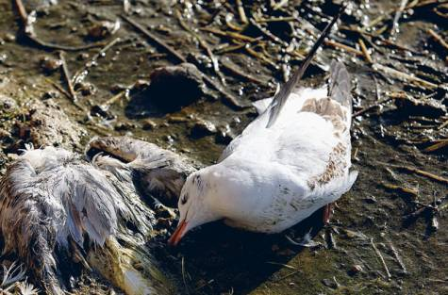
Dead and paralysed seagulls resulting from Avian Botulism

History: Occurrence of Avian Botulism in Victoria

The frequency and severity of Avian Botulism outbreaks have gone through cycles over the last several decades, annual die-offs of birds and fish on the shores of Victorian wetlands, lakes and ponds have been observed with certain regularity.
Recent increases and expansion of the affected areas and species involved, have led to concern for the ecological health of the Victorian wildlife.

Over the past few years, Avian Botulism outbreaks Have been particularly severe in wet-lands and lakes around Melbourne.

Disease Transmission

There are a few potential pathways for Avian Botulism transmission. The carcass-maggot cycle is one possible route. Dead fish and birds that wash up on the beaches of ocean wetlands, lakes and ponds can become sources for C. botulinum growth, and shorebirds may ingest the toxins as they feed on maggots and carrion beetles within the decaying carcasses. Several thousand toxic maggots can be produced from a single waterfowl carcass. Consumption of as few as two to four toxic maggots can kill a bird and further perpetuate the cycle.
Waterfowl and other birds are known to feed on maggots, which is consistent with common observations of recently dead birds very close to an older carcass full of maggots.

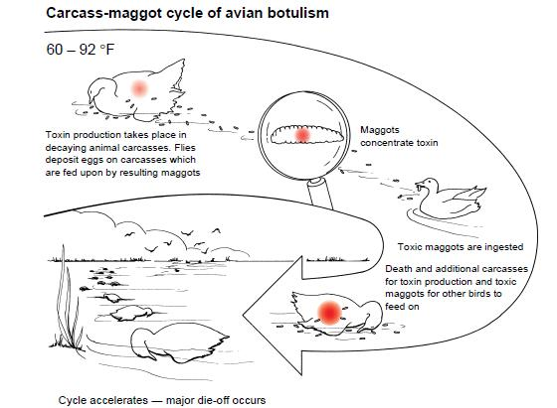

Carcass-maggot cycle of Avian Botulism (USGS 1999)

Other species may also play a key role in the transmission of Avian Botulism.
Current hypotheses under study are whether certain mussel beds may create additional habitat for C. botulinum and accumulate the toxin. The mussels may then facilitate the transport of the toxin up the food chain as they are consumed by fish, especially those species which feeds heavily on mussels (Getchell and Bowser 2006). The fish, after ingesting toxin-laden food, are in turn consumed by larger predatory fish and fish- eating water birds. Obvious signs of such a near-shore outbreak are numerous stretches of beach with dead and dying birds and fish strewn along the water’s edge.

The prolific growth of certain algae is also believed to contribute to Avian Botulism outbreak because the decaying large mats of sloughed algae in the near shore area may lead to pockets with low oxygen and a rich growth nutrient medium. This creates an ideal environment for the vegetative state of C. botulinum and resultant toxin production (Hecky et al. 2004).

The ecological pathway of Avian Botulism might be closely related to impacts from a host of invasive species. The exact mechanism that transports it through the food chain has not been scientifically documented nor is it fully understood.

Prevention of Avian Botulism

Although we don’t know all the environmental triggers that cause C. botulinum to start producing toxin, we do know that if mortalities are detected early enough, certain management techniques, if implemented quickly, could possibly stop and/or mitigate the magnitude of wild-birds mortality. These measures include monitoring, detection, carcass reporting, removal of sick birds and carcasses, carcass disposal, wetland management, bird rehabilitation and bird hazing, as discussed below.

Monitoring and surveillance

Monitoring and surveillance of areas can often be the first line of defence against Avian Botulism outbreaks, because many outbreaks can occur in the same areas year after year. Outbreaks also often follow a consistent and predictable warm weather conditions and time frame. These conditions have direct management implications that should be applied toward minimizing losses. Specific actions that should be taken include accurately documenting conditions and dates of outbreaks in problem areas, planning for and implementing intensified surveillance, and then choosing the best management options during the Avian Botulism outbreak.

“Season” surveillance and carcass pickup should be implemented 10-15 days prior to the earliest documented case of the season in a known Avian Botulism area, and 10-15 days after the end of the Avian Botulism season in a known area.

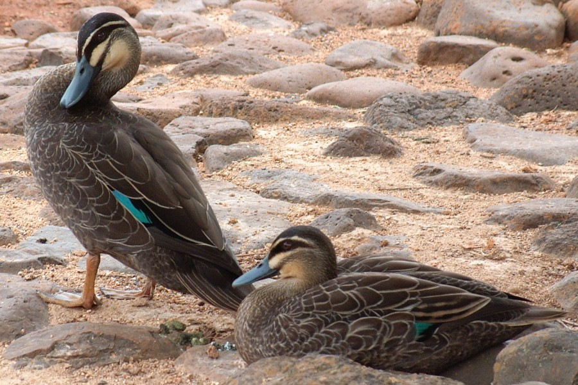

Detection and diagnosis

Outbreaks generally occur in Victoria from November through to April. Numerous birds may die during a single outbreak. No lesions are specifically associated with this disease; however, some visual signs of Avian Botulism infection are typically evident.
Affected birds often have trouble holding up their heads, a condition known as “limber neck” which can lead to drowning. They may also exhibit an inability to fly and/or walk or may appear emaciated if they have been poisoned over an extended period of time. Birds that have lost the power of flight and use of their legs often attempt escape by propelling themselves across the water. Another common sign in intoxicated birds is paralysis of the inner eyelid. Dead birds often appear in good body condition because Avian Botulism toxin generally kills rapidly after intoxication.
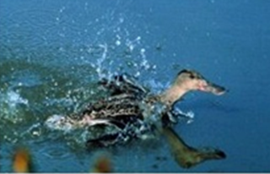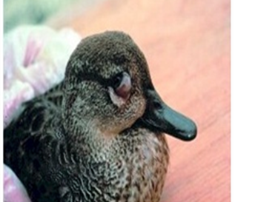
Bird that have lost the power to fly or use the Paralysis of the inner eyelid legs, attempt to escape by using the wings

Photos by Milton Friend

Affected fish lose their equilibrium and may be found floating or swimming erratically near the surface. This behaviour may attract birds to prey upon these fish, further spreading Botulism.

Diagnosis of Avian Botulism requires animal testing and is based on evidence of the toxin in the blood serum or in tissue samples of dead birds, such as from the heart or liver. The heart from a carcass suspected of Avian Botulism intoxication is preferred for testing because this organ contains a significant amount of blood.

Removal of Dead Birds & Fish

Prompt removal and proper disposal of fish and bird carcasses by deep burial (75 cm) or burning (in accordance with applicable EPA regulations) is highly effective in removing toxin and maggot sources from the environment.
C. botulinum needs protein to produce the botulinum toxin. Removal and disposal of animal carcasses remove this protein source and thus reduce the resources the bacterium needs to produce the toxin and further the spread of the disease. Because birds affected by avian botulism often hide in vegetation, thorough carcass retrieval is critical. A single carcass left in the water or on the beach could significantly prolong an outbreak.

Carcass Handling & Disposal

For the procedures of proper disposal of bird or fish carcasses suspected of being affected by Avian Botulism, one should contact the DJPR or EPA immediately upon discovery of a carcass for further direction regarding safe disposal. A
A contact list is included with this document.

The following tips are suggested for handling bird or fish carcasses:
- Carcasses should not be handled with bare hands.
- Wear rubber, plastic or disposable gloves or use a garbage bag over your hands.
- Carcasses should be placed in garbage bags; double bagging may be necessary.
- Once the handling of carcasses is finished, dispose of gloves in a bag and place them in the rubbish. Remember to thoroughly wash hands with soap after handling carcasses.
- If off-site disposal is not possible, and carcasses are being buried, ensure this is done away from the shoreline, remove them from the garbage bag(s), and bury them at least 75 cm deep. Burying them to this depth will discourage other animals from unearthing them.
- Burning / incineration of Avian Botulism infected carcases is considered the safest method of disposal.
- Do not compost carcasses of suspected Avian Botulism intoxication.

* Inspect carcasses for leg bands and other devices (e.g. radio-transmitters) and report marked birds to The Australian Wildlife Health Network (AWHN).

Clean up kits can be created with the following items:
- Plastic garbage bags
- Latex gloves
- Duct tape
- Paper and pencil to record—what died, how many, where, and when
- List of contacts for carcass reporting

Carcass Reporting

Persons that encounter a live animal suspected of Avian Botulism intoxication should immediately contact the landowner or custodian, for example DJPR, Parks Victoria or local council. A complete contact list is provided as part of this manual.

Wet Land Management

Draining or flooding wetland areas where an Avian Botulism outbreak has recently occurred can change the environmental conditions sufficiently to stop production of toxin by C. botulinum. However, one should use caution when employing this method, and avoid altering water depth during hot weather. This may increase invertebrate and fish die-offs, providing another protein source for the bacteria and prolonging an outbreak.

Bird Rehabilitation

Providing mildly affected birds with fresh water, shade, and protection from predators may help them recover from the intoxication. Under special circumstances, such as for the treatment of endangered birds, Avian Botulism antitoxin may be available, but its use requires veterinary training and must be administered soon after intoxication. Birds that survive an Avian Botulism outbreak are not immune to the Avian Botulism toxin during subsequent outbreaks.

Bird Hazing

If other management techniques fail, hazing birds away from a hot spot until toxin production stops may be an option. This action should be taken in consultation with
DJPR or Parks Victoria to avoid violation of the Wildlife Act 1975.This is important when endangered birds are known to be present in the affected area. In some areas, wetland impoundments can be constructed to facilitate rapid and complete drainage to encourage bird movement to alternate areas.

Summary

The numerous fish and wildlife mortalities caused by Avian Botulism across a widening geographic region are a continuing cause for concern and highlight the need for Avian Botulism management plan. Avian Botulism is affecting native and sensitive wildlife populations, and it has implications for the overall ecological health of Victoria. It may also impact tourism and the enjoyment of the many visitors to local beaches, ponds, and lakes. Taking action to prevent Avian Botulism outbreak is an important way to reduce these impacts.

Human and Pet Health
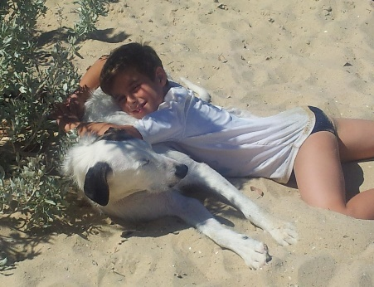

Botulism in humans is usually the result of eating improperly home-canned foods and is most often caused by Type A or Type B botulinum toxin.
Type C has not been shown to cause illness in humans; while Type E on the other hand does, although it has been extremely rare.

Recent laboratory-based studies investigating the effect of botulism on fish and resulting toxin levels in their organs and tissues have further supported the assumption that Type C and E Botulism associated with wildlife poses minimal human health risks (Yule et al. 2006). However, additional laboratory and field research and definitive Department of Health statements regarding consumption of sport fish and waterfowl during an outbreak would help ensure delivery of a cohesive message to the public about their safety.

Most available safety-related information includes general food handling and preparation guidelines by federal and state agencies or refers to cases in which specific fish curing and preparation methods led to production of the toxin under conditions of non-environmental outbreak.

Botulinum toxins can be inactivated by heat during cooking, if cooked at the right internal temperature of at least 90°C and for the minimum length of time of 6 minutes.
Applying common safety precautions when handling fish or waterfowl and following correct food preparation guidelines will help ensure maximum protection from the botulinum toxins.
Consider the following general precautions to protect human and pet health:
- Do not handle dead birds or fish with your bare hands. Always wear rubber, plastic, or disposable gloves.
- Hunting and fishing activities should be avoided in areas during a botulism outbreak or where an outbreak has occurred in the previous month.
- Beware of fish that are floating—if they are not fighting, they are likely not to be healthy and should not be consumed.
- Hunters should never harvest birds that appear to be sick or are dying, and never consume if any portion of the game looks or smells bad.
- Remove and discard intestines soon after harvesting and avoid direct contact with the intestinal contents.
- Keep harvested waterfowl cool (either with ice or refrigerated) below 7.5°C until butchered, then refrigerate or freeze.
- Do not eat undercooked or improperly prepared fish or waterfowl.
- Do not let pets eat sick or dead birds or fish.

Frequently Asked Questions (FAQ)

General Avian Botulism Information

This part of the manual was compiled by the Agriculture Victoria of DJPR to answer questions that might arise by the public when an Avian Botulism outbreak occurs, affecting the wild bird population and the ecological system.

This information is provided so that hunters, recreational anglers, coastal residents, and interested citizens can take simple, common sense precautions to reduce or eliminate any risk from handling or consuming waterfowl or fish that have been exposed to Botulinum toxin.
One should keep in mind that the threat to human health from botulinum toxins of types C and E is minimal.

What is Avian Botulism?

Avian Botulism is a serious neuromuscular illness caused by a toxin that is produced by the bacterium Clostridium botulinum. Avian Botulism has been recognised as a major cause of mortality in wild birds since the 1900s. The first outbreak in Australia occurred in 1938.

Humans can become sick from botulism typically by eating improperly canned or stored foods. The bacterium is classified into seven types (A-G) according to the neurotoxins that are produced. Four of these types (A, B, E, and rarely F) cause human Botulism, while types C, D, and E cause illness in mammals, birds, and fish.
All types of Botulism may cause paralysis to some degree, due to the nature of the neurotoxins produced by the bacteria. The following are the four most common types of Botulism:
Type A or Type B Botulism is most commonly caused by consumption of bacteria in improperly home-canned foods
Diluted and purified forms of the type A and B toxins are also used in certain facial aesthetic products (Botox therapy).
Type C and Type E Botulism are responsible for extensive waterfowl and some fish kills. They are both brought on by consumption of these types of the botulinum toxins through food-web interactions. Type C Avian Botulism mostly impacts waterfowl (especially ducks gulls, and other shorebirds) and is typically restricted to marshes and wetlands.
Type E Botulism is more prevalent in wetlands, lakes, and pond areas, affecting many susceptible bird and fish species, as are some amphibians, like mudpuppies and most mammals. Type E botulism might also affect humans.

Where does Botulism come from?

Botulism spores (the resting stage of the bacteria) are abundant in anaerobic habitats (lack in oxygen), such as soils, and aquatic sediments of many wetlands and lakes, and can be readily found in the gills and digestive tracts of healthy fish living in those lakes. The spores can remain in the ecosystem for extended periods of time, even years, and are quite resistant to temperature changes and drying. These spores, themselves, are harmless until the correct environmental factors and anaerobic conditions prompt them to germinate and begin the vegetative growth of the toxin-producing bacterial cells. The active bacteria that cause Avian Botulism grow only in a nutrient-rich substrate, such as in areas with large amounts of decaying plant or animal materials, which are also anaerobic. Fish that die for any reason and that contain the bacterial spores in their tissues are also suitable substrates for growth and toxin production by the bacteria (Leighton 2000).

How do birds end up dying because of the Avian Botulism toxin?

Fish-eating birds that die of Type E Botulism are poisoned by eating fish that contain the toxin. However, it is not clear exactly how this happens.
Birds such as loons and mergansers normally capture and eat only live fish. Yet, Clostridium botulinum Type E should not grow and produce the actual toxin in living fish (Leighton 2000).
Possibly, circumstances can cause toxin production in the tissues and digestive tracts of live, perhaps of dying fish.
Alternatively, it may be that the fish captured alive and eaten by the birds had themselves fed on a source of Type E toxin. In these cases, the toxin in the digestive tracts of the live fish would be the source of toxin for the birds through a secondary intoxication (Leighton 2000).

It is also possible that the live fish captured by the birds already were partially paralysed by the Type E toxin and were therefore particularly easy prey for the birds. This might account for preferential feeding on toxin-containing fish by the affected
birds (Leighton 2000). Ingestion of maggots from the carcass of an infected animal can continue the spread of Avian Botulism, which may be responsible for large kills of shorebirds.

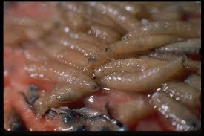

Why are we so concerned about Avian Botulism outbreaks?

Natural resource managers, environmental organisations, and others are concerned about the numerous native and migrating birds that have died, including Pelicans, Sacred Ibises, and other bird species. Additionally, dead wildlife may contain toxin levels that once consumed could harm other animals, including pets.

Has Avian Botulism always been in the Victorian wetlands, lakes, and ponds?

Different types of Botulism have had destructive effects on wild bird population throughout Australia for a considerable time, and probably predate written records. One of the earliest major reported die-offs of many waterfowls linked to Avian Botulism was encountered in Victoria in 1938.
Over the last decades significant die-offs of birds and fish have occurred regularly in Victorian wetlands, lakes, and ponds.

Why are Avian Botulism outbreaks occurring now?

Scientists believe that outbreaks of Avian Botulism happen only when a variety of ecological factors occur concurrently, such as warmer water temperatures, anoxic (oxygen-deprived) conditions, and adequate levels of bacterial substrate in the form of decaying plants, algae, or animal materials. As average air and water temperatures have risen on a global scale, warmer temperatures and anoxic conditions have been occurring more frequently on the Victorian wetlands, lakes, and ponds, possibly resulting in the increase of Avian Botulism (Lafrancois et al. 2010).
Once these factors lead to production of the toxin in food material eaten by fish, the toxin can be passed up the food chain as wild birds consume the contaminated fish or eat maggots from the decaying carcasses of infected individuals (Leighton 2000).

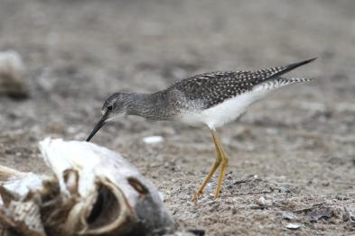

Is there a link between Avian Botulism outbreaks and fluctuating water levels?

There is some evidence that outbreaks correspond to low water level events. Historically, larger bird die-offs because of Type E Botulism have occurred during periods of low or rapidly declining water levels. Water level fluctuations and draw down events in wetlands have also correlated with Type C Avian Botulism outbreaks. Research into the mechanism behind this possible link is required, but the mechanism likely is related to warmer water and sediment temperatures during low water events.

What are some symptoms that an animal with Avian Botulism may display?

Type E Botulism often results in paralysis; therefore, infected species begin to exhibit unusual behaviour. Water birds may not be able to hold their head up and as a result, often drown. Gulls can often walk, but not fly. Other birds may drag one or both wings, exhibiting poor posture while standing.

Once infected with Type E Botulism, fish may flounder or swim erratically near the surface of the water. Their equilibrium may be affected, and they may have trouble staying right-side up. “Breaching” may also occur, during which a fish will float with its head near the surface and tail end lowered below. Infected fish usually die quickly and are most likely to be seen washed up on shore.

Note:
Any fish or waterfowl that seem sick should not be harvested or eaten.

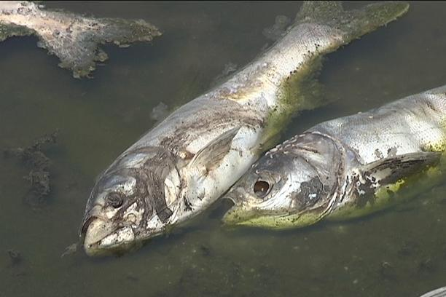

Why is it difficult for scientists to positively determine if birds died from Avian Botulism?

Both type C and type E Botulism, as well as a few other types of poisoning, can produce similar symptoms in affected wildlife. Definitive diagnosis of Avian Botulism requires that the botulinum toxin be found in the blood of a live, sick bird.
Currently only the ….lab in Queensland can identify botulinum toxins. Although finding the toxin in a recently dead bird may be evidence that the bird died of Avian Botulism, it is also possible that the toxin detected was produced after death, during putrefaction, and may not have been the cause of the bird’s death (Leighton, 2000).

Do the algal blooms play any role in the Avian Botulism outbreaks?

The recent increases in the growth of algae blooms in Victorian wetlands, lakes and ponds ultimately result in increased decaying plant matter. This decomposition can create an oxygen-deprived environment suitable to the bacterium that produces the Botulism toxin.

Are inland lakes and ponds susceptible to Avian Botulism outbreaks?

Scientists believe that the threat of Avian Botulism outbreak transfer between near ocean wetlands and lakes to inland lakes and ponds is minimal because the disease itself is not transferable.
The likelihood of an infected, sick animal getting from the near ocean wetlands and lakes to an inland lake and ponds is small because it would probably be too incapacitated by the toxin to travel.

Furthermore, the Avian Botulism spores already existing everywhere, including the gut of healthy birds and the most likely way an outbreak will occur in a new location is if the optimal environmental conditions exist that allow the bacteria to enter a vegetative state and produce the toxin.

Human and Pet Health

Is it safe to eat fish or waterfowl?

When fishing or hunting, don’t fish or hunt in a wetland or lake during a botulism outbreak or where botulism has occurred in the previous month. You should always harvest only fish and waterfowl that act and look healthy. Don’t take any fish or game that show signs of illness or smells bad, and you should always follow good sanitary practices when preparing them. It is especially important to remove and discard intestines soon after harvesting and avoid direct contact with the intestinal contents, wearing rubber or plastic gloves is highly recommended to ensure maximum safety.
The harvested fish or waterfowl should be kept cool (either with ice or refrigerated) below 7.5°C until butchered, then refrigerated or freeze.
One should never eat undercooked or improperly prepared fish or waterfowl. Cooking at the right internal temperature of at least 90°C, for the minimum length of time of 6 minutes, will ensure inactivation of botulinum toxins.
Making the meat into jerky or smoked is not recommended, as it does not go through the proper heat cycle.

Can I get Avian Botulism?

Botulism in humans is usually caused by consumption of improperly home canned foods and is most often a result of the Type A or Type B botulinum toxin.
Only few cases of Type C and E Botulism in humans have been reported in North America as the result of eating improperly smoked or cooked fish, but these cases are very rare (Leighton, 2000).
Thorough cooking is necessary to destroy the bacteria and bacterial toxins.

As a precaution, any fish or waterfowl that are sick or act abnormally should not be harvested or eaten because cooking, when has not been properly done (minimum internal temperature of 90°C for 6 minutes) may not destroy the botulinum toxin. More information on Botulism from a human health and food safety standpoint can be obtained through the Department of Health (DoH).

Can I swim in the water?

You are at minimal risk for Avian Botulism poisoning by swimming in Victorian lakes waters. Avian Botulism is contracted only by ingesting fish or birds contaminated with the toxin. Although there is a remote possibility you might get poisoned by ingestion of infected maggots, present in the water. If you have concerns about water quality, you should contact Melbourne or Victoria waters or your local health department. At
Remember that beaches and lakes sometimes close for other reasons such as faecal contamination (e.g., Salmonella contamination). More information regarding beach/lake advisories can be found through the EPA website.

Is it safe to walk dogs on the beach after a bird kill?

If you bring pets to the shore, keep them away from dead animals on the beach.

Will my dog get sick if it eats a dead bird?

Dead wildlife may contain potentially harmful bacteria or toxins. You should not bring your pet to the shore during botulism outbreak. If you think your pet may have ingested a contaminated carcass or maggots, monitor it for signs of sickness, and contact a veterinarian if you suspect your pet is falling ill.

Botulism type C and E can potentially cause illness in hunting dogs used to retrieve game. Caution should be used and again, avoiding areas with sick birds and stagnant water, fish kill, etc.

Do I have to wash my hands after I touch a dead bird?

Yes, you should always wash your hands with soap after handling any wildlife. Ideally, you should also wear rubber or plastic protective gloves to handle any dead animal.

What steps should I take when preparing healthy fish or birds for consumption to ensure maximum safety?

- Wear rubber or plastic protective gloves while filleting, field dressing, skinning, or butchering.
- Remove the intestines of birds soon after harvest; don’t eat the intestines and avoid direct contact with intestinal contents.
- Keep harvested waterfowl cool (either with ice or refrigerated) below 7.5°C until butchered, then refrigerate or freeze.
- Fish should be filleted soon after harvest and contact with any gut material should be avoided.
- Hands, utensils, and work surfaces should be washed before and after handling any raw food, including fish and game meat.
- Remember that proper and thorough cooking to internal temperature of 90°C for 6 minutes is necessary to inactivate botulinum toxin and destroy disease causing organisms that occur naturally or that can be introduced during handling, storage, or preparation.
- Making the meat into jerky or smoked is not recommended, as it does not go through the proper heat cycle.

What Can I Do to Help?

What steps I can take to help stop the spread of Avian Botulism?

Identifying possible cases of avian Botulism at the early stages is the key to effective control.
Public education and awareness of the conditions that lead to Avian Botulism and prompt corrective action can greatly reduce the epidemics that claim wild birds each year. Hunter education of the presence of disease outbreak at given sites and educating them on botulism is recommended.
Sick and dead birds in areas of Avian Botulism epidemics should be reported immediately to DSE, Park Victoria or the local council. Contacting your local education and outreach organization may also aid in its efforts to track outbreaks, and it can provide you with answers to additional questions.

Immediate removal of dead birds and fish can also help prevent the spread of Botulism, as the bacteria in the carcasses can serve as the source of outbreaks for months. One should follow the appropriate safe disposal methods.

How should I notify authorities of a potential Avian Botulism-related fish or bird kill?

In case of a die-off, individuals are urged to contact the state authorities such as DJPR, Park Victoria and EPA, responsible for fish and wildlife health and management or the local council to report fish and bird mortalities (Refer to page ii for specific contact information).
It is important to record the location, type of birds or fish, and number of carcasses found.
By reporting accurate information about Botulism, you will assist natural resources managers and others involved in wildlife conservation planning.

How can people who want to help clean up after a bird kill best protect themselves?

People who handle dead wildlife should wear protective gear, such as disposable rubber or plastic gloves or an inverted plastic bag over their hands. If a diseased or dead bird is handled without gloves, hands should be thoroughly washed immediately thereafter with hot, soapy water or an anti-bacterial cleaner.

What is the best way to dispose of dead fish or birds in my area, especially after a Botulism outbreak?

Be sure to follow EPA or DJPR recommendations in handling dead fish and wildlife. Wear disposable, rubber or plastic gloves or invert a plastic bag over your hands when handling sick, dead, or dying fish, birds, or other animals. In certain areas, deep burial (75 cm) of the carcasses is allowed, while in other areas incineration may be recommended. One should contact EPA and follow their instructions regarding dead bird disposal.
If dead birds or fish are to be collected, they should be placed in heavy plastic bags to avoid the spread of Avian Botulism-containing maggots.
The major goal should be to protect yourself, while also ensuring that the dead birds or fish are not available for consumption by other wildlife or pets.

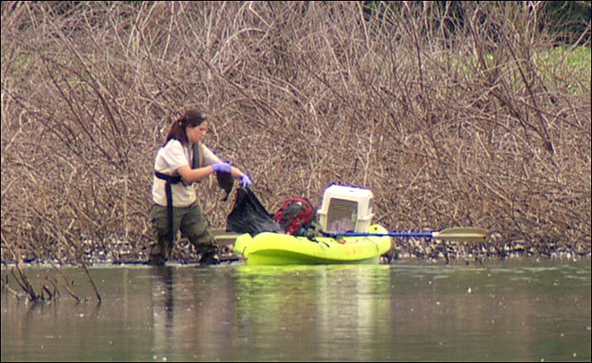

Is rehabilitation of sick birds possible? If so, how, and who should I contact about it?

Sick birds should always be examined and treated by a veterinarian or certified wildlife carer. Rehabilitation is unusual but may be possible if birds did not ingest a large amount of the toxin. Recovery can be aided by providing these birds with rest, fresh water, and shade. They should be protected from predators during this process.
Under special circumstances, such as for the treatment of endangered species, a Botulism antitoxin is available, but it requires special handling and must be administered early on.
Surviving an outbreak will not provide birds with immunity to Avian Botulism.

Please remember that extreme caution should be practiced when handling wildlife. Contact the local office of Parks Victoria, Agriculture Victoria of DJPR for more information about rehabilitation possibilities. (Refer to page ii for specific contact information).

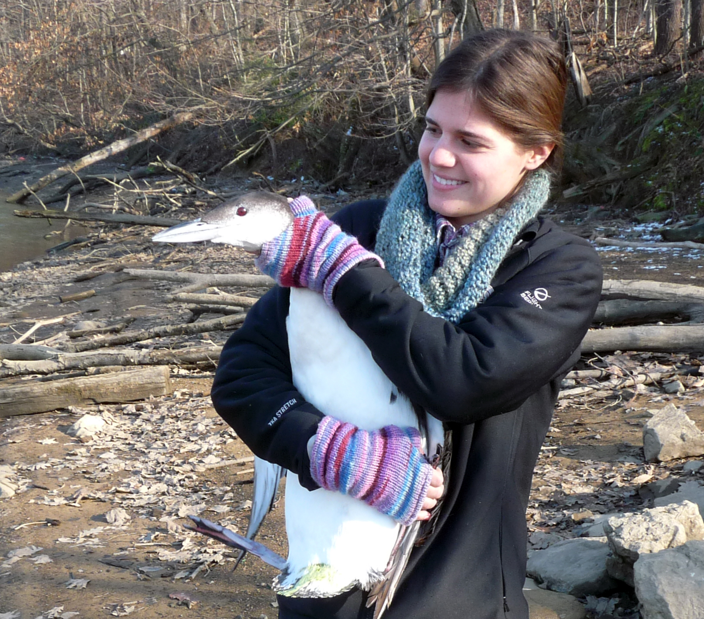

Sources

Brand, C.J., Schmitt, S.M., Duncan, R.M., and Cooley, T.M. 1988. An outbreak of Type E Avian Botulism among common loons (Gavia immer) in Michigan’s Upper Peninsula. Journal of Wildlife Diseases 24(3): 471-476.

http://www.ccwhc.ca/wildlife_health_topics/Avian Botulism/Avian Botulismc.php (accessed September 13, 2011

Canadian Cooperative Wildlife Health Centre (CCWHC). 2000 (updated). Type C Avian Botulism in Birds. March).

CCWHC. 2007. “Type E Avian Botulism in Birds.” October, 2007.
http://www.ccwhc.ca/wildlife_health_topics/Avian Botulism/Avian Botulisme_org.php (accessed January 2008).

Domske, H. 2003. Avian Botulism in Lakes Erie 2003 Workshop Proceedings. New York Sea Grant, Ohio Sea Grant and Pennsylvania Sea Grant. http://seagrant.psu.edu/publications/proceedings/Avian Botulism(2003).pdf.

Fay, L.D. 1966. Type E Avian Botulism in Great Lakes water-birds. Michigan Department of Conservation, Research and Development Report No. 54. March 3, 1966. Rose Lake Wildlife Research Center, East Lansing, MI.
Presented at the 31st North American Wildlife and Natural Resources Conference, March 14, 1966.

Getchell, R.G., and Bowser, P.R. 2006. Ecology of Type E Avian Botulism within Dreissenid Mussel Beds. Aquatic Invaders 17(2): 1-8.

Hecky, R.E., Smith, R.E.H., Barton, D.R., Guildford, S.J., Taylor, W.D., Charlton, M.N., and Howell, T. 2004. The near shore phosphorus shunt: a consequence of ecosystem engineering by dreisseneids in the Laurentian Great Lakes. Canadian Journal of Fisheries and Aquatic Sciences 61(7):2185-1293.

Kaufmann, O.W. and L.D. Fay. 1964. “Clostridium botulinum type E toxin in tissues of dead loons and gulls.” Michigan State University Agricultural Experiment Station Quarterly Bulletin. 7(2):236-242.

Leighton, F.A. 2000. Wildlife Health Topics, “Avian Botulism.” Canadian Cooperative Wildlife Health Centre
(CCWHC). March. http://www.ccwhc.ca/wildlife_health_topics/Avian Botulism/Avian Botulism.php (accessed
September 13, 2011).

Lafrancois, B.M., Riley, S.C., Blehert, D.S., and Ballmann, A.E. 2011. Links between type E Avian Botulism outbreaks, lake levels, and surface water temperatures in Lake Michigan, 1963-2008. J. Great Lakes Res., 37:86-91.

Michigan Department of Natural Resources. 2011a. Michigan Wildlife Disease Manual, “Avian Botulism.” http:// www.michigan.gov/dnr/0,1607,7-153-10370_12150_12220-26493--,00.html (accessed September 13, 2011).

Michigan Department of Natural Resources. 2011b. “Information about Type E Avian Botulism in Michigan’s Wildlife: Collection and Disposal of Carcasses.” http://www.michigan.gov/dnr/0,1607,7-153-10370_12150- 93515--,00.html (accessed September 14, 2011).

Michigan Sea Grant. 2007. Personal communication regarding Sleeping Bear Dunes mortality estimates (supplied by Ken Hyde, Sleeping Bear Dunes National Lakeshore). March 1. http://www.nps.gov/slbe/.

Michigan Sea Grant. 2009 (updated). Avian Avian Botulism. January 29. http://www.miseagrant.umich.edu/explore/coastal-habitat/avian-Avian Botulism.html (accessed September 13, 2011).

New York, Pennsylvania and Ohio Sea Grant. 2006. Avian Botulism in Lakes Erie and Ontario. November 30. http:// www.seagrant.sunysb.edu/Avian Botulism/ (accessed September 13, 2011).

New York State Department of Environmental Conservation. No date. Type E Avian Botulism in Lakes Erie and
Ontario – Q & A, http://www.dec.ny.gov/animals/28433.html (accessed September 13, 2011).

Pennsylvania Sea Grant and Penn State Erie. 2003. Avian Botulism Factsheet: http://www.pserie.psu.edu/seagrant/ publications/fs/Avian Botulism_12-2003.pdf.

U.S. Geological Survey (USGS). 1999. “Avian Avian Botulism,” In Field Manual of Wildlife Diseases: General Field Procedures and Diseases of Birds, pp. 271-282. http://www.nwhc.usgs.gov/publications/field_manual/chapter_38.pdf (accessed November 2009).

USGS – National Wildlife Health Center. 2006. Disease Information, “Avian Avian Botulism.” November 7. http://www.nwhc.usgs.gov/disease_information/avian_Avian Botulism/index.jsp (accessed December 2006).

USGS – National Wildlife Health Center. 2007. “Avian Avian Botulism.” In Disease Information. http://www.nwhc. usgs.gov/disease_information/avian_Avian Botulism/index.jsp (accessed November 2009).

USGS – National Wildlife Health Center. 2008. Mortality figures from internal databases. Estimate totals.

Yule, A.M., Austin, J.W., Barker, I., Cadieux, B., and Moccia, R.D. 2006. Persistence of Clostridium botulinum Neurotoxin Type E in Tissues from Selected Freshwater Fish Species: Implications to Public Health. Journal of Food Protection 69(5): 1164-1167.

Zuccarino-Crowe, C. 2009. “Type E Avian Botulism.” In Nearshore Areas of the Great Lakes 2009, pp. 99-103, USEPA and Environment Canada. EPA 905-A-09-013. Cat No. En 164-19/2009E. http: //www.scribd.com/ doc/19817297/nearshore-areas-of-the-Great-Lakes-2009 (accessed September 10, 2011).

WWW.Agriculture.vic.gov.au

