Foot-and-Mouth Disease Pocket Guide – Domestic and Feral Pigs
Developed by Agriculture Victoria with endorsement from Animal Health Australia
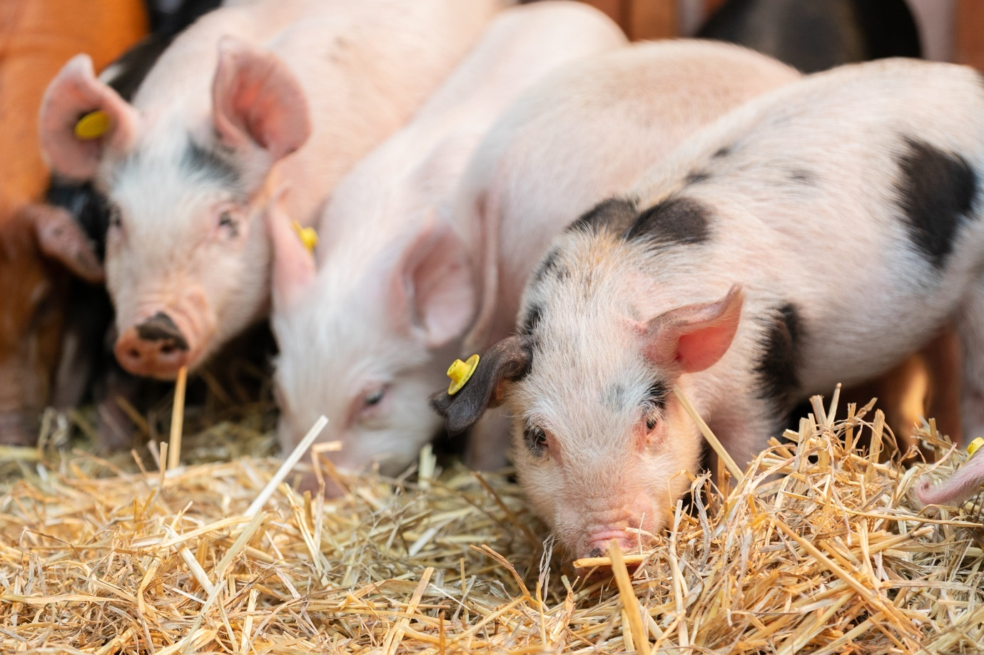

Acknowledgements
Agriculture Victoria would like to acknowledge USDA‑APHIS for providing the original publication for this pocket guide.
This pocket guide was developed to enhance vesicular disease surveillance in pigs through cooperative agreement Q09‑9119‑1270 from USDA‑APHIS. The cooperative effort included contributions from the Animal and Plant Health Inspection Service (APHIS), the American Association of Swine Veterinarians, National Pork Board, and the Center for Food Security and Public Health at Iowa State University.
ISBN 978‑1‑76136‑220‑0 (pdf/online/MS word) Published June 2023
The content of this publication is provided for information purposes only. While every effort has been made to ensure the currency, accuracy or completeness of the content no claim is made as to the accuracy or currency of the content on this publication or as to whether it is appropriate for your particular purposes. The State of Victoria disclaims all liability for any error, loss or other consequence which may arise from you relying on any information in this publication. We endeavour to keep the content relevant and up to date and reserve the right to make changes as required.
Credit for images goes to the Visual Information Services at the Plum Island Disease Center (PIADC).

Procedures to follow if you suspect an Emergency Animal Disease (EAD)
Foot-and-mouth disease is a notifiable exotic disease
Domestic and feral pigs with FMD may display vesicles, erosions or ulcerations on the mouth (snout, muzzle, tongue, dental pad, gum, cheek, hard palate, soft palate); and vesicles, erosions, ulcerations or sloughing of digital horn on at least one foot.
Even though the lesions shown here are characteristic of FMD, the first visible sign may be as simple as a lame pig.

Report any unusual signs or suspected cases of emergency animal disease immediately.
EMERGENCY ANIMAL DISEASE HOTLINE 1800 675 888
The EAD hotline is available 24 hours a day, seven days a week.
Download the Notify Now smartphone app to alert Agriculture Victoria to notifiable diseases in any animal species.

Early reporting increases the chance of effective control and eradication. If you suspect an emergency animal disease or have seen something unusual – report it! When you make a call to the EAD hotline an on‑duty animal health expert will take your call and discuss the symptoms with you.
If they determine that the condition you are describing warrants further investigation they will organise it. This may include taking some samples for testing and discussion of the next steps.

You may be asked to provide the following information to assist with an EAD investigation:
- Contact details for the property, owner or farm manager and Property Identification Code (PIC) number
- Location of animals (address point, GPS, etc)
- What clinical signs do the animals have?
- Number of animals affected and the total number of animals on the property
- History of the animals, for example, recent travel, vaccinations, treatments

Methodology
This set of photos was taken by the personnel at Plum Island Animal Disease Center. Infected animals were inoculated with foot‑and‑mouth disease (FMD) virus strain A24 Cruzeiro.
The pigs depicted in the following photographs were allowed contact with infected animals 48 hours post‑inoculation and remained with the inoculated animals for the duration.
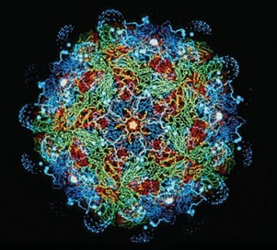
Photo credit: Dr. Fred Brown

Day 1 Domestic Pig
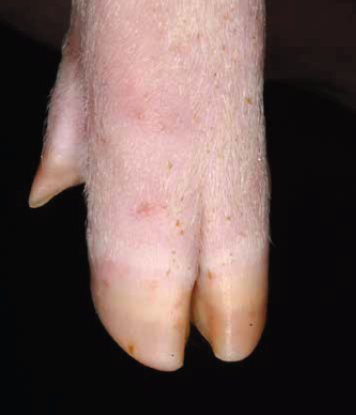No visible lesions.
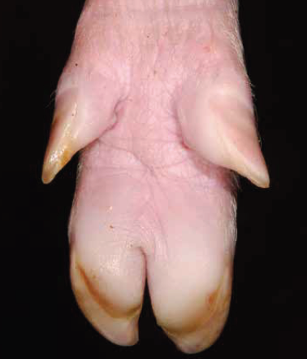Blanched swollen hoof pads.
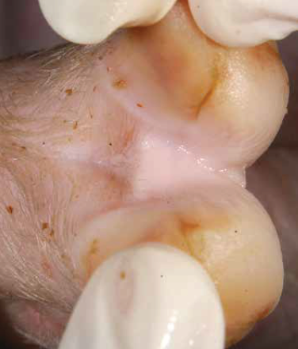No visible lesions.
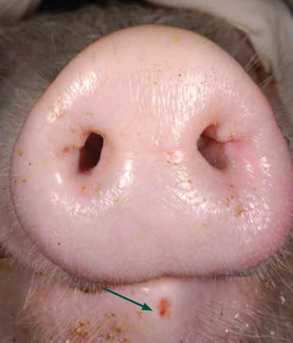Erosion of tip of lower lip.

Day 2 Domestic Pig
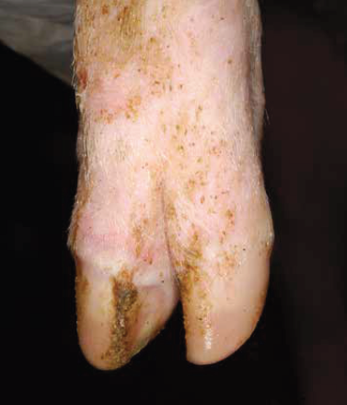Blanched coronary band.
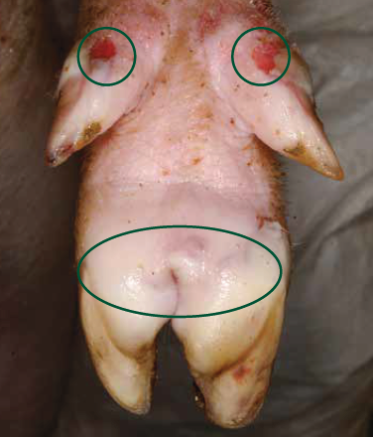Vesicles of hoof pads and ruptured vesicles of dewclaws.
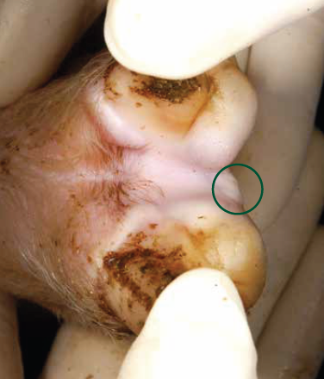Vesicle in interdigital area.
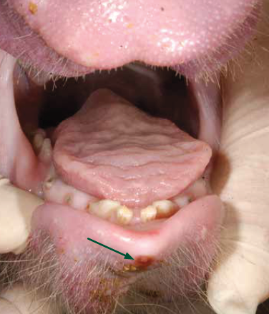Erosion of tip of lower lip.

Day 3 Domestic Pig
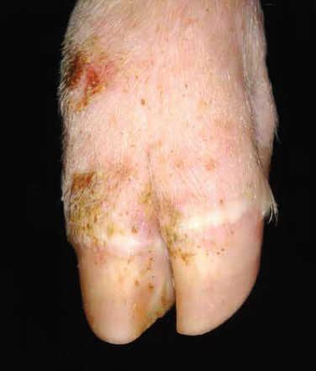Blanched coronary band with abrasions of skin over knuckle.
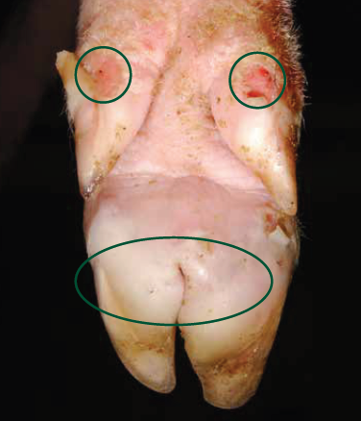Vesicles of hoof pad and ruptured vesicles of dewclaws.
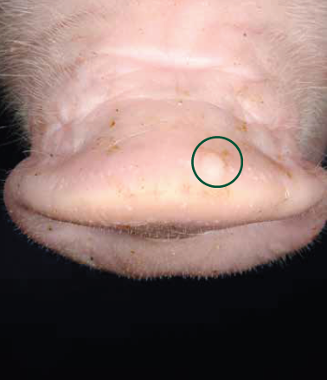Vesicle on top of snout.
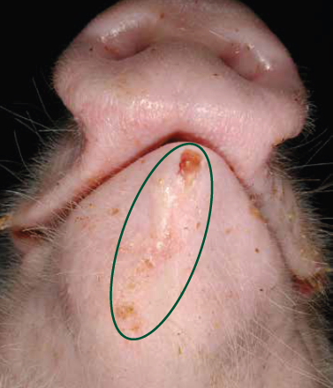Vesicle and erosion on lower lip.

Day 4 Domestic Pig
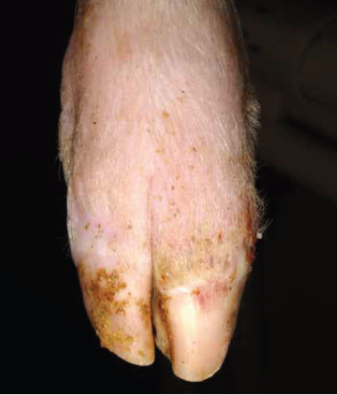Blanched coronary band.
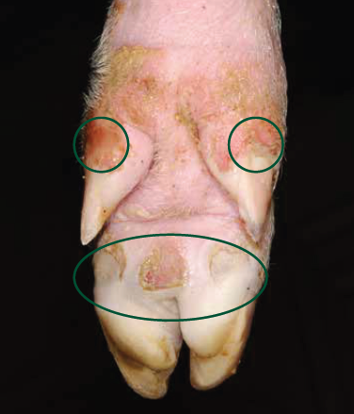Ulcerations and erosions from ruptured vesicles.
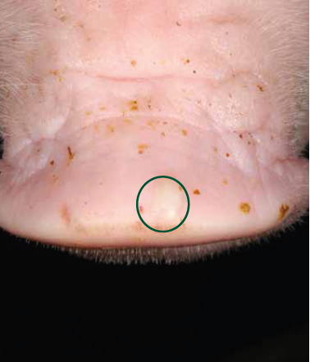 Vesicle on top of snout.
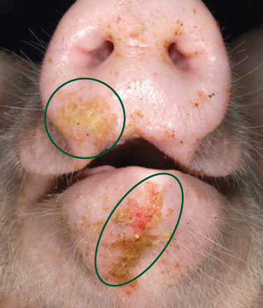Erosion of lower lip and snout with fibrin.

Day 6 Domestic Pig
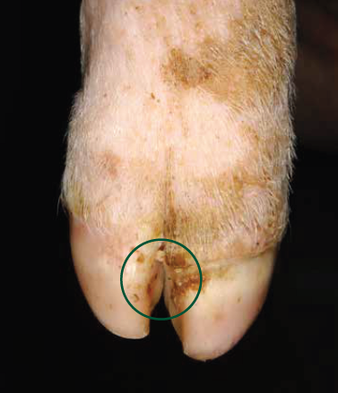Necrosis of coronary band with crusting.
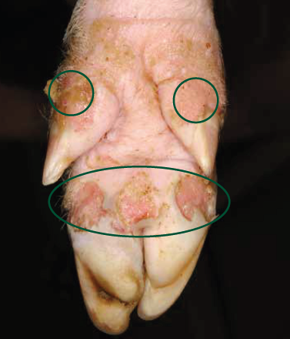Multifocal deep ulcers, hoof pad and dewclaws at the coronary band.
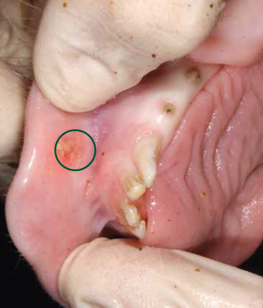Erosion with fibrin deposition.
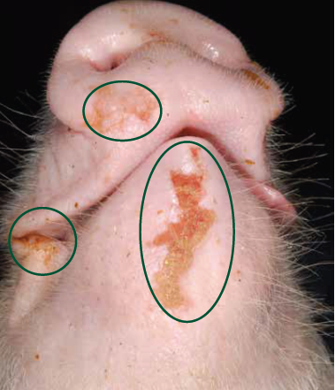Ulcerative and erosive lesions of the skin on the lower jaw, lower snout, and unilateral commissure.

Day 7 Domestic Pig
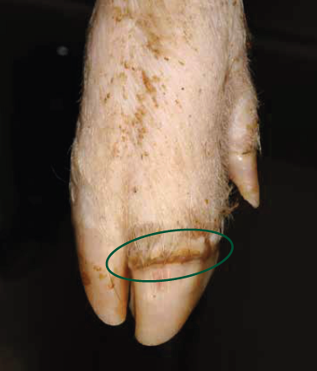Necrosis of coronary band with crusting.
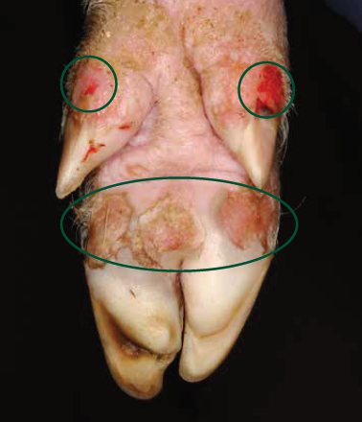Multifocal deep ulcers, hoof pad and dewclaws at the coronary band.
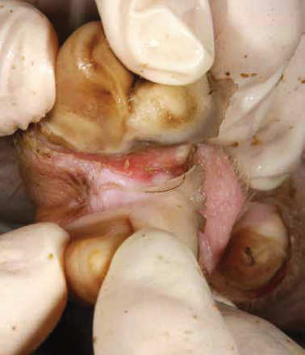Interdigital ulceration at coronary band.
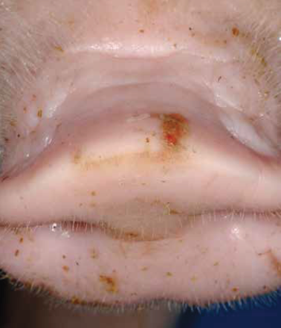Ruptured vesicle on top of snout.

Day 19 Domestic Pig
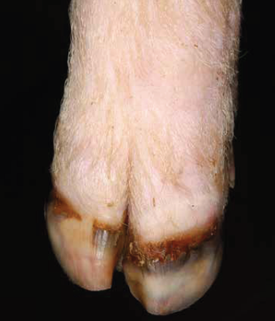Necrosis of coronary band with hoof sloughing and new hoof growth.
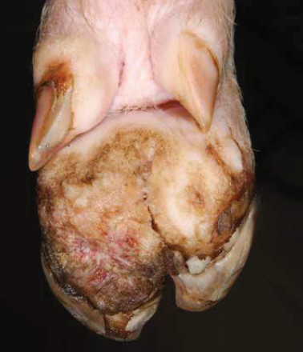Bilateral necrosis and ulceration with sloughing of hoof wall.
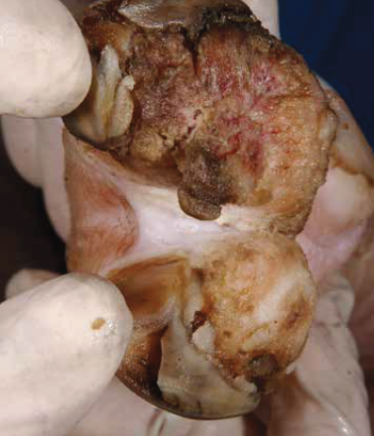Bilateral necrosis and ulceration with sloughing of hoof wall.
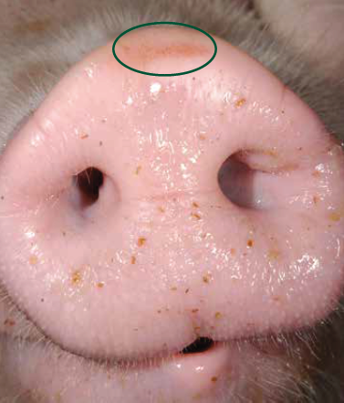Healing ruptured vesicle.

Day 26 Domestic Pig
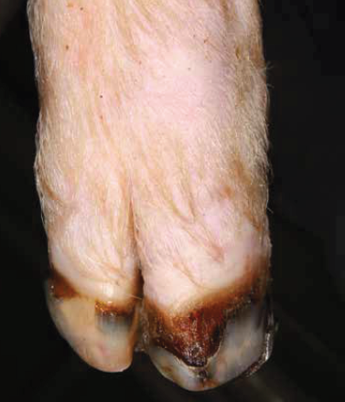Necrosis of coronary band with hoof sloughing and new hoof growth.
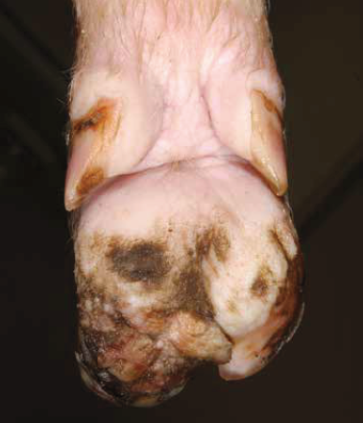Bilateral necrosis and ulceration with sloughing of hoof wall.
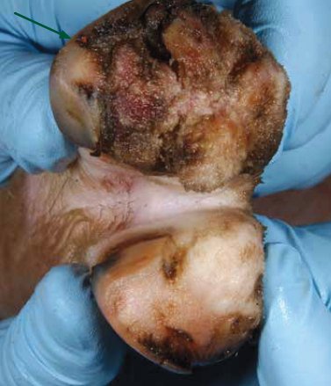Bilateral necrosis and ulceration with sloughing of hoof wall.
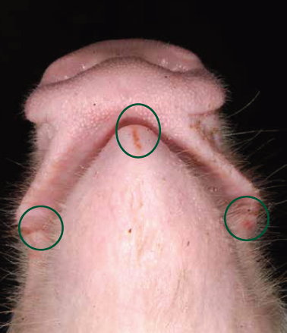Healed erosion of lower lip.

Feral Pig
Feral pigs (Sus scrofa) are declared as established pest animals in the state of Victoria under the Catchment and Land Protection Act 1994 (CaLP Act). They are found at many locations throughout Victoria, and their spread and population densities are affected by environmental conditions.
Most established populations can be found along the Murray River, far south‑west Victoria, the Otways, East Gippsland, and parts of central‑west and north‑east Victoria. New populations continue to emerge as conditions change. The following series of photos represent clinical signs of FMD in feral pigs.
Please note that feral pigs may have thicker skin and darker pigmentation which makes vesicular lesions more difficult to detect than in their domestic pig counterparts.
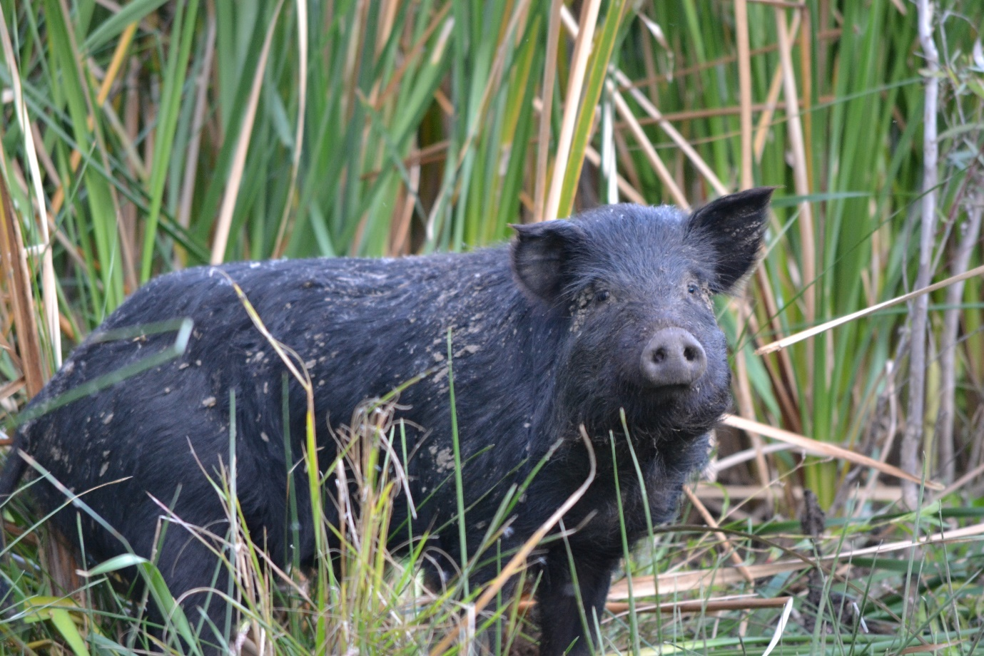

Day 1 Feral Pig
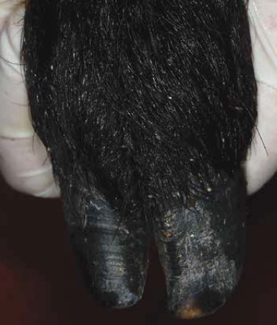No visible lesions.
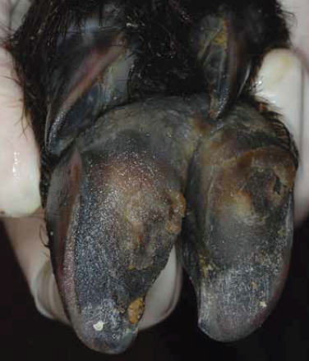No visible lesions.
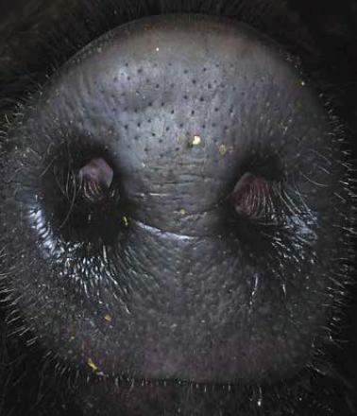No visible lesions.
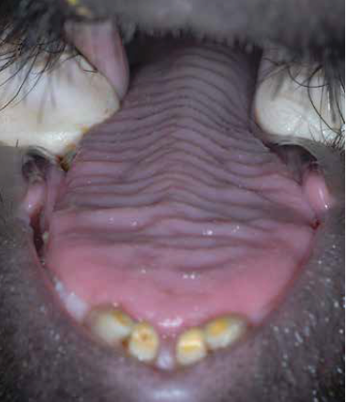No visible lesions.

Day 2 Feral Pig
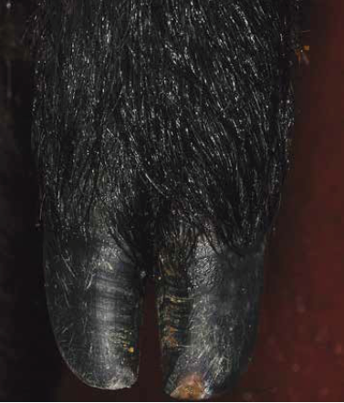No visible lesions.
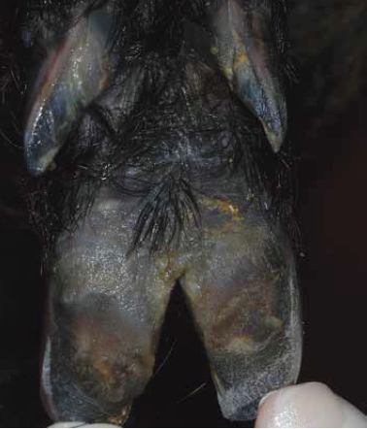No visible lesions.
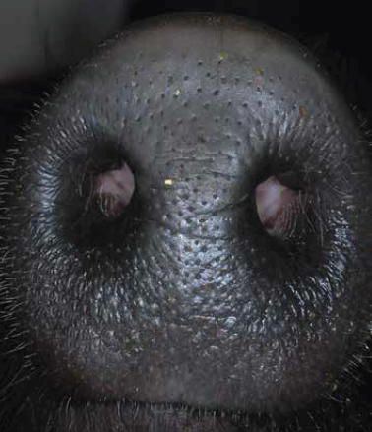No visible lesions.
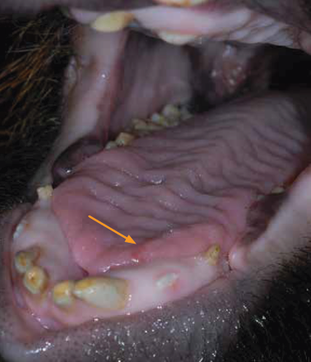Small early vesicle on tongue edge.

Day 3 Feral Pig
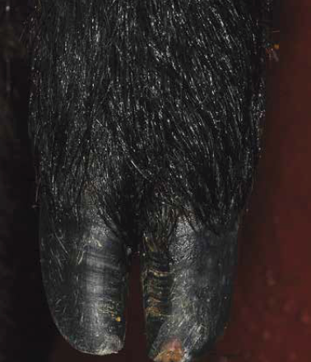Blanched coronary band.
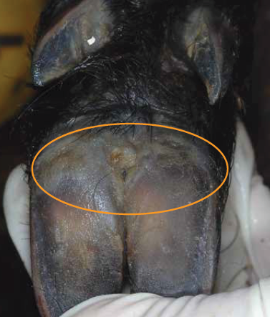Pale areas and swelling on the area of hoof pad.
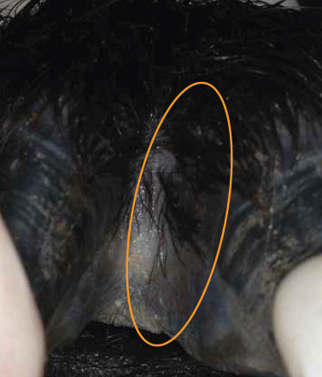Blanched interdigital space.
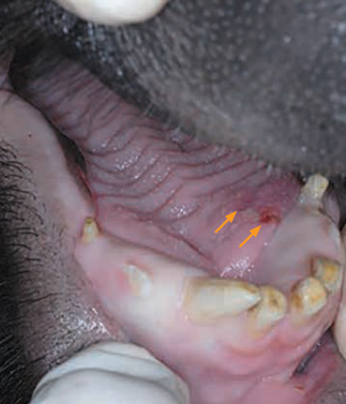Focal ulcer and adjacent early vesicle on the dorsal tongue.

Day 4 Feral Pig
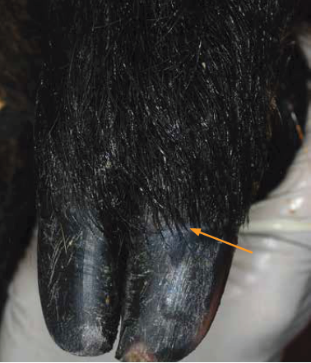Blanched coronary band.
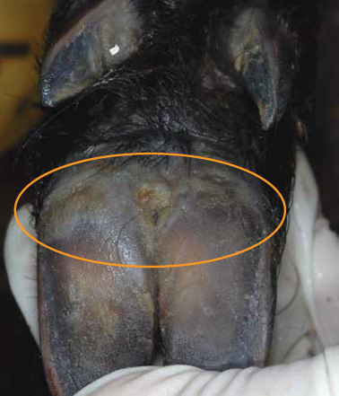Raised pale area of hoof pad.
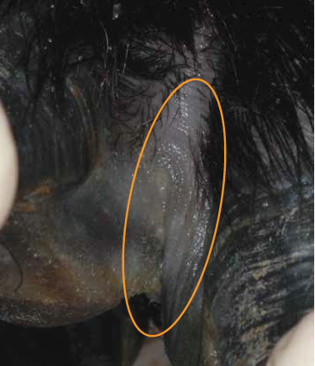Blanched interdigital space.
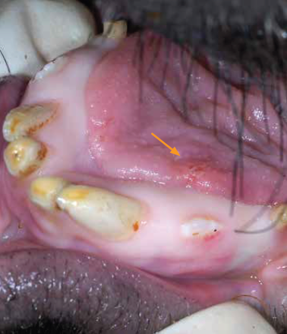Focal ulcer and adjacent early vesicle on the dorsal tongue.

Day 6 Feral Pig
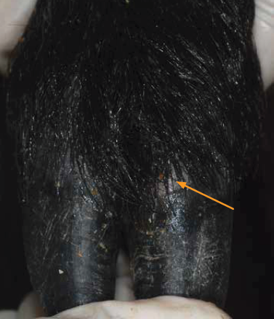Vesicle at coronary band.
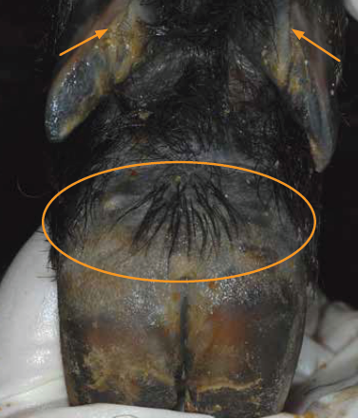Blanched hoof pad and coronary bands of dewclaws.
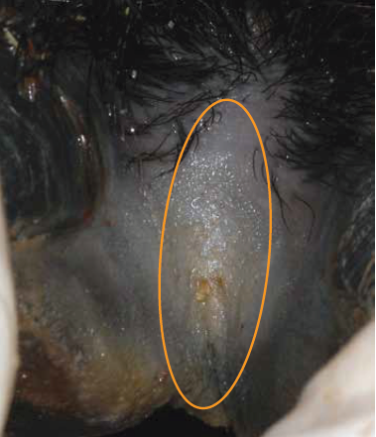Blanched interdigital space.
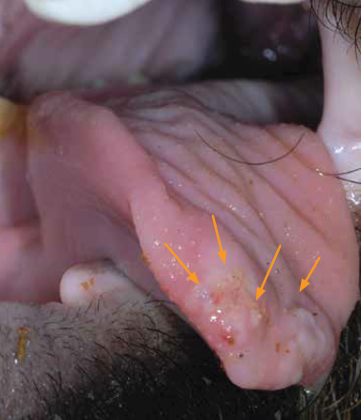Blanched tissue with erosions and vesicles on rostral area of tongue.

Day 7 Feral Pig
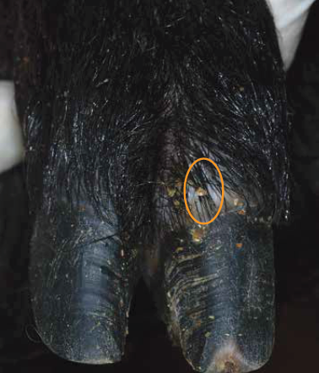Vesicle at coronary band.
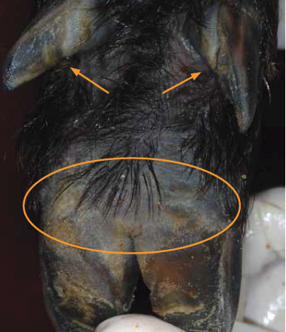Blanched hoof pad and coronary bands of dewclaws.
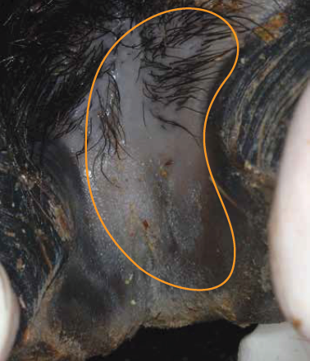Blanched interdigital space.
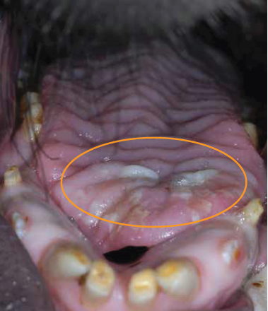Tongue with erosions and sloughing epithelium.

Day 12 Feral Pig
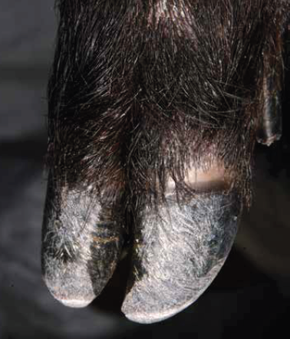Crusting of coronary band.
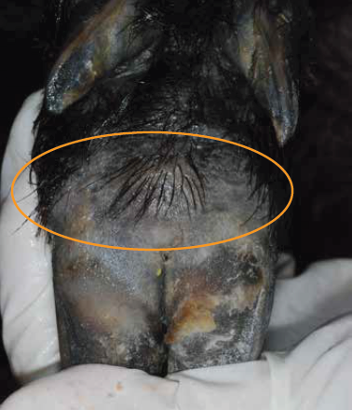Blanched hoof pad.
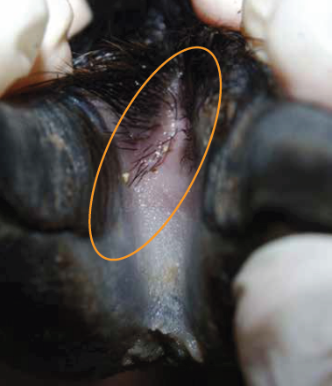Rupture of skin in interdigital space.
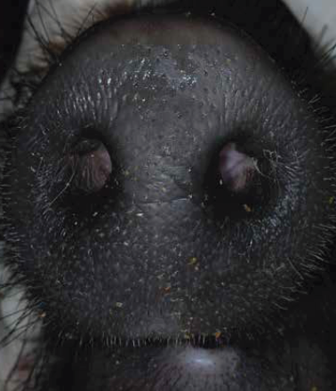No visible lesions.

Day 19 Feral Pig
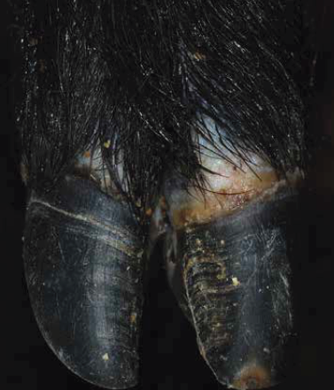Ulceration and necrosis at coronary band with early sloughing of hoof.
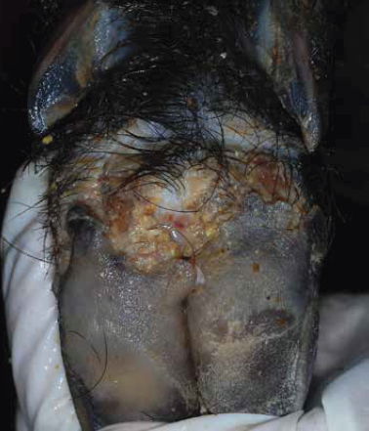Extensive hoof pad ulceration with crusting.
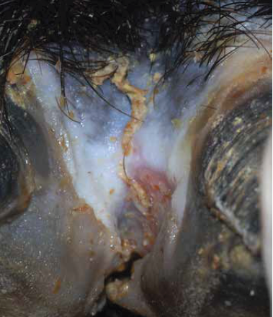Necrosis of interdigital space with ulceration and crusting.
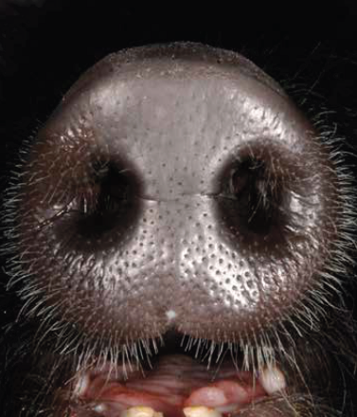No visible lesions.

Day 26 Feral Pig
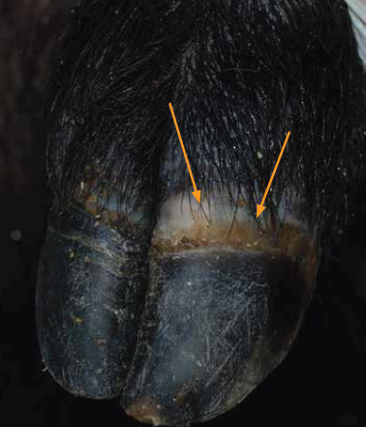Healing coronary band with new hoof growth.
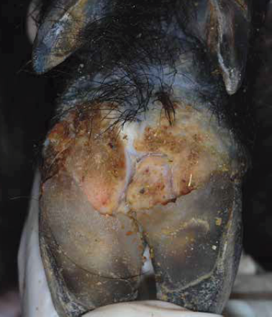Extensive hoof pad ulceration with crusting.
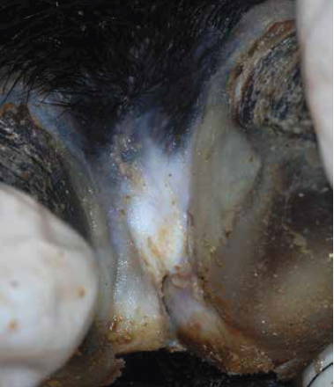Healing of interdigital space.
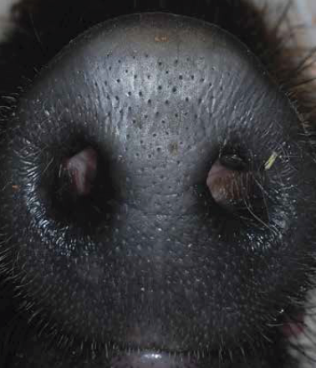Ruptured vesicle on top of snout.

Developed by Agriculture Victoria with endorsement from Animal Health Australia

