African swine fever. A guide for veterinarians.

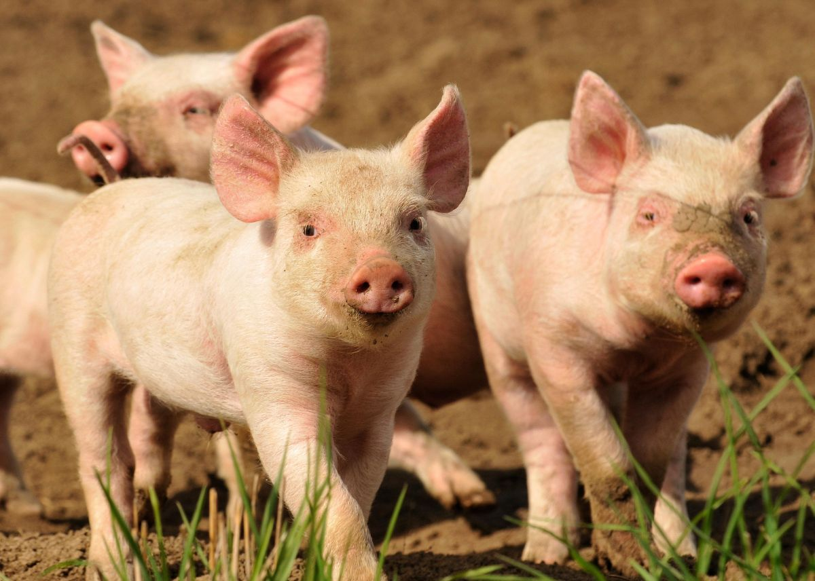
About African swine fever
If you suspect African swine fever in pigs, you MUST report it to the Emergency Animal Disease Hotline on 1800 675 888
African swine fever is a severe and infectious haemorrhagic viral disease that affects domestic and feral pigs and has spread rapidly around the world in recent years. African swine fever is not present in Australia.
The disease would have a significant impact on pig health and production in Australia and contribute to wider economic impacts for our primary industries and communities.
There is currently no vaccine or treatment for African swine fever.
The African swine fever virus is a complex, large, enveloped DNA virus. It is currently classified as the only member of the Asfarviridae family, genus Asfivirus. The virus is stable at a wide range of pH levels and can remain viable for long periods in blood, faeces and tissues, particularly in chilled and frozen meat.
African swine fever can present as peracute, acute, subacute and chronic forms.
The incubation period is usually 5–15 days but may be as long as 20 days.
African swine fever is unrelated to classical swine fever; however, the clinical signs may be similar.

African swine fever is a notifiable disease
In Australia, if you suspect African swine fever in pigs, you MUST report it to the Emergency Animal Disease Hotline on 1800 675 888, which will redirect to your state biosecurity jurisdiction.

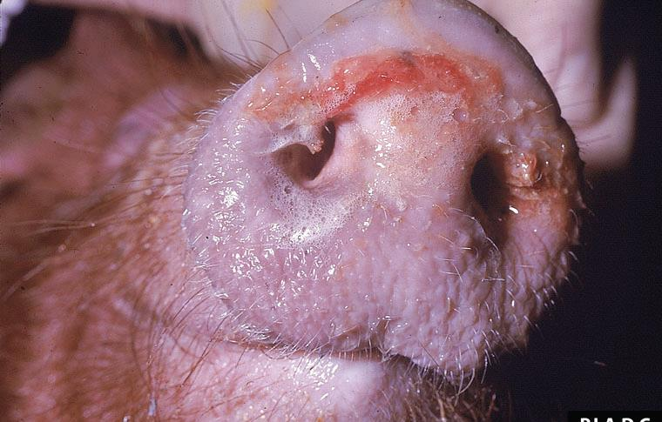
Bloody, mucoid, foamy nasal discharge
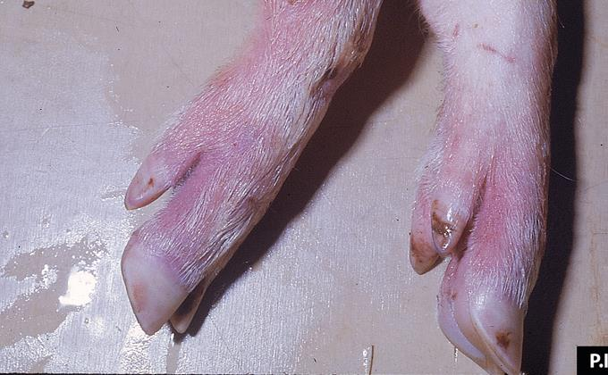
Marked hyperaemia of the distal limbs
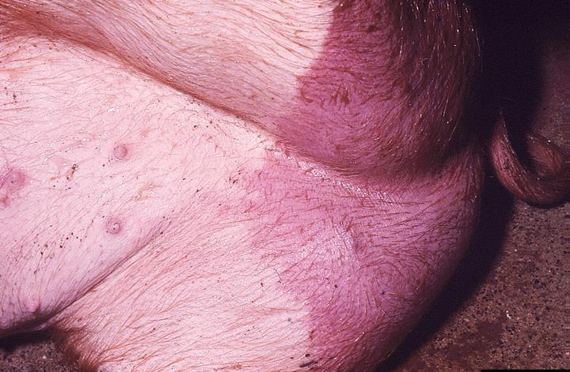
Large, sharply demarcated zone of hyperaemia of the perineal skin.
Clinical signs
Large numbers of pigs may become affected simultaneously and display a range of clinical signs depending on the stage of infection, severity of the disease process and virulence of the virus.
Peracute form
Pigs may be found dead with no prior clinical signs.
Acute form
• High fever (40.5–42 °C)
• Depression, listlessness
• Anorexia
• Haemorrhages in the skin (redness of skin on ears, abdomen, legs)
• Abortion in pregnant sows
• Cyanosis
• Vomiting, diarrhoea
• Death in 6–13 days (but sometimes up to 20 days)
• Mortality rates up to 100%

Subacute form Moderately virulent or low-virulent viruses may show less intense clinical signs for much longer periods (5–30 days).

• Abortion in pregnant sows
• Slight fever
• Reduced appetite and weight lossDepression
• Death in 15–45 days
• Mortality rates vary widely (30–70%)

Chronic form Moderately or low virulent virus may show varying and less intense clinical signs for a much longer period (2-15 months)

- Weight loss
- Irregular peaks of temperature
- Respiratory signs
- Necrosis in areas of skin and chronic ulcers
- Arthritis
- Swelling over joints
- Low mortality

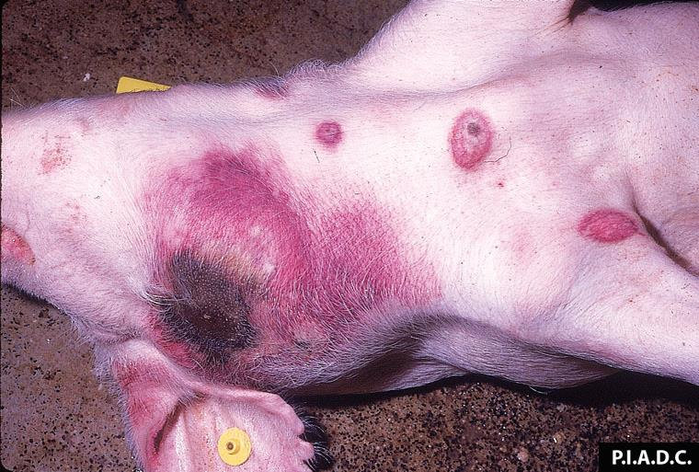
Multiple, sharply demarcated foci of cutaneous haemorrhage and/or necrosis; haemorrhagic lesions, some containing dark-red (necrotic) centres.
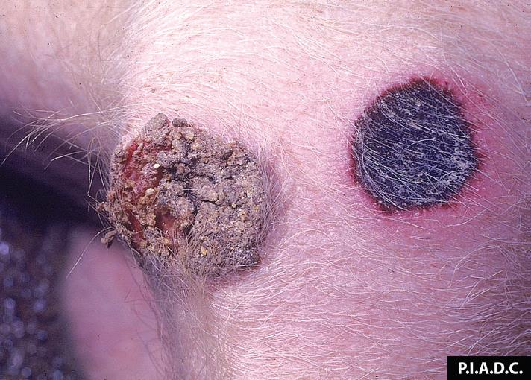
Necrotic exudate sloughing from the left lesion; rim of hyperaemia around the focus of haemorrhage and necrosis (infarct) on the right.
Image source: PIADC

Sampling and laboratory testing
If you need advice about sampling and testing for African swine fever, contact the veterinary diagnostic laboratory in your state or territory (see pages 13–14) or call 1800 675 888.
To allow a definitive laboratory diagnosis, obtain a full range of samples.
The agent can be detected by qPCR and virus isolation and further characterised by PCR and gene sequencing.
Serological tests include ELISA and immunofluorescence antibody test (IFAT).
If you can, collect samples from 10 animals (dead or alive). This may be a combination of post-mortems and
blood/swab samples from sick pigs.

Collection container | Collect from live pigs | Collect from dead pigs
EDTA tube (purple top) – full | Blood | Blood (recently deceased animals only)
Plain tube (red or grey/red speckled top) | Blood for serology
Swab in viral transport media | Oral cavity, tonsils, nasal cavity | Oral cavity, tonsils, nasal cavity
Separate sterile collection containers  (no media) for fresh samples *.  (kept chilled at 4 0C, not frozen) |  | Tonsils, spleen, lymph nodes (gastrohepatic and mesenteric), lung, kidney, ileum
Large collection container with 10% neutral buffered formalin |  | Tonsils, spleen, liver, lymph nodes, lung, kidney,  ileum, heart, brain, lesions seen in any tissue##.
*Take tissue samples from affected pigs that have been killed and from pigs that have recently died. To minimise the risk of contamination, take tissue samples as aseptically as possible and without delay.
** The fixed samples listed are a guide. To discuss your state or territory’s requirements further, contact the laboratory directly.

Forward the samples to the veterinary diagnostic laboratory in your state or territory. The laboratory will provide relevant samples to the national reference laboratory (the Australian Animal Health Laboratory in Geelong, Victoria) if required.
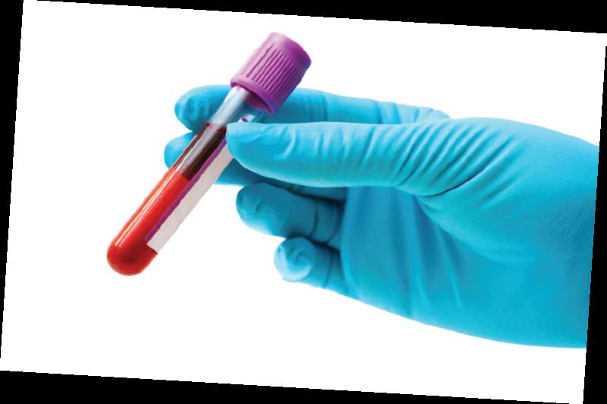

Post-mortem findings
Peracute form
There may not be many post-mortem findings, as the pigs may die before any gross pathology is seen.

Acute form (not all lesions are seen, depending on the isolate.)
• Pronounced haemorrhages in the gastrohepatic and renal lymph nodes
• Petechiae of the renal cortex, medulla and pelvis
• Congestive splenomegaly
• Oedematous areas of cyanosis in hairless parts
• Cutaneous ecchymoses on the legs and abdomen
• Excess of pleural, pericardial and/or peritoneal fluid
• Petechiae in the mucous membranes of the larynx and bladder, and on
visceral surfaces of organs
• Oedema in the wall of the gall bladder and mesenteric structures of the
colon and adjacent to the gall bladder

Chronic form
• Possible focal caseous necrosis and mineralisation of the lungs
• Enlarged lymph nodes

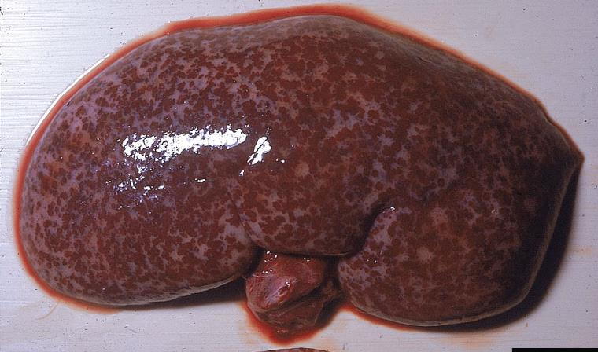
Cortical petechiation of the kidney

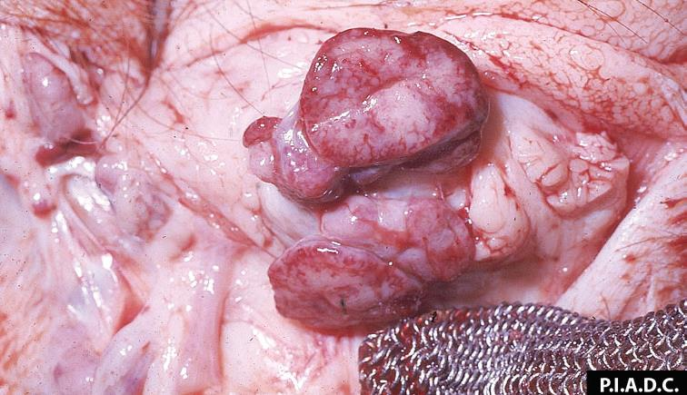
Moderate peripheral (medullary) haemorrhage of the mandibular lymph node
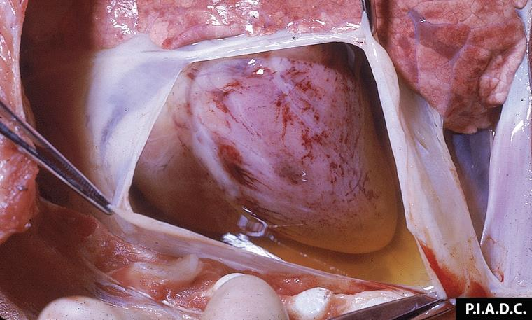
Abundant, straw-coloured pericardial fluid (hydropericardium), and multifocal epicardial haemorrhage
Image source: PIADC

Transmission
The epidemiology of African swine fever is variable and complex, with different epidemiological patterns of
infection occurring in Africa, Europe and Asia.
Transmission depends on:
• the environment
• the pig production systems
• the presence/absence of competent vectors
• human behaviours
• the presence/absence of feral pigs.
The primary method of transmission within herds is by direct contact.
Spread also occurs indirectly though the ingestion of contaminated material (e.g. food waste, garbage, feed).
Spread of infection between properties and areas may readily occur due to movement of infected pigs
or contaminated vehicles, equipment, people or animal products.
The virus may remain viable for long periods in blood, faeces, secretions and tissues of infected pigs.
It is highly resistant to low temperatures and can survive at least 30 days in the environment (e.g. pig pens) and up to 300 days in some pork products.
Pigs that have recovered from either acute or chronic infections may become persistently infected, acting as
virus carriers.
Ticks of the genus Ornithodoros are the only known natural arthropod hosts of the virus and act as reservoirs
and biological vectors.
It is not fully understood whether soft ticks (such as kangaroo tick of the genus Ornithodoros) may contribute
to the transmission of the virus in Australia. Work is continuing in this area.
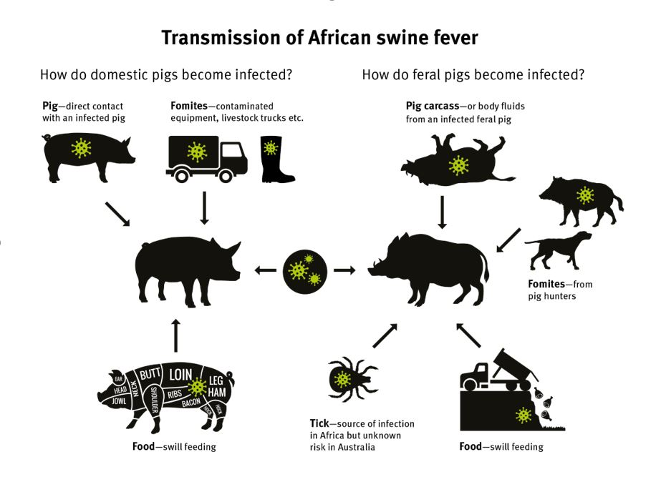

Personal biosecurity controls
If African swine fever is suspected, always follow the appropriate personal biosecurity protocols when entering and exiting the premises. Before entering the premises, assess the biosecurity risk—in particular the risk of iatrogenic disease spread—and determine the most appropriate course of action.
Consider the:
• tasks at hand (e.g. clinical examination and sampling)
• tools required (e.g. animal restraint, sedative and sampling equipment)
• personal items required (e.g. mobile phone)
• personal decontamination procedures necessary for biosecure entry and exit.
Establish and use a personal decontamination site at the periphery of the premises. This is essential to minimise the likelihood of iatrogenic spread of the virus. A ‘gold standard’ site is detailed in the images on the right.
Search ‘daf personal decontamination’ in YouTube for videos on:
• biosecure entry and exit of premises
• personal decontamination
• decontamination of samples and equipment.

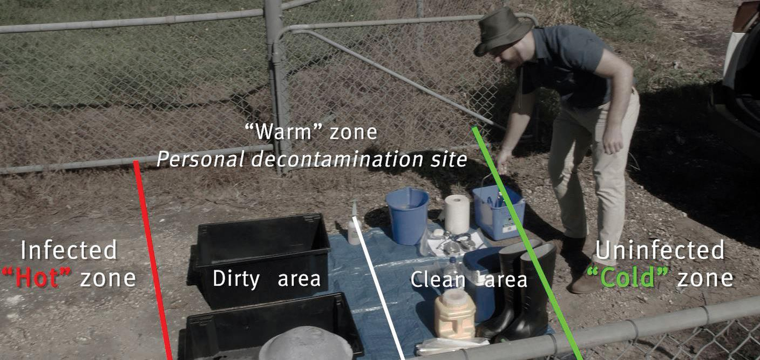

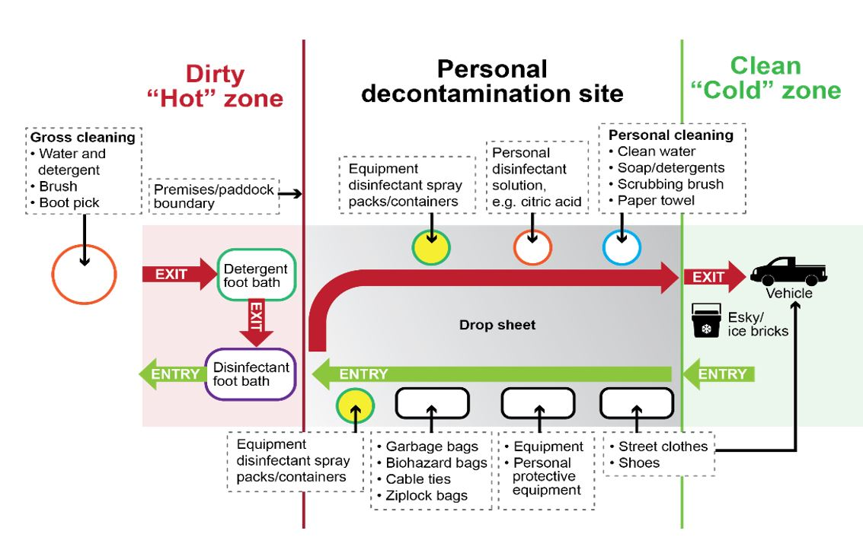
Reporting and immediate measures
Any suspected case of African swine fever must be reported immediately to the Emergency Animal Disease Watch Hotline on 1800 675 888.
African swine fever is a notifiable disease in Australia.
Collect as much relevant history, clinical information and epidemiological information as possible. This information will help inform likelihood and risk assessments and guide next steps.
You or the property manager may be asked to apply enhanced biosecurity measures such as:
• Immediately isolate affected pigs and keep free-range pigs away from the premises boundary.
• Depending on the size of the premises and nature of farming, inspect the premises or paddock boundary to ensure there are no breaches or points where suspect pigs could escape, wander off or contact feral pigs.
• Prevent pigs being moved to or from the premises.



Reporting and immediate measures

Prevent movement from the premises of material that has been in contact with suspect pigs, including
bedding, feed, equipment, clothing, footwear and vehicles.
• Prevent people from having unnecessary contact with pigs. If possible, place a ‘No entry’ sign on farm gates
and other access points.
• Advise people who have been in contact with the suspect pigs to avoid contact with other pigs and to
shower and change their clothing. Clothing and any equipment used must be decontaminated, taking
special care to ensure footwear has no organic material on the soles.
• Ensure that someone will remain on the premises and remain contactable by phone.
Warn people that they risk breaching their general biosecurity obligation if they do not take adequate
biosecurity precautions.
Biosecurity officers will provide further information and support in relation to managing the premises while
laboratory testing is in progress to confirm or exclude the presence of African swine fever. If African swine
fever is confirmed, a range of biosecurity measures will be applied to contain and eradicate the disease on
the premises.

Differential diagnosis
It is not possible to differentiate African swine fever from classical swine fever by clinical or post-mortem examination. It is essential to send samples for laboratory examination.
Other clinically indistinguishable diseases include:
• porcine reproductive and respiratory syndrome
• erysipelas
• salmonellosis
• Aujeszky’s disease
• pasteurellosis
• other septicaemic conditions.

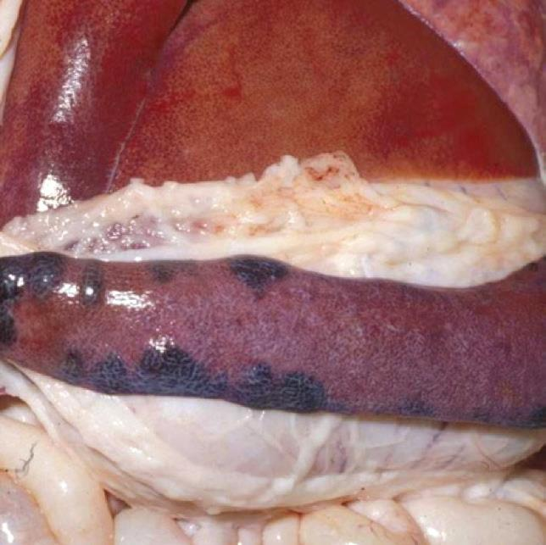
Multiple coalescing, swollen, dark-red infarcts along the margins of the spleen
Image source: PIADC and Centre for Food Security and Public Health.

Australian control policy
An incident of African swine fever would have a significant impact on pig health and production in
Australia, and contribute to wider economic impacts including those caused by a loss of access to overseas
markets for our pork products. It is vital that any suspicion of African swine fever is immediately reported.
The response policy would be determined by a number of factors including:
• how early the outbreak is detected
• the extent of the outbreak
• the location of affected premises
• the virus virulence
• whether feral pigs are involved.
The default policy is to control and eradicate the disease in the shortest possible time using a combination
of strategies outlined in the Australian Veterinary Emergency Plan (AUSVETPLAN) Disease strategy:
African swine fever, which is available at animalhealthaustralia.com.au.
The policy’s strategies include:
• implementing strict biosecurity and movement controls over pigs, pig products and fomites in declared areas to minimise disease spread
• an epidemiological study to establish the potential role of vectors in the transmission of African swine fever in Australia
• tracing and surveillance to identify the source and extent of infection
• destruction and sanitary disposal of all pigs on infected premises
• decontamination of fomites to eliminate the virus
• intensified control strategies for feral pigs to eliminate potential reservoirs in restricted areas
• a public awareness campaign.

Australian control policy
Keep prohibited food products out of Australia
The Australian Government Department of Agriculture is responsible for biosecurity at our international border.
Passengers, mail and cargo are screened for potential pest and disease risks.
Existing biosecurity import controls for goods that pose a risk of introducing African swine fever are very
stringent, in accordance with Australia’s appropriate level of protection.
All high-risk pig products are prohibited from entering Australia. These include all personal consignments of
smallgoods, pork jerky and pork biltong, which can arrive with international passengers and via international mail.
A range of products and import pathways are closely monitored to identify and manage risks. Goods that do
not meet Australia’s import requirements are seized, and then exported or destroyed.
Illegal importation of virus-contaminated food is considered to be the most likely means by which
the virus will be introduced to Australia.
Do not feed pigs swill
Swill is food or food waste containing meat, meat products, some milk or milk products or anything that has
been in contact with these items. Pigs must not be fed swill because the African swine fever virus may
remain viable in food after some forms of chilling, freezing or inadequate cooking.
Swill feeding is illegal in all states and territories of Australia.
Pig owners should implement strong on-farm biosecurity practices, including limiting contact between
domestic and feral pigs. Visit farmbiosecurity.com.au for more information.


The content in this guide was originally authored by the Queensland Government
© State of Queensland, 2023.
For more information on this licence,
visit creativecommons.org/licenses/by/4.0.
Disclaimer: The information contained herein is subject to change
without notice. The Queensland Government shall not be liable for
technical or other errors or omissions contained herein. The reader/user
accepts all risks and responsibility for losses, damages, costs and other
consequences resulting directly or indirectly from using this information.
State and territory laboratory contact details




New South Wales and Australian Capital Territory
NSW State Veterinary Diagnostic Laboratory
Phone: 1800 675 623
Email: laboratory.services@dpi.nsw.gov.au
Website: dpi.nsw.gov.au (search for ‘State Veterinary Diagnostic Laboratory’)
Delivery address:
Elizabeth Macarthur Agricultural Institute (EMAI)
Woodbridge Road
MENANGLE NSW 2568


Northern Territory
Berrimah Veterinary Laboratory
Phone: (08) 8999 2249
Email: bvl@nt.gov.au
Website: dpir.nt.gov.au (search for ‘Berrimah Veterinary Laboratory’)
Delivery address:
29 Makagon Road
BERRIMAH NT 0828


Queensland
Biosecurity Sciences Laboratory
Phone: (07) 3708 8762
Email: bslclo@daf.qld.gov.au
Website: qld.gov.au/AfricanSwineFever
Delivery address:
Block 12, Health and Food Sciences Precinct
39 Kessels Road
COOPERS PLAINS QLD 4108


South Australia
Gribbles VETLAB
Phone: (08) 8202 3300
Email: glenside.enquiries@gribbles.com.au
Website: gribblesvets.com.au
Delivery address:
33 Flemington Street
GLENSIDE SA 5065

Tasmania
Animal Health Laboratory
Phone: (03) 6777 2111
Email: specimenreception@dpipwe.tas.gov.au
Website: dpipwe.tas.gov.au/AHLabs
Delivery address:
165 Westbury Road
PROSPECT TAS 7250

Western Australia
DPIRD Diagnostics and Laboratory Services—Animal Pathology
Phone: (08) 9368 3351
Email: ddls@dpird.wa.gov.au
Website: agric.wa.gov.au (search for ‘Animal Pathology’)
Delivery address:
DDLS, C Block
Department of Primary Industries and Regional Development
3 Baron-Hay Court
SOUTH PERTH WA 6151


Victoria
AgriBio—Veterinary Diagnostic Services
Phone: (03) 9032 7515
Email: vet.diagnostics@agriculture.vic.gov.au
Website: agriculture.vic.gov.au (search for ‘Veterinary Diagnostic Services’)
Delivery address:
5 Ring Road
La Trobe University Campus
BUNDOORA VIC 3083

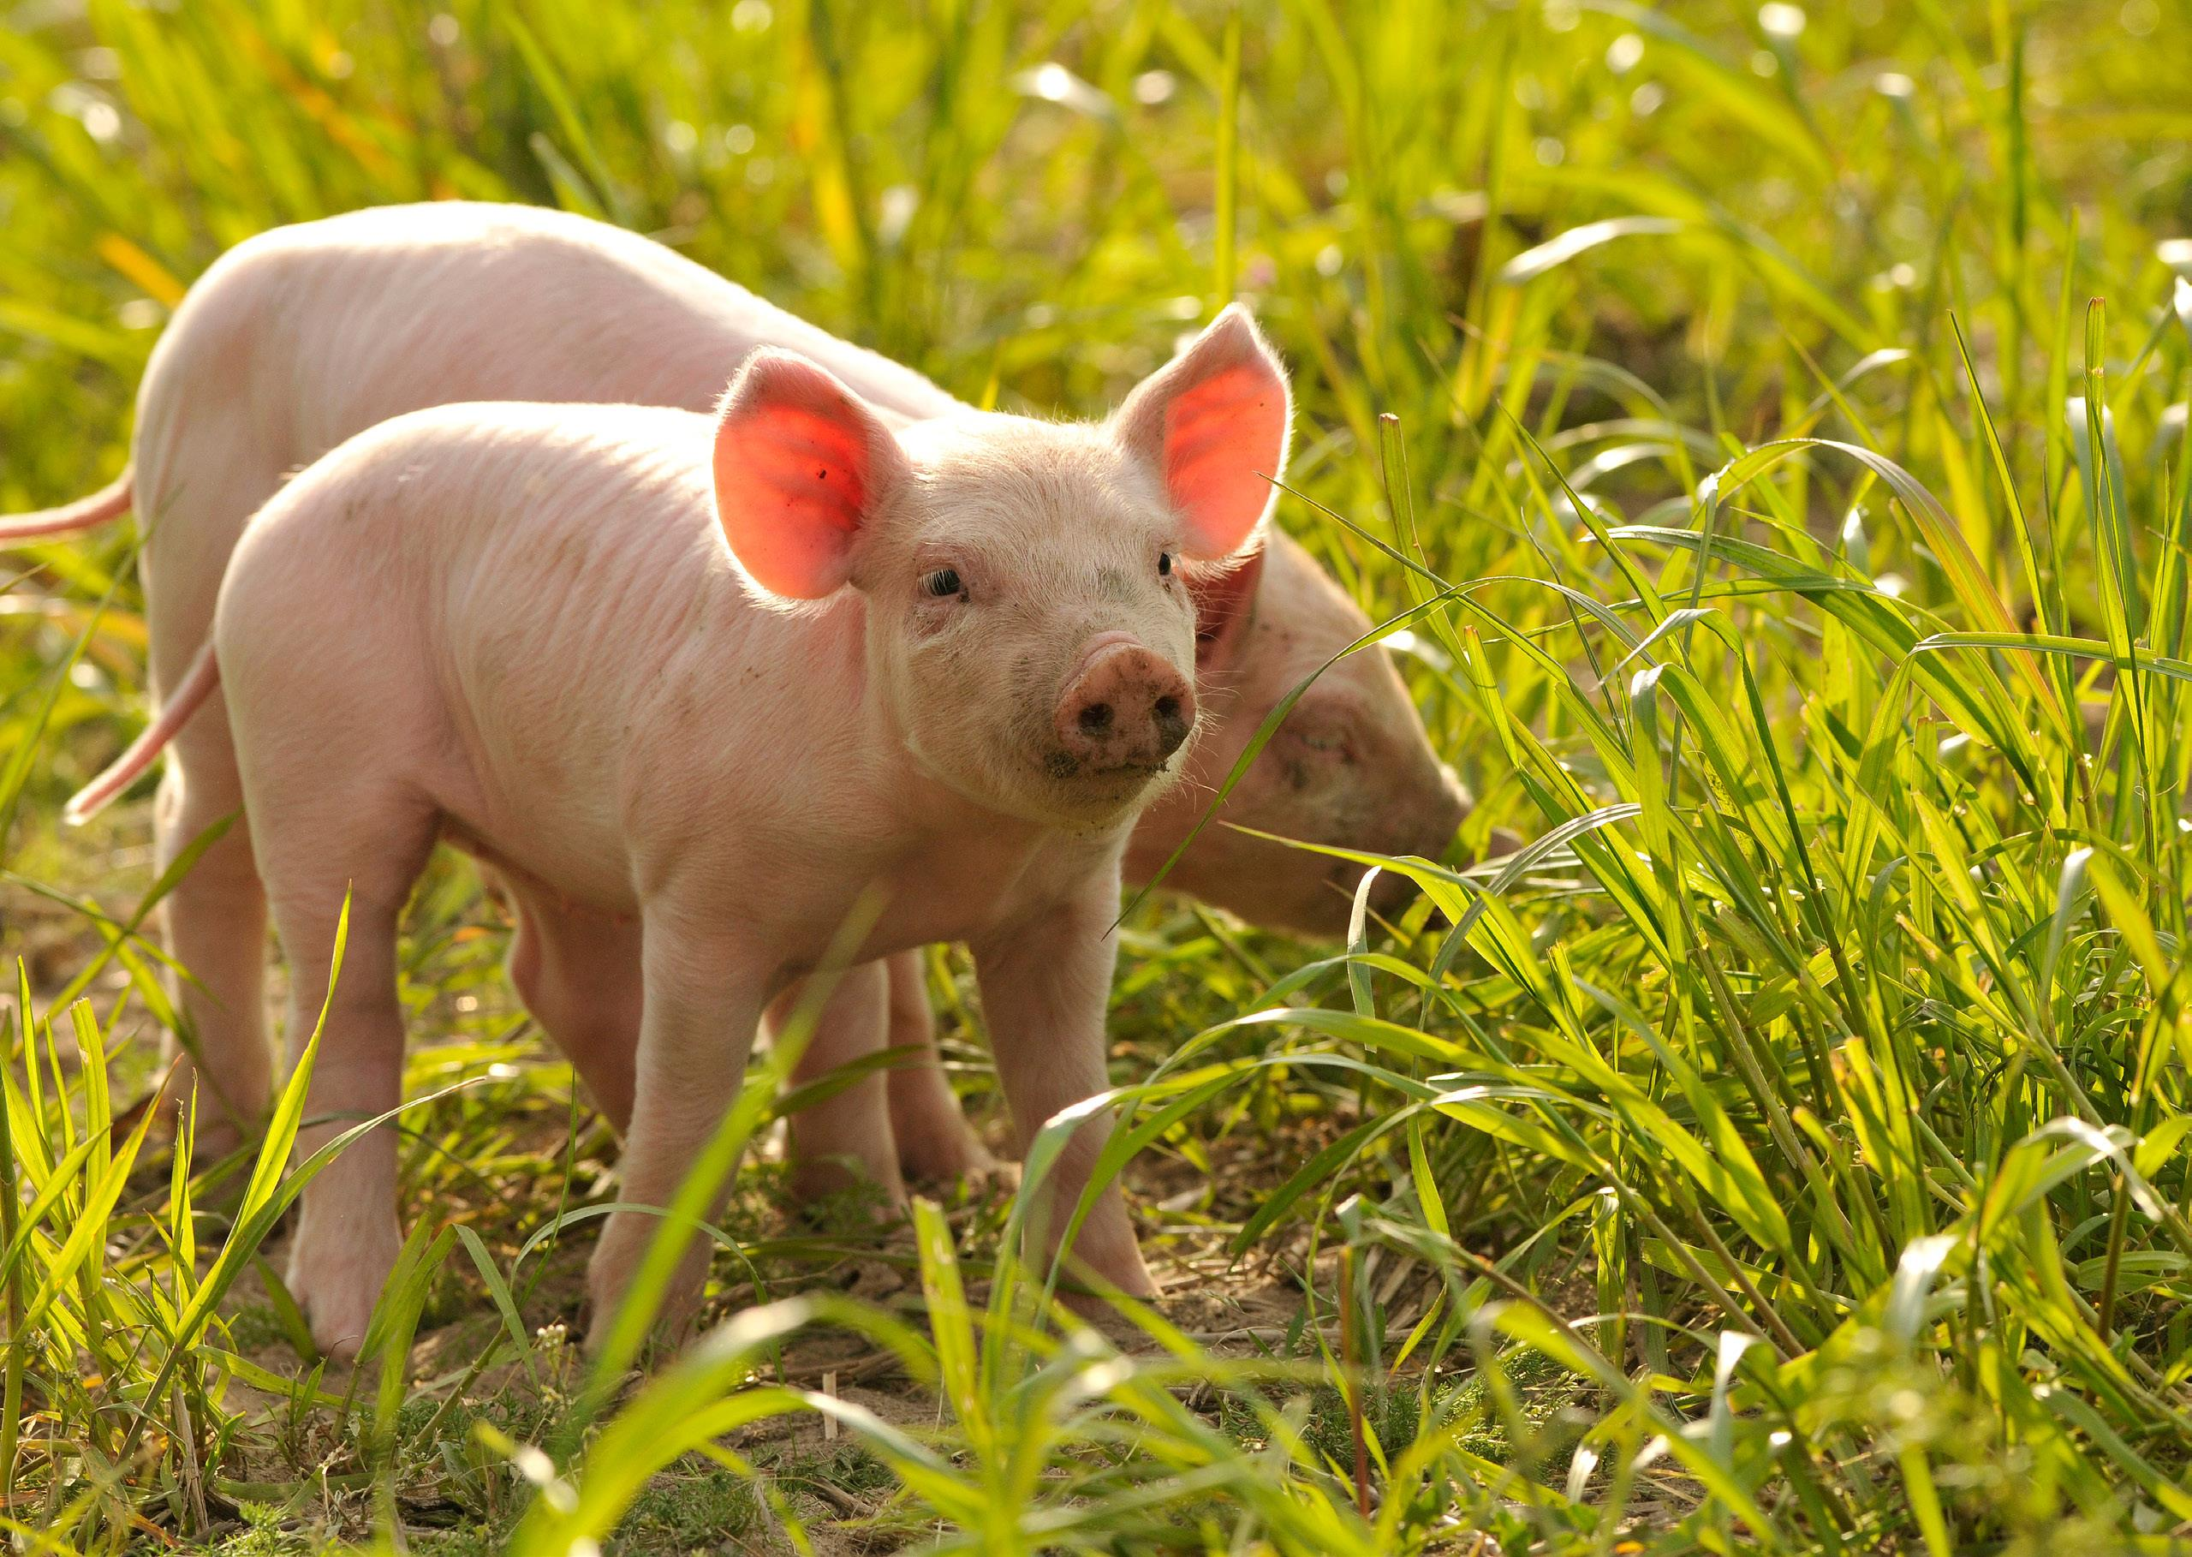

More information
Visit animalhealthaustralia.com.au/asf
African swine fever is a notifiable disease
If you suspect African swine fever in pigs, you MUST report it to the Emergency Animal Disease Hotline on 1800 675 888

