Food Safety Requirements for Horticulture

Melons, Leafy Vegetables and Berries
Food Standards Australia and New Zealand have introduced new food safety and compliance standards for berries, leafy vegetables and melons into the national Food Standards Code. These Standards will take effect from 12 February 2025 and will be regulated in Victoria by Agriculture Victoria.

The requirements and who they affect
The standards contain requirements including product traceability, managing safety of inputs, and worker and premises hygiene. The standards provide for a focus on food safety, protecting and enhancing confidence in the industry.
The Standards apply to all leafy vegetable, melon and berry businesses that grow or complete primary or ‘early-stage’ processing.
- Leafy Vegetables
Leafy vegetables are defined in the Standard as vegetables of a leafy nature where the leaf is consumed raw. Examples of leafy vegetables include but are not limited to: all lettuces, romaine, red leaf, butterhead, endive, oak leaf, watercress, radicchio, baby leaf, battavia, kale, chicory, watercress, swiss chard, rocket, Asian leafy greens, all leafy herbs consumed raw, spring onions, microgreens, spinach leaves, silverbeet and cabbage.
- Berries
Berries are defined in the Standard as fresh berries and include berries such as strawberries, blueberries, and berries from the genus Rubus.

- Melons
Melons are defined in the Standard as fresh melons and includes melons such as watermelon, rockmelon, honeydew melon and piel de sapo.
Agriculture Victoria will work with all businesses who need to follow the Standards. This will include:
- Recognising current food safety arrangements where possible
- Providing a system to develop, document, approve, and verify (audit) your plans to meet the requirements
- Actively working to identify all relevant businesses that must meet the requirements and bring them into the food safety system

- Providing tailored resources and workshops to allow businesses to be prepared for and implement the Standards.
These Standards will take effect from 12 February 2025 and will be regulated in Victoria by Agriculture Victoria.

Promoting a food safety culture
Horticultural produce is generally considered safe, and a strong food safety culture exists within the majority of businesses. However, foodborne illness, product recalls and other food safety incidents continue to be linked to fresh horticultural produce. Such events can be readily reduced through food safety measures and by ensuring everyone (owners, managers, employees) understands the importance of producing safe food and the consequences when things go wrong. The standards will support national consistency, as all affected businesses will need to be involved. This will improve food safety standards and culture, helping to prevent food safety incidents that damage the reputation of industry.

Where to register
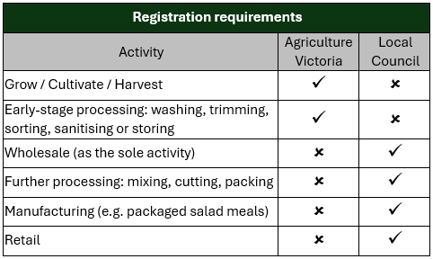
Depending on your business's activities, you will need to register with Agriculture Victoria, local council or both.
Businesses that grow or complete primary or ‘early-stage’ processing will need to register with Agriculture Victoria. Activities further along the supply chain may require registration with Council.
Registration requirements based on activity are summarised in the table.

Registration pathways
Once you begin your registration with Agriculture Victoria, there are different registration ‘pathways’ dependant on commodity group, and whether you are in a Global Food Safety Initiative (GFSI) benchmarked food safety scheme or not.
If your business is already in a GFSI scheme, you must register and provide information so that Agriculture Victoria can verify your certification(s). Provided your certification is maintained, and available for review and verification by Agriculture Victoria, your business will be immediately recognised as meeting the relevant standard.

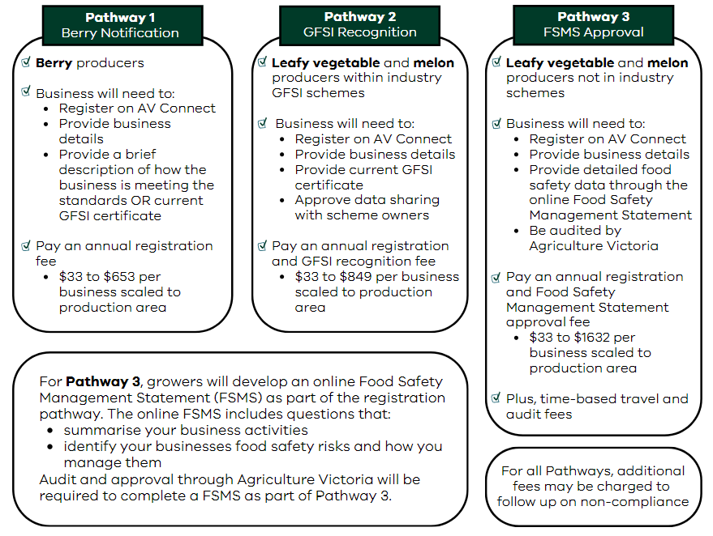

How to register with Agriculture Victoria

Agriculture Victoria has developed an online system called Agriculture Victoria Connect. The system provides a single-entry point for accessing services related to regulatory compliance.
Businesses are required to log into Agriculture Victoria Connect from 12 February 2025 to complete their food safety registration. Use the QR code to access Agriculture Victoria Connect.

Fees
There will be an annual fee to register with Agriculture Victoria depending on pathway, and a fee for audits, where needed. The fees will be scaled to the size of your production area.
It is proposed that very small melon and leafy vegetable producers (<1ha) will need to follow their relevant regulatory pathway but will only be charged the registration fee (audit and travel fees may apply).
To support and encourage businesses to sign up in 2025 a temporary fee discount/rebate of 50% is proposed at point of registration. Further discounts may be applied in future years at the discretion of the Regulator.

Frequently asked questions
I have seen information from Food Standards Australia and New Zealand (FSANZ) and from other States, and it seems there's a slightly different approach. I'm confused?
- FSANZ has played an important role in communicating about the content of the Standards that they developed however, each state government has responsibility for implementing the Standards from 12 February 2025. This means that some requirements might be different in each state.
What will I have to do from 12 February 2025?
- Victorian growers are required to log into Agriculture Victoria Connect to register and provide information about how they are meeting and complying with the Standards. Whilst we expect businesses to make reasonable attempts to register soon after 12 February 2025, we understand that it’s a busy time in the season and there may be a short delay. We're initially adopting an educative and awareness approach to registration.
What Global Food Safety Initiative (GFSI) Schemes will be recognised?
- GlobalG.A.P, Freshcare, Safe Quality Foods (SQF) and BRCGS are the recognised GFSI benchmarked schemes. If you are a member of Freshcare, your membership will allow you the most streamlined access.
My business falls within Pathway 3, will I be audited every year?
- Yes, businesses who are in Pathway 3 will be required to complete an online FSMS and be audited annually by Agriculture Victoria.
What if my business is already registered with Local Government?
- Some farm businesses may already be registered with local government (Council) if they conduct substantial transformation, wholesale, food service, retail, or off-farm processing activities. From 12 February 2025, depending on a business's activities, registration will be required with Agriculture Victoria, local government, or both (see previous ‘registration requirements’ table). Businesses that grow or complete primary or ‘early-stage’ processing will need to register with Agriculture Victoria. Activities further along the supply chain will require continued registration with local government.
What are the consequences of non-compliance?
- The focus from 12 February 2025 will be on education and awareness. There will be a transition period before regulatory action will be taken by Agriculture Victoria to allow time to build awareness of the requirements and for businesses to register. It is a legal requirement to register with Agriculture Victoria and follow the Standards.

Further information
Agriculture Victoria is working with industry representative bodies as part of the regulation development and implementation processes, including AUSVEG, Melons Australia and Berries Australia.
Agriculture Victoria: For further information on the Standards and their regulation
Fresh Produce Safety Centre: Access the food safety helpdesk and multi-language grower guides

