Report marine pests in your aquaculture facility

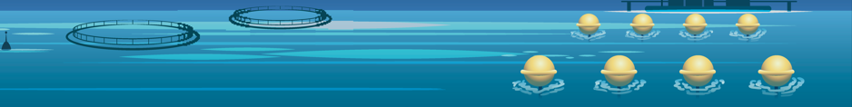

Marine pests can damage infrastructure, kill your stock, and spread disease.

There are simple steps you can take to help protect your aquaculture business:

Keep your facility clean

Check submerged structures and equipment for unusual growth or pests

Avoid any action that could spread pests to a new location.

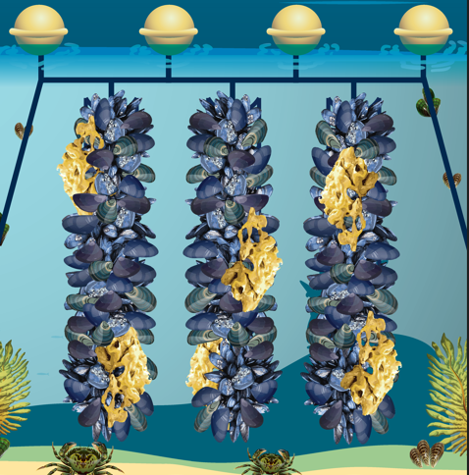

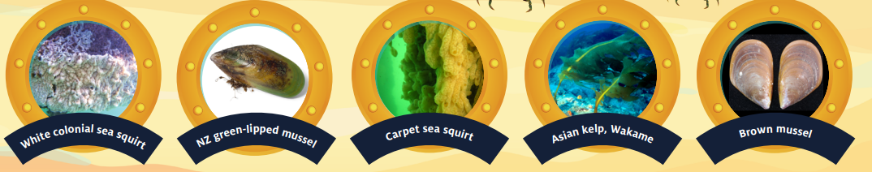

Go to vic.gov.au/marine-pests to learn more.

