Agriculture Victoria Regulatory Capability Assessment
Summary Report
Department of Jobs, Precincts and Regions
August 2021


Contents
Summary 5
Strategic Capabilities 5
Technical Capabilities 5
Core Capabilities 6
Capability Framework 6
Agriculture Victoria as a regulator across five systems 8
Strategic Capabilities 8
Insights 8
Decision-making 8
Innovation 8
Technical Capabilities 8
Policy 8
Compliance 8
Core Capabilities 9
Outreach 9
Collaboration 9
Performance 9
Corporate Enabling Capabilities (Out of scope) 9
Strategic Capabilities 10
Insights 10
Decision making 11
Innovation 11
Technical Capabilities 12
Policy 12
Compliance 12
Core Capabilities 13
Outreach 13
Collaboration 13
Performance 14
Next Steps 15
Agriculture Victoria Capability Improvement Action Plan 16
Capabilities identified as most in need of improvement through the Capability Assessment 16
Capabilities identified by staff as priorities for improvement 17
Capabilities identified by stakeholders as priorities for improvement 17
KPMG Contacts 18

Disclaimer
This document provides an extract of KPMG’s findings during the course of the work undertaken for the Department of Jobs, Precincts and Regions under the terms of the contract dated 3 February 2021. The contents of this document do not represent our conclusive findings, which are contained in our final report.
Inherent Limitations
The final report was prepared as outlined in the Review objective, scope and methodology section of the report. The services provided in connection with this engagement comprise an advisory engagement, which is not subject to assurance or other standards issued by the Australian Auditing and Assurance Standards Board and, consequently no opinions or conclusions intended to convey assurance have been expressed.
No warranty of completeness, accuracy or reliability is given in relation to the statements and representations made by, and the information and documentation provided by staff and stakeholders consulted as part of the process. KPMG have indicated within the final report the sources of the information provided. We have not sought to independently verify those sources unless otherwise noted within the report.
KPMG is under no obligation in any circumstance to update this document or the final report, in either oral or written form, for events occurring after the report has been issued in final form.
The findings in this summary and the final report have been formed on the above basis.
Accessibility
To comply with the Victorian Government’s accessibility requirements for publishing on the internet, two versions of this document are available: a KPMG-branded PDF version and an unbranded Microsoft Word version. The KPMG-branded PDF version of this document remains the definitive version of this Summary Report.

Summary
Agriculture Victoria’s regulatory activities play a critical role in delivering its vision of a Victorian agriculture sector that is strong, innovative and sustainable.
To realise this vision, Agriculture Victoria has embarked on a four-year reform journey through the Strengthening Victoria’s Biosecurity System Program (the SVBS Program). A key focus of the Program is to modernise regulatory practice to better address regulatory risks and improve biosecurity outcomes.
As part of this work, Agriculture Victoria commissioned KPMG to develop a Capability Framework and complete an assessment of its capability as a regulatory. This document summarises the high-level outcomes of that assessment.
Agriculture Victoria has the ability to independently improve some regulatory capabilities. However, existing legislation may limit the extent to which these approaches may uplift some specific regulatory capabilities.
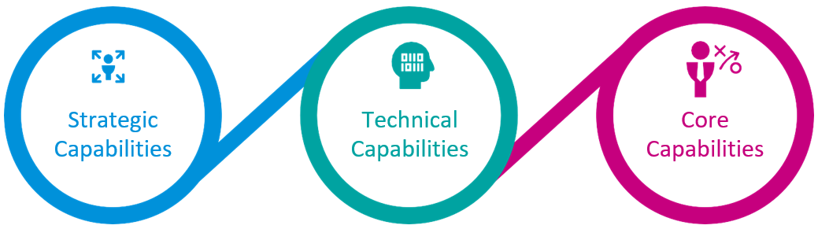

Strategic Capabilities
Key findings
Agriculture Victoria has capability strength in its strong knowledge of sector and government insights. There are opportunities to improve on data analysis, development of strategic responses, use of innovative tools and approaches, and resource allocation.

Technical Capabilities
Key findings
Agriculture Victoria has relative capability strength in code of practice development and responding to non-compliance.
The rating for legislative and regulatory reform reflects capability in regulatory practice within the existing regulatory environment as much as possible. There are opportunities for development in monitoring compliance.

Core Capabilities
Key findings
Agriculture Victoria has capability strength in education and advice to sector, working with other regulators and developing operating procedures. There are opportunities to improve in raising awareness in the community, promoting proactive compliance, as well as across performance capabilities such as reporting, monitoring and evaluation, and continued improvement.

Capability Framework
KPMG developed a Capability Framework to assess Agriculture Victoria’s capabilities as a regulator across its five regulatory systems.
The Capability Framework includes a range of capabilities needed to drive positive regulatory outcomes for industry and the community. The Capability Framework was designed to allow Agriculture Victoria to continue to assess its progress in improving its capabilities over time.
The capability assessment was based on input from Agriculture Victoria staff, leadership and external stakeholders.
Qualitative and quantitative insights collected through workshops and a staff survey were triangulated to inform the overall assessment for each capability. Staff insights have not been independently verified.
The Capability Framework groups 27 capabilities within four domains:
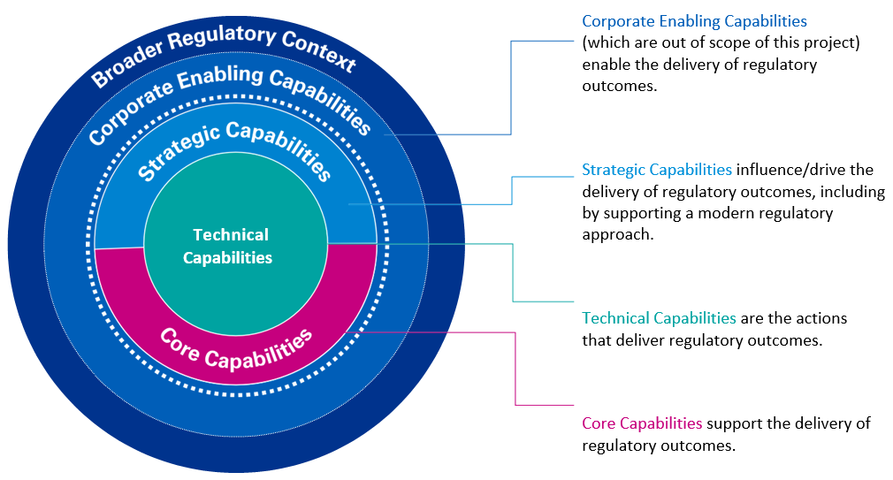
Corporate Enabling Capabilities (which are out of scope of this project) enable the delivery of regulatory outcomes.
Strategic Capabilities influence/drive the delivery of regulatory outcomes, including by supporting a modern regulatory approach.
Technical Capabilities are the actions that deliver regulatory outcomes.
Core Capabilities support the delivery of regulatory outcomes.
The Broader Regulatory Context, within which Agriculture Victoria operates, also impacts the effectiveness of Agriculture Victoria as a regulator. Agriculture Victoria has limited scope to influence this broader operating environment and it is not included within the Capability Framework.
The impact of the broader regulatory context has not been considered when assessing Agriculture Victoria’s capabilities.
The Broader Regulatory Context consists of:
- Whether appropriate legislation is in place to support and facilitate effective regulation
- The Government oversight regime imposed upon the regulator to hold it accountable for fulfilment of its mandate, including requirements for external performance reporting
- Resourcing and funding decisions set by Government
  - The legitimacy of the regulator within the sector and broader community.

Agriculture Victoria as a regulator across five systems

Strategic Capabilities
The capabilities which influence/drive the delivery of regulatory outcomes, including by supporting a modern regulatory approach:

Insights
- Sector Understanding
- Intelligence on Emerging Risks
- Government Insights
- Understanding Regulatory Objectives
  - Environmental Scanning

Decision-making
- Data Analysis
- Developing Strategic Responses
- Risk Assessment
  - Resource Allocation

Innovation
- Knowledge of Innovative Tools & Approaches
- Use of Innovative Tools & Approaches
  - Training in Best- Practice Regulation

Technical Capabilities
The actions that deliver regulatory outcomes:

Policy
- Legislative and Regulatory Reform
  - Code of Practice Development

Compliance
- Permissioning
- Monitoring Compliance
  - Responding to Non- Compliance

Core Capabilities
The capabilities that support the delivery of regulatory outcomes:

Outreach
- Raising Awareness
- Education & Advice to Sector
  - Preparing Education and Guidance Material

Collaboration
- Working with Other Regulators
- Working with Other Teams
  - Sector/Stakeholder Engagement

Performance
- Monitoring & Evaluation
- Reporting
- Continued Improvement
  - Operating Procedures

Corporate Enabling Capabilities (Out of scope)
Enable the delivery of regulatory outcomes:
- Organisational Strategy
- Leadership and Governance Arrangement
- Data and Information Management Systems
- Workforce Planning
- Finance
- Learning and Development
- Legal and Procurement
- Business Operations including HR

Strategic Capabilities
The 12 Strategic Capabilities influence and drive the delivery of regulatory outcomes, including by supporting a modern regulatory approach.

Insights
Assessment | Capability
Relative capability strength | Sector Understanding: The capability to understand the community and industry which Agriculture Victoria regulates, including the activities and concerns of the sector; to foresee relevant industry and community trends across the sector; and to translate this knowledge into insights for their work.
Relative capability strength | Government Insights: The capability to understand and work with government and its agenda, operations, expectations, drivers and pressures, and understand the impact on Agriculture Victoria.
Capability benefiting from some improvement | Understanding of Regulatory Objectives: The capability of staff to understand the purpose of Agriculture Victoria as a regulator and their contribution to better outcomes.
Capability needing moderate improvement | Intelligence on Emerging Risks: The capability to broadly understand the sector risk environment and foresee and plan for any emerging risks and trends that should be addressed.
Capability needing moderate improvement | Environmental Scanning: The capability to collect and analyse information from environmental scanning and surveillance, identifying events that may have an impact on Agriculture Victoria’s activities and regulatory outcomes.

Decision making
Assessment | Capability
Capability needing moderate improvement | Risk Assessment: The capacity to undertake a science-based assessment of risk exposure to people and the environment from a range of hazards, including analysis of causes, risks, impact and the effectiveness of mitigants and controls in place to reduce risk.
Capability needing significant improvement | Resource Allocation: The capability to strategically decide how resources are allocated across the organisation to meet strategic priorities and, when appropriate, respond to incidents.
Capability needing significant improvement | Development of Strategic Responses: The capability to develop strategic approaches to manage identified risks and leverage opportunities.
Capability needing significant improvement | Data Analysis: The capability to translate large and complex sets of data into insights that can build knowledge and inform decision making.

Innovation
Assessment | Capability
Capability benefiting from some improvement | Knowledge of Innovative Tools and Approaches: The capability to identify and understand innovative regulatory tools and approaches that enable better regulatory outcomes.
Capability needing moderate improvement | Training in Best Practice Regulation: The capability to develop, deliver and facilitate relevant training to staff on best-practice regulatory activities and reinforce learnings.
Capability needing significant improvement | Use of Innovative Tools and Approaches: The capability to implement innovative tools and approaches to enable better regulatory outcomes.

Technical Capabilities
The 5 Technical Capabilities related to actions that deliver regulatory outcomes.

Policy
Assessment | Capability
Capability benefiting from some improvement | Code of Practice Development: The capability to develop and implement a clear, comprehensive and responsive code of practice that guides day-to-day regulatory activities across Agriculture Victoria, and is aligned to delivering regulatory outcomes.
Capability needing moderate improvement | Legislative and Regulatory Reform: The capability to understand the legislative environment and respond to legislative changes that impact Agriculture Victoria’s regulatory activities.

Compliance
Assessment | Capability
Capability benefiting from some improvement | Responding to Non-Compliance: The capability to respond to sector non-compliance with legislated requirements, including education through to enforcement action.
Capability needing moderate improvement | Permissioning: The capability to effectively use statutory regulatory tools that give sector permission to operate, such as issuing licenses, permits and approvals, with the overall aim of preventing harm.
Capability needing significant improvement | Monitoring Compliance: The capability to comprehensively and effectively monitor regulatory compliance and proactively detect non-compliance.

Core Capabilities
The 10 Core Capabilities support the delivery of regulatory outcomes.

Outreach
Assessment | Capability
Relative capability strength | Education and Advice to Sector: The capability to prepare and provide specific advice in response to enquiries from the sector that increases knowledge and promotes compliance.
Capability benefiting from some improvement | Preparing Education and Guidance Material: The capability to develop education and guidance materials that promote understanding of best practice and the benefits of compliance to the sector.
Capability needing significant improvement | Raising Awareness: The capability to raise awareness of potential risks and the benefits of compliance in the sector and community, through sharing accurate and relevant information in a timely manner.

Collaboration
Assessment | Capability
Relative capability strength | Working with Other Regulators: The capability to effectively collaborate with and gain insights from other regulators who interact with Agriculture Victoria’s responsibilities.
Capability benefiting from some improvement | Working with Other Teams: The capability for teams within Agriculture Victoria to collaborate with each other and share intelligence with each other to promote better day-to-day regulatory outcomes.
Capability needing moderate improvement | Sector/ Stakeholder Engagement: The capability to work with stakeholders to create relationships and enable stakeholder input and involvement in the design of processes that impact them.

Performance
Assessment | Capability
Relative capability strength | Operating Procedures: The capability to develop and update operating procedures to guide regulatory activities.
Capability needing moderate improvement | Continued Improvement: The capability to be attuned to feedback and to self-improve through analysis and observation at an individual and organisational level.
Capability needing significant improvement | Monitoring and Evaluation: The capability to monitor and measure efficacy and efficiency of day-to-day operations to inform improvement of those operations.
Capability needing significant improvement | Reporting: The capability to measure and accurately communicate performance of Agriculture Victoria’s regulatory activities.

Next Steps
Agriculture Victoria has an opportunity to draw on this assessment to inform its approach to capability uplift and development.
KPMG’s assessment is intended to be used to support an action plan for improvement, to be developed by Agriculture Victoria based on the organisation’s priorities. During consultations with staff and external stakeholders, we were able to identify.
In developing the Action Plan, Agriculture Victoria could consider:
- What are the areas where the expected short-term impacts are highest? (Depending on the level of serious non- compliance, areas where there have been most visible issues).
- What are the areas where there is relative ease of implementation (which is affected by cost, level of support for a change, internally and externally)?
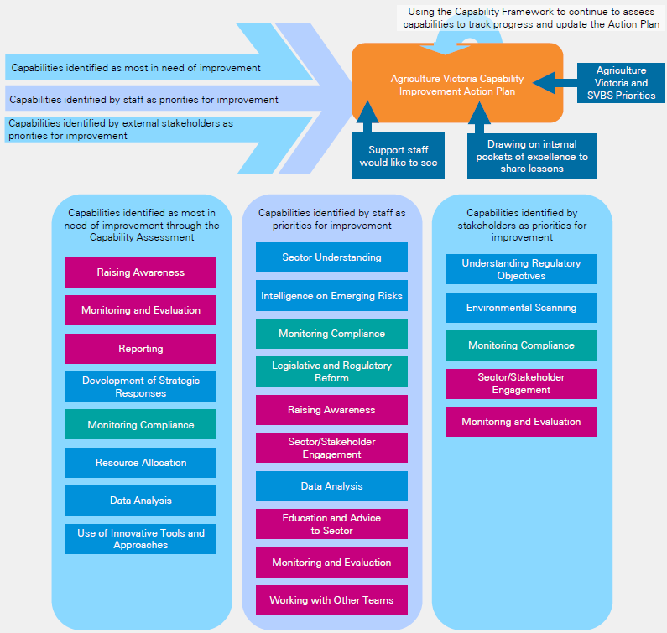
In developing an Action Plan, Agriculture Victoria should consider the following inputs:
- Capabilities identified as most in need of improvement
- Capabilities identified by staff as priorities for improvement Capabilities identified by external stakeholders as priorities for improvement
- Using the Capability Framework to continue to assess capabilities to track progress and update the Action Plan.

Agriculture Victoria Capability Improvement Action Plan
- Using the Capability Framework to continue to assess capabilities to track progress and update the Action Plan
- Agriculture Victoria and SVBS Priorities
- Support staff would like to see
- Drawing on internal pockets of excellence to share lessons.

Capabilities identified as most in need of improvement through the Capability Assessment
Capability identified | Type of Capability
Raising Awareness | Core
Monitoring and Evaluation | Core
Reporting | Core
Development of Strategic Responses | Strategic
Monitoring Compliance | Technical
Resource Allocation | Strategic
Data Analysis | Strategic
Use of Innovative Tools and Approaches | Strategic

Capabilities identified by staff as priorities for improvement
Capability identified | Type of Capability
Sector Understanding | Strategic
Intelligence on Emerging Risks | Strategic
Monitoring Compliance | Technical
Legislative and Regulatory Reform | Technical
Raising Awareness | Core
Sector and Stakeholder Engagement | Core
Data Analysis | Strategic
Education and Advice to Sector | Core
Monitoring and Evaluation | Core
Working with Other Teams | Core

Capabilities identified by stakeholders as priorities for improvement
Capability identified | Type of Capability
Understanding Regulatory Objectives | Strategic
Environmental Scanning | Strategic
Monitoring Compliance | Technical
Sector/Stakeholder Engagement | Core
Monitoring and Evaluation | Core

KPMG Contacts
Contacts in relation to this document:
Corrina Bertram
Partner
T: +61 3 9838 4564
E: cjbertram@kpmg.com.au
Adam Mason-Jefferies
Director
T: +61 3 9288 6026
E: amjefferies@kpmg.com.au
Ethan Bowering
Manager
T: +61 3 9288 6172
E: ebowering@kpmg.com.au
KPMG.com.au
©2021 KPMG, an Australian partnership and a member firm of the KPMG global organisation of independent member firms affiliated with KPMG International Limited, a private English company limited by guarantee. All rights reserved.
The KPMG name and logo are trademarks used under license by the independent member firms of the KPMG global organisation.
The information contained in this document is of a general nature and is not intended to address the objectives, financial situation or needs of any particular individual or entity. It is provided for information purposes only and does not constitute, nor should it be regarded in any manner whatsoever, as advice and is not intended to influence a person in making a decision, including, if applicable, in relation to any financial product or an interest in a financial product. Although we endeavour to provide accurate and timely information, there can be no guarantee that such information is accurate as of the date it is received or that it will continue to be accurate in the future. No one should act on such information without appropriate professional advice after a thorough examination of the particular situation.
To the extent permissible by law, KPMG and its associated entities shall not be liable for any errors, omissions, defects or misrepresentations in the information or for any loss or damage suffered by persons who use or rely on such information (including for reasons of negligence, negligent misstatement or otherwise).
Liability limited by a scheme approved under Professional Standards Legislation.
©2021 KPMG, an Australian partnership and a member firm of the KPMG global organisation of independent member firms affiliated with KPMG International Limited, a private English company limited by guarantee. All rights reserved. The KPMG name and logo are trademarks used under license by the independent member firms of the KPMG global organisation.
Liability limited by a scheme approved under Professional Standards Legislation.

