Shaping Victoria’s Biosecurity Future Workshop
A framing paper to help bring together industry, community and government perspectives on the challenges and opportunities for biosecurity in Victoria.
June 2021
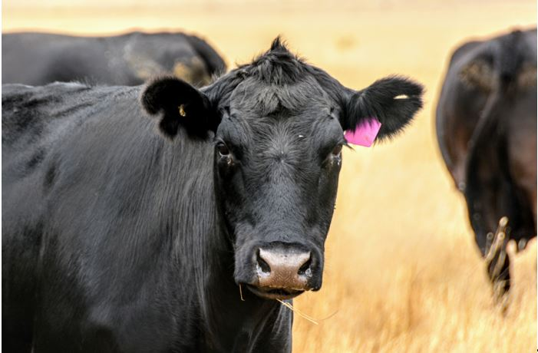

Acknowledgment
We acknowledge and respect Victorian Traditional Owners as the original custodians of Victoria’s land and waters, their unique ability to care for Country and deep spiritual connection to it. We honour Elders past and present whose knowledge and wisdom has ensured the continuation of culture and traditional practices.
We are committed to genuinely partner, and meaningfully engage, with Victoria’s Traditional Owners and Aboriginal communities to support the protection of Country, the maintenance of spiritual and cultural practices and their broader aspirations in the 21st century and beyond.

Welcome
Thank you for taking part in the upcoming Shaping Victoria’s Biosecurity Future workshop.
Over the past 12 months many of you have been involved in our interviews, meetings, and survey about Victoria’s biosecurity. The workshop is an opportunity to share what we’ve learnt and look at ways we can work together to strengthen biosecurity.
We know that an outbreak of a pest or disease can be devastating. It has the potential to cost our export-based economy tens of millions of dollars, harm the health and livelihoods of Victorians, and damage our landscapes, ecosystems, and cultural heritage. We also know that the risk of new pests and diseases is rising and there is a growing burden of established pest species to manage.
This has recently been emphasised at the national level, through CSIRO’s Australia’s Biosecurity Future report, which highlights that “scaling current approaches will not be enough” and that “now is the time for a system re-think”.
In 2019, the Victorian Government made a significant investment to strengthen Victoria’s biosecurity system:
- $114.7 million over four years to maintain delivery of current biosecurity services and address critical capability gaps
- $30.2 million ongoing funding to build specialist technical capability, and
$27.8 million over four years to implement a change program to strengthen Victoria’s biosecurity system.
The funding is supporting Agriculture Victoria to address increasing pressure on the biosecurity system by improving delivery of biosecurity services and building stronger relationships across the system.
A new Agriculture Strategy for Victoria was launched in 2020, outlining a path forward for a strong, innovative and sustainable agriculture sector. It includes commitments that will ensure Victoria is well-placed to respond to climate change, pests, weeds, disease, and increased resource scarcity into the future. Improving biosecurity will support how we recover faster, grow partnerships with industry and community to increase market access, modernise our methods and legislation, promote biosecurity awareness and increase consumer confidence while protecting what matters to Victorians.
The past 18 months has highlighted the critical importance of an effective biosecurity system, as Victoria has faced concurrent emergency responses and recoveries to bushfire, COVID-19, and avian influenza. Exotic diseases such as African swine fever are becoming increasingly present in the Asia-Pacific region, while fall army worm has rapidly spread through Australia after first being detected in Far North Queensland in January 2020. Transformation within the Victorian biosecurity system is needed now more than ever.
To respond to these challenges and support our agriculture sector to thrive we must strengthen the biosecurity system and further reform, develop, and implement innovative approaches. Agriculture Victoria is engaging with industry, community, and government to determine how we do this. By coming together at this workshop with people from across the biosecurity system, you ensure your sector or interest is represented in this important collective conversation.
Whatever your role in the biosecurity system, the agricultural industry, or the many other connected sectors – the shared knowledge you bring to this conversation will shape the future of biosecurity in Victoria. We look forward to the discussions that will support better outcomes in biosecurity for all Victorians.
Matt Lowe
Chief Executive, Agriculture Victoria


Contents
Acknowledgment 1
Welcome 1
1. This paper 2
2. The purpose of the workshop 2
3. What is biosecurity? 3
4. Why does Victoria need a strong biosecurity system? 3
5. Insights and perspectives from across Victoria’s biosecurity system 4
Theme 1: Strengthening partnerships and engagement 5
Theme 2: Modernising legislation and enhancing regulatory practice 8
Theme 3: Improving our preparedness for biosecurity emergencies 10
Theme 4: Enhancing information sharing and surveillance 12
6. What happens next? 15
More information 15

1. This paper
This framing paper outlines what we have heard over the past 12 months from industry, community, and government representatives about their views, knowledge, and aspirations for Victoria’s biosecurity system. It is intended to share perspectives from people across the system, highlight opportunities and gaps, and provide another step towards meeting future challenges.

2. The purpose of the workshop
The Shaping Victoria’s Biosecurity Future Workshop is part of Agriculture Victoria’s efforts to strengthen Victoria’s biosecurity system.
The purpose of the workshop is to:
- develop a shared understanding of the challenges facing the biosecurity system
- explore opportunities to strengthen the system
identify how we can work together to achieve these improvements.
It will bring together individuals from industry, community, and all levels of government, across a diverse range of organisations and sectors related to agriculture, land management, environmental protection, and biosecurity regulation, among others.
It follows on from a survey and a series of interviews about biosecurity with individuals from across the system. It also builds on the 2019 Agriculture Victoria Biosecurity Roundtable, by seeking the perspectives of a broader cross-section of the biosecurity system about the issues and opportunities for Victoria.

3. What is biosecurity?
Biosecurity is reducing the harm caused by pests and diseases entering, emerging, establishing or spreading, and impacting on the community, economy, and environment – these measures can be on-farm, regional, state-based, national, or international.
An effective biosecurity system relies on the shared actions of, and partnerships between, federal, state, and local government agencies, industry and environmental bodies, landowners and managers, and the broader public.
Our biosecurity system is a layered defence involving many people, roles, and responsibilities. The system includes biosecurity activities offshore (reducing risk posed by other countries), at the Australian border (stopping pests and diseases entering Australia), and within Victoria (finding, eradicating, or managing pests, diseases and weeds that have entered Victoria). Biosecurity measures reduce the risk along the continuum from offshore, to the border, to within Victoria. This involves research, capability building, leadership and coordination, and intelligence and information sharing.
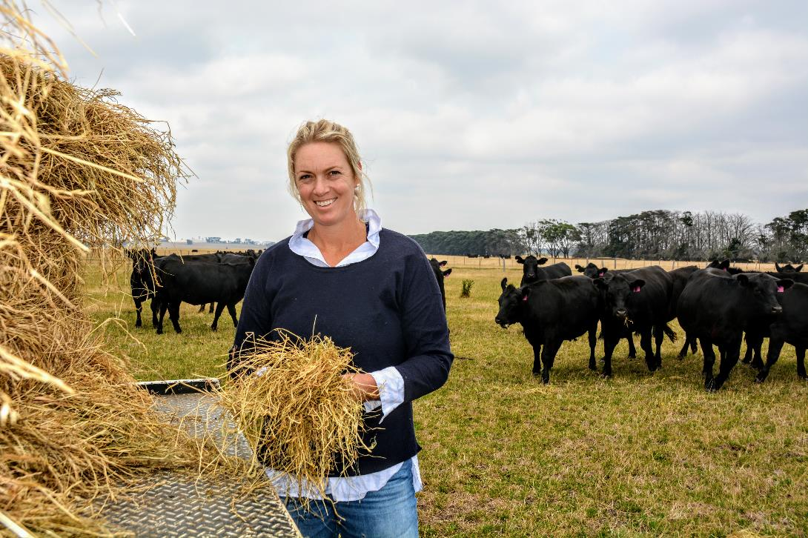

4. Why does Victoria need a strong biosecurity system?
Australia is free from many pests and diseases found around the world. This enables our farmers to be more productive and profitable and makes our agricultural products more attractive overseas. These benefits are made possible thanks to a strong biosecurity system that protects our agricultural industries, environment, and economy from the threat of exotic pests and diseases.
Biosecurity is essential to our economy, supporting a thriving domestic and export agricultural industry in Victoria. Protecting our pest and disease status provides product assurances that support a sector worth over $14.9 billion in milk, fruit, vegetables, meat, fibre, eggs, and grain – of which the majority is exported. Consumer confidence, here and overseas, is underpinned by the credibility of our regulatory systems for biosecurity, animal welfare, food safety, and agricultural chemical use.
Pest and disease outbreaks may affect our market access and impact our ability to export. In a significant outbreak, the economic, social, and animal welfare consequences can be far beyond the immediate pest or disease impacts. Re-gaining markets requires a highly effective and rapid response.
A strong biosecurity system…
… Provides resilience against increasing pressures and demands
To continue Victoria’s performance in biosecurity into the future we must prepare for the effect of increased pressure on the system: more movement of people and goods; changes in climate, land use, and industry structures and practices; and shifts in community expectations.
As biosecurity risks increase so too do demands for government biosecurity services, and the Victorian Government is looking closely at these challenges at a state level.
… Protects the Victorian economy and employment
Victoria’s agricultural industry is essential in our economy, creating jobs in many other sectors, including tourism and hospitality, and supporting thriving regional communities. But the biosecurity system extends well beyond the agriculture sector. A strong and healthy biosecurity system also benefits and protects other areas of the economy and environment. The forestry, marine and water supply sectors, for example, all rely on the biosecurity system to protect them from the emergence and spread of pests and diseases.
Biosecurity has a role to play in protecting public health and food security and is vital for preserving the integrity of our parks, waterways, gardens and native habitats, which in turn support the tourism and recreation sectors. Pests and weeds can have a major impact on Aboriginal cultural heritage and values, damaging sensitive sites and emerging bush food enterprises, and threatening endangered indigenous flora and fauna.
… Needs us all to work together
We all benefit from a strong, effective biosecurity system, regardless of the role we play. It cannot be left to one individual or organisation – we can do it better when we work in partnership with others across the spectrum of biosecurity. In a strong and robust biosecurity system, people can see their role, play their part, and work in partnership with others to share the responsibility for biosecurity decisions and actions.
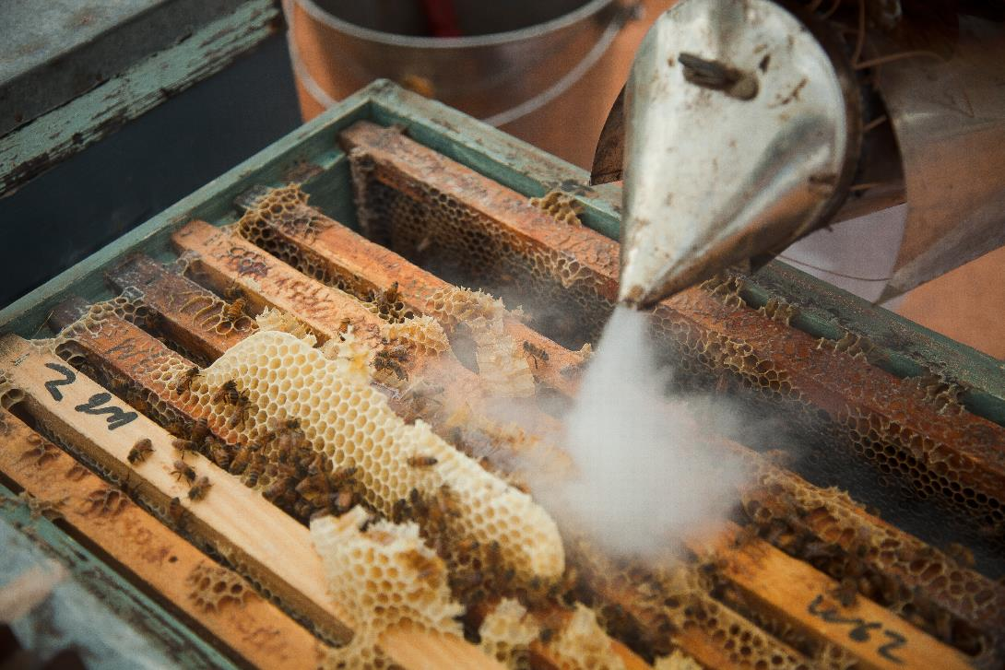

5. Insights and perspectives from across Victoria’s biosecurity system
Agriculture Victoria’s engagement process over 2020–21 captured the diversity of views, voices, and expertise across the biosecurity system. This included a statewide survey and a series of one-on-one interviews, both conducted by independent consultants.
The statewide survey invited farmers, businesses, industry groups, and community members to have their say on biosecurity. More than 1400 people shared their views on questions covering potential biosecurity threats and impacts, where they source their information, and what could be improved in the system.
One-on-one interviews were conducted with 114 people from across industry, community, and government, including farmers, public land managers, Traditional Owners, government staff, peak body representatives, and Landcare leaders. Participants’ views on biosecurity were sought across themes such as roles and responsibilities (Figure 1), decision-making, relationships, strengths and weaknesses.
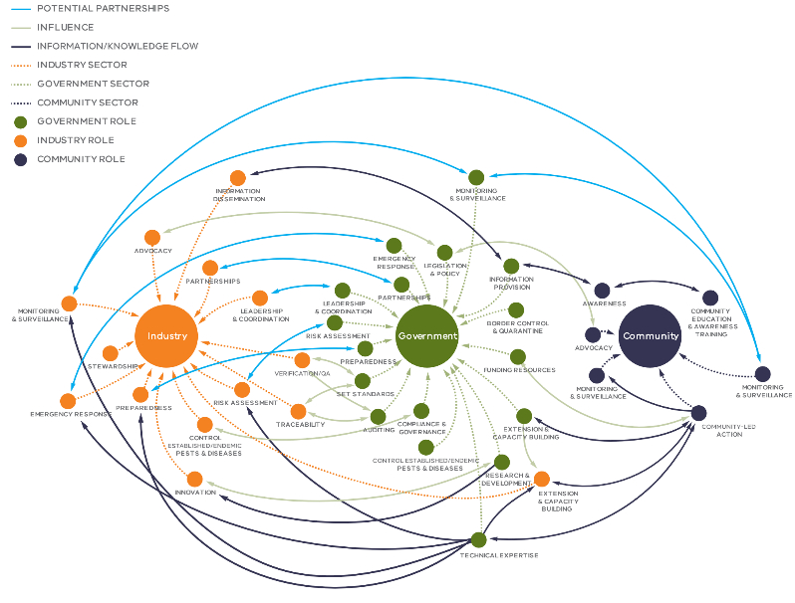
Figure 1: A map of government, industry, and community roles and responsibilities, developed using data collected through one-on-one interviews with people across the biosecurity system. The map illustrates where the roles and responsibilities of government, industry, and community intersect, signalling potential for partnerships and shared decision-making based on common interests, e.g. emergency response, monitoring, and surveillance.
The following sections provide an overview of the insights and findings that emerged from the engagement. These are grouped into broad themes that reflect the structure of the workshop:
strengthening partnerships and engagement, modernising legislation and regulatory practice, improving preparedness for biosecurity emergencies, and enhancing information sharing and surveillance.
The full reports from the survey and interviews are available on our website.

Theme 1: Strengthening partnerships and engagement
A strong biosecurity system is underpinned by our individual and collective efforts. It requires partnerships and meaningful, principled engagement. These need to be supported by institutional arrangements that support co-operation and facilitate collective action.
There are many examples of robust and effective collaboration in biosecurity, including Victoria’s Community Pest Management Groups, and the partnerships between Agriculture Victoria and the apiary industry on the varroa mite threat. There are also many situations where collaboration and sharing of responsibility happen, but a lack of formal arrangements mean that roles and responsibilities aren’t well understood.
Our engagement process showed there is a strong willingness across community and industry to engage and partner with government on biosecurity. There are major benefits to be realised through greater involvement of industry and community in decision-making, including driving greater ownership of the challenges and increasing participation in the system.
The engagement highlighted a range of perspectives on partnerships and engagement in Victoria’s biosecurity system.

Shared responsibility
Stakeholders recognise that government neither could, nor should, address biosecurity issues alone; rather it requires shared responsibility. In the survey, farmer respondents rated State Government as having the greatest responsibility for biosecurity, though other levels of government, business, industry bodies, communities, and individuals were all key players too (Figure 2). However, there were only moderate ratings on the question of whether ‘everyone is working together’ on biosecurity in Victoria (Figure 3).

Relationships
The engagement highlighted the wide variation in strength and quality of relationships between government and other participants in biosecurity. Relationships are generally seen as strong between the State and Federal Governments, and with primary industry peak bodies. In the environment, Local Government, Aboriginal land management, and natural resource sectors, there is a view that engagement from Agriculture Victoria is low or has declined, and the opportunities to collaborate are very limited.
“The fact that they are doing this work, this is motivating. Great to see.” – Plant industry respondent
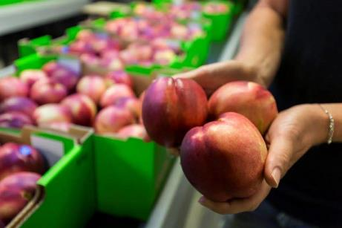

Emergency experiences
Many industry representatives pointed to previous experience working together with government on emergency responses or preparedness programs, as a key factor in establishing effective working relationships. Outside of these situations, relationship building can be viewed as challenging to resource and quantify.
“Incursions mean that there is more experience and previous incidents have made sure that communities and farming groups are ready. However, this is often a hard way to learn.” – Plant industry respondent

Environmental biosecurity
Some interviewees believed that government efforts to engage on environmental biosecurity are misguided, and that more work is needed to identify and develop relationships with relevant groups. Fragmentation between the multiple government agencies with responsibilities in this space were highlighted as a key challenge. Some groups in natural resource management reported that they have already taken on greater responsibility for biosecurity advice and support to land managers. They are concerned they have been left to provide this support alone, where previously they worked in partnership with government agencies.
“There needs to be recognition that there are not just one community but many types of communities and community engagement is not a one-way activity.” – Community interest group respondent
“The Landcare network is being told that they are an important part of the system and solution, community driven priorities and shared responsibility is really important. [But] when they make … some positive suggestions that will make a difference in the region, it falls flat. The partnership approach isn’t genuine or two-way.” – Landcare respondent

Engagement efforts
There was a perception amongst some interviewees that governments’ engagement is tokenistic and not driven by a genuine desire to share responsibility, resources, and decision-making. In addition, interest groups are concerned about low general community awareness about biosecurity, and see lack of engagement with backyard, small and lifestyle farmers as a significant risk.
“The shared models need to be developed with the stakeholders rather than the government providing the approach and seeking permission and support after the fact.” – State Government respondent

Institutional arrangements
Inclusive and equitable institutions guide collective action in biosecurity management, changing the way responsibility is shared. Many interviewees had concerns about a lack of formal opportunities for groups outside of the traditional agricultural industry sector to engage with Agriculture Victoria on biosecurity and have input into decision-making.
“This consultation is a first – bringing it to the forefront. There are not strong relationships currently, but we have strong interest to re-engage.” – Landcare respondent

Traditional owners
There was a perception among Traditional Owner corporations that Agriculture Victoria is not strong in engagement with Aboriginal people and Traditional Owners, compared to other State Government departments. Interviewees stated that senior managers in the department need to build relationships with Traditional Owners so they can engage appropriately and include Elders in conversations and solutions about biosecurity.
“Water sector and land managers relationships are good – huge networks. Agriculture Victoria, no, not so much” – Aboriginal land manager respondent
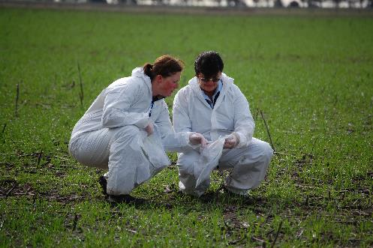

Government responsibilities
Some interviewees were concerned that government is falling short of its own biosecurity responsibilities, especially in management of weeds and pests on public land. There were also concerns raised about any assumption that government has the lion’s share of responsibility for biosecurity issues, noting that many industries and groups have taken leadership in areas where government has reduced investment.

Costs for non-government groups
There is some concern that government may not fully appreciate the extent to which some groups (e.g. Landcare, industry organisations) have already assumed biosecurity responsibilities. Some stated that there has been ‘cost shifting’ and withdrawal of government services.

Willingness to engage
Regardless of roles, there is strong willingness to engage with government on biosecurity. Community and industry are open to building partnerships that do not necessarily have government at the centre and are keen to discuss how to build true partnerships. Respondents noted that the process of determining how responsibility should be shared must be collaborative.
Figure 2: Farmer perceptions on responsibility for biosecurity in Victoria. Q28: On a scale from 1 to 5, where 1 means ‘not at all’ and 5 means ‘to a great extent’, to what extent do the following groups have responsibility for Victoria’s biosecurity?
Figure 3: Perceptions on the extent to which everyone in the biosecurity system is working together. Q29a: Thinking now about all the individual businesses, organisations and people involved in the biosecurity system. On a scale from 1 to 5, where 1 means ‘not at all’ and 5 means ‘to a great extent’, to what extent do you feel that everyone is working together? Base sizes (n=): Farms 752; Related businesses 301; Affiliated farmers / businesses 201; Small holdings / lifestyle farmers 77; Interest groups 66; Government 43.

What do you think?
What are the goals we want to achieve by strengthening partnerships and engagement in Victoria’s biosecurity system?
What are the principles and values that should drive our future work around partnerships and engagement?
How can government drive the engagement process and at the same time support a more active role for stakeholders in terms of responsibility, power, and decision-making?

Theme 2: Modernising legislation and enhancing regulatory practice
Modern and flexible legislation is a key aspect of a strong and responsive biosecurity system. Legislation should enable the regulator to hold a stewardship role, and then systems can continually improve with the involvement of other key participants in the system. Regulators remain responsible for policy advice and legislation but do so with mechanisms to collaboratively adapt to changes in the system.
By developing a consolidated Biosecurity Act, the Victorian Government will create the legislative environment necessary to support effective system stewardship. This will strengthen the collective management of biosecurity risks and our response to new challenges. A modernised system will support Victoria’s ongoing contributions to national and international biosecurity arrangements.
Our biosecurity system is also shaped by policy and regulatory practices. At a government level, this covers the way we use the legislation to achieve biosecurity outcomes, marshal capability and expertise to where it’s needed, set biosecurity risk management, compliance, and enforcement priorities, and make resourcing decisions.
A key aspect of building confidence is performance evaluation, underpinning accountability of participants in the system. Broadly, the key measures of success are how well the system reduces the likelihood of new pests and diseases occurring, prepares for, and responds to emerging threats.
Our engagement highlighted a range of perspectives on improving legislation, regulation, and performance measurement.

Modernised and integrated
Many interviewees held a view that Victoria’s legislation is not contemporary and does not align with approaches used in other states and territories around Australia. Legislative reform presents an opportunity to look at where better alignment with other biosecurity frameworks might be possible, while still protecting Victoria’s interests.
“Victorian legislation is outdated. For example, Victoria would have to pay compensation if other states declined. The national deeds are disconnected from Victorian legislation.” – Federal Government respondent

Build on what works well
Legislative reform and regulatory practice need to look at where things are working well and explore how these strengths could be modelled across the whole system. There are great examples of shared responsibility in practice and aspects of legislation that are effective and robust. It will be important to retain and build upon these strengths.
“What’s being done with fruit fly currently is fantastic. Fruit fly has no silver bullet to get rid of it. It involves everybody – backyard gardeners, councils, community, growers, government… On farm we control it well ... we can’t control what’s happening in the community. But the councils are managing hygiene, getting rid of unwanted host trees and running school programs. And we’re really noticing the impact of the program in Cobram.” – Plant industry respondent
“Animal biosecurity has a good agreed system in place to deal with an outbreak – including authorisations and processes. Key players are aware of their roles and responsibilities and those of others. There is a clear understanding of the purpose of each of the steps in the system.” – Industry peak body respondent

Strategic direction
Many interviewees identified a lack of clarity about government investment decisions between different species of pests, e.g. blackberry but not deer. There was a perception that investment decisions, including on enforcement action, sometimes don’t align to the risk and the stated policy objectives. People were also unclear on government priorities on environmental biosecurity issues.
Several respondents believed that opportunities to build compliance through education, advice, engagement, and guidance were being missed, resulting in an over-reliance on enforcement.

Performance measurement
Many survey respondents were not confident in the performance of the biosecurity system, with only 44 per cent and 55 per cent of farmers and businesses, respectively, rating it as ‘functioning well’. However, some government and industry stakeholders interviewed thought it was performing strongly, pointing to the few new pests and diseases entering the region and the number of markets that Victorian commodities are accepted into as evidence of its strength. The measurement and communication of system performance warrants review to ensure participants have confidence that the objectives of the biosecurity system are being met. To achieve this, we need to understand what performance information is relevant to the level and scale at which stakeholders operate and make decisions.

Social and cultural drivers
In the interviews, legislative and regulatory obligations, industry or business reputation, and involvement in an outbreak or incursion were highlighted as key drivers of biosecurity action across the system. In comparison, respondents to the survey – including farmers – ranked altruistic factors such as ‘doing the right thing’ and ‘protecting environmental values’ as the strongest motivator of biosecurity efforts, above economic factors (Figure 4).
In interviews with Traditional Owners and Aboriginal land managers, the management of pest plants and animals was viewed as just one part of a holistic approach to healing Country, in which cultural practice and the Aboriginal Heritage Act are both key drivers of action. The impacts of pest plants and animals on Aboriginal cultural heritage is well understood by Traditional Owners interviewed,
but values can be at odds with Western views – for example, pest horses that are protected for historical or social values are doing damage to culturally significant Aboriginal sites.
An understanding of the range of motivations that drive behaviour will help us to be more effective in the way we legislate and regulate.
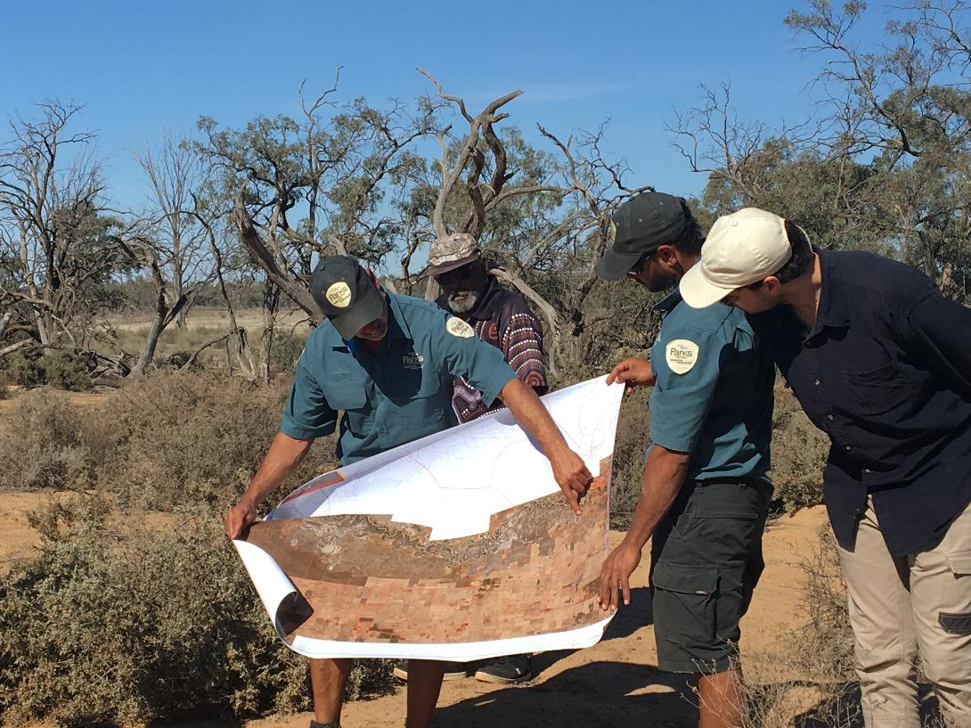
“Biosecurity is not just about economic development but about healing and managing Country… Management needs to be aware of protecting all elements of cultural heritage, even the intangible heritage – story lines, totem species.” – Aboriginal land manager
Figure 4: Factors that “strongly influence” the amount of time and money farmers devote to biosecurity. Q27: For each of the following factors, how weakly or strongly do they influence the amount of time and money you / your business devotes to biosecurity? Base sizes (n=): Farms 752.
“Government role has to be driven by something greater than profit, economic gain and growth. We need regulations that truly care for Country in all ways.” – State Government respondent

What do you think?
What aspects of the existing legislation create pain and what aspects create gain? Are there examples where other legislation or jurisdictions do something well that could be an opportunity for our reforms?
How could shared responsibility be supported by legislation and regulation?
What could the legislative and regulatory framework do to promote innovation and growth?
Given that the threats and priorities will always exceed the available government investment, how do we make decisions about priorities and who should pay for biosecurity activities?
How do non-government groups invest in biosecurity currently? What co-investment models are currently in use or should be considered?
How can good biosecurity behaviours be encouraged?

Theme 3: Improving our preparedness for biosecurity emergencies
The risks posed by exotic pests and diseases are increasing due to growing international passenger and trade volumes, population expansion, the emergence of new pests and diseases, and regional instabilities. Now more than ever, it’s important that we ensure we are getting biosecurity preparedness right and that we have the long-term commitment and resources to do so.
The allocation of resources to a prevention outcome is the most cost-effective method for managing the threat of biosecurity incursions. However, we must be prepared for incursions that slip through border measures, spread, and establish, and then pose a serious threat to the community, economy, and environment. Detection of ehrlichiosis in dogs in Australia in 2020, and the detection of red imported fire ants in Western Australia in 2019 and at the Port of Brisbane in 2021, are examples of such an incursion. Likewise, avian influenza, which emerged from the wild bird population into commercial poultry in Victoria in 2020, causing the destruction of over 460,000 birds and costing over $20 million to eradicate. There is also increasing awareness about the implications of climate change for pest, disease, and weed incursions, with recent investments at the national and state level into improving preparedness for changing biosecurity risks.
When significant pest or disease incursions occur, the government has biosecurity emergency management responsibilities it must meet according to international standards. We know that the direct impacts of incursion and response activities can be enormously damaging to the community, environment, and industry, and that the broader impacts can be felt for many years.
Working together to optimise our levels of preparedness at scale makes sense. But what does this mean for various stakeholders? And how can each stakeholder and the government best contribute to improving our overall biosecurity emergency preparedness? Agriculture Victoria’s recent experience in responding to avian influenza and participating in preparedness exercises have highlighted the importance of being able to scale up at speed, as well as the large number of considerations required for a response. Thinking through the issues in partnership with industry is essential to understanding the reality of what is involved in responding.
Preparedness is a broad subject and covers not just emergency response. Other elements include biosecurity planning as a vital way for producers and related businesses to manage risks and build resilience so that the impact on stakeholders is minimised whilst a response is underway and government can rollout as effectively as possible from detection, to response, to recovery.
Our consultations highlighted a range of views about the structures and resources in place to support preparedness for biosecurity emergencies.

Prevention efforts
Some interviewees reported that while government was very active and effective in incursion responses, efforts in prevention, including surveillance and enforcement of current regulations, are far less prominent. Others highlighted the need for clarity around the role of industry and community in prevention efforts.

Biosecurity planning
Industry peak bodies and other agencies strongly encourage producers to develop biosecurity plans, including as part of production assurance programs, however only six out of ten of farmers and four out of ten of related businesses said they have a biosecurity plan (Figure 5). About two-thirds cited safety risk management as the main reason for having a plan while one-third said that legislative and regulatory requirements were the main reason.
Figure 5: Survey respondents with a biosecurity plan. Q20: Does your business / organisation have a biosecurity plan? Base sizes (n=): Farms 752; Related businesses 301. Q21. What is the main reason for adopting a biosecurity plan? Base sizes (n=): Farms 410; Related businesses 128.
“Agriculture Victoria needs additional resourcing for preparedness work… [they] are not combat ready…. Ideally, they should be moving from an incident response to a policy response with a focus on prevention. They are not resourced to do the horizon scanning and to consider changing public expectations, e.g. climate change impacts.” – State Government respondent

Resources and data
Almost 20 per cent of interviewees identified preparedness as a weakness in the system, citing reductions in capability, resources, and budget due to a lack of serious historic outbreaks, as a key factor. Other concerns included a lack of data (or access to data) on impacts, spread, and control of biosecurity risks.
A widely held view was that government’s short-term funding cycles are a challenge for the long-term nature of biosecurity management. Interviewees viewed short-term projects as leading to inconsistency and uncertainty regarding government’s commitment to biosecurity.

Technical capabilities
Many interviewees viewed Victoria’s capabilities in biosecurity as among the best in the country with the avian influenza outbreak highlighted as an example. However, government staff noted that in real terms this was only a small outbreak of seven infected farms. For them it highlighted that improvements in preparedness are necessary to ensure response capabilities can be scaled effectively in a widespread incursion. Other interviewees pointed to Victoria’s collaborative efforts in scenario planning for varroa mite as a strong example of preparedness and planning efforts.
“Unless you can actually document what preparedness is – you can’t really measure progress against it… There is a big difference between being prepared for foot-and-mouth disease versus a fire season, versus an avian influenza outbreak. At the end of this, you should really know what being prepared is.” – Federal Government respondent
“Victoria is the strongest state in emergency planning in biosecurity. We’ve done courses in emergency situations and have run at least one emergency scenario planning session as if [exotic parasite] had hit. So, we’re part of the way there in emergency planning.” – Industry respondent
“The incorporation of climate change risk into local planning still has a long way to go.” – Catchment Management Authority respondent
“From a human health and environmental perspective, it is understanding the impacts of climate change on biosecurity and ensuring safe drinking water and food safety for humans… ensuring we don’t have spread of biological food agents from animals to humans – prefer prevention rather than response.” – State Government respondent

Climate change and biosecurity
Climate change presents many biosecurity challenges and a significant proportion of interviewees mentioned the changing risks under changing climate. This is very much a preparedness and prevention situation. At the time of interviews, many people highlighted that government was not setting any strategic direction or taking leadership in this area.

What do you think?
What are the principles, values, and outcomes that should drive our future work around preparedness for and resilience to biosecurity emergencies?
What does preparedness look like for individual businesses and whole industries? What’s needed to support this?
What does preparedness look like for government? What’s needed to support this?
What activities could improve preparedness for industry and government?

Theme 4: Enhancing information sharing and surveillance
A strong biosecurity system has interconnectivity and interdependence, which is reflected in the coordination of information sharing between community, industry, and government. Sharing information, creating intelligence that is actionable, and tapping into our collective capacity to innovate and adopt new technology are all critical to prepare for the emerging risks. Enhancing the way we do this collectively can avoid duplication of effort and support more efficient use of resources.
Surveillance information is collected by governments, industry, and the community, and there is significant value in collaboration with this data. However, a lack of awareness of the impacts at a broader scale can create a barrier to sharing data and reporting detections, especially where people believe that this may have a detrimental effect on livelihoods.
Our consultations have highlighted concerns in a range of areas.

Border processes
Some interviewees reported that different biosecurity processes in each state, and at a national level, add to costs and complications for businesses seeking to meet biosecurity requirements.

Barriers to data sharing
There was a perception among some interviewees that there was a lot of information collection happening but little sharing of that information with stakeholders in industry, community, and environment and natural resource management bodies. The lack of resourcing for data analysis and publication was highlighted as a barrier to better sharing.
“There is an opportunity to recognise industry data. The best approach would involve a partnership between industry and government with a Memorandum of Understanding which would ensure appropriate editing and validation.” – Plant industry respondent
“There […] needs to be more trust in industry and the opportunity to work collaboratively. Development of effective relationships and communication and flow of data between government and industry is essential for this.” – Plant industry respondent
“Data is often readily available for agricultural diseases and pests but is less clear and available for environmental issues.” – Federal Government respondent

Citizen science opportunity
Several interviewees stated that the broader community isn’t used enough in surveillance and early detection of weeds, pests, and disease. Currently there are no formal avenues for citizen science data to contribute to biosecurity in Victoria. Others highlighted a number of community-focused surveillance and reporting tools developed in other jurisdictions that could be implemented in Victoria given appropriate funding.
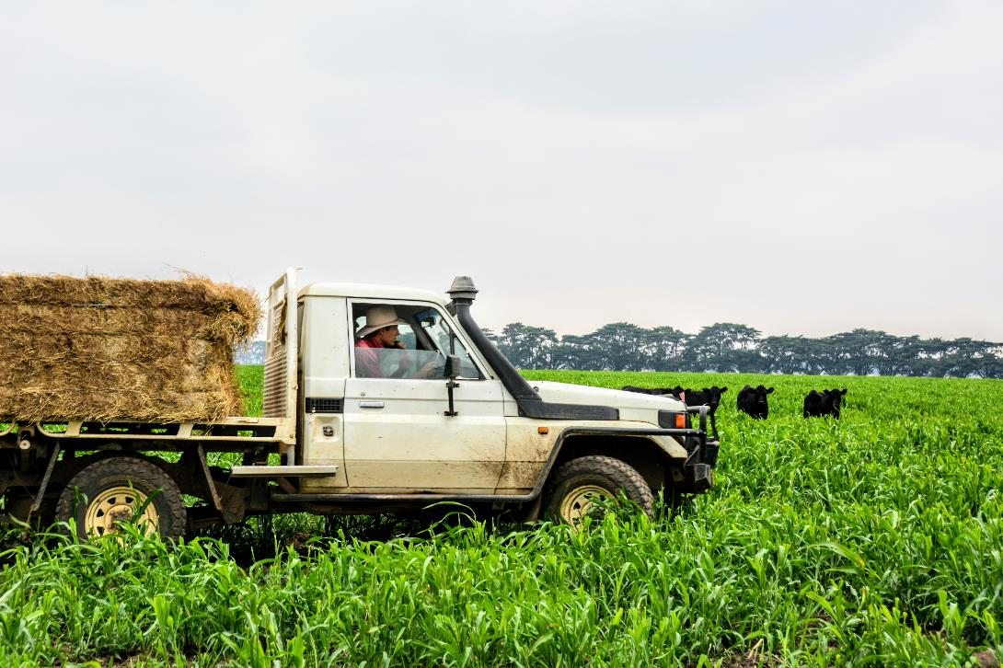
“The strength of citizen science in biosecurity is the sheer number of eyes you can have looking for something... Citizen science can cover a huge area. They can provide diversity, coverage, and frequency in data collection that agencies or researchers can’t. People can look for something daily if it’s in their local area. Another strength is that people know their local area.” – Community interest group respondent

Detecting and reporting an outbreak
Almost 60 per cent of farmers surveyed said they are very likely to report an outbreak of a pest, disease, or invasive species, though less than 25 per cent said it was very likely they had the procedures in place to detect an outbreak promptly (Figure 6).
Figure 6: Percentage of survey respondents very likely to detect and report an outbreak. Q9: Please consider a hypothetical situation where an unusual pest, disease or invasive plant or animal species found its way onto your business / farm and starts to spread. A. What is the likelihood that you / organisation have procedures in place to identify the biosecurity threat promptly. B. What is the likelihood of you reporting the biosecurity threat. Base sizes (n=): Farms 752; Related businesses 301; Affiliated farmers /businesses 201; Small holdings / lifestyle farmers 77; Interest groups 66; Government 43.
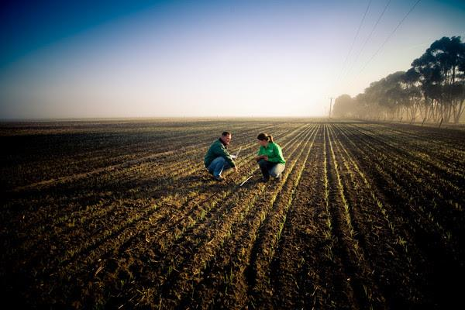
“Reporting results in a loss of business due to quarantine, negative impact on social standing, and potential loss of future contracts. The system doesn’t support reporting. This highlights that the legislation and quarantine are a problem.” – Plant industry respondent
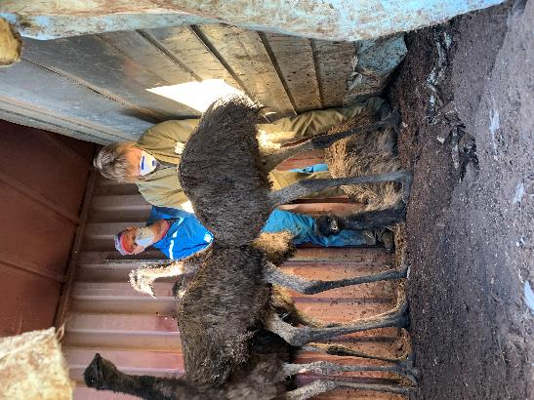

Consequences of reporting
Surveillance and early detection of a biosecurity risk was noted as a key influence on biosecurity decision-making for many industry interviewees, but this was tempered by concerns about the repercussions (for a business) that could come with a detection on your property. Many people highlighted that land manager consequences for reporting an incursion or outbreak compromise the ability to detect new threats.

Livestock traceability
Interviewees with a nationwide perspective also highlighted the importance of Victoria’s leadership in biosecurity issues like the sheep and goat electronic identification system. Others coming from a statewide point-of-view noted that the potential benefits of this system are not fully utilised.

Peak bodies’ role in the information chain
Survey respondents indicated that they rely more on peak bodies than on government for information about biosecurity (Figure 7). However, there are also concerns among interviewees that many commercial farmers, lifestyle farmers, and landowners aren’t connected to a peak or industry body and so are not captured through industry communication and information sharing channels.
“There is a role for government to ensure parts of the industry that are not covered by levy organisations are still subject to biosecurity requirements and responsibilities; for example, peri-urban farms with one or two animals.” – Livestock industry respondent
“There are around 10,000 registered beekeepers in Victoria and about 95% of these are recreational. Only a small number are members of clubs and therefore getting information about biosecurity... This poses a massive biosecurity risk to other commercial beekeepers as well as food production more broadly.” – Industry respondent

Communication and education gaps
Fewer than half of farmers surveyed said that Victoria’s biosecurity system is functioning well. Some of the key areas highlighted for improvement were better communication, information, and education. Farmers identified ‘warnings and alerts’ as the most important type of information they need to receive, followed closely by ‘how to identify pest and disease symptoms’ (Figure 8).
“Feedback to community is also very important and something that’s often overlooked once the data has been collected. Community want to know their influence and how it has informed decision-making.” – Community interest group respondent

Preferred communications channels
Email is the most effective way for government to communicate biosecurity information to farmers, according to the survey. Less than a quarter (24 per cent) of farm respondents said that social media is an effective way to communicate, significantly lower than postal (52 per cent) and newspapers (41 per cent).
Figure 7: Farmers’ sources of biosecurity information. Q15: How important are the following sources of biosecurity information for you? Q16: And for each of those sources of information, how much do you rely on them to inform your decisions about biosecurity? Base sizes (n=): Farms 616.
Figure 8: The most important types of biosecurity information for farmers. Q18. Which are the most important types of biosecurity information you need to receive? Base sizes (n=): Farms 667.

What do you think?
our collective capability in surveillance and data collection across the system?
What are the principles and values that should drive our work in this area?
What goals do we want to achieve by improving information sharing and surveillance in Victoria’s biosecurity system?
How do we optimise engagement with those not associated with peak bodies?

6. What happens next?
The past 18 months has been challenging right across the biosecurity system, with industries, government agencies, and communities alike needing to adapt quickly to respond to and recover from consecutive emergencies while keeping pace with business-as-usual. Over 2020-21 Victoria has experienced considerable pressure on its biosecurity system – a reminder that disease and pest threats require constant preparedness. It is unlikely that this pressure will significantly ease in the future. We know that biosecurity risks are increasing, and the system is already under strain.
A clear message from the survey and interviews is that we need to continue to build capacity and capability in the face of inevitable and growing biosecurity risks. The challenge is how we can better co-ordinate our collective resources, knowledge, and expertise to foster a more resilient biosecurity future for Victoria. Now is that time.
We are at a point where this collective discussion on the challenges and opportunities has the potential to lead to real change for the system – strengthening our partnerships, modernising our legislation and regulatory approaches, enhancing preparedness and resilience, and improving how we share information across the system.
Feedback from the workshop will be captured, reported, and used to inform the next steps in this program of work. Your input will be critical to driving a reform agenda for the transformation of Victoria’s biosecurity system beyond June 2021.

More information
For more information visit our websiteagriculture.vic.gov.au/svbs-program or email questions to SVBSProgram@agriculture.vic.gov.au
