Victoria’s Biosecurity Roundtable 2022
Final report
Strengthening Victoria’s Biosecurity Program
Agricuture Victoria
Published by Agriculture Victoria
Department of Environment, Energy and Climate Action
1 Spring Street Melbourne, Victoria 3000
January 2023
© Copyright State Government of Victoria 2023
This publication is copyright. No part may be reproduced by any process except in accordance with provisions of the Copyright Act 1968.
This report was prepared by Currie Communications.
Disclaimer
This publication may be of assistance to you but the State of Victoria and its employees do not guarantee that the publication is without flaw of any kind or is wholly appropriate for your particular purposes and therefore disclaims all liability for any error, loss or other consequence which may arise from you relying on any information in this publication. While every effort has been made to ensure the currency, accuracy or completeness of the content we endeavour to keep the content relevant and up to date and reserve the right to make changes as required. The Victorian Government, authors and presenters do not accept any liability to any person for the information (or the use of the information) which is provided or referred to in the report.
Accessibility
To request an accessible Word version please email SVBSprogram@agriculture.vic.gov.au or visit agriculture.vic.gov.au/svbs-program.

Acknowledgement of Country
We acknowledge the Traditional Owners of Country throughout Victoria and their ongoing connection to this land, and we pay our respects to their culture and Elders past, present and future.
We recognise and value the ongoing contribution of Aboriginal people and communities to Victorian life and how this enriches our society.
Traditional Owners and First Peoples have an intrinsic connection to their Country and we acknowledge their ongoing knowledge and their contribution to the management of land, water, the natural landscape and our built environments.
We recognise the unique knowledge, rights and interests of Aboriginal people in Victoria’s biosecurity system. We seek to create respectful partnerships and to develop policies and programs that respect Aboriginal self determination and align with treaty aspirations.
In the context of biosecurity, this means building meaningful relationships and collaborative partnerships that seek to incorporate the knowledge, laws, culture, customs and traditions of Aboriginal people into our biosecurity laws and system.

Contents
1 Executive summary 4
1.1 Insights 4
1.2 Next Steps 7
2 Context 9
3 Launch of the Biosecurity Statement 12
3.1 Introducing Victoria’s Biosecurity Statement 12
3.2 Industry and community perspectives 13
4 A biosecurity strategy for the future 15
4.1 Introduction to strategy development 15
4.2 Discussion questions: From vision to strategy 15
5 Biosecurity in the context of caring for Country 23
5.1 First Nation perspectives 23
5.2 Discussion insights 24
6 Driving behavioural change for preparedness and resilience 26
6.1 Government roles and responsibilities in biosecurity preparedness and communication 26
6.2 Discussion question: Gaps and opportunities for biosecurity awareness 29
6.3 Industry and community roles in biosecurity preparedness and communication 31
6.4 Discussion questions: Biosecurity messaging 31
7 Biosecurity legislative reform 36
7.1 Biosecurity legislative reform discussion paper 36
8 Glossary 44

1 Executive summary
Agriculture Victoria’s Strengthening Victoria’s Biosecurity System (SVBS) Program is engaging with stakeholders from across the biosecurity spectrum to build a stronger biosecurity system for the future.
The engagement has provided a deeper understanding of strengths and gaps and built a coalition of partners and stakeholders to support improvements to Victoria’s biosecurity system.
The Victoria’s Biosecurity Roundtable 2022 (the Roundtable) brought together a diverse mix of 141 individuals from industry, community, and all levels of government on 12–13 September 2022.
Victoria’s Biosecurity Statement (the Statement) – a vision for the future that expands our thinking on what biosecurity means and the notion of shared responsibility – was launched at the Roundtable, and participants explored how, together, this vision can be brought to life.
This report reflects the discussions held by participants at the Roundtable and not necessarily the views of Agriculture Victoria.

1.1 Insights

Session 1: Launch of Victoria’s Biosecurity Statement
In setting the scene, the opening session launched Victoria’s Biosecurity Statement. It is a bold new vision for Victoria’s biosecurity system, providing a foundation for the development of a new Biosecurity Strategy and supporting legislative reform.
Shared responsibility and action are at the heart of biosecurity preparedness, responses and management and will bring to life the vision outlined in the Statement.
The development of a Biosecurity Strategy for Victoria (the Strategy) will acknowledge existing initiatives that involve successful industry and community collaboration, and address gaps in engagement to support more comprehensive biosecurity capacity. It will set the stage for meaningful conversations that decide and prioritise action.
Insights included:
- Biosecurity needs system-wide reform: changes in strategy, organisational processes, technology platforms as well as culture and identity.
- Cross-sector cooperation and collaboration, together with collective action, are required to build capability and resilience into the biosecurity system.
- More trust in the wisdom of communities is needed to mobilise collective action.
- Reflecting industry and community stories and wisdom in Victoria’s Biosecurity Statement and the Biosecurity Strategy is important to stakeholders.

Session 2: A biosecurity strategy for the future
Participants shared their views about Victoria’s Biosecurity Statement, including perceived barriers and opportunities for implementation, and key focus areas for the Biosecurity Strategy.
Participants agreed the Statement is important because it provides clarity on where we are at, direction on how we should move forward and sets a shared vision for collective action.
Insights included:
- Engagement to date highlights there are no boundaries to biosecurity and to rise to the challenge, all stakeholders must employ a systems-lens to develop a strategy fit for the future.
- Key challenges to implement the Strategy were identified as stakeholder engagement across the spectrum, communication and awareness, investment in tools and resources, addressing existing community attitudes, and alignment with national biosecurity systems and governance.
- The Strategy needs to be supported by a commitment to funding, investment, and awareness-raising within the general public.
- Focus areas for strategy development should include:
o research and development (R&D) and innovation: building new knowledge, tools and technologies
o people: supporting and empowering people working in biosecurity
o systems and processes: designing effective systems and processes
o governance: setting up shared, integrated and inclusive governance of biosecurity
o legislation: creating legislation that supports positive biosecurity behaviour.

Session 3: Biosecurity in the context of caring for Country
First Nations leaders shared stories of Aboriginal-led biosecurity and land management approaches for healing Country, and opportunities for improved collaboration in biosecurity.
Participants were asked to understand that traditional cultural lands have been under biosecurity threat since colonisation. Working with Traditional Owners and First Nations landholders and communities in a holistic approach to biosecurity and biodiversity offers an opportunity to build a better biosecurity future.
Insights included:
- A whole-of-landscape approach is necessary to achieve long-term solutions.
- A holistic approach to biosecurity is needed, that mirrors and calls on Aboriginal knowledge, culture and practices.
- The involvement of Traditional Owners from the beginning is critical.
- Partnerships and collaboration between Traditional Owners and private landowners go a long way.
- There is much to be done within First Nations communities, and the right people need to be involved.

Session 4: Driving behavioural change for preparedness and resilience
Participants heard that the risk of a significant biosecurity incursion is continuing to grow, particularly in Victoria.
Preparedness is imperative, and it has several parties – government, industry, and community.
The roles and responsibilities of community, industry and government, particularly around awareness-raising and communication, are imperative to a biosecurity system fit for the future.
Alertness of biosecurity threats and effective responses must be built on a contract of trust, and a shared understanding of each other’s roles and challenges. This appreciation should be developed during ‘peacetime’.
Insights included:
- Strengthening communities' ownership and decision-making power – including in hard-to-reach areas – builds resilience and capacity to prepare for and respond to a biosecurity threat.
- Gaps in biosecurity preparedness include information flows, often caused by silos in government and a lack of a clear source of truth.
- Opportunities exist to:
o learn from and leverage emergency management sector structures and systems
o get involved in the Commonwealth’s strategic conversations about emergency management strategy to help set up early triggers
o establish transparent communication chains/processes within Agriculture Victoria
o provide education, training and effective distribution of communications to industry and community.
- Messaging must be tailored, speaking to people's values (what they care about) and delivered by trusted sources at a local level.
- Simple, clear, practical guidance on the ‘what’ and ‘how’ is sought by many.

Session 5: Biosecurity legislative reform
Stakeholder and community input is being sought through extensive engagement on biosecurity legislative reform. Participants explored how expert advice could be recognised in legislation, and how legislation could support shared responsibility and collective action to strengthen Victoria’s biosecurity system.
Participant insights and suggestions included:
- Engage early and engage often to navigate challenges in developing biosecurity legislation.
- Current legislation does not sufficiently recognise the roles of stakeholders outside of government and industry, which can be a barrier to full participation.
- The importance of localised knowledge and action should be recognised. People trust information from people they know and are often influenced by what they see their neighbours doing.
- Biosecurity is more effective when people collaborate on decisions and set priorities together, and then work together on implementing strategies.
- There is a lack of understanding of legal obligations and the role we each play.
- Legislation should be clear on roles and responsibilities, and expectations to ensure accountability throughout the system.
- Legislation should be easy to understand.
- New legislative tools that could be considered in reformed legislation include a general biosecurity duty and appointment of an Inspector-General of Biosecurity for Victoria. ,
- Ensuring jurisdictional legislation alignment is considered a challenge.

1.2 Next Steps
The Roundtable discussions will be considered by the Strengthening Victoria’s Biosecurity System (SVBS) Program as it works with stakeholders to develop the new Biosecurity Strategy for Victoria by June 2023.
The Strategy will turn the broad aspirations of Victoria’s Biosecurity Statement into tangible priorities. It will be co-developed with key stakeholders from across the system – including government, industry, community, and Agriculture Victoria staff – to ensure joint ownership and to drive coordinated change.
Feedback from Roundtable participants on the biosecurity legislative reform will be considered together with feedback on the public discussion paper to inform the development of policy proposals around new biosecurity legislation. Stakeholders and the public will have further opportunity to provide feedback on the policy proposals.

2 Context
We all have a role to play in biosecurity, to help protect and enhance Victoria. We know our efforts are more effective when we work together, share information, and invite diverse perspectives into decision making.
Agriculture Victoria has engaged with people and organisations across the biosecurity system since 2019 to strengthen how we all work together to protect Victoria from the harms of pests and diseases. The engagement has provided a deep understanding of strengths and gaps in biosecurity in Victoria and built a coalition of partners and stakeholders to support improvements to Victoria’s biosecurity system.
We’re committed to ongoing, consistent, and inclusive engagement as we shape the future of biosecurity in Victoria.
Victoria’s Biosecurity Roundtable 2022 launched Victoria’s Biosecurity Statement – a vision for the future that expands our thinking on what biosecurity means and the notion of shared responsibility – and explored how together, this vision can be brought to life.
It brought together a diverse mix of individuals from industry, community, and all levels of government (Figure 1). Participants were located across the state and beyond (Figure 2) and represented different sectors including agriculture, land management, environmental protection, and biosecurity regulation, among others.

Figure 1. Roundtable participants came from industry, community, and local, state/territory and federal government.
Description of Figure 1: The figure is a pie chart showing the three sectors were represented by 48 per cent of participants from government, 28 per cent from industry and 24 per cent from community.
PURPOSE
The Roundtable sought to:
- launch Victoria’s Biosecurity Statement
- determine strategic priorities and explore opportunities to strengthen biosecurity in Victoria
- discuss Victoria’s biosecurity legislative reform
- explore opportunities for partnerships and preparedness as part of the next steps in reforming Victoria’s biosecurity system.
FORMAT
The online event was held on 12–13 September 2022 and incorporated five individual sessions.
- Session 1: Opening and Biosecurity Statement launch
- Session 2: A biosecurity strategy for the future
- Session 3: Biosecurity in the context of caring for Country
- Session 4: Driving behavioural change for preparedness and resilience
- Session 5: Biosecurity legislation reform
Three sessions had breakout rooms to allow everyone to contribute to discussions. Each room had pre-assigned hosts to facilitate and capture the discussions. Key insights were shared with all participants after each breakout session.
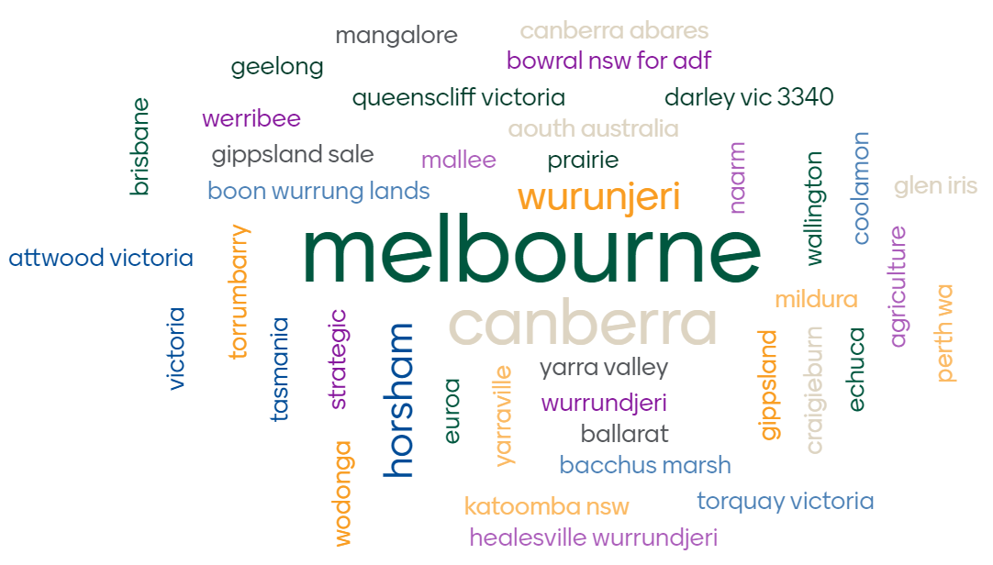
Figure 2. Representation of participant locations.
Description of Figure 2:
- The figure is a word cloud showing participant locations.
- Roundtable participants were based in Victoria, New South Wales, Queensland, South Australia, Western Australia and Tasmania, with Melbourne being the most common location.
- Other locations include: Wurundjeri, Euroa, Naarm, Boon Wurrung, Canberra, Mangalore, Bowral, Geelong, Queenscliff, Darley, Gippsland, Mallee, Prairie, Werribee, Brisbane, Wallington, Coolamon, Glen Iris, Perth, Echuca, Craigieburn, Gippsland, Mildura, Attwood, Torrumbarry, Wodonga, Horsham, Yarraville, Katoomba, Yarra Valley, Ballarat, Bacchus Marsh, Katoomba, Healesville, Torquay and Melbourne.
PARTICIPATION
Of the 177 registered, a total of 141 participants attended the Roundtable.
Agriculture Victoria leadership and staff attended the Roundtable as speakers and facilitators, and participated in discussions with stakeholders.
See Appendix A for the list of organisations represented across the two days.
DESIGN
The SVBS Program team led the design and delivery of the Roundtable with help from the consulting firm Currie Communications.
REPORTING
This report was prepared by Currie Communications and is intended to provide a summary of discussions held at the event. The information contained in this report represents the views of Roundtable participants. Insights presented were gathered through the notes recorded in breakout sessions and group discussions. For transparency and record keeping purposes, the report writers have tried to retain the intent of the discussions and have not revised or corrected points after the event.
APPENDICES
Appendices A-D are available as a separate document on the Agriculture Victoria Website.

3 Launch of the Biosecurity Statement
Session 1: The purpose of this session was to open the event, launch Victoria’s Biosecurity Statement, and set the scene for discussions about delivering a biosecurity system for the future.
This session was attended by 99 participants.

3.1 Introducing Victoria’s Biosecurity Statement
Two keynote speakers opened the Roundtable with the launch of the Statement:
Matt Lowe, Chief Executive, Agriculture Victoria
Matt acknowledged that biosecurity is at the front of people’s minds with varroa mite affecting, Foot-and-mouth disease (FMD) and Lumpy skin disease (LSD) on Australia’s doorstep. He outlined the extensive preparedness activity already underway, and the ongoing commitment from government at all levels.
Shared responsibility and action are at the heart of preparedness, response and management and will bring to life the vision outlined in Victoria’s Biosecurity Statement (Figure 3). The Statement sets out a bold new vision, co-written by people across the biosecurity system. It will be a foundation for a new Biosecurity Strategy for Victoria that is being developed alongside legislative reforms.
Dr Katherine Clift, Executive Director, Biosecurity Victoria, Agriculture Victoria
Katherine highlighted the importance and necessity of system-wide reform and improvement which will require changes in strategy, organisational processes, technology platforms, as well as culture and identity.
Victoria’s Biosecurity Statement is the culmination of several years of stakeholder engagement and consultation. It provides a light on the hill, to guide the development of the new Biosecurity Strategy over the coming nine months.
The Strategy will acknowledge existing initiatives that involve successful industry and community collaboration, and address gaps in engagement to support more comprehensive biosecurity capacity. It will set the stage for meaningful conversations that decide and prioritise action.
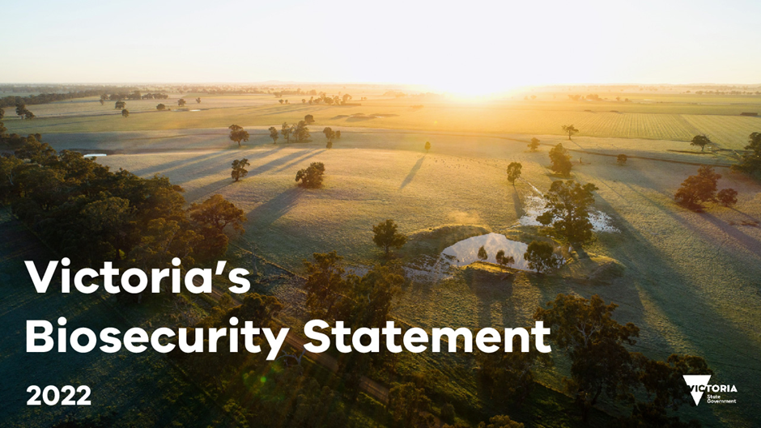
Figure 3. Image of Victoria’s Biosecurity Statement

3.2 Industry and community perspectives
Three speakers provided community and industry perspectives on opportunities across the system for setting strategic direction for the ongoing reform.
Andrew MacLean, CEO, Landcare Victoria
Andrew provided an overview of Landcare and its role as a community-led partnership that supports biosecurity systems across Victoria (Figure 4). He noted the importance of a collaborative approach, and that it was critical for government to trust in the wisdom of communities, and to invest in them. This means government needs to be more open to the uncertainty and inconsistency that can come with working with diverse communities.
Mark McDonald, Executive Officer, Australian Livestock Saleyards Association
Mark provided insight into the livestock saleyard system, a challenging biosecurity environment with a high volume of livestock movement from around the state and beyond. He said this challenge was exacerbated by recent activists coming onto properties, with there being little support from laws. Mark highlighted that the most effective way to enhance biosecurity at saleyards was to ensure that systems are working before livestock arrive at the yards.
Danyel Cucinotta, Vice-President, Victorian Farmers Federation
Danyel provided a farmer perspective on biosecurity, and the importance of biosecurity for protecting Victoria’s food future. She noted that the involvement of farmers in the Statement was a positive step, and continued involvement along the way was critical. She expressed the importance of reflecting farmer and community stories in the Statement and any future strategy.
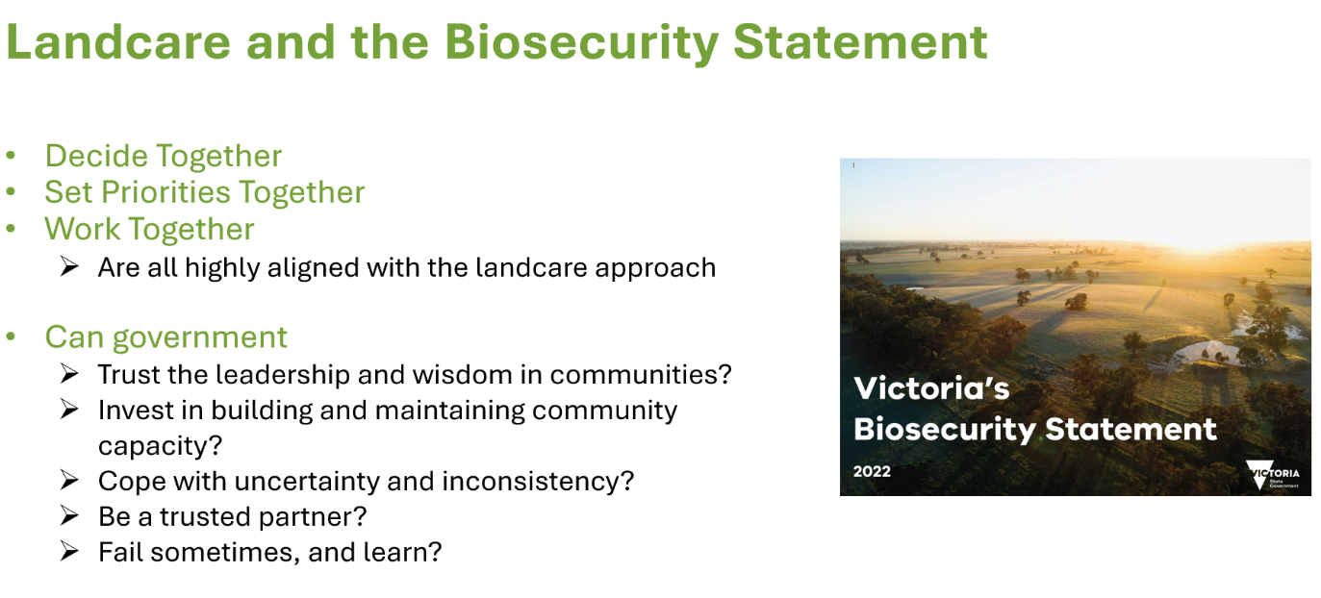
Figure 4. A slide from the presentation by Andrew MacLean, CEO, Landcare Victoria.

4 A biosecurity strategy for the future
Session 2: The purpose of this session was to consider the practical implications of Victoria’s Biosecurity Statement and highlight connections with the development of the Strategy, as well as identify barriers and opportunities for implementation of the Statement’s vision, and key focus areas for the Strategy.
This session was attended by 90 participants.

4.1 Introduction to strategy development
Michael Reid, Director, Biosecurity Strategy, Agriculture Victoria
Michael introduced the challenge to bring Victoria’s Biosecurity Statement to life through the Biosecurity Strategy. The Strategy development is an opportunity for biosecurity stakeholders to be deliberate and intentional in our collective action.
Engagement to date has highlighted there are no fences in biosecurity and to rise to the challenge, government and stakeholders must employ a systems-lens to develop a strategy fit for the future.
The need for strong partnerships in biosecurity is clear and must be built on two-way trust. Michael encouraged participants lean into the idea that great minds think differently.

4.2 Discussion questions: From vision to strategy
In breakout rooms, participants were asked for input on the following questions:
- What is important about Victoria’s Biosecurity Statement?
- What are the challenges and opportunities that will be involved when implementing the Biosecurity Statement’s vision?
- What focus areas need to be in Victoria’s Biosecurity Strategy to achieve the vision set out in the Biosecurity Statement?
Insights provided below were identified through the assessment of breakout session notes provided as Appendix B.

4.2.1 What is important about Victoria’s Biosecurity Statement?
Key insights
Participants said the Statement helps more people understand what biosecurity means, their roles and responsibilities in the Victoria’s biosecurity system, and how they can work together. Participants agreed the Statement is important because it provides clarity on where we are at, direction on how we should move forward, and sets a shared vision for collective action.
“[From the] Statement and this process that we're going through, it’s clear that we are willing to listen to all parties, to be heard, [the] Statement is important in this respect.”
Participants commented that the Statement’s collaborative approach, acknowledgment of First Nations knowledge, and inclusion of a wider environmental perspective brings stakeholders across sectors and industries together. It appeals to a broad group, demonstrates a sense of priority, and a genuine shared commitment to protect and strengthen the Victoria’s biosecurity system, as well as leadership from the Victorian Government.
Regarding biosecurity concerns, some participants suggested the Statement needs to draw out the seriousness of biosecurity risks and recognise biosecurity as a national challenge.

4.2.2 What are the challenges and opportunities that will be involved when implementing the Biosecurity Statement’s vision?
Key insights
Participants highlighted the priority challenges and opportunities in implementing the Statement vision as:
- engagement with stakeholders across the spectrum
- communication and awareness
- investment, tools and resources
- community attitudes towards biosecurity
- alignment with the national biosecurity system and governance.
Beyond these five priorities responses were highly fragmented. Further investigation of the five priorities is detailed below.

4.2.2.1 Engagement with stakeholders across the spectrum
Participants identified engagement with stakeholders across the spectrum as a common challenge.
Many expressed the need for all stakeholders to be actively engaged, yet recognised the complexity of differing values and interests (e.g. environment, agriculture, commercial, health, etc.) means it is difficult to factor all community needs and elements.
For some industries, disengagement has become more pronounced due to the lack of in-person interactions since the COVID-19 pandemic.
“Broad spectrum of stakeholders may be difficult to reach. Biosecurity is everyone's responsibility, and everyone has a role to play.”
“People may have become a little disconnected from the pandemic and this might be a broader issue across community.”
Multiple participants mentioned the engagement gap in land management between public and private land managers.
“Difficulty with engagement at the same level. Public land that is adjacent or runs through private land. Not enough biosecurity between public and private land by contractors.”
“Management of land along railway lines, weeds that are not being managed do become a serious issue. One of the biggest is going to be commitment across multiple agencies.”
Silos within government was mentioned as a challenge for engagement, particularly between Agriculture Victoria and the Department of Environment, Land, Water and Planning. Participants suggested the state government should ensure a whole-of-government approach to biosecurity.
Another challenge raised was the loss of key engagement contacts, as people change roles and organisations.
“[For the pig/beef industry], contacts with previous extension officers based across the state and key engagement staff have been lost – this cannot be a responsibility of just the government but needs to be shared.”
Opportunities:
- Find the right motivators and articulate support to put shared responsibility in everyone’s mind.
- Recognise many different sources of expertise and ensure all are engaged.
- Take a collaborative approach and encourage participation from all stakeholders, especially in the creation of the new Biosecurity Strategy for Victoria as it will lead to better buy in.
- Understand the unique circumstances of different participants in the system as well as the common experiences.
- Make biosecurity plans for all stakeholders a priority, with tailored solutions for each industry/sector.
- Help empower people through better training and support.
- Strengthen regulation to ensure all players participate.
- Develop shared priorities based on clear eagerness and goodwill to work together.
- Engage those that are hard to reach such as peri-urban residents through local councils and community groups.

4.2.2.2 Communication and awareness
Many participants considered the general lack of awareness and the amount of biosecurity issues to be a challenge. Discussions highlighted that biosecurity is seen by many as something at or beyond Victoria’s borders, or outside their property. Participants acknowledged it is important for everyone to see the significance of biosecurity across the landscape, including in their own actions.
Communication challenges include closing the communication loop, and the need to be clear on sources of factual information. Participants recognised the opportunity to connect with the knowledge of First Nations people for cross-cultural biosecurity practice and management.
“Factual knowledge (e.g., defining a source of truth). E.g., FMD, there’s a lot of hearsay that has not been corrected and [is now] dispersed throughout community.”
“Producers put lots of time and effort into initiatives – communication back is an issue. Surveillance as example, the data doesn't get fed back well to farmers.”
“There is a lot of talk, the main thing is the way the First Nations people think is different to the way that non-First Nations people think. Need to connect to community and to the people that matter, [otherwise] it isn't worth much. First Nations and farmers think along the same lines. First Nations have been doing biosecurity for thousands of years, but it just isn't written down. People need to connect with the knowledge that the First Nations peoples have.”
Other challenges mentioned were low brand recognition of Agriculture Victoria, the need to define the scope, boundaries and outcomes of the Biosecurity Strategy, and to have clear, consistent and prompt messages that appeal to everyone. Some people expressed the need to see progress and achievements against the Strategy.
“[D]uring Japanese encephalitis virus outbreak, research into farmers [showed] low brand recognition of [Agriculture Victoria]. People don't know we exist.”
“Important for Statement to be remembered and kept in front of mind. Communication and collaboration [are] important. Message needs to be consistently reinforced. National issue, not just Victoria.”
Opportunities:
- Provide awareness and education as early as possible across a wide spectrum of stakeholders, and frame and target messages correctly.
- Invest in early education – look into the Kitchen Garden program for inspiration – to help kids learn about pests and diseases at a young age.
- Consider using value-based messaging to make it real and relevant to all people in the biosecurity ecosystem.
- Harmonise the messaging across Victoria and Australia to help people understand how the Strategy fits into the bigger picture.
- Create a compelling narrative that covers the need for resourcing, funding, benefits and risks for all stakeholders.
- Set up clear measures and indicators around achievement of the vision (look at scope; targets).
- Facilitate collaboration between government and industry/community groups to ensure messages reach everyone across the biosecurity spectrum.
- Use different channels to maximise the reach and engage the right people.

4.2.2.3 Investment, tools and resources
While participants felt that everyone has a role in strengthening the biosecurity system, many considered the time, work, energy and resources required for biosecurity as a challenge. A lack of people with the right skills, knowledge and experience, and the lack of equitable funding solutions were highlighted.
“Things [we] need to do now to uplift biosecurity capability. It's a continuous thing from a strategic perspective, we need things in place that are scalable to position well – technology, processes, way engaging with industry.”
“From the tech space, finding the right talent to do the job – you can have the great ideas, but you need the right knowledge and experience to drive things.”
“A gap can often be local government. Underfunded, under resourced and lack of funding. Don't have capacity to operate in this space. Don't know their delivery capacity.”
Some participants expressed the need to adopt and improve technologies (e.g. QR codes, photo systems with the capability of interpreting data and data sharing systems) to support data collection and knowledge sharing. However, the speed of adoption can also be a key barrier to implementing new technologies.
Opportunities:
- Provide education and training programs to uplift biosecurity capability.
- Increase investment and support for R&D, innovation and technology as we need tools for all stages of the invasion curve.
- Invest with the private sector, and other states.
- Establish industry liaison officers, trained and in place.
- Facilitate consistent funding to allow people to see value in the investment.
- Look at trends from existing data across agencies for human health impacts and using that to focus efforts and resources.

4.2.2.4 Community attitudes towards biosecurity
Some participants considered community attitudes to be a challenge, particularly complacency at the farm level. Despite acknowledging the importance of being biosecurity-ready, there is a perception that people do not act until the risk is at their door.
Without collective action, complacency is a risk and biosecurity impacts are likely to be much worse. Collective action requires shifting the resilience agenda from an emergency management issue to a whole-of-government and whole-of-nation focus.
Many participants raised the need to change community attitudes toward biosecurity, shifting to a similar position as fire preparedness, where the community is aware, vigilant and prepared.
Opportunities:
- Raise awareness of the benefits of having a strong biosecurity system, as well as the risks.
- Embed preparedness thinking into the broad community.
- Tap into research and development – using those findings to drive awareness pieces and behavioural change.
- Learn from our approach to emergency management – what has worked and what has not worked.

4.2.2.5 Alignment with the national biosecurity system and governance
Many participants identified the challenge in aligning the Biosecurity Strategy for Victoria with the new National Biosecurity Strategy, as well as the opportunities and the need to work with all states and territories on a coordinated national biosecurity system.
Key gaps mentioned were transport tracking, disinfection and a national permit system. The new National Biosecurity Strategy and the work of the National Biosecurity Committee (NBC) are seen as critical, but the states/territories need to drive action.
“Challenge with national system: saw this with COVID – same challenges with biosecurity system. NBC work is critical. More work to do on a coordinated national biosecurity system. Need systems to be working much better together – challenge and opportunity.”
The culture shifts articulated in the Statement – such as the inclusion of First Nations and environment in biosecurity considerations and the changing role of government – will challenge the traditional way of doing things. Some noted the collaborative approach to biosecurity would require more time for different perspectives to be taken onboard. This can be a challenge when timely decisions are required.
Effective governance was raised as an important factor to successful strategy implementation. Clearly defined roles and responsibilities for various aspects of biosecurity are considered necessary. The identification of priority outcomes and actions across different biosecurity areas, a clear understanding of the decision-making process, and where people go to for support and get direction from are also required.
Opportunities:
- Make sure decisions are inclusive of the parties that will be involved.
- A need for national consistency and clearly defined roles, responsibilities and relationships between national and state/territory jurisdictions.
- Governance and decision-making should focus less on areas of action, more on the way of working. It should consider dual flows – not telling others but rather sharing information and deep listening.
- A need to integrate with other existing strategies and frameworks such as Regional Catchment Management Authorities strategies, Parks Management Plans, Regional Pest Management Plans, and Protecting Victoria’s Environment – Biodiversity 2037.

4.2.3 What focus areas need to be in Victoria’s Biosecurity Strategy to achieve the vision set out in the Biosecurity Statement?
Key focus areas identified:
- R&D and innovation: building new knowledge, tools and technologies.
The importance of innovation was noted, including research into resilient animal and plant varieties, digital technology to help identify pests and weeds, and various tools that could be developed to support pest management.
- People: Supporting and empowering people working in biosecurity.
The importance of supporting people working in biosecurity was highlighted. This included the need to build up skills, increase the labour force, provide mental health support, and more broadly empower people and communities on the ground to act on biosecurity measures.
- Systems and processes: Designing effective systems and processes.
Systems and processes need improvement across the biosecurity invasion curve from surveillance, preparedness and prevention to eradication, containment and recovery. In particular, information systems and processes were identified as a key area, including the frequency, accuracy and distribution of important information.
- Governance: Setting up shared, integrated and inclusive governance of biosecurity.
Participants highlighted the need for the Biosecurity Strategy to create a shared and inclusive system of governance, where decision-making responsibility is shared with the diverse set of stakeholders, from grassroots up. This new system of governance needs to provide clarity around roles and responsibilities and be integrated with national and multi-jurisdictional policies and strategies.
- Legislation: Creating contemporary legislation that fosters positive biosecurity behaviours.
The need for more contemporary legislation was raised by numerous participants, in particular, legislation that has more effective incentives and disincentives to support compliance.
Supporting areas were also identified by participants:
- Awareness and education: Raising awareness and educating the public on the importance and risks of biosecurity.
Participants noted the limited public awareness of the importance and risks of biosecurity, and the importance and urgency of awareness raising and education. It was noted that greater public awareness would support the delivery of the Strategy.
- Funding and investment: Providing funding and investment to deliver the Biosecurity Strategy for Victoria.
Numerous participants raised the need for funding and investment to implement the Biosecurity Strategy. Concern was given about the level of funding needed to implement on-ground change, and the risk the Strategy would become a motherhood statement.
Additional comments were made about other key features that should be included in the Strategy to ensure success. These included a:
- clear definition of success, with KPIs and measures for outcomes
- focus on implementation and action beyond motherhood statements
- reflection on shared responsibility and collective action.

5 Biosecurity in the context of caring for Country
Session 3: The purpose of this session was to share examples of indigenous-led biosecurity and land management approaches for healing Country and increase understanding of how First Nations’ involvement can improve biosecurity outcomes in Victoria.
This session was attended by 87 participants.

5.1 First Nation perspectives
Hosted by Russell Adcock, Senior Advisor, Aboriginal Employment and Engagement, Agriculture Victoria, this session featured three First Nation’s speakers who shared their lived experiences of biosecurity on-country and insights into opportunities for government, industry and community collaboration with Traditional Owners.
Speakers included:
Uncle Dave Wandin, Wurundjeri Elder and Chairperson, Wandoon Estate Aboriginal Corporation
With extensive experience working in Aboriginal agriculture and environmental management, Uncle Dave asked that participants understand that traditional cultural lands have been under biosecurity threat since the time of colonisation. He reflected on the opportunity that working with Traditional Owners in a holistic approach to biosecurity and biodiversity offers, and encouraged open, ongoing dialogue. He highlighted the important role of traditional practices, such as burning, for managing pests and diseases on Country.
Uncle Lawrence Clarke, Board member Western Local Land Service NSW
Uncle Lawrence shared stories of his own experience working with and between different Aboriginal community groups, using practical examples to demonstrate the need and benefit of connecting with the right people in these groups, and the value of taking the time necessary to ensure all are involved.
Damien Jackson, Cultural Heritage Protection Officer, Parks Victoria
With significant experience working in management of pests on public land, Damien shared firsthand experiences of managing pest incursions, in particular rabbits. He highlighted the intersection of biosecurity and Traditional Owner concerns through the example of the significant rabbit problems in Victoria’s north-west and its impact on ancestral burial sites.

5.2 Discussion insights
Key takeaways from the discussions included:
- A whole-of-landscape approach is necessary to achieve long-term solutions.
o Providing funding for individual slices of land to tackle biosecurity fails to consider neighbouring land and the wider landscape. For example, fencing pests out doesn't remove the problem. It pushes pests into neighbouring land, making it someone else's problem and causing issues for native species.
o Historically, when funding runs out, a lack of neighbourhood support leads to the land being reinfested very quickly.
o In this vein, there needs to be a long-term commitment to a sustainable solution. Short-term goals like cutting pest numbers down to 30 per cent fails to address the issue in the long-term.
- A more holistic approach to biosecurity can draw on Aboriginal knowledge, culture and practices.
o The current approach often looks at the value of land through a commercial or agricultural lens only, rather than thinking holistically.
o We often overlook the context that defines something as a pest, for example kangaroos weren't traditionally pests, they were natural to their landscape. However, we have changed that landscape and in this new context they are considered pests.
o It is often forgotten that there are also invasive indigenous plants as well, and that Traditional Owners have had biosecurity systems in place to deal with this, such as cultural burning. These systems have only recently been recognised as legitimate practices despite being effectively used for over 65,000 years.
o A more holistic approach fits with Aboriginal practices and looking at landscapes as part of a broader spiritual or cultural connection may make it easier to manage pest animals at a whole-of-landscape level.
- For active biosecurity initiatives, it is critical to involve Traditional Owners from the beginning.
o Involvement of Traditional Owners early ensures full consideration in the development of deeper, richer, more effective initiatives and responses.
o Parks Victoria is an organisation that works closely with Traditional Owners throughout the biosecurity management process, regularly talking with Traditional Owners to share their knowledge about local fauna and inform the approach they will take to manage pests.
- Partnerships and collaboration between Traditional Owners and private landowners go a long way.
o Having private landholders and Traditional Owners simply sit down and hear each other's side of the story builds valuable trust and connection and presents an opportunity for collaboration and learning.
o Sometimes private landholders feel threatened but Traditional Owners are keen to help and share knowledge for the betterment of land and waterways.
o There is much to be done within Traditional Owner communities, and the right people need to be involved.
o Within communities, there is opportunity for education and sharing of knowledge around land degradation.
o Involvement of a diverse range of Traditional Owner communities, and Aboriginal women, will strengthen the impact and value of collaboration around biosecurity and land management.
o People who work amongst and between Aboriginal and Traditional Owner communities can help identify the correct people to talk and engage with.
o There is a need to be aware that approaching a specific community can create tension between Traditional Owner communities.

6 Driving behavioural change for preparedness and resilience
Session 4: The purpose of this session was to explore the roles and responsibilities of community, industry and government in biosecurity preparedness, in particular, around awareness-raising and communication. The session also aimed to examine the gaps and opportunities that must be addressed to improve communication and drive behavioural change around biosecurity preparedness.
This session was attended by 86 participants.

6.1 Government roles and responsibilities in biosecurity preparedness and communication
A government perspective on biosecurity preparedness and communication was shared by:
Dr Graeme Cooke, Chief Veterinary Officer, Agriculture Victoria.
The risk of a major biosecurity incursion is continuing to grow, particularly in Victoria. Livestock and people movement creates risk.
Preparedness is imperative, and it has several parties – government, industry, community. Government has a huge role to play in biosecurity preparedness, however there are important activities that require the willingness and collaboration of the broader population.
Graeme emphasised the need to focus ‘hearts and minds’ to maintain alertness around biosecurity threats, and to effectively respond to biosecurity incursions. This must be built on a contract of trust, and a common understanding of each other’s challenges and roles (Figure 5).
Dr Rosa Crnov, Chief Plant Health Officer, Agriculture Victoria.
There is also an increased risk of pests and diseases of plants and bees being introduced to Victoria. In the last calendar year, there have been 713 public reports of suspected exotic plant and bee pests in Victoria (Figure 6).
Rosa provided several examples of preparedness partnerships in action, that effectively work at a local level to increase the awareness and reporting of plant pests and diseases. This supports early detection, which maximises the chance of eradication. It increases surveillance data and area of freedom.
Partnerships across government, industry and communities have helped establish a strong understanding of our shared roles and responsibilities, as well as built up trust in peacetime that stand us in good stead in the event of an incursion.
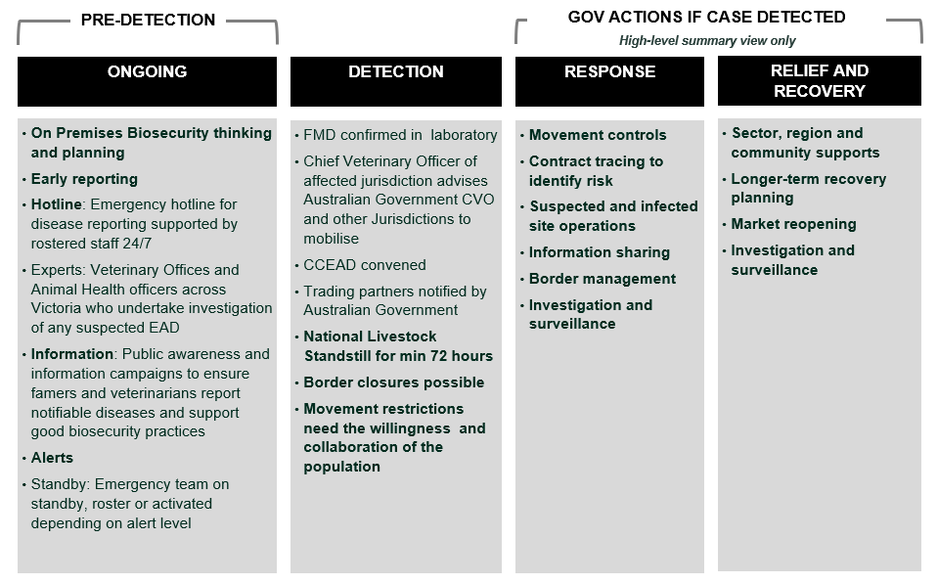
Figure 5. An overview of preparedness activities across the invasion curve, from the presentation by Dr Graeme Cooke, Chief Veterinary Officer, Agriculture Victoria.
Description of Figure 5:
- The slide has four columns of text providing an overview of preparedness activities across the invasion curve. The four columns, from left to right, are: ongoing, detection, response, and relief and recovery.
- Above the ‘ongoing’ column, the text reads ‘pre-detection’.
- Above the ‘response’ and ‘relief and recovery’ columns, the text reads ‘gov actions if case detected (high-level summary view only)’.
- Ongoing.
o On Premises Biosecurity thinking and planning
o Early reporting
o Hotline: Emergency hotline for disease reporting supported by rostered staff 24/7
o Experts: Veterinary Offices and Animal Health officers across Victoria who undertake investigation of any suspected EAD
o Information: Public awareness and information campaigns to ensure farmers and veterinarians report notifiable diseases and support good biosecurity practices
o Alerts
o Standby: Emergency team on standby, roster or activated depending on alert level
- Detection:
o FMD confirmed in laboratory
o Chief Veterinary Officer of affected jurisdiction advises Australian Government CVO and other Jurisdictions to mobilise
o CCEAD convened
o Trading partners notified by Australian Government
o National Livestock Standstill for min 72 hours
o Border closures possible
o Movement restrictions need the willingness and collaboration of the population
- Response:
o Movement controls
o Contract tracing to identify risk
o Suspected and infected site operations
o Information sharing
o Border management
o Investigation and surveillance
- Relief and recovery:
o Sector, region and community supports
o Longer-term recovery planning
o Market reopening
o Investigation and surveillance
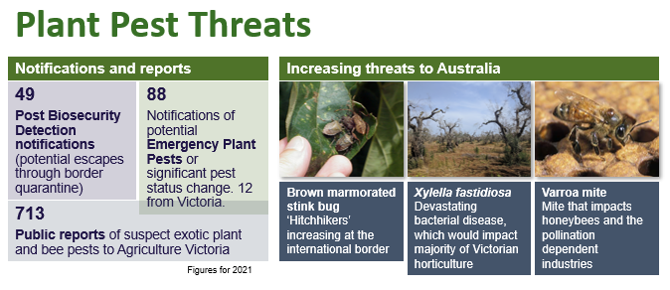
Figure 6. An overview of current plant biosecurity threats, from the presentation by Dr Rosa Crnov, Victoria’s Chief Plant Health Officer.
Description of Figure 6:
- The slide provides an overview of current plant biosecurity threats.
- In terms of notifications and reports, there are:
o 49 Post Biosecurity Detection notifications (potential escapes through border quarantine)
o 88 notifications of potential Emergency Plant Pests or significant pest status change. 12 from Victoria.
o 713 public reports of suspect exotic plant and bee pests to Agriculture Victoria.
- Increasing threats to Australia are:
o Brown marmorated stink bug: ‘Hitchhikers’ increasing at the international border
o Xylella fastidiosa: Devastating bacterial disease, which would impact majority of Victoria horticulture
o Varroa mite: Mite that impacts honeybees and the pollination dependent industries

6.2 Discussion question: Gaps and opportunities for biosecurity awareness
In breakout groups, participants responded to the question ‘What are the major gaps and opportunities in terms of biosecurity preparedness awareness in your industry or community?’ A summary of the responses is provided below. Full responses are provided in Appendix C.
Gaps in biosecurity preparedness
Participants identified the following as key gaps in biosecurity preparedness.
- Poor information flow, often caused by silos in government.
- Lack of a clear source of truth.
- Right systems not in place.
- Lack of early triggers in the system.
- Not enough in-person and printed communication.
Social media misinformation can prevent appropriate preparedness awareness.
Opportunities in biosecurity preparedness
Participants identified the following as opportunities for biosecurity preparedness.
- Learning from and leveraging emergency management structures and systems.
- Involvement in the Commonwealth Government’s strategic conversations about emergency strategies.
- Establish clear communication chains / processes within Agriculture Victoria.
- Provision of education, training and effective distribution of communications to industry and community.
Tap into research and development, using those findings to drive awareness pieces, to engage with broader stakeholders.

6.3 Industry and community roles in biosecurity preparedness and communication
Industry and emergency management insights were delivered by:
Fiona Conroy, Partner and Manager, Knewleave Partnership.
Fiona shared her experiences as a farmer, and the evolution of her on-farm biosecurity practices over two decades. Her biosecurity plan is a living document that involves an annual review, as well as an annual veterinary audit.
As a farmer, tracking the movement of animals is easy compared with tracking the movement of people, and she proposed the implementation of a QR code system to digitise the process.
Fiona highlighted the biosecurity challenge in peri-urban areas, where properties can change hands frequently and there is typically less awareness and understanding of biosecurity risks and preparedness measures.
The best way to communicate from her experience is through trusted local community sources, face to face interactions, and local events.
Amanda Leck, Deputy Commissioner, Capability and Risk, Emergency Management Victoria.
Amanda stated that key attributes of a resilient community include ability to cope, adapt and transform in response to a future risk or threat. She also raised that resilience should be seen as a capacity rather than an endpoint which means community-led responses are most effective. By strengthening the ownership and decision-making power of community members, we help build resilience capacity.
Amanda identified that building community ownership starts with personalising the risk to community members. Currently, many in the community don’t perceive the risk or threat of biosecurity on a personal level.
She noted that engagement with the community needs to be inclusive, broad-sweeping and equitable to properly represent a community’s diverse perspectives. It must be clear to the community what their role is in the shared space with industry and government. Without this understanding, communities will lack accountability and ownership.

6.4 Discussion questions: Biosecurity messaging
In breakout rooms, participants were asked for input on the following questions about biosecurity messaging. The summaries and insights provided below were identified through the assessment of breakout session notes provided in Appendix C.

6.4.1 What is the top message your community or industry needs to hear to improve their biosecurity preparedness?
Several common themes were identified in participant responses about what messages would improve biosecurity preparedness. The themes are summarised in Figure 7.

Figure 7. Key messages identified by participants as required to improve biosecurity preparedness
Description of Figure 7: The diagram shows five key messages identified by participants as required to improve biosecurity preparedness. The key messages are:
- Biosecurity is…[insert clear definition].
- We’re all in this together. Biosecurity is everyone’s responsibility.
- Good biosecurity has benefits: markets, environment, community.
- We can’t take it for granted. The risk is high.
- Make a plan
Participants suggested messages should:
- speak to people's values (what they care about)
- be tailored to each audience
- highlight the ‘wins’ (no matter how small)
- be delivered at the local level (e.g., on-farm, at footy clubs, in schools)
- provide the ‘how’ at an audience-specific level
- be on repeat
- make it easy and simple
- encourage and promote planning (e.g., have a biosecurity plan on your property or for your business)
- create incentives (this can be achieved by industry bodies and local council rebates)
- identify and communicate the ‘stick’ (legal obligations and consequences) but also the ‘carrot’ (benefits).

6.4.2 How can this message be shared across your community or industry and who should lead it?
Similar discussions were had between groups. A summary on the methods identified by participants to share messages within specific groups are presented in Table 1.
Table 1. Suggested methods to share messages to stakeholder groups and who could be responsible for the delivery.
All stakeholders
- Roles:
o Empower local communities to create plans suitable for their regions and sectors
o Share the message
- Approaches to sharing messages: Suggested approaches are covered below.
Federal government
- o Roles: Lead biosecurity communication at the Australian border
o Approaches to sharing messages: Reach out to individual growers at the border
State government
- Roles:
o Lead, develop and coordinate messages at a high level through peak bodies/industry bodies
o Drive ‘source of truth’ information and work with local government who can get information to landholders
o Lead the narrative and then others to support and enhance the messages for their community/industry
- Approaches to sharing messages:
o Work with industry/community groups and local government to develop a database of stakeholders, especially people in areas that are hard to reach (e.g., in peri-urban areas)
o Create a framework for awareness and communications
o Utilise different channels (e.g., digital, press, radio, etc.) for different audiences
o Provide resources such as awareness / communication campaign grants to industry / community groups
o Develop factsheets, communication toolkits and guidelines
o Strengthen partnerships with industry / community groups to maximise outreach
Local government, including councils and offices
- Roles:
o Work with state government to get factual information to landholders
o Work with local schools on raising awareness of biosecurity
o Localised community biosecurity plans
- Approaches to sharing messages:
o Councils can send letters as they have databases
o Utilise EMV – alerts and messages via communication channels
o Utilise local press, council news and interest groups
o Appoint an emergency coordinator for each local area
o Appoint a disaster planner within communities/councils
o Strengthen the rural community
o Work with state government to ensure the directory and database of those working within local communities are up-to-date, especially in rural and regional communities
Peak industry bodies
- Roles:
o Lead and share messages with their networks
o Listen to members’ perspectives and needs, work with government in the development of messages
- Approaches to sharing messages:
o Have flyers and messages at special events such as State Emergency Service day, Bushfire Season day, Mental Health Day, or Christmas party
o Pushing notifications of suspect detection on the website, similar to what the grain industry is doing nationally
o Work with government to develop materials such as flyers and peri-urban booklets and get these out to members
Community representative groups
- Roles:
o Lead and share messages with their networks
- Approaches to sharing messages:
o Work with state government to ensure the directory and database of those working within the community are up-to-date, especially in rural and regional communities
o Use footy clubs, field days to engage with the community
o Meet landholders on their land
o Share messages at farmgate meetings
o Utilise community media outlets to maximise outreach
o Use national networks and stores (e.g., using signage, display notices) to spread biosecurity messages to consumers
Retailers
- Roles:
o Work with government to develop materials targeting the consumer, highlighting their responsibilities
- Approaches to sharing messages:
o Display notices in stores for consumers to see while they shop.

7 Biosecurity legislative reform
The Reforming Victoria’s Biosecurity Legislation Discussion Paper (the Discussion Paper) was released on Engage Victoria in August 2022, seeking public feedback on priority areas of reform of Victoria’s biosecurity legislative framework. Consultation was open at the time of the Roundtable and closed on 9 October 2022.
Session 5: The purpose of this session was to drive participation in the public consultation process for the Discussion Paper and have participants consider various tools and mechanisms for shared responsibility in biosecurity legislation, which may inform future policy proposals.
Participants were provided with pre-reading material to support breakout discussions in this session.
The session was attended by 73 participants.

7.1 Biosecurity legislative reform discussion paper
Two speakers provided context for this session.
Angela Brierley, Acting Executive Director, Animal Welfare Victoria and Agricultural Regulatory Policy, Agriculture Victoria
Angela provided an overview of the Victoria’s Biosecurity Legislative Reform Discussion Paper, key opportunities of the reform, and encouraged the participants to make a submission on the Engage Victoria website.
She observed that reformed legislation could better reflect that all Victorians have a role in biosecurity. New legislation could empower more Victorians to be involved in managing biosecurity risk.
The reform is an opportunity to update Victoria’s biosecurity legislation in line with contemporary understanding of pest and disease management. This could include removing any barriers in legislation that prevent the widest range of people from playing their part in the biosecurity system.
Dr Lloyd Klumpp, DAFF Inspector-General of Biosecurity
Having led the development of the reform to the Tasmanian Biosecurity Act 2019, Lloyd offered extensive insights into the legislative reform process. He identified shared responsibility tools that were successfully implemented in Tasmanian legislation and provided an overview of the role of the Inspector-General of Biosecurity (Figure 8).
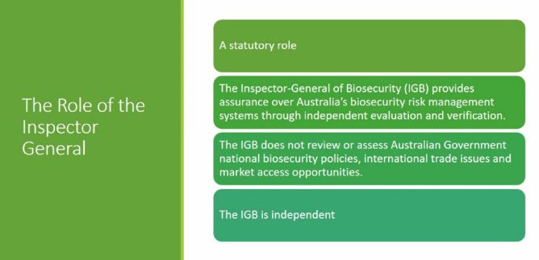
Figure 8. A slide from presentation by Dr Lloyd Klumpp, DAFF Inspector-General of Biosecurity.
Description of Figure 8: The slide provides an overview of the Inspector-General role, which includes:
- A statutory role.
- The Inspector-General of Biosecurity (IGB) provides assurance over Australia’s biosecurity risk management systems through independent evaluation and verification.
- The IGB is independent.
Tasmania’s biosecurity system reform took a partnership approach and provided the following learnings:
- Engage early and engage often.
o Establish a primary stakeholder group consisting of representatives from diverse industry and community groups to navigate through challenges in the development of biosecurity legislation.
o Engage the public through consultations and forums and develop Policy Papers based on these discussions
- Supporting shared responsibility.
o Governance – decisions were made through co-regulation arrangements, which underpinned the partnerships that arose in the regulatory system.
o One way to ensure shared responsibility is to make them a legal obligation. Tasmania’s Biosecurity Act 2019 introduced the General Biosecurity Duty (GBD).
o GBD translates some biosecurity responsibilities to legal obligations and imposes penalties for contravention.
o The Tasmanian Biosecurity Act also binds the Crown.
o Provisions within the Act where two types of biosecurity programs can be developed to encourage wider participation: (1) government-led program, and (2) community-led program. Discussion questions
In breakout rooms, participants were asked for input on the following questions:
- How can expert advice be recognised in legislation (e.g., advisory committees, scientific or other types of advice considered in decisions)?
- How can biosecurity legislation define roles and responsibilities to support greater participation by community and industry (e.g., co-regulation models, general biosecurity duty)?
Insights provided below were identified through the assessment of breakout session notes provided in Appendix D.

7.1.1 How can expert advice be recognised in legislation?
What we heard
There was consensus around:
- the need for a wider range of voices and perspectives on managing biosecurity risk
- the importance of localised knowledge and action. Detailed understanding of local pests and diseases together with awareness of valued plants, animals and landscapes
- localised action is a trusted source of information and behaviours – people trust information from people they know and are often influenced by what they see their neighbours doing
- biosecurity is more effective when people collaborate on decisions and set priorities together, and then work together on implementing strategies.
“There is expertise with stock feed, agents and local truck drivers with skin in the game – at the interface with farmers, how can we connect with them to provide ideas to inform legislation”
“Advisory committees – could look at a more regional basis to draw out regional issues that are relevant in some regions and not others. E.g. peri-urban [issues are] not so relevant in the Mallee.”
Participant suggestions for what this could look like
- Advisory versus standing committees – having a statewide council along big picture advisory lines, and another tier to deal with specific short-term issues.
- Recognition of other skills and expertise – using knowledge brokers (e.g., livestock agents, transport agents) as trusted resources to test ideas and bring in the knowledge in legislative reform process. Listening to experts from all industries – plant, animal, apiary, etc. – recognizing differences but building on similarities.
- Face-to-face industry meetings – developing a listening post using weekly sales (store sales), community spaces/community meeting hubs to get local voices; having a saleyard roundtable to get local expertise.
- Recognition of private schemes – there are different quality assurance schemes in agriculture industry (e.g., dairy processes need best management practices) that can be codified into legislation and implemented.
- Consolidation of multiple pieces of legislation – harmonising emergency response functions. As management aims are the same across industries, areas of best practice can be consolidated.
- Codification of advisory body – establishing advisory committees of technical experts under legislation to provide advice to the Minister responsible for administering the legislation. A good example is the Environment and Invasives Committee (EIC).
- Community-led/bottom-up approach – voices of on-the-ground government staff and frontline farmers need to be heard. Legislation needs to be implementable, fit for purpose and keep up with technology.
- Simplification of documents – standardising documents and using Plain English in government gazettes.
- Broader reference group – including a range of industries. The legislated ministerial advisory committee would be around what gets recommended.
- Strong representation through industry bodies – great examples are Victoria’s Farmers Federation (VFF) and White Land Kings. Group to represent is land management from the pathogen perspective, not from the pest perspective.
Perceived challenges identified
- Jurisdictional differences – enormous challenge to get legislation to align. This requires more state and territory communication.
- Political agenda – be aware of possible link between advisory bodies and political agenda.

7.1.2 How can biosecurity legislation define roles and responsibilities to support greater participation by community and industry?
What we heard
Clarity on roles and expectations will ensure accountability and responsibility.
To support shared responsibility, participants supported tools such as the introduction of a general biosecurity duty, co-regulation for greater shared responsibility, and arrangements to empower localised actions.
There is a lack of understanding of legal obligations. Every section of the industry plays a role and should be held accountable.
“There is a disconnect with industry (livestock agents) – denying responsibility – maybe a lack of awareness of legal obligations – livestock.”
“Everyone who has an animal should have accountability – needs to be considered in legislation to ensure accountability, responsibility and traceability.”
The implementation process of compliance – who is involved, what compliance activities are they responsible for, and the penalties and/or consequences of not fulfilling their duties, would support greater shared responsibility.
“Penalties/ consequences need to apply if people don't fulfil their roles and responsibilities.”
“Staged approach to penalties to support roles and responsibilities. Are our current penalties appropriate?”
Participant suggestions of what this could look like
- Clear, easy to understand legislation, or creation of ‘industry liaison’ to interpret for industry and community.
- Creation of an Inspector-General of Biosecurity for Victoria.
- Recognition of industry-led programs in legislation – such as pollination programs.
- Proper provisions for new legislation – including environmental provisions. Minister to be engaged to manage risks to environmental outcomes.
- Biosecurity compendium including biosecurity obligations and supporting materials – ensuring everyone has clear information about what their obligations are.
- Compliance and imposing penalties – current perception of no enforcement, and support for resources to enforce legislation and penalty options that have an impact.
- Third-party audited quality assurance programs – to ensure transparency.
- Incentives for progressing biosecurity actions – such as needing to meet certain quality assurance standards in order to export.
- Clear governance structure – legislation to spell out not just roles and responsibilities, but also relations between roles.
- Effective education program – ensuring that everyone is educated and aware of their roles and responsibilities to support the legislation.
Perceived challenges identified
- General Biosecurity Duty – in NSW, a general biosecurity duty created confusion because it was ‘vague’. Be clear on what the duty is, and make sure people understand and are aware of what it involves. This would require good communications, education and awareness raising campaigns.
- Barriers to non-government participation – reform of the legislation could consider barriers to participation for system participants other than government or industry.
- Limitation to reference groups – the same faces tend to be across the board (e.g. biosecurity, sustainability, etc.) due to limited number of people in the sector/industry that volunteer their time.
- Privacy and confidentiality issues in co-regulation models – depending on certain agreements such as Emergency Animal Disease Response Agreement (EADRA), this can cause certain information to become confidential and slow down surveillance of horizontal properties. This needs a better understanding of how other states use co-regulation models.
- Conflicting roles – local government needs clarity.
- Non-compatible legislated practices – some industries are being legislated to change practices that they are not compatible with (e.g. poultry with free range and biosecurity requirements) and may confuse some in the system.
- Financial resources – quality assurance and biosecurity cost money, especially for businesses. The businesses that don't do the right thing end up ahead financially – frustrating for businesses that do the right thing.
- Future proof – take care in the development of legislation to ensure it is fit for purpose into the future.

7.1.3 What are your priority focus areas for Victoria’s biosecurity legislation?
Wrapping up this session, participants were asked to identify what they considered priority focus areas for Victoria’s biosecurity legislation.
Co-regulation of biosecurity risk between government and stakeholders, information sharing to support decision-making, clarification of roles and responsibilities, and governance frameworks to support decision-making were identified as most important in biosecurity legislative reform (Figure 9).

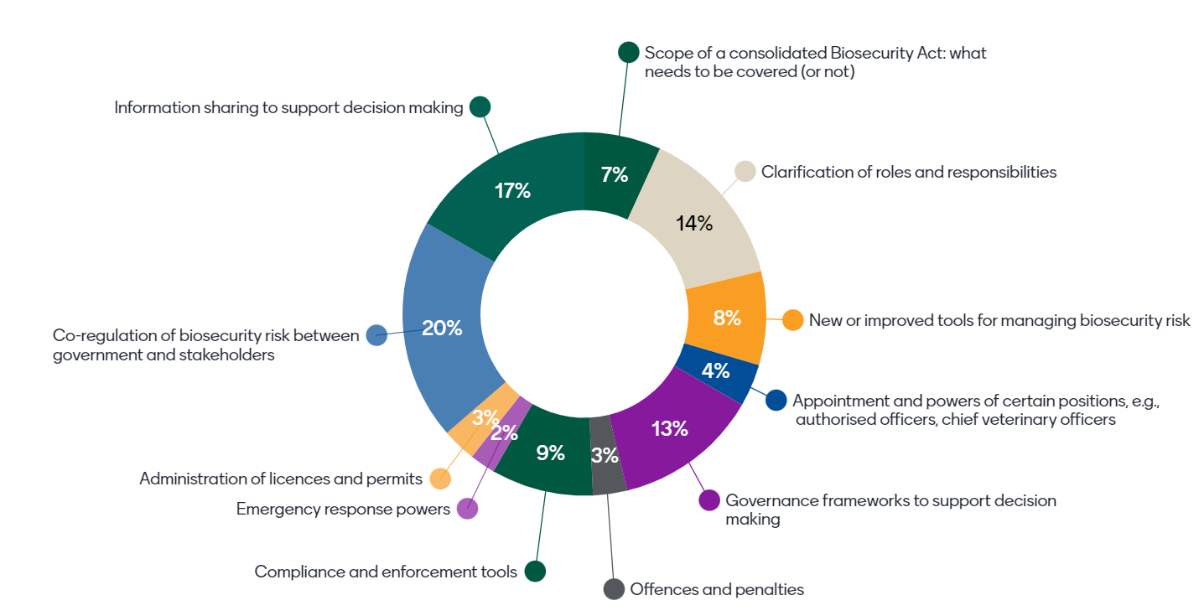
Figure 9. Participant preferences for areas to focus on for Victoria’s biosecurity legislation reform.
Description of Figure 9: The figure is a pie chart showing participant preferences for areas to focus on for Victoria's biosecurity legislation reform. Of the 73 people that participated in Session 5:
- 20 per cent chose 'co-regulation of biosecurity risk between government and stakeholders'
- 17 per cent chose 'information sharing to support decision making
- 14 per cent chose 'clarification of roles and responsibilities'
- 13 per cent chose 'governance frameworks to support decision making'
- 9 per cent chose 'compliance and enforcement tools'
- 8 per cent chose 'new or improved tools for managing biosecurity risk'
- 7 per cent chose 'scope of consolidated Biosecurity Act: what needs to be covered (or not)'
- 4 per cent chose 'appointment and powers of certain positions, e.g., authorised officers, chief veterinary officers'
- 3 per cent chose 'administration of licenses and permits'
- 3 per cent chose 'offences and penalties'
- 2 per cent chose 'emergency response powers'.

8 Glossary
The following is a list of common terms and acronyms that are contained in this report
- AHA: Animal Health Australia
- BIC: Biosecurity Interagency Committee of Victorian government department representatives, formed by Agriculture Victoria to consult on biosecurity matters.
- BMSB: Brown marmorated stink bug is a ‘hitchhiker’ pest increasingly intercepted at the international border.
- BRG: Biosecurity Reference Group of industry and community representatives, formed by Agriculture Victoria to consult on biosecurity matters.
- CaLP Act: Catchment and Land Protection Act
- CMA: Catchment Management Authority
- CPHO: Chief Plant Health Officer
- CVO: Chief Veterinary Officer
- DAFF: The Commonwealth Department of Agriculture, Fisheries and Forestry
- DAWE: The former Commonwealth Department of Agriculture, Water and the Environment (now called ‘DAFF’, as above)
- DEECA: Victorian Department of Environment, Energy and Climate Action
- DELWP: The Victorian Department of Environment, Land, Water and Planning
- EAD: Emergency Animal Disease – a disease that is exotic to Australia, a variant of an endemic disease, a serious infectious disease of unknown or uncertain cause, or a severe outbreak of a known endemic disease, and is of national significance with serious social or trade implications. Refer to the Emergency Animal Disease Response Agreement for details.
- EMV: Emergency Management Victoria
- EPA: Environmental Protection Authority
- First Nations: People who identify as Aboriginal or Torres Strait Islander.
- FMD: Foot and Mouth Disease – a highly contagious virus of mammals with great potential for causing severe economic loss in susceptible cloven-hoofed animals. The virus is carried by live animals, in meat and dairy products, as well as soil, bones, untreated hides, vehicles and equipment used with these animals. It can also be carried on people’s clothing and footwear.
- GBD: General biosecurity duty
- IGB: Inspector General of Biosecurity
- LSD: Lumpy Skin Disease – a highly infectious disease of cattle and buffalo. The disease is caused by a virus similar to sheep pox and goat pox and mostly transmitted by biting insects.
- NBC: National Biosecurity Committee
- NRM: Natural Resource Management
- PHA: Plant Health Australia
- PV or Parks: Parks Victoria
- RAP: Registered Aboriginal Parties - recognised by the Victorian Aboriginal Heritage Act 2006 as the primary guardians, keepers and knowledge holders of Aboriginal Cultural Heritage.
- SVBS: Strengthening Victoria’s Biosecurity System Program, the Victorian Government’s investment to strengthen Victoria’s biosecurity system. The Program is led by Agriculture Victoria.
- TOs: Traditional Owners – In the Aboriginal Heritage Act 2006 (Vic) - Section 7. A person is a traditional owner of an area if the person is an Aboriginal person with particular knowledge about traditions, observances, customs or beliefs associated with an areas, and the person has the responsibility under Aboriginal traditions for significant Aboriginal places located in or significant Aboriginal objects originating from the area, or is a member of a family or clan group that is recognised as having responsibility under Aboriginal traditions for significant Aboriginal places located in or significant Aboriginal objects originating from the area.
- Varroa mite: Varroa destructor – a mite that negatively impacts honeybees and the pollination dependent industries. Australia is the last honey producing country to detect varroa.
- VFF: Victorian Farmers Federation
- Xylella: Xylella fastidiosa – a devastating bacterial disease with the potential to severely impact Victorian horticultural production

