Agriculture Victoria - Victoria’s Biosecurity Roundtable 2024

DEECA
What Was Said Report
December 2024

Contents
Introduction 4
Overview 4
Purpose 4
Participants 5
Speakers 7
Roundtable agenda 8
Workshop outputs 10
Session 1: Opening and overview of biosecurity in Victoria 10
Summary of keynote presenter talks 10
Hopes 11
Key priorities and concerns 11
Session 2: Tackling our biggest biosecurity threats 13
Summary of keynote presenter talks 13
Questions for the panel on biosecurity threats 15
Session 3: Prevention 15
Summary of keynote presenter talks 15
Ideas for making biosecurity top of mind 16
Session 4: Preparedness and response 17
Summary of keynote presenter talk 17
What would you include in your response plan? 17
Session 5: Management 18
Summary of keynote presenter talks 18
Ideas for successful partnerships and management approaches 19
Session 6: Connecting to Country 20
Summary of keynote presenter talk 20
Questions for the panel on Country 21
Reflections (Head, Heart, Hands) 21
Feedback Survey 22
Appendices 32
Appendix 1- Session 1- Key priorities and concerns 32
Appendix 2 – Session 2 – Questions for the panel 36
Appendix 3 – Session 3 – Ideas for making biosecurity top of mind 39
Appendix 4 – Session 4 – How can we collaborate more effectively in an emergency response? 42
Appendix 5 – Session 5 – What is the key to successfully partnering with the community to manage biosecurity threats, what do we want to do more of? 44
Appendix 6 – Questions for the panel on Country 46
Appendix 7 – Final reflections on the Biosecurity Roundtable 47

Introduction

Overview
Victoria’s Biosecurity Strategy outlines a comprehensive approach to safeguarding the state's agriculture, environment, and community from the threats posed by pests and diseases. Launched in November 2023 and developed through extensive consultation with Traditional Owners and nearly 450 stakeholders—including farmers, industry bodies, community groups, and government agencies—the strategy translates the vision from Victoria’s Biosecurity Statement into actionable priorities.
Victoria’s Biosecurity Roundtable 2024 built upon this strategic foundation. The one-day online event, held on 20 November 2024, brought together participants to explore the implementation of the strategy's 5 strategic goals and 20 priority actions. The Roundtable featured diverse speakers across 6 sessions, including Traditional Owners and representatives from a range of sectors, including, government officials, industry leaders, and community representatives.

Purpose
The 2024 Roundtable was designed to:
- share knowledge about the current status of biosecurity in Victoria
- explore practical strategies for improving biosecurity awareness, prevention, and response
- showcase successful examples of community leadership and collaboration in biosecurity management
- discuss innovative solutions and best practices
- identify ways for stakeholders to contribute to better biosecurity outcomes for Victoria.
The event emphasised that protecting Victoria's lands, waters, industries, economy, culture and way of life from pests and diseases is a collective effort, requiring active participation from all stakeholders.
This report reflects the discussions held by participants at Victoria’s Biosecurity Roundtable 2024 and not necessarily the views of Agriculture Victoria.

Participants

Participants included Traditional Owners, industry, community, federal, state and local government representatives – from farming related industries such as viticulture, horticulture, dairy, grains, meat and wool, agribusinesses, retail, transport, and supply chain; to community interest groups representing wildlife, Landcare, marine and national park sectors; recreation industries such as zoos, racing and hunting; alongside government agencies such as Catchment Management Authorities and Parks Victoria. Invitations were sent via direct email and expression of interest via the Strengthening Victoria's Biosecurity System email newsletter.
In total, 168 participants* attended the 6 sessions, as follows:

Session 1: 110
Session 2: 78
Session 3: 41
Session 4: 34
Session 5: 21
Session 6: 71

*participants could opt in to multiple sessions

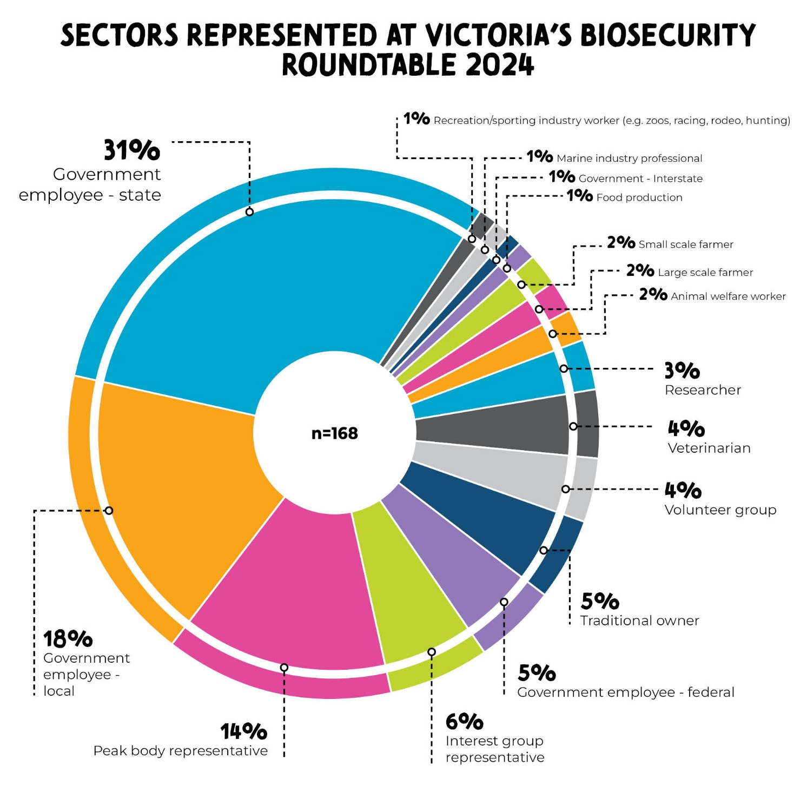
Attendee sector | % of total attendees | Count
Government employee - state | 31% | 52
Government employee - local | 18% | 30
Peak body representative | 14% | 24
Interest group representative | 6% | 10
Traditional owner | 5% | 9
Government employee - federal | 5% | 8
Veterinarian | 4% | 7
Volunteer group | 4% | 6
Researcher | 3% | 5
Animal welfare worker | 2% | 4
Large scale farmer | 2% | 3
Small scale farmer | 2% | 3
Food production | 1% | 2
Recreation/sporting industry worker (e.g. zoos, racing, rodeo, hunting) | 1% | 2
Government - Interstate | 1% | 1
Marine industry professional | 1% | 1
Total | n= | 168

Speakers
In order of presenting across the 6 sessions:
- The Hon. Ros Spence, Victorian Minister for Agriculture
- Lucy Etheridge, General Manager, Yarrawalla Vineyards
- Beth Jones, Chief Executive, Agriculture Victoria
- Simone Vitali, Program Manager, Emergencies, Wildlife Health Australia
- Melinda Hashimoto, CEO, Egg Farmers of Australia
- Graeme Cooke, Chief Veterinary Officer, Agriculture Victoria
- David Spicer, Director, Verian Research
- Shakira Johnson, Farm Biosecurity Coordinator, AUSVEG
- Kim Allan, Program Coordinator, East Gippsland Catchment Management Authority
- Mick Freeman, Facilitator, Vertebrate Species Management Program, DEECA
- Kirby Leary, Projects Officer, South Gippsland Landcare
- Shana Nerenberg, Biodiversity Lead, DJANDAK (Dja Dja Wurrung Clans Aboriginal Corporation)
- Rhianna Kerr, Program Manager, Aboriginal Partnerships, Regions, Climate Action and First Peoples, DEECA
- Bambi Lees, Aboriginal Partnerships Manager, Bush Heritage Australia
- Aunty Marilyne Nicholls, Dja Dja Wurrung & Yung Balug Elder, and Returning Spirit Officer, DJANDAK (Dja Dja Wurrung Clans Aboriginal Corporation)

Roundtable agenda
Time | AGENDA
9:30AM | Arrival and Welcome
9:45AM | Session 1: Opening and overview of biosecurity in Victoria  Minister for Agriculture, the Hon. Ros Spence opened the event, with Lucy Etheridge from Yarrawalla Vineyards discussing pest and disease threats to the wine industry, highlighting phylloxera management. Small group conversations explored biosecurity issues across sectors and interest groups.
10:45AM | Morning tea break
11:00AM | Session 2: Tackling our biggest biosecurity threats  Beth Jones provided an overview of major biosecurity threats, with Simone Vitali and Melinda Hashimoto offering insights into sector preparations for avian influenza H5N1. A panel featuring Beth Jones and Graeme Cooke addressed participant questions through small group conversations and a Q&A.
12:45PM | Lunch break
1:30PM | Concurrent sessions  Session 3: Prevention  David Spicer from Verian Research and Shakira Johnson from AUSVEG shared behavioural insights into Victorians' biosecurity perceptions, discussing strategies for engaging hard-to-reach audiences. The session focused on engagement approaches that work to raise community awareness about biosecurity in Victoria.  Session 4: Preparedness & response  Kim Allan from East Gippsland Catchment Management Authority reflected on developing the Marine Pest Response Plan for the Gippsland Lakes. Industry, community, and government representatives collaborated to address biosecurity preparedness challenges. This session asked how stakeholders can collaborate better in preparing and responding to biosecurity threats.  Session 5: Management  Kirby Leary from South Gippsland Landcare showcased innovative community engagement strategies. Mick Freeman from DEECA Vertebrate Species Management Program discussed feral pig management and the community action network's approach to biosecurity challenges. This session addressed the question “How is community leading effective management of biosecurity?”.
2:45PM | Afternoon tea break
3:00PM | Session 6: Connecting to Country  Shana Nerenberg presented DJANDAK's Wheel Cactus management case study on Djaara Country. A panel featuring Rhianna Kerr, Shana Nerenberg, Dja Dja Wurrung and Yung Balug Elder Aunty Marilyne Nicholls, and Bambi Lees from Bush Heritage Australia explored Traditional Owner perspectives.  Beth Jones concluded by reflecting on lessons learned and gathering participant insights.
4:30pm | Close

Workshop outputs

Session 1: Opening and overview of biosecurity in Victoria

Summary of keynote presenter talks
The Minister for Agriculture, The Hon. Ros Spence, opened the event. The talk focused on:
- the importance of deepening conversations about how we can work together for a stronger biosecurity system.
- progress since the release of Victoria’s Biosecurity Strategy in November 2023 and continued focus on ‘Making biosecurity everyone’s business’.
- acknowledgement of the hard work of everyone involved in the most recent H7 avian influenza emergency response, the largest biosecurity response undertaken in Victoria.
- praise for the work and contributions from everyone across industry and community in strengthening biosecurity and keeping our food and fibre industry safe.
Lucy Etheridge General Manager of Yarrawalla Vineyards talked about the pest disease threats to the wine industry and her personal experiences managing phylloxera. The presentation covered:
- recognition of Australia’s 65 wine regions, 21 of which are Victoria-based representing a large diversity of regional and climate sites across our state.
- the major biosecurity threat to the wine industry, phylloxera, a microscopic pest that impacts and kills grape vines, thus impacting the livelihood of farmers.
- identifying where phylloxera is currently found, mainly in central and eastern parts of Victoria, and how it can be spread.
- acknowledgement of farms within phylloxera-infested zones experiencing large time- and cost-impacts with additional compliance and hygiene costs, regulatory requirements, and social stigma.
- the importance of raising awareness of good biosecurity through education and collaboration are required to induce behavioural change within and outside the sector for continued phylloxera management.
Watch the full video presentations by Hon. Ros Spence and Lucy Etheridge.

Hopes
In the first activity for the day, participants were invited to consider what hopes they had for their time at the Biosecurity Roundtable. Their answers, which were shared on the online collaboration platform GroupMap, are reproduced verbatim below:
- Find opportunities for collaboration between industry and government - using expertise and past experience and global learnings to inform our response and preparedness.
- Get more of an idea around strategy implementation and what it means in a ‘front line’ or ‘on the ground’ sense.
- Learn about how to engage with those beyond an individual industry around the importance of on-farm biosecurity measures.
- Learn more about biosecurity.
- Listen and learn.
- To gain different perspectives and move beyond my horticulture community bubble.
- To gain perspectives and understand stakeholders needs and wants.
- To listen and hear from industry and communities about what can be improved to support their biosecurity activities.
- To see the progress in partnerships to manage pests and weeds in regions.
- To think about the next steps for engaging community to build a sense of collective responsibility for biosecurity. Translating the evidence.
- Understand current and emerging threats.
- Understand how industry can effectively contribute to biosecurity in Victoria.
- Understand how we as producers can help with biosecurity.
- Updates and discussions about how we move forward and how the catchments management industry can contribute.

Key priorities and concerns
Following presentations from the Minister for Agriculture, the Hon. Ros Spence and Lucy Etheridge from Yarrawalla winery, participants were asked to each share their one main priority and/or concern in the biosecurity landscape, via the online collaboration platform GroupMap. Participants were given an opportunity to ‘like’ any other responses that they identified as equally important.
Participants’ responses are captured in Appendix 1.
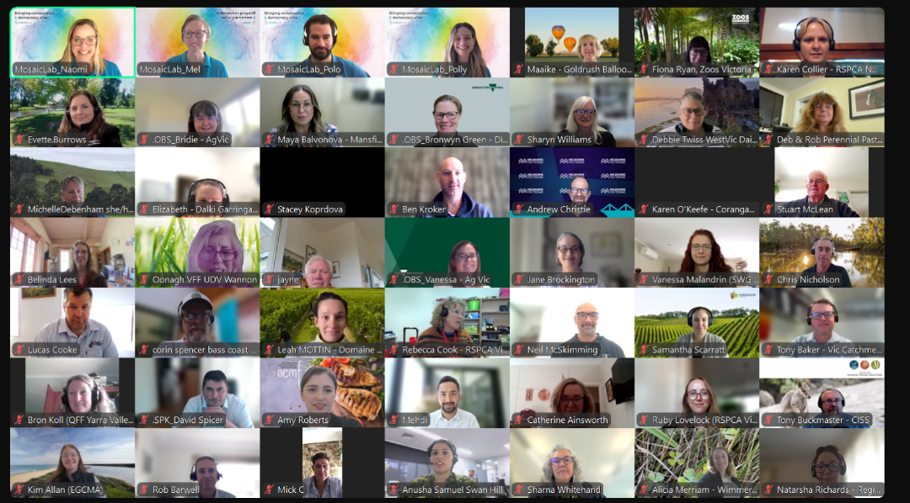
Figure 1: A screenshot of some participants, DEECA staff and MosaicLab facilitators during Session 1

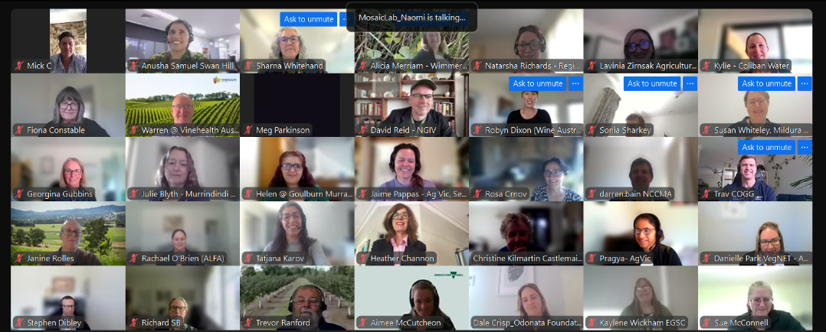
Figure 2: A screenshot of some participants during Session 1

Session 2: Tackling our biggest biosecurity threats

Summary of keynote presenter talks
Agriculture Victoria Chief Executive Beth Jones provided an overview of Victoria’s biggest biosecurity threats to kickstart conversations for the session. The overview covered:
- significant pests and diseases that pose a threat to Victoria’s environment including our livestock, industries, pets, wildlife, the environment and communities.
- that our biosecurity system exists within a dynamic operating environment and the need for constant vigilance – emphasising the importance for strong collaboration, partnerships, working together, sharing information, exercising and awareness.
- key themes of Victoria's Biosecurity Strategy, its goals and priority actions.
- Victoria’s continued investment in programs and preparedness for biosecurity incursions and emergency responses.
- working within the national context, and also with Traditional Owners environmental agencies.
- the value and importance of participants’ insights and perspectives in this year’s Roundtable and a commitment to ongoing conversation.
Wildlife Health Australia’s Simone Vitali, Program Manager Emergencies, shared actions to prepare for potential incursions of highly pathogenic avian influenza (HPAI) H5N1 in wildlife. The presentation focused on:
- communication as the cornerstone of their national HPAI preparedness and Wildlife Health Australia’s relationship networks being central to their effectiveness as an agency – enabling them to coordinate, communicate and inform about avian influenza in wildlife across both government and non-government disciplines and jurisdictions.
- a major role of Wildlife Health Australia’s HPAI preparedness involves coordination of the National Avian Influenza Wild Bird Surveillance Program, which includes HPAI screening of healthy birds, and targeted surveillance such as during the recent H7 outbreaks.
- Wildlife Health Australia provides current and relevant information on HPAI through frequently updating their website, sending newsletters, and providing expertise to national biosecurity planning and policy on avian influenza, delivering frequent presentations on HPAI, and developing key guidance documents and toolboxes.
- the importance of collaboration, with Wildlife Health Australia facilitating interdisciplinary discussions on HPAI and wildlife, and working on projects to further expand wildlife surveillance and preparedness tools and technologies.
Egg Farmers of Australia CEO Melinda Hashimoto spoke about the egg industry’s experience with preparing for and responding to avian influenza incidents. The main points were:
- the importance that industry understands not only about the virus, but also what work other sectors are doing.
- there are many stakeholders involved during an avian influenza response, that roles and responsibilities must be clearly understood.
- due to other threats such as Salmonella enterica and COVID, the industry is well-placed around biosecurity where many farms have implemented various on-farm measures to ensure best biosecurity for their staff.
- some farmers use companies that provide solutions and methods for traceability to ensure that records are easily accessible should a biosecurity incursion occur
- the topic of capacity for clean-up during a response is an issue, especially for smaller-sized farms with smaller workforces who may need to rely on external support from contractors or government.
- Federal government support has recently been made available to the egg industry which will aid in preparedness should an incident occur – work is being done to gain an understanding on industry mapping and the type of communications and linkages that would happen in a large outbreak.
- learnings from other countries and the experts who have experienced an avian influenza incursion are valuable to improving how the industry can be better prepared.
- the communication between government and industry that ‘they’re not alone’ has been improved over time, and if this continues will allow us to overcome a potential H5N1 incursion in the future.
- the need to continue these discussions to continually improve, be better prepared, thus leading to a better response.
Watch the full video presentations by Beth Jones, Simone Vitali and Melinda Hashimoto.

Questions for the panel on biosecurity threats
Following presentations from Beth Jones from Agriculture Victoria, Simone Vitali from Wildlife Health Australia, and Melinda Hashimoto from Egg Farmers of Australia, participants were asked to pose any questions they might have to Graeme Cooke, Chief Veterinary Officer, and Beth Jones. Participants were given an opportunity to ‘like’ any other questions that they deemed particularly important.
Their questions are reproduced verbatim in Appendix 2. Note: panel responses were not recorded.

Session 3: Prevention

Summary of keynote presenter talks
Verian State Director David Spicer described a qualitative research project completed for Agriculture Victoria in 2023 to assess community and producer awareness, attitudes, understanding and behaviours regarding biosecurity across Victoria to foster a collective approach to biosecurity. The insights from the research revealed that:
- for producers, biosecurity is the third major concern, following cost of operation and shortage of labour, whereas for community biosecurity was a very, very low-level concern in terms of perception of the threat.
- producers identified a variety of drivers of biosecurity as a threat, with some concerns for the lack of education and financial concerns, as well as varied confidence levels in government capability.
- farm size also played a part, where smaller farms may see less of a threat from biosecurity hazards due to being smaller and more isolated.
- the community mostly perceived the threat as a border issue.
- the business of biosecurity is seen mostly as a federal and state government responsibility by both farmers and producers, with the recognition of Victorian community being responsible being lesser in producers’ views and even more so in the community.
- the community expressed more confusion about the interface between government and community in terms of responsibility.
- throughout the research process, shared responsibility was a topic that was brought up and it was found that people are willing and open to receive the message about there being a shared responsibility, but they just need to be walked through the process.
- future actions suggest a communications campaign that focuses on roles and awareness, or referring to the saying from COVID lockdowns ‘We’re all in this together’, because the bar for community engagement about biosecurity is currently very low.
AUSVEG’s Farm Biosecurity Coordinator, Shakira Johnson, explored how to best connect with hard-to-reach audiences, specifically culturally and linguistically diverse (CALD) communities and peri urban communities. The message acknowledged:
- the need to be mindful of cultural sensitivities when communicating with different groups, for example with CALD communities, we may be asking them to adapt their traditional farming practices.
- strategies that have worked for AUSVEG include not only printing and distributing resources in the language of key audiences, but also engaging with community leaders to share their stories and experiences to build a connection.
- examples of reaching CALD communities included Hmong growers in far North Queensland being biosecurity champions in their community, and the Vietnamese community being engaged through Vegetables WA.
- peri urban communities have a mix of residential, agricultural and recreational land uses with competing interests, potentially meaning an increase in biosecurity risk when moving from region to region.
- examples of reaching peri-urban communities included an urban biosecurity pilot in collaboration with multiple groups including the Urban Plant Health Network working with community gardens across Melbourne, a peri-urban biosecurity program using text messages to collate data and distribute reports about crop pests and diseases, and VegNET connecting with young growers in Darwin.
- connecting with hard-to-reach audiences will strengthen collaboration across all different stakeholders and help to understand behavioural economics and the nudge to influence people to be prepared.
Watch the full video presentations by David Spicer and Shakira Johnson.

Ideas for making biosecurity top of mind
After presentations from David Spicer from Verian Research and Shakira Johnson from AUSVEG, participants were placed into small groups and discussed campaign and engagement approaches they had seen succeed in raising community awareness about biosecurity. They were then asked to each write their top 2 ideas for making biosecurity top of mind. Participants were given an opportunity to ‘like’ other participants’ suggestions.
Their ideas are reproduced verbatim in Appendix 3.

Session 4: Preparedness and response

Summary of keynote presenter talk
East Gippsland Catchment Management Authority Program Coordinator, Kim Allan, shared how the Marine Pest Response Plan for the Gippsland Lakes was developed. The presentation covered:
- the threat of future incursions of high-risk marine pest species has the potential to greatly impact the ecological character of the Gippsland Lakes
- the development of a Strategic Response Plan was initiated as marine pests were identified as a priority for management in the Gippsland Lakes Ramsar Site Management Plan.
- an Agency based Marine Pest Working Group was established using East Gippsland CMA’s strong connections with regional agencies to help gather information and expert advice.
- the first stage of developing the Strategic Response Plan involved the working group identifying key roles in preparing for and responding to an incursion.
- a consultant was engaged to assess relevant information from existing policies and procedures for land managers.
- efforts were made to ensure the plan is easy for anyone to understand and implement should an incursion occur in the Gippsland Lakes.
- collaboration and networking was a key aspect in the development of the Marine Pest Strategic Response Plan for the Gippsland Lakes.
Watch the full video presentation by Kim Allan.

What would you include in your response plan?
Following the presentation by Kim Allan from East Gippsland Catchment Management Authority, participants were put into small groups and asked to discuss the following questions:
- Knowing what you know now… what would you include in your response plan?
  - What are your first steps? (What do you need to take into account?)
  - Who do you need to talk to/partner with?
  - Where do you go for information?
  - What would your role be in a response?
Note: small group discussions were not recorded.
Afterwards, participants were asked to individually propose one idea for how to collaborate more effectively in an emergency response.
Participants were given an opportunity to ‘like’ ideas that they thought should be prioritised.
The results from this activity are reproduced verbatim in Appendix 4.

Session 5: Management

Summary of keynote presenter talks
South Gippsland Landcare Projects Officer, Kirby Leary, shared successes from the group’s community-led pest control projects. Highlights of the talk covered:
- bringing the community together to focus on what the community can do.
- sharing ideas and methods of pest control and management has been a key element in past projects involving deer and ragwort management.
- the current community-led pest control project has brought together a large variety of speakers to contribute to a seminar on pest control.
- the community were interested in connections with contractors and the people working within the community.
- an example involved participants of the seminar inspired by a pest control contractor sharing rabbit control methods which used smokers as a treatment and empowered people to take their own action by applying the same method.
- people had an appetite for planning for future pest management.
- another key goal of the community network is to keep on top of and share technologies available for data collection and sharing such as camera traps, FeralScan and WeedScan, iNaturalist and Slack.
- the effective demonstration of using the innovative engagement tools and technology to collect and share data or communicate with people in the Landcare network – using apps such as FeralScan, iNaturalist, WeedScan and Slack and tools such as camera traps or drones.
- how community groups are continuing to meet after a project end using Slack to share knowledge with others.
- the connections that have been made through all of their projects have been invaluable, showing the community what they can achieve together.
DEECA’s Vertebrate Species Management Program Facilitator, Mick Freeman, explored effective management of biosecurity and pest species through community programs, specifically through a feral-pig project in Benambra, the Ovens area and Mansfield. The talk covered:
- how the project aligns closely with both the National Feral Pig Action Plan and Victoria’s Biosecurity Strategy and was designed in close collaboration with Agriculture Victoria’s Established Invasive Species and Animal Health programs to increase biosecurity surveillance capacity.
- the project has held 3 initial community meetings with key stakeholders, 3 community information sessions and 3 community field days.
- field days covered a large variety of information for the community about best practice pig management, biosecurity and feral pigs from a variety of presenters, including Agriculture Victoria, DEECA, the National Feral Pig Management Coordinator, DPI NSW, Parks Victoria, VicPol.
- this project has been a catalyst for pulling agencies and programs together, encouraging better information flow between government and community.
- there has been a high-level of interest and support from land managers, biosecurity staff and industry, and communities are better equipped and more aware of what’s available and what to do.
- as this project continues, they hope to continue to grow participation and seek collaboration opportunities.
Watch the full video presentations by Kirby Leary and Mick Freeman.

Ideas for successful partnerships and management approaches
Following presentations by Kirby Leary from South Gippsland Landcare and Mick Freeman from DEECA, participants were placed into small groups and discussed the following questions:
- What example does your sector have of a successful partnership and pest plant and animal management approach?
- Why has it been successful?
Note: small group discussions were not recorded.
After the group discussion, participants were asked to individually identify the key to successful partnerships with community to manage biosecurity risks and threats.
Participants were given an opportunity to ‘like’ ideas they agreed with.
Their responses are reproduced verbatim in Appendix 5.

Session 6: Connecting to Country

Summary of keynote presenter talk
DJANDAK (Dja Dja Wurrung Clans Aboriginal Corporation) Biodiversity Lead, Shana Nerenberg, presented on DJANDAK's Wheel Cactus management case study. The talk focused on:
- the impact that Wheel Cactus has had in Buckrabanyule.
- how it went from being managed by community volunteers, to dominating the landscape through an absentee landholder, to being purchased by Bush Heritage Australia to reclaim the land.
- the biosecurity efforts to control and manage Wheel Cactus.
- the effective use of chemical spraying through funding and grants, where a third of the property (228 acres) has been successfully treated with foliar spraying.
- the ongoing challenge of controlling and managing reinfestation – even after these adult plants have been killed, there are still remaining adult plants supplying seed into these areas and there are a lot of soil-stored seed – therefore, maintenance is also a large part of their project.
- DJANDAK’s 10-year management strategy which outlines how the whole property can be progressively treated, 40 hectares at a time, and maintained.
- lessons from this project including the necessity for long-term funding to tackle large weed and biosecurity issues, the need for local community support which was a key element in maintaining Wheel Cactus in the past, and to support and inform absentee landholders to prevent these problems from occurring again.
Watch the full video presentation by Shana Nerenberg.
Panel discussion
Following the keynote presentation, DEECA’s Aboriginal Partnership Manager and proud Yorta Yorta, Rhianna Kerr, then moderated a panel conversation between Shana Nerenberg, Dja Dja Wurrung and Yung Balug Elder Aunty Marilyne Nicholls, and Bush Heritage Australia Aboriginal Partnerships Manager Bambi Lees, where Traditional Owner perspectives were explored.
Panel members – Shana, Aunty Marilyne and Bambi – joined the session live from Djaara Country where the DJANDAK Wheel Cactus Management Project training, community engagement and weed management is underway. Highlights of the panel included Shana’s live report from the ground showing the visible evidence of the efforts to date and how much is still to be done. Discussion from Aunty Marilyne about the importance of cultural values and cultural heritage of Buckrabanyule – and hearing how the tree violets and greenery are returning and how cultural burns are being considered in the future. Bambi’s insights on how relationships and strategic partnerships, using language, sharing knowledge and time spent on Country to inform the management approach to deliver mutual outcomes is crucial.

Questions for the panel on Country
Roundtable participants were asked to pose any questions for the panel. These questions are captured in Appendix 6. Overall, there was an interest in the connections between biosecurity management and reconciliation. People were interested in learning more about DJANDAK’s Wheel Cactus management case study, specifically about the methods to spray the cactus, effect on native forbs, long-term management plans and feasibility of revegetation. There was also interest in whether grazing and cultural burns would be effective for managing other pests and diseases or other rehabilitated areas. The panel acknowledged that land managers and Traditional Owners are continuing to listen to Country and learn from its story and more research is going into what methods will be suitable.
Key reflections about Country during the Roundtable included that Traditional knowledge should be appreciated and learnt from especially when it comes to land management, and that input from Traditional Owner Groups should not just be limited to consultation but to be incorporate through true and meaningful collaboration. Many participants appreciated the live tour of Country that showed meaningful work in real time.

Reflections (Head, Heart, Hands)
Participants were asked to reflect on the workshop in the form of one thing they learned, one thing that inspired them and one action they would take after the Roundtable’s conclusion. Their reflections are captured in Appendix 7.

Feedback Survey
A survey was distributed to all who attended any part of the Biosecurity Roundtable.
A total of 32 participants participated in the survey and answered some or all of the questions.
The questions in the survey were:
- Which session or sessions did you attend?
- Overall, how valuable did you find the sessions you attended?
- What did you enjoy most about the sessions? What should we make sure we do for next year’s event?
- What, if anything would you recommend doing differently for next year’s event?
- Anything else you would like to add?
- The industry sector that I'm primarily representing today is...
Question 1 - Which session or sessions did you attend?
Answer Choices | Percentage | Count
Session 1 - Opening Including: Biosecurity threats affecting the wine industry | 90.63% | 29
Session 2 - Tackling our biggest threats Including: Preparing for avian influenza strain H5 | 87.50% | 28
Session 3 (concurrent) - Prevention Including: How can we make biosecurity top of mind? | 34.38% | 11
Session 4 (concurrent)- Preparedness and response Including: How can we collaborate better in preparing and responding to biosecurity threats? | 46.88% | 15
Session 5 (concurrent)- Management Including: How is community leading effective management of biosecurity? | 15.63% | 5
Session 6 - Connection to Country and Close Including: Hearing from Traditional Owners around cultural heritage and caring for Country. | 71.88% | 23
Total participant responses | n = | 32
*participants could opt-in to multiple sessions
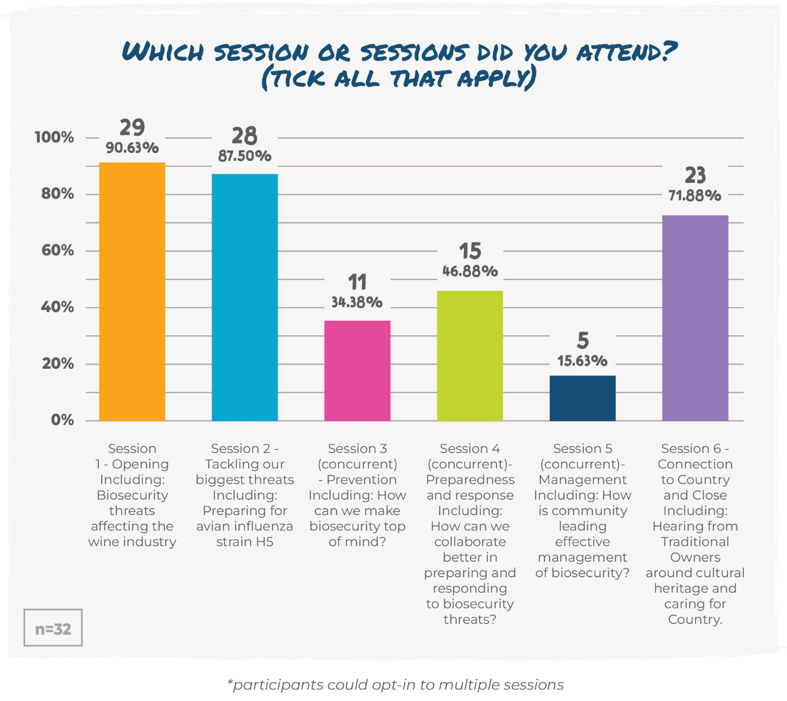

Question 2 - Overall, how valuable did you find the sessions you attended?
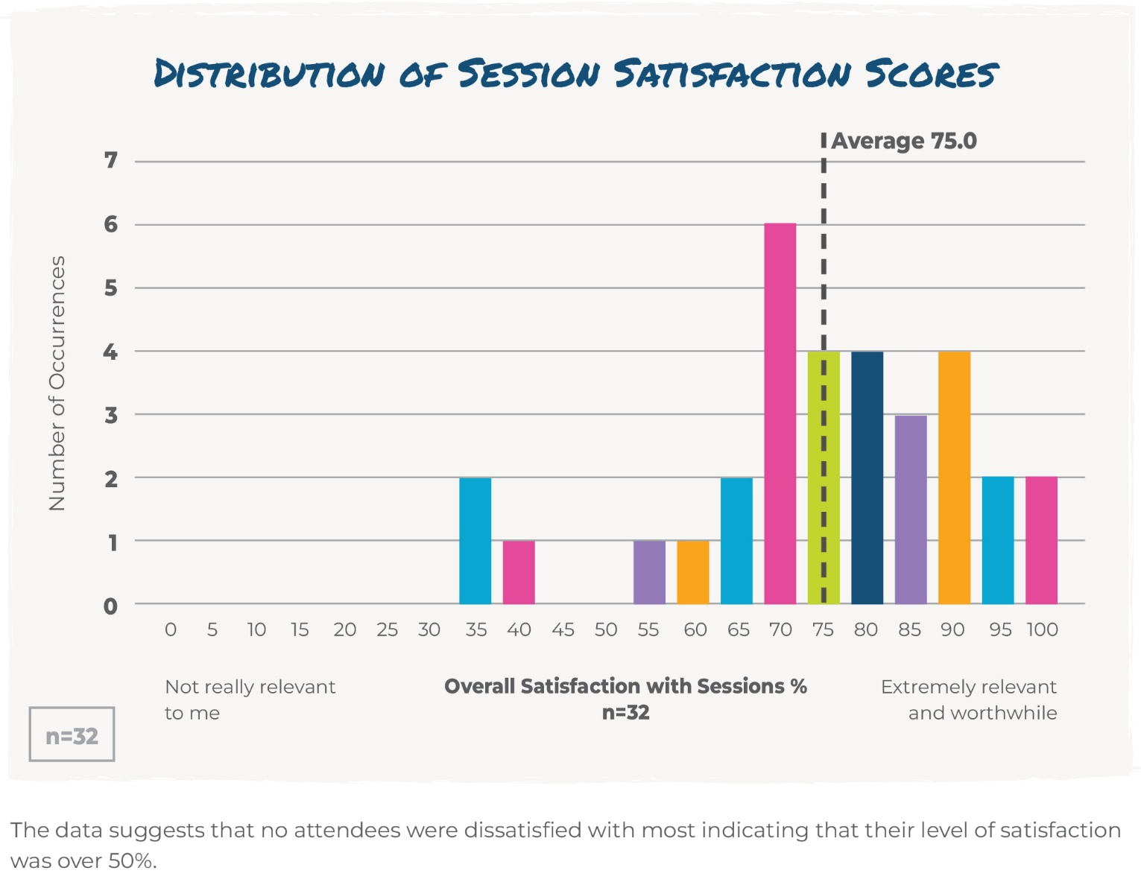

Satisfaction level percentage | Frequency of responses
0 | 0
5 | 0
10 | 0
15 | 0
20 | 0
25 | 0
30 | 0
35 | 2
40 | 1
45 | 0
50 | 0
55 | 1
60 | 1
65 | 2
70 | 6
75 | 4
80 | 4
85 | 3
90 | 4
95 | 2
100 | 2
Total | n=32

The data suggests that no attendees were dissatisfied, with most attendees rating their level of satisfaction over 50%.

Question 3 - What did you enjoy most about the sessions? What should we make sure we do for next year’s event?
Participant responses (n=30):
- I enjoyed hearing about what others do when we were in the breakout sessions.
- Networking is very valuable. Official presentations don’t add much to the whole thing, while ideas exchange and discussion are very useful.
- Networking.
- I enjoyed the diversity of presenters and that they were well experienced in their fields.
- Hearing from examples of biosecurity.
- The breakout rooms and discussions with other participants.
- The array of speakers from different industries.
- I enjoyed hearing the real stories.
- Updates by CVO and CEO Ag Victoria, interaction with other stakeholders.
- Informative and allowed for questions.
- Was interesting to listen to people who have a different role in preparedness - industry, state, federal. Was a good mix of people participating. The breakout sessions were good.
- The interaction with self-minded people…diversity of people.
- Continue the share of actual case studies that people need to deal with.
- The case studies and real-life experiences.
- Interacting with a range of people. It's a long day perhaps it could be run over a couple of days.
- The small group discussion were very valuable and were a good place to discuss ideas and gain insights into what other people were doing.
- Hearing the latest activities and interactions.
- Breakout rooms are very useful to discuss things more in depth and to make connections.
- The energy and interactive nature of the sessions with information provided and followed by breakout discussion.
- The mix of presentations and conversation and the size of the breakout groups was good as smaller groups promote better contribution.
- The guest speakers were excellent as were the breakout rooms.
- Specific case studies. Also the final session was incredible. So meaningful to be transported to Country where people are doing the meaningful work in real time, and not just be looking at slides, maps and photos.
- Hearing the willingness to engage and share.
- The case studies that were provided were very good value and worthwhile.
- Hearing stories and information giving different insights and perspectives.
- The variety of speakers.
- The variety of presentations and topics. Perhaps more inclusion of wildlife and maybe slightly longer in some of the breakout sessions, and maybe less time in the one that was longer?
- The sharing of information and experiences. Just keep up the good work, the event was well facilitated, organised.
- The interesting range of perspectives and experiences.
- Interactive, informative, well facilitated, range of stakeholders presenting inc Landcare and TO's.
- I think that was great, there were many people in the room and many opportunities to make connections and chat.

Question 4 - What, if anything would you recommend doing differently for next year’s event?
Participant responses (n=23):
- I was disappointed I had to choose between the sessions. I would have liked to hear them all.
- The lists of topics voted by people disappeared very quickly, it would be good to keep a copy of each one of them.
- Make it in person and shift the focus slightly, didn't care for the heavy wine industry info.
- If biosecurity practitioners wish to promote "come clean-go clean" principles, then utility companies should be part of the discussion.
- For the sessions to be more focused on the actions of the strategy, advising what has been done to deliver the strategy. The sessions felt like just ticking a box of engagement and not really delving into the strategy actions and what has been achieved and what is happening or needed to continue to deliver the actions of the strategy.
- I would suggest not to waste time on the breakout rooms, the few I did people were just wondering why we were doing them, they had little impact, and we spent most of our time just talking about other items. I was unsure about what they were trying to achieve.
- Run over two days so there's more time to chat with other participants.
- Ability to attend all sessions and not have to choose between concurrent sessions.
- A few more people in breakout rooms, perhaps 5 to 6, sometimes the numbers were a touch low.
- More updates from the different stakeholders i.e. more awareness of all the different threats and the industries affected.
- Nothing at this stage.
- It’s a very loooong day.
- I think we need to hear about the previous year’s Roundtables and what was discussed and how it influenced the implementation of the biosecurity. There is no line of sight between the discussions and action.
- It was well run so no suggestions.
- A little more time in the breakout sessions.
- Maybe extend the invitation to more diverse stakeholders to broaden the representation and the ideas shared.
- Nothing to add.
- There was a heavy focus on avian influenza, and while topical and useful for lessons, I think highlighting a range of current responses in Victoria and other states may have assisted engagement for some participants.
- I thought a couple of the breakout sessions went too long. It’s obviously a hard balance because it so depends on how much people want to contribute to the conversation.
- I didn't like the comment boards, felt clunky.
- As good as the networking opportunities were, I would like to have seen less breakout sessions; I did feel at the end of the day there were probably too many of these.
- The background colours made Micro lab look like AI people, in a good way.
- Nothing comes to mind.
- Give access to all 3 concurrent sessions.

Question 5 - Anything else you would like to add?
Participant responses (n=17):
- I really did not like the music playing when we were asked to respond to questions. This is not accessible to all needs. I found this very distracting, and it made me disengage in the session. I realise they were trying to keep things light and fun, but they need to think about what they are asking of participants. Listen to the music or answer the question?
- It would have been great to have practical advice on implementing "come clean-go clean" for utility companies and contractors who access multiple properties a day. The discussions focussed more on policy or strategy and were not practical for implementation on the ground.
- Unfortunately, I checked out halfway through the day due to I felt it was not really delivering what I had expected from the sessions.
- Always an inspiring event.
- No.
- The program was very engaging, and the sessions were valuable.
- Thank you for opening it up nationally.
- You are doing a great job at engaging with stakeholders.
- No.
- Given the interest demonstrated in reaching out to CALD communities, maybe invite some reps from that sector?
- Keep doing what you are doing. I feel the power of building the network through these forums is invaluable for biosecurity. Also - I loved the live cross to country.
- It was a huge day, but having the short breaks made it doable. Thanks for a very informative session.
- Overall, this was a very worthwhile event to attend.
- I'm not sure what change the day achieved.
- I would really appreciate a way to share my contact details so that others can contact me - and would be very grateful if others did the same. The cross-section of groups at this round table was good - but hard to contact some of them - especially when they were only identified in chat by names - not organisations.
- Well done, was great.
- No, I thought it was a really valuable session that was delivered seamlessly.

Question 6 - The industry sector that I'm primarily representing today is...
Answer Choices | Percentage | Count
Industry Group/Peak Body | 12.12% | 4
Grower/Producer | 3.03% | 1
Land owner/manager | 0.00% | 0
Government - Local | 30.30% | 10
Government - State | 24.24% | 8
Government - Federal | 0.00% | 0
Retail/wholesaler | 0.00% | 0
Supply chain/logistics | 0.00% | 0
Community Group | 9.09% | 3
Education | 3.03% | 1
Other (please specify)  - Utility company  - WA  - Research provider  - Zoo and wildlife  - Traditional owners  - RSPCA | 18.18% | 6
Total | n = | 33

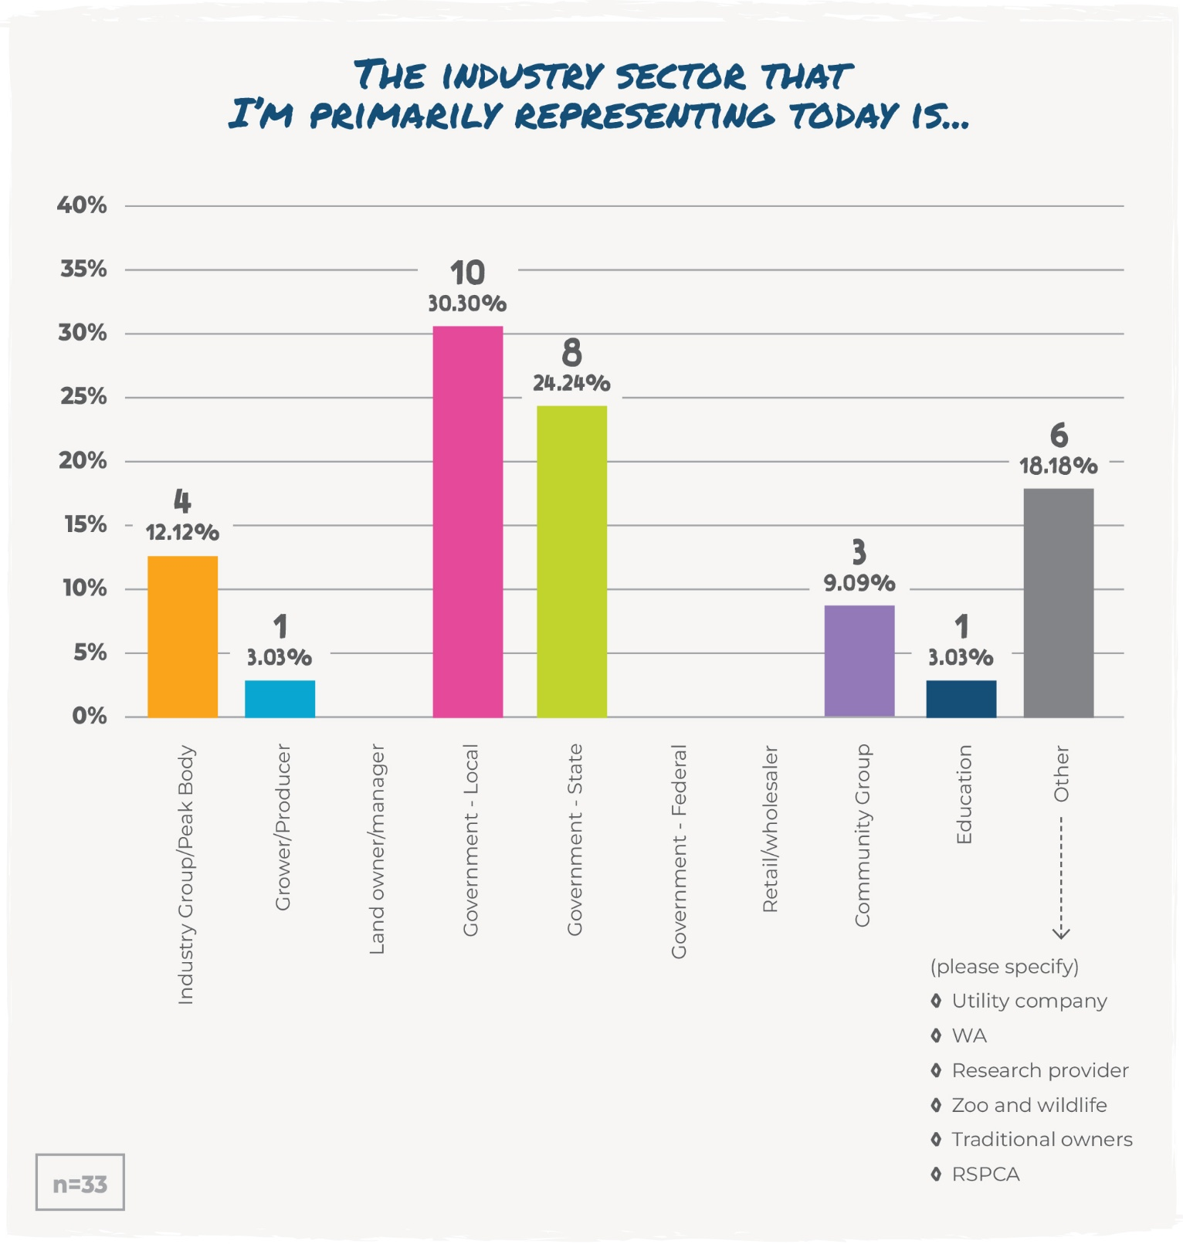

Appendices

Appendix 1- Session 1- Key priorities and concerns
Priority/Concern | Number of likes
Absentee landholders and weed management. | 17
Educating smaller property owners on the importance of reporting any animal/weed concerns. | 15
Keeping biosecurity front of mind. | 14
Lack of awareness/understanding of biosecurity and how it relates to all. | 12
Awareness of the general public. | 12
Raising awareness, educating and empowering the broader community about environmental and agricultural biosecurity, it impacts us all. | 11
The widespread impacts of H5N1. | 10
Climate change affecting pest and pathogen ranges and the rising cost to manage them. | 9
Prevention & preparedness. | 9
Funding being cut/stopped for effective programs. | 7
Educating the public so they willingly adopt good biosecurity practices and understand why it's needed to protect our environment, industries and way of life - and getting cooperation and collaboration across sectors. | 6
Protecting Country from pest animals and weeds. | 6
Education - many in the general population would not understand the significant impacts and the ongoing consequences. | 6
Bird flu virus affecting our wildlife. | 6
Government and industry work together in the event of an outbreak. | 6
Avian Influenza. | 6
Educating small farm owners about the risks associated with their various enterprise. | 5
Having active doable practical biosecurity plan on farm, not tick box papers in a folder that don't translate to actions. | 5
Wild dogs & dingoes. | 5
Slow response and recovery times – incurs huge costs for government, industry and the community. | 5
Improving recovery. | 5
Keeping Australia free of foot and mouth disease. | 4
Ensuring practices that support good biosecurity work in harmony with what all stakeholders need/want. | 4
Priority need to ensure that biosecurity measures are understood as to why necessary and actioned. | 4
Risk of introduction of marine pests through increasing international trade and lack of funding across Australia. | 4
Making sure that biosecurity is implemented on farms, big and small. | 4
Private landholders and businesses having to wear the cost of biosecurity actions with no recognition for the increase in cost of production at the farmgate value of product. | 4
My priority is protecting dingoes and that dingoes are NOT pests. | 4
Awareness and traceability. | 3
Communicating with culturally diverse groups. Speaking in clear language that does not ’beat around the bush’. | 3
’Making Biosecurity Everyone's business‘ is critical, and will take some investment and concerted campaigning, not industry specific. Reaching people where they are affected (i.e., at the supermarket) will be important. | 3
Engaging the community on biosecurity will be a challenging, long-term task. We know we are starting from a very low base in terms of engagement and cognition. How do we start planning now for engagement that will likely take years to build knowledge and behaviour change? | 3
Utilities accessing properties via easements (not front office/gate of farm). | 3
Don't stop raising awareness on biosecurity. | 3
Parks Victoria lack or resources and the risk that creates in terms of planning and control. | 3
Improving traceability for better biosecurity, food safety response and market access. | 2
Appropriate funding and recognition on preparedness, don't wait until there is a threat. | 2
Shared partnerships. | 2
Making sure that we and our customers do not add to any biosecurity threats. | 2
High Pathogenic Avian Influenza. | 2
That people entering farms register at office/house before doing anything on the property. | 2
Planning failure to protect agricultural land – the peri-urban issue. | 2
Funding unable to cope with the extent of the problem. | 1
What does ‘on the ground’ implementation look like? | 1
Bringing people together to work collectively to address biosecurity issues can be very challenging. | 1
Spreading awareness and prevention measures. | 1
Quantifying the potential for transmission of EADs (Emergency Animal Diseases) from feral animals to the domestic herds. | 1
Zoonotic diseases. | 1
Control methods disrupt current Integrated Pest and Disease Management methods. | 1
Worrying lack of knowledge or surprise by landholders that they need to be taking biosecurity measures on their property. | 1
The Australian Lot Feeders Association is focusing on prevention and response to EAD's (Emergency Animal Diseases) through the ALFA EAD Biosecurity Project. Its key objectives are to create resources that aid in awareness raising of best biosecurity practices as well as behaviour change to address gaps in feedlot biosecurity planning. | 0
Identifying greatest risk to prioritise actions. | 0
Risk of spread of phylloxera is great. Valuable research undertaken by Agriculture Victoria is critical. Simple techniques such as signs (with snakes) and footbaths are easy solutions to keep it at bay. Need to be wary of other methods of transmission. | 0
Lack of preparedness from lead agencies in responding to potential threats or outbreaks. | 0
Providing more. | 0
The response to avian influenza. We know it’s coming, we know it will impact wild and domestic animals. What we don't really seem to know is what the response should be. | 0
Wider general community awareness of how they can help contain and not introduce. | 0
Various threats to drinking water sources for human consumption. | 0

Appendix 2 – Session 2 – Questions for the panel
Questions for the panel | Number of likes
How do we ensure that people who have legal access to a property, comply with biosecurity requirements (e.g. in irrigation areas people access property via channels)? | 8
Historically there has been little to no focus on the peri-urban area and the fact that this area is the first line of defence against imported diseases given the proximity to international airports, etc. With the increase in lifestyle, hobby farmers and land bankers [sic] in these areas, is there going to be a concerted effort and focus placed on engaging with and educating these cohorts as to the importance of biosecurity and actually implementing it on their own properties? Particularly where they border or are surrounded by commercial famers? | 5
What are we expecting from the H5N1 disease in terms of disease spread and risks to wildlife and poultry sector? | 4
How do we broaden awareness not just in the emergency / response moments? | 4
Do we really have the resources to manage a major incident and/or multiple incidents? | 4
How do we support threats from opposing industries and the relatability to your own industry? | 4
What lessons have been learned from H7? | 4
Is there a consideration to include backyard chicken breeders as they may be affected as well? | 3
Are we learning from overseas experiences re biosecurity preparedness and management? | 3
Is vaccination for HPAI being investigated? | 2
As a government agency working in a regional area closely with community, I'd like to hear about how information is being made publicly available. | 2
What is the number one thing we need to change to improve the Vic Biosecurity system? | 2
How can we move quicker to reinstate freedom after an outbreak? | 1
What strategies help to communicate the importance of biosecurity, particularly to stakeholders who are not directly involved in the business? | 1
What systems are in place to support recovery in the event of a widespread H5N1 outbreak? | 1
Biosecurity is a continuum, extending from the national and state level to the land manager at a local level. We all agree local and fast action is crucial. How to we better fund and enable action at a local level to improve prevention, response and control? | 1
Can you tell me have you considered collaborating with recreational hunters to monitor for and detect outbreaks of Highly Pathogenic Avian Influenza in wild waterfowl? I'd love to communicate with you on behalf of Field & Game Australia, but haven't been able to reach the right people. | 1
What weaknesses were seen in multistate response to Emergency Animal Diseases and what actions could address these to deliver eradication in future? | 1
We discussed small flocks and people having small flocks or poultry in back yards, are there vaccines available to help mitigate this? | 0
What preparedness and response activities are being considered for disease impacts to free ranging wildlife populations? | 0
What thinking is going into recovering more quickly from outbreaks? | 0
How has the relationship with industry changed during the course of the H7 response and is there a need / appetite for industries to take a more active approach in an actual response? | 0
Are the same vehicle hygiene standards in place for domestic lawn mowing businesses? LG and contractors must wash down vehicles before transiting between, but domestic businesses don’t adhere to these. | 0
How do you inform the home that has a few poultry – seemed there was not enough information available (similar to per-urban issue). | 0
Ramping up, surge response, incident management at a local level and responding involving communities is a great strategy – but it is reliant on volunteer input. Is this sustainable economically for those volunteering (groups and individuals)? How can we get the greater public to recognise and cough up for this critical contribution to biosecurity? | 0
Is it time for a new emergency department? How can lead agents do it all i.e. manage business as usual, biosecurity emergencies and natural disasters? | 0
Biosecurity is a growing concern due to globalisation. There is a need for international collaboration and consistent biosecurity standards to manage threats while keeping the trade open. | 0

Appendix 3 – Session 3 – Ideas for making biosecurity top of mind
Ideas for making biosecurity top of mind | Number of likes
Answer the 'why me?' question for the average person. | 8
Use case studies, what would happen if I don't think about biosecurity for a particular issue. | 5
Use local champions. | 4
Connect at the community level making sure you engage community leaders. Engage in an environment and manner that is comfortable for the individuals within the community. | 4
Education/awareness - community, schools, industry. | 4
Consistent, visible messaging – people don't think it's an issue once they don't hear or see about it anymore. | 4
Build awareness through long term sustained campaigns that biosecurity needs to be integrated into our day to day activities (not an add on). | 4
Meet where they are, than where we are. | 4
Be good to have a state 'if you buy a property' where do you go to access information on region's issues around pests and weeds, etc. | 3
Build a ’safety first approach‘, like we try to do for occupational health and safety, so we are reminded to consider this at every step. | 3
Multi-pronged approach – Government departments to lead by example with having biosecurity kits in their cars, changing boots between each property to ensure they're not spreading weeds or disease. | 3
Pull at people’s heart strings! Make them feel an emotional connection to the threat so they feel driven to act. | 3
Routine messaging in more spaces (national parks, peri-urban regions, supermarkets). | 2
Conduct a long-term annual marketing campaign to grow public awareness and participation in good biosecurity practices. | 2
Making it relevant and/or impactful to the audience you are targeting. How will it affect them and why should they care? Message will need to be tailored for each cohort/audience as it will constantly vary and change depending on who you are trying to target. | 2
Engage interested recreational groups more efficiently – not just industry bodies. | 2
Emphasise the sheer level of importance attached to biosecurity; remind people what is at stake, and that industries may literally collapse if incursions are serious enough. | 2
Engage at a local level – interpersonal relationships very important. | 2
Use influencers for engagement. | 2
Lack of understanding of where food comes from and the risks, for example signs in supermarkets with honey isle information on varroa, make connection with product and risks, eggs/chicken with avian influenza, fruit with fruit fly. | 2
Creating media campaigns that bring the importance and relevance of biosecurity to everyone, particularly the general public. Play in prime time and during sporting events, etc., when everyone will see and take notice. Tailor the campaign and messaging to the audience likely to be watching at that time. | 1
To make biosecurity front of mind: link to value concern of audience. | 1
Build linkages in people's minds between an outbreak and what it means locally. Avian flu ... no eggs on shelves. Biosecurity risks are something that happens 'elsewhere' for many Victorians, particularly metropolitan dwellers. Bring the issue home. | 1
Educate the population. | 1
Advertising and awareness campaigns need to be rolled out each year and have simple messages and actions for people to follow. | 1
Have a consistent campaign. | 1
Saturate all media streams, couple with high profile people and events. | 1
Long term programs that are ’opt out‘ not ’opt in‘ (Landcare is opt in). | 1
Use of biosecurity programs as a pathway to educate about biosecurity. | 1
Consistent messaging across all agencies and authorities. | 1
Suggest that agencies & organisations working with primary producers develop their own biosecurity protocols – actively lead by example when going on farm. | 1
Increase conversation to educate those not connected to the problem or state media. | 1
Including in the school curriculum to improve understanding. | 1
Basic principles – Rather than expecting people to come to us, we need to take our messages to where they are, in a relevant way (e.g. supermarket – honey + varroa mite, eggs = avian influenza; meat = foot and mouth...) | 1
Get rid of the term Biosecurity – let’s get back to managing pests and diseases. | 1
Sustainable solution – has to be doable. | 0
Educate by interest group – has to be something they are interested in/stand to lose personally. | 0
Build facilities that ensure action and not just words. | 0
Appropriate punishment for breaches – hopefully people take it more seriously. | 0
Associate with something immediately / locally important. | 0
Assist producers to maintain biosecurity. | 0
Education of all in communities, not just regional. | 0
Agencies need to take responsibility in controlling abandoned orchards and properties. | 0
That not opting in is not an option. I.e. mandatory for Industry, and all sectors. | 0
Repeat messages – well advertised across a multitude of media/advertising methods. | 0
Leading by example. | 0
Effective awareness campaigns. | 0
Loved Shakira's presentation on how to reach hard to reach communities. | 0
Affect business working, e.g. Foot and Mouth Disease. | 0
Scare tactics. | 0

Appendix 4 – Session 4 – How can we collaborate more effectively in an emergency response?
How can we collaborate more effectively in an emergency response? | Number of likes
Timely communication channels. | 8
Simple and visual information (which is disseminated by lead agencies). | 7
Regular review together of plans. | 6
Think beyond agency relationships and consider active community and interest groups. | 6
Knowing who needs to be informed/involved. | 6
Fund facilitators at a regional level to work on encouraging all stakeholders to invest. | 5
Clear roles and responsibilities. | 5
Clear and concise communication. | 5
Response plan templates with agency and non-government roles outlined. | 4
Share resources. | 4
Get investment in a local plan early in peacetime. | 4
Start by collaborating during preparedness phase. | 4
Build partnerships with other people / departments before an emergency occurs. | 3
Effective stakeholder mapping to ensure all parties are engaged, represented and communication channels identified for those not in regular communication with peak agencies. | 3
Being accurately informed of the land managers throughout the state so that the correct land manager can be contacted. | 2
Prepare the technical and operational side of things during peacetime with stakeholders. | 2
Keep response plan current and up to date. | 2
Know your audiences. | 2
Understanding/mapping connections for enabling better communication and response. | 1
Communication through all forms. | 1
Ensure stakeholders are aware they have a role to play and that the role is enacted in the response. | 1
Having done your procedure prior to a response requirement so that when a biosecurity event is underway you can respond & collaborate accurately and with confidence. | 1
Use previous responses/emergencies as a guide for what worked well vs. what could be improved. | 1
Limit sources of information – stick to a couple to limit confusion. | 1
Have visuals that assist with common understanding. | 0
Keep talking to people. Keep connected and informed. Identify lead agencies. | 0
Industry specific exercises to test response plans. | 0
Ensure there is effective internal communication as well as external communication. | 0
Collaboration between different groups and educating the community. | 0

Appendix 5 – Session 5 – What is the key to successfully partnering with the community to manage biosecurity threats, what do we want to do more of?
What is the key to successfully partnering with the community to manage biosecurity threats, what do we want to do more of? | Number of likes
A plan that is owned by the community and partners. With clear roles and responsibilities. | 6
Make it relatable and easy to understand and action. Give purpose. | 5
Coordination. | 5
Key person to bring stakeholders together to facilitate partnerships and action (often a Landcare facilitator). | 5
Giving the community a sense of ownership of the program. | 5
Education and incentive should be the first approach. Also advocating for the desired result not necessarily being the absence of the threat, but rather the enhancement of biodiversity or increased output of primary production and celebrating these results. | 4
Leveraging local knowledge & expertise. | 3
Definitely more education, a feel a fair portion of community would have little to no idea of the biosecurity threats. Therefore, no deep understanding of the consequences either. | 2
To resource the trusted local facilitators who bring people together and enable functional/successful collaboration. | 2
More assistance and collaboration from public land managers. | 2
Communication and education to the general public to increase awareness. | 2
True and meaningful collaboration not just consultation with Traditional Owner Groups. | 1
A bit more ‘grease’ (grants/practical resourcing) to help with action. | 1
Valuing the role of partnering within organisations and funding those roles appropriately. | 1
Trust/relationships. | 1
Partnerships. | 1
Communicating successful stories to the public. | 1
Government support of grant applications from small community groups to collaborate with local partners to undertake on groundwork. | 0
Appreciating and learning from Traditional and western sciences. Allow for Traditional knowledges to guide and lead the way. | 0
Reminding people what matters, and by doing that, fostering involvement whether that is a farmer that gives up time and space to have people on his property to talk and witness the issues firsthand, or someone willing to host/send out invites to a town hall style meeting - even meeting at a cafe to talk to get started on thinking about an issue/pest management. | 0
If there is a plan, are there action items that could be divided up between the stakeholders to ensure momentum? Then review it frequently. | 0

Appendix 6 – Questions for the panel on Country
Question:
- Am I wrong to think that Biosecurity management and Reconciliation/Closing the Gap work hand in hand together? All the weeds and pest animals and many of the diseases have come as a consequence of colonisation/invasion, and the work we have to do to prevent more and regain control of the species here, is working to heal country, and heal relationships...
- Can cultural burns be used to manage wheel cactus or other noxious weeds?
- Do the cultural burns help reduce the biomass of the dead plants and therefore the spines that impact so much fauna?
- What is the long-term management plan for the area? Will it be revegetated in the future to provide competition or will it make management of cactus more difficult?
- What is the single most important thing you think that I (a person with no indigenous background but a keen sense of the injustice to both land and people that has occurred through colonisation) can do to connect with Traditional Owners to make progress on righting wrongs?
- What method was used to spray the cactus and how have native forbs [sic] responded?
- What other risks or pests do the cactus host (e.g. Queensland fruit fly?) and can grazing be a part of ongoing control and management of rehabilitated areas?
Note: panel responses were not recorded.

Appendix 7 – Final reflections on the Biosecurity Roundtable
One thing I learned today…
- A reminder to not have preconceived ideas about stakeholder groups.
- Experts are the people on the ground and their ideas/experience are valuable to drive better outcomes.
- Highlighted the importance of networks and connections for biosecurity preparedness and response.
- I must say, I was disappointed there weren't more Local Government participants because community members call Local Government no matter what the issue, even if it isn't Local Government connected. More Local Government.
- Land management can be effective with Traditional Owner inputs.
- People's thinking about responsibilities re biosecurity.
- Phylloxera.
- Sessions from Country make for an exciting experience :)
- The breadth of industries working to protect our biosecurity and that can be impacted by breaches.
- The difference between producers and Vic population in the concerns for agriculture in survey presented by David Spicer.
- The power of partnerships and the sharing of information.
- There are things that some industries do or support that are a biosecurity risk to others - e.g., wineries promote balloon rides that can bring cattle disease risks to the area when passengers get out of balloon baskets on landing in cattle paddocks.
- There were some missing points including the Varroa mite incursions and the dreadful response.
- We need more support and funds for volunteers and regional organisations to be able to act locally and step up in many ways. We need to invest in these people to keep them present (on established pests) to both prevent biosecurity issues developing and to escalate an effective and efficient response to exotic pests.
- Wheel cactus reportedly hosts Queensland Fruit Fly.

One thing that inspired me…
- Fantastic report live from Country.
- Hearing from experts in this space.
- How willing everyone is to engage, share knowledge and collaborate.
- I loved Shakira's talk about reaching [hard to reach audiences].
- On country culture.
- Plan.
- Some of the case studies that were highlighted were outstanding; lots of common ground out there!
- Stay in touch with agencies.
- Strengthening connection between local and state levels of organisations and peak industry bodies – and between regions!!!!
- The coming together of everyone with a shared vision for communicating better.
- The comment that despite differences the principles of biosecurity remain the same across industries.
- The connections and people power who are driving biosecurity outcomes – from managing pigs, sharing info, collaborating.
- The variety of groups represented today, and the guest speakers.
- The willingness of people to work together on biosecurity.
- What a wide and extensive field is Biosecurity! It includes so many aspects, which makes it stimulating.

My first action after today…
- Adding biosecurity to my 2025 work plan.
- Connecting better with local government who are often the front line of contact for the community.
- Connecting more with city audiences.
- Continue our preparedness work!
- Continue to build relationships with various agencies to keep dialogue flowing.
- Continue to keep biosecurity front of mind in my work.
- Contribute to strategic conversations and bringing people together in sessions like this.
- Create an even longer-term plan with a more open scope of participants for preventing and managing Queensland Fruit Fly in the Yarra Valley.
- Engage with those who I have met virtually today.
- Having a draft.
- Somewhat more of the same; keep spreading the word and involving community groups in the management of marine pests.

PLEASE NOTE:
This report has been prepared by MosaicLab on behalf of and for the exclusive use of Department of Energy, Environment and Climate Action (DEECA). The sole purpose of this report is to provide DEECA with materials produced at the forum.
This report has been prepared in accordance with the scope of services set out by the DEECA. In preparing this report, MosaicLab has relied upon the information provided by the participants at the forum. DEECA can choose to share and distribute this report as they see fit. MosaicLab accepts no liability or responsibility whatsoever for or in respect of any use of or reliance upon this report by any third party.
MosaicLab is a Victorian-based consultancy that specialises in community and stakeholder engagement, facilitation, negotiation, strategic planning. and coaching.

