Best Practice Guideline: Movement within a Phylloxera Infested Zone

This guideline describes the biosecurity practices with the highest impact relevant to controlling the spread of phylloxera within a Phylloxera Infested Zone (PIZ). This guideline is a tool for industry to make decisions on the adoption of biosecurity best practices to protect their properties. The practices described in this guideline are in addition to the permit requirements for leaving a PIZ. These practices are encouraged to be applied to movements between properties within a PIZ, as they can assist in the prevention of the introduction of new genetic strains of phylloxera to already infested properties.

Contractors and visitors
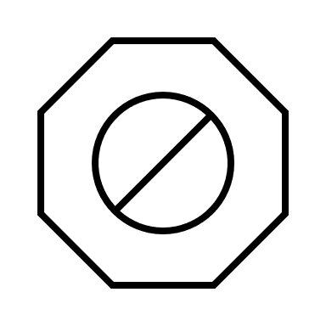
Control and limit access to vineyards, ensuring all visitors meet entry requirements, including footbaths.

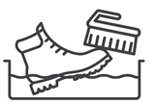
Footbaths should be used by all people entering the vineyard. Ensure correct footbath procedure is followed.
- Wash and scrub boots of all dirt and plant material.
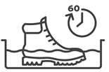
- Disinfest in 2% sodium hypochlorite (50% household bleach, 50% percent water) for at least 60 seconds.
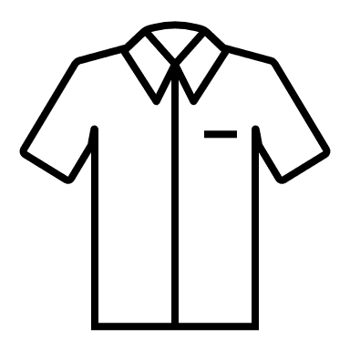
Ensure clean clothing is applied between properties.
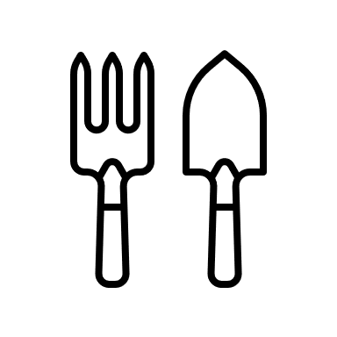

Clean small hand tools between blocks and properties with Dettol (undilute 4.8%) or alcohol spray (95% ethanol, undilute for methylated spirits). These can also be cleaned in the bleach footbath, but this can be corrosive on tools.
Train all contractors, winemakers, viticulturists, and agronomists to follow correct farmgate procedures.

Cleaning and disinfestation

At a minimum, ensure all harvesters and vineyard machinery have been pressure washed to remove all soil and plant material before entering your property.
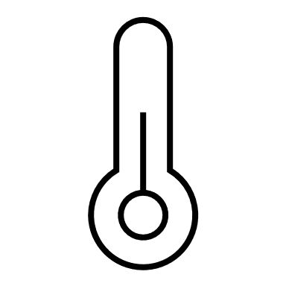
It is recommended all harvesters and vineyard machinery and equipment, including bins and tractors, are dry heat-treated prior to entering your vineyard.
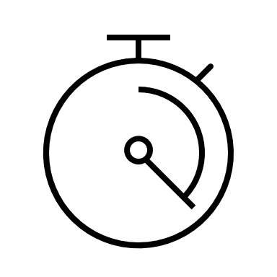
Ensure steam cleaning is effective - apply for at least 10 seconds and not further than 1 metre from the nozzle across the entire target.
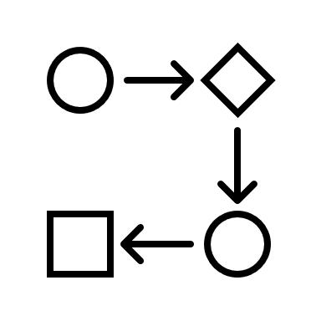
Create flow when cleaning, moving machinery and equipment from dirty to clean areas, and isolating throughout to prevent cross-contamination.

Used vineyard equipment and infrastructure

Only move used vineyard equipment and infrastructure (e.g., posts) between vineyards if isolated from vines for more than 12 months.

Plant material

Do not move plant material or soil between vineyards.



Further information
Scan the QR code for more information on best practice vineyard biosecurity.

