
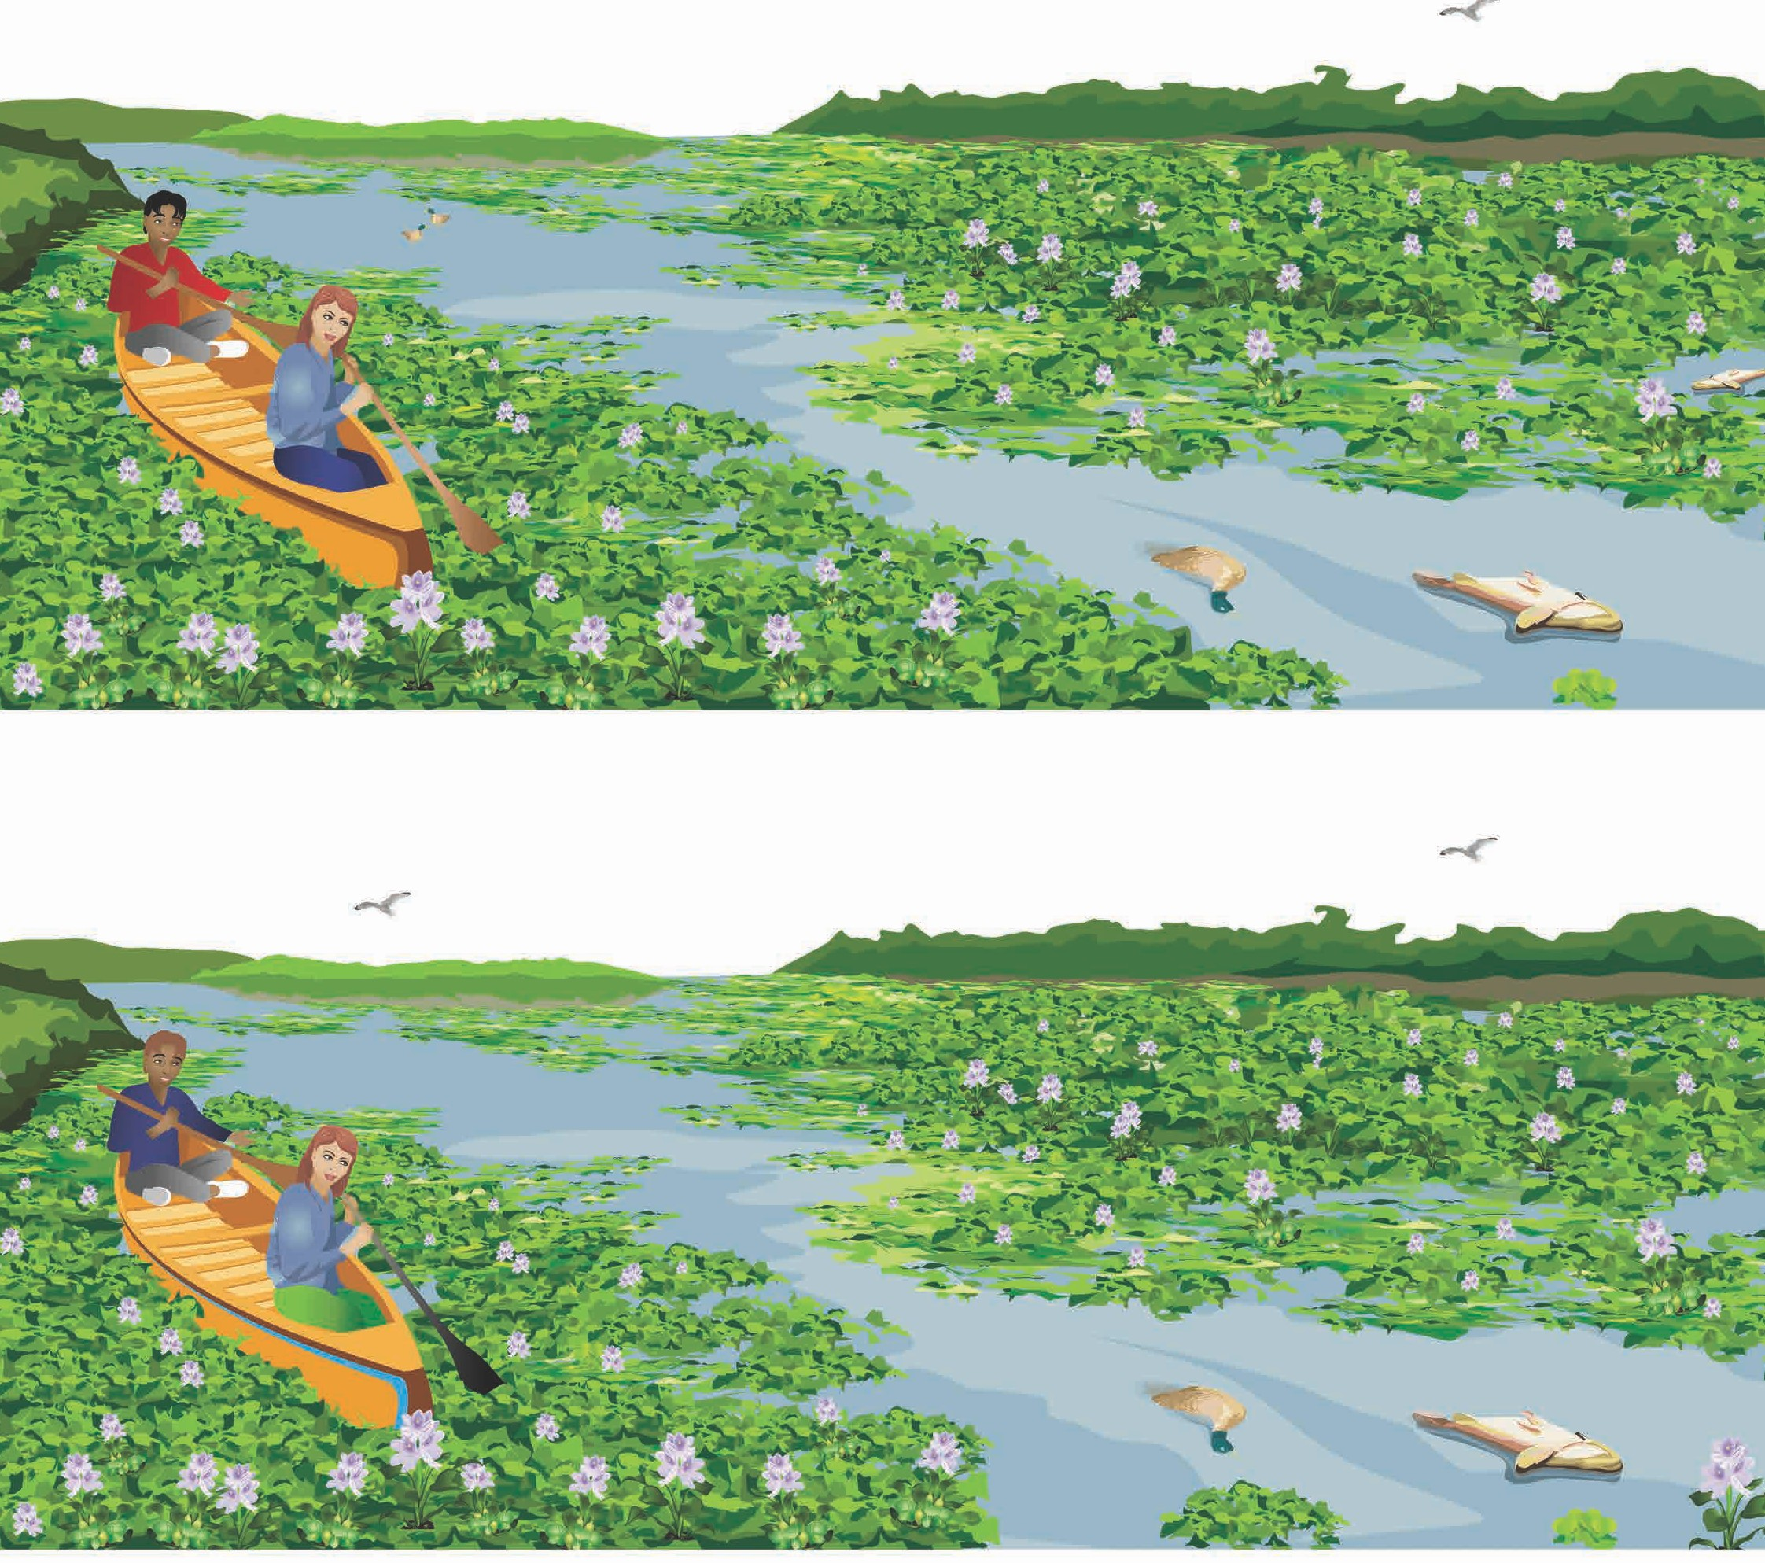Spot the difference activity sheet

Look closely at the two pictures of water hyacinth taking over this lake. Ten things are different in Picture 2, see if you can find them all.

Picture 1

Picture 2

Water hyacinth is a State prohibited weed in Victoria.
At Agriculture Victoria we are working hard to protect our waterways and environment from this weed and we need your help.

Please call us on 136 186 or email weed.spotters@agriculture.vic.gov.au if you have water hyacinth or see it in a pond, river, lake or stream. Agriculture Victoria will remove and safely dispose of water hyacinth plants.

agriculture.vic.gov.au/biosecurity/weeds/state-prohibited-weeds/water-hyacinth

© The State of Victoria, Agriculture Victoria 2018
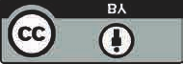This work is licensed under a Creative Commons Attribution 3.0 Australia licence.
To view a copy of this licence, visit http://creativecommons.org/licenses/by/3.0/au/deed.en

