Colac Analogue Poster – (text to accompany pdf poster)
Title: What might Colac’s climate be like in 2030, 2050 & 2090?

Map: showing the general location of Colac and the location of three possible analogue towns that have similar climates to that which is projected for Colac in 2030, 2050 and 2090. The map also shows the average annual maximum temperature gradient range from southern to northern Victoria to illustrate the increase in temperature heading north and inland.
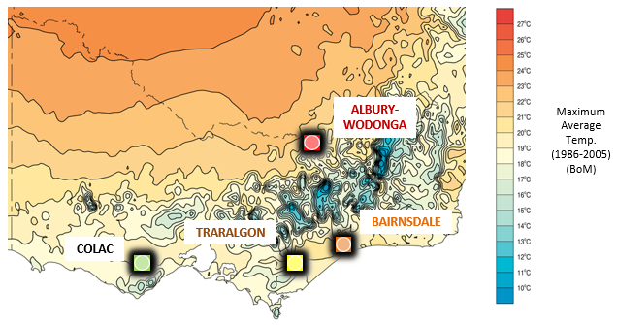
Text: Climate Analogues explore what the future climate could be like for a given location. These analogue localities have been developed using the Analogues Explorer Tool from the CSIRO’s Climate Change in Australia. This tool matches the proposed future climate of a region with the current climate experienced in another region using average annual rainfall and average annual maximum temperature (within set tolerances). They were developed using the maximum consensus of models (based on CMIP5) for the high greenhouse gas emissions scenario, (RCP 8.5). NOTE: These analogues have been further refined to align with projected seasonal changes based on Model GFDL-CM3 which was selected by John Clarke, CSIRO Climate Science Centre, as the most representative model. This assumes a slight rainfall increase to 2030, later declining across the Southern Slopes Region and an average temperature increase of 3.18⁰ C by 2090, based on data from the Climate Futures Tool. NOTE: The analogue towns selected for Colac are focussed primarily around projected temperature change rather than projected rainfall.

Table showing current and projected seasonal and annual mean maximum temperature and mean rainfall for Colac, both currently, and as projected by CSIRO for Colac in 2030, 2050 and 2090. These projected temperatures and rainfalls are similar to the current average seasonal temperatures and rainfall analogue towns of Traralgon (2030), Bairnsdale (2050) and Albury-Wodonga (2090). The current average seasonal temperatures and rainfall for each of those towns are shown alongside those projected for Colac in the table.
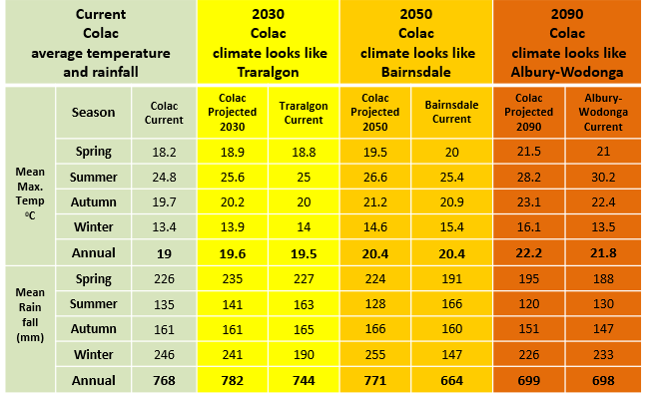

Note: More information on how analogues can be used to visualise the future can be found in the document: ‘Climate Analogues for NRM in Victoria: How might your town/region look in the future?’

