Hamilton Analogue Poster
Title: What might Hamilton’s climate be like in 2030, 2050 & 2090?
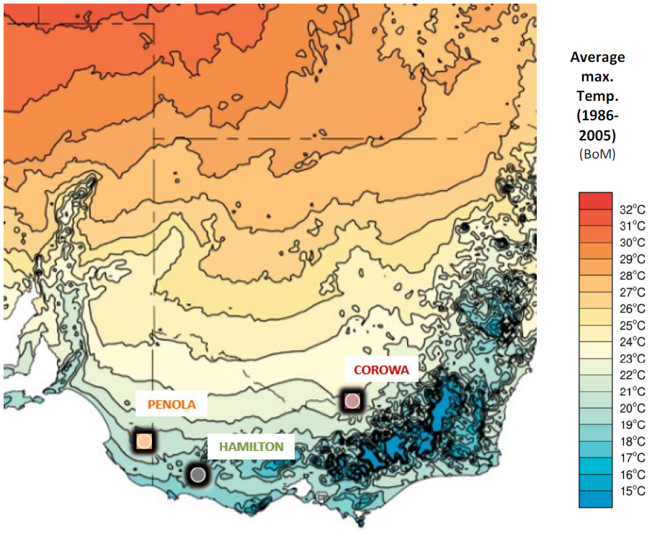
Mean annual
max.
temp C⁰
Map: showing the general location of Hamilton and the location of two possible analogue towns that have similar climates to that which is projected for Hamilton in 2030, 2050 and 2090. The map also shows the average annual maximum temperature gradient range from southern Victoria to northern New South Wales to illustrate the increase in temperature heading north and inland.
Text: Climate Analogues explore what the future climate could be like for a given location. These analogue localities have been developed using the Analogues Explorer Tool (hyperlink) from the CSIRO’s Climate Change in Australia (hyperlink). This tool matches the proposed future climate of a region with the current climate experienced in another region using average annual rainfall and average maximum annual temperature (within set tolerances). They were developed using the maximum consensus of models (based on the CMIP5 (hyperlink) model) for the high greenhouse gas emissions scenario, (RCP 8.5 (hyperlink)). NOTE: These analogues have been further refined to align with projected seasonal changes based on Model CNRM-CM5 which was selected by John Clarke, CSIRO Climate Science Centre, as the most representative model. This assumes a slight rainfall increase to 2050, later declining across the Southern Slopes Region and an average temperature increase of 3.18C⁰ by 2090, based on data from the Climate Futures Tool (hyperlink) data.

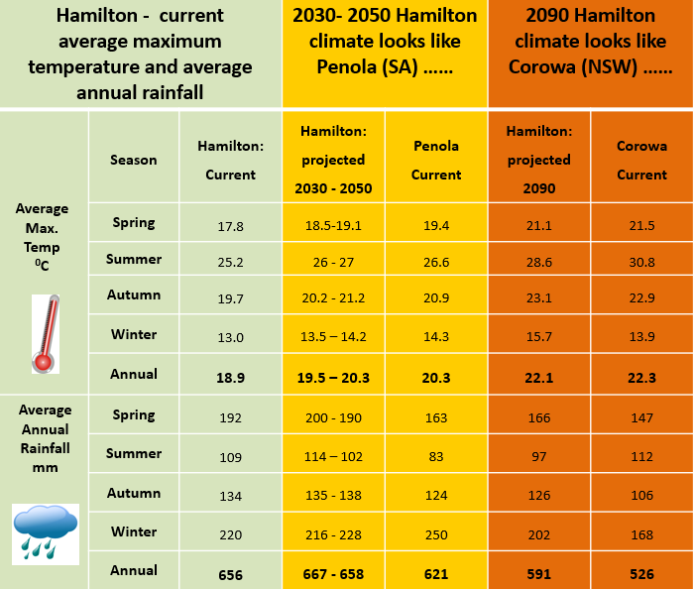

Table showing current and projected seasonal and annual mean maximum temperature and mean rainfall for Hamilton both currently, and as projected by CSIRO for Hamilton in 2030, 2050 and 2090. These projected temperatures and rainfalls are similar to the current average seasonal temperatures and rainfall analogue towns of Penola (2030), Penola (2050) and Corowa (2090). The current average seasonal temperatures and rainfall for each of those towns are shown alongside those projected for Hamilton in the table.

Note: More information on how analogues can be used to visualise the future can be found in the document: ‘Climate Analogues for NRM in Victoria: How might your town/region look in the future?’

