Warracknabeal Analogue Poster
Title: What might Warracknabeal’s climate be like in 2030, 2050 & 2090?
Map: showing the general location of Warracknabeal and the location of three possible analogue towns that have similar climates to that which is projected for Warracknabeal in 2030, 2050 and 2090. The map also shows the average annual maximum temperature gradient range from southern Victoria to northern New South Wales to illustrate the increase in temperature heading north and inland.
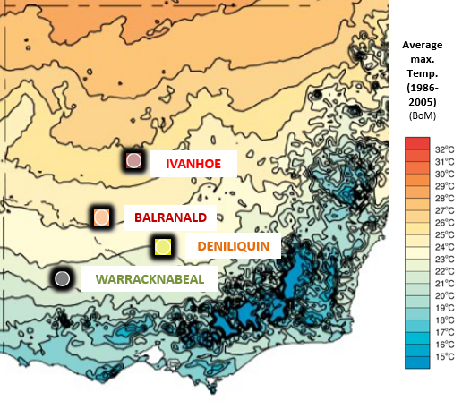
Text: Climate Analogues explore what the future climate could be like for a given location. These analogue localities have been developed using the Analogues Explorer Tool (hyperlink) from the CSIRO’s Climate Change in Australia (hyperlink). This tool matches the proposed future climate of a region with the current climate experienced in another region using annual average rainfall and average maximum annual temperature (within set tolerances). They were developed using the maximum consensus of models (based on the CMIP5 (hyperlink) model) for the high greenhouse gas emissions scenario, (RCP 8.5 (hyperlink)). NOTE: These analogues have been further refined to align with projected seasonal changes based on Model CESM1-CAM5 which was selected by John Clarke, CSIRO Climate Science Centre, as the most representative model. This assumes a slight rainfall increase to 2030, later declining across the Murray Basin Region and an average temperature increase of 4.83C⁰ by 2090, based on data from the Climate Futures Tool (hyperlink) data.
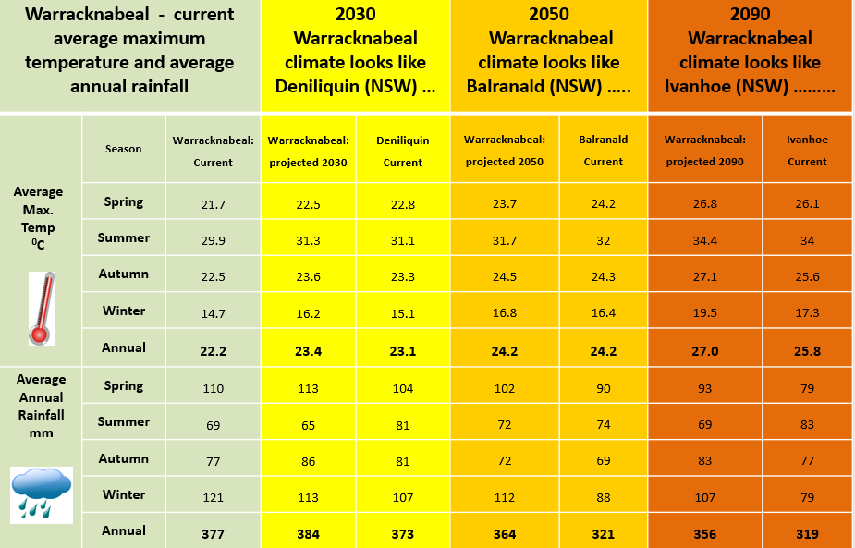
Table showing current and projected seasonal and annual mean maximum temperature and mean rainfall for Warracknabeal both currently, and as projected by CSIRO for Warracknabeal in 2030, 2050 and 2090. These projected temperatures and rainfalls are similar to the current average seasonal temperatures and rainfall analogue towns of Deniliquin (2030), Balranald (2050) and Ivanhoe (2090). The current average seasonal temperatures and rainfall for each of those towns are shown alongside those projected for Warracknabeal in the table.

Note: More information on how analogues can be used to visualise the future can be found in the document: ‘Climate Analogues for NRM in Victoria: How might your town/region look in the future?’

