Grow your future in fruit.

Your guide to a career in the Goulburn and Murray fruit industry.

Acknowledgments
We would like to thank the case study participants and reviewers. This guide is funded through the Victorian Government Smarter, Safer Farms Program.
SBN 978-1-76090-470-8 (pdf/online/MS word)
Published May 2021.
Authorised and published by Department of Jobs, Precincts and Regions, 1 Spring Street, Melbourne. April 2020 Accessibility
If you would like to receive this publication in an accessible format, such as large print, audio or in another language, please call the Department of Jobs, Precincts and Regions on 136 186, email customer.service@ agriculture.vic.gov.au or go to www.agriculture.vic.gov.au

Disclaimer
This publication may be of assistance to you but the State of Victoria and its employees do not guarantee that the publication is without flaw of any kind or is wholly appropriate for your particular purposes and therefore disclaims all liability for any error, loss or other consequence which may arise from you relying on any information in this publication.
This guide was produced in association with RM Consulting Group.

The Goulburn Murray fruit industry
The Goulburn Murray is in the heart of Victoria and is the state’s largest horticultural production region. It is renowned for growing quality assured fresh fruit, particularly apples, pears and summerfruit.
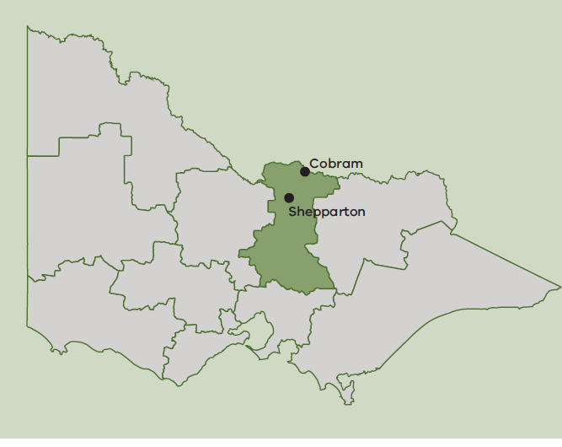

Pome Fruit - Including apples,pears and nashis
159,000 tonnes is produced in the Goulburn Murray. This is 78% of Victoria’s pome fruit production.
Stone Fruit - Including cherries, nectarines and peaches
44,000 tonnes is produced in the Goulburn Murray. This is 57% of Victoria’s stone fruit production
Sourced from:
Australian Bureau of Statistics (May 2021), Agricultural Commodities Australia, ABS Website, accessed 25 May 2021
https://www.abs.gov.au/statistics/industry/agriculture/agricultural-commodities-australia/latest-release

Careers in the fruit industry
The Goulburn Murray fruit industry is made up of a diverse community of fruit growers supported by agribusiness advisors, suppliers, marketers, transport specialists and retailers.
The industry is dynamic and innovative and skilled workers are in high demand.
As businesses adopt the latest technologies to grow, process and sell fruit, many exciting career opportunities are emerging.
There are many different career pathways available in the fruit industry catering for a broad range of qualifications, experience and interests.
- Orchard Production
- Service and technology providers
- Media and communication
- Dispatch and logistics
- Marketing and sales
- Packhouse
- Engineering and maintenance
- Administration
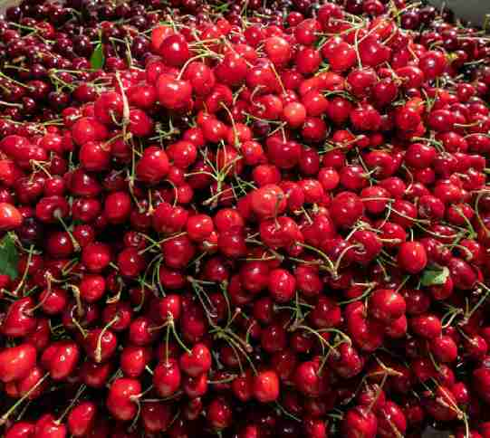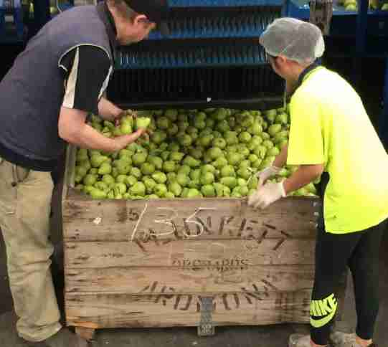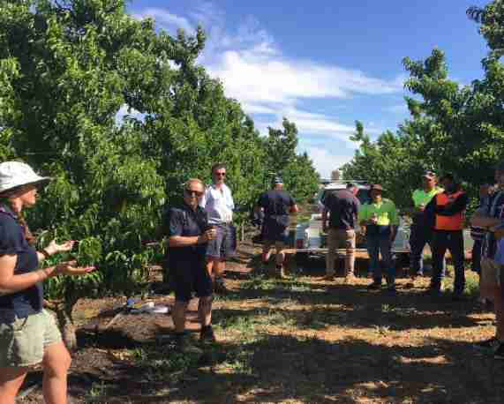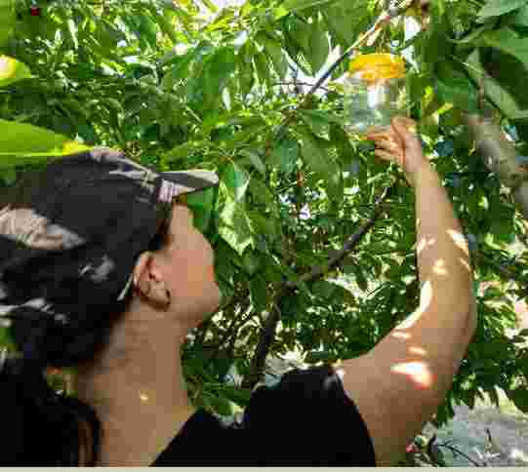

Fruit industry career snapshots

Orchard Production

Cliff Bramich – Orchard Hand to Assistant Orchard Manager
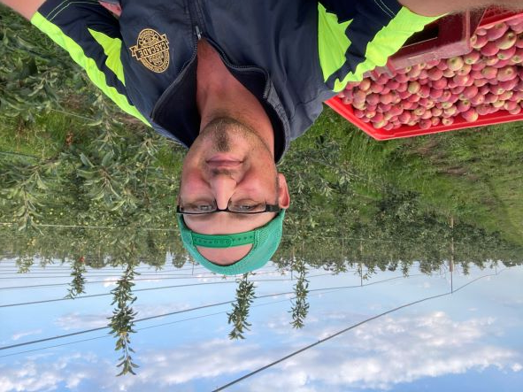
Cliff worked in retail for 20 years before finding a career in horticulture. Cliff started as an orchard hand with Jeftomson Orchards, growing apples and pears.
After six months he took the opportunity to become the Assistant Orchard Manager. Cliff is currently doing a Certificate IV in Horticulture and developing his skills and knowledge in plant nutrition, soil health and irrigation.
“Working on an orchard brings different jobs and challenges each day, no two days are the same. The satisfaction that you get from helping grow a product from start to finish is fantastic and something that you can be proud of. Working with great people and working outdoors is something I look forward to every morning.”

Career Pathway
Retail – Orchard Hand – Assistant Orchard Manager – Studying Cert IV Horticulture

Bhupinder Kaur – Technical Officer
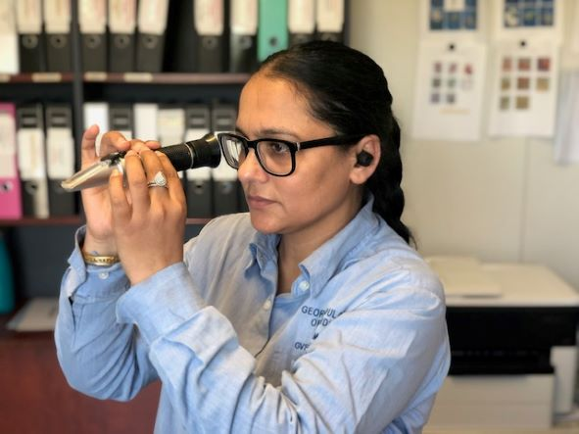
Bhupinder grew up in India and studied a Bachelor of Agricultural Science. She came to Australia and completed a Masters of Agricultural Science at the University of Melbourne and is now working for GV Independent Packers in the Goulburn Murray as an agricultural technician. During the fruit growing season she monitors pests and diseases in pome and stone fruit orchards and advises management about orchard spray programs.
“I think the fruit industry will provide good careers for a new generation. There is a lot of freedom, demand for our skills, and for food production in general. Now that coronavirus (COVID-19) is here, it has shown how essential we are, and we are lucky to have permanent jobs and a very secure future.”

Career Pathway
Bachelor of Agricultural Science – Masters of Agricultural Science- Agricultural Technician

Service and Technology Providers

Madeliene Peavey – Research Scientist
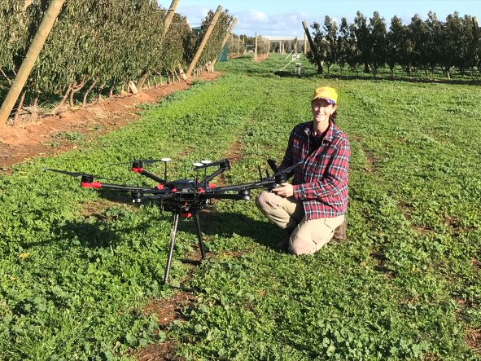
Madeleine studied a medical and surgery degree before deciding to pursue a Masters of Agricultural Science at the University of Melbourne. She spent time working on organic farms in Europe before returning to Australia and beginning work as a technical assistant at Agriculture Victoria in Tatura. She progressed to a scientist position and now works on horticultural research projects.
“I enjoy the balance between indoor and outdoor tasks. I like living in rural Victoria, having opportunities to further my career, working with new and exciting technologies, and contributing to the future of the fruit industry. The variety in my day-to-day job keeps things interesting.”

Career Pathway
Medical and Surgery Degree – Master of Agricultural Sciences – Organic Farm Hand – Research Scientist

Michelle Eagan – Agronomist
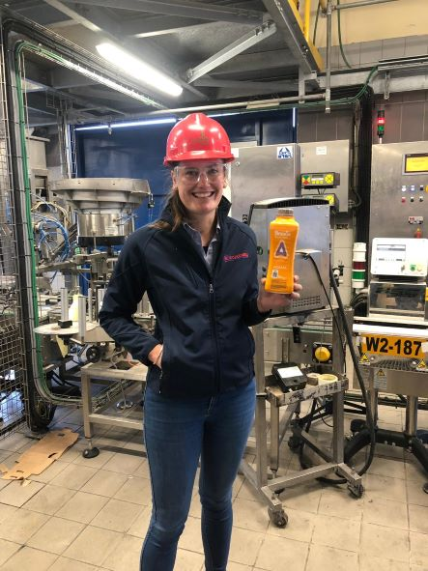
Michelle studied a Bachelor or Rural Science at the University of New England. She worked as a research scientist with a contract research company and then accepted a job as a junior agronomist at IK Caldwell, a rural supplier. She works with predominantly horticulture growers to develop solutions and programs specific to their business goals.
“I really enjoy working with our team and the growers. I like working with new products and technologies and being able to introduce something to a grower that I know is going to make life easier or improve outcomes for them. It is a very rewarding job to do.”
“I love the opportunities that come along with the role. I have been able to work with companies developing some pretty cool technologies for the future.”

Career Pathway
Bachelor of Rural Science – Research Scientist – Agronomist

Administration

Debbie Cooper – System Coordinator
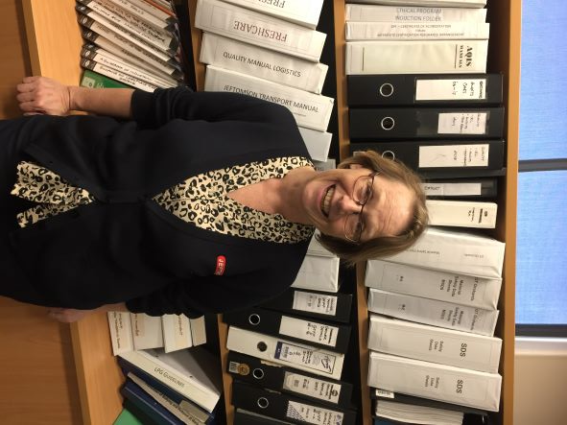
Debbie worked in clerical roles in accounting departments and payroll before moving to the Goulburn Murray. She started working with the Geoffrey Thompson Fruit Packing Company in a position managing payroll, quality control and Workplace Health and Safety. Debbie’s role has grown with the company and now covers a range of system functions across eight orchards, five logistics divisions a transport division and pack house.
“I’m not stuck at my desk or in the office; as I need to visit the various sites, learning what people do and how things work, meeting new people and challenges. Life is rarely boring and one year is never the same as the next. This isn’t a normal office position. I love the people I work for and with, the variety of work, being able to travel around the sites.”

Career Pathway
Accounting and Payroll – Payroll, quality control and Workplace health and safety – System Coordinator

Marketing and Sales

Colleen Dangerfield – Export Manager
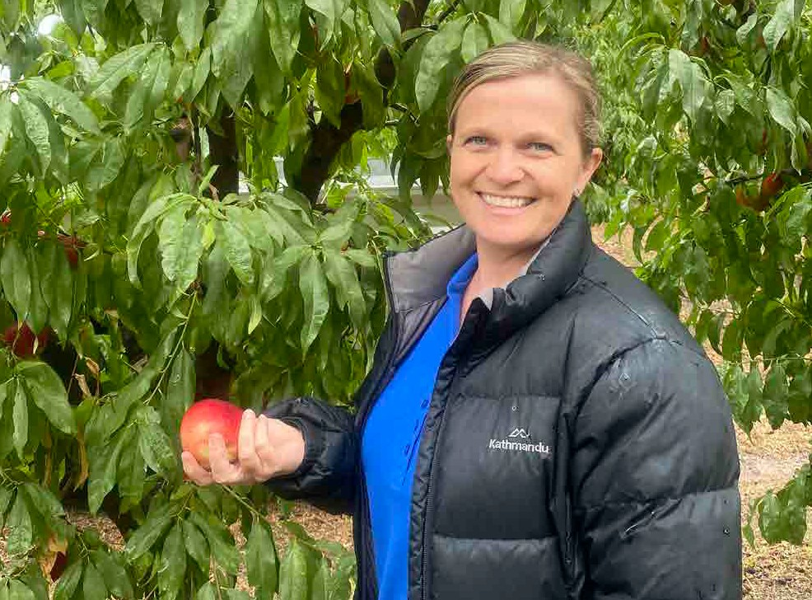
Colleen started her career as a receptionist for a major fruit wholesaler. Over 20 years with the company she moved through different roles before running the trading division. Colleen now works for VFS exports a leading stone fruit grower, packer and exporter. She has a diverse role in the small export team that involves interaction with farm managers, growers, shipping lines, freight forwarders and importers.
“The job never gets stale, there is always something to learn and something to do. I have met some amazing people and been blessed to have the flexibility in my role to raise my two daughters.”

Career Pathway
Receptionist – Assisting Export and Trading Division, Managing Trading Division – Export Manager

Packhouse

Jonathan Elliot – Packing Shed Manager
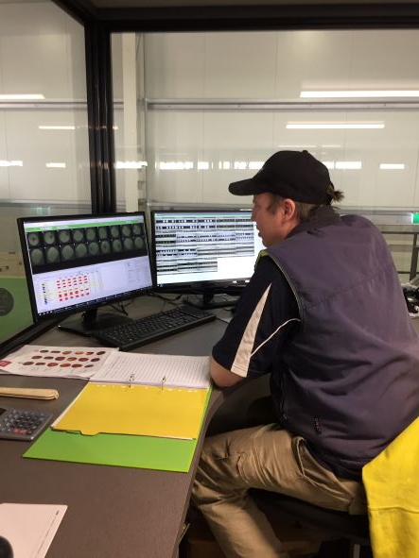
Jonathan grew up on a family orchard in New Zealand. After leaving school Jonathan worked in a packing shed for 10 years before starting up a new packing shed.
Jonathan currently works as a Packing Shed Manager for Plunkett Orchards. Apples and pears come in from the orchards in bins,are washed, photographed internally and externally and then categorised on size, colour and weight. Fruit is then put into bins and onto the packing lines.
“I enjoy the machinery side of it and seeing the end product. I like seeing us get the right classing of fruit for the grower and the market. Getting that balance between toomany rejections and too many imperfections can be tricky. I still enjoy seeing our product in the supermarket.”

Quick Guide to Career Pathway Qualifications and Certifications

Administration

Certificate II and III
- Business administration officer
- Procurement officer

Certificate IV and Diploma
- Agribusiness bank clerk
- Business administration manager
- Computer technician
- System coordinator
- Payroll officer
- Bookkeeper
- Work Health and Safety manager
- Quality Assurance officer/ supervisor/ manager
- Human resource officer

Tertiary qualification
- Accountant
- Agribusiness bank manager
- Human resource manager
- Data management specialist

Service and technology providers

Certificate II and III
- Agribusiness / input supplier
- Contractor (e.g. crop protection, fertiliser application pruning)

Certificate IV and Diploma
- Robotics technician
- Precision Agriculture/ GIS/ Drone specialist

Tertiary qualification
- Entomologist
- Pathologist
- Agronomist / Crop scout
- Training provider/ teacher
- IT consultant
- Research Scientist

Media and communications

Tertiary qualification
- Communications officer
- Graphic designer
- Photographer / Videographer
- Product designer, Innovator, Inventor

Engineering and maintenance

Entry Level 1 - Certificate I
- Cleaner

Certificate IV and Diploma
- General mechanic / Welder
- Refrigeration/ cool store technician
- Electrician
- Fitter and turner
- Builder

Tertiary qualification
- Engineer (e.g. process, mechanical, irrigation, construction)

Dispatch and logistics

Entry Level 1 - Certificate I
- Cleaner

Certificate II and III
- Truck driver
- Operator – ticketing and labelling
- Forklift driver
- Storage controller

Certificate IV and Diploma
- Supervisor
- Logistics manager
- Despatch manager

Orchard production

Entry Level 1 - Certificate I
- Orchard hand

Certificate II and III
- Tractor driver
- Machinery operator
- Irrigation operator

Certificate IV and Diploma
- Orchard supervisor
- Orchard manager
- Irrigation manager
- Crop protection/nutrition manager
- Technical Officer

Packhouse

Entry Level 1 - Certificate I
- Cleaner
- General hand
- Packing shed worker

Certificate II and III
- Forklift/ truck driver
- Quality inspector

Certificate IV and Diploma
- Packing shed supervisor
- Packing shed manager

Marketing and Sales

Certificate II and III
- Supply chain officer
- Market agent / Sales representative
- Domestic / Export sales and procurement specialist (retailers and wholesale)

Certificate IV and Diploma
- Marketing / Promotion
- Supply chain manager

Where to find more information
More about the Fruit Industry Career Snapshots
- agriculture.vic.gov.au
More about the Fruit Industry
- Fruit Growers Vic - fgv.com.au
- Cobram Fruit Growers- cdfga.com.au
More about the Goulburn Murray
- Great things happen here – Greater Shepparton - greatthings.com.au
- Moira Shire Council - moira.vic.gov.au/Home
More about Education and Training in the Goulburn Murray
- GMLLEN - gmllen.com.au
- GoTafe - gotafe.vic.edu.au
More about Education and training opportunities in Agriculture
- Career Harvest - careerharvest.com.au

