CropSafe

Annual Report 2023

Contents

2023 CropSafe Program 3
Passive crop surveillance 5
Sampling Reminder 7
Diseases of Concern 7
Field Crop Diseases Victoria 8
2023 CropSafe Findings 8
Area of Freedom Data 10
2023 CropSafe: Findings by region 11
Mallee 11
Wimmera 12
Southern 13
Northern 15
Further Information 16

2023 CropSafe Program
Exotic plant pests and diseases pose a significant threat to Victoria's cropping and horticulture sectors. Increased movement of plant materials, farm products and international travel, have increased Victoria’s risk of significant exotic plant pest and disease incursions.

Preventing pests and diseases from becoming established, and quickly identifying and eradicating localised outbreaks, is critical to protecting these industries.

CropSafe, is a surveillance program designed to enhance the monitoring, identification, and reporting of plant pests and diseases by agronomists, providing a reliable biosecurity service that safeguards valuable industries. Agriculture Victoria (DEECA) delivers the CropSafe program in partnership with leading agribusiness companies and an extensive network of private consultants. The CropSafe program also provides targeted industry training and awareness initiatives for agronomists to enhance their knowledge of identifying endemic diseases and recognizing symptoms of exotic pests and disease. During 2023, 78 samples were submitted to CropSafe for identification of unknown pests and diseases, up from 68 samples submitted the previous year. The average number of samples submitted each year is around 90 excluding 2014 data which was skewed by a Turnip yellows virus outbreak in canola.

Less samples were submitted during 2023 for ‘easy’ identification. Early samples centred around poor emergence, root disease, stunting, and unusually severe disease symptoms. In later samples agronomists looked for assistance with identifying unknown head infections in wheat and soil-borne diseases in pulses. Several samples were submitted with ‘odd’ symptoms and screened for potential exotic pests and diseases by Crop Health Services.

Fusarium screening was conducted on wheat samples after heads showed discoloration at harvest. This is the second year in a row that CropSafe has contributed to a host range expansion/new fusarium for Victoria. All Victorian lupin samples submitted to CropSafe during 2023 were negative for anthracnose.

Disease pressure was high early in the 2023 season (June/July) and several diseases caused significant issues including Septoria tritici blotch (STB) in wheat and Ascochyta blight in lentils. Early STB infections resulted in significant green leaf area loss in maturing crops and will have impacted yield in susceptible varieties.

Fungicide resistance was a significant concern for agronomists during 2023, in particular net form of net blotch resistance to group 7 (SDHI) seed treatments. Eleven samples were submitted specifically for fungicide resistance screening. The Centre for Crop and Disease Management (CCDM) (Curtin University) continues to provide resistance testing services to the grains industry. For sampling details and further information including the current fungicide resistances visit the CCDM website.

For further information regarding fungicide resistance, visit the Australian Fungicide Resistance Extension Network.

Passive crop surveillance
The 2023 CropSafe surveillance survey resulted in CropSafe agronomists reporting on just over 2.04 million hectares which is over 50% of the estimated 3.46 million hectares (ABARES ’20-21 cropping estimates) of grain crop in Victoria (Table 1). Crops were inspected 3 to 7 times (on average 4 times) during the growing season, depending on the crop type and scouting program required for crop pest and disease surveillance and management.

Analysis of this data by the Victorian Chief Plant Health Officers Unit (biosecurity branch) provides Victoria with confidence in the absence of key pests. The probabilities listed take into account the area surveyed, the likelihood that a specific pest will be detected and the number of years in which data has been reported. For pests that are readily identifiable by agronomists, such as American serpentine leaf miner, Maize leafhopper and Turnip moth, we have reached, and can maintain a high level of confidence (>95%) in their absence provided surveillance data continues to be collected and shared. For root and leaf diseases that are difficult to detect and diagnose, analysis of surveillance data over many years has allowed us to build our level of confidence over time. In many cases, for instance lentil anthracnose and rust, we now have a high level of confidence the pest is absent from Victoria. For some pests, such as lupin anthracnose and Fusarium wilt of chickpea, our confidence is less, however with time and continued surveillance, we can reach and maintain confidence in the states Area of Freedom.

By continuing to collaborate with industry and diagnose samples as part of general surveillance, CropSafe will continue to deliver increased confidence in Victoria’s Area of Freedom for these exotic pests and diseases.

Table 1: 2023 Passive crop surveillance inspection reported to Crop Safe.
Diagnosis | Number of samples
Loose Smut | 3
Ascochyta | 2
Crown rot | 1
Fusarium oxysporum | 1
Septoria blotch | 1
Environmental/physiological | 2

Table 2: Probability of freedom for 2023 based on the area surveyed by CropSafe agronomists for Victoria's top exotic pests and diseases in broadacre agriculture.
Exotic pest/ disease | 2023
American Serpentine Leaf Miner | 0.982
Maize Leafhopper | 1.000
Turnip Moth | 1.000
Barley Stem Gall Midge | 1.000
European Wheat Stem Sawfly | 1.000
Cabbage Seedpod Weevil | 0.998
Canola Verticillium Wilt | 1.000
Fusarium Wilt of Canola | 1.000
Fusarium Wilt of Chickpea | 0.431
Barley Stripe Rust | 1.000
Lentil Rust | 0.999
Lupin Anthracnose | 0.253
Lentil Anthracnose | 0.970
Karnal Bunt | 1.000
* Given design prevalence of 1:1000 plants and 1:1000 crops affected, and a 1:20 year chance of incursion

Sampling Reminder
When sampling, collect 2 to 3 plants with a range of symptoms. Please include roots plus a healthy sample for comparison. It is best to dig plants out, as pulling plants from the ground will damage the root system. Shake loose dirt from roots, wrap in moist paper and place in a sealed plastic bag. For pest specimens, place in a sealed jar along with pieces of host material.

Record all known information on the CropSafe submission form. Distribution of symptoms, paddock and chemical history are all vital to assist with prompt diagnosis. Keep samples away from heat and light before putting them in the mail. Please list your agronomist code on the submission sheet. If this is unknown, please contact the CropSafe team.

Diseases of Concern
Of particular concern to our cropping industry are exotic diseases (not presently found in Australia) including barley stripe rust, bunted cereals, rust on lentils or field peas, and wheat saw stem fly as outlined in the CropSafe manual.

Samples should be sent to:
CropSafe
Agriculture Victoria
Private Bag 260
Horsham VIC 3401

Field Crop Diseases Victoria
The aim of Field Crop Diseases Victoria (FCDVic) is to provide up to date, timely, and relevant information for endemic and exotic crop diseases to the Victorian grains industry. The website hosts 2 books ‘The Victorian Guide to Exotic Pests and Diseases of Grain Crops’ and ‘The Identification & Management of Field Crop Diseases in Victoria, current and historical CropAlerts as well as other useful crop disease information.

The FCDVic extensionAUS site had 11,162 users, 15,153 sessions and 28,026 page views between Jan 1, 2023, and Dec 31, 2023. Of the page views, 908 were of the exotic pests and disease information hosted on the website. Visit extensionaus Field Crop Diseases Vic for crop pest and disease information.

2023 CropSafe Findings
During 2023, 78 samples were submitted to CropSafe for suspected exotic pests and diseases. This number is around the average range of recent years. An average year sees between 70-90 samples submitted.

Endemic crop diseases caused 63% of the symptoms on the 2023 CropSafe samples submitted.

Wheat accounted for 44% of samples submitted and pulses made up 33% of samples. Barley made up 19% and unusually no canola samples were received for the year. Other crop types included oats 3%, lupins 1%, clover 1% and chickpea 1%.

The sample distribution was spread between the Wimmera (32%), Southern (33%) and Mallee and Northern combined (35%). The drier winter, followed by the high spring rainfall, favoured disease symptoms and progression in the longer growing season areas.
Figure 1. Percentage of crop types submitted to CropSafe during 2023.

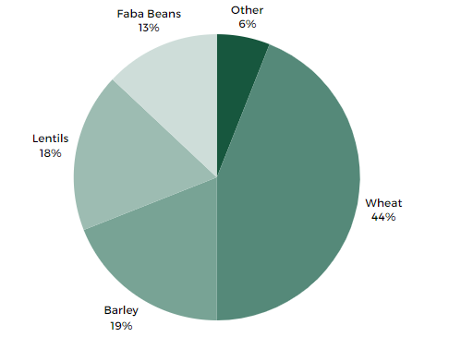
Figure 2. Percentage of samples submitted to CropSafe by region during 2023

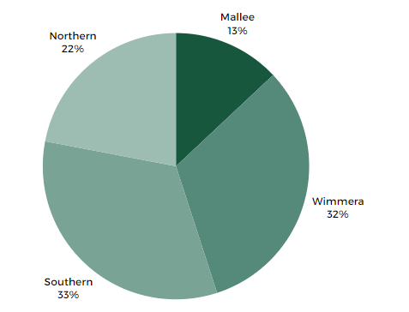

Area of Freedom Data
Thank you to the agronomists who provided details of passive crop surveillance for the 2023 cropping season. This critical information is an important component in the CropSafe program and assists the continuation of CropSafe services.

Surveillance information provides strong evidence that Victoria is free from exotic pests and diseases and assists in maintaining and gaining market access.

Analysis of the surveillance statistics provided by CropSafe for all grain crops provides strong evidence of their health status (this can only be applied to exotics featured in the CropSafe manual and where we can be assured that participating agronomists are aware of these exotics and have received some level of training in their identification).

It is recognised that the partnership with industry through CropSafe provides a breadth of crop health surveillance data and quality of disease freedom information, that cannot be achieved otherwise.

The sources of information to generate the Area of Freedom data remain anonymous.

2023 CropSafe: Findings by region
The following pages are regional summaries of the CropSafe findings from 2023, outlining the pests and diseases that were detected in Victorian crops.

Mallee
- The Mallee region includes Buloke and Gannawarra shires and Mildura and Swan Hill rural cities.
- 10 samples were received by CropSafe from the Mallee region during 2023, down from 13 in 2022.
- Crop types were divided between wheat, barley and lentils samples.
- Loose smut of barley was detected in non-seed-treated crops.
Figure 3. Crop type breakdown of samples submitted to CropSafe from the Mallee region in 2023.
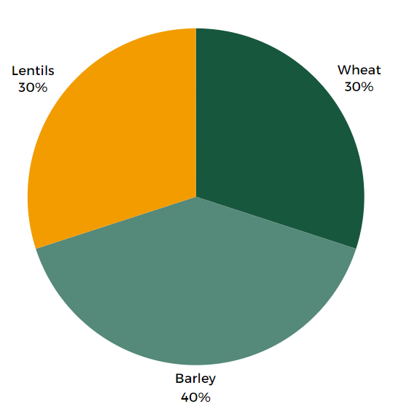
Table 3: Primary diagnosis of CropSafe samples submitted from the Mallee region (abiotic, non-pest or disease submissions are highlighted).
Diagnosis | Number of samples
Loose Smut | 3
Ascochyta | 2
Crown rot | 1
Fusarium oxysporum | 1
Septoria blotch | 1
Environmental/physiological | 2

Wimmera
- Wimmera region includes the West Wimmera, Hindmarsh, Yarriambiack and Northern Grampians shires and Horsham Rural City.
- In the Wimmera, 25 CropSafe samples were received during 2023, the same as 2022.
- Lentils were the major crop submitted followed by wheat and barley.
- Ascochyta and Fusarium in lentils were the main diseases identified.
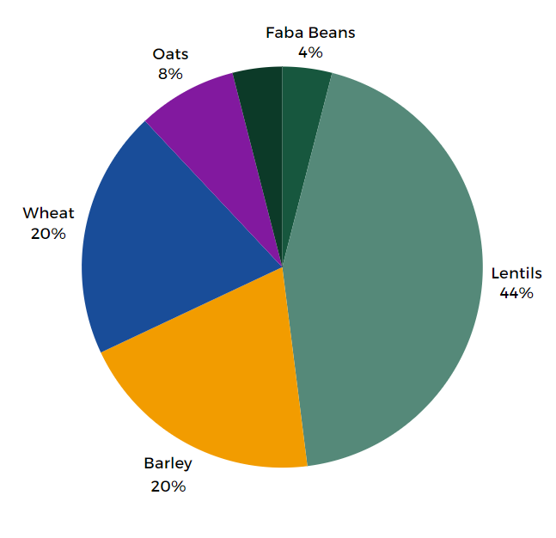
Figure 4. Crop type breakdown of samples submitted to CropSafe from the Wimmera region in 2023.

Diagnosis | Number of samples
Ascochyta | 4
Fusarium avenaceum | 2
Fusarium oxysporum | 2
Net form of net blotch | 2
Botrytis grey mould | 1
Crown rot | 1
Loose Smut | 1
Macrophomina | 1
Insect damage | 1
Powdery mildew | 1
Red leather leaf | 1
Rhizoctonia | 1
Septoria blotch | 1
Spot form of net blotch | 1
Environmental/physiological | 5

Table 4: Primary diagnosis of CropSafe samples submitted from the Wimmera region (abiotic, non-pest or disease submissions are highlighted).

Southern
- The Southern region includes Glenelg, Southern Grampians, Moyne, Pyrenees, Corangamite, Colac-Otway, Golden Plains, Hepburn, Moorabool, Surf Coast, Cardinia, Baw Baw, Bass Coast, South Gippsland, Wellington and East Gippsland shires. Also included in the region is the Rural City of Ararat and the City of Greater Geelong, Ballarat, Latrobe and Melbourne.
- A total of 26 samples were submitted to CropSafe from the Southern region during 2022, up from 12 in 2022.
- Wheat was the most common crop submitted and represented 73% of all samples received.
- Crown rot of wheat, net form of net blotch in barley and barley yellow dwarf disease were the main diseases identified.
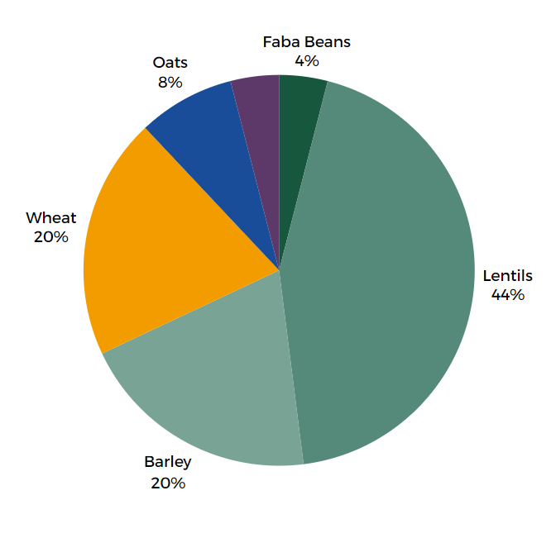
Figure 5. Crop type breakdown of samples submitted to CropSafe from the Southern region in 2023.

Table 5. Primary diagnosis of CropSafe samples submitted from the Southern region (abiotic, non-pest or disease submissions are highlighted.
Diagnosis | Number of samples
BYDV | 3
Crown rot | 3
Net form of net blotch | 3
Ring Spot | 1
Powdery mildew | 1
Septoria | 1
Fusarium spp | 1
Unidentified | 1
Environmental/physiological | 12

Northern
- Northern region includes Loddon, Campaspe, Central Goldfields, Mount Alexander, Macedon Ranges, Mitchell, Strathbogie, Moira, Mansfield, Alpine, Indigo and Towong shires; the rural cities of Benalla, Wangaratta and Wodonga; and the cities of Greater Bendigo and Greater Shepparton.
- In the Northern region, 17 samples were received by CropSafe during 2023, up from 6 in 2022.
- Wheat and faba beans were the most common crops submitted. Various issues were identified in these samples however root diseases in wheat was the most common. Several faba bean crops were found to have no isolated viruses and were diagnosed with environmental or physiological conditions.
Figure 6. Crop type breakdown of samples submitted to CropSafe from the Northern region in 2023.
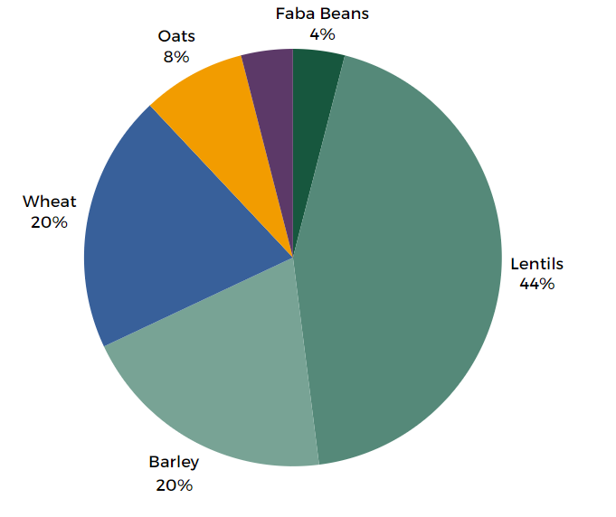

Table 6: Primary diagnosis of CropSafe samples submitted from the northern region (abiotic, non-pest or disease submissions are highlighted)
Diagnosis | Number of samples
Take-all | 2
BYDV | 1
Fusarium avenaceum | 1
Physical damage | 1
Rhizoctonia | 1
Sclerotinia | 1
Septoria blotch | 1
Soldier beetle larvae | 1
Environmental/physiological | 8

Further Information
For more information visit the Agriculture Victoria CropSafe webpage or contact CropSafe coordinators Dale Boyd at Agriculture Victoria Horsham on (03) 5450 8301 (Horsham reception).

