Using stock containment areas
Case study – Jim Younghusband, Powlett Inglewood district - Central Victoria
Jim Younghusband is all for stock containment areas (SCAs). The four SCAs on his Inglewood district farm have proven to be perfect for all-purpose, all-season and all-weather use.
Farm information:
Producer: Jim Younghusband
Location: Powlett
Property size: 930 hectares
Annual Rainfall: 300-350mm
Enterprise: Prime lambs and wool from Merinos and White Suffolk breeds
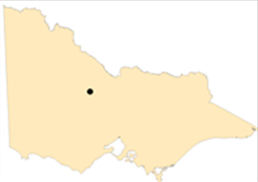

Figure 1 Map of Victoria identifying Powlett in Central Victoria.

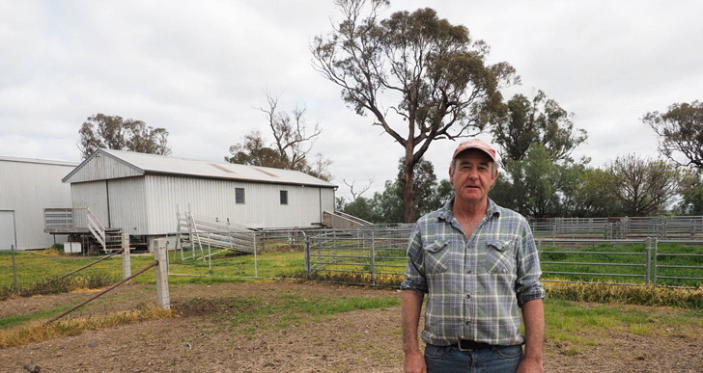

Photo: Jim Younghusband.
Jim’s farm mix is about 85-90 per cent sheep and the rest cropping. Over the past 10 years Jim has developed and refined a system to include SCA’s in his farm management plan.
“Before we started using SCAs, the place was like a dust bowl in summer. Sheep walked around the paddock and it powdered off.”

SITING AND SPACE
Located next door to the shearing shed and the stock yards, the SCAs are used regularly during shearing and crutching, before sheep are loaded for market and as an adjustment paddock for any new rams.
“The sites were convenient, with shelter and shade, water and the nearby shearing shed and yards,” he said.
Jim finds the optimum space allowance in his SCAs is 3-5 m² per head and generally keeps containment mobs to around 300.
ENTERING CONTAINMENT
“If the year has not been flash I start thinking in December about what I am going to do. If you are starting to think it is time for them to be in containment, you probably should have done it a month earlier.”
The self-replacing 18-19 micron Merino ewes are joined either to Merinos or White Suffolk rams, with crossbreds lambing from mid-April and the straight Merinos a month later.
Shearing occurs in early October and lambs are weaned, cull ewes disposed of and White Suffolk rams put in with the ewes before any sheep move into containment.With straight Merino joining occurring in December, the rams have at times been with ewes in the containment areas.

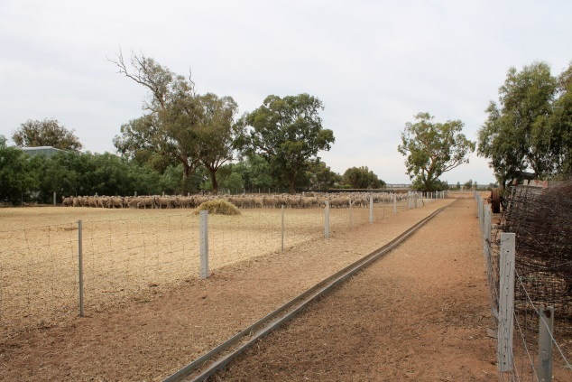

Photo: Steel purlin in adjacent laneway used for feeding grain.

Jim said the sheep must start on a good footing so their condition can be maintained over the containment period.
“You put them into containment in good condition and keep them going. It is much easier to keep something in
good condition than to have to improve condition during a dry year,” he said. All sheep are drenched and vaccinated before going into containment and Jim estimates it takes about seven to 10 days for the stock to get accustomed to the new environment.

FEEDING AND WATER
Straw and grain are fed in the early weeks, with a mix of straw and hay later into the pregnancy. The grain ration is generally barley, grown on the farm, and fed into a seven metre long piece of steel purlin sitting on the ground in a laneway adjacent to the SCA.

“I drive the grain trailer over the top (filling the purlin) and then open up the gate for one yard and let the sheep in,” Jim said. This is done every second day with 400 kilograms of grain feeding 300 sheep.
Water comes in a pipeline from the Loddon River and Jim also has a bore that services about seven paddocks on the farm.
Jim keeps a close eye on the water quality. Dust and hay on the surface of the trough can discourage sheep from drinking, so he regularly skims this off rather than emptying the whole trough and potentially wasting water.
Wind direction is a key consideration when delivering a new bale of hay and straw, to avoid too much debris ending up in the water troughs.

ANIMAL HEALTH
His decade working with containment has taught Jim the value of keen observation.
“I get a bit paranoid about having 1,200 sheep locked up and first thing every day I just come out and stand and look at them.”
This helps him identify shy feeders or other issues and any early signs of illness, which increases in risk after six to eight weeks of containment.

His keen eye has helped reduce such risks but one year some very healthy ewes, who were heavy in lamb, suddenly took ill.
He called in an Agriculture Victoria vet, who identified the problem as a Vitamin B1 deficiency – a common complication of containment. The worst-affected sheep were injected and the rest of the mob drenched with Vitamin B1.
BEHAVIOUR
Jim has also gained some insights into the body language of his flock and the vast differences between breeds.
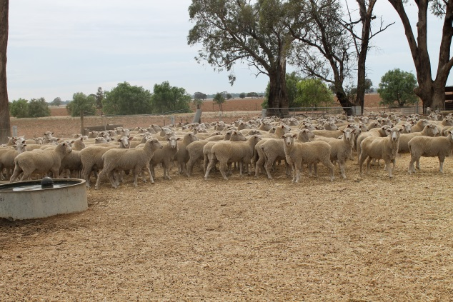

Photo: Sheep in containment.

He said crossbreds had a very healthy appetite and a small space with lots of food was sheer paradise for them. But for Merinos it is a different story.
“Merinos like to fossick about the paddock. A SCA is a confined space and it doesn’t suit their nature as much.”
He will never forget what happened when the two breeds were put in the one SCA.
“The crossbreds bossed them around and the Merinos sulked. I won’t ever box them up together again.”
LEARNING
“You learn from your own mistakes and if you don’t there is something wrong. My biggest learning is you must drench and vaccinate before putting them in and preferably put sheep in with the minimum amount of wool on them. If you don’t their fleece gets full of dirt and you are wasting all the feed on wool,” he says.
“It is important to have shade and shelter but you also have to allow the air to flow through the area. And think carefully where you put them. Can it be connected to your sheep yards and serve several purposes?”
Trees in his containment areas have been protected by several old gates that were around the farm and one fence has been sheltered with several old bales of straw.

FURTHER INFORMATION
For further information or to obtain a copy of the relevant Drought Feeding Guide visit agriculture.vic.gov.au/dryseasons contact your local Agriculture Victoria Extension Officer or call the Customer Service Centre on 136 186.

Accessibility
If you would like to receive this publication in an accessible format, please telephone Agriculture Victoria on 136 186 or email drought.support@agriculture.vic.gov.au

This document is also available in (HTML and/or PDF and/or Word) format at agriculture.vic.gov.au

Disclaimer
Republished by Agriculture Victoria 2020.
This publication may be of assistance to you but the State of Victoria and its employees do not guarantee that the publication is without flaw of any kind or is wholly appropriate for your particular purposes and therefore disclaims all liability for any error, loss or other consequence which may arise from you relying on any information in this publication.



