Stock containment areas
Case study – Lachlan Ralton, Woodstock West - Central Victoria
Lachlan Ralton farms in partnership with his brother, Chris, and his uncle, Howard, at Woodstock West, in Central Victoria. The sheep and cropping farm is 1500 hectares (ha), with 600 ha sown to cereal crops each year. Two thousand breeding ewes graze primarily on lucerne pasture. Half the ewes are joined to Merino rams and half to White Suffolk rams, producing both meat and wool.
Farm information:
Producer: Lachlan Ralton, Chris Ralton and Howard Hepburn
Location: Myrtleford, Woodstock West
Property size: 1500 ha
Annual Rainfall: 480 mm (long term average), average of 350 mm over 2013-2015
Soils: Clay loams
Enterprises: Cereal crops 600 ha; self-replacing Merino ewe flock and White Suffolk first cross prime lambs.

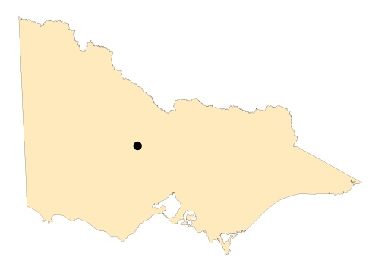
Map of Victoria identifying Woodstock West in Central Victoria.

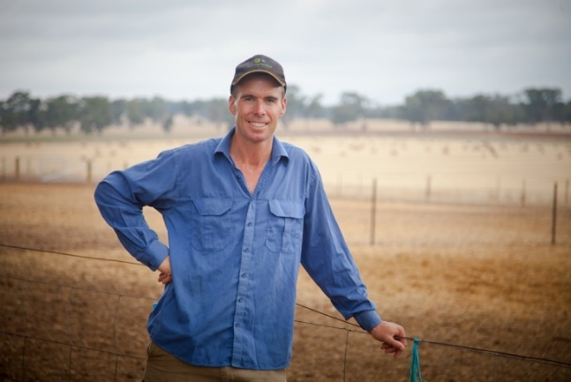
Photo: Lachlan Ralton

“During the Millennium Drought we managed by destocking our older ewes. It was certainly easier for us, with good prices for stock, than it was for farmers who were forced to destock in the 1982 drought when sheep were not worth much at all. We did not have containment areas during the Millennium Drought, we just locked the sheep up in small sacrifice paddocks.” Lachlan said.
A big shift in risk management has occurred since then. “We had been thinking about building a stock containment area (SCA) for the last few years, but we only purchased this property (‘Gourdie Farm’) three years ago and we were looking for the most suitable site.
“The government funding for containment areas was certainly an incentive. We had piped underground water from a bore two kilometres away and laid the pipe in the track going to the house. We were using the site next to the track as a ram paddock and I had a ‘lightbulb moment’ and realised that with water going past, this was probably the place to build the stock containment area. We dug the pipe in and left risers for the troughs,” Lachlan said.
SITING AND SHADE
Lachlan researched the guidelines thoroughly, but worked flexibly. He selected a site with a moderate slope and stable soil (red clay loam) and ironstone gravel for extra stability. Nutrient run off is captured in the cropping paddock below the yards.
Protecting mature trees from ringbarking was important in considering the site, as was a reliable and clean water supply.
“The literature suggests that the water troughs should be located at the bottom of the yards. We sited the troughs at the top of the yards near the pipeline, but I am happy to move them in the future if things get too wet.”

Lachlan also notes that the laneway should be at the top of the stock containment area, and theirs is at the bottom. “I don’t really know how wet the laneway might get, but I don’t expect it to be a problem.”
“The yards are about 50 metres by 50 metres and we have not had more than 200 sheep in any one yard at a time. We find that two self-feeders and a bale of hay will keep that many sheep happy.”
“Trees on the northern edge provide fantastic shade all day for the sheep. On hot days the sheep are all camped next to the fence in the shade of the big old trees. I thought the shade was really important to provide.”
When selecting the site for the yards, Lachlan also considered proximity to other facilities. “Whether I am dipping or crutching, there is a big benefit in having the sheep in a containment area close to your main facilities.”
The yards were also located so that the animals could be checked regularly and easily.
FEEDING
Already having one tonne capacity self-feeders on hand, Lachlan placed them in the yards adjacent to the
access laneway. “We use a Bromar feeder to fill the troughs from the laneway without having to enter the yards.” This is a good time saver and a safer option for the sheep during containment.

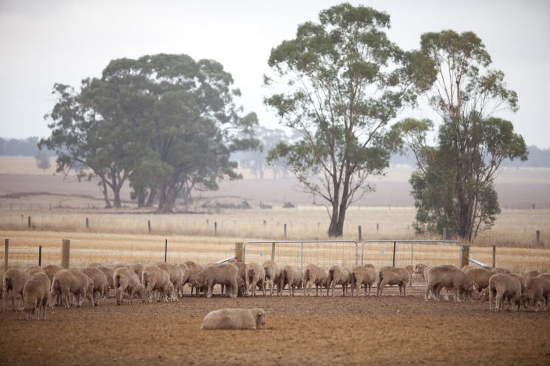

Photo: sheep in the SCA

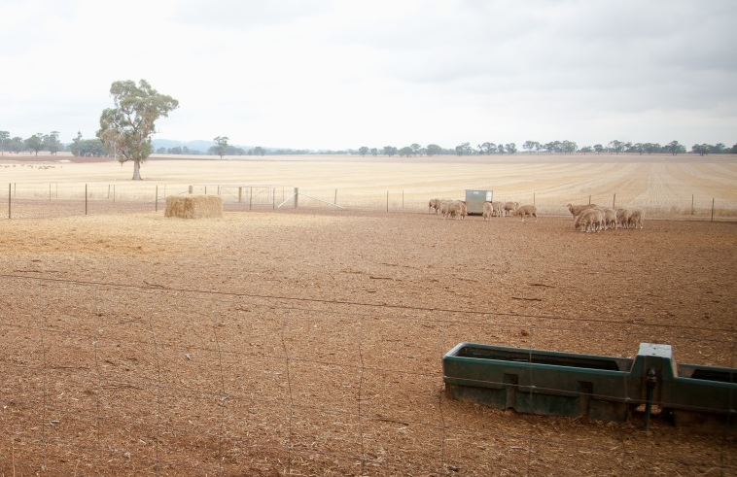

Photo: Water trough in the SCA

“We put hay in the yards either by entering the yards or putting it over the fence. The sheep are very content in containment. They have shade, water and food on call. They settle down very quickly. We find stock in containment areas are much easier to manage. They are not walking around looking for feed when it is sparse – so in containment they save energy and it is easier to maintain their weight.”
BENEFITS
Having sheep in containment means that soil erosion has been minimised across the rest of the farm.
“I can see the benefit of containment areas in dry times. The yards provide great flexibility in management. You can lock up the sheep and protect your ground cover. Having grain, hay and water makes it easy to manage and keep an eye on them. I also don’t have to drive all over the farm to get feed to the sheep, which can be spread out over a large area.”
As a flexible management tool, Lachlan plans to experiment. “I will certainly use the yards in future, particularly over Summer when there is not much paddock feed around. I plan to use the yards more and run more sheep.”

FURTHER INFORMATION
For further information or to obtain a copy of the relevant Drought Feeding Guide visit agriculture.vic.gov.au/dryseasons contact your local Agriculture Victoria Extension Officer or call the Customer Service Centre on 136 186.

Accessibility
If you would like to receive this publication in an accessible format, please telephone Agriculture Victoria on 136 186 or email drought.support@agriculture.vic.gov.au

This document is also available in (HTML and/or PDF and/or Word) format at agriculture.vic.gov.au

Disclaimer
Republished by Agriculture Victoria 2020.
This publication may be of assistance to you but the State of Victoria and its employees do not guarantee that the publication is without flaw of any kind or is wholly appropriate for your particular purposes and therefore disclaims all liability for any error, loss or other consequence which may arise from you relying on any information in this publication.


