Strategies for dry weather farming
Case study – Joan and Rob Lily, Fish Creek - South Gippsland
Sometimes in life you have to look at the evidence and make a quick call. Fish Creek beef farmers Joan and Rob Liley did just that when the season started failing in late 2015.

[Watch the video at https://agriculture.vic.gov.au/farm-management/managing-for-and-during-drought/preparing-your-farm-for-drought]
“The first thing that rang alarm bells for us in 2015 was the exceptionally dry winter,” Joan said. “As we started to go into spring we were watching the Bureau of Meteorology’s climate outlook very closely, and watching the El Nino spread across the Pacific Ocean, and thinking this is not looking good for us.”
The Liley’s fatten about 800 prime bullocks each year on their farm close to the coast near Waratah Bay in South Gippsland. The total farm area of 436 hectares (ha) is spread across two farms, including 85 ha of revegetation.

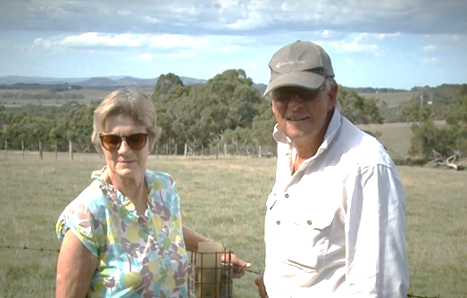

Photo: Joan and Rob Liley

MAKING THE CALL EARLY
“The key for us was making the call very early and acting accordingly,” Joan said. “As spring approached we ordered our fertiliser and we locked up our hay paddocks early. “We put a lot more fertiliser on our hay paddocks than we normally would, and so not only did we get a good crop of hay in November, we got probably as much as we would normally get, despite the record low rainfall.”
The Liley’s October to December 2015 rainfall turned out to be the lowest on record.
STOCK NUMBERS AND OPPORTUNITIES
Four years ago the couple moved from breeding sheep and cattle to fattening bought-in steers. In 2015 they continued with the plan despite the dry conditions, but added some priorities to the process.
“The steers that had the potential to be prime and saleable over the summer got the priority paddocks, as foremost in our mind, was the fact that we had to get off as many cattle as we possibly could,” Joan said.
Exceptional prices provided a bonus in a difficult season. “If we had partially destocked we would have probably found that we were still making a profit. We had lots of options - we could have leased country, we could have agisted cattle, we could have sent them to East Gippsland where it has been much wetter, we could have bought in feed.
“But in the end it’s a financial decision and you need to do your budgeting properly and see if any one approach is worthwhile doing.
“The exceptional thing about the 2015 year has been how the market has held up.”

STAYING TRUE TO A CONSERVATION ETHIC
The Lileys’ properties adjoin the Cape Liptrap Coastal Park and the couple have a strong conservation focus and like to think of their farm as an extension of the Park. About 20 per cent of their farm is fenced out to creeks, drainage lines and tree lines that add to the beauty of the place.
“We would never compromise our conservation efforts in any way. We would never dream of letting our stock into the creeks in dry times. We would sell before we did that.
“We don’t extract water from rivers or streams. We don’t have any groundwater so we are wholly dependent on our dams.” These dams are big and deep. “They all have trees around them to keep the water cool in summer. We would sacrifice a paddock if it meant having a containment area, but that sacrifice would only be done in order to maintain the rest of the farm.”
SUMMING UP

Joan knows their early call on the drought could have gone either way. “We could have just as easily been wrong. Nothing that we did would have been detrimental. Sometimes you have just got to be brave and make that call.
“I am a great believer that the climate science is good enough now to be able to predict what’s happening. Who would have thought that ten years ago we all

would have known about the Indian Ocean Dipole or the Southern Oscillation Index, or even El Nino for that matter.
“Once it was possibly only grain farmers who were watching the weather to that extent, but now I think everybody does.
“So that would be my tip, keep yourself informed and call it early.”
FURTHER INFORMATION
For further information or to obtain a copy of the relevant Drought Feeding Guide visit agriculture.vic.gov.au/dryseasons contact your local Agriculture Victoria Extension Officer or call the Customer Service Centre on 136 186.

Accessibility
If you would like to receive this publication in an accessible format, please telephone Agriculture Victoria on 136 186 or email drought.support@agriculture.vic.gov.au

This document is also available in (HTML and/or PDF and/or Word) format at agriculture.vic.gov.au

Disclaimer
Republished by Agriculture Victoria 2020.
This publication may be of assistance to you but the State of Victoria and its employees do not guarantee that the publication is without flaw of any kind or is wholly appropriate for your particular purposes and therefore disclaims all liability for any error, loss or other consequence which may arise from you relying on any information in this publication.



