Pasture Recovery After Fire – Quick Reference Guide

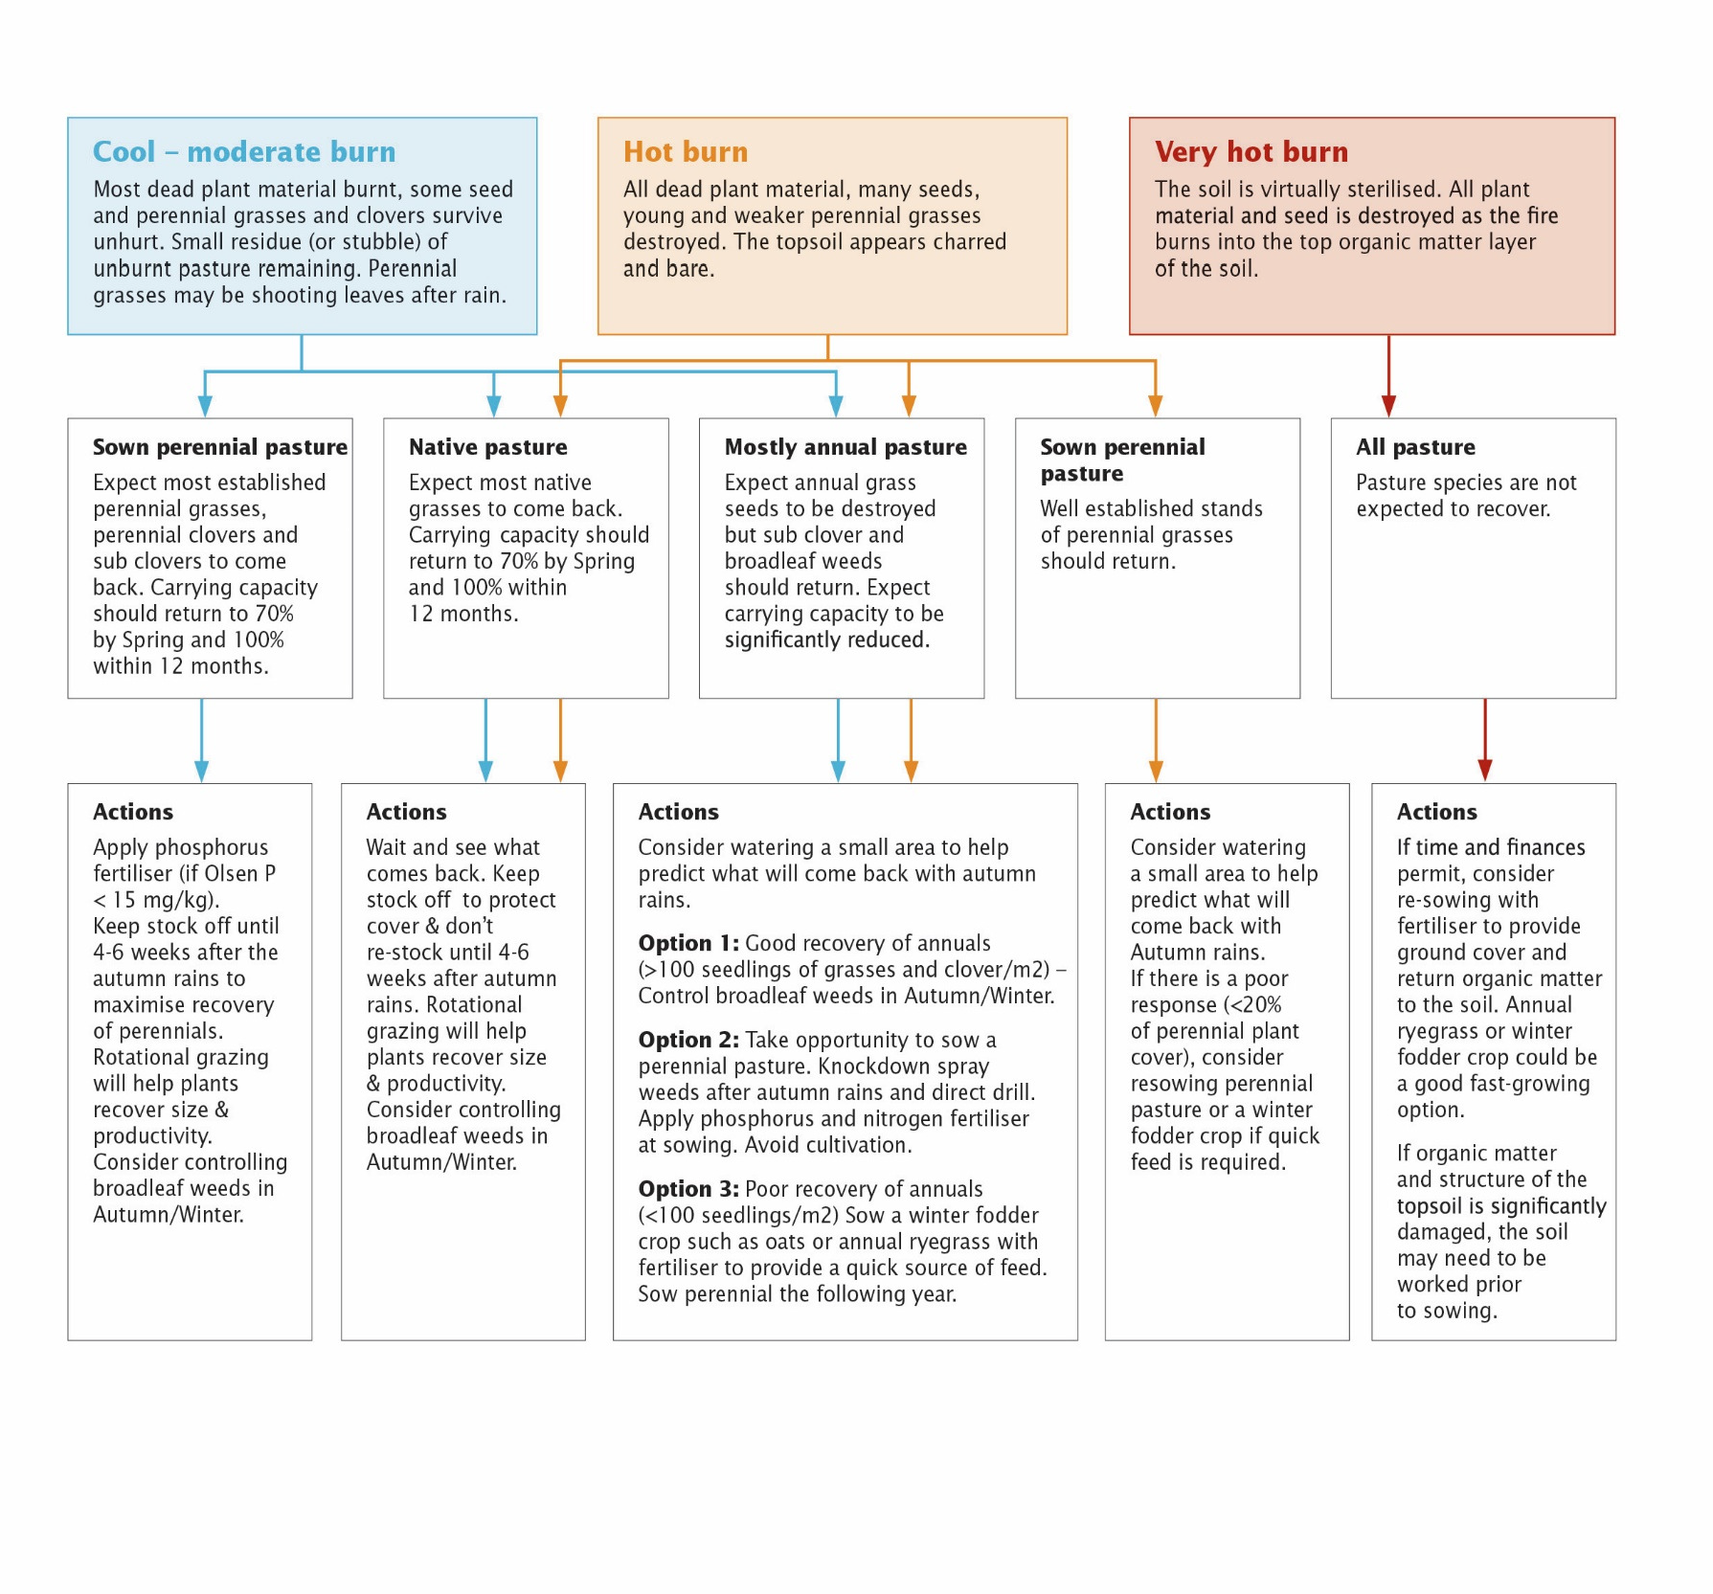
DECISION FLOW CHART

Lorem ipsum dolor sit amet, consectetuer adipiscing elit. Maecenas porttitor congue massa. Fusce posuere, magna sed pulvinar ultricies, purus lectus malesuada libero, sit amet commodo magna eros quis urna. Nunc viverra imperdiet enim. Fusce est.

Heading 1
Normal – Lorem ipsum dolor sit amet, consectetuer adipiscing elit. Maecenas porttitor congue massa. Fusce posuere, magna sed pulvinar ultricies, purus lectus malesuada libero, sit amet commodo magna eros quis urna.

Heading 2
Normal –Fusce posuere, magna sed pulvinar ultricies, purus lectus malesuada libero, sit amet commodo magna eros quis urna.
- List Bullet Lorem ipsum dolor sit amet, consectetuer adipiscing elit. Maecenas porttitor congue massa.
- List Bullet Lorem ipsum dolor sit amet, consectetuer adipiscing elit. Maecenas porttitor congue massa.
- List Bullet Lorem ipsum dolor sit amet, consectetuer adipiscing elit. Maecenas porttitor congue massa.

IMAGES OF PASTURE RECOVERY AFTER FIRE WITH DIFFERENT BURN INTENSITIES ON PERENNIAL BASED PASTURE
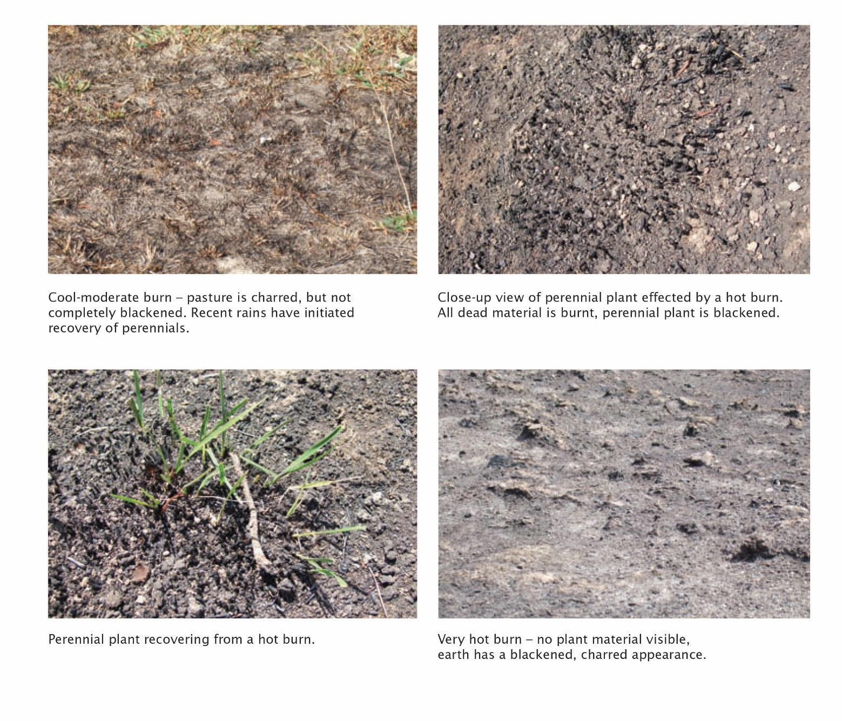

ACCESSIBILITY
If you would like to receive this publication in an accessible format, please telephone the Department of Energy, Environment and Climate Action on 136 186 or the National Relay Service on 133 677.
This document is also available in PDF and/or HTML format at www.agriculture.vic.gov.au

