


New land use planning regulations for animal production in Victoria
Public consultation
engagement summary

January 2025



We acknowledge and respect Victorian Traditional Owners as the original custodians of Victoria’s land and waters, their unique ability to care for Country and deep spiritual connection to it.
We honour Elders past and present whose knowledge and wisdom
has ensured the continuation of culture and traditional practices.
DEECA is committed to genuinely partnering with Victorian Traditional Owners and Victoria’s Aboriginal community to progress their aspirations.
© The State of Victoria Department of Energy, Environment and Climate Action December 2024.
Creative Commons
This work is licensed under a Creative Commons Attribution 4.0 International licence, visit the Creative Commons website (http://creativecommons.org/licenses/by/4.0/).
You are free to re-use the work under that licence, on the condition that you credit the State of Victoria as author. The licence does not apply to any images, photographs or branding, including the Victorian Coat of Arms, and the Victorian Government and Department logos.
ISBN 978-1-76176-048-8 (pdf)
Disclaimer
This publication may be of assistance to you but the State of Victoria and its employees do not guarantee that the publication is without flaw of any kind or is wholly appropriate for your particular purposes and therefore disclaims all liability for any error, loss or other consequence which may arise from you relying on any information in this publication.
Accessibility
To receive this document in an alternative format, phone the Customer Service Centre on 136 186, email customer.service@delwp.vic.gov.au, or contact National Relay Service on 133 677. Available at DEECA website (www.deeca.vic.gov.au).
Contents
1. Executive Summary 3
Previous engagement and consultation 4
Next steps 5
2. About the Clause 53.AA Animal production 6
Incorporated technical documents 6
What is new? 7
Risk-based approach to planning 7
Separation distances 7
Exemption from notice and review 8
Approved Measures 8
Protection for the community 8
Protection for the environment 9
Benefits for industry 9
Supporting information 10
3. Demographics of engagement respondents 11
4. What we heard in the submissions 12

1. Executive Summary
Agriculture Victoria released draft land use planning regulations for the establishment and expansion of animal production facilities in Victoria, for public consultation from 13 February 2024 to 22 April 2024.
Clause 53.AA Animal Production covers intensive animal production, including pig, poultry, intensive dairy, cattle feedlot, sheep, and goat industries.
The proposed regulations are intended to be added as a new Clause in the Victoria Planning Provisions (VPP) and all planning schemes in Victoria.
The regulations have been under development since 2018 and have been co-designed with the agriculture sector, community, technical consultants and government agency partners.
The Clause is underpinned by the following aims:
- Environmental and community impacts are well-managed by adopting a risk-based approach to planning applications.
- Local government is supported to make well-informed and faster planning decisions.
- Producers have confidence in a clearer, more consistent, and fit-for-purpose planning system.
The consultation provided stakeholders the opportunity to submit detailed written submissions on the new regulations and collected demographic information via an online survey.
The consultation was designed to explore potential unintended outcomes and gaps, and to enable the reforms to meet community, industry, and other stakeholders’ expectations.
Responses were received from 6 individuals and 21 organisations, comprising 27 submissions.
Most respondents supported the strategic goals of the draft regulations. Many submitted suggestions and recommendations for improvements or clarifications. A significant amount of feedback was focused on the technical planning detail and how this impacted various industry sectors.
The feedback was broad in scope, however some key themes emerged, including:
- The need for government to provide appropriate supports and guidance for planning applications.
- Technical changes to the draft regulations to improve clarity and support requirements that are appropriate to the specifics of different animal industries
- Differing interpretations of the planning outcomes being sought that necessitated amendments to improve clarity.
- Changes to the risk-based controls for irrigated and smaller production systems.
- Comments relating to the definition of grazing animal production systems.
- Suggestions for further work in other areas of regulation.
Respondents’ feedback will be used to clarify planning guidance and update the final version of the land use planning regulations for animal production facilities in Victoria, Clause 53.AA Animal production.

Previous engagement and consultation
Work on these reforms began in 2016, when a series of high-profile planning disputes informed the then, Minister for Agriculture’s decision to review the planning controls for intensive animal industries.
A Ministerial Advisory Committee was appointed to consider how the planning system could better support the establishment and expansion of productive, competitive and market-responsive animal industries in Victoria, while balancing environmental outcomes and community expectations. The committee handed down a report and the government committed to 12 actions in response, 10 of which have now been finalised (Figure 1).
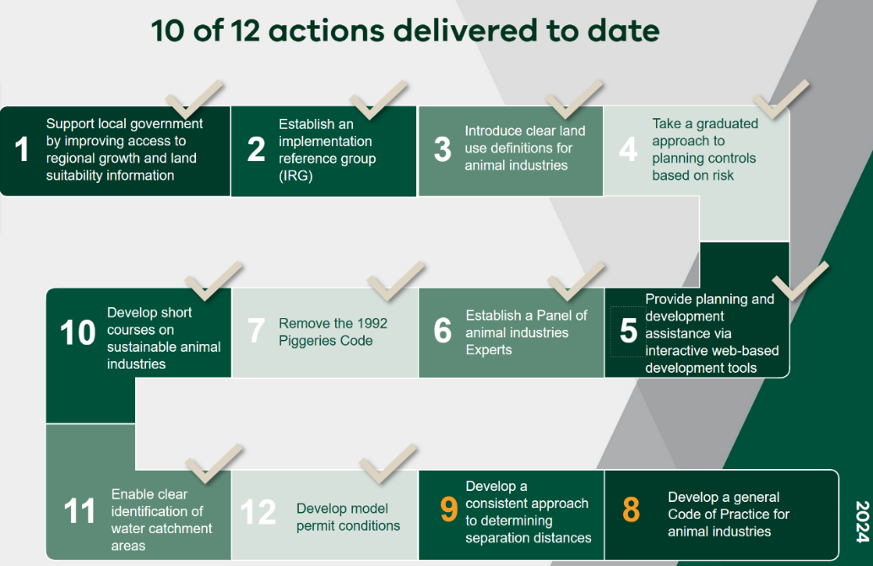
Figure 1 – Actions resulting from the recommendations of the Ministerial Advisory Committee
The two remaining actions are the subject of this report and the recent consultation. Agriculture Victoria has worked closely with an Implementation Reference Group, composed of industry organisations, planners, state government representatives and community members to co-design technical content and balance the needs of all stakeholders.​
An initial targeted public consultation was undertaken in 2021, with over 240 organisations and individuals engaged. This helped to refine the approach for the reforms and informed the design of the draft reforms. ​
The recent Victoria wide public consultation took place in early 2024, and included industry specific webinars, a print and social media campaign and a formal Engage Victoria submission process which is the subject of this report.

Next steps

In response to industry and community feedback, Agriculture Victoria is finalising the regulations. While this work is currently in progress, a summary of some key areas of feedback is provided in the body of this report below.
Following the redrafting process, materials will be prepared for consideration by the Minister for Agriculture and Minister for Planning, for potential incorporation into the Victoria Planning Provisions.
Agriculture Victoria will release guidance materials and provide expert advice via its Planning and Advisory Service, to support a smooth transition to the new regulatory approach.
If you have any questions about the reforms, please contact psai@agriculture.vic.gov.au

2. About the Clause 53.AA Animal production
The Clause sets out the planning requirements for how an animal production facility must be located, designed, and managed to have a planning application approved. The Clause will be applicable to producers who wish to build a new facility or expand an existing facility in Victoria. Changes to lawful pre-existing production facilities, such as cattle feedlots and piggeries will not be necessary.
All planning requirements for animal production facilities will be included in a single Clause within the Victoria Planning Provisions, rather than referencing planning regulations across different documents.
Some of the key changes to existing requirements include a consistent approach to separation distances for all industries, exemptions from notice and review, and a risk-based approach to protecting communities and the environment.
The clause will cover all animal production, excluding Grazing animal production, as outlined in Figure 2 below.
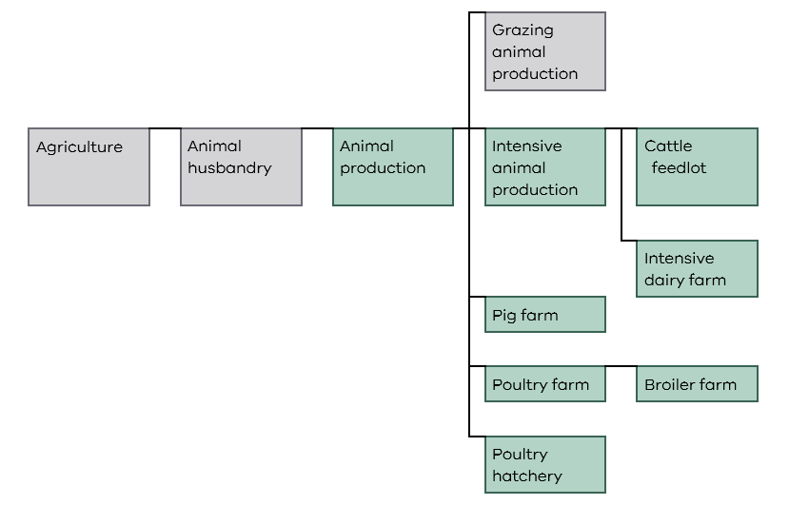
Figure 2: 73.04-3, Agriculture group (sub-group of Animal production) where green colored land use definitions apply under the Clause.

Incorporated technical documents
There are five incorporated technical documents outlining the requirements for animal production. These documents provide technical detail to help assess the approved measures and are designed to guide decision making of applicants and responsible authorities. These documents are intended to be incorporated in the Victoria Planning Provisions and all planning schemes in Victoria.
- Separation distance requirements for animal production
- Surface water and groundwater requirements for animal production
- Impermeable lining design requirements for animal production
- Vegetated filter strip design requirements for animal production
- Operational and environmental management plan requirements for animal production

What is new?

Risk-based approach to planning
The new Clause takes a risk-based approach to the planning, assessment, and approval of planning applications. This approach recognises the variability of impacts within animal industries, and the need for planning requirements that are appropriate for the size, location, scale and expected impacts of various production systems. This approach also emphasises that different sizes of production have different potential for off-farm impacts on the environment and community.

Separation distances
The Clause provides separation distance methods for all animal production industries in Victoria. Separation distances help to identify whether the location of a proposed animal production farm is suitable when considering surrounding land uses (Figure 3).
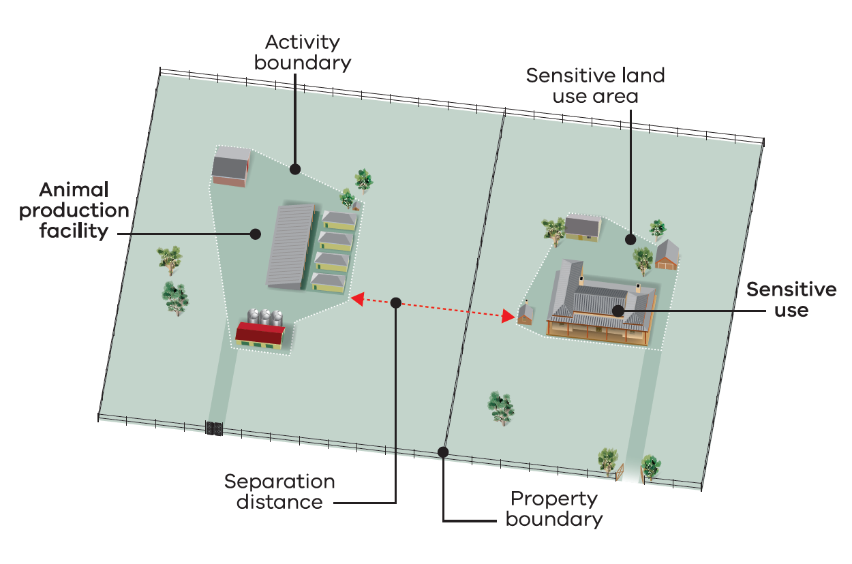
Figure 3: Animal production facilities must have adequate separation from sensitive uses such as neighbouring homes.
The Clause introduces a new three-tier approach to calculating separation distances for animal production industries in Victoria. This approach provides flexibility based on farm size and environmental factors:
- Tier 1: Fixed separation distances for small farms.
- Tier 2: Variable separation distances calculated using a formula that considers location, facility size, animal numbers, landscape, terrain, and wind direction.
- Tier 3: An Environmental Risk Assessment is applied for more complex cases.
These separation distances help determine the suitability of a proposed farm location concerning surrounding land uses.
When submitting a planning application, animal production facilities must have appropriate separation from sensitive uses, such as housing and populated areas, to minimise the risks of nuisance from odour, dust, and noise.

Exemption from notice and review
Some low-risk applications can be exempt from notice and review, meaning they are not required to give planning notice to third parties, including neighbouring properties.
Exemption from third-party notice and review is only granted to applications where the minimum separation distance requirements are fully contained within the farm boundary.
Third parties cannot request a review of the final decision on the application through the Victorian Civil and Administrative Tribunal (VCAT). However, applicants will still be able to appeal to VCAT if they are not satisfied with the result of their application assessment.

Approved Measures
The structure of the Clause, with Objectives and Approved Measures, allows an applicant to propose alternative designs to meet the objective. If all approved measures are met, the objective is deemed to be met. However, if the responsible authority is satisfied that an application for an alternative design solution meets the objective, the alternative design solution may be approved.

Protection for the community
Greater protection for the future use and development of neighbouring land is provided by the inclusion of an approved measure that limits the area that separation distances for animal production facilities can extend across neighbouring properties.
When determining the location of a proposed animal production facility, the approved measure requires the minimum separation distance envelope to not extend over more than 50 per cent of the area of a neighbouring property (Figure 4).
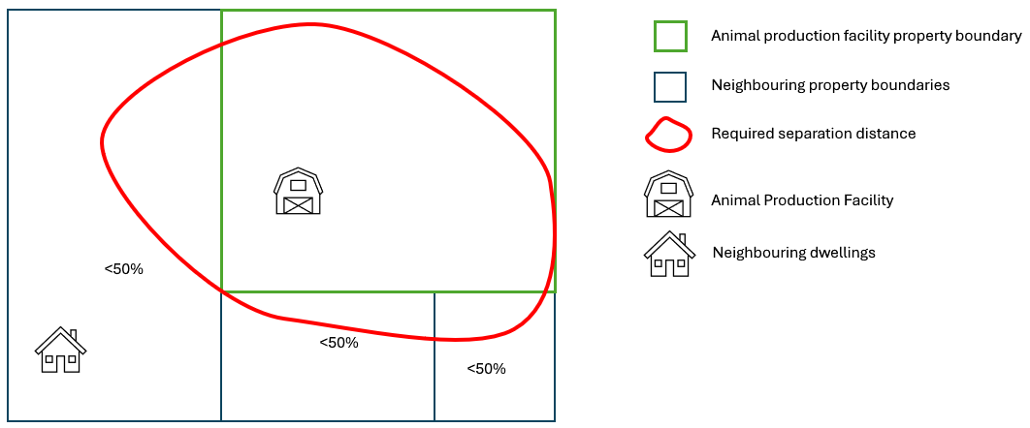
Figure 4: AM 1.1 – protection for future use and development. No more than 50 per cent of the area of a neighbouring property can be used in the separation distance.

Protection for the environment
Protection of the environment and waterways is provided through a range of approved measures and risk-based assessment tools.
Approved measures recommend minimum buffer distances between animal production facilities and waterways, along with design requirements such as impermeable lining, to protect surface and groundwater.
Newly developed surface water and groundwater risk assessment tools use a site-specific approach to identify suitable locations and design requirements, minimising the risk of runoff to waterways and groundwater.

Benefits for industry
The new Clause introduces planning regulations for all animal production industries and is aligned to national guidelines where available. The Clause removes out-dated regulation (such as the Victorian Code for Cattle Feedlots 1995) and provides clear planning requirements for industries where there was previously a gap in information or standards (such as intensive dairy) which previously led to delayed decisions.
Applicants and planners will be supported by detailed user guides and advice from Agriculture Victoria’s Planning and Advisory Service, to support a full understanding of what is required for a planning application.
The reforms aim to provide greater confidence to investors and applicants of the requirements for establishing new developments in Victoria. The reforms will also provide clear guidance to responsible authorities to assess and determine applications

Supporting information
Agriculture Victoria will prepare specific information for each animal production industry in a user guide, along with other general supporting information, to assist in understanding and implementing the Clause by planners, applicants, and consultants.
For further information visit: www.agriculture.vic.gov.au/planninghub

3. Demographics of engagement respondents

Section 3 summarises the demographics of 21 survey respondents.
Submissions were received from a wide range of stakeholders including people representing cattle feedlots, intensive dairy, pigs and chicken meat animal production industries. Submissions were also received from Local Government Authorities, , environmental organisations, catchment management and water authorities and planning consultants.
Respondents identified as having a range of different occupations, as outlined in Table 1 below.
Table 1: Occupation of respondents.
Occupation | Number of respondents
Advocacy group | 5
Community member | 3
Farmer | 3
Hobby farmer | 2
Industry member | 2
Local government – other | 1
Local government – planner | 8
Planning consultant | 4
Potential applicant | 1
State government | 1

4. What we heard in the submissions

A total of 27 formal submissions were received from individuals (6) and organisations (21) either via Engage Victoria consultation or by submission directly to Agriculture Victoria.
The feedback covered a diverse range of subjects, spanning the full breadth of the planning reforms and amounted to over 620 discrete items for Agriculture Victoria’s consideration. A categorical summary of these items is provided in Figure 5 and Table 2 below.

Figure 5: Categorisation of feedback
Out of scope: where matters were out of scope, this feedback has been passed on to the relevant agency or department for consideration.

Table 2: Category descriptions.
Category | Entries | Description
Technical Change - Supported | 236 | Technical feedback requesting a change to the wording, correcting errors, resolving duplication, resolving unforeseen consequences.
Technical Change – Not Supported | 128 | Technical feedback suggesting amendments that are not in keeping with the policy intent of the reforms or not technically feasible.
Include in guidance | 76 | Feedback highlights areas to include in guidance to improve clarity of interpretation.
Grazing Versus Intensive | 20 | Feedback highlights the difficulties arising from the distinction between grazing and intensive animal production.
Biosecurity | 7 | Feedback relating to biosecurity issues that were outside of the planning scheme.
Animal welfare | 2 | Feedback relating to animal welfare issues that were outside of the planning scheme.
Out of scope | 55 | Feedback on unrelated matters, including those that reside outside the planning scheme or relate to other production systems or other regulation.
Additional Clarification Sought | 84 | A question has been posed that does not request a change but rather seeks clarification. These will be addressed through formal guidance.
Further work | 6 | Proposals to instigate work in other areas.
In addition to the above categorisation, several themes have emerged through the engagement and ongoing assessment process.

Suggested technical amendments
Much of the survey responses sought changes and made alternative suggestions in relation to the technical parameters of the regulations.
Agriculture Victoria supports over 200 technical changes and suggestions provided through the consultation feedback. This includes, for example, redrafting how the surface water and groundwater risk assessment tools are applied to irrigated reuse areas, and removing the requirement for access roads to match the surface of the joining public road.
Where possible, Agriculture Victoria will look to support the suggestions or provide greater clarification regarding the rationale for retaining the existing conditions.

Single planning Clause for animal production
Recent updates to the policy direction of the Victoria Planning Provisions have supported a shift in the format of these regulations, from a general Code of Practice to one overarching Clause for animal production. The original recommendation from the Animal Industries Advisory Committee was for a general Code of Practice supported by technical guidelines and a risk management operational framework to support appropriate management of risks to the environment and community amenity.
The development of a single, ‘universal’ Clause for animal production industries simplifies the planning system, removes multiple industry specific clauses and provides clarity for those industries which were previously a gap in the planning scheme. However, the creation of a single Clause requires the use of more generic terms than would otherwise be used for industry specific codes.
In response to feedback, Agriculture Victoria is reviewing the use of generic terms and will use terms that are specifically relevant to the animal production systems as far as possible.
Supporting materials have been developed to help guide local council planners and applicants with definitions and the Agriculture Victoria Planning and Advisory Service will also be available to assist with interpretation.

Support for small scale operations
Some feedback focused on technical suggestions to better reflect the lower risk associated with operations of smaller scale facilities and to support consideration for the regulations and requirements to be fit for purpose.
Agriculture Victoria is considering options, including suggestions made through the consultation process, to better accommodate the lower risk profile of smaller scale operations. This includes requirements for road access, auditing and impermeable lining requirements for loading areas, as examples.

Grazing animal production definition
Some respondents noted challenges with the interpretation of grazing and intensive animal production systems. These include:
- Local councils having difficulty in defining a production system as grazing,
- Problems associated with environmental and public amenity detriment from supplementary feeding and concentration of animals,
- Challenges of jurisdiction between Local government and enforcement agencies like the Environmental Protection Authority.
Agriculture Victoria is aware of these challenges and in consultation with the Environment Protection Authority, a range of appropriate pathways for action are under consideration.

Protection for future use and development of neighbouring land
Some respondents raised concern that the approved measure that separation distances cover no more than 50 per cent of the area of a property not in the same ownership could constrain the development of new or upgraded animal production facilities.
Agriculture Victoria notes that this measure may place limitations on the establishment or future expansion of animal production operations in some locations. However, community feedback over multiple reviews has identified that the expansion of animal industry operations should not occur at the expense of the neighbouring property’s development. The structure of the Clause, with Objectives and Approved Measures, allows an applicant to propose alternative designs to meet the objective.

Biosecurity: The avian Influenza outbreak has brought biosecurity into sharp focus for Victoria.
The recent H7N3 avian influenza outbreak in a major poultry production region in Victoria has highlighted biosecurity risks associated with closely located intensive animal operations. Biosecurity is a collective effort to prevent and manage the harms caused by pests and diseases. Farm specific biosecurity plans are critical to ensuring site specific risks, including consideration of proximity to other farms, are addressed with mitigation strategies and contingency plans in place
The Clause requires that a biosecurity plan is maintained for all animal production facilities in Victoria.

Appropriate guidance and support
Given the complexity of the reforms, the feedback identified that appropriate guidance will be needed to support planners and planning permit applicants to navigate and interpret the regulations following their introduction.
Agriculture Victoria is developing detailed user guidelines to support the roll out of the Clause. The Victorian Animal Production Guidelines will provide additional information, a common interpretation of the objectives and approved measures in the Clause and guidance for applicants, planners and the community.
Agriculture Victoria’s Planning and Advisory Service will also be made available to assist council planners, planning applicants and community members to navigate the planning permit process for agricultural developments.
The Planning and Advisory Service consists of a small team of advisors with specialist knowledge of Victorian agricultural farming systems and planning regulation.
The service provides advice to council planners and agricultural landholders on planning rules and requirements for the establishment of a new agricultural development or expansion of an existing agricultural business.
Additional support is available via the Agriculture Victoria Planning Hub which contains content on industry productions systems.
Planning and farm development | Farm management | Agriculture Victoria

Note 27 submissions were received in total, however only 21 survey respondents provided submissions via the Engage Victoria process.

