

Action Plan
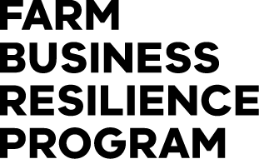
Term | Issue or opportunity identified | Priority (1-5) Priority:  1 = High  3 = Medium  5 = Low | Farm management action proposed | Time frame | Information or support required | Outcome | Review date
Short Term
Short Term
Medium Term
Medium Term
Long Term
Long Term

The Farm Business Resilience Program is supporting farmers to build stronger, more productive agricultural businesses. Visit: agriculture.vic.gov.au/FBRP
The Farm Business Resilience Program is jointly funded through the Australian Government’s Future Drought Fund and the Victorian Government’s Future Agriculture Skills Capacity Fund.

