

Apiary Business Fitness Checklist
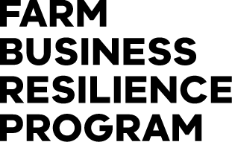
Contents
Farm Business Resilience Program 2
Partners 2
Business Fitness Checklist 3
Where are you and your Business at now? 3
Now, where, how? 3
How to use this checklist 3
Our People 5
Things we can do 7
Our Infrastructure 8
Things we can do 9
Our Business 10
Things we can do 11
Our Resources 13
Things we can do 14
Our Risks 16
Things we can do 17
SWOT Analysis 18
Internal Factors 19
Strengths 19
Weaknesses 19
External Factors 19
Opportunities 19
Threats 19
Your Farm Business Plan 20

Farm Business Resilience Program

Partners
This Business Fitness Checklist has been developed by Dairy Australia in collaboration with the NSW Department of Primary Industries and Agriculture Victoria. It will be used to support the roll out of the Farm Business Resilience Program, a key initiative of the Australian Government’s Future Drought Fund.
This version of the checklist was developed by Agriculture Victoria in partnership with the Victorian Apiary Association and Apiary Branch of the Victorian Farmers Federation.
The checklist is designed to assist all businesses to be more prepared and better planned, ultimately making them more resilient and able to meet challenges and grasp opportunities.
Dairy Australia would like to acknowledge the support of the Gardiner Dairy Foundation and DairyNZ.
The Gardiner Dairy Foundation has supported the development and roll out of the Our Farm, Our Plan program to all dairy farmers, reinforcing the value of the dairy industry working together. DairyNZ kindly gave permission to Dairy Australia to adapt their Farm Fitness Checklist for use in the Our Farm, Our Plan program, another example of Trans‑Tasman collaboration providing benefit to Australasian dairy farmers.


Farm Business Resilience Program

Business Fitness Checklist

Where are you and your Business at now?
A fit and healthy business provides the platform needed to achieve your goals (business and personal), and be profitable and resilient in the long term.
How well do you and your partners know your farm and your business, and its fitness for the future? Use this checklist to assess where you’re at now and to help identify opportunities for improvement. It also suggests where to go to get the information, resources and support you need to make it happen.

Now, where, how?
Completing the checklist will give you a good sense about where you and your business are at now. This is an important step in the planning process, followed by clearly identifying your ‘where and how’ and, preferably, getting it down on paper.

How to use this checklist
Each section of this checklist is designed to prompt your thinking about different aspects of your business. It’s a ‘self‑assessment’ and there are no right or wrong answers. Your job is to identify areas that might be a priority for you by ticking the box that best describes where you are at for each question.
Yes, we’ve nailed it | Ok, but we could do better | No, and we should do something about it | No, and it’s not relevant to us
P | P | P | P

Try scanning through the checklist before you start ticking so that you have an idea of what’s included. The aim is to identify and focus on a small number of areas that will move you forward significantly.
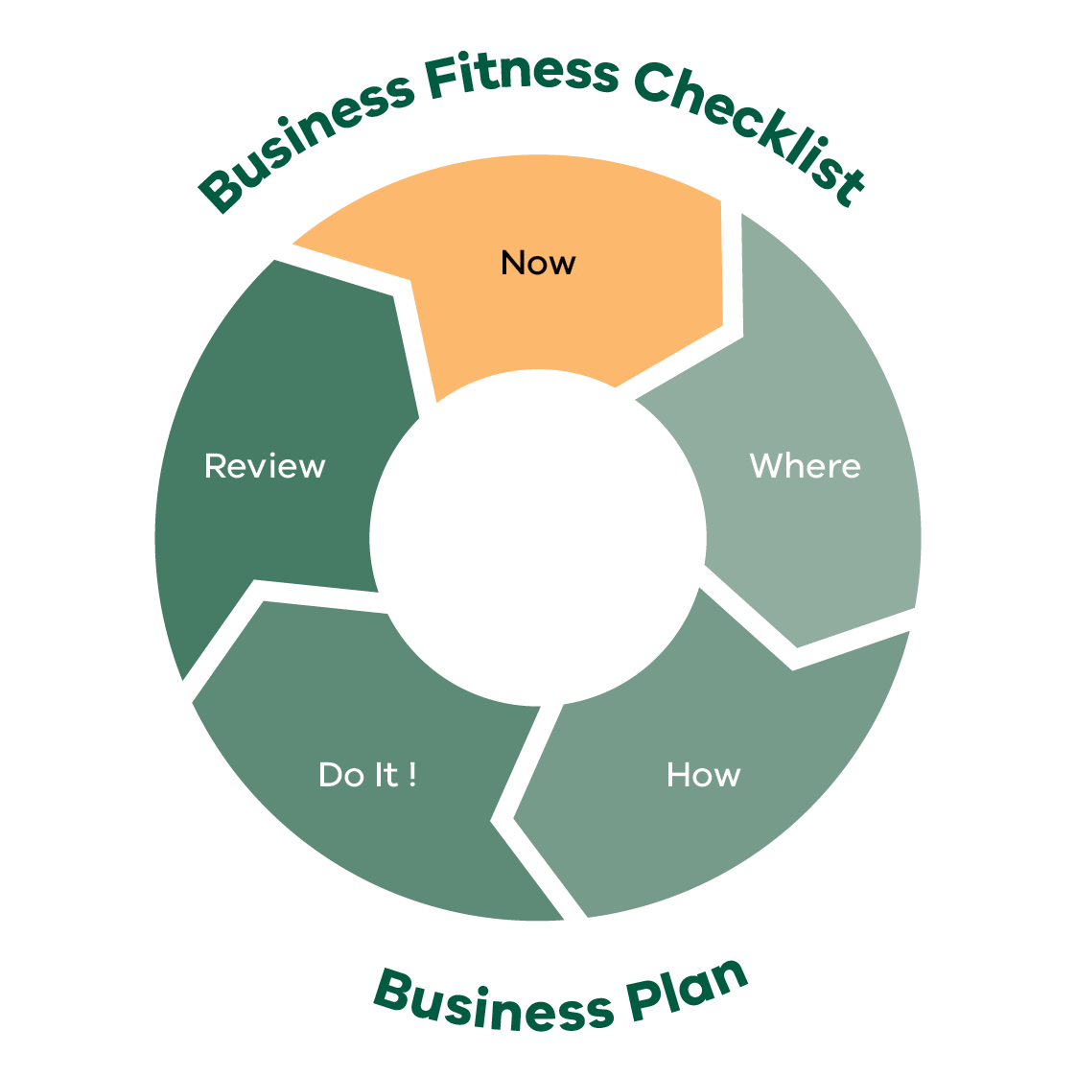
Business Fitness Checklist Business Plan
Now
Where
How
Dot It!
Review
This process will help you to focus on what’s achievable — none of us can do everything at once.
After completing each section think about how you’ve rated yourself and list some goals and actions that you reckon will make the biggest difference in improving what you do.

Our People
(Please place x in relevant cell)
Questions | Yes, we’ve nailed it | Ok, but we could do better | No, and we should do something about it | No, and it’s not relevant to us
We know who our neighbours are and we help them in times of need
We really enjoy what we are doing
We know what we want our life to look like in 5 years’ time
We have considered our retirement needs and what it will take to get there
We have a plan to develop our skills (e.g. communication, people management, financial and safety)
We have enough time to spend with family and friends
Most days I am happy to go to work
We have a healthy lifestyle and have an annual health check
We are compliant with our legal obligations when employing staff
We have the right number of people for the tasks we need to complete
We have a documented plan of our labour requirements for the business
Our staff are adequately trained for the roles they perform including appropriate licences (e.g. ChemCert, heavy vehicle and forklift licenses)
Our team understands our business’ purpose and their role in achieving that purpose
Our employees/contractors have been inducted and the induction process is recorded
We have regular team meetings to discuss plans, progress and opportunities for improvement
Our contractors are appropriately licensed and legally compliant
We are involved in local groups and activities that strengthen the local community
We have and emergency management plan in place
We are up to date with vaccines including tetanus
We have a safety plan in place for remote workers
Staff are trained in Safe Work Practices
We provide access and awareness to Mental Health Support programs for ourselves and our staff

Things we can do
Think about the ratings you’ve given yourself above. What areas do you want to focus on? Can you see opportunities? Write some goals and actions down here.

Things to think about (goals/ actions) | Who is responsible | Priority level | Timeframe

Notes

Our Infrastructure
(Please place x in relevant cell)
 | Yes, we’ve nailed it | Ok, but we could do better | No, and we should do something about it | No, and it’s not relevant to us
The accommodation is suitable (e.g. family home and staff accommodation)
We have a plan to improve our business infrastructure to meet future needs
Our hive boxes are in good condition and we have a replacement plan recorded and in place
Our supplement feed and product storage capacity is sufficient
We had sufficient apiary stock water supply in the last drought
We have a water use plan for drought conditions
We had enough house water to get us through the last drought
Our investment in plant, equipment and technology is well planned and suitably matched to the needs and scale of the operation
We plan our hive movements a season in advance
We monitor and record our business information on a regular basis (e.g. fuel, breeding, hive health, water, sites, biosecurity, honey volume)
We operate under a documented quality assurance system (e.g. BQual) and are registered with BeeMax
We have sufficient bee sites for our business
We have a suitable base of operations/ honey flow locations

Things we can do
Think about the ratings you’ve given yourself above. What areas do you want to focus on? Can you see opportunities? Write some goals and actions down here.

Things to think about (goals/ actions) | Who is responsible | Priority level | Timeframe

Notes

Our Business
(Please place x in relevant cell)
Questions | Yes, we’ve  nailed it | Ok, but we could do better | No, and we should do something  about it | No, and it’s not relevant to us
We have a written business plan and a list of goals that we are working towards
I feel we are in control of our business
We have measures and targets for our apiary production
We are aware of our financial performance measured by profitability and net worth over time
We know our cash flow position and ability to pay bills on a monthly basis
We have a good handle of our costs of production and profit‑making commodity price targets
We develop an annual plan and budget and update it throughout the year
We look at other businesses for ways we can improve what we do
We have a documented succession plan which is regularly reviewed and discussed with family members
We have a good relationship with our accountant, our bank and other service providers
We have non‑apiary income streams (e.g. rental income, day job, contracting)
We understand what the likely effects of climate change will be on our business and have plans (short/long) to adapt accordingly
We, as much as possible, take a pro‑active rather than reactive approach to running our business but remain flexible
We are members and/or connected with an industry body

Things we can do
Think about the ratings you’ve given yourself above. What areas do you want to focus on? Can you see opportunities? Write some goals and actions down here.

Things to think about (goals/ actions) | Who is responsible | Priority level | Timeframe

Notes

Our Resources
(Please place x in relevant cell)
Questions | Yes, we’ve nailed it | Ok, but we could do better | No, and we should do something about it | No, and it’s not relevant to us
We have documented procedures in place for identifying environmental risks for bee sites and depots (e.g. waterways, wells, bridges, culverts, infrastructure, steep slopes)
We encourage responsible spray practices to those we offer pollination services to and educate them on the impact of sprays to the bees and pollination
We are on track to leave an improved natural resource base for the next generation
We monitor our bee/hive health, and our management strategies to enhance our bee/hive capability
We know our resources and what’s needed to manage any constraints
We participate in projects that increase the plantings of beneficial plants for future pollination
We encourage and work with land managers to improve/enhance the local landscape
We encourage strategic use of plants as bee food and/or a pollen/nectar source
We have procedures in place to ensure farm properties and public land is preserved (e.g. vehicle hygiene to avoid transporting weeds and other pests and diseases)
We are aware of land use practices surrounding bee sites and watering points for bees are effectively managed
We ensure there is suitable resource base for our hives and plan in place to ensure we can maintain the resource base as required
We are prepared to provide supplemented feed in times of minimal resources availability
We are aware of and manage fire/flood risk
We plan our working season/equipment to reduce environment impacts

Things we can do
Think about the ratings you’ve given yourself above. What areas do you want to focus on? Can you see opportunities? Write some goals and actions down here.

Things to think about (goals/ actions) | Who is responsible | Priority level | Timeframe

Notes

Our Risks
(Please place x in relevant cell)
Questions | Yes, we’ve nailed it | Ok, but we could do better | No, and we should do something about it | No, and it’s not relevant to us
Our business is robust and can withstand various ‘shocks’ (e.g. commodity price drops, interest rate hikes, drought, floods, staff vacancies)
In the event of these shocks, we have recovery plans and know where to access support information
We have an appropriate business structure in place (e.g. sole trader, partnership, company or trust)
We have effective insurance coverage (e.g. business and life insurance)
We have identified the major risks associated with our business and have risk mitigation strategies in place
We have access to finance that allows us to invest in development work or opportunities when they arise
We have identified and documented the hazards within our business which are effectively managed to keep ourselves, our team and our visitors safe
In the last drought we had enough supplementary feed to meet requirements
We have a plan for managing the hives during extreme weather e.g. droughts, fire, floods, storms
We have a biosecurity plan in place
We are confident that our bees are healthy and well fed, and meeting biosecurity obligations as per the Apiary Code of Practice
We are effectively managing chemical resistance for pests of bees (OTC)
We are developing plans to manage new pests and diseases, such as Varroa mite, in preparation for incursions
Our team has health and safety front of mind, the safety risks are identified and systems are in place to isolate or minimise these
We use short‑ and long‑term seasonal forecasts to make informed decisions and adapt our management practices and business plans (e.g. Apiary Flora Map)

Things we can do
Think about the ratings you’ve given yourself above. What areas do you want to focus on? Can you see opportunities? Write some goals and actions down here.

Things to think about (goals/ actions) | Who is responsible | Priority level | Timeframe

Notes

SWOT Analysis
Considering your business Strengths, Weaknesses, Opportunities and Threats (SWOT) after completing Checklist questions can assist with your next move and priorities.

Internal Factors

Strengths
“Build on…”

Weaknesses
“Correct or avoid…”

External Factors

Opportunities
“Take advantage of…”

Threats
“Mitigate…”

Developing strategies will help you achieve your goals and objectives. Use your strengths to take advantage of opportunities, and work to mitigate your weaknesses and minimize threats. Remember that creating a SWOT plan is an ongoing process. You should continually assess your Strengths, Weaknesses, Opportunities and Threats, and adjust your plan accordingly to stay ahead of the curve.
Questions | Strategies to build on
Ways to build on strengths
Ways to take advantage of opportunities
Ways to reduce the effects of weaknesses
Ways to reduce the effects of threats

Your Farm Business Plan
Putting your goals and actions on in a plan will help you to focus on the things that matter the most. It means you have taken the plans in your head and put them on paper, which also means you get the full picture of the things you’d like to achieve next in one place.
This gives all of the decision makers in your business the chance to see the plan and to make sure you’re all on the same page.
Importantly it allows you to:
be confident that you have a shared view of what’s next
communicate your plan with other people, either inside or outside your business
refer back to your plans and track your progress and achievements.
You can find the Farm Business Plan template and other resources on the Farm Business Resilience Program webpage: agriculture.vic.gov.au/FBRP

Notes

The Farm Business Resilience Program is supporting farmers to build stronger, more productive agricultural businesses.
Visit: agriculture.vic.gov.au/FBRP
The Farm Business Resilience Program is jointly funded through the Australian Government’s Future Drought Fund and the Victorian Government’s Future Agriculture Skills Capacity Fund.

