Securing water for a rainfed dairy farm



Published by Agriculture Victoria,
Department of Jobs, Precincts and Regions,
1 Spring Street Melbourne, Victoria 3000

November 2019

© Copyright State Government of Victoria 2019
This publication is copyright. No part may be reproduced
by any process except in accordance with provisions of
the Copyright Act 1968.

Authorised by the Victorian Government, Melbourne.

ISBN 978-1-76090-239-1

For more information about Agriculture Victoria visit the website at www.agriculture.vic.gov.au or call Customer Service on 136 186.

Accessibility
If you would like to receive this publication in an accessible format, please telephone (Agriculture Victoria, Dairy Services, Benita Kelsall) on (03) 5624-2218.
This document is also available in (PDF and/or Word) format at www.agriculture.vic.gov.au
Disclaimer
This publication may be of assistance to you but the State of Victoria and its employees do not guarantee that the publication is without flaw of any kind or is wholly appropriate for your particular purposes and therefore disclaims all liability for any error, loss or other consequence which may arise from you relying on any information in this publication. While every effort has been made to ensure the currency, accuracy or completeness of the content we endeavour to keep the content relevant and up to date and reserve the right to make changes as require. The Victorian Government, authors and presenters do not accept any liability to any person for the information (or the use of the information) which is provided or referred to in the report.

Contents
Introduction 4
planning FOR YOUR dairy farm water NEEDS 4
1. Property water requirements 5
Estimating water use 5
Stock water requirement 6
Dairy Shed Water requirement 6
Evaporation and other losses 6
Other uses of water 7
Applying water requirements on-farm to storage size and flow rates 8
Estimating the Water on-hand and the storage capacity 9
2. Navigating the rules associated with water licensing 9
Licensing water from a dairy farm 10
3. Identifying possible Options for water supply and storage 12
Dams 12
Pumping water from a waterway 13
Accessing groundwater 14
Capturing rainfall from a building 15
Other options 16
Reticulation considerations 17
4. Identifying the risks to water security 18
5. Assessing options associated with water security 19
Conclusion 20
Appendices 21

Introduction
Having a secure and reliable water supply is a key foundation for a rainfed dairy farm. Water sustains life and therefore water is needed for stock and human drinking, for cleaning the dairy, in the household, for firefighting purposes, for watering gardens, weed spraying or for washing machinery. The quality of water can also affect animal performance and welfare.
Securing and distributing water for a rainfed dairy farm can be a complex task. This can be particularly challenging when the business changes: for example: as the herd expands; when a new block or farm is purchased, and existing water line locations are unknown; or when water supplies fail due to quality or declining availability.
This booklet provides guidance on working through key water challenges including:
- an immediate water crisis (such as running out of water in the short term); and
- planning options to help secure water in the long term.
The booklet also identifies where a license may be needed, and which agency should be consulted. This booklet has a focus on rainfed dairy systems outside irrigation districts.

planning FOR YOUR dairy farm water NEEDS
The first step to addressing and therefore improving the reliability of a farm water supply is to first understand current water availability. An Online Farm Water calculator is available at agriculture.vic.gov.au/watercalculator. Figure 1 below provides a summary of the key components to consider when planning water for a dairy farm including the water supply, storage, and usage.

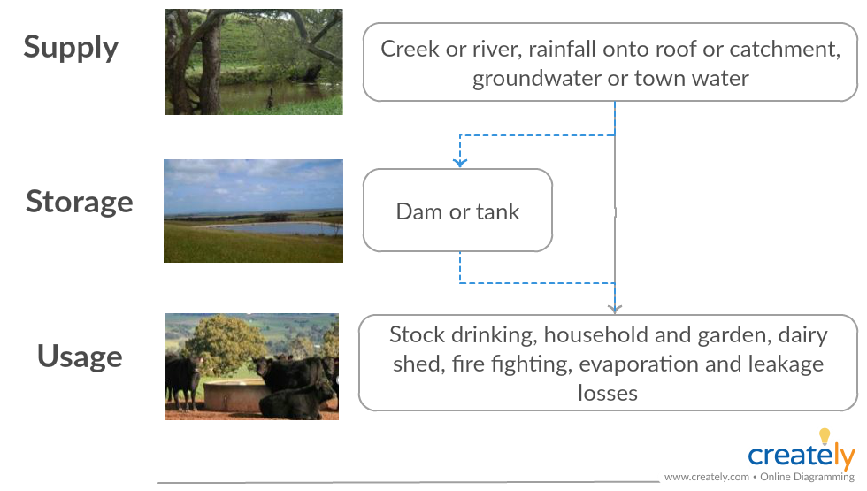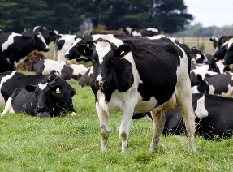
Figure 1. Key components to consider around farm-water planning

This booklet explores these components of farm water planning and includes the following sections:
- Property water requirements
- Estimating the water on-hand and the storage capacity
- Navigating the rules associated with water licensing
- Identifying possible options for water supply and storage
- Identifying the risks to water security
- Assessing options associated with water security.

Property water requirements
Understanding how much water the farm needs is critical to planning and preventing farm water shortages. The daily summer water requirement for the farm can be used to help with addressing immediate shortages to estimate how much extra water may be required. The summer requirement should also be used to determine flow rates to troughs. A yearly water requirement for the farm is also useful to have to compare how much water is available in storage for long-term risk management. Having a contingency amount of water available in storage, such as a year’s worth of supply can help with risk management. Water requirements and supply can also vary across the milking area, turnout or leased areas. It is therefore necessary to consider all components of the farm and their varying requirements.

Estimating water use
Estimating the property water requirement involves determining how much water is used on-farm. Typical water uses include: stock, the dairy, evaporative losses, household use, and a contingency supply that may also be needed for fire-fighting purposes. The following section provides some average figures to estimate on-farm water use. Measuring your own use is the most accurate way of estimating your water requirements as use varies considerably between farms.

Measuring your own water use
There are two methods that can be used to estimate your on-farm water use: 1) the storage volume method; and 2) the flow rate method.
- Storage Volume Method
The storage volume method involves turning off the replenishment valve on a water tank of known volume and then estimating the proportion of water used from the tank for that purpose. In the case of stock water, it may also be necessary to time how long it takes for the tank to empty, as multiple tanks may be required per day.
To calculate the volume of a tank:
- Volume of tank = $π x radius squared x height$
- Where $π \left(pi\right)=3.14$
- Where radius is half of the diameter in metres
- Where height is in metres (Figure 2)
- To convert the volume of m³ into litres multiply the answer by 1,000
Example:
- Radius = 1.7m Height = 2.3m
- Volume (m³) = 3.14 x (1.7)² x 2.3 = 20.87m³
- 20.87 x 1,000 = 20,870 litres

- Flow Rate Method
The flow rate method can be applied for water used from a hose. It involves using a container of known volume and a stopwatch to time how long the container takes to fill up. This will then provide the flow rate in litres per second, which is the volume of the container (litres) divided by the time to fill (seconds). This flow rate can then be multiplied by the number of minutes the water is used for. Please refer to the publication ‘Dairy Shed Water –how much do you use?’ for more information (Appendix 3).

Stock water requirement
There are many factors that influence how much water animals require, including: type of animal condition or physiological state of animal; pregnancy; diet; level of activity; quality of water on offer; and environmental conditions. Table 1 provides average figures that can be used to determine stock water requirements.
Table 1. Average stock water figures
Livestock unit | Average daily (L/head/day) | Winter daily (L/head/day) | Summer daily (L/head/day) | Annual litres/head
Milking cow | 150 | 90 | 210 | 54,750
Replacement heifer | 50 | 30 | 70 | 18,250
Calves | 25 |  |  | 9,125
Bulls | 80 | 48 | 112 | 29,200
Dry Cow | 80 | 48 | 112 | 29,200

Using the above figures for example, a 300-cow farm requires:
- 16.43 megalitres a year for the milking herd on the milking area.
- Another 1.64 megalitres a year for 60 replacement one and two-year olds.

Dairy Shed Water requirement
Dairy shed water use is extremely variable even when milking the same number of cows in the same type of dairy. Differences occur as some dairies recycle water for yard washing and use fresh water sparingly, whereas other sheds do not. For example, water use in a 300-cow dairy shed has the biggest uses of water to be platform sprays in rotaries, plate cooling water (if not recycled), and water for yard washing.
In 2009, the State Government compared water use from 780 dairies across Victoria. Table 2 provides a summary of the 75th percentile of water use meaning that 75 per cent of dairies would use a daily volume of water below the figures shown.
Table 2. Predicted 75th percentile for dairy water use per day (L/day) by herd size and dairy type (DEPI 2009).
Dairy Type | 50 | 100 | 200 | 300 | 400 | 500 | 600 | 700 | 800 | 900
Double-up | 5,642 | 6,456 | 8,465 | 11,131 | 14,654 | 19,348
Swing over | 4,921 | 6,113 | 9,444 | 14,618 | 22,663 | 25,195
Rotary |  | 18,358 | 21,057 | 24,142 | 27,694 | 31,790 | 36,509 | 41,957 | 48,243 | 55,502

For example, using the 75th percentile figures in Table 2, a 300-cow swing over herringbone shed requires 14,618 litres/day and around 5.3 megalitres/year.

Evaporation and other losses
The amount of water lost from a farm dam through evaporation, can be a significant proportion of the total amount of water stored, particularly for smaller, shallower dams. Reducing the total surface area of the water by having fewer larger, deeper dams rather than many smaller shallower dams reduces evaporative losses.
When planning new farm dams, evaporative losses can be minimised by reducing the surface area and increasing the depth where possible. In times of drought or water shortages, losses can be reduced from existing dams by maintaining fewer key dams rather than numerous smaller, shallower dams. Moving water to key dams reduces the total surface area and increases the depth of water stored, thereby reducing the amount of water lost to evaporation.
There are a variety of products available to reduce evaporative losses from farm dams such as covers that are placed over the dam or additives that create a film on the water surface. However, the economics and feasibility of using these should be carefully considered.
Seepage losses are difficult to quantify but can also be significant, in some cases up to at least 10 per cent of the volume of a dam per year. Some soil types are unsuitable for dam construction or will require lining to be able to hold water. Leaking troughs and pipes can also contribute to unseen losses.
The following formula is used to estimate evaporative losses on-farm which uses the Pan Evaporation rate sourced from the Bureau of Meteorology (Figure 2), the dam surface area, and a factor to account for the dam depth of 0.67.

Evaporative Loss (litres) = 0.67 x PAN evaporation (m) x dam surface area (m²) x 1000
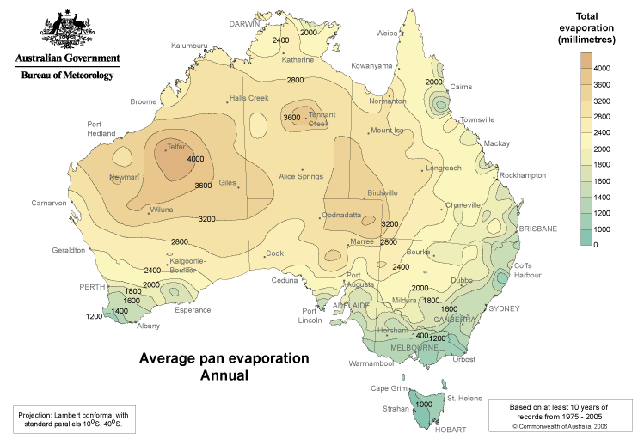

Figure 2. Bureau of Meteorology Map of Average Annual PAN evaporation across Australia

For example, a gully dam in Gippsland that is 70 m long by 50 m wide at the bank and 4 m deep has a storage capacity of 2.8 megalitres and has a surface area of 1,750 m². The yearly evaporative loss across the year is 1.4 megalitres, and the daily summer evaporation rate is approximately 5,863 litres per day (this doesn’t account for the rainfall directly onto the dam surface). The evaporative loss is around half the total volume of the dam in this case.

Other uses of water
Other uses of water should also be accounted for including: water for spraying; cleaning equipment; firefighting; household; garden and irrigation water. For resources relating to bushfire preparation, refer to the CFA at www.cfa.vic.gov.au.

Applying water requirements on-farm to storage size and flow rates

Yearly water requirement for the farm
During periods of low rainfall, dams and farm catchments receive limited run-off and creeks can run dry. Dam and tank water then become a limited resource. Comparing the available storage on-farm (in dams and tanks) to how much water is needed (the yearly water requirement) can help with risk planning to avoid running out of water where water supply is intermittent. Even where supplies are considered reliable, it is still necessary to have some water on-hand such as three days of on-farm storage in the event of pump breakdowns, power outages and supply issues such as blue green algae outbreaks affecting water quality.
For example, a 300-cow farm:
- has a yearly water requirement of 20 megalitres including the evaporative losses
- is relying entirely on catchment run-off into dams for water by consolidating and enlarging the dams on-farm to be at least 20 megalitres. The farm would therefore have one year’s supply of water in the event of periods of low rainfall.
Having an alternative supply such as groundwater could be investigated as a risk management strategy.

Daily peak water requirement for the farm
Understanding the maximum daily water requirement for the farm can be very helpful when planning flow rates for troughs and sizing header tanks to account for a minimum of three day’s back-up in the event of a pump breakdown.
The daily peak flow rate is based on the maximum number of stock drinking from a trough in summer and assumes that the stock drink the water within a four-hour period. A four-hour period is used as it assumes that cattle come to the water trough in groups rather than a steady stream.
For example, on a 300-cow dairy:
- Cows drink around 63,000 litres (L) on a hot summer’s day (as per Table 1). If they consume this volume within a four-hour period, the required flow rate would be 63,000 L divided by four hours = 15,750 L/hour which is equivalent to 263 litres/minute or 4.4 litres/second.
- A header tank with three day’s storage would therefore need to be at least 189,000 litres.

Estimating the Water on-hand and the storage capacity

How much water do I have?
On-farm water storages such as tanks and dams provide a contingency for periods when it doesn’t rain and in situations where there is an absence of a reliable water supply. Understanding how much water is available on-farm is also needed if there is likely to be a water shortage; this will help with estimating how much extra water might be needed, and the possible options available.
Dam and tank volumes/levels can be measured to estimate their size and can be compared to water available on-hand. The look-up tables (Tables 8, 9 and 10 in Appendix 1) provide some basic estimations of dam volumes. An on-farm water calculator tool is available where you can alter the depth of the dam to establish the volume of water on-hand (agriculture.vic.gov.au/watercalculator).
In the case of an immediate water shortage, it is necessary to understand how much water you have on-hand to be able to plan to alleviate any shortfall. This involves measuring the depth of water that is remaining in the dams.
For long term water planning it is necessary to understand the total capacity of the dam, to understand how much water the farm can hold in the event of a period of low rainfall.

How long will the water last?
To see how many days of water is available we need to use the following formula: Amount of water left in dams (in litres) divided by the daily farm water requirement (in litres) is equal to the number of days of water left (where no rain falls).

An example:
A dairy farm has three main dams and has experienced a very dry year with little run-off. The farmer is concerned about running out of water and has measured the depth of water left in each dam, as well as the total depth of each dam to calculate overall the dam volume and volume of water left (Table 3 below). The farm is requiring approximately 45,000 litres per day for 300 cattle and 14,520 litres per day for the dairy washdown, therefore a total daily water requirement of 59,520 litres/day.
Table 3. Example worksheet for on-farm storage volumes
Dam or Tank Name | Total Volume of storage (litres) | Approximate volume of water on hand (litres). (On 15 December)
Big dam | 5,000,000 litres | 1,850,000 litres
Gully dam | 2,100,000 litres | 500,000 litres
Hill dam | 1,000,000 litres | Empty
Total | 8,100,000 litres | 2,350,000 litres

How many days left of water on-farm?
Daily farm water requirement is 59,520 (litres/day) and there is 2,350,000 litres in storage.
2,350,000 (litres) divided by 59,250 (litres) = 39 days’ worth of water left on-farm (where no rain falls)

Navigating the rules associated with water licensing
If you’re considering securing or changing a water supply for your farm, the first thing to consider is the licensing requirements to assess if it’s possible to go ahead with your plans. Water is licensed depending upon how it’s used. If you’re not sure what existing licenses are in place for the property, please check with your Rural Water Corporation. Table 4 below provides an overview of who manages water.

Rural Water Corporation | Local Government | Catchment Management Authority** | Retail Urban Water Authority
- Permits to take and use water  - Groundwater extraction  - Bore construction  - Dam construction license | - Permits associated with undertaking earthworks or construction  - Planning and building permits | - Permits to undertake works on waterways  - Flood information and advice  - River health | - Urban water and sewerage infrastructure  - Urban bill enquiries
**Melbourne Water is the authority in the Western Port and Port Phillip Catchment Management Region
Table 4. Summary of government organisations associated with water and their role

Water for a commercial use
Water used in a dairy shed, or for irrigation or any other intensive purpose, is considered a commercial use of water, which means it requires a license as per the Water Act 1989. Rainwater collected from rooftops and buildings is exempt from any Rural Water Corporation licensing requirements.
Examples of licenses for dairy include:
Section 51 take and use license (with a volume that can be used in the dairy)
Dam registration license
If you require a new Section 51 take and use license talk to your Rural Water Corporation and discuss options to buy or trade a license with an existing holder, as in most areas of Victoria there are no new entitlements available for this type of license.

Water for stock and domestic use
Stock and domestic use includes water for stock drinking, household and garden use as well as fire prevention.
You can take bore water for domestic and stock use if the bore is located on your property. You can take river or creek water for domestic and stock use if:
- your property title includes the river;
- your property title directly abuts the river; or
- you lease Crown Land abutting the river.
If you still require access to a creek or waterway and you don’t meet these conditions, then you may need a Surface Water License. Contact your Rural Water Corporation to discuss.

Licensing water from a dairy farm
The following dot points identify the licensing requirements associated with water from dairy farms.
- Rainfall captured from shed rooves doesn’t require a license if used in the dairy (commercial use) or stock drinking.
- For dam water, groundwater and surface water if it’s is used for stock drinking then water can be taken without a license if the dam or bore is located on your property without the need for a license. Water can be taken from a river if the property includes the river, or directly abuts the river or you lease crown land abutting the river.
- For dam water, groundwater and surface water if it’s is used in the dairy (or irrigation) then a section 51 take and use license is required if sourced from surface water (dams, creeks or rivers) or groundwater. Please note: a dam registration license also covers dam water to be used in dairy sheds. Contact your Rural Water Corporation to see if there are any new entitlements available or you may need to trade with an existing holder to secure an entitlement.
- For town water availability, please discuss this directly with your Retail Urban Water Authority. There is no need for a license.

When to seek planning permission from your local council
A planning permit may be required to undertake earthworks associated with construction of a dam or track or even the installation of a pump. Please contact your local council to see if you require a permit prior to commencing works.
To see which planning overlays affect your property visit:
https://www.planning.vic.gov.au/schemes-and-amendments/planning-report-search

An example:
A dairy farm in Ellinbank in Baw Baw Shire would like to expand a dam on a waterway. The farm has several planning overlays. Two of the overlays that may trigger the requirement for a planning permit prior to construction include:
- Areas of Cultural Heritage Sensitivity
- Environmental Significance Overlay – ES04

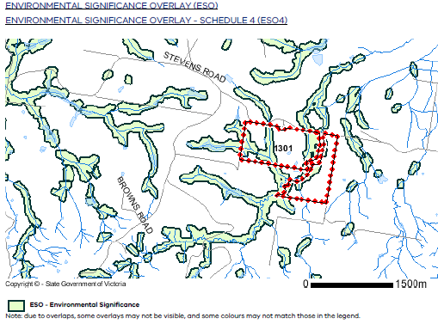
Figure 4. VicPlan Property Report example
In addition to local government planning permits, a Works license from a relevant Rural Water Corporation would also be required. This Works license is needed for dams that are constructed or altered on a waterway. A Works on Waterway permit would also be required as the dam is also located on a waterway; this would need to be obtained from the Catchment Management Authority. It may therefore be necessary to seek approvals from multiple authorities for some types of works.

Works on Waterways permits
A Works on Waterway permit may also be required when activities are undertaken on a designated waterway such as: crossings; stormwater outlets; stabilisation works such as bank protection or retaining structures; vegetation and debris removal; or sand and gravel extraction. A Works on Waterway permit can be obtained from your local Catchment Management Authority or Melbourne Water (if you live in Western Port or Port Phillip catchment). Works on Waterway permits are a requirement as poorly constructed crossings and other structures can cause erosion, obstruct water flow, and hinder the passage of aquatic life. To find your relevant authority see Appendix 3 – Key Contacts and Resources.

Identifying possible Options for water supply and storage

Dams
Constructing or enlarging a dam requires careful planning and in some cases licensing as well. Licensing of new dams is required when dams are constructed within a waterway or if they have a large dam wall. This is because these dams are deemed to be potentially hazardous and require a Works permit for their construction. Prior to any dam construction it is best to consult with your Rural Water Corporation.

While dams provide a risk management strategy for farm water, they can also create environmental impacts as they have the potential to modify stream flows, including acting as a barrier for fish passage if located on a waterway.

Dam planning considerations
Key points to consider prior to dam construction include:
- location of the dam in an area with a generous catchment area
- a soil type suitable for dam construction to ensure it holds water
- the legal requirements (please ensure the Rural Water Corporation is consulted prior)
- the dam size to account for evaporation, seepage, storage reliability, dam health reserve and for it to be properly engineered with a spillway (professional can be sought).

How much water can be captured from paddock run-off into the dam?
Catchment run-off depends upon many factors such as soil type, vegetation cover, property location, area of the catchment and rainfall. The example below has a gully dam with a catchment area of approximately 134 hectares.
The dam illustrated in the picture below includes a catchment area of 134 hectares, on a clay loam soil type with perennial pasture cover and an annual rainfall of around 1,000 mm/year. In this example, approximately seven per cent of the rain that falls can run into the dam. Over a year the 134 hectare catchment could potentially supply approximately 88 megalitres of water. To estimate your own catchment run-off please refer to the On-Farm Water Calculator Tool (Appendix 3).
Figure 5 below shows that aerial maps with contour lines can be used to determine the catchment areas. Where contour lines are closest together this indicates the direction water will flow.
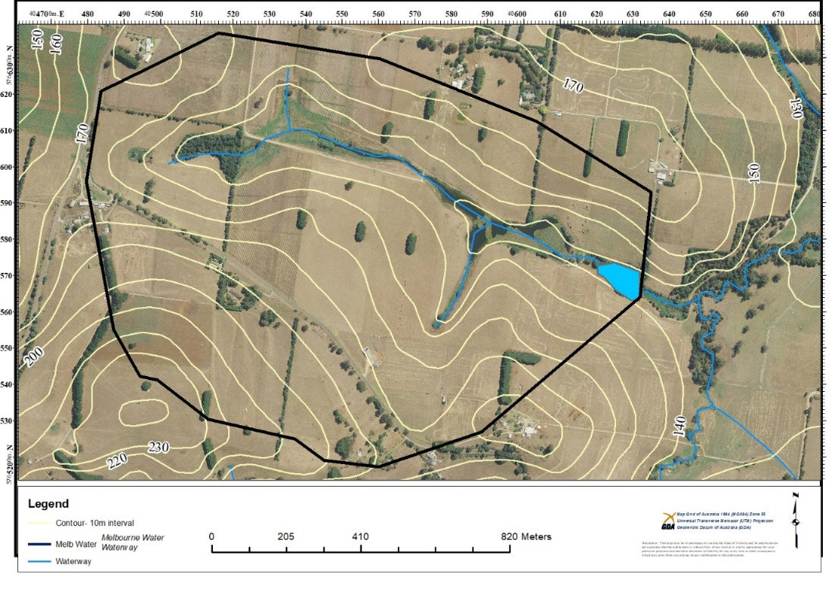
Figure 5. Aerial photo of catchment area providing run-off to dam

Pumping water from a waterway
Pumping from a waterway is typically achieved using a permanent or temporary pump located at the waterway, which is pumped either directly to the farm under pressure, to a header tank or to a holding dam before distribution. A header tank uses gravity to provide water supply under pressure. Header tanks are located on a higher location than the water troughs. If there is no power at the preferred pumping location, installation of electricity will be necessary, or other options such as a solar pump, air displacement pump, windmill or fuel pump will be needed.
If you are taking water from a creek where you own land on both sides, then you may have a right to take water from this creek for stock and domestic purposes without the need for a Surface Water License.
In many instances however, accessing water from a waterway will require a Surface Water License that can be obtained from your Rural Water Corporation. This will be needed for any commercial use of water when the water is taken from a waterway that does not flow over your property (for example, if there is public land located between your property and the waterway you wish to take water from, such as a Crown River Frontage, where you don’t hold the license (Section 3, page 9).
Licenses
A license allows you to take and use a certain amount of water from a waterway or dam for a specific purpose. It can also contain conditions such as: maximum extraction rates, periods when water can be extracted, minimum stream flows needed before water can be diverted, location where water can be taken and where it can be used. In some instances, a license may specify that water can only be taken during high-flow periods such as between July and October; this type of license is called a ‘Winter Fill’ license. Water in this instance will require storing in a dam for use throughout the rest of the year.
Challenges associated with pumping directly from a waterway – a case study
Water quality and reliability of supply are the two main risks associated with pumping water directly from a waterway. While there are steps you can take such as excluding cattle from waterways across your farm to help maintain water quality, it’s hard to control what is coming from upstream. Excluding cattle from waterways through stock exclusion fencing helps to maintain water quality as cattle are unable to enter the waterway where they can defecate directly. Fencing also protects streambanks from erosion and therefore reduces sediment going into the waterway. Groundcover is also able to establish with the removal of grazing, which helps to filter water before it enters the waterway.
The following case study describes some of the challenges of taking water from a waterway and a few strategies that can be used to help improve reliability of this supply. Possible strategies to address these risks include having on-farm storage where river water can be held to supply the farm in the event of a decline in water quality and/or supply.
From direct pumping to supplementing with storage
Switching from directly pumping from a creek to pumping from a gully dam was necessary for a farm near Warragul to help improve water security. The farm which runs around 500 cows was directly pumping water for stock drinking to a header tank with gravity-fed troughs. During drier years over summer, there were periods when the creek would become low, making pumping difficult.
The farm has installed power down to a gully dam that is located on a minor waterway to pump to a series of four header tanks and reduce the pressure off the creek.
The farm manager explains that ‘by pumping from the gully dam we will have enough storage to be able to supply the farm over summer, which will take some pressure off the creek and make use of an existing resource’.

Accessing groundwater
Researching groundwater aquifers prior to drilling for a bore is a useful step that can help with planning as the quantity and quality of water can vary considerably depending on the location. In some areas groundwater is also fully allocated (which may require trading to obtain a license for dairy use) and is managed with a groundwater management plan (see Section 3, page 9).
Seeking local intelligence around groundwater availability from neighbours and local drilling contractors can also be useful. There are interactive mapping tools available online to see where existing groundwater bores are located, at what depth they occur and the quality of water available.
Examples of two online mapping tools are listed below:
- Visualizing Victoria’s Groundwater at https://www.vvg.org.au
- South Gippsland Water’s groundwater Hub (covering Southern Victoria) at http://gwhub.srw.com.au
Hydrogeologists can also be consulted to help provide advice on groundwater availability.

License to construct a bore
A Bore Construction license should be obtained from your Rural Water Corporation prior to constructing a bore. This will provide you with permission to construct the bore. The Rural Water Corporation regulate this to ensure that groundwater bores are constructed correctly, and so that water doesn’t cross-contaminate between aquifers.
A licence to use the water may also be needed if it’s being used for anything other than for stock and domestic purposes such as ‘commercial use’ which is needed if water is being used in the dairy.

Bore drillers
To identify a qualified and licensed driller in Victoria, contact the Australian Drilling Industry Association on (03) 9770 4000 or visit their website www.adja.com.au.

Water quality of the bore
The water quality of the bore should be assessed to ensure it’s suitable for stock drinking. For further information please see the DPI NSW Note: On farm water quality and treatment (Appendix 3).

Storage tank
A storage tank will still be required, to allow for water storage if the pump breaks down. Ideally this should be for about three to five days of storage.

Capturing rainfall from a building
A benefit of using rainfall from a building roof is that a licence is not required for the use of the water in the dairy. Rainfall collected from a roof is also typically of good quality making it ideal for vat and plant wash. The evaporative losses are limited as the water is stored in a tank. If installing a new water tank and/or shed, please check with your local council to ensure you are adhering to any planning conditions that may apply.

How to calculate the volume of rainfall collected from a roof
The following formula can be used to determine how much rainfall can be collected from a roof surface.
Volume (litres) = Area (m²) x Rainfall (mm) x 0.95*
*to account for evaporation/overflowing gutters
Can I harvest enough water off my sheds for vat and plant wash?
A dairy farmer is wanting to see if they can capture enough rainwater off their dairy and nearby calf sheds to supply the dairy with plant and vat washing. Their daily water requirement for plant and vat washing is 1,500 L/day or 547,500 L/year. The dairy and shed roof areas combined are approximately 600 m². The dairy farm is in Drouin with a rainfall of approximately 1,000 mm/year.
Volume (litres) = 600m² x 1000mm/year x 0.95 = 570,000 litres/year
The dairy farmer can therefore expect, in an average year, to harvest 570,000 litres/year off the 600 m² shed roof area. The dairy and associated sheds adequately supply enough water provided there is enough storage (such as water tanks) to capture water during winter and supply the water in summer when there may be insufficient run-off. There will be an extra 22,500 litres a year provided ‘average’ rainfall falls. The rainfall figure can be changed to see how much water can be harvested in a variety of scenarios such as dry years. The Bureau of Meteorology provides climate data online for a range of sites across Australia, see: www.bom.gov.au/climate/data/

What size tank is required?
A monthly water balance can be used to help size a water tank. It compares the monthly rainfall averages (amount of potential rainfall harvested) and the water demand across the year as per Table 5. It’s also important to consider:
- How much room is there for a tank?
- What will it cost to get installed?
- What’s the optimum size to reduce risk but also balance with cost?

Table 5. Monthly Water Balance—the potential rain supply of water versus monthly stock usage
 | May | June | July | Aug | Sept | Oct | Nov | Dec | Jan | Feb | March | April | Total
Average Monthly  Rainfall (mm) | 92.6 | 85.7 | 86.9 | 95.1 | 100 | 104.5 | 89.7 | 80.2 | 60.8 | 55.1 | 67.8 | 82.4 | 1000
Monthly yield (litres) | 52,782 | 48,849 | 49,533 | 54,207 | 57,000 | 59,565 | 51,129 | 45,714 | 34,656 | 31,407 | 38,646 | 46,968 | 570,000
Monthly usage (litres) | 45,000 | 46,500 | 46,500 | 46,500 | 45,000 | 46,500 | 45,000 | 46,500 | 46,500 | 42,000 | 46,500 | 45,000 | 547,500
Deficit/Surplus (litres) | 7,782 | 2,349 | 3,033 | 7,707 | 12,000 | 13,065 | 6,129 | -786 | -11,844 | -10,593 | -7,854 | 1,968 | 22,500
Cumulative storage (litres) | 7,782 | 10,131 | 13,164 | 20,871 | 32,871 | 45,936 | 52,065 | 51,279 | 39,435 | 28,842 | 20,988 | 22,956

Interpretation of the monthly water balance
The monthly water balance (as per Table 4) starts in May to allow the tank to fill over winter and spring as this is normally when there is more rain than what is needed for plant and vat washing.
Approximately 31,077 litres is the most the tank will need to store across the year to supply the animals throughout summer and autumn. This can be calculated by adding the deficit of months (seen in Table 4 as a negative value) between December and March when usage exceeds rainfall. A tank of 50,000 litres would capture all the excess water in winter/spring as the largest cumulative volume is 52,065 litres in November.
A larger tank such as a 50,000-litre tank could help to provide some extra storage for lower than average rainfall years. A monthly analysis can also be undertaken using less than average rainfall figures to see how the water supply would cope in a drought.

Other options

Emergency supplies
Victoria has a network of about 300 emergency water supply points (EWSPs). The EWSPs provide water carting for emergency stock and domestic purposes during severe dry seasonal conditions and surface water scarcity. To locate an emergency water supply point, see:
https://www.water.vic.gov.au/groundwater/emergency-water-supply-points
Town water
While some farms can access mains town water, this is done so in an arrangement directly with the Urban Water Authority and the farm will be purchasing the water at town water rates. In some areas where urban water supplies are becoming increasingly strained, incentives are offered to farmers to seek alternative water supplies to ease pressure.
Community pipeline
A community pipeline can be used as a last resort to secure a short-term water supply so multiple farms can share a water resource. A community pipeline approach requires a lot of co-ordination with neighbors as well as government organisations for appropriate permissions.

An example: Inverloch community pipeline, drought of 2015–16

- Involved a group of affected farmers coming together and forming a group.
- A disused town water supply dam owned by South Gippsland Water was identified by the group as a potential water source.
- Each farm calculated how much water they needed for their cattle to help design the system.
- The farmers spent $140,000 to buy 15 km of pipe and three pumps; the pipe was removed after the drought.
- A collective approach to water-use and drought relief helped support the community.

Agistment and or selling stock
Agistment of young stock and dry cows is another way to alleviate pressure on water supplies for the milking area. This may be a last resort, however, economically it may be cheaper than carting water. Selling stock may also be another option for conserving water resources for the main herd. These options require careful consideration, including weighing up the economics of the situation.

Reticulation considerations
When considering reticulation requirements such as pumps and pipes, it’s important to consult an irrigation specialist or plumber. The following information may be helpful to map out and have ready to inform design of the system:
• Contours (elevation heights)
• Future trough locations and pipe locations and distances
• Daily peak flow rate needed at each trough
• Header tank location (if gravity-fed system)
• Power source location or preferred method of pumping
• Location of water source/s
The peak flow rate should be calculated to determine the peak flow of water needed at a water trough. This is the daily peak water requirement for the farm as explained on page 7.

Gravity-fed system
A gravity-fed system is ideal because it is independent of power failures, and is simple and easy to operate and maintain, with no ongoing pump maintenance. However, this type of system relies on having the water supply located above where the water is needed.
Alternatively, a header tank can also be used where the water is pumped to a storage tank and then gravity feeds the reticulation system. This header tank can act as a buffer in case there is a problem with pumps or the water source.

Pumped system
If water needs to be pumped to troughs there will be the cost of laying the power cable to the pump site, and/or a pumping device such as a fuel pump, solar pump, air-well pump or windmill, and the associated maintenance required. The type of pump selected needs to be carefully matched to the water supply type, pumping distance, volume and height required. For example, different pumps are needed for pumping from surface and groundwater water sources. Example pumping methods are describe in Table 6 below.
Table 6. Types of pumping methods
Type of pump | Description
Electric pump | If the power source is close to the water source, this is usually the most common and cost-effective method of pumping water. Electric pumps are relatively cheap and have few moving parts.
Petrol and diesel pumps | Petrol and diesel pumps can provide a good back-up option or short-term pumping solution. They can be quite labour intensive and need refueling to operate. There is also the ongoing cost of the fuel.
Solar pump | Solar pumps are often used when there is no mains power and supervision of a pump isn’t practical. A solar system requires careful planning and expert advice. A solar system tends to match demand for water when stock need it most (when sunny – better than a windmill) and has few ongoing running costs. They have a high initial capital cost (Figure 13).
Windmill | A windmill may have high initial capital costs, with few ongoing running costs. The amount of power (water) a windmill can supply depends upon wind-speed at the site and tower height. The pump needs to match the wind resource and site conditions. Windmills require regular inspection and require ongoing maintenance (which at height can be a safety concern). Windmills don’t pump water unless there is wind, so require a storage tank as a backup when there is no wind.
Direct air displacement pumps | Direct air displacement pumps are driven by compressed air from a compressor, which is connected to mains power. They are often used when mains electricity is a long distance away from the water source. Polypipe is laid to transport compressed air, which supplies the pump with the air that is used to pump the water.

Identifying the risks to water security
To create a secure water supply, addressing the risks to water security is necessary. Table 7 below provides a summary of some of the risks to supply and possible options to reduce this risk.
Table 7. Table of potential risks and options to address water security issues.
Risks associated with usage, storage and supply | Description of risk | Options to reduce the risk
Evaporative losses | Evaporative losses from multiple small dams with a large combined surface area. | - Consolidating water in larger storage dams over summer will help to reduce the surface area exposed to evaporation.  - Deepening existing dams rather than building new shallow dams can provide a more reliable storage of water for the farm and improve water security.
Leaky dams | Some soil types, and the construction method can result in a leaky dam | - For any new dam construction, have the soil tested at the site of the dam construction to ensure it will hold water. If not, the dam may need sealing (especially the dam embankment) and/or lining.  - Protect existing dams from stock by fencing them; this will help to maintain the integrity of the dam embankments and help to maintain water quality.
High stock water requirement | Drinking water for cows is the biggest use of water. | - Provision of shade across the farm can help to reduce the stock drinking water demand. Shelter belts also help to protect stock in winter and can help to reduce evaporative losses.
High dairy shed requirement | Water for the dairy is also a large user of water for the business. | - Recycle plate cooler water and effluent for yard washing where appropriate.  - Capture rainfall off sheds for uses that need high quality water.  - Use a timer on platform and cup sprays on rotary platforms or restrict use to the start or end of milking. Also, consider installing low flow rate heads on these sprays.
Losses from leaking troughs | There is the potential to lose a lot of water if a float valve breaks, or pipe splits. | - Fix leaking taps and troughs.  - Install float guards to prevent stock playing with floats.  - Where possible put extra taps into the reticulation system so leaks can be isolated early.  - Use a pressure gauge to check if there are any leaks in the reticulation system or telemetry tank-level readers.
Power or pump failure | For some systems this could mean running out of water | - Having back up pumps and using header tanks as part of the reticulation design can help to manage this risk.  - During bushfires, electricity supplies are usually the first thing to go.
Poor water quality | Stock unable to drink | - Poor water quality due to bacteria, pathogens or blue green algae can impact water supplies. Protecting water quality by excluding stock from dams and waterways and avoiding applying fertilizer prior to rainfall events helps to protect water quality. Incentives for excluding stock from waterways may be available; check with your Catchment Management Authority.
Limited tank or dam storage | Limited storage to buffer periods of no run-off | - Ideally there would be enough storage on farm, to be able to supply the farm for one year if it didn’t rain, when relying solely on catchment run-off.  - May vary across the State and depends on availability of other reliable supplies.
Limited catchment area for dams | If the catchment area is small, then run-off is reduced. | - Having the ability to transfer water around the farm between storages or larger catchment areas, or from waterways where you have either a license or a right, can help to secure the supply for dams with smaller catchment areas.
Relying solely on one supply of water | If this supply fails, then carting water or reducing stock is the only option. | - Having access to multiple supplies of water can help to manage the risk of running out of water in the event of a dry year. Protecting water quality through stock exclusion of dams and creeks can help.

Assessing options associated with water security
When weighing up options it may be necessary to seek advice from a range of people and organisations such as water corporations for advice about licensing, retailers of pumps or earthmoving contractors, and family members, business partners or staff who will ultimately be managing the system. Please refer to Appendix 3. Table 8 below provides a template that can be useful for assessing different options with some worked examples. This process can be applied to your own situation to help with decision-making. Reducing water use as a first option can be the easiest solution as it is within direct control of the farm business and can usually be done with minimal need for permits or licenses.
Table 8. Example of process to assess options to address the risks associated with water security
Potential Options | Description of the potential option and assumptions | Ways to address the assumptions | Benefits | Costs/Weaknesses and potential risks
Option 1. Deepen an existing dam to increase the on-farm storage potential. | Increasing the main dam capacity to provide extra storage of water to overcome periods of low rainfall and run-off.  This assumes that a license to increase the dam capacity and relevant planning permits will be granted if necessary.  That the existing dam holds water and can be increased and the soil at the site will still hold water. | Obtain and investigate relevant permits and licenses early on.  Check that the soils at the proposed dam site will hold water. | Alleviate pressure on water supplies over summer.  Using a large storage dam to store a large amount of water with a minimal surface area will help to reduce evaporative losses.  Reduce labour associated with chasing water. | Costs associated with earthworks.  Costs associated with licensing and/or permits and associated investigations.  Costs associated with investigations to ensure the dam site is suitable and will hold water.
Option 2. Accessing groundwater for stock drinking. | Drilling a bore to provide an additional supply of water to the farm.  This assumes that there is groundwater available and the water quality is adequate for the farm’s needs. | Investigate groundwater supplies in the area from neighbours and your local water corporation’s resources. | Can provide a reliable supply of water.  Water is even in temperature.  Less land is taken up with storage dams. | Drilling of the bore. Multiple holes may be required to be drilled prior to finding a successful site.  Costs associated with bore registration license is required.  Ongoing pumping costs to extract the water.  Groundwater supplies can also be under pressure and decline over time. During droughts, pumping restrictions and rosters may be implemented by the Rural Water Corporation.

Conclusion
This booklet provides both short and longer-term strategies for addressing on-farm water deficiencies.
Managing and updating water supplies can be difficult and can sometimes require quite a lot of pre-planning, including talking to government agencies prior to commencing works to ensure the right licenses are obtained.
Protecting water quality and using water efficiently through activities such as stock exclusion of waterways and dams, providing shade for stock, fixing leaking troughs and pipes, and reusing effluent in the dairy are initial first steps that can help improve on-farm water security with minimal licensing implications.
Becoming efficient with water and improving water quality on-farm provides multiple benefits to your business as well as the community and environment.

Appendices

Appendix 1. Water audit
The following tables 9 to y are used in series to complete a water audit.
Table 9. Step 1 to determine Stock Drinking.
Stock Drinking | Milking cow | Replacement heifer | Calves | Bulls | Dry cows | Total
Number of cows
Summer Daily Requirement | 210 | 70 | 25 | 112 | 112
- Total daily summer stock requirement (multiply number of cows by summer daily requirement)
Annual requirement (litres/head/year) | 54,750 | 18,250 | 9,125 | 29,200 | 29,200
- Total Yearly Stock Requirement (multiply number of cows by annual requirement)

Table 10. Step 2 calculate the dairy shed water use

Dairy shed water use | Daily volume  (litres/day)
Yard cleaning (inside the shed)
Yard cleaning (outside the shed)
Milk cooling
Activities in the pit (trigger hoses etc.)
Fixed cluster and platform sprays
Milking machine and bulk tank/vat cleaning
Other tasks (such as sprinklers on the yards for cooling cows)
- Total Daily Dairy Use (litres/day)
- Total Yearly Dairy Use (multiply daily use by number of days dairy operates e.g. 365 days)
- Daily total water requirement (litres/day) (A+C+E+G)
- Annual water requirement (litres/year) (B+D+F+H)

Table 11. Step 3 Estimating dam evaporation
Dam Name |  |  |  |  | Total
- Surface area
- Depth factor | 0.67 | 0.67 | 0.67 | 0.67
- Daily summer evaporation rate (mm) | 7 mm/day | 7 mm/day | 7 mm/day | 7 mm/day
- Yearly evaporation (mm) | 1200 mm/yr | 1200 mm/yr | 1200 mm/yr | 1200 mm/yr
- Total Daily Evaporation Loss (i x ii x iii)
- Total Yearly Evaporation Loss (I x ii x iv)

Table 12. Step 4 Calculating the overall total of ‘other uses of water’.
Description of other uses of water including firefighting and household | - Total Daily ‘Other’ Water Use (litres/day) | - Total Yearly ‘Other’ Water Use (litres/year)
 | Overall Total

Table 13. Step 5. Calculating the volume of water in storage in dams and tanks

Dam or Tank Name | Total Volume of storage (litres) | Approximate volume of water on hand (litres)
Total | K. | L.
How long will the water last? | L. Approximate volume of water on hand (litres) divided by  I. Daily total water requirement (litres/day) | Days (assuming no rain falls)

Table 9. Lookup table to estimate the volume of a rectangle or square dam (assumed batter slope of 1:2.5)

Width (m) | 15 m length | 20 m length | 30 m length | 40 m length | 60 m length
15 m (depth 3m) | 0.23 ML | 0.34 ML | 0.56 ML | 0.79 ML | 1.24 ML
20 m (depth 3m) | 0.34 ML | 0.53 ML | 0.9 ML | 1.28 ML | 2.02 ML
40 m (depth 4m) |  | 1.3 ML | 2.53 ML | 3.73 ML | 6.13 ML
60 m (depth 4m) |  | 2.13 ML | 4.13 ML | 6.13 ML | 10.13 ML
Table 10. Lookup table to estimate the volume of a round dam (assumed batter slope of 1:2.5)

Radius (metres) | Depth (metres) | Volume (mega litres)
10 m | 2 m | 0.21 ML
20 m | 4 m | 1.67 ML
25 m | 4 m | 3.24 ML
30 m | 5 m | 5.63 ML

Table 11. Lookup table to estimate the volume of Gully dams
Dam surface area (m²) | Depth (metres) | Volume (mega litres)
100 m² | 2 m | 0.08 ML
500 m² | 3 m | 0.6 ML
1000 m² | 4 m | 1.6 ML
1500 m² | 5 m | 3 ML
2000 m² | 5 m | 4 ML
5000 m² | 6 m | ML

Appendix 2. Monthly water balance – worksheet to determine how long the dam will last without rainfall
A monthly water balance can also be used to assess the farm water situation and allows flexibility for seasonal variation; this can be updated as the season unfolds. To complete this worksheet, you will need to multiply the daily average water use for each component by the number of days used per month and make seasonal adjustments. The animal stocktake table can be used to help as a first step to calculating the water requirements for the stock.
Monthly Water Balance  Water requirement/uses | Feb | March | April | May | June | July | Total
Stock drinking water
Milking cows
Dry cows
Replacement heifers
Calves
Bulls
Dairy shed water
Evaporative loss from dams
Total monthly water requirement (litres) (A+B+C)
Storage volume (water on-hand) – Cumulative Total

Animal Stocktake  Total Animals on Hand | Feb | March | April | May | June | July | Total
Stock drinking water | Number | Number | Number | Number | Number | Number
Milking cows
Dry cows
Replacement heifers
Calves
Bulls

Appendix 3. Key Contacts and Resources
Rural Water Corporations
Rural Water Corporations manage rural water. They deliver water to irrigators in irrigation districts, harvest bulk water for rural and urban use, and licence and monitor extractions from most surface and groundwater systems. They also licence the construction of farm dams and groundwater bores across the region. A list of all Victorian Water Corporations including both Urban and Rural Water Corporations is available on the Vic Water website at:
https://vicwater.org.au/victorian-water-sector/regional%20victoria

Catchment Management Authorities
Catchment Management Authorities (CMAs) are responsible for catchment and waterway management. Contact your regional CMA to obtain a Works on Waterways permit prior to undertaking any earthmoving or construction in and around a waterway. For a list of CMA’s go to https://www.water.vic.gov.au/waterways-and-catchments/our-catchments/catchment-management-framework

Groundwater Hub
Information and interactive maps relating to existing bores, aquifers and licensing. You can also download a copy of the Gippsland Groundwater Atlas from this website which provides an illustrated guide to the aquifers across Gippsland.
http://gwhub.srw.com.au

Emergency Water Supply Points
Victoria has a network of about 300 emergency water supply points which provide water for emergency stock and domestic purposes during severe dry seasonal conditions. Contact your local council, Rural or Urban Water Corporation about emergency water supply points in your local area and to confirm the information on the below map. https://www.water.vic.gov.au/groundwater/emergency-water-supply-points

Bore drilling
A list of drilling contractors can be found on the Australian Drillers Association website athttp://www.adia.com.au

Water carting and irrigation suppliers
The yellow pages and/or a general internet search is one method for finding water carters and irrigation suppliers.
www.yellowpages.com.au

On-farm Water Calculator Tool and farm water planning resources
Agriculture Victoria, Department of Jobs, Precincts and Regions,
http://agriculture.vic.gov.au/agriculture/farm-management/soil-and-water/water/farm-water-solutions/
Phone: 56242218

Farm Water Quality Information Note
Farm Water Quality and Treatment – DPI NSW, 2014,
http://www.dpi.nsw.gov.au/__data/assets/pdf_file/0013/164101/Farm-water-quality-and-treatment.pdf

On-farm Water Reticulation Planning Guide
GWM Water,
http://www.gwmwater.org.au/services/wimmera-mallee-pipeline/on-farm-water-reticulation-guide

Dairy Australia
Saving Water in Dairies Resources
https://www.dairyaustralia.com.au/farm/land-water-carbon/water-and-irrigation/other-areas-to-save-water

Dairy Shed Water – how much do you use? Booklet,
DJPR, Agriculture Victoria,
http://agriculture.vic.gov.au/__data/assets/pdf_file/0007/197080/Dairy-shed-water.pdf

Crown Land Water Frontages Fact Sheet
Department of Environment, Land, Water and Planninghttps://vicwater.org.au/wp-content/uploads/2013/08/Publication-Crown-Land-Water-Frontages-Factsheet-2013.pdf

